**Summary of How to Tell Wild Animals**

This article is about how to tell wild animals summary from class 10 English. Its poetess is Carolyn Wells. The poetess described the wildlife vividly and in a very lively manner. If anyone gets a chance to go into the forest in Asia and if a huge terrible animal comes in front of, then we must know about them for their identification. If the wild animal is having black stripes on yellow hide then it is Bengal tiger. Hence, if the animal whose hide is covered with spots, jumps at us and starts eating then it is a leopard.

Also, if we are meeting the animal who hug us tightly then certainly it is a bear. A beginner can differentiate between crocodiles and hyena by knowing the facts. Hyena always smiles whereas tears are there in crocodile’s eyes. If there is nothing on the tree then there is a Chameleon.

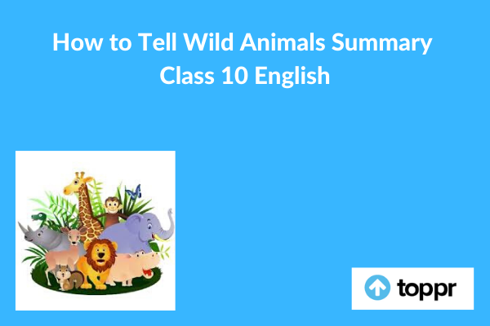

**How to Tell Wild Animals Summary in English**

The poet is describing the various wild animals in a very interesting and mysterious way. These animals are very dangerous, but poetess is introducing them one by one in a very funny way. First of all, she tells us about the Asian lion. She says that if you are visiting the jungles of the east and there we see an animal that has tawny skin and may roar that we may die out of fear. It means we saw an Asian lion. Next, she explained the Bengal tiger as a royal animal that at once attacks and kills a man. She says in a humorous way that if this beautiful black striped animal kills us and eats, then we have surely met a Bengal tiger.

After this, she says that if we met an animal with black-spotted skin and it at once jumps on him, then it is a leopard. Also, she says that if one will cry out in pain, then it may be of no use as the leopard will not stop attacking him. Then she introduces the bear that she says will hug very tightly. Because in this way bear may kill a person by hugging him very tightly.

Further, she asks a question to the readers that do we know the way of recognizing beasts that hunt their prey. Then she explains about hyenas having a smiling face always and the crocodiles which have tears in their eyes. It is quite visible when they are killing their prey. Lastly, in the list of animals, she introduces the Chameleon. She says that it is a lizard type creature which doesn’t have ears and wings just like a lizard. Only this information can help us to differentiate between a lizard and chameleon. She further says that the chameleon has a quality of changing its colour as per the colour of its surrounding and surface.

Therefore, to explain this she says that if we look at the tree and if we are seeing the tree only, then certainly it means that there is a chameleon sitting on it. And it has already turned its colour to brown just like the branch of the tree.

**Conclusion of How to Tell Wild Animals**

This poem is beautifully introducing the wild animals in a different way analogous to the hidden human beings.