**1. Why is diffusion insufficient to meet the oxygen requirements of multicellular organisms like humans?**

**Ans.**As in multicellular organisms, all the cells are not in direct contact with environment, simple diffusion does not meet the requirement of all the body cells.

**2. What criteria do we use to decide whether something is alive?**

**Ans.**All the living organism must have movement at molecular levels along with respiration and other life process like nutrition, respiration, transportation and excretion to be called alive.

**3. What are outside raw materials used for by an organism?**

**Ans.**Outside raw materials used for by an organism includes:

a. Food

b. Water

c. Oxygen

**4. What processes would you consider essential for maintaining life?**

**Ans.** The processes essential for maintaining life are

a. Nutrition

b. Respiration

c. Transportation

d. Excretion

**1. What are difference between autotrophic and heterotrophic nutrition?**

**Ans.**Distinction between autotrophic and heterotrophic nutrition:

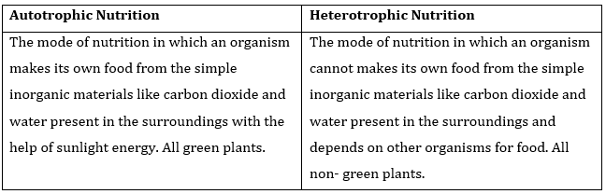

**2. Where do plants get each of the raw materials required for photosynthesis?**

**Ans. (a)** Carbon dioxide from atmosphere.

**(b)** Light from Sun

**(c)** Water from Soil

**(d)** Chlorophyll from chloroplast of green plants.

**3. What is the role of the acids in our stomach?**

**Ans.**HCl plays following role in our stomach:

**(a)** Make the medium acidic for action of enzyme pepsin.

**(b)** Kills the harmful bacteria present in food

**(c)** Prevents fermentation of food

**4. What is the function of digestive enzymes?**

**Ans.**Enzymes break-down the various complex components of food into simple and soluble components so that they can be absorbed easily.

**5. How is small intestine deigned to absorb digested food?**

**Ans.** The inner lining of small intestine has numerous finger-like projections called villi which increase the surface area for absorption. The villi are richly supplied with blood vessels which transport the absorbed food to each and every cells of the body. Where, it is utilized to obtaining energy and repair of old tissues.

NCERT Solutions for Class 10 Science Life Processes Part 1

**1. What advantage over an aquatic organism does a terrestrial organism have with regard to obtaining oxygen for respiration?**

**Ans.**The rate of breathing is slower in terrestrial organisms as compared to aquatic organisms. This is due to the fact that in water, the amount of oxygen is less as compared to air while in aquatic organisms the rate of breathing is faster.

**2. What are different ways in which glucose is oxidized to provide energy in various organisms?**

**Ans.**The pathways of break-down of glucose in various organisms are as below:

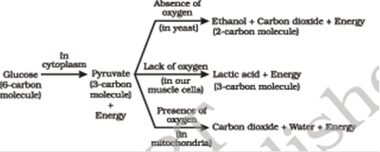

**3. How is oxygen and carbon dioxide transported in human beings?**

**Ans.**In human beings, a pigment hemoglobin is present in RBC which has high affinity for oxygen, takes up the oxygen from the air in the lungs and carry it to tissues which are deficient in oxygen. Some oxygen is carried in dissolved state in blood plasma. Carbon dioxide is more soluble in water than oxygen is mostly transported in the dissolved form in our blood.

**4. How are the lungs designed in human beings to maximize the area for exchange of gases?**

**Ans.**In lungs, the bronchioles terminate in balloon-like structures called alveoli. The alveoli contains network of blood capillaries that increase the surface area for exchange of gases.

**1. What are the components of the transport system in human beings? What are the functions of these components?**

**Ans.**The components of human transport system include:

**(a)** Heart- receives and pumps the blood.

**(b)**Arteries- carry oxygenated blood away from the heart to various organs.

**(c)**Veins- Bring back blood to heart.

**(d)**Capillaries- exchange of various materials and gases between blood and tissues.

**2. Why is it necessary to separate oxygenated and deoxygenated blood in mammals and birds?**

**Ans.**The separation of the right and left side of heart is useful to prevent oxygenated blood and deoxygenated blood from mixing. Such separation allows a highly efficient supply of oxygen to the body. This is useful in animals that have high energy needs, such as birds and mammals that constantly use the energy to maintain their body temperature.

**3. What are the components of transport system in highly organized plants?**

**Ans.**The transport system of higher plants consists of xylem and phloem. Xylems have vessels and trachieds to transport water and minerals from root to other part of the plants.

Phloem, which consists of sieve tubes and companion cells, transport food from leaves to storage organs and other parts of plant.

**4. How are water and minerals transported in plants?**

**Ans.**Water and minerals are transported in plants through xylem which consists of trachieds and vessels. Water and minerals absorbed by root hairs present in root by osmosis is passed to xylem tissues of root. From root xylem it passes to stem xylem and thus water reaches to leaves.

NCERT Solutions for Class 10 Science Life Processes Part 1

**5. How is food transported in plants?**

**Ans.** Food is transported in plants through phloem which consists of sieve tubes, sieve cells and companion cells. The food prepared in leaves in soluble form transported to leaves phloem. Active transport of food passes to all other parts of plants.

**1. Describe the structure and functioning of nephron.**

**Ans.**Each nephron is a cluster of very thin-walled blood capillaries. Each capillary cluster in the kidney called glomerulus is associated with the cup shaped Bowman’s capsule that collects the filtered urine. Nephron filters the blood in order to remove nitrogenous waste. They also absorb some useful substance such as glucose, amino acids, minerals and major amount of water from filtrate.

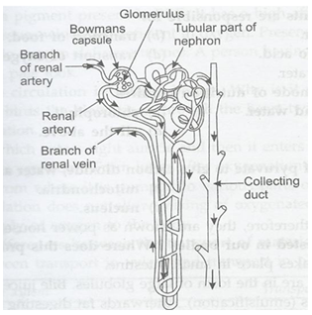

NCERT Solutions for Class 10 Science Life Processes Part 1

**2. What are the methods used by plants to get rid of excretory products?**

**Ans. (i)** Plant produces carbon dioxide as wastes during respiration and oxygen as waste during photosynthesis.

**(ii)** Excess of water is removed through transpiration.

**(iii)** Some waste products like gums and resins are stored in older xylem tissue.

**3. How is amount of urine produced regulated?**

**Ans.** The amount of urine depends on how much excess of water is in the body and how much a water soluble waste is to be excreted. If the amount of water and dissolved wastes in boy are more than amount of urine will be more and if amount of wastes is less the amount of urine produced will be less.