**Summary of The Ball Poem**

The Ball Poem summary is for students of class 10 English. Its poet John Berryman is beautifully describing a boy who has lost his ball. He gave a lesson that is full of wisdom through the loss of everyone, must learn to bear the pain associated with loss.  The poet assumes a boy who is playing with a ball. Once the ball bounces out of his control and consequently falls into the water. The boy became sad. The poet feels that no other ball will be sufficient to lessen his sadness. Here, the lost ball stands for the general loss of a human being.

The losses may be the loss of personal possession or the death of some near and dear one or due to the separation from the beloved one. As long as there is life, everyone has to bear many types of losses. Therefore we need to learn the way for bearing those losses.

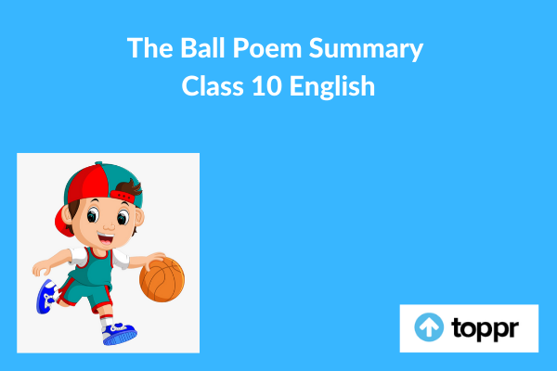

**The Ball Poem Summary in English**

This poem is about losing something which we love and then learning to grow up. It is about a little boy, who in his young life, for the first time, is learning what it is like to experience grief after the loss of a much-beloved possession which is here his ball. Maybe for us, the loss of a ball is of minor consequence. Our natural reaction may be that still there are many more balls. So, need not worry. But to a little boy, this is something different. One can get another ball with a very less amount of money. But, money is external and immortal here, as it cannot buy back the love and hence cannot replace the things that we love.

In this poem, the boy’s ball van is easily personifying with his young days and which were happy and innocent. People may take balls just as they will take away our innocence and force us to grow up soon. And once we lose our innocence, then we cannot get it back. But, despite all of these we have to learn to stand up. Obviously we need to be strong and get on with our life, irrespective of the sadness inside. This is the only way we will survive. Therefore, we have to learn to accept and let go.

The poet has made the use of the imagery while telling how the ball personifies the spirit of the boy’s childish innocence. We may visualize how the spirit of this little boy, like the ball, is sinking into the dark waters of the harbour. And as it drifts further away, the little boy will learn to grow up, and that part is linked to that ball grows up as well, until it is no longer a little boy.

Thus the reader may interpret this poem literally and metaphorically both. If literally, then it is a soulful picture of little boys growing up and learning to deal with the loss of the first in his possession. If metaphorically, then it is the story of mankind learning to deal with the loss of their loved things or people.

**Conclusion of The Ball Poem**

This poem successfully describes how we may feel to lose something that we love and grow up eventually without it.