# Windows Azure Storage Plugin for WordPress

## Introduction

This WordPress plugin allows you to use Windows Azure Storage Service to host your media for your WordPress powered blog. Windows Azure Storage is an effective way to scale storage of your site without having to go through the expense of setting up the infrastructure for a content delivery.

## Features

Key features of this plug-in are listed below,

### Transparent Storage for End User

Actual storage location details are transparent to the end user.

### Automatic File Upload to Windows Azure Storage

Uploaded media file are automatically saved into configured Windows Azure Storage Blob Container without any extra steps. Media files will be delivered by Windows Azure Storage, instead of your own web host

### Highly Configurable

This plugin provides several options for configuration underlying Windows Azure Storage service.

### Search Media Files

Provides ability to search media files based on criterions (like tag, file type, creation date etc.) provided by user. The plugin performs search using Windows Azure Storage Services APIs available in Windows Azure SDK for PHP.

## Target Users

### Personal blogging web sites

This is for a personal blogging web site that uses WordPress software. Such user need not invest in infrastructure setup for storage and can use his Windows Azure Storage account. Global account settings with single Blob Container would be sufficient for such user.

### WordPress blog hosters

There are several professional web hosting providers who offer blogging services based on WordPress software. These include [www.wordpress.com](http://www.wordpress.com), <http://www.bluehost.com/track/wp/one>. Each such provider may contain thousands of users and millions of blog posts.

Windows Azure will be natural option for such providers to reduce storage cost.

## Architecture

WordPress Plugin APIs allows easy modification, customization, and enhancement to a WordPress blog. A high level architecture diagram for this plugin is shown below,

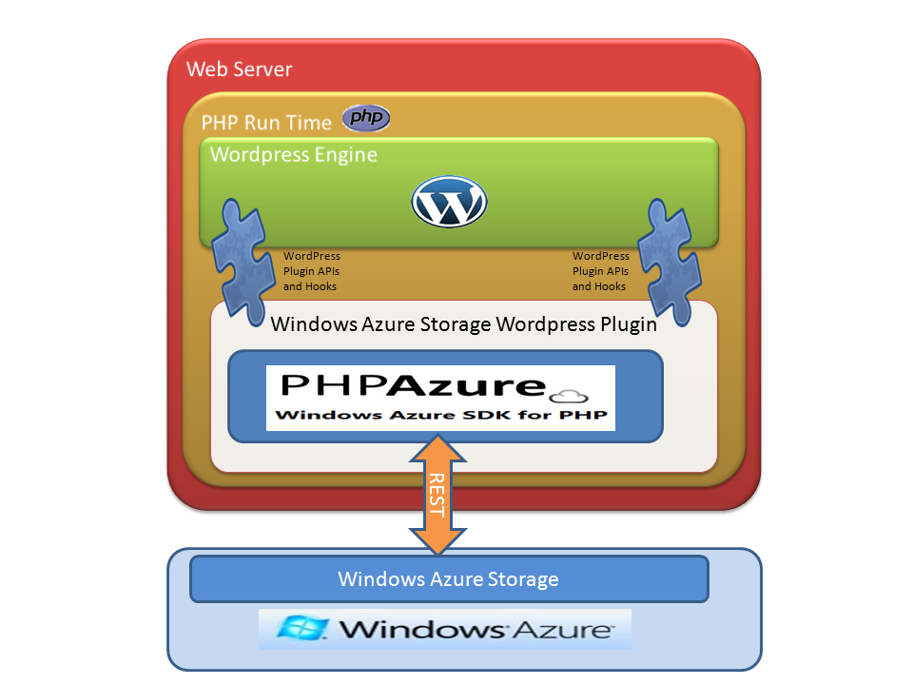

## Installation Instructions

* Extract the Windows Azure Storage Plugin **windows-azure-storage.zip** to the plugins directory of the WordPress installation.

e.g. With a default install ofWordPress in “**/var/www/html/wordpress**”, extract the **windows-azure-storage.zip** file into directory “**/var/www/html/wordpress/wp-content/plugins**”.

* To activate the plugin, log in into the WordPress as administrator and navigate to list of plugins. Then check the associated checkbox for the plugin and click on “**Activate**” link.

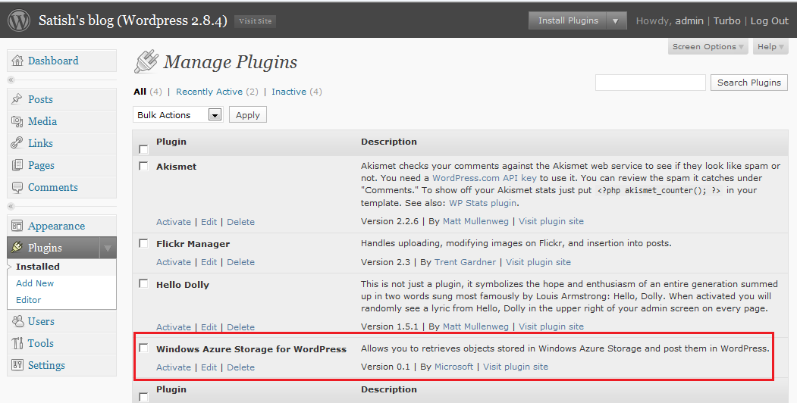

## Configure Windows Azure Storage Account

After activating the plugin, user needs to configure it with their Windows Azure Storage Account using following instruction;

* To activate the plugin, log in into the WordPress as administrator and navigate to “**Windows Azure**” sub-Tab inside “**Settings**” Tab.
* Enter Windows Azure Storage account name in “**Storage Account Name**” text box and enter Windows Azure Storage primary access key in “**Primary Access Key**” text box and then click on “**Save Changes**” button. If the underlying Web Server uses http proxy for connecting to the internet, please provide http proxy server details in “**HTTP Proxy Host Name**”, “**HTTP Proxy Port Name**” and “**HTTP Proxy Credentials**” fields.

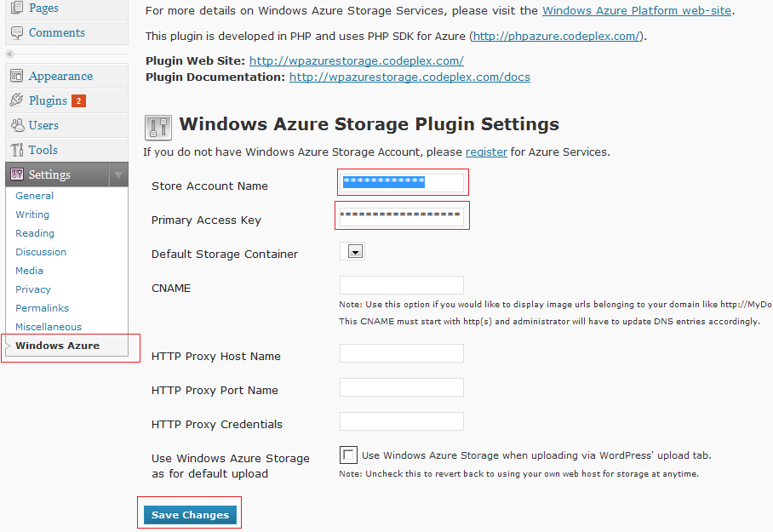

* Once Windows Azure Storage account details are set correctly, the page will be refreshed and “**Default Storage Container**” drop down will be populated with all available blob containers associated with the storage account. Please select the one container for storing your media files and click on “**Save Changes**” button.

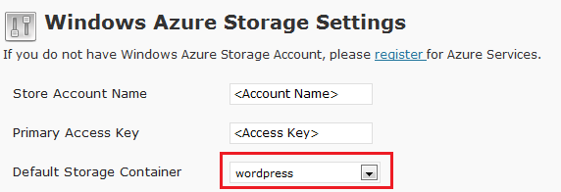

* All media files stored in Windows Azure Storage will have URL like “http://<AccountName>.blob.core.windows.net/<ContainerName>/<MediaFileName>”. One can hide usage of underlying Windows Azure Storage account by defining CNAME entry in the “**CNAME**” text box and then click on “**Save Changes**” button. This CNAME has to start with http(s) and user will have to update DNS entries appropriately to route request back to blob.core.windows.net.

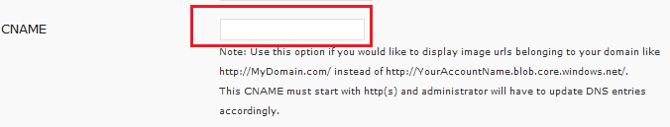

* User can set Windows Azure Storage as default location for storing all media file uploaded via “WordPress upload tab”. File uploads will be automatically saved into configured Windows Azure Storage Blob Container without any extra steps. Just tick the “**Use Windows Azure Storage as default upload**” checkbox and click on “**Save Changes**” button.

## Using the Plugin

* Once this plugin is configured, user will be able to view a new toolbar button on the “**Edit Post**” page. This button has the “**Windows Azure Logo**” as shown in following diagram.

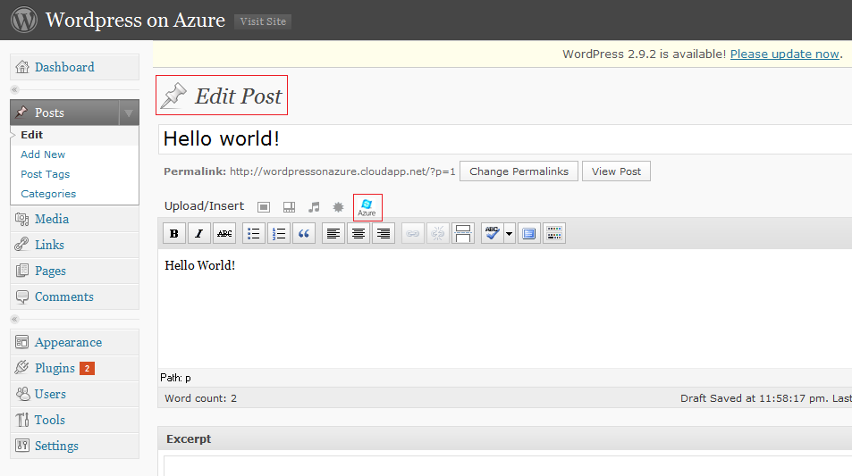

* Clicking on the toolbar button, following “**Windows Azure Storage**” dialog will be displayed.

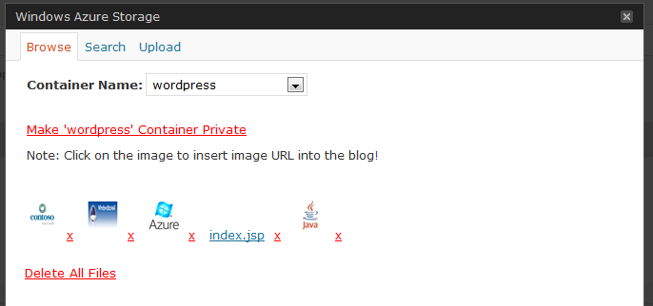

* This dialog will have 3 tabs: Browse, Search and Upload.
* Browse Tab is the default tab and shows all files available in the default container set. For image files, it shows small thumbnail of the image.
* User can change the container by selecting different item in the “Container Name” dropdown. The page will be refreshed and files in the new container will be displayed.
* To insert the media file in the blog post, user has to click on the image in the list of files displayed on screen. Once user clicks on image, the dialog is closed and an image link is added into the text area of the post being edited. HTML view of such post is shown below. Look at the URL for image. It points to the Windows Azure storage host for blobs i.e. blob.core.windows.net.

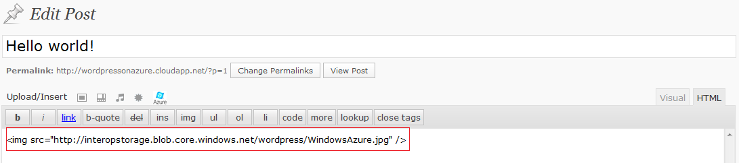

* If user has defined a custom CNAME as follows,



Then the added image URL will look like follows,

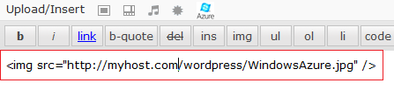

* If the file type is different than image, then the html hyperlink is added to the edit post text area as shown below,



* To upload a new file, click on the “**Upload**” Tab. Following controls will be shown in Upload Tab.

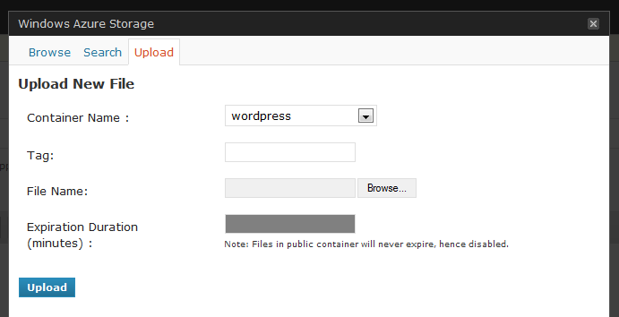

* New files will be uploaded to the default container, however user can change container by selecting different container from the drop down.
* User will be able to provide custom tag for the file to be uploaded. Use comma as separator for multiple tags.
* Click the “**Browse…**” button and select the file to be uploaded using File Open Dialog.
* “**Expiration Duration**” text box will be disabled for public container because all files in public container never expire. But if a private container is selected, then user can set expiration duration on the file to be uploaded. The URL associated with such file will be valid only for the specified duration. Public users will not be able to view this file once the URL expires. This feature uses shared signature feature of the Windows Azure Blob Storage.
* Such file having expiration duration set will be added to the edit post text using associated shared signature, as shown below,

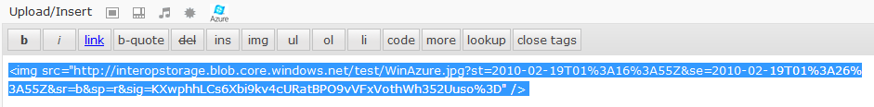

* If Windows Azure Storage is used for default file upload using following option, then all file uploads happening via default media upload dialogs will be routed to Windows Azure Storage account. Same files will be displayed in Browse Tab in the Windows Azure Storage popup dialog.



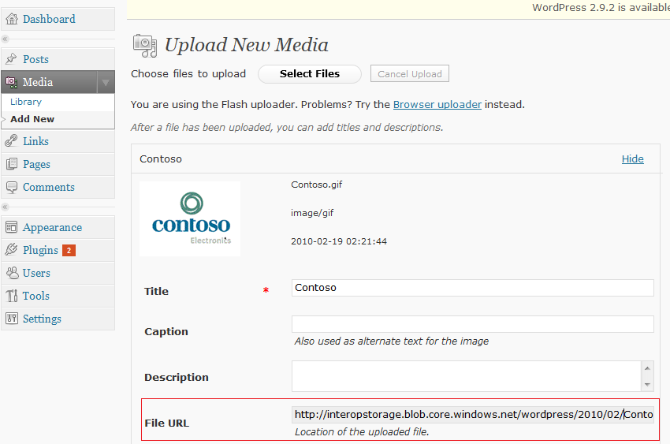

* If the XML-RPC option is set in “**Writing Settings->Remote Publishing**” as shown below and Windows Azure Storage is set for default file upload, then all file uploads happening via XML-RPC will be routed to the configured Windows Azure Storage account.

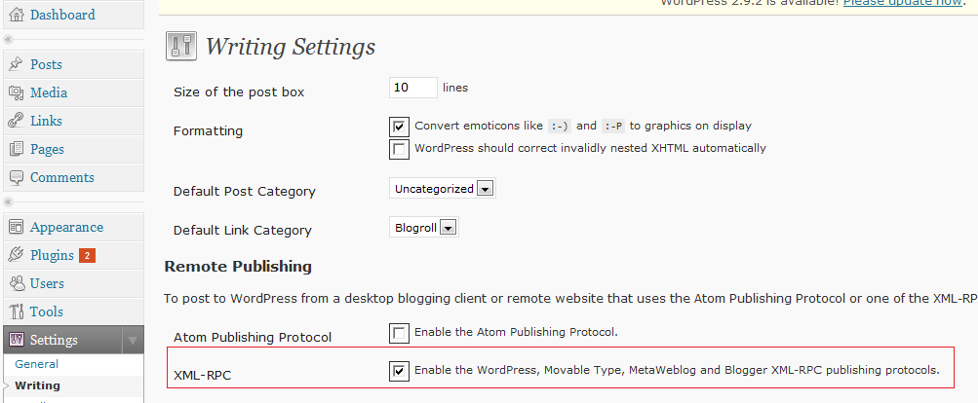

* Search Tab shows following controls,

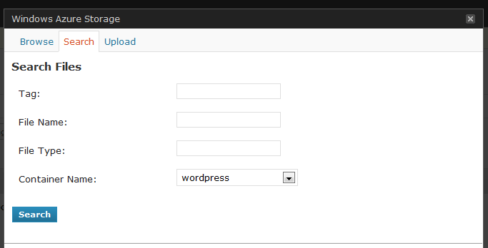

* Default container is selected for search. User can change the container to be searched for specified criteria. User can also search in all containers.
* User can search files based on Tag, File Name and File Type. Logical AND operation is performed on multiple criterions.
* Click on “**Search**” after specifying various criterions. Result will be displayed in the “**Browse**” Tab as follows.

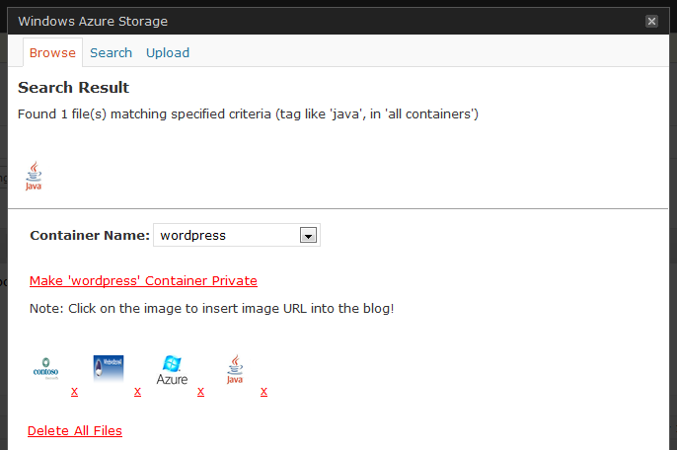

## Known Issues WordPress MU edition (prior to WordPress 3.0)

This plugin does not work out-of-box with the WordPress MU (Multi User) edition. The only workaround is to edit the **\wp-admin\options.php** file within the WordPress MU installation. Perform following changes in this file,

* Open **\wp-admin\options.php** file and search for the function call “check_admin_referer”. This call is inside one if condition and looks like follows,

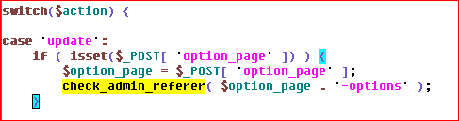

* WordPress MU edition does not contain any else block in this if statement. Add following else block to this if-statement and save options.php file.

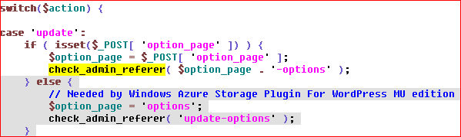

For details, please refer the article <http://mu.wordpress.org/forums/topic/12474>

## Resources

* For more details on Windows Azure Storage Services, please visit the [Windows Azure Platform web-site.](http://www.microsoft.com/azure/windowsazure.mspx)
* Windows Azure SDK for PHP is at the core of this plugin. This SDK is available at <http://phpazure.codeplex.com/>.
* Official PHP on Windows Azure website: http://azurephp.interopbridges.com