CORE-ET CPU Subsystem Micro-Architecture Reference
2026-09-29

Table of Contents
Document Control
Revision History
1 ET-SoC-1 Overview
1.1 ET-SoC-1 at a Glance
1.2 The ET-Minion Hierarchy
1.2.1 ET-Minion Core
1.2.2 Neighborhood
1.2.3 Minion Shire
1.2.4 Minion Shire Array
1.3 ET-Maxion and Service Processor
1.3.1 ET-Maxion Cores
1.3.2 Service Processor
1.4 Mesh Network-on-Chip
1.4.1 Mesh Topology and Mesh Stops
1.4.2 Memory Shires
1.4.3 PCIe Shire
1.4.4 I/O Shire
1.5 ET-SoC-1 Accelerator Card
2 ET-Minion Core
2.1 Core Overview
2.1.1 Block Partitioning
2.1.2 Hardware Threads
2.1.3 Instruction Flow Through the Core
2.1.4 Interfaces to the Neighborhood
2.1.5 Clocks, Resets and Power
2.1.6 Debug Support
2.2 Front End
2.2.1 Overview
2.2.2 Interface
2.2.3 Pipeline Stages
2.2.4 Interaction with the L0 Micro-Cache
2.2.5 Thread Buffer
2.2.6 Entry Invalidation, Redirect and Thread Start
2.2.7 Decoders
2.2.8 Instruction FIFO
2.2.9 Thread Scheduler
2.2.10 Halt and Debug Program Buffer
2.3 Integer Pipeline
2.3.1 Overview
2.3.2 Pipeline Stages
2.3.3 Interfaces
2.3.4 Register File and Operand Read
2.3.5 Immediate Generation and ALU
2.3.6 Multiply/Divide Unit
2.3.7 Scoreboards and Hazards
2.3.8 Hart Interleaving and Stalls
2.3.9 Branches, Redirects and Replay
2.3.10 Interface to the Data Cache
2.3.11 Interface to the VPU
2.3.12 CSRs and Privilege Modes
2.3.13 Exceptions and Interrupts
2.3.14 Debug and Breakpoints
2.3.15 Performance Counters
2.3.16 Verification Notes
2.4 Data Cache
2.4.1 Overview
2.4.2 Organization and Operating Modes
2.4.3 Interfaces
2.4.4 Request Pipeline
2.4.5 Address Translation and PMA Checks
2.4.6 Tag, Data and LRU Arrays
2.4.7 Miss Handling
2.4.8 Replay Queue
2.4.9 Writeback and Store Merge
2.4.10 Atomic Operations
2.4.11 Cache-Management Operations
2.4.12 Scratchpad Control
2.4.13 Tensor Load and Reduce
2.4.14 Interface to the Neighborhood
2.4.15 Errors
2.4.16 Performance
2.4.17 Verification Notes
2.5 Vector Processing Unit
2.5.1 Overview
2.5.2 Interfaces
2.5.3 Control and Micro-Instruction Decode
2.5.4 Register Files
2.5.5 Lanes
2.5.6 Mask Unit
2.5.7 Bypass Network
2.5.8 Shift and Swizzle Unit
2.5.9 TxFMA Unit
2.5.10 Integer Multiply-Accumulate Unit
2.5.11 Transcendental Unit
2.5.12 Tensor Operations
2.5.13 Interfaces to the Integer Pipeline and Data Cache
2.5.14 Performance
2.5.15 Verification Notes
3 Neighborhood
3.1 Neighborhood Overview
3.1.1 Partitioning
3.1.2 Shared Resources and Core Connections
3.1.3 Voltage-Domain Crossings
3.1.4 External Interfaces
3.2 Neighborhood Instruction Cache
3.2.1 Structure and Connections
3.3 Front End – I-Cache Interface
3.3.1 Overview
3.3.2 Interface Signals
3.3.3 Request Arbitration
3.3.4 Request and Response Timing
3.3.5 Miss, Sleep and Fill-Done Protocol
3.3.6 Fault and Error Reporting
3.3.7 Complete Path for Four Cores
3.3.8 Livelock and Starvation Avoidance
3.3.9 Known Limitations
3.4 L0 Micro-Cache
3.4.1 Overview
3.4.2 Internal Blocks
3.4.3 Pipeline Stages
3.4.4 Instruction TLB
3.4.5 Micro-Tag and Micro-Data Arrays
3.4.6 PMA Check
3.4.7 Replacement
3.4.8 Miss Handling
3.4.9 L1 Bypass
3.4.10 Software Prefetch
3.5 L1 Instruction Cache
3.5.1 Overview
3.5.2 Organization
3.5.3 Tag, LRU and Data Arrays
3.5.4 External Data RAM
3.5.5 Request Arbitration Between L0 Micro-Caches
3.5.6 Miss Path
3.5.7 Errors and ECC
3.6 Shared Page-Table Walker
3.6.1 Clients and Arbitration
3.6.2 Walk Sequence and Page Sizes
3.6.3 PTE Cache and Invalidation
3.7 Memory Request and Response Path
3.7.1 Miss, Evict and Fill FIFOs
3.7.2 Request Arbitration
3.7.3 Response Routing and Backpressure
3.8 Tensor Support
3.8.1 Cooperative Tensor Load
3.8.2 Tensor Store Buffer
3.8.3 TBOX Router
3.9 Synchronization, Messaging, Registers and PMU
3.9.1 Fast Local Barrier
3.9.2 Local Message Network
3.9.3 IPI and FCC Paths
3.9.4 Neighborhood Registers and APB Access
3.9.5 Debug Channel
3.9.6 Performance Monitoring Unit

List of Tables
Table 1. ET-SoC-1 key characteristics
Table 2. Shires on the mesh
Table 3. ET-Minion core blocks
Table 4. Per-thread and shared resources
Table 5. Front End submodules
Table 6. Front End I/O signals
Table 7. frontend_icache_req: fetch request (58 bits)
Table 8. minion_vm_status: virtual-memory status (8 bits)
Table 9. icache_frontend_resp: fetch response (261 bits)
Table 10. minion_fe_req: redirect (52 bits)
Table 11. frontend_core_resp: instruction to the integer pipeline (89 bits)
Table 12. frontend_thread_data: instruction FIFO entry (179 bits)
Table 13. Decoded control words
Table 14. Front End configuration parameters
Table 15. Thread-buffer entry state
Table 16. Fetch PC update
Table 17. Request conditions
Table 18. Entry fill sequence
Table 19. Instruction fetch status
Table 20. Entry release conditions
Table 21. Effect of a redirect
Table 22. Decode thread selection
Table 23. Instruction FIFO update
Table 24. Thread selection
Table 25. Debug program-buffer sequence
Table 26. Program-buffer word mapping
Table 27. Front End – I-cache interface signals
Table 28. Grant pipeline in the Neighborhood
Table 29. Starvation avoidance mechanisms in the instruction fetch path
Table 30. Prefetch retry windows

List of Figures
Figure 1. ET-Minion hierarchy
Figure 2. ET-Minion core
Figure 3. Neighborhood
Figure 4. Minion Shire
Figure 5. ET-Maxion pipeline
Figure 6. ET-SoC-1 block diagram
Figure 7. ET-SoC-1 PCIe card
Figure 8. Front End in the ET-Minion core
Figure 9. Front End block diagram
Figure 10. Front End pipeline
Figure 11. Front End to L0 micro-cache request and response path
Figure 12. Request and hit response
Figure 13. Miss, sleep and retry
Figure 14. Redirect while a request waits in F1
Figure 15. Thread buffer operation
Figure 16. Thread buffer pipeline
Figure 17. Thread-buffer entries and read pointer
Figure 18. Redirect to first target instruction
Figure 19. Thread enable to first instruction
Figure 20. Decoders, instruction FIFOs and thread scheduler
Figure 21. Round-robin issue with a stall
Figure 22. Neighborhood instruction cache
Figure 23. Front End – I-cache interface
Figure 24. Request and hit response at the L0 micro-cache
Figure 25. Miss, sleep, fill done and retry
Figure 26. Request capture, arbitration and response for four cores
Figure 27. Miss counters and bid mask in the fetch path
Figure 28. Miss-count guard: saturation, bid mask and release

Document Control

Revision History
Version | Date | Author | Notes
v0.1 | 2026-09-22 | Ryan Naveed | - First draft of the document.  - Chapter 1, ET-SoC-1 Overview: written.  - Chapter 2, ET-Minion Core: Core Overview (block partitioning, hardware threads, instruction flow) and Front End written. Integer Pipeline, Data Cache and VPU contain headings only.  - Chapter 3, Neighborhood: headings only.

1 ET-SoC-1 Overview

1.1 ET-SoC-1 at a Glance
ET-SoC-1 is a many-core RISC-V system-on-chip developed primarily for artificial-intelligence and machine-learning (AI/ML) workloads. It is designed as a flexible, fast and efficient inference engine for ML applications. Its compute resources are arranged in a multi-level hierarchy that delivers high sustained performance on regular, parallelizable workloads, such as those of ML algorithms.
The device integrates 1,093 general-purpose 64-bit RISC-V cores of three types:
- 1,088 ET-Minion cores for ML computation
- 4 ET-Maxion cores for management and general-purpose tasks
- 1 Service Processor for boot and device management
The cores are connected to on-die SRAM, external memory and a set of standard interfaces through a mesh network-on-chip (NoC). Table 1 summarizes the device.
Table 1. ET-SoC-1 key characteristics
Item | Description
ET-Minion cores | 1,088 in-order, dual-threaded RV64IMFC cores, each with an 8-lane vector/tensor unit
ET-Maxion cores | 4 single-threaded, superscalar, out-of-order 64-bit RISC-V cores
Service Processor | 1 single-threaded core derived from the ET-Minion
On-die SRAM | Each Minion Shire’s 4 MB Shire Cache can be partitioned by ESRs into L2, a slice of the chip-wide L3, and scratchpad.
Interconnect | Mesh NoC with 44 mesh stops
External memory | LPDDR4X, 16 channels x 16 bits, up to 4,266 MT/s
PCI Express | Gen4, 8 lanes. Endpoint, root complex, or both at once.
Other interfaces | eMMC, USB 2.0 OTG, I2C/SMBus, I3C, SPI, UART, GPIO. Debug access through JTAG and a USB 2.0 device port.

1.2 The ET-Minion Hierarchy
The ET-Minion cores are organized in three levels, as shown in Figure 1:
- ET-Minion core
- Neighborhood: 8 ET-Minion cores
- Minion Shire: 4 Neighborhoods (32 ET-Minion cores)
Each level adds resources that are shared by the units it contains. The device contains 34 Minion Shires, which together form the Minion Shire array (1.2.4. Minion Shire Array).
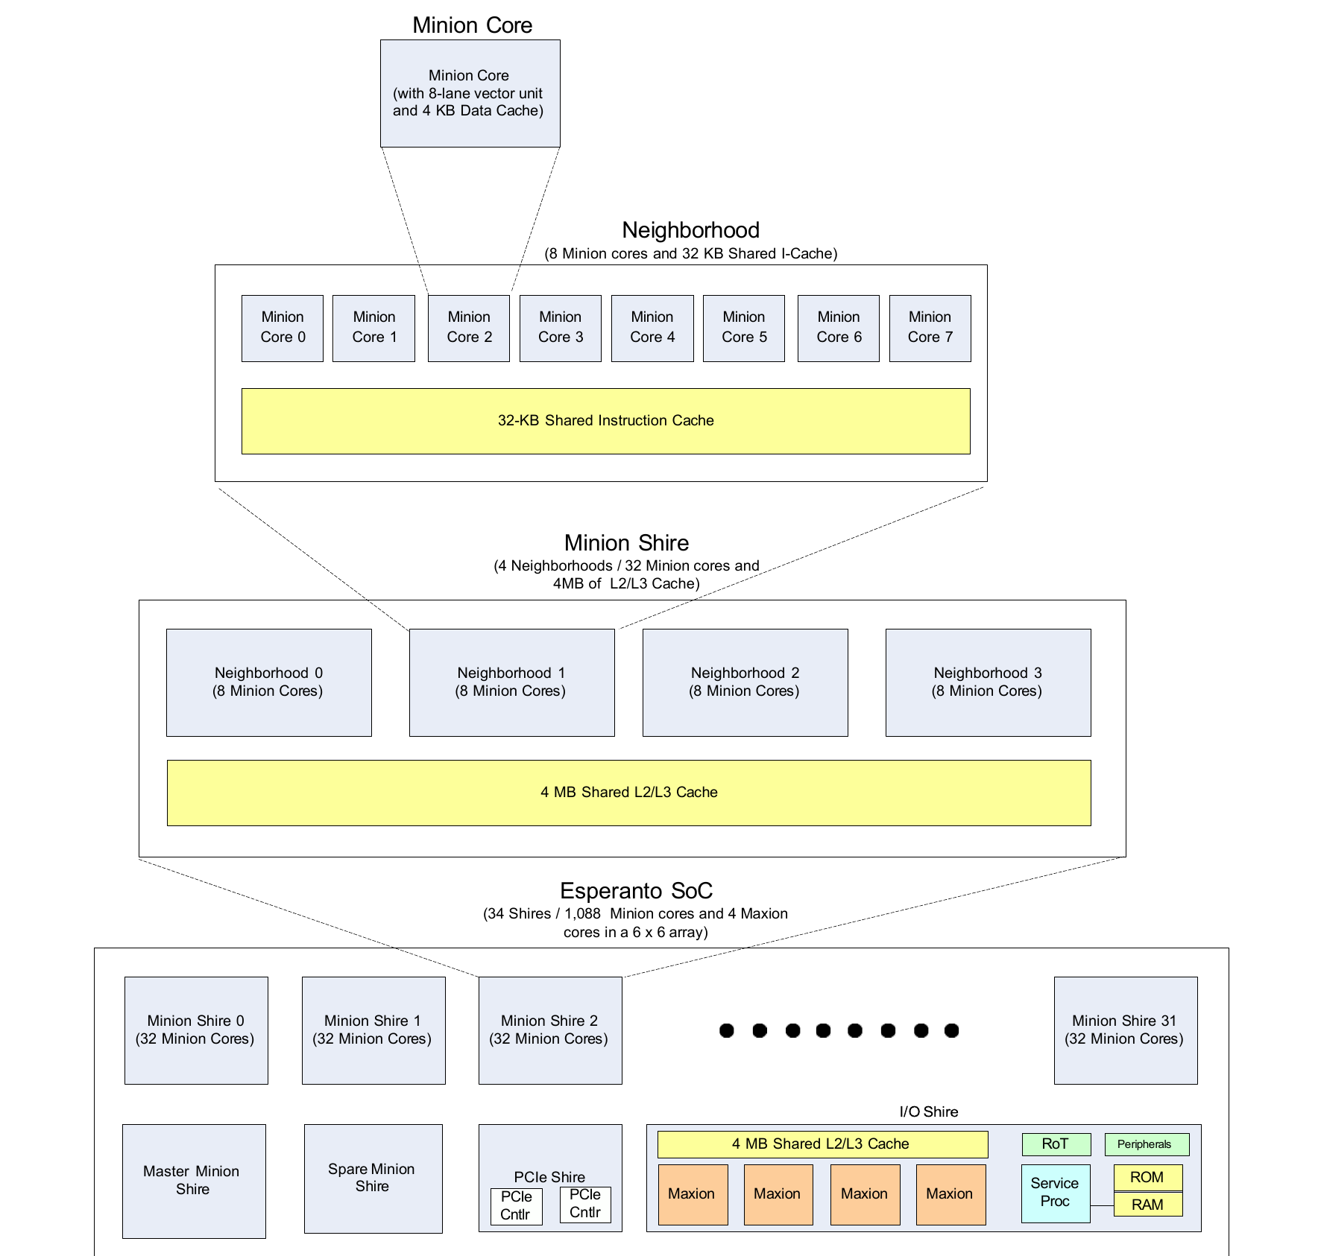
Figure 1. ET-Minion hierarchy

1.2.1 ET-Minion Core
The ET-Minion is a dual-threaded, in-order, single-issue 64-bit RISC-V core that implements RV64IMFC. Its main features are:
- Two hardware threads (harts)
- 4 KB private L1 data cache, partly configurable as scratchpad memory
- Vector processing unit (VPU) with eight identical lanes operating in lock-step. Each lane contains:
  - Floating-point multiply-add unit (FMA): one 32-bit or two 16-bit operations
  - Two integer multiply-add units (IMA): four 8-bit multiply-accumulates each
  - Integer unit (INT)
  - Transcendental unit (TRANS)
- Esperanto instruction extensions for vector, tensor, atomic, message, cache-management and fast-synchronization operations
The core consists of four top-level blocks, shown in Figure 2:
- Front end (FE)
- Integer pipeline
- L1 data cache and scratchpad
- VPU
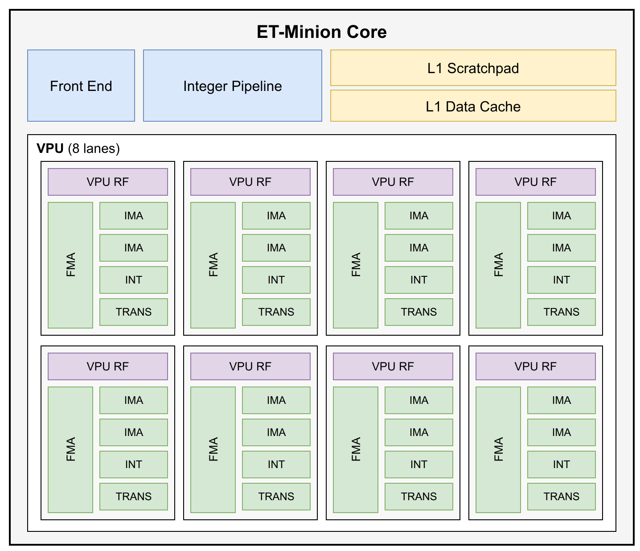
Figure 2. ET-Minion core

1.2.2 Neighborhood
A Neighborhood groups eight ET-Minion cores that share the following resources. In Figure 3, the L0 micro-caches are labeled "I-Cache".
A Neighborhood also spans two supply-voltage regions. The cores and most of the Neighborhood logic are in the low-voltage region, while the interface towards the Shire Channel and the memory cells that need speed, among them the data RAMs of the L1 instruction cache, are in the high-voltage region (3.1.3. Voltage-Domain Crossings).
- L1 instruction cache: 32 KB, organized as 128 sets × 4 ways with 64-byte lines. It is shared by all eight cores, and its data RAMs are located outside the Neighborhood.
- L0 micro-caches: two, each shared by four cores. Each holds 16 fully associative cache lines, sits between its cores and the L1 instruction cache, and accesses the L1 instruction cache on a miss.
- Page-table walkers (PTWs): two, each shared by four cores. Each PTW serves the data caches of its four cores and the instruction-cache side.
- Request/response path: a single path to the memory hierarchy outside the Neighborhood. Requests from the eight data caches, the instruction cache, the two PTWs and, the cooperative TensorLoad/TensorStore units are arbitrated into (256-bit internally which is converted to a 512-bit ET-Link bus).
- Performance monitoring unit (PMU): twelve 64-bit event counters shared by the eight cores.
Eight counters count ET-Minion events and four count Neighborhood events.
- Cooperative TensorLoad: coalesces the TensorLoad requests that several cores issue for the same address into a single memory request, and delivers the one response back to every cooperating core. Cores in all four Neighborhoods of a Minion Shire can cooperate; one Neighborhood acts as master and sends the combined request.
- Cooperative TensorStore: combines the partial writes of cooperating cores into one Shire Cache write, and replicates the acknowledgement to every core that took part. Cores cooperate in two fixed groups, cores 0 to 3 and cores 4 to 7, in one of three modes:
  - Quad-128: 128 bits from each of four cores, forming a full 512-bit cache line
  - Pair-256: 256 bits from each of two cores, forming a full 512-bit cache line
  - Pair-128: 128 bits from each of two cores, forming half a cache line
  - Each core holds its request until every core of the group has presented one, so operations of different modes cannot mix.
- Fast Local Messaging Network (FLN): carries messages between cores of the same Neighborhood directly, instead of sending them out through the request path and back in through the response path. Connections are not all-to-all; they follow the pattern used by the tensor reduction instructions, and a message arriving over this network takes priority over the other responses to that core.
- Fast local barrier (FLB) path
- Neighborhood ESRs
- Interrupts: routes the external, timer and software interrupt lines to the cores, and delivers the inter-processor interrupts (IPIs). A software write to a Shire ESR raises a machine software interrupt for a hart, or a redirect IPI that sends the selected harts to the PC held in the Neighborhood ipi_redirect_pc ESR.
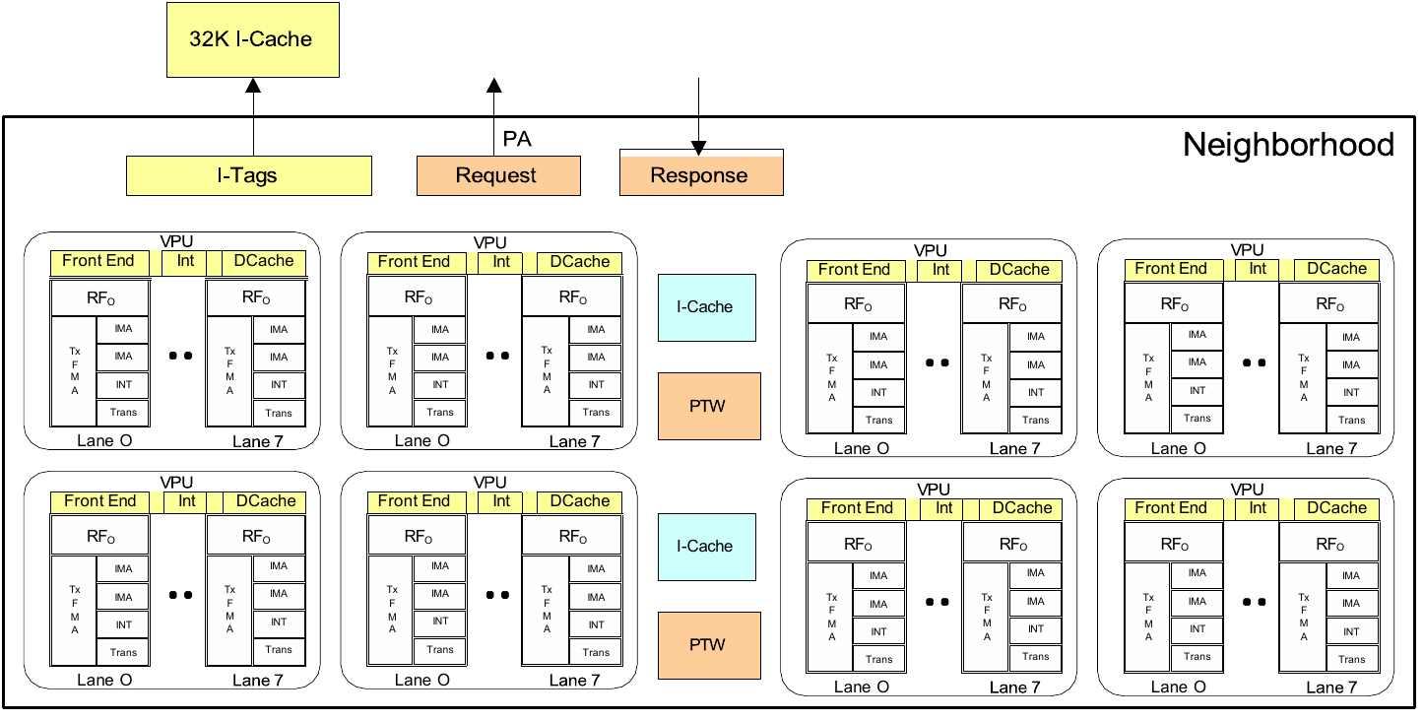
Figure 3. Neighborhood

1.2.3 Minion Shire
A Minion Shire groups four Neighborhoods (Figure 4). It also contains:
- Shire Cache: 4 MB, in four 1 MB banks. Programmable ESRs divide the cache into three kinds of partition:
  - L2 cache, private to the Shire
  - Slice of the chip-wide distributed L3 cache
  - Scratchpad memory
- Crossbar: Request and response crossbars connect four Neighborhoods and the RBOX port to the four Shire Cache banks and the UC block. Each Neighborhood has one request and response port into the Shire Cache, and each bank accepts at most one request per cycle. The crossbar also connects the Neighborhoods to the un-cached (UC) block.
- Uncached (UC) block: receives the Neighborhood requests that are not sent to the Shire Cache banks. It handles uncacheable accesses, contains the fast local barrier (FLB) and fast local credit counter (FCC) units, and delivers messages sent between ET-Minion cores of different Shires.
- ESR banks: the Esperanto System Registers (ESRs) configure the blocks in the Shire.
- NoC interface: L2 misses and uncacheable accesses leave the Shire here, bound for other Shires or the memory controllers.
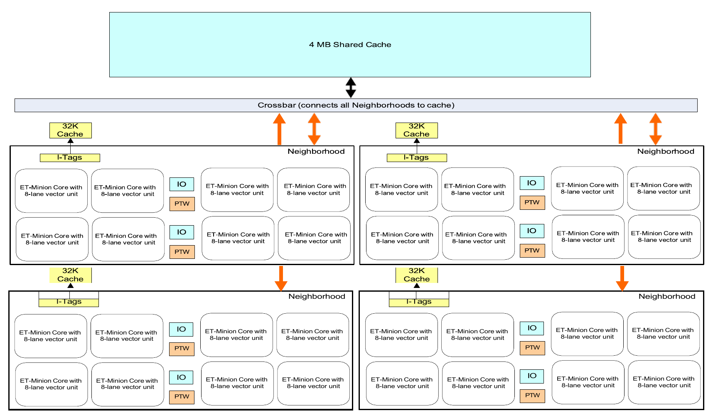
Figure 4. Minion Shire

1.2.4 Minion Shire Array
The 34 Minion Shires, 1,088 ET-Minion cores in total, form the Minion Shire array. The roles of the Shires are assigned by software:
- Compute: 32 Minion Shires operate in parallel as the compute array.
- Master (management): one Minion Shire receives work and distributes it to the compute array.
- Spare: one Minion Shire.
All Minion Shires are identical in hardware, so any Minion Shire can take any of these roles.

1.3 ET-Maxion and Service Processor
In addition to the ET-Minion cores, the device contains two other core types. Both are located in the I/O Shire (1.4.4. I/O Shire). This document does not describe them beyond this section.

1.3.1 ET-Maxion Cores
The ET-Maxion is a single-threaded, superscalar, out-of-order 64-bit RISC-V core intended for management and general-purpose tasks. The device contains four identical ET-Maxion cores. Together with a 4 MB shared L2/L3 cache they form the Maxion Neighborhood, and a system bus and coherency hub in the I/O Shire connects them. Figure 5 shows the ET-Maxion pipeline.
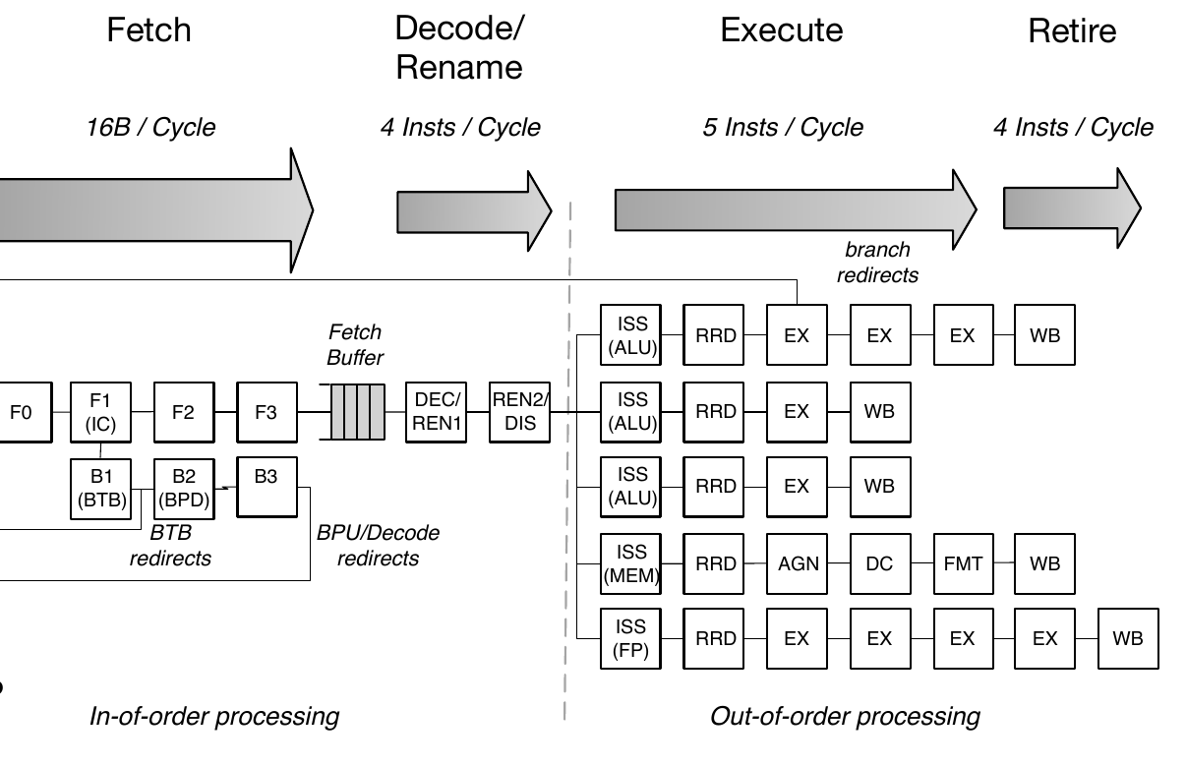
Figure 5. ET-Maxion pipeline

1.3.2 Service Processor
The Service Processor (SP) is a single-threaded ET-Minion core without the vector/tensor extensions. It has its own ROM and a 1 MB scratchpad SRAM, but none of the Neighborhood or Shire shared resources.
- Boot. The SP is the first major block released from reset. It executes the boot code from ROM and initializes the device interfaces, including DDR, PCIe and USB.
- Run time. It provides management services for the whole device.
- Access. The SP can access every resource on the device, and some resources are accessible only to it.
The I/O Shire also contains a hardware root of trust, and six secure mailboxes for communication between four agents:
- Service Processor
- Master Minion Shire
- ET-Maxions
- PCIe host

1.4 Mesh Network-on-Chip
The mesh NoC is the top-level interconnect of ET-SoC-1 and connects all Shires. Figure 6 shows the device with the Shire array on the mesh, the external memory and PCIe interfaces, and the peripheral, Service Processor and debug networks.
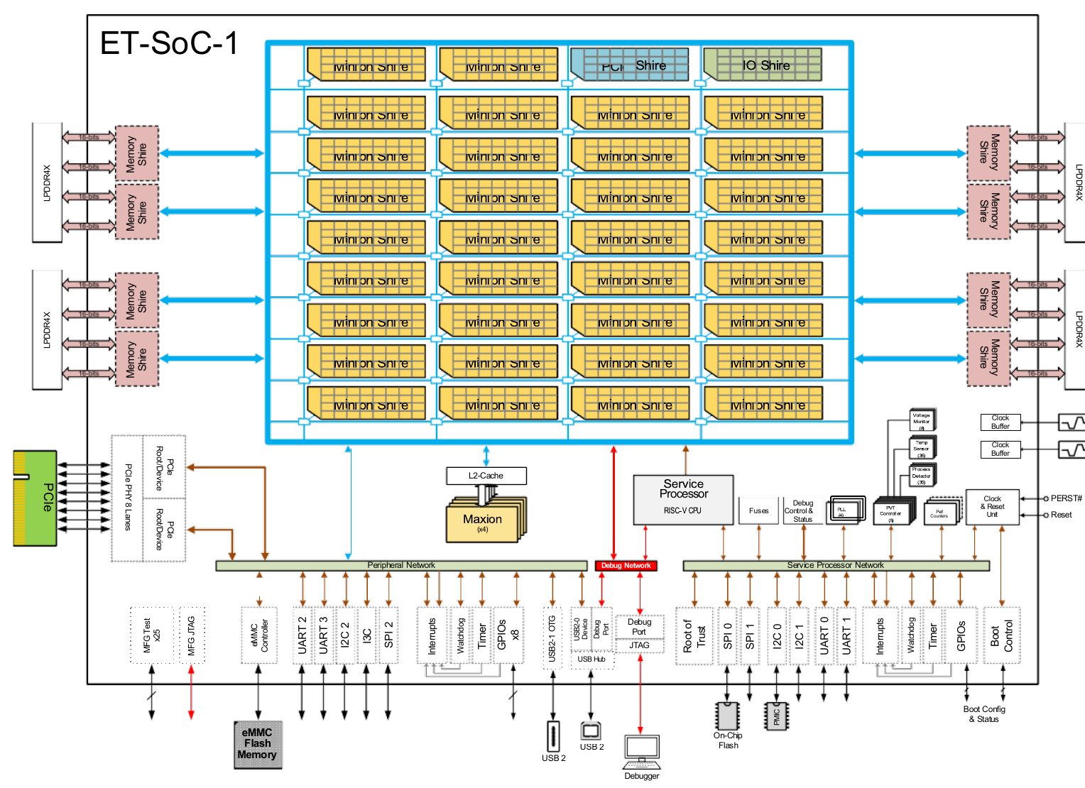
Figure 6. ET-SoC-1 block diagram

1.4.1 Mesh Topology and Mesh Stops
The mesh is organized as an 8 × 6 grid, and each Shire attaches to it at a mesh stop. The Memory Shires occupy the east and west edges, four on each side, which leaves the corners of the grid unoccupied. The result is 44 mesh stops, listed in Table 2.
Table 2. Shires on the mesh
Shire | Count | Contents
Minion Shire | 34 | 32 ET-Minion cores and a 4 MB Shire Cache
Memory Shire | 8 | LPDDR4X memory controller
PCIe Shire | 1 | PCIe controllers and PHY
I/O Shire | 1 | ET-Maxions, Service Processor and peripherals
Total | 44

1.4.2 Memory Shires
Each Memory Shire contains a 32-bit LPDDR4X PHY and two memory controllers, each driving one 16-bit channel achieving 4,266 MT/s/channel. The Memory Shires also support global atomic operations.

1.4.3 PCIe Shire
The PCIe Shire contains two dual-mode PCIe Gen4 controllers that share an 8-lane PHY. It supports three lane configurations:
- Single 8-lane endpoint or root complex
- Single 4-lane endpoint or root complex
- 4-lane endpoint together with a 4-lane root complex
The interface is normally factory-configured as an endpoint.

1.4.4 I/O Shire
The I/O Shire contains the ET-Maxions and the Service Processor (1.3. ET-Maxion and Service Processor). It also contains the device peripherals, which are grouped on three networks according to which agents may access them.
- Service Processor network. Accessible only to the SP. It contains:
  - SPI, including the boot-flash controller
  - I2C, including the link to the external power-management controller
  - UART, including the SP console
  - GPIO, timers, watchdog and boot control
- Peripheral network. Shared by the SP, the ET-Maxions and the master Minion Shire. It contains:
  - eMMC, USB 2.0 OTG, I2C/SMBus, I3C, SPI and UART
  - GPIO, timers and watchdog
- Debug network. Provides debug access through JTAG and a USB 2.0 device port.

1.5 ET-SoC-1 Accelerator Card
ET-SoC-1 operates as an accelerator attached to a host system over PCI Express. It is mounted on a PCIe add-in card (Figure 7) with the following features:
- PCIe x16 card-edge connector, with an 8-lane Gen4 interface to ET-SoC-1
- ET-SoC-1 soldered to the card
- Four LPDDR4X devices forming a 256-bit memory interface
- 64 GB eMMC flash memory
- USB connectors for the ET-SoC-1 device and debug ports and for a UART interface, and a JTAG connector
- DIP switches that select the boot options
Multiple ET-SoC-1 devices can also be integrated on a single card.
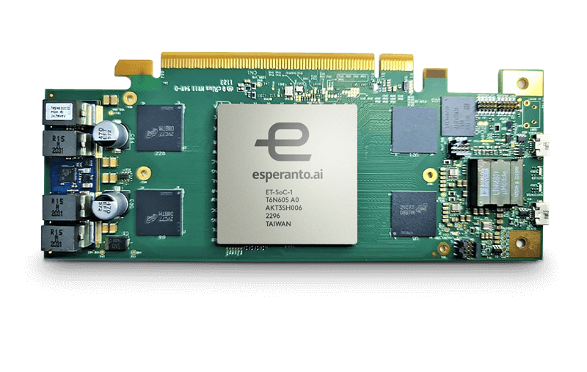
Figure 7. ET-SoC-1 PCIe card

2 ET-Minion Core

2.1 Core Overview
This section describes the internal organization of the ET-Minion core: its block partitioning, hardware threads and instruction flow. The features of the core and its position in the ET-Minion hierarchy are summarized in 1.2.1. ET-Minion Core.
The ET-Minion is a dual-threaded, in-order, single-issue 64-bit RISC-V core that implements RV64IMFC with the Esperanto instruction extensions. It is implemented in minion_top and consists of four units: the Front End, the integer pipeline, the L1 data cache and the VPU. The core fetches instructions from the Neighborhood L0 micro-cache and accesses memory through the Neighborhood memory path; it has no instruction cache of its own.

2.1.1 Block Partitioning
The ET-Minion core is implemented in minion_top (Figure 2). minion_top contains two blocks: core_top, which holds the Front End, the integer pipeline, the L1 data cache and the debug APB slave, and vpu_top, the vector processing unit. Table 3 lists the blocks.
Table 3. ET-Minion core blocks
Block | Module | Function
Front End | frontend_top | Fetches instructions for both threads from the Neighborhood L0 micro-cache, expands compressed instructions, decodes them for the integer pipeline and the VPU, and issues one instruction per cycle to the integer pipeline (2.2. Front End).
Integer pipeline | intpipe_top | In-order, single-issue pipeline with the stages ID, EX, GSC, TAG, MEM and WB. Contains the integer register file, ALU, multiply/divide unit, integer, FP and mask scoreboards, and the CSRs. Redirects the Front End on a change of control flow.
Data cache | dcache_top | 4 KB private L1 data cache, partly configurable as scratchpad memory. Contains the data TLB, PMA check, miss handling, replay queue, store merge, atomic (AMO) forwarding to L2 through the miss handler’s UC flow, scratchpad controller, write-back unit, cache management, tensor-load and reduce units, and the interface to the Neighborhood memory path.
APB slave for debug registers | minion_debug_apb_slv | APB slave for debug access to the core, including writes to the debug program buffer.
VPU | vpu_top | Vector processing unit with a control block and eight identical lanes. Executes floating-point, packed-integer, transcendental and tensor operations.

2.1.2 Hardware Threads
The core runs two hardware threads (CORE_NR_THREADS = 2). Each thread has its own architectural state; the pipeline and execution units are shared, and instructions of the two threads are interleaved in the pipeline.
Table 4. Per-thread and shared resources
Per thread | Shared by both threads
Fetch PC, thread buffer and instruction FIFO in the Front End | Front End request port, decoders and thread scheduler
32 x 64-bit integer registers, in one register file indexed by thread | Integer pipeline, ALU and multiply/divide unit
32 vector registers, (also the FP f-registers), 256 bits wide, held as a 32-bit slice in each lane’s RF, which are indexed by the thread number. Eight 8-bit mask registers. | VPU control and execution units
CSR state, interrupt inputs and debug state | L1 data cache and scratchpad
Each thread is enabled by its corrseponding bit of the enabled input of minion_top. minion_top registers enabled once, and the integer pipeline and debug logic uses this registered copy directly. The Front End regsisters it twice more, so that it can detect the edges of the enable and turn each rising and falling edge into a one-cycle enable of disable event (Section 2.2.6.3). When a thread is enabled, it starts fetching at reset_vector, which is the same for both threads.
The Front End selects one thread per cycle for issue to the integer pipeline. The integer pipeline can stall each thread independently, for example on WFI, a fence, a scoreboard hazard, or while the other thread holds exclusive mode. As a result, the Front End sees a change of enabled two cycles later than the integer pipeline does.

2.1.3 Instruction Flow Through the Core
The Front End fetches instructions for both threads from the Neighborhood L0 micro-cache, expands compressed instructions, decodes them, and presents one instruction per cycle to ID, the first stage of the integer pipeline. The integer pipeline executes the instructions in order and passes memory operations to the data cache and vector operations to the VPU. In the opposite direction, the integer pipeline redirects the Front End to a new fetch address after a branch misprediction, exception or other change of control flow, and stalls a thread that must not issue.
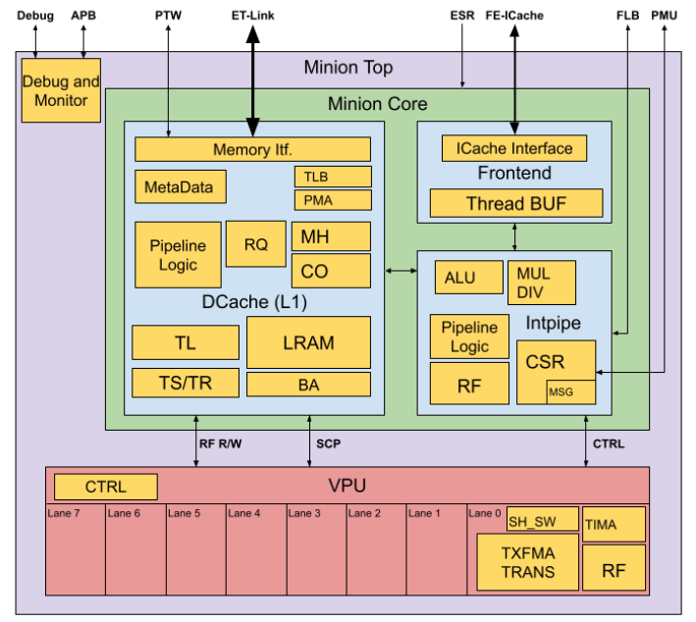
Figure 8. Front End in the ET-Minion core

2.1.4 Interfaces to the Neighborhood
Table: ET-Minion core interface groups.

2.1.5 Clocks, Resets and Power

2.1.6 Debug Support

2.2 Front End

2.2.1 Overview
The Front End (frontend_top) supplies instructions to the ET-Minion core. It sits between the Neighborhood L0 micro-cache and the ID stage of the integer pipeline. It holds the program counter of each of the two threads and fetches 32-byte instruction blocks from the L0 micro-cache. It then extracts the instruction, expands compressed instructions to 32 bits and decodes them for both the integer pipeline and the VPU. It delivers one decoded instruction per cycle to ID, from either thread. The core has no instruction cache of its own. Each L0 micro-cache is shared by four ET-Minion cores, eight threads in all, so the design of the Front End is driven by the need to hide the latency of shared fetch path.
The Front End is built around the following four concepts:
- Fetch is double-buffered: each thread has a thread buffer with two 256-bit entries, each holding half a cache line, so the next block can be requested while the current one is being consumed.
- Each thread has at most one fetch request in flight: the L0 micro-cache answers every accepted request, hit or miss, after a fixed latency, so a thread recognizes its own by timing alone, without a thread identifier. On a miss the thread sleeps until the L0 micro-cache reports that a fill has completed, and then retries.
- Instructions are decoded before they are queued: one integer decoder and one VPU decoder, shared by both threads, decode in F7, and each thread has a two-entry instruction FIFO that holds decoded instructions until ID accepts them. This moves decode out of the ID stage and lets a thread keep fetching while ID serves the other thread.
- The two threads are independent: each thread fetches, sleeps, stalls and restarts on its own. They share only the fetch request port, the decoders and the issue slot into ID, and the thread scheduler alternates between them when both are eligible.
The Front End is a pipeline of eight stages, F0 to F7. F1 to F5 overlap the L0 micro-cache pipeline. With an L0 hit and no competing requests, the first instruction of a block reaches ID nine cycles after it is requested. The first target instruction reaches ID ten cycles after a redirect, and the first instruction reaches ID eleven cycles after a thread is enabled.
The integer pipeline controls the Front End through two per-thread signals. A redirect (f0_core_req_valid, f0_core_req) flushes the thread and restarts fetch at a new PC. It is used for mispredictions, exceptions, replays, interrupts and debug-mode transitions. A stall (id_core_stall) stops the thread from being scheduled, for example on WFI, a fence, a CSR access that must wait, or a scoreboard hazard. The Front End attaches the fetch status to each instruction: page and access faults, bus and ECC errors, and a replay flag for uncacheable fetches issued while older instructions are still in flight. The integer pipeline acts on this status in ID.
The Front End also starts and stops threads through their enable inputs and reset vector. It supports debug in two ways: it generates the placeholder instruction on which a halt is taken, and it lets entry 0 of a halted thread’s buffer serve as the debug program buffer. Each thread buffer runs on its own gated clock; a chicken bit disables the gating.
Table 5 lists the submodules and Figure 9 shows how they are connected. The sections that follow cover the interface (2.2.2. Interface), the pipeline stages (2.2.3. Pipeline Stages), the fetch protocol with the L0 micro-cache (2.2.4. Interaction with the L0 Micro-Cache), the thread buffer (2.2.5. Thread Buffer and 2.2.6. Entry Invalidation, Redirect and Thread Start), decode (2.2.7. Decoders), the instruction FIFO (2.2.8. Instruction FIFO), the thread scheduler (2.2.9. Thread Scheduler), and halt and debug support (2.2.10. Halt and Debug Program Buffer).
Table 5. Front End submodules
Submodule | Instances | Function
Thread buffer (frontend_thread_buffer) | 2, one per thread | 64-byte instruction buffer and the thread’s program counter. Issues fetch requests to the L0 micro-cache.
RVC expander (frontend_rvc_expander) | 2, one per thread buffer | Expands compressed (RVC) instructions to 32 bits.
Request arbiter (arb_lru_data) | 1 | 2:1 LRU arbiter. Selects the thread whose fetch request is sent to the L0 micro-cache.
Integer decoder (intpipe_decode) | 1 | Decodes the instruction into integer-pipeline control signals.
VPU decoder (vpu_decoder) | 1 | Decodes the instruction into VPU control signals.
Instruction FIFO  (inline generate block) | 2, one per thread | Two-entry queue of decoded instructions waiting for the integer pipeline.
Thread scheduler (frontend_thread_sched) | 1 | Selects the thread whose instruction is presented to the integer pipeline.
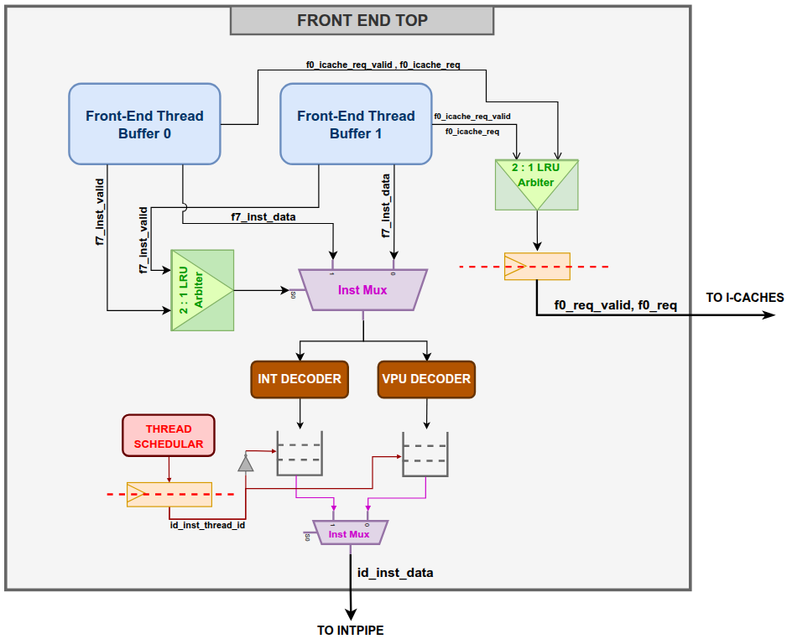
Figure 9. Front End block diagram

2.2.2 Interface
This section defines the boundary of frontend_top. Section 2.2.2.1 lists its ports in six groups. The system group has the clock, the warm and debug resets and the clock-gating chicken bit. Thread control has the thread enables, the reset vector and the virtual-memory status of each thread. The L0 micro-cache group has the fetch request and response and the fill-done signal. The integer-pipeline group has the per-thread redirect and stall inputs. The output group carries the instruction and it’s decoded data to ID. The debug group has the halt, halted and program-buffer signals. For each port the table gives the net it connects to in core_top.
Section 2.2.2.2 gives the field layout and bit width of each packed structure that crosses these ports. These are the fetch request and response, the virtual-memory status, the redirect, the instruction delivered to ID, the instruction FIFO entry, and the two decoded control words. Section 2.2.2.3 lists the defines that set the number of threads, the buffer geometry and the PC width.

2.2.2.1 I/O Signals
Table 6 lists the ports of frontend_top. Connected to gives the signal in core_top. A width of 2 denotes one bit per thread.
Table 6. Front End I/O signals
Signal | Dir | Width / type | Connected to | Description
System
clock | in | 1 | clock | Core clock. Each thread buffer derives a gated clock from it.
reset | in | 1 | reset_w | Warm reset. Synchronous.
reset_debug | in | 1 | reset_d | Debug reset. Clears the program-buffer control and, while the thread is halted, refills the program buffer with EBREAK.
chicken_bit | in | 1 | chicken_bit_frontend | Disables Front End clock gating. Driven by the min_frontend_clock_gate_disable chicken bit.
Thread control
f0_thread_enabled | in | 2 | enabled | Thread enable. A rising edge starts fetch at the reset vector; a falling edge stops fetch.
f0_reset_vector | in | 48 | reset_vector | Fetch address after reset or thread enable.
vm_status | in | 2 x minion_vm_status | vm_status | Virtual-memory status of each thread, forwarded with every fetch request.
Fetch request to the L0 micro-cache
f1_icache_req_valid | out | 1 | icache_req_valid | The F1 I-cache request register holds a request.
f1_icache_req | out | frontend_icache_req | icache_req | Fetch request: thread, VM status and address.
f1_icache_req_ready | in | 1 | icache_req_ready | The Neighborhood accepts the request in this cycle.
Fetch response from the L0 micro-cache
f5_icache_resp_valid | in | 1 | icache_resp_valid | A response is present. It carries no thread identifier.
f5_icache_resp_miss | in | 1 | icache_resp_miss | The response is a miss and carries no instruction data.
f5_icache_resp | in | icache_frontend_resp | icache_resp | 32-byte block and status.
f6_icache_fill_done | in | 1 | icache_fill_done | The L0 micro-cache has completed a line or translation fill.
Redirect and stall from the integer pipeline
f0_core_req_valid | in | 2 | id_core_fe_req_valid | Redirect. Flushes the thread and restarts fetch at f0_core_req.pc.
f0_core_req | in | 2 x minion_fe_req | id_core_fe_req | Redirect PC, speculation status and debug-mode transition.
id_core_stall | in | 2 | id_core_fe_stall | Thread must not issue. Raised for WFI, CSR accesses that are replayed until a resource is ready (e.g., TensorWait, tensor ops, FCC), a fence, exclusive mode held by the other thread, and integer or FP scoreboard stalls. The WFI/CSR term is suppressed while debug mode or halt request is active.
Instruction to the integer pipeline (ID)
id_inst_valid | out | 1 | id_fe_core_resp_valid | The instruction presented to the integer pipeline is valid.
id_inst_ready | in | 1 | id_core_fe_resp_ready | The integer pipeline is ready to accept the instruction.
id_inst_thread_id | out | 1 | id_fe_core_resp_thread_id | Thread of the instruction.
id_inst_data | out | frontend_core_resp | id_fe_core_resp | Instruction, PC and fetch status.
id_intpipe_ctrl | out | minion_control | id_intpipe_ctrl | Integer decode.
id_vpu_decoder_sigs | out | vpu_ctrl_sigs_t | id_vpu_decoder_sigs | VPU decode. Valid only for VPU instructions.
id_vpu_core_ctrl | out | vpu_minion_id_ctrl | id_frontend_vpu_ctrl | VPU and mask register usage, for hazard checks in the integer pipeline.
Debug
halt | in | 2 | debug_in_core.halt | A halt request is pending.
halted | in | 2 | debug_out.halted | The thread is in debug mode.
debug_ffb_wdata | in | 64 | debug_ffb_wdata | Program-buffer write data.
debug_ffb_en | in | 4 | debug_ffb_en | Program-buffer word write enables.
debug_ffb_thread_sel | in | 1 | debug_ffb_thread_sel | Thread whose program buffer is written.
debug_ffb_exec | in | 2 | debug_ex_program_buffer | Start executing the program buffer.

2.2.2.2 Data Structures
Table 7. frontend_icache_req: fetch request (58 bits)
Field | Width | Description
thread_id | 1 | Requesting thread.
vm_status | minion_vm_status | Virtual-memory status of the thread (Table 8).
addr | 49 | Fetch address. The L0 micro-cache returns the aligned 32-byte block that contains it.
Front End addresses are 49 bits wide: the 48-bit virtual address and one additional bit that allows a non-canonical 64-bit address to be represented.
Table 8. minion_vm_status: virtual-memory status (8 bits)
Field | Width | Description
prv | 2 | Current privilege level.
mprv, mpp, sum, mxr | 1, 2, 1, 1 | Corresponding mstatus fields.
debug | 1 | Thread is in debug mode.

Table 9. icache_frontend_resp: fetch response (261 bits)
Field | Width | Description
data | 256 | 32-byte instruction block.
page_fault | 1 | Instruction page fault.
access_fault | 1 | Instruction access fault.
cacheable | 1 | Block is in a cacheable region.
bus_err | 1 | Bus error on the line.
ecc_err | 1 | ECC error on the line.

Table 10. minion_fe_req: redirect (52 bits)
Field | Width | Description
pc | 49 | New fetch PC.
speculative | 1 | Thread has older instructions in the integer pipeline. Driven every cycle, independently of f0_core_req_valid. Used for replay (Section 2.2.5.6).
debug_info.halt | 1 | Redirect enters debug mode.
debug_info.resume | 1 | Redirect leaves debug mode.

Table 11. frontend_core_resp: instruction to the integer pipeline (89 bits)
Field | Width | Description
pc | 49 | PC of the instruction.
inst_bits | 32 | Instruction. Compressed instructions are delivered expanded.
pf0, af0 | 1 each | Page fault / access fault on the entry holding the start of the instruction.
pf1, af1 | 1 each | Page fault / access fault on the entry holding the upper half of an instruction that crosses entries.
replay | 1 | Instruction must be replayed.
rvc | 1 | Instruction was compressed.
bus_error, ecc_error | 1 each | Bus error / ECC error on the entry or entries holding the instruction.

Table 12. frontend_thread_data: instruction FIFO entry (179 bits)
Field | Width | Description
core_resp | 89 | Instruction and fetch status (Table 11).
vpu_ctrl_sigs | 45 | VPU decode (vpu_ctrl_sigs_t).
intpipe_ctrl | 45 | Integer decode (minion_control).

Table 13. Decoded control words
Structure | Width | Content
minion_control | 45 | Legal instruction; software-emulated (M-code) instruction; branch, JAL, JALR; integer source reads and destination write; ALU operand selects, function and width; immediate format; memory operation, command and size; FP/VPU destination write; mask register read/write; multiply/divide; CSR command; fence; global memory access; gather/scatter; graphics; implicit use of x31.
vpu_ctrl_sigs_t | 45 | VPU function; execution unit (TxFMA, shift/swizzle, transcendental ROM); conversion and load/store type; source, third-source and destination reads and write; mask register reads; operand swaps; scalar or packed; data type; integer-register transfer; rounding; FP flag update.

2.2.2.3 Configuration Parameters
Table 14. Front End configuration parameters
Define | Value | Description
CORE_NR_THREADS | 2 | Threads per core.
FE_FETCH_BUFFERS | 2 | Thread-buffer entries per thread.
FE_FETCH_READ_SIZE | 256 | Bits per fetch block and per entry.
FE_FETCH_PTR_SIZE | 5 | Read-pointer width: 1 entry bit and 4 halfword bits.  log2(FE_FETCH_VALID_INST_SIZE * FE_FETCH_BUFFERS) = log2(16 * 2) = 5
PC_SIZE_EXT | 49 | Front End PC width.

2.2.3 Pipeline Stages
This section describes the eight Front End stages, F0 to F7, and how they line up with the L0 micro-cache pipeline. Two activities run in parallel and meet in the thread buffer. Fetch runs from F0 to F6: a thread’s request is arbitrated and sent in F0, waits for acceptance in F1, is looked up in F1 to F5, and the response is written into the thread buffer in F6; a miss writes nothing and the thread goes to sleep. In F7 each thread pulls its next instruction out of its buffer and expands it if compressed. One thread’s instruction is decoded and placed in its FIFO. The scheduler presents one thread’s FIFO head to the integer pipeline each cycle
Fetching and extracting are independent: a thread keeps extracting instructions from a filled buffer entry while its next request is still in F0-F5.
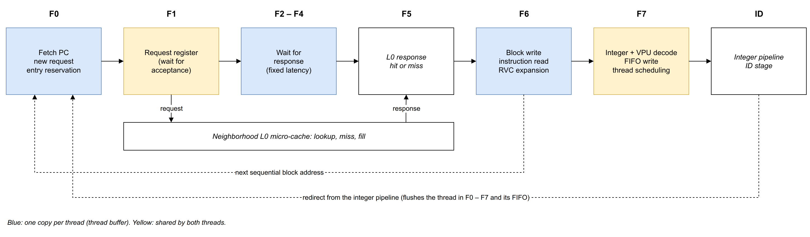
Figure 10. Front End pipeline
F0 Stage
The F0 stage receives instruction-block requests from both thread buffers and decides which one gets access to the L0 micro-cache using a 2:1 LRU arbiter. The selected request is registered and sent to the L0 micro-cache through the Neighborhood interface. This stage also handles the enabling and disabling of threads and redirect requests from the integer pipeline, for example the new address after a mispredicted branch.
F1–F5 Stage
The selected request is held in F1 until the L0 micro-cache accepts it, which happens at the earliest in the second F1 cycle. The thread then waits for the response. The L0 micro-cache always responds to an accepted request, whether it is a hit or a miss, with a fixed five-cycle latency: counting the cycle in which it accepts the request as the first cycle, the response is returned in the fifth cycle, in F5 (Figure 12).
F6 Stage
The response from the L0 micro-cache is checked. If it is a hit, the instruction block is stored in the buffer of the thread that issued the request. If it is a miss, nothing is stored, and the thread waits for the cache to be filled. Instruction reading is independent of the fetch request: whenever a buffer entry holds instructions, the thread reads its next instruction, expands it if it is compressed, and passes it on for decoding, in parallel with any request in F0 to F5.
F7 Stage
This stage selects which thread’s instruction is read from its buffer. The selected instruction is decoded and stored, along with its control signals, in that thread’s FIFO. The thread scheduler decides which thread’s FIFO issues an instruction to the integer pipeline in the next cycle. If both threads are eligible, they are selected in round-robin order; otherwise, the eligible thread is selected.
With an L0 hit and no competing requests, the first instruction of a block reaches ID nine cycles after its request is issued in F0.

2.2.4 Interaction with the L0 Micro-Cache
This section describes the fetch protocol between the Front End and the L0 micro-cache, from the Front End side. It covers the following four things:
- How a request is arbitrated and accepted: by the 2:1 LRU arbiter and F1 request register in the core, then by the 8:1 arbiter of the Neighborhood.
- The fixed response timing, and how a thread recognizes its own responses with a token tracker, since responses carry no thread identifier.
- The miss, sleep and fill-done protocol, and why its timing guarantees that no wake-up is lost.
- How a redirect cancels requests already in flight, including one still waiting in the F1 register.
Each L0 micro-cache serves the eight threads of four ET-Minion cores. Figure 11 shows the request and response path of one core. The Neighborhood side of the interface is described in 3.3. Front End – I-Cache Interface.
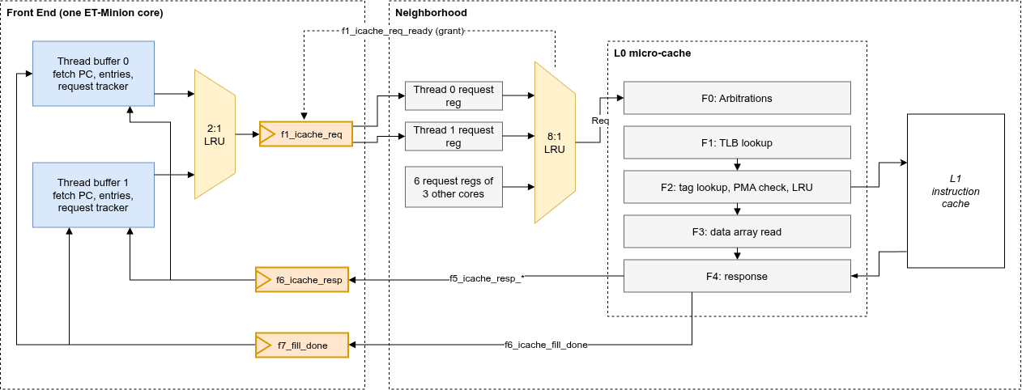
Figure 11. Front End to L0 micro-cache request and response path

2.2.4.1 Request Arbitration and Acceptance
A fetch request passes through the following steps:
- 2:1 LRU arbiter, F0. Selects between the two threads of the core. With two clients the grant alternates when both threads request. The priority is updated on every grant.
- F1 I-cache request register (f1_icache_req). Holds the granted request until the Neighborhood accepts it with f1_icache_req_ready. The register accepts a new request when it is empty or its current request is accepted in the same cycle; otherwise the 2:1 arbiter issues no grant.
- 8:1 LRU arbiter, Neighborhood. The request is first captured in a per-thread request register, then arbitrated against the other seven threads served by the same L0 micro-cache. The grant of this arbiter is returned as f1_icache_req_ready. Because of the capture register, a request is accepted at the earliest in its second F1 cycle.

2.2.4.2 Response Timing and Ownership
The L0 micro-cache has a five-stage pipeline and returns exactly one response per accepted request, from its last stage, for a hit and for a miss alike. The response reaches the Front End in F5.
The response carries no thread identifier. Each thread buffer identifies its responses by position in time: when its request is granted, the thread inserts a token (a valid bit and the reserved entry number) into its own F1–F6 tracker. The token remains in F1 until the request is accepted and then advances one stage per cycle. A response registered in F6 together with a valid token belongs to that thread, and the token selects the entry to be written. The response and fill-done signals are registered in frontend_top and broadcast to both thread buffers.
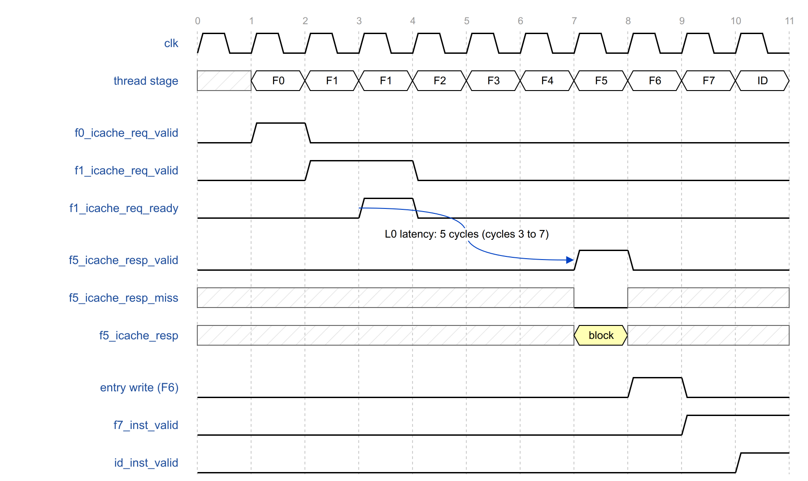
Figure 12. Request and hit response
In Figure 12 the request is issued in cycle 1, accepted in cycle 3, and the block returns in cycle 7. It is written in cycle 8; the first instruction of the fetched block is in the F7 stage in cycle 9 and in the ID stage in cycle 10.

2.2.4.3 Miss Handling and Fill Done
A miss response has the same timing as a hit and carries no data. On a miss the thread writes nothing, keeps its fetch PC and enters a sleep state (f0_miss_pending) in which it issues no requests.
On completion of a line fill from the L1 instruction cache, or of a translation fill, the L0 micro-cache pulses f6_icache_fill_done. The signal is broadcast to all threads of the L0 micro-cache and carries no address. Every sleeping thread wakes and retries; a thread whose line is still absent misses again and sleeps until the next fill. A redirect, a thread disable or a pending halt also clears the sleep state.
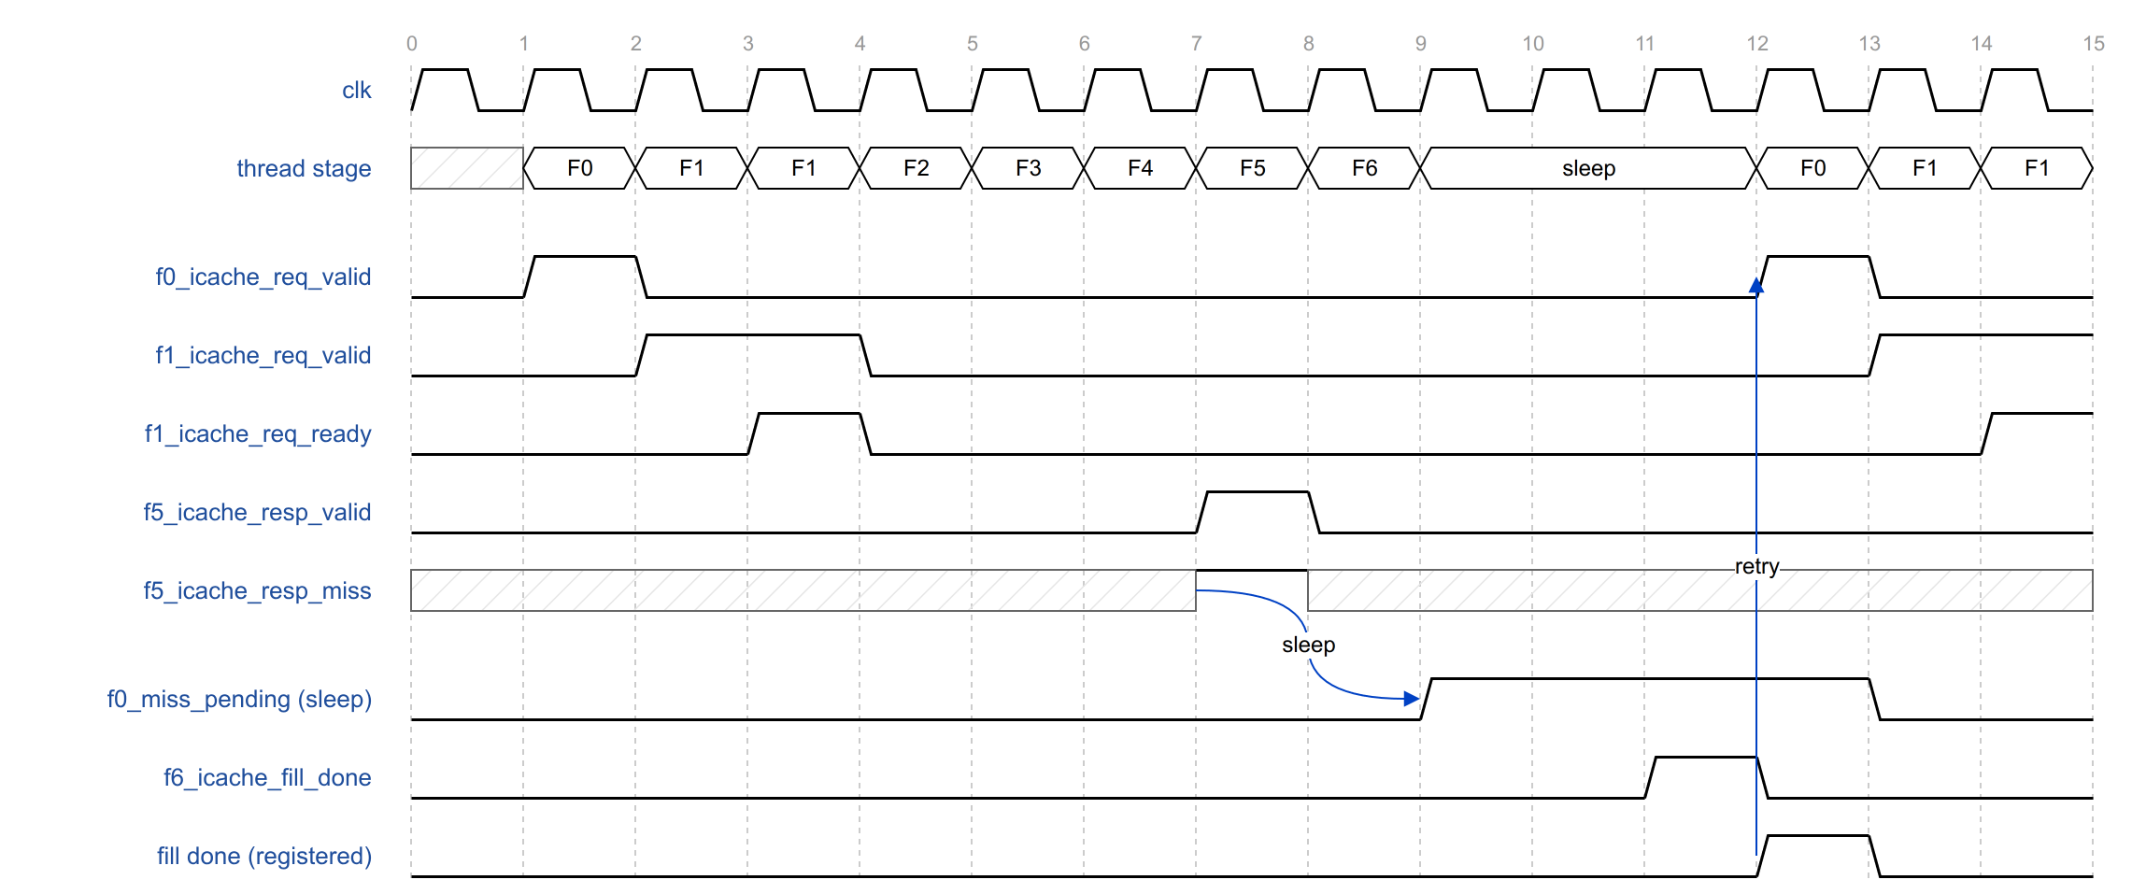
Figure 13. Miss, sleep and retry
In Figure 13 the miss response arrives in cycle 7 and the thread sleeps from cycle 9. Fill done arrives in cycle 11, is registered, and the thread retries in cycle 12.
Fill done is issued one cycle after the response slot. A request that looks up the L0 micro-cache while a fill is being written still misses, and its response is the last miss that the fill can cause. Issuing fill done one cycle after that response, and registering it again in the Front End, ensures that every thread has entered the sleep state before the wake-up arrives. A wake-up that arrived first would be lost, and the thread would wait for an unrelated fill.

2.2.4.4 Request Cancellation
A redirect invalidates the thread’s tokens in F2 to F5 and suppresses the F6 write, so the responses of in-flight requests are discarded.
A request still waiting in the F1 I-cache request register cannot be withdrawn: the register is shared and the Neighborhood already holds a copy. The thread records the cancellation and does not advance the token when the request is accepted. The I-cache lookup is performed and its response is discarded. The thread’s new request is issued only after the cancelled request has been accepted.
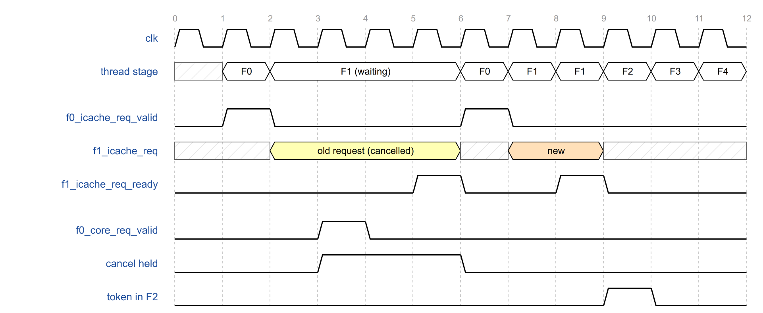
Figure 14. Redirect while a request waits in F1
In Figure 14 the redirect arrives in cycle 3 while the request waits in F1. The cancellation is held until the request is accepted in cycle 5; no token enters F2. The new request is issued in cycle 6 and accepted in cycle 8.

2.2.5 Thread Buffer
The thread buffer (frontend_thread_buffer) holds almost all of a thread’s Front End state; there is one buffer per thread. This section describes how the buffer stores instructions: two 256-bit entries in a latch register file with a 32-bit, wrap-around read port. It then describes the state kept for each entry, the fetch PC and how it is updated, and the conditions under which the thread requests a new block. It also shows how an entry is reserved and written.
The section then shows the instruction side: how the read pointer extracts one instruction per cycle, including instructions that cross from one entry to the other and the bypass from incoming data. It then covers how the RVC expander turns compressed instructions into 32-bit ones, and which fault, error and replay status is attached to each instruction on its way to the integer pipeline.
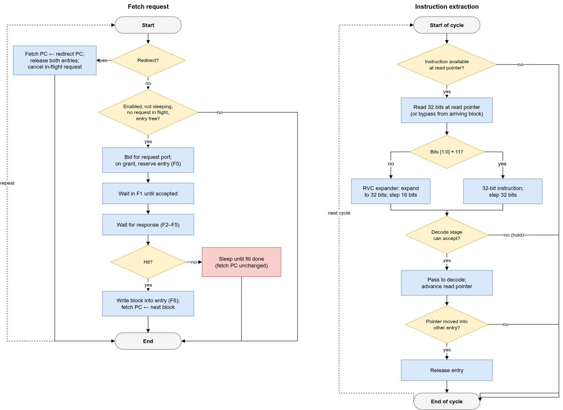
Figure 15. Thread buffer operation
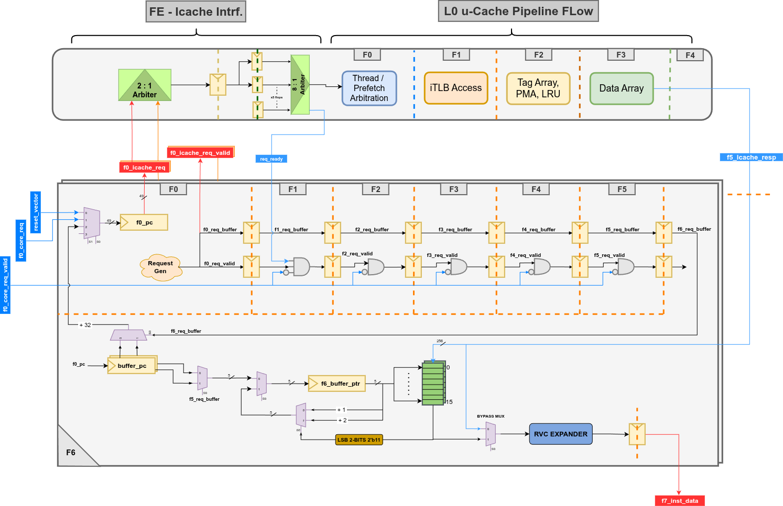
Figure 16. Thread buffer pipeline

2.2.5.1 Buffer Entries
The instruction buffer has two entries of 256 bits (32 bytes). An entry holds one fetch block: eight 32-bit instructions, sixteen compressed instructions, or a combination. Two entries allow the next block to be fetched while the current block is consumed.
The entries are implemented as one latch-based register file with two ports:
- Write port, 256 bits. Writes a complete block into one entry, with one write enable per 32-bit word.
- Read port, 32 bits. Addressed by the 5-bit read pointer buffer_ptr: bit 4 selects the entry, bits 3:0 select a halfword within it. The read returns the 32 bits starting at that halfword.
The read port wraps around: halfword 15 of one entry is followed by halfword 0 of the other. The entries therefore form a ring of 32 halfwords, and a 32-bit instruction that starts in the last halfword of an entry is read in one access.
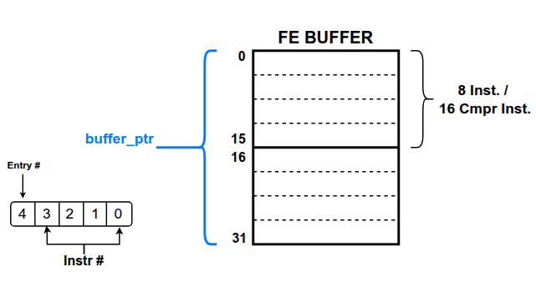
Figure 17. Thread-buffer entries and read pointer
Table 15. Thread-buffer entry state
State | Description
Empty flag | Entry holds no instruction still to be sent. Set for both entries at reset.
Block address | Address of the instruction block held in the entry (buffer_pc). Only the words from this address onward are written, extraction in the entry starts at this address, and it provides the upper PC bits of every instruction read from the entry.
Fault flags | Page fault and access fault of the block.
Error flags | Bus error and ECC error of the block.
Cacheable flag | Block is in a cacheable region. Used for replay.

2.2.5.2 Program Counter
Each thread buffer holds a 49-bit fetch PC, the address of the next block to request. It is updated as listed in Table 16.
Table 16. Fetch PC update
Event | New fetch PC
Reset, or thread enabled | f0_reset_vector, sign-extended.
Block written into an entry | Start of the next aligned 32-byte block.
Redirect (highest priority) | f0_core_req.pc.
Only the first block after a reset or redirect can start within a 32-byte block; all later blocks are aligned. A miss does not change the fetch PC, so the same address is requested again after the fill.
The PC of each extracted instruction is formed from the upper bits of its entry’s block address and the halfword position of the read pointer.

2.2.5.3 Request Generation and Entry Fill
A thread issues a request in F0 when all conditions in Table 17 are met.
Table 17. Request conditions
Condition | Reason
Thread enabled, and not in the enable cycle | Reset vector is loaded at the end of the enable cycle.
No redirect in the current cycle | Redirect PC is loaded at the end of the cycle.
Thread not sleeping, or registered fill done in this cycle | After a miss the thread waits for a fill; the request is issued in the cycle the registered fill done arrives.
No request of the thread in F1 to F6 | At most one request per thread is in flight, which keeps responses in order and allows ownership by timing.
An entry is empty or is released in the current cycle | The response cannot be stalled and must have a destination.
No halt pending | While a halt is pending the thread sends no request to the L0 micro-cache; it produces a placeholder instruction instead (Section 2.2.10.1).
Not in reset; not executing the debug program buffer | —
On a grant, the thread reserves an entry and records the fetch PC of the request as the entry’s block address. If both entries are empty, entry 1 is reserved.
Table 18 shows the entry sequence after a thread is enabled at address A. [m, n] gives the block number in entry 0 and entry 1; x denotes an empty entry.
Table 18. Entry fill sequence
Step | Event | Entries
1 | Thread enabled at address A. | [x, x]
2 | Block containing A written into entry 1; extraction starts at the halfword of A. | [x, A>>5]
3 | Entry 0 empty: the next block is requested when the first request completes. | [(A>>5)+1, A>>5]
4 | Last instruction of entry 1 extracted; entry 1 released. | [(A>>5)+1, x]
5 | Next block requested into entry 1; extraction continues in entry 0. | [(A>>5)+1, (A>>5)+2]
A block write enables only the words from the word containing the request address to word 7. The register file requires its write-data enables one clock phase before the write; the thread computes them in F5 from its token and f5_icache_resp_miss, holds them in a phase latch, and applies the word write enables in F6.

2.2.5.4 Instruction Extraction
When both entries are empty, the read pointer is loaded in F5 with the halfword position of the request address within the reserved entry, so that extraction can start within a block. Afterwards the pointer advances with each extracted instruction.
An instruction is available when the entry it is read from is not empty. A 32-bit instruction that starts in halfword 15 requires both entries to be non-empty; the wrap-around read returns both halves, the pointer moves to halfword 1 of the other entry, and the first entry is released.
If the entry being read is empty but its block is written in the same cycle, the instruction is taken directly from the response data (bypass). The upper half of an instruction that crosses into an entry being written is bypassed in the same way. The first instruction of a block is therefore extracted in the cycle the block is written. The bypass does not check the destination entry of the response; with one request in flight per thread, the only block that can arrive is the one being waited for.

2.2.5.5 RVC Expander
The 32 bits read at the pointer are passed to the RVC expander (frontend_rvc_expander), a combinational RV64C decompressor:
- If bits [1:0] are not 11, the instruction is compressed. It is expanded to its 32-bit equivalent and the pointer advances by 16 bits.
- If bits [1:0] are 11, the instruction is 32 bits wide. It passes through unchanged and the pointer advances by 32 bits.
All instructions are therefore 32 bits wide after F6. The rvc bit of frontend_core_resp indicates a compressed instruction; the integer pipeline uses it to advance the PC by 2 instead of 4.

2.2.5.6 Fault and Error Status
Each instruction carries the status of the entries it was read from:
Table 19. Instruction fetch status
Field | Source
pf0, af0 | Fault flags of the entry holding the start of the instruction.
pf1, af1 | Fault flags of the entry holding the upper half of an instruction that crosses entries; zero otherwise.
bus_error, ecc_error | Error flags of the instruction’s entry, or of both entries for an instruction that crosses entries.
replay | Set when the entry’s block is not cacheable and f0_core_req.speculative indicates older instructions of the thread in flight. Captured when the instruction is written into the FIFO.
All status fields are forced to zero while the debug program buffer is executed.

2.2.6 Entry Invalidation, Redirect and Thread Start
This section describes the events that discard buffered instructions or restart fetch. Section 2.2.6.1 lists when a buffer entry is released: normally when its last instruction has been extracted, but also on a redirect, a thread disable or entry to debug mode. Section 2.2.6.2 describes a redirect from the integer pipeline: what triggers it, what it clears in each stage, and how long the thread takes to deliver its first target instruction. Section 2.2.6.3 describes how thread enable and disable events are derived from the enable input, how fetch starts at the reset vector, and what state a thread has after reset.

2.2.6.1 Entry Invalidation
An entry is released when its last instruction leaves F6, or when the whole buffer is flushed (Table 20).
Table 20. Entry release conditions
Condition | Entries released
32-bit instruction at byte offset 28 of the entry is extracted | This entry
Compressed instruction at byte offset 30 is extracted | This entry
32-bit instruction at byte offset 30 is extracted (upper half in the other entry) | This entry
Redirect (f0_core_req_valid) or thread disable | Both entries
Entry to debug mode | Both entries
A response that reports a fault or error marks the reserved entry non-empty even if no data is written, so that the fault is delivered to the integer pipeline with the next instruction read from that entry.

2.2.6.2 Redirect
The integer pipeline redirects a thread by asserting f0_core_req_valid with the new PC in f0_core_req.pc. Redirects are issued for branch and jump mispredictions, exceptions and returns from trap, replays, inter-processor interrupts, and entry to or exit from debug mode. Table 21 lists the effect in the redirect cycle.
Table 21. Effect of a redirect
Stage | Effect
F0 | Fetch PC loaded with the redirect PC. No request in this cycle. Sleep state cleared.
F1 | Request waiting in the F1 I-cache request register marked cancelled.
F2–F5 | Tokens invalidated.
F6 | No block written. Both entries released.
F7 | Instruction discarded.
FIFO | Emptied. The thread is not eligible for scheduling in this cycle.
The target block is requested in the following cycle. Its first instruction reaches ID ten cycles after the redirect (Figure 18).
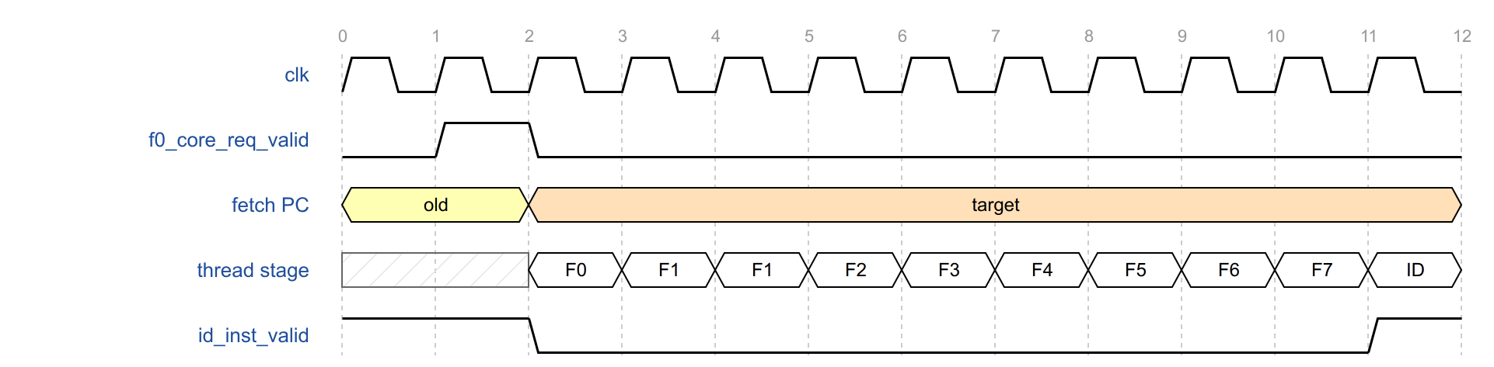
Figure 18. Redirect to first target instruction

2.2.6.3 Thread Enable and Reset Vector
f0_thread_enabled is registered on entry to the Front End, and one-cycle enable and disable events are derived from its edges.
- Enable. The fetch PC is loaded with f0_reset_vector at the end of the enable cycle, and the first request is issued in the next cycle. The first instruction reaches ID eleven cycles after f0_thread_enabled rises (Figure 19).
- Disable. No further requests are issued, both entries are released and the sleep state is cleared. A fetch already in flight is not cancelled: its response is still written into its reserved entry. The instruction in F7 and the FIFO contents are not cleared. The thread is removed from the scheduler’s eligible set one cycle later. Because the scheduler defaults to thread 0, FIFO entries left by a disabled thread 0 can still be presented to ID. The eleven-cycle enable latency applies to a thread whose F7, FIFO and buffer are empty, for example the first enable after reset.
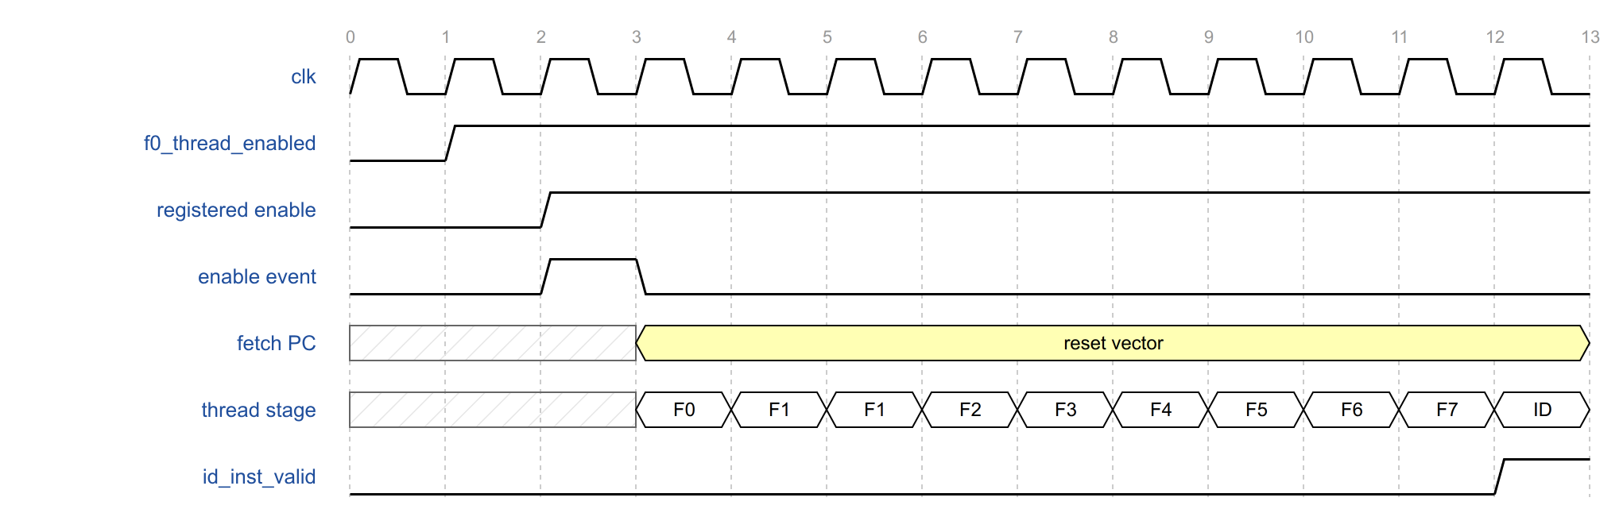
Figure 19. Thread enable to first instruction
After reset, both entries are empty and the fetch PC holds the reset vector.

2.2.7 Decoders
This section describes the integer decoder (intpipe_decode) and the VPU decoder (vpu_decoder). Both are shared by the two threads and decode in F7, before the instruction is queued. It describes the control words the decoders produce, minion_control and vpu_ctrl_sigs_t, and how each decoder handles an encoding it does not recognize. It also describes the rule that selects which thread’s instruction is decoded in a cycle.
The section also explains how the VPU decode is used once the instruction reaches ID. The Front End does not issue to the VPU itself: the VPU control word goes directly to the VPU. The integer pipeline issues the instruction to the VPU and uses a summary of the control word for its FP and mask scoreboard checks
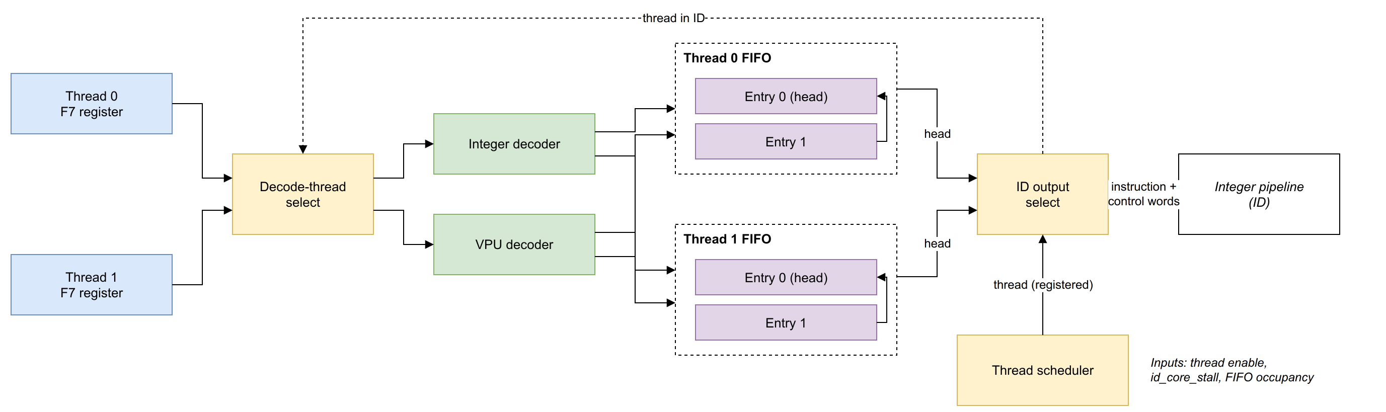
Figure 20. Decoders, instruction FIFOs and thread scheduler
Both decoders are combinational look-up tables over the 32-bit instruction:
- Integer decoder. Produces minion_control (Table 13). An unlisted encoding is marked not legal, and the integer pipeline raises an illegal-instruction exception.
- VPU decoder. Produces vpu_ctrl_sigs_t and a flag that identifies VPU instructions. An unlisted encoding is a non-VPU instruction.
A thread is a decode candidate when it has an extracted instruction, its FIFO is not full and it is awake (2.2.9. Thread Scheduler). The decoded thread is selected as follows:
Table 22. Decode thread selection
Candidates | Thread decoded
Thread 0 only | Thread 0
Thread 1 only | Thread 1
Both | Thread not presented in ID in the current cycle
None | Thread not presented in ID in the current cycle
The instruction is written into the FIFO when the selected thread has an extracted instruction and its FIFO is not full; the awake condition affects only the selection.
The Front End does not issue instructions to the VPU. In ID, the VPU control word of the presented instruction (id_vpu_decoder_sigs) is sent directly to the VPU, bypassing the integer pipeline. The integer pipeline issues the instruction to the VPU in the same cycle, when the instruction is accepted in ID and decoded as an FP or VPU instruction, together with its thread and that thread’s fcsr rounding mode. The integer pipeline also receives a summary of the VPU control word (id_vpu_core_ctrl), with the VPU and mask register reads and writes of the instruction, for its FP and mask scoreboard checks.

2.2.8 Instruction FIFO
This section describes the two-entry instruction FIFO that each thread has (uses) between F7 and ID. The FIFO decouples fetch from issue. While ID is stalled or serving the other thread, the thread keeps extracting and decoding, and the FIFO holds the decoded instructions with their fetch status. The section covers what an entry holds and the pointer scheme that tracks occupancy. It explains why the storage is arranged for timing, as a fixed head register and a holding register, and gives the update rules. It also covers when the VPU control word is valid and how a redirect empties the FIFO.
The FIFO is written when its thread is selected for decode and read when the integer pipeline accepts the thread’s instruction (id_inst_valid, id_inst_ready and id_inst_thread_id). It uses 2-bit read and write pointers; it is full when the pointers differ only in the wrap bit and empty when they are equal.
The storage is organized for timing rather than as an indexed array. Entry 0 is always the head, whose content drives the ID outputs; entry 1 is a holding register. The ID multiplexer therefore selects between two fixed registers, one per thread.
Table 23. Instruction FIFO update
Occupancy | Event | Update
Empty | Write | Entry 0 ← new instruction
One | Write and read | Entry 0 ← new instruction
One | Write | Entry 1 ← new instruction
One | Read | None; FIFO becomes empty
Full | Read | Entry 0 ← entry 1
The VPU control word of an entry is written only for VPU instructions. For other instructions it retains the value of an earlier VPU instruction, so id_vpu_decoder_sigs and id_vpu_core_ctrl are valid only for VPU instructions.
A redirect empties the thread’s FIFO.

2.2.9 Thread Scheduler
The integer pipeline accepts one instruction per cycle from either thread. This section describes how the thread scheduler (frontend_thread_sched) chooses which thread’s FIFO head is presented to ID in the next cycle. It defines when a thread is awake (enabled and not stalled by the integer pipeline) and when it is ready (it has an instruction and is not being redirected). It gives the round-robin rule between eligible threads, including the default choice when neither thread is eligible. It then describes the handshake with ID: what drives the ID outputs, why the valid signal is not qualified with the stall, and what happens to an instruction that ID does not accept.
Awake
The thread is enabled and id_core_stall is deasserted. Awake is registered, so a stall affects scheduling one cycle after it is asserted.
Ready
The thread’s FIFO is not empty or is being written in the current cycle, and the thread is not being redirected. Including the write allows an instruction to pass from F7 to ID in consecutive cycles.
A thread that is awake and ready is eligible. The scheduler selects between eligible threads in round-robin order:
Table 24. Thread selection
Thread 0 eligible | Thread 1 eligible | Selected
Yes | No | Thread 0
No | Yes | Thread 1
Yes | Yes | Thread not selected previously
No | No | Thread 0
The previous selection is updated only when at least one thread is eligible. The selection is registered and drives id_inst_thread_id in the next cycle.
The head of the selected thread’s FIFO drives id_inst_data, id_intpipe_ctrl, id_vpu_decoder_sigs and id_vpu_core_ctrl. id_inst_valid is asserted when that FIFO is not empty, and the integer pipeline accepts the instruction with id_inst_ready. id_inst_valid is not qualified with id_core_stall; the integer pipeline applies the stall. The thread in ID is reselected every cycle, so an instruction that is not accepted can be replaced by the other thread’s instruction in the next cycle; it remains at the head of its FIFO.
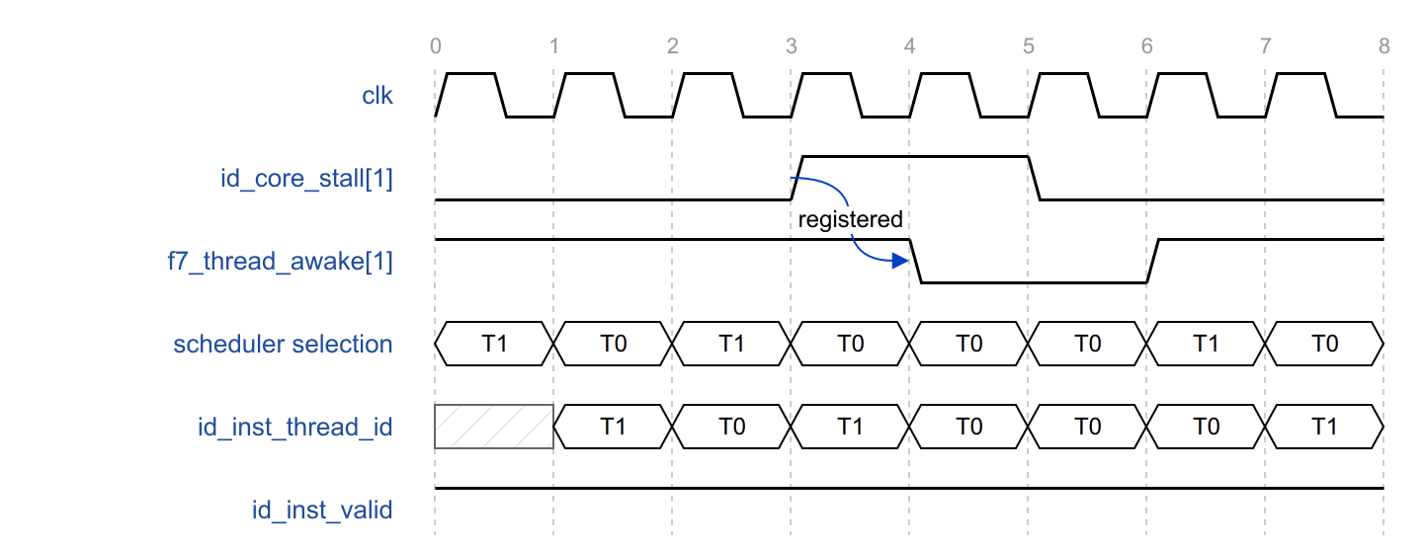
Figure 21. Round-robin issue with a stall
In Figure 21 both threads are eligible and alternate. id_core_stall of thread 1 is asserted in cycles 3 and 4, and thread 1 is not awake in cycles 4 and 5. Thread 0 is selected in cycles 3 to 5 and presented in ID in cycles 4 to 6; the selection alternates again from cycle 6.

2.2.10 Halt and Debug Program Buffer
This section describes the Front End’s two debug functions. Section 2.2.10.1 covers halt. The integer pipeline takes a halt only on a valid instruction in ID, so while a halt is requested the thread buffer generates a placeholder instruction instead of fetching, and passes it through the normal pipeline to ID.
Section 2.2.10.2 covers the debug program buffer. In debug mode, entry 0 of the halted thread’s buffer holds the instructions written by the debugger. The section describes how the buffer is prepared with EBREAK on entry to debug mode, how the debugger writes words into it and starts execution, and how a resume redirect ends program-buffer mode. It also shows which write data goes to which word, and why the last word always holds EBREAK.

2.2.10.1 Halt
The integer pipeline takes a halt on a valid instruction in ID. While halt is asserted for a thread, the thread buffer generates a placeholder instruction instead of fetching:
- The thread follows the normal request conditions but does not bid for the request port. The request is treated as accepted internally, and its token enters the tracker.
- The token passes through F1 to F6.
- In F6 an entry write is forced without a response. The data is the last registered response data; fault and error flags are cleared, and the instruction is treated as 32 bits wide.
- The placeholder passes through decode and the FIFO to ID, where the integer pipeline takes the halt.
The content of the placeholder is undefined. A pending halt also clears the sleep state.

2.2.10.2 Debug Program Buffer
In debug mode, entry 0 of the halted thread’s buffer is used as the program buffer: the debugger writes instructions into it and the thread executes them.
Table 25. Debug program-buffer sequence
Step | Operation
Entry | A redirect with debug_info.halt arrives; the thread stops fetching in the same cycle. In the next cycle both entries are released, the extracted instruction is discarded, and words 0 to 4 of entry 0 are written with EBREAK.
Write | The debugger writes the program buffer through debug_ffb_wdata, debug_ffb_en and debug_ffb_thread_sel (Table 26). The data and enables come together but the data is written into the entry in the cycle after the enables.
Execute | debug_ffb_exec resets the read pointer to halfword 0 of entry 0. In the next cycle entry 0 is marked non-empty and entry 1 empty, and instructions are extracted from word 0.
Exit | A redirect with debug_info.resume ends program-buffer mode; fetch restarts at the redirect PC.

Table 26. Program-buffer word mapping
Word | Write enable | Data
0 | debug_ffb_en[0] | debug_ffb_wdata[31:0]
1 | debug_ffb_en[1] | debug_ffb_wdata[63:32]
2 | debug_ffb_en[2] | debug_ffb_wdata[31:0]
3 | debug_ffb_en[3] | debug_ffb_wdata[31:0]
4 | — | EBREAK
Word 4 cannot be written by the debugger and always holds EBREAK, so execution returns to debug mode at the end of the program buffer. While the program buffer is executed, all fault, error and replay status is forced to zero. A debug reset while the thread is halted rewrites words 0 to 4 with EBREAK.

2.3 Integer Pipeline

2.3.1 Overview
Figure: Integer pipeline block diagram.

2.3.2 Pipeline Stages
Figure: Integer pipeline stages (ID, EX, TAG, MEM, WB).

2.3.3 Interfaces
Table: Integer pipeline interface signals.

2.3.4 Register File and Operand Read

2.3.5 Immediate Generation and ALU

2.3.6 Multiply/Divide Unit

2.3.7 Scoreboards and Hazards

2.3.7.1 Integer Scoreboard

2.3.7.2 FP Scoreboard

2.3.7.3 Mask Scoreboard

2.3.8 Hart Interleaving and Stalls

2.3.9 Branches, Redirects and Replay

2.3.10 Interface to the Data Cache

2.3.11 Interface to the VPU

2.3.12 CSRs and Privilege Modes
Table: CSR groups.

2.3.13 Exceptions and Interrupts

2.3.14 Debug and Breakpoints

2.3.15 Performance Counters

2.3.16 Verification Notes

2.4 Data Cache

2.4.1 Overview
Figure: Data cache block diagram.

2.4.2 Organization and Operating Modes
Table: Data cache operating modes.

2.4.3 Interfaces
Table: Data cache interface signals.

2.4.4 Request Pipeline
Figure: Data cache request pipeline.

2.4.5 Address Translation and PMA Checks

2.4.6 Tag, Data and LRU Arrays

2.4.7 Miss Handling

2.4.8 Replay Queue

2.4.9 Writeback and Store Merge

2.4.10 Atomic Operations

2.4.11 Cache-Management Operations

2.4.12 Scratchpad Control

2.4.13 Tensor Load and Reduce

2.4.14 Interface to the Neighborhood

2.4.15 Errors

2.4.16 Performance

2.4.17 Verification Notes

2.5 Vector Processing Unit

2.5.1 Overview
Figure: VPU block diagram.

2.5.2 Interfaces
Table: VPU interface signals.

2.5.3 Control and Micro-Instruction Decode

2.5.4 Register Files

2.5.5 Lanes
Figure: VPU lane.

2.5.6 Mask Unit

2.5.7 Bypass Network

2.5.8 Shift and Swizzle Unit

2.5.9 TxFMA Unit

2.5.10 Integer Multiply-Accumulate Unit

2.5.11 Transcendental Unit

2.5.12 Tensor Operations

2.5.12.1 Tensor FMA

2.5.12.2 Tensor Quantization

2.5.12.3 Tensor Reduce

2.5.13 Interfaces to the Integer Pipeline and Data Cache

2.5.14 Performance

2.5.15 Verification Notes

3 Neighborhood

3.1 Neighborhood Overview

3.1.1 Partitioning
Figure: Neighborhood block diagram.

3.1.2 Shared Resources and Core Connections

3.1.3 Voltage-Domain Crossings
A Neighborhood is divided into two clock and voltage domains:
- Low-voltage (LV) region: the eight ET-Minion cores and most of the Neighborhood channel, running on the Neighborhood clock.
- High-voltage (HV) region: the logic that interfaces to the Shire Channel, running on the Shire clock.
Blocks were assigned to the two regions for performance and power: the cores and the channel logic run at the lower voltage to save power, while the logic and the memory cells that need speed run at the higher one. Two properties of an SRAM cell decide where its memory has to go, and both improve with voltage:
- Access time. A cell driven from a higher supply switches its bit lines faster, so the array is read and written in less time.
- Noise margin. Noise margin is the amount of disturbance, from coupling between neighbouring lines, supply droop or process variation, that a cell can absorb before the value it holds or the value being read out flips. It shrinks as the supply falls, so reads and writes become less reliable. A memory macro is therefore characterized with a minimum operating voltage, and carries trim settings, read assist, write assist and write-pulse width, that buy margin back at low voltage at the cost of speed.
Memory cells were kept at the higher voltage for both reasons, which is also why the cells of the crossing FIFOs themselves are always placed in the high-voltage region, whichever direction the interface goes. Margin is not the same as immunity, so the data path from the memory is protected as well: the line returned from the L1 instruction cache data RAM is covered by ECC, the error is reported to the requesting core with the response and it is logged in the Neighborhood ESRs (3.3.6. Fault and Error Reporting).
The two regions are connected by a semi-synchronous interface, and every path between them passes through voltage-crossing FIFOs, whose crossing elements contain the level shifters. The paths that cross are the memory request and response paths, the fast local barrier path, the debug and ESR accesses, and the SRAM interface of the L1 instruction cache, whose data RAM is in the high-voltage region of the Shire Channel. Each crossing costs latency, which is why these paths are longer than their logic alone suggests.

3.1.4 External Interfaces
Table: Neighborhood interface groups.

3.2 Neighborhood Instruction Cache
A Neighborhood groups eight ET-Minion cores. Each core has its own private L1 data cache, but none of them has a private instruction cache. Instead, the eight cores share one instruction cache, which is part of the Neighborhood. The cores of a Neighborhood normally execute the same code, so a shared cache holds one copy of it instead of eight, and that saves both area and power.
The shared instruction cache has two levels because of the voltage region its memory has to be built in. SRAM cells are faster and hold their contents more reliably at a higher supply voltage, so the cache data RAM is placed in the high-voltage region, while the Neighborhood itself is low-voltage (3.1.3. Voltage-Domain Crossings).
The data RAM is therefore placed outside the Neighborhood, in the Shire Channel, and every access to it crosses the voltage domain, which lengthens the access time. Serving every core from that cache alone would also leave all 16 threads of the Neighborhood, eight cores with two threads each, competing for its single request port. That port is handed out by LRU arbitration, so a thread would wait behind up to 15 others for its turn, even when the line it needs is already present.
To overcome both, the long read latency of a data RAM in another voltage region and the wait for a turn among 16 bidding threads, a micro level was added in front of that cache: two small first-level caches, called L0 micro-caches, inside the Neighborhood, next to the cores. Their data arrays are built in the Neighborhood channel, so a hit is served without crossing into the Shire Channel, and each micro-cache serves half the cores, so eight threads share a port instead of 16.
The shared instruction cache of the Neighborhood is thus split into the following hierarchy:
- L0 micro-caches: 16 fully associative lines of 64 bytes each, with their own instruction TLB, PMA check, LRU victim selection and page-table walker port (3.6. Shared Page-Table Walker), and a five-stage lookup. There are two of them, called the north and the south micro-cache, serving Minions 0 to 3 and Minions 4 to 7 respectively, that is eight threads each. Both are identical except for one function, the code prefetcher, enabled in the north micro-cache only, for fetching cache lines into the L1 instruction cache.
- L1 instruction cache: 32 KB, 128 sets × 4 ways, 64-byte lines, shared by both micro-caches and accessed only when one of them misses. Its tags, LRU and control are inside the Neighborhood; its data RAM is the one in the Shire Channel.
Figure 22 shows the structure. 3.2.1. Structure and Connections describes how the two cache levels are packaged in the RTL and what the block connects to. The micro-caches and the L1 instruction cache are described in detail in 3.4. L0 Micro-Cache and 3.5. L1 Instruction Cache, and the path from the core’s Front End to the cache, with its arbitration and miss handling, in 3.3. Front End – I-Cache Interface.
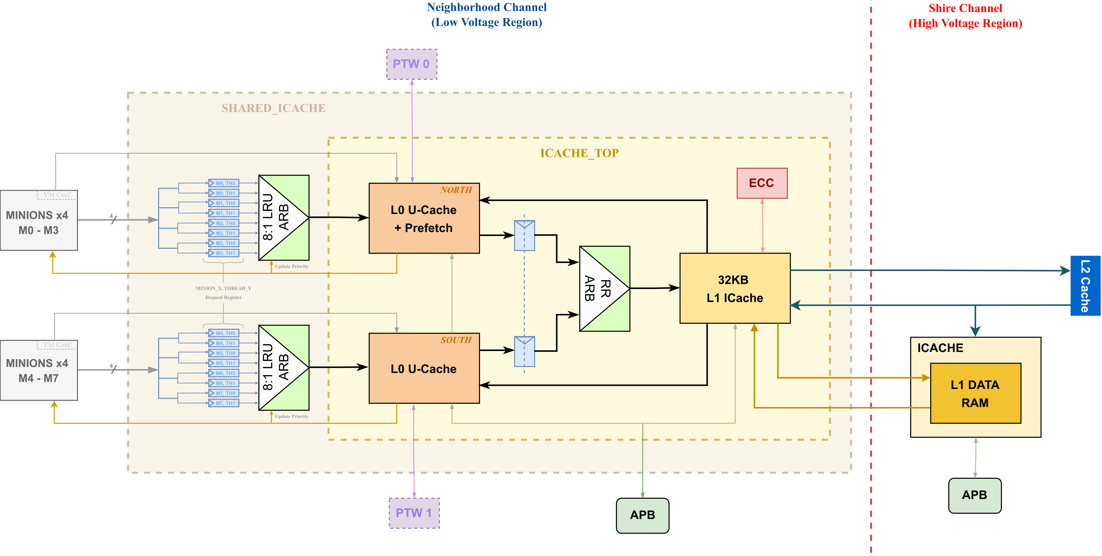
Figure 22. Neighborhood instruction cache

3.2.1 Structure and Connections
The cache is implemented in two modules:
- icache_top contains both L0 micro-caches and the L1 instruction cache, everything except the L1 data RAM, that is the micro-cache arrays and pipelines, the instruction TLBs, the PMA checks, the L1 tag, LRU and data-array control, and the round-robin arbiter through which the two micro-caches reach the L1.
- neigh_shared_icache wraps icache_top and adds the Neighborhood-side logic of the core interface, the logic that receives the fetch request of each of the eight cores, holds it per thread and presents one of them to a micro-cache: one request register per thread, the 8:1 LRU arbiter that selects among them, and the per-thread miss counters and bid mask that prevent livelock. These are described in 3.3. Front End – I-Cache Interface.
The block connects to five things outside itself:
Interface | Purpose
Cores | Fetch requests and address-translation configuration, one port per core. Responses and the fill-done indication, one port per L0 micro-cache, each driven to the four cores that micro-cache serves.
Page-table walkers | Translation requests from the instruction TLB of each micro-cache, one walker per micro-cache.
Shire Cache | Line requests on an L1 miss, and their responses, over the Neighborhood request and response path.
L1 data RAM | SRAM read and write requests to the data RAM in the Shire Channel, and the read data returned from it.
ESR and APB | Configuration (prefetch, bypass, protection and page size), error logging, and debug access to the arrays.
The signals of each interface are listed with the block that uses them: the core-side signals in 3.3.2. Interface Signals, and the rest in the detailed sections of the two cache levels.

3.3 Front End – I-Cache Interface
This section describes the fetch protocol between the ET-Minion cores and the instruction cache, from the Neighborhood side. The core side is described in 2.2.4. Interaction with the L0 Micro-Cache.

3.3.1 Overview
The eight cores of a Neighborhood are served by two L0 micro-caches, each shared by four cores, that is by eight threads. Both L0 micro-caches are backed by the L1 instruction cache of the Neighborhood. Figure 23 shows the whole path and names the signals of the interface: the two thread buffers and the 2:1 LRU arbiter inside each core, the per-thread request registers and the 8:1 LRU arbiter of each micro-cache, and the round-robin arbiter through which both micro-caches reach the L1 instruction cache.
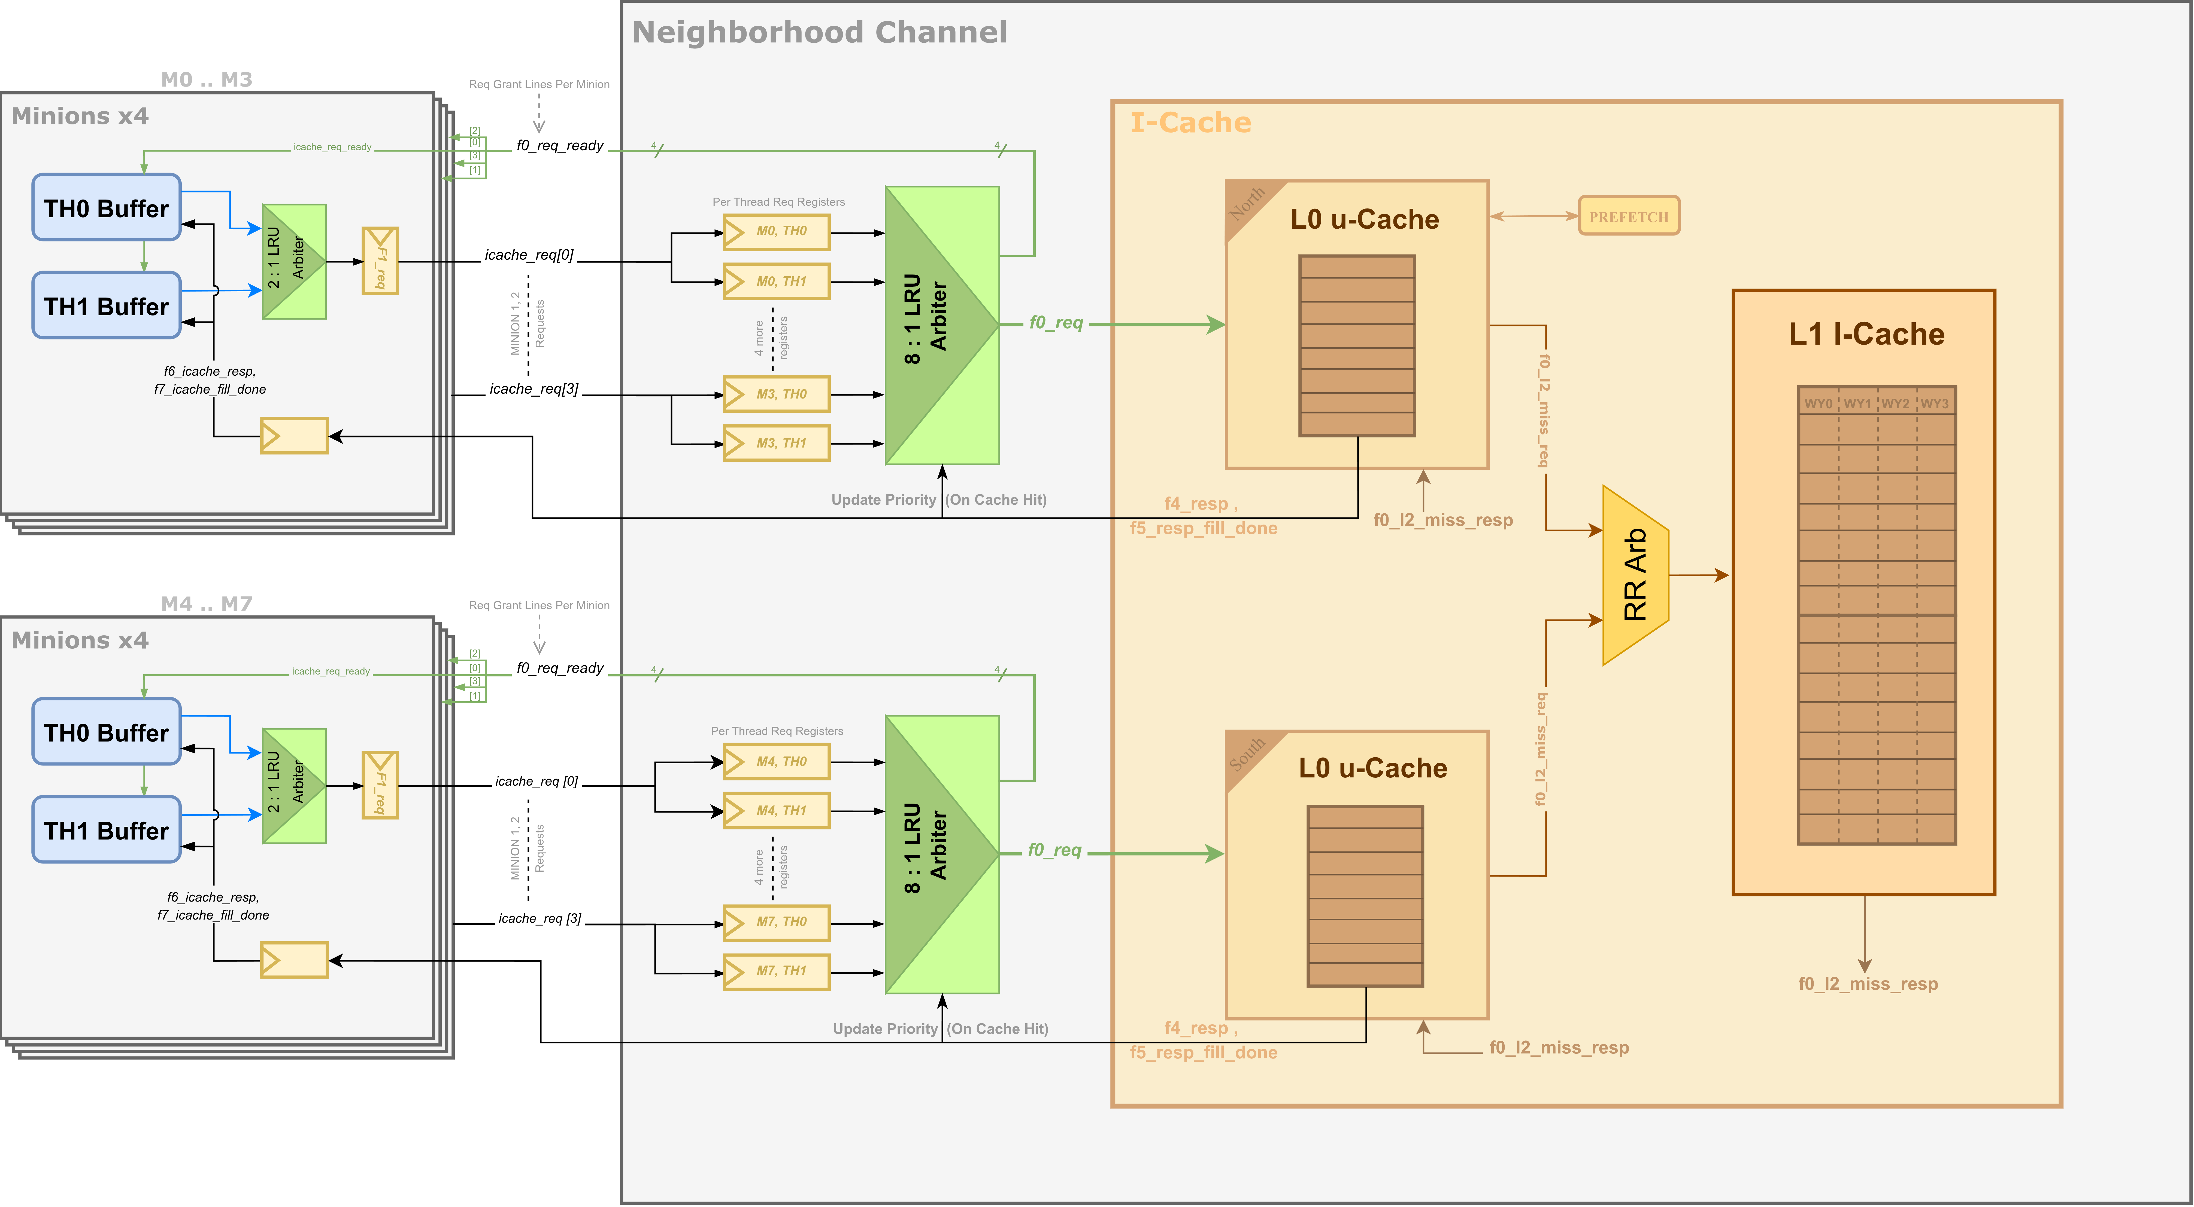
Figure 23. Front End – I-cache interface
A fetch request, that is a request from the Front End of a core for the instruction block at a thread’s fetch address, travels as follows:
- In the core, the 2:1 LRU arbiter selects one of the two threads, and the selected request is flopped into the F1 request register, which holds it until the Neighborhood accepts it. Each core therefore presents one request at a time.
- In the Neighborhood, the request is steered into the request register of the thread that made it, using the thread identifier it carries. One register exists per thread, so eight per L0 micro-cache, which lets the threads of all four cores arbitrate on equal terms.
- The 8:1 LRU arbiter selects one of the eight captured requests and presents it to the L0 micro-cache. Its grant is returned to the core as the acceptance of the request.
- The L0 micro-cache looks the request up in five stages: arbitration, instruction-TLB translation, tag lookup and PMA check, data-array read, and response.
- One response is returned a fixed four cycles after the grant, for a hit and for a miss alike, and it reaches the core in its F5 stage. It is shared by the eight threads the micro-cache serves and carries no thread identifier; on a hit it carries the instruction block. How a core recognizes its own response is described in Section 2.2.4.2.
- On a miss, the L0 micro-cache requests the line from the L1 instruction cache, through a round-robin arbiter that the two micro-caches share. When the fill completes, the micro-cache pulses fill done, which is shared in the same way, and the sleeping threads wake and retry.

3.3.2 Interface Signals
Table 27 lists the signals between one core and the Neighborhood. Directions are given from the Neighborhood side.
Table 27. Front End – I-cache interface signals
Signal | Dir | Width / type | Description
Fetch request
icache_req_valid | in | 1 | The core presents a fetch request.
icache_req | in | frontend_icache_req | Requesting thread, its virtual-memory status and the fetch address.
icache_req_ready | out | 1 | The 8:1 arbiter has granted the request; the core may present the next one.
Fetch response
icache_resp_valid | out | 1 | A response is returned in this cycle. It carries no thread identifier.
icache_resp_miss | out | 1 | The response is a miss and carries no instruction data.
icache_resp | out | icache_frontend_resp | 32-byte block with its fault, error and cacheable status.
icache_fill_done | out | 1 | A line or translation fill has completed in the L0 micro-cache.
Address translation and maintenance
satp_info, matp_info | in | 2 × minion_satp_info | Supervisor and machine address-translation registers of the core, used by the instruction TLB.
tlb_invalidate | in | 1 | Invalidate the instruction-TLB entries of this core.
icache_flush_data | in | 1 | Invalidate the data stored in the L0 micro-cache.
Responses and fill-done pulses are driven to all four cores of the L0 micro-cache at the same time; each core keeps only what belongs to it (3.3.4. Request and Response Timing).

3.3.3 Request Arbitration
This section describes how the Neighborhood decides which thread reaches the L0 micro-cache in a given cycle, and when the arbiter updates the priority that decision is based on. Both start with the registers that hold a request on its way in.
A fetch request is flopped twice before it enters the L0 micro-cache.
First flop, in the core. Two threads share one fetch port, so the 2:1 LRU arbiter selects one of them and its request is held in the F1 request register. That register keeps the request until the Neighborhood accepts it, so a core presents one request at a time, carrying the identifier of the thread that made it.
Second flop, in the Neighborhood. Each micro-cache is served by four cores, so it sees at most four requests in a cycle, and it holds one request register per thread, eight in all. Each request is written into the register of the thread its identifier names. At most four of the eight registers are valid at a time, because a core frees its F1 register only when its request is accepted. Eight registers exist nevertheless so that every thread bids for itself, which is what makes the arbitration fair between the two threads of a core as well as between cores.
The eight registers bid through the 8:1 LRU arbiter (arb_lru_delayed_data). A bid is the register’s valid qualified with the thread’s bid mask. The mask exists to avoid livelock and is described in 3.3.8. Livelock and Starvation Avoidance; until then, take it that masking suppresses a thread’s valid at the arbiter, so the thread takes no part in the arbitration while its request stays in its register.
The arbiter is stalled while the micro-cache cannot accept a request, which the micro-cache reports with f0_req_ready. Its pipeline never stalls, so this signal is tied high: a request is accepted in every cycle in which at least one thread bids, and the rest of this section takes that for granted.

3.3.3.1 Priority Matrix
The 8:1 LRU arbiter holds its priority in an aging matrix: one bit for every pair of the eight threads it serves, recording which of the two was served more recently. A thread wins when it has priority over every other thread bidding in that cycle, which makes the grant one-hot. Two threads can never hold the same priority, because every pair is ordered by exactly one bit. Granting a thread clears all of its bits, that is it is placed behind every other thread, and the threads that have waited longest move up.
The grant is combinational. In the same cycle it is returned to the core as icache_req_ready, the thread’s request register is freed, so it reads invalid in the next cycle, and the core may load the request of its other thread into the F1 register. This is why a request is accepted at the earliest in its second F1 cycle.

3.3.3.2 Deferred Priority Update
Every accepted request gets exactly one response, and it comes back a fixed four cycles after the grant, whether it hits or misses (3.3.4. Request and Response Timing). The arbiter waits for it: priority is not updated when the grant is issued, but when that response arrives.
Waiting means the arbiter has to remember whose response is due. The grant vector travels down with the request in its own registers, f1_grant to f4_grant, so that in F4 it can be told which thread the response belongs to (Table 28).
Table 28. Grant pipeline in the Neighborhood
Stage | Register | Content
F1 | f1_grant | One-hot grant of the arbiter, loaded in the cycle the L0 micro-cache accepts the request
F2 | f2_grant | Same vector, one cycle later
F3 | f3_grant | Same vector, one cycle later
F4 | f4_grant | Thread whose response is returned in this cycle; selects the priority bits and the miss counter to update
The update is enabled by f4_update_prio, asserted when a response is valid in F4 and that response is a hit, or reports a page fault or an access fault:
- Hit. Priority is updated and the thread moves behind the others, which gives the waiting threads their turn.
- Miss. Priority is left unchanged, so the thread keeps its position while it sleeps and is served early when it retries after the fill (Figure 25).
- Page fault or access fault. Priority is updated, because the thread does not retry the same fetch: the core records the fault with the instruction and takes the trap (3.3.6. Fault and Error Reporting).
Bus and ECC errors do not appear in this condition. Both are reported only with a hit, and a hit already updates the priority.

3.3.3.3 Edge Cases
- Masked thread. Masking removes the bid, not the request. When the mask is released the request is still in the register and bids in the next cycle.
- New request while the register is occupied. Cores present no second request for a thread that already has one in flight, so the case does not arise. The register ignores it in any event.
- Reset. All priority bits start at zero, which orders the threads by index until the first responses have updated the matrix.

3.3.4 Request and Response Timing
The L0 micro-cache has a five-stage pipeline:
Stage | Operation
F0 | Arbitration; the granted request enters the pipeline.
F1 | Instruction-TLB lookup, which translates the virtual address.
F2 | Tag lookup, PMA check and LRU update; on a miss, the request to the L1 instruction cache is generated.
F3 | Data array read.
F4 | Response to the cores.
Every accepted request receives exactly one response from the last stage, for a hit and for a miss alike, so the response arrives a fixed four cycles after the grant. The response is broadcast to the four cores of the L0 micro-cache and carries no thread identifier; each core identifies its own response from the position of its request in time (Section 2.2.4.2).
The fill-done signal is driven one stage later than the response, from the stage after F4.
Figure 24 shows a request that hits: the core presents it, the 8:1 LRU arbiter grants it in the next cycle, and the response is returned four cycles later.
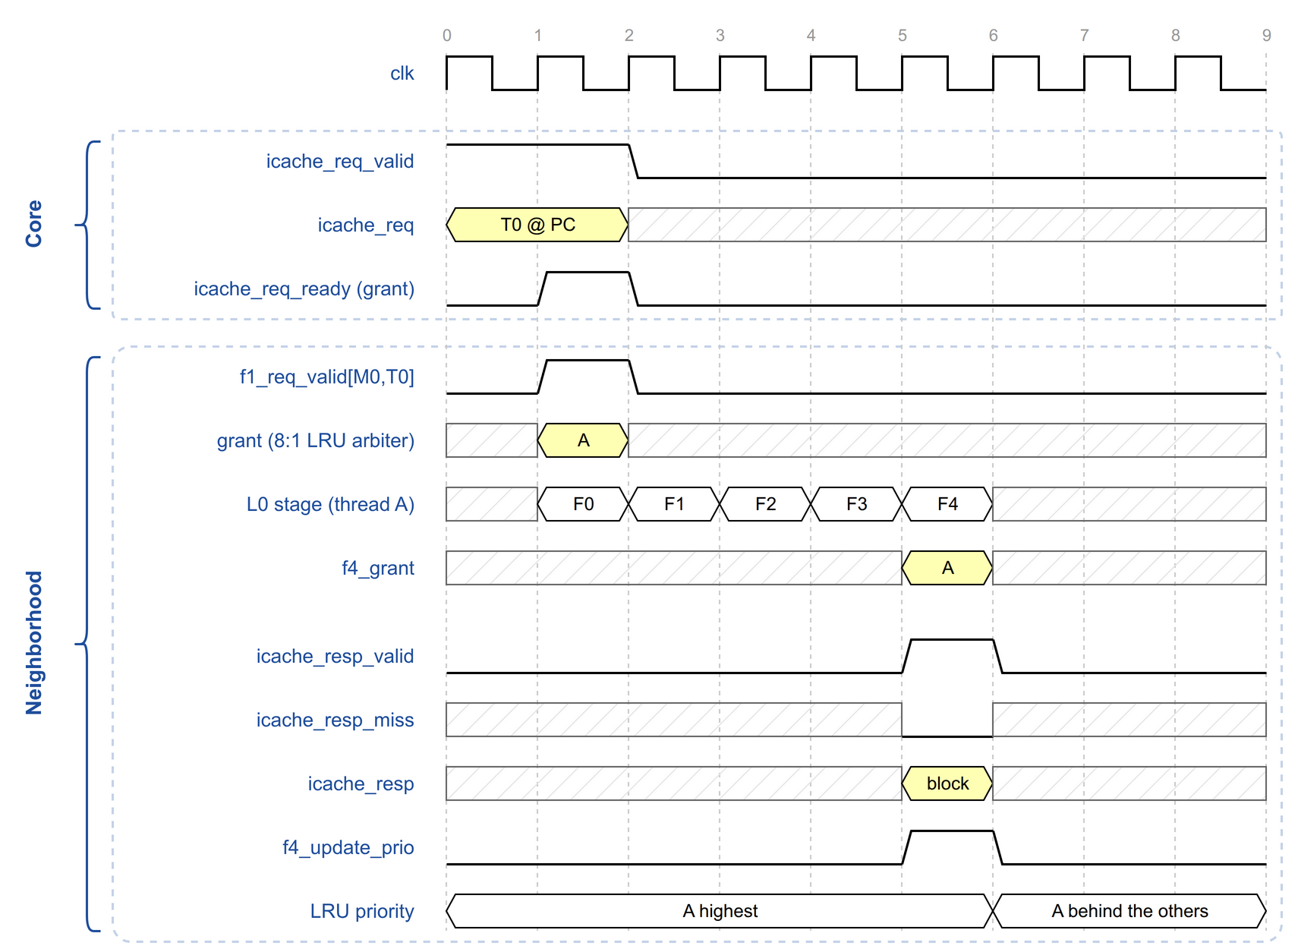
Figure 24. Request and hit response at the L0 micro-cache

3.3.5 Miss, Sleep and Fill-Done Protocol
A request misses in the L0 micro-cache either because the instruction TLB has no translation for it, or because the line is not in the micro-cache:
- TLB miss. A request is sent to the shared page-table walker (3.6. Shared Page-Table Walker), and the lookup continues down the pipeline, so the requesting thread receives its miss response with the normal timing.
- Tag miss. A request for the line is sent to the L1 instruction cache. The two L0 micro-caches share one request port to the L1 and are selected by a round-robin arbiter, each with a holding register for its request.
In both cases the core that made the request receives a miss response and puts the requesting thread to sleep.
When the fill completes, that is when the translation has been written into the TLB or the line into the micro-cache data array, the L0 micro-cache pulses icache_fill_done. The pulse is common to all eight threads it serves and carries no address, so every sleeping thread wakes and retries. A thread whose line is still absent misses again and sleeps until the next fill.
Fill done is deliberately driven one stage later than the response. A request that looks the cache up while the fill is being written still misses, and its miss response is the last one that this fill can cause. Sending fill done after that response guarantees that every thread has entered the sleep state before its wake-up arrives, so no wake-up is lost.
Figure 25 follows one thread through a miss and its retry. The lookup misses in F2, so the miss handler leaves Ready, sends the request to the L1 instruction cache in Request and waits in Fill_Wait. The response in F4 is a miss, the thread sleeps and its priority is left unchanged. When the line arrives the handler returns to Ready and fill done is pulsed; the thread wakes, requests again and hits, and only that second response updates the priority.
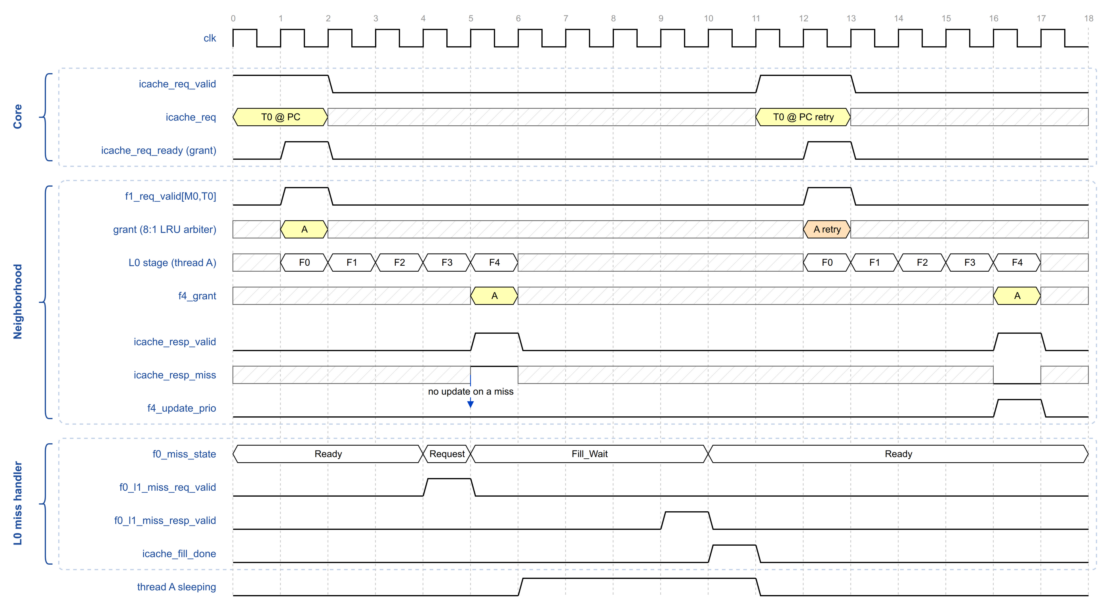
Figure 25. Miss, sleep, fill done and retry

3.3.6 Fault and Error Reporting
The response carries the fault and error status of the fetch together with the data:
Field | Meaning
page_fault | The instruction TLB could not translate the address, or the translation forbids the access. Reported whether the lookup hit or missed.
access_fault | The PMA check rejected the physical address. Reported whether the lookup hit or missed.
cacheable | The block comes from a cacheable region, as reported by the PMA check. Valid on a hit.
ecc_err | The line was filled with an ECC error. The micro-cache has no ECC of its own: it stores the error flag that arrived with the fill next to the line and returns it on every hit on that line, until the line is replaced. Only the error classes enabled in the error-log control ESR set the flag. Valid on a hit.
bus_err | The line was returned with an error by the memory hierarchy. Valid on a hit.
A response that reports a fault is delivered like any other response, and the core marks the faulting instruction so that the integer pipeline raises the exception (Section 2.2.5.6). Errors detected in the L1 instruction cache data RAM are also logged in the Neighborhood ESRs, which hold a sticky single-bit and double-bit error flag and, for the access that was logged, its way, set and physical address and the ECC blocks of the line in which the error was found.

3.3.7 Complete Path for Four Cores
Figure 26 puts the pieces together: four cores requesting in the same cycle, the two flops each request passes through, the arbitration between the threads, and the five responses. Threads are numbered 2 × Minion + thread, and the LRU order lane lists them highest priority first.
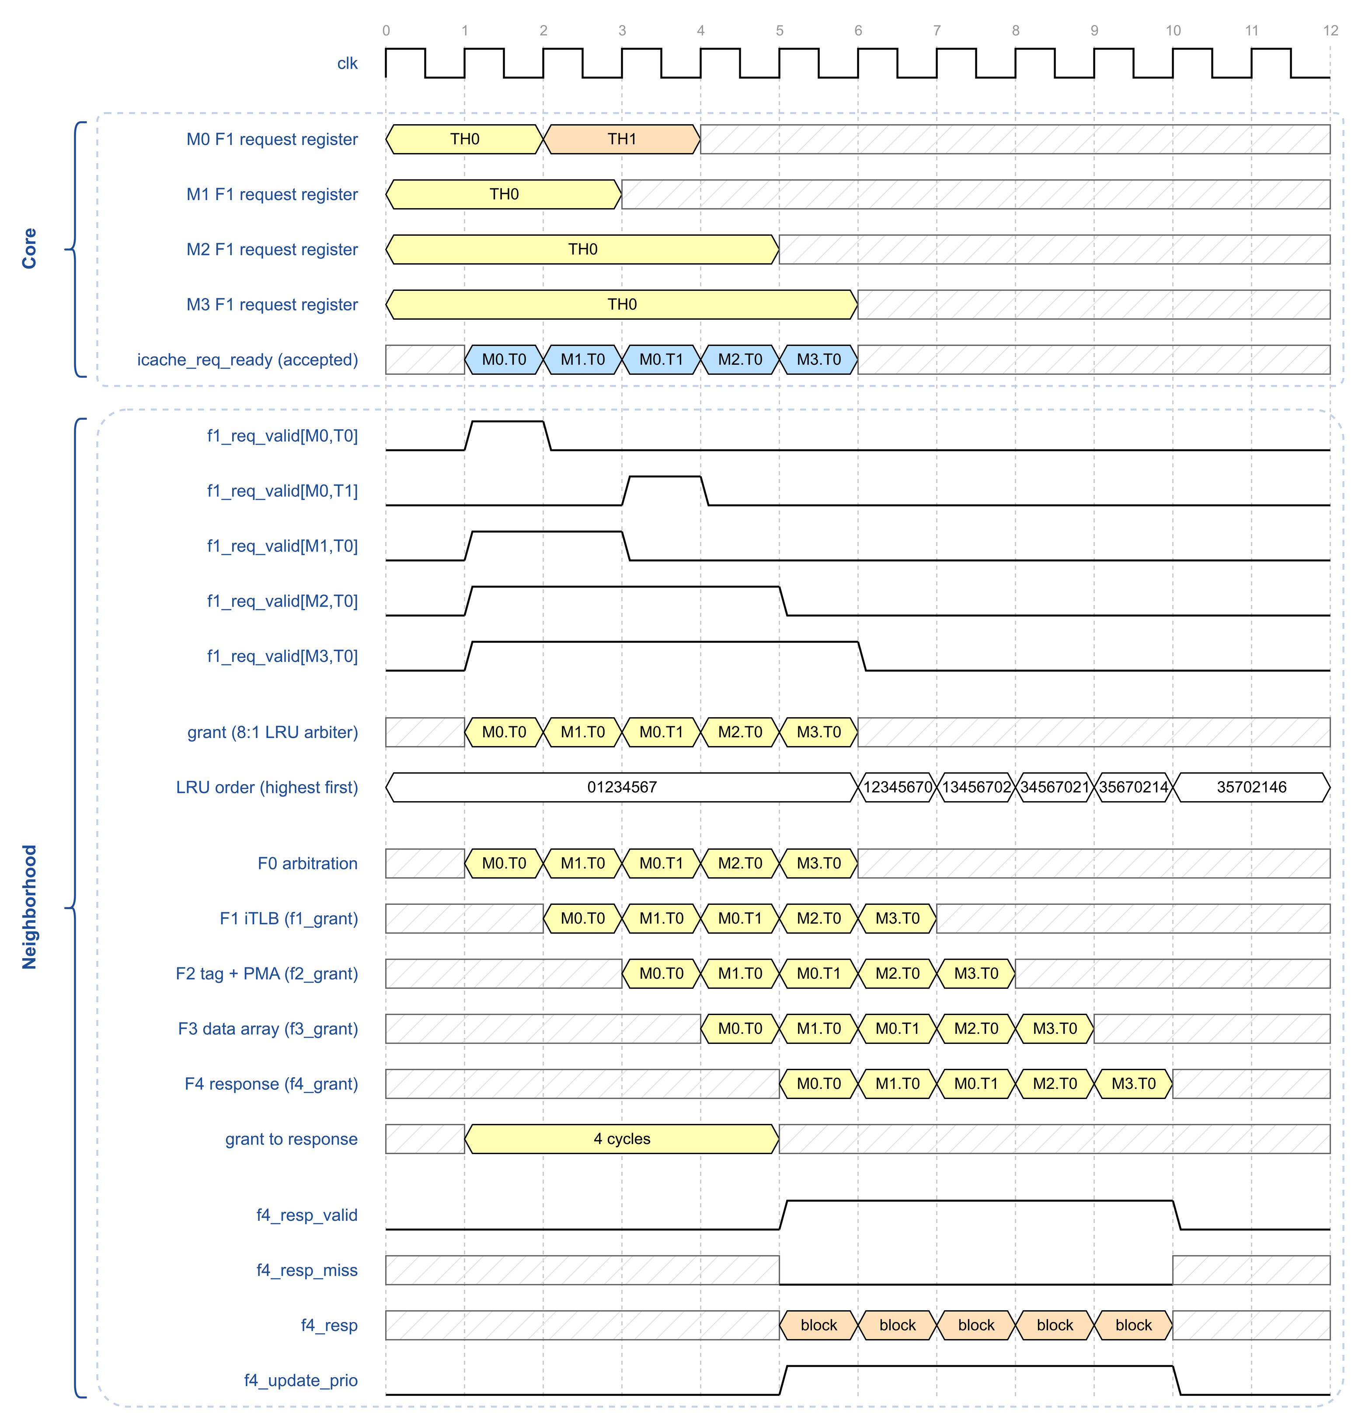
Figure 26. Request capture, arbitration and response for four cores
In cycle 0 the four cores present a TH0 request each, and the F1 registers hold them. The thread registers go valid in cycle 1, M0.T0 wins and icache_req_ready frees M0’s F1 register, which reloads with TH1 in cycle 2. M1.T0 is granted in cycle 2, and in cycle 3 M0.T1 is granted, while M2 and M3 are still holding their first request.
M0 is therefore served twice before M2 and M3 are served once. That is the deferred update at work: M0.T0’s grant does not move it behind the others until its response arrives in cycle 5, and until then M0.T1 is the highest-priority bidder. The same property is what lets a thread that missed win its retry immediately, and the miss-count guard bounds how long a thread can be passed over (3.3.8. Livelock and Starvation Avoidance).
The response for M0.T0 appears in F4 in cycle 5, four cycles after its grant, with f4_grant naming the thread. It hits, f4_update_prio is asserted and the order changes from 01234567 to 12345670.

3.3.8 Livelock and Starvation Avoidance
Up to eight threads share each L0 micro-cache, and the two threads of a core share its fetch port, decoders and issue slot. At every shared point one thread can be delayed by the others. Each shared point therefore has a policy that limits how long a thread can be held back: LRU or round-robin arbitration, a priority rule that favours threads whose requests missed, a wake-up protocol that never loses a wake-up, and a miss-count guard that gives a starving thread exclusive access to the L0 micro-cache. Table 29 lists these mechanisms, and the subsections that follow describe them.
Figure 27 adds to the interface of Figure 23 the two blocks that carry the guard: the per-thread miss counters, one set per micro-cache, and the mask they drive, which gates the bids into the 8:1 LRU arbiter.
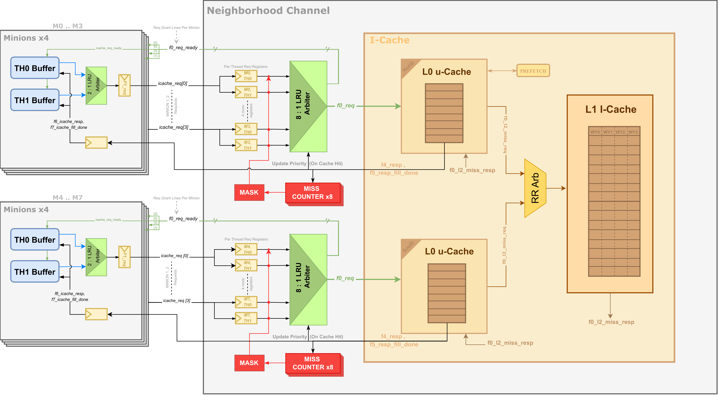
Figure 27. Miss counters and bid mask in the fetch path
Table 29. Starvation avoidance mechanisms in the instruction fetch path
Shared resource | Contenders | Mechanism | Guarantee
Core fetch port (F1 request register) | 2 threads of a core | 2:1 LRU arbiter, priority updated on every grant | A waiting thread is granted after at most one request of the other thread
L0 request arbiter | 8 threads of 4 cores | 8:1 LRU arbiter whose priority is updated only on a hit or a fault | A thread whose request missed keeps its priority for its retry
L0 miss handler | 8 threads and the prefetcher | Fill-done broadcast with ordered timing; thread wakes on fill done, redirect, disable or halt | A thread sleeps only while a fill is in progress, and always wakes
L0 miss handler (repeated misses) | 8 threads | Per-thread consecutive-miss counters and bid mask | A thread with 31 consecutive misses gets exclusive access for its core until it hits
L0 miss handler (prefetch) | Prefetcher and threads | Prefetch requests enter the L0 micro-cache only in cycles with no core request | Demand fetches always win the L0 pipeline over prefetch
L0 miss handler (retry windows) | Prefetcher and waking threads | 8-cycle prefetch pause after each fill done; prefetch blocked after an unattended miss until the next fill done, then until a core request or 16 cycles | Waking threads get the first chance at the freed miss handler, and prefetching is never blocked for good
L1 I-cache miss port | 2 L0 micro-caches | Round-robin arbiter | Each L0 micro-cache waits for at most one miss of the other
Decoders and ID issue slot | 2 threads of a core | Alternating decode selection and round-robin thread scheduler, per-thread FIFOs and stalls | Each eligible thread issues at least every other cycle

3.3.8.1 Core Fetch Port
The two thread buffers of a core compete for the core’s single request register (f1_icache_req) through a 2:1 LRU arbiter (arb_lru_data in frontend_top). The arbiter updates its priority on every grant, so when both threads request, the grants alternate. The request register accepts a new request only when it is empty or its current request is accepted in the same cycle. Each thread has at most one request in flight. A thread waiting at the core port is therefore granted after at most one request of the other thread has been accepted by the Neighborhood.

3.3.8.2 L0 Request Arbitration
In the Neighborhood, each request is captured in a per-thread register and arbitrated against the other seven threads of the same L0 micro-cache by the 8:1 LRU arbiter, which updates its priority with a delay (arb_lru_delayed_data in neigh_shared_icache). The arbiter keeps a pairwise priority matrix. A granted thread normally moves to lowest priority, but here the update is deferred until the request’s response leaves the L0 pipeline. The grant vector is carried from F1 to F4 alongside the request (f1_grant to f4_grant), and the priority is updated only when the response is a hit or a page or access fault (f4_update_prio).
A thread whose request misses therefore keeps its priority ([fig-ch3-td-l0-prio]). When it wakes and retries, it wins over any thread that has been served since, so the threads that have waited longest are served first. Only one request per core can be presented at a time, because each core has a single request register, so the arbiter sees at most four active requests in any cycle.

3.3.8.3 Sleep and Wake-Up
Each L0 micro-cache has one miss handler: the logic that handles the L0 micro-cache’s single outstanding request to the L1 instruction cache. It consists of:
- a three-state machine (f0_miss_state: Ready, Request, Fill_Wait),
- a register holding the physical address of the missing line (f0_miss_addr), and
- a flag that marks the miss as a prefetch miss (f0_miss_is_prefetch).
A miss is accepted only in the Ready state. The handler then sends the request to the L1 instruction cache (Request state), waits for the line (Fill_Wait state), writes it into the L0 micro-cache unless it is a prefetch, and returns to the Ready state, at which point fill done is generated. A lookup that does not hit returns a miss response to the thread in one of the following three cases:
- The line is not present in the L0 micro-cache and the handler is idle, so the handler accepts the miss and sends it to the L1 instruction cache.
- The line is not present but the handler is busy with another miss, so the miss is not recorded and no request is sent to the L1 instruction cache for it.
- The address misses in the L0 TLB, so a translation is requested from the page-table walker and no request is sent to the L1 instruction cache for it.
In all three cases the thread enters the sleep state (f0_miss_pending) and issues no request. The L0 micro-cache pulses icache_fill_done to all its threads whenever an L1 fill completes, whether it is a demand miss or a prefetch, and whenever a translation fill completes. On seeing fill done, every sleeping thread wakes and retries according to the arbitration priority. A thread whose line is now present hits, including a thread that missed on the line that was already being filled, and a thread whose line is still absent misses again; if the handler is now idle, its miss is sent to the L1 instruction cache.
A thread sleeps only while a fill is in progress: its own miss, the fill of another thread that kept the handler busy, or a translation fill. Every sleeping thread is woken when fill done arrives. The fill-done timing (Section 2.2.4.3) makes sure that no wake-up is lost: fill done is issued one cycle after the last response the fill can affect, and it is registered again in the Front End. A redirect, a thread disable or a pending halt clears the sleep state of the affected thread only; fill done is the only event that wakes all sleeping threads.

3.3.8.4 Miss-Count Livelock Guard
The rules above limit each individual wait, but they do not prevent a thread from missing repeatedly. For example, when many threads miss on different lines and keep competing for the one miss handler, a thread can keep missing and never receive its instructions. The Neighborhood therefore counts, for each thread, the number of consecutive responses to that thread’s own requests that were misses (th_miss_cnt, 5 bits, saturating at 31). A thread’s counter is incremented when its request misses and cleared when it hits. All counters are cleared when any response reports an error (page fault, access fault, bus error or ECC error).
While no counter is saturated, all threads may request access to the cache. When one or more counters saturate, a mask register (th_miss_mask) allows only the two threads of one core: the lowest-numbered core that has a saturated thread. Requests from all other threads are blocked. Both threads of the selected core are allowed because the core has a single request register: if it holds the other thread’s request, that request must be accepted before the starving thread’s request can reach the Neighborhood. The mask is recomputed one cycle after every response.
Figure 28 shows the guard at work: the counter of thread A saturates on its last miss, the mask is recomputed one cycle later and leaves only the threads of that core bidding, so A wins the arbitration as soon as it wakes. Its response is a hit, which clears the counter and releases the mask.
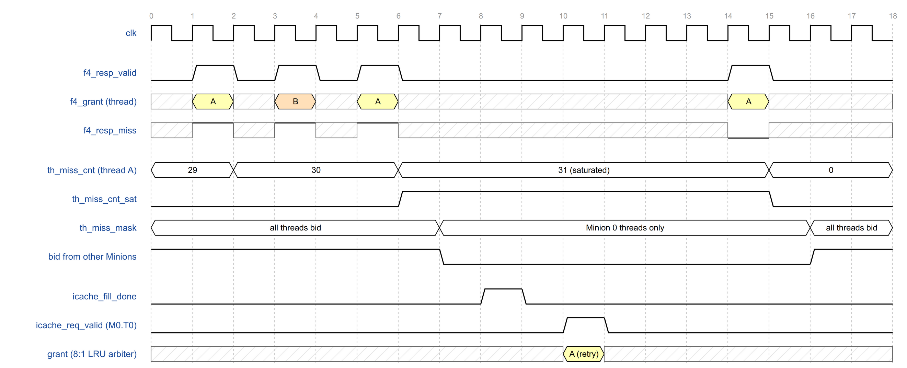
Figure 28. Miss-count guard: saturation, bid mask and release
With all other cores masked, only the selected core’s misses can reach the miss handler, so the starving thread’s line is filled and cannot be displaced before the thread retries. The thread then hits, its counter is cleared, and the mask passes to the next core with a saturated thread, or is removed if there is none.
Clearing every counter on an error avoids a corner case in which a core hangs on a faulting address. A faulting thread never hits on that address, so its counter would saturate and it would keep exclusive access, which is only meant to end on a hit. Clearing the counters and the mask lets the fault be handled normally instead of leaving a mask in place based on stale counts. If the access pattern that caused the livelock persists, the counters saturate again and the guard is triggered again.

3.3.8.5 Prefetcher Interaction and Retry Windows
The code prefetcher can be started only in the north L0 micro-cache, the one that serves cores 0 to 3: both micro-caches contain the engine, but the prefetch configuration and start registers are connected to that instance alone and tied off in the other. It uses the same miss handler as demand fetches. Three rules keep it below every thread in priority. First, a prefetch request enters the L0 pipeline only in cycles with no core request. The other two rules are timed windows, implemented as two separate state machines in icache_micro_cache. They start on different events, end for different reasons and serve different purposes (Table 30).
Table 30. Prefetch retry windows
 | Prefetch pause | Unattended-miss hold
Where | The prefetcher’s own state machine (state PreReq_Pause), a 3-bit counter | A separate tracker (states FillDone_Wait and Req_Wait), a 4-bit counter
Starts | On a fill done that arrives while the prefetcher is waiting for one (state FillDone_Wait). The fill done can come from the prefetcher’s own fill or from a thread’s fill. The pause is not started if the prefetcher is in any other state. | Only when a demand lookup misses but is not accepted by the miss handler, normally because it is busy, so a thread is put to sleep without its miss being handled
Length | Always exactly 8 cycles after fill done | Until fill done, then until the first core request enters the L0 micro-cache, or at most 16 cycles
Ends | When the counter expires | Usually early, on the first core request or at the 16-cycle timeout
Purpose | Step back after a fill it was waiting for, most importantly a thread’s fill that had blocked it, so that newly woken threads reach the freed handler first | Keep prefetch out while a thread is known to be waiting, until it has retried
Prefetch pause. When a fill completes, the miss handler becomes free at the same moment as all sleeping threads wake up. Without the pause, the prefetcher, which issues in any cycle the L0 micro-cache is idle, could take the handler before the waking threads reach the L0 pipeline. The prefetcher waits for a fill done in three cases: when its prefetch lookup found the miss handler busy with a thread’s miss, in which case the pause lets that thread and the other woken threads retry first; after its own prefetch fill, when more lines remain; and after a line that faulted. In each case it pauses 8 cycles after fill done before its next request.
The pause is tied to the prefetcher’s own state, not to every fill. If a thread’s fill completes while the prefetcher is still waiting for an idle cycle to issue its request (state Request), no pause is started. The prefetcher may then issue in an idle cycle between the woken threads' retries and take the freed handler. The unattended-miss hold covers this case only if a thread’s miss was turned away while the handler was busy; otherwise the waking threads rely on the livelock guard (Section 3.3.8.4).
Unattended-miss hold. A fixed 8 cycles is not always enough: a woken thread may have to wait behind up to seven other retrying threads in the L0 arbiter, so its retry can arrive after the pause has ended. When a demand miss is turned away, new prefetch requests are blocked until the next fill done and then until a core request enters the L0 micro-cache. Without it, a prefetch could take the handler before the retry, and the thread would miss again and sleep for another full fill.
How the two combine. A prefetch request is issued only when both windows allow it. If no demand miss was turned away, only the pause applies and prefetching resumes 8 cycles after fill done. If one was, the pause runs first, and if no core request has arrived by then, the prefetch waits until one does or until the 16-cycle limit.
Limits of the hold. The hold is released by the first core request from any thread, not necessarily the one whose miss was turned away. It is a heuristic that threads have become active again, not a guarantee for that particular thread; that thread is protected by the livelock guard (Section 3.3.8.4). The 16-cycle limit also protects the prefetcher: if no thread retries, for example because the waiting thread was redirected, disabled or halted, the block would otherwise never clear and prefetching would stop for good. A prefetch fill also generates fill done, so threads that miss while a prefetch holds the handler are woken like any other.
After a prefetch line faults, the prefetcher waits for a fill done before moving to the next line, but a faulting line does not generate a fill of its own. Prefetching then resumes only after some thread’s miss causes a fill. If all threads are hitting, this can take a long time.

3.3.8.6 L1 I-Cache Miss Port
The two L0 micro-caches of a Neighborhood each hold their single outstanding miss request in a staging register and share the L1 instruction cache through a round-robin arbiter (arb_rr_data in icache_top). At this level the requesters are the L0 micro-caches, not threads: each staged request is the one miss that the L0 micro-cache’s miss handler accepted from one of its threads. When both L0 micro-caches have a request staged, the arbiter alternates, so a miss request waits for at most one miss request of the other L0 micro-cache before it is sent to the L1 instruction cache.

3.3.8.7 Decode and Issue
Inside the core, the two threads share the decoders and the issue slot into ID. When both threads have an instruction ready to decode, the decode selection picks the thread that is not presented to ID in the current cycle. The thread scheduler selects between eligible threads in round-robin order and updates its last selection only when at least one thread is eligible. Each thread has its own instruction FIFO and its own stall input (id_core_stall), so a stalled thread does not block the other. A halted thread generates its placeholder instruction without bidding for the fetch port. An eligible thread is therefore presented to ID at least every other cycle.

3.3.8.8 Assumptions
These mechanisms guarantee forward progress in the fetch path under the following conditions:
- Every L1 miss request eventually returns a fill, and every translation request eventually completes.
- Software does not keep a thread’s exclusive mode, WFI or other architectural stalls asserted indefinitely. These deliberately stop the affected thread and are not starvation.
- Error responses are not sustained. Because an error clears every thread’s miss counter, a continuous stream of faulting fetches from other threads would defer the livelock guard. In practice each fault redirects the faulting thread to its trap handler, so such a stream does not persist.
- When several cores have saturated counters, they are served in fixed order, lowest-numbered core first. The waiting time of a higher-numbered core is bounded, because each exclusive period ends when the selected thread hits.

3.3.9 Known Limitations
The properties below follow from the design of the interface. They are not defects, but they constrain how the interface may be changed and how it behaves under load.
- Response carries no thread identifier. A core matches a response to its request by counting cycles, so the fixed response latency is part of the interface contract. A change to the depth of the L0 pipeline has to be matched in the Front End.
- Fill done carries no address. Every fill wakes every sleeping thread of the micro-cache. Threads waiting for a different line arbitrate, miss again and sleep again, which costs L0 bandwidth on every fill and grows with the number of threads waiting on different lines.
- One outstanding miss per L0 micro-cache. A miss that arrives while the miss handler is busy is answered with a miss response but is not recorded, so its line is not requested. That thread makes progress only after an unrelated fill wakes it and it retries.
- Starving cores are served in a fixed order. When several cores have a saturated thread, the mask always selects the lowest-numbered one first. Its waiting time is bounded, because each exclusive period ends when the selected thread hits, but the order is not fair.
- Unattended-miss hold is released by any core request. Which thread issues that request is not checked, so the hold can end before the thread whose miss was turned away has retried. That thread is covered by the miss-count guard rather than by the hold.
- Prefetching can pause for a long time after a faulting line. The prefetcher waits for a fill done before it moves to the next line, and a faulting line produces no fill of its own. If every thread is hitting, no fill done is generated and prefetching stays paused.

3.4 L0 Micro-Cache

3.4.1 Overview
Table: L0 micro-cache characteristics.

3.4.2 Internal Blocks
Figure: L0 micro-cache block diagram.

3.4.3 Pipeline Stages
Figure: L0 micro-cache pipeline.

3.4.4 Instruction TLB

3.4.5 Micro-Tag and Micro-Data Arrays

3.4.6 PMA Check

3.4.7 Replacement

3.4.8 Miss Handling

3.4.8.1 TLB Miss

3.4.8.2 Tag Miss

3.4.8.3 Fill and Thread Wake-Up

3.4.9 L1 Bypass

3.4.10 Software Prefetch
Figure: Prefetch state machine.

3.5 L1 Instruction Cache

3.5.1 Overview
Figure: L1 instruction cache block diagram.

3.5.2 Organization

3.5.3 Tag, LRU and Data Arrays

3.5.4 External Data RAM

3.5.5 Request Arbitration Between L0 Micro-Caches

3.5.6 Miss Path

3.5.7 Errors and ECC

3.6 Shared Page-Table Walker

3.6.1 Clients and Arbitration

3.6.2 Walk Sequence and Page Sizes
Figure: Page-table walk state machine.

3.6.3 PTE Cache and Invalidation

3.7 Memory Request and Response Path

3.7.1 Miss, Evict and Fill FIFOs
Figure: Neighborhood memory request and response path.

3.7.2 Request Arbitration

3.7.3 Response Routing and Backpressure

3.8 Tensor Support

3.8.1 Cooperative Tensor Load

3.8.2 Tensor Store Buffer

3.8.3 TBOX Router

3.9 Synchronization, Messaging, Registers and PMU

3.9.1 Fast Local Barrier

3.9.2 Local Message Network

3.9.3 IPI and FCC Paths

3.9.4 Neighborhood Registers and APB Access

3.9.5 Debug Channel

3.9.6 Performance Monitoring Unit

