Technical proposal · RISC-V International RFP v1.1

Automatic Test Generation from the Sail Golden Model
A hybrid framework that uses ISLA for symbolic derivation and a Concrete Oracle for concrete execution, with a control layer routing each target to the appropriate backend. Eight weeks, two engineers, measured against the Sail model's own coverage targets.
Part 1

Objective and deliverables
A configuration-aware test-generation framework for RISC-V, driven by the upstream Sail model, focused on the privileged architecture, and integrated into the Golden Model's continuous integration (CI).
 | Deliverable
1 | Repository with the framework, user documentation and developer documentation
2 | Example scripts that generate a test suite from a given Sail model configuration
3 | Example scripts that execute a suite, collect results and produce a summary
4 | CI integration into the Golden Model
5 | Pull requests for any Golden Model changes the framework requires

What we are building
The framework uses the Sail model as the executable reference for generation, validation and coverage. Routing is by extension. Floating point and Vector route to the Concrete Oracle; every other extension routes to ISLA, which symbolically executes the model and uses the Z3 SMT solver to derive the operands that reach a chosen behaviour. A small template backend handles branch and jump cases that require explicit construction.
Because floating point and Vector are deferred, the Oracle leg generates no tests in this project. Its job here is to read the model’s branch structure, derive the configurations it implies — PMP, PMA, exceptions, interrupts, translation — and emit the assembly that sets each one up. That setup code is embedded in the object emitter.
Generating one test takes both legs. The scenario goes to the emitter as flags, ISLA solves the operands, and the emitter writes one program: setup code, the instruction, the expected result. It runs on Sail and on Spike and the results are compared. Coverage from the instrumented model returns the missing scenarios to the generation engine, which derives a case for each.
A control layer runs the same loop for every configuration.
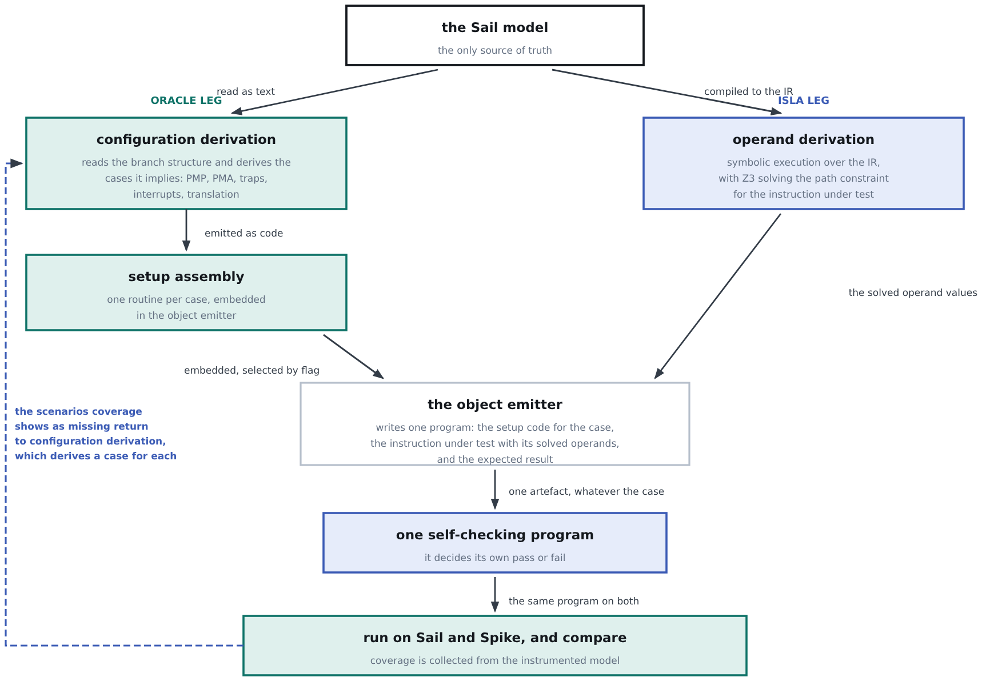
The legs do different jobs and meet at the emitter: the Oracle leg supplies the configuration and the code that establishes it, ISLA the operands. Coverage is not only reported — the scenarios it shows as missing come back as new cases.

What this work adds
Model-derived test inventory | Tests are derived from the current Sail model rather than from a separately maintained instruction list
Hybrid generation | ISLA and the Concrete Oracle are routed according to the capabilities and limitations of each backend
Privileged-state construction | The framework explicitly constructs the machine state needed to exercise privileged behaviour
Reachable coverage denominator | Coverage is measured against the targets the selected configuration can actually reach
Independent validation | Generated tests are checked against an independent simulator or implementation
ACT4 integration | Generated tests can be consumed and executed through the RISC-V Architectural Certification Test (ACT4) framework

Scope
Area | Committed | Deferred — architecture ready | Excluded
M-mode | CSR access, trap entry and return, privilege transitions, PMP, PMA, interrupt delivery and delegation | Nested traps | —
S-mode | Translation schemes through Sv48 — Svbare, Sv32, Sv39, Sv48 — with negative controls, plus PTE content features and the fault taxonomy | Sv57. The model implements it; this project does not commit coverage to it | —
Privileged extensions | Those the Sail model supports; the list follows below | — | —
Unprivileged ISA | Only what the privileged scenarios require | Systematic generation across the unprivileged ISA | —
Floating point | — | F/D instruction functionality. Configurations with F and D enabled are still generated and run through the Oracle | —
Vector | — | Vector instruction functionality, same route | —
Hypervisor | — | — | Not implemented in the selected Sail model
Deferred is not excluded. Floating-point (FP) and Vector functionality is deferred, not ruled out: the Oracle path generates and runs it today, and configurations that enable F, D and Vector are still built and executed. Only the hypervisor is excluded, because the selected Sail model does not implement it.

Privileged targets, by group
Each name is an extension the Sail model declares, so each resolves to a set of instrumented coverage targets. That is what makes coverage a measurable claim per group.
Group | Targets
Privilege modes | S, U
CSR access and counters | Zicsr, Zicntr, Zihpm, Smcntrpmf, Sscounterenw
State enable, QoS, overflow | Smstateen, Ssstateen, Ssqosid, Sscofpmf
Timer and trap value | Sstc, Sstvala
Pointer masking | Smmpm, Smnpm, Ssnpm
Translation modes | Svbare, Sv32 (RV32), Sv39, Sv48 (RV64) — Sv57 deferred
Translation maintenance | Svinval
Page table and PTE features | Svade, Svadu, Svnapot (RV64), Svpbmt (RV64), Svrsw60t59b
Translation guarantees | Svvptc, Ssccptr

The committed configurations
The model generates sixteen configurations as a full XLEN × VLEN × ELEN cross-product. We commit to seven of them, spanning both XLENs and all four vector lengths. Each keeps its own reachable denominator, exclusions and coverage result.
Configuration | XLEN | VLEN | ELEN | Generation route
rv32d_v64_e32 | 32 | 64 | 32 | ISLA and Oracle
rv64d_v64_e64 | 64 | 64 | 64 | ISLA and Oracle
rv32d_v128_e32 | 32 | 128 | 32 | ISLA and Oracle
rv64d_v128_e64 | 64 | 128 | 64 | ISLA and Oracle
rv32d_v256_e32 | 32 | 256 | 32 | Oracle only
rv64d_v256_e64 | 64 | 256 | 64 | Oracle only
rv64d_v512_e64 | 64 | 512 | 64 | Oracle only
The last three are Oracle-only because ISLA cannot represent Vector state at VLEN 256 and 512. This is a representation limit, not a scheduling choice.
Part 2 · Methodology

The framework end to end
The method is one loop, run separately for each committed configuration. The Sail model is the only source of truth in it: the same model supplies the instruction inventory, the machine states worth reaching, the paths the solver reasons about, and the coverage targets everything is measured against.
The model is read twice, by different means, and the readings meet at the object emitter. One leg reads its branch structure and turns it into configurations and the assembly that sets them up. The other compiles it to an intermediate representation (IR) and solves for the operands that drive an instruction down a chosen path.
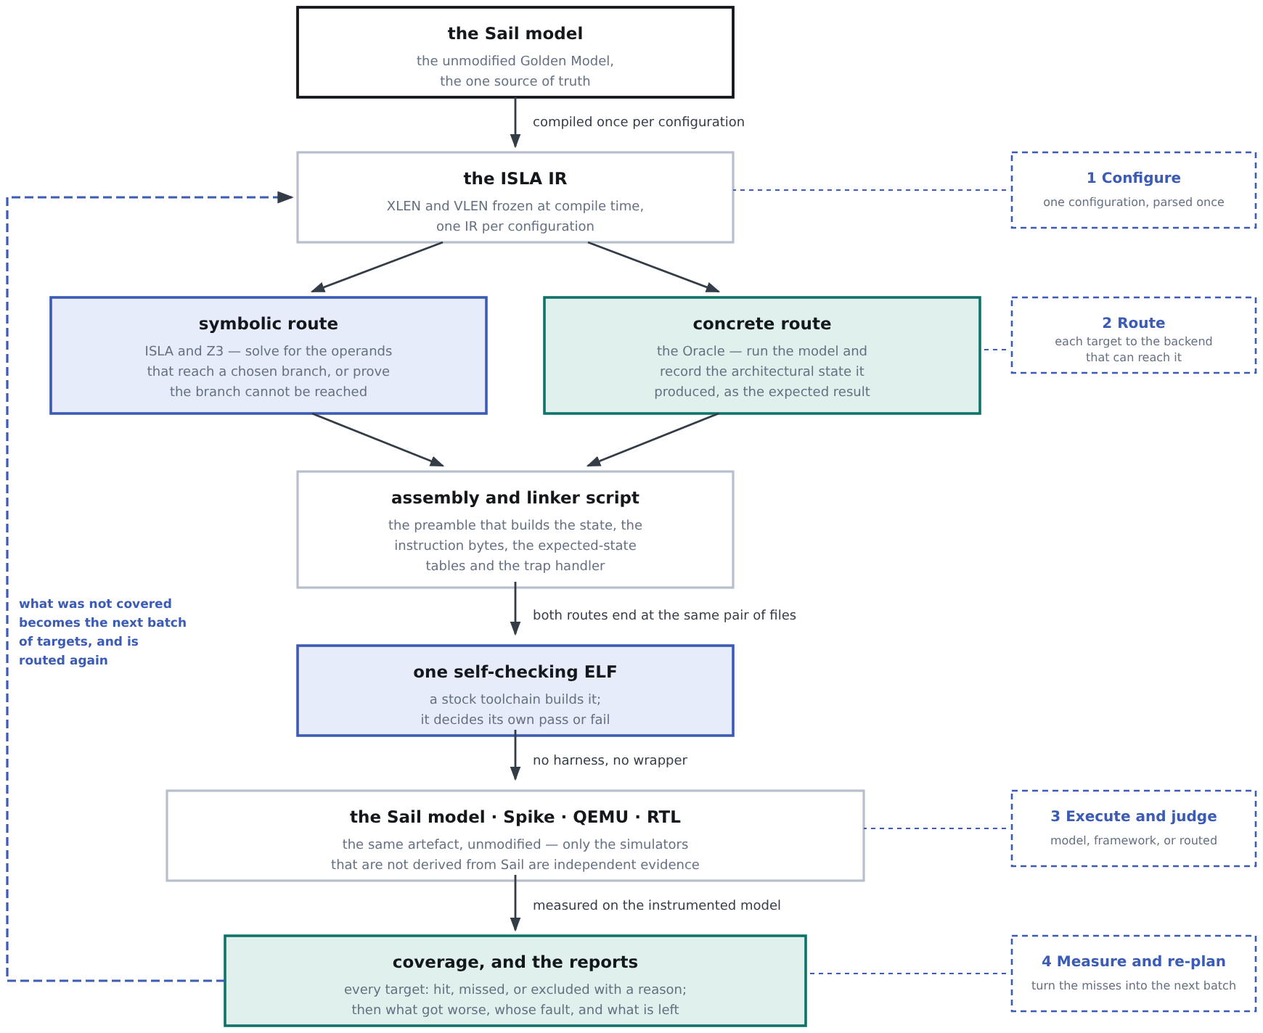
One loop per configuration. The split is early and the convergence is early: the two routes differ only in how a test’s values are obtained, never in what a test is. Everything below the assembler is shared, which is why a test generated either way runs on any of the simulators without a per-target build.
The same loop, component by component. Each arrow says what is handed to the next stage, which is where the two routes differ: the symbolic route passes constraints to a solver, the concrete route passes a program to the model and reads the answer back.
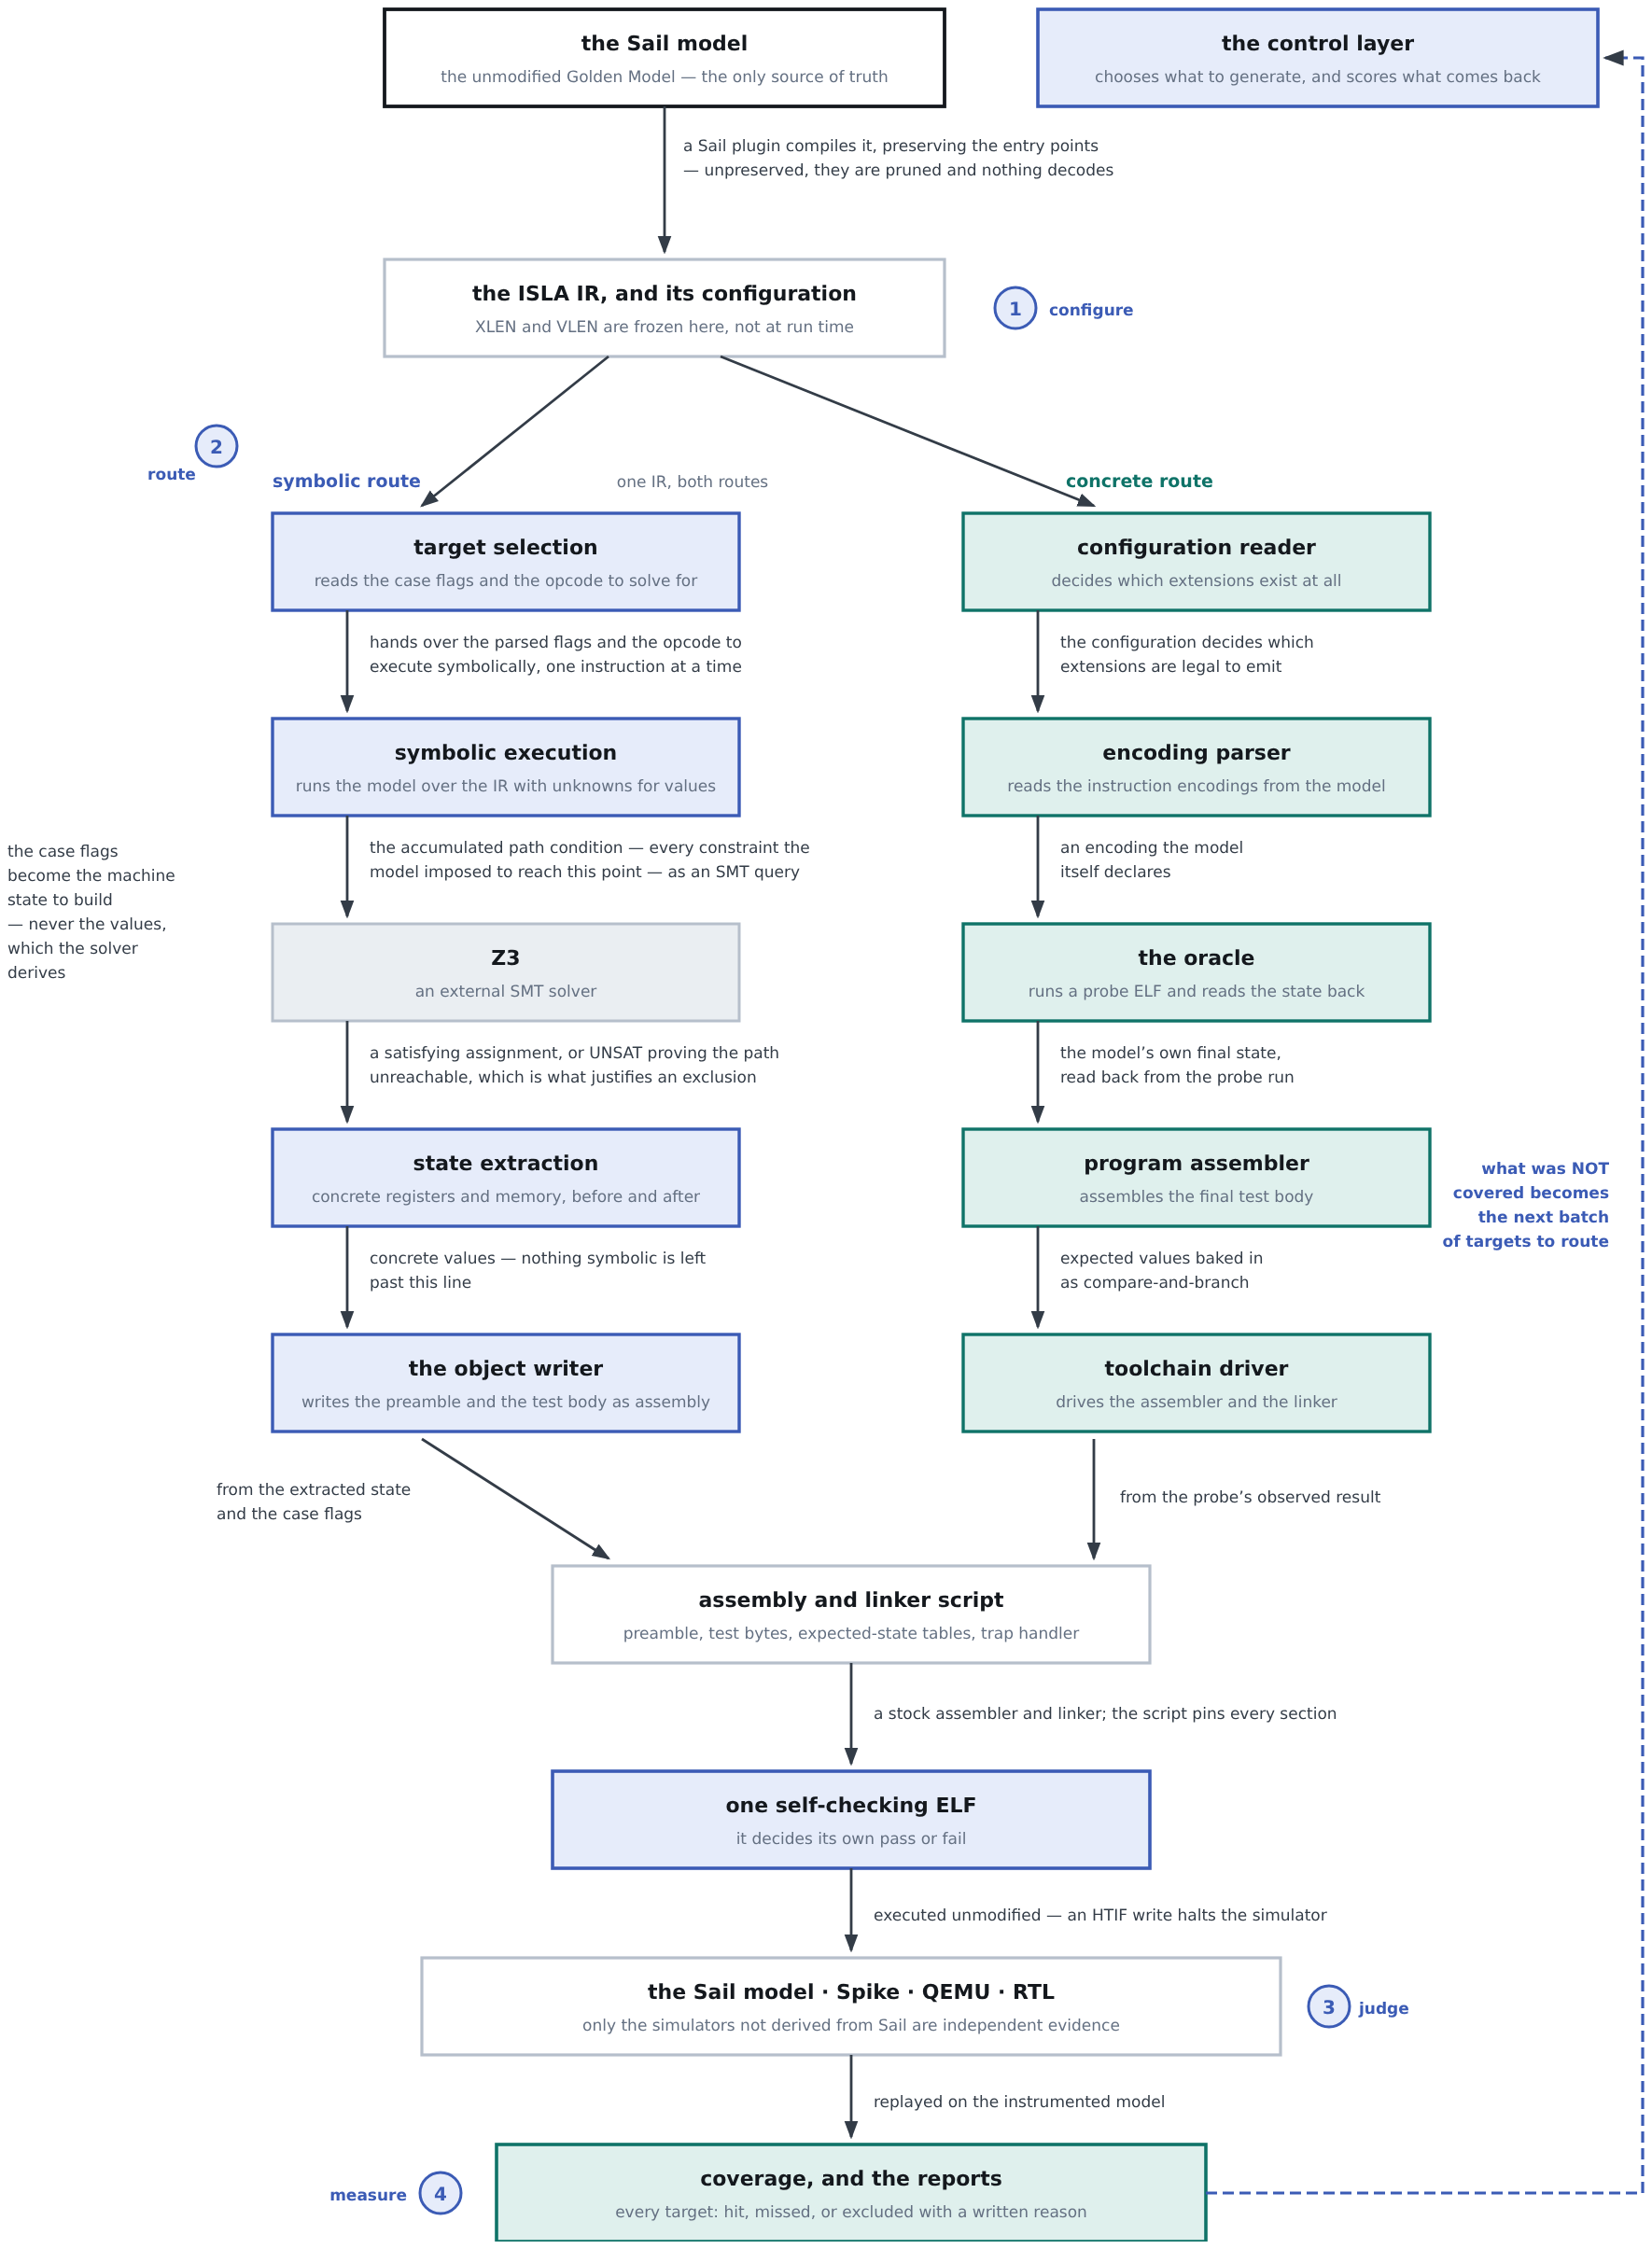
The two routes are separate all the way down and meet only at the assembly and linker script. Below that line there is one artefact, one runner and one measurement, whichever route produced the test. The numbered points are where the control layer acts.
What follows takes the loop in order: how a target is routed, how privileged machine state is constructed, and how a test is executed, validated and measured.
Maintenance follows from the model being the source. The instruction inventory, the machine states worth reaching and the coverage denominator are all derived from the Sail model, so a change to the model changes all three. No table in the framework is hand-edited when an instruction is added.

Routing, by extension
The route is decided by which extension a target belongs to, not case by case.
Extension group | Route | What that route contributes
F, D, Zf*, Zd*, Zh* | Concrete Oracle | Test generation by observation. Deferred, so not exercised in this project
V, Zv*, vector crypto | Concrete Oracle | The same, and for the same reason
Branch and jump | Template backend | An explicit control-flow structure neither engine constructs. Capped at four builders; growth in that number is a defect signal
Every other extension | ISLA | Operand derivation — the values that make the instruction take a chosen path
Privileged machine state  PMP, PMA, traps, interrupts, translation | Oracle leg, into the emitter | Configuration derivation and the setup assembly for it, embedded in the object emitter and selected by flag
The two legs are not alternatives for a single test. A privileged test uses both: the Oracle leg supplies the configuration and the code that establishes it, ISLA supplies the operands of the instruction under test, and the emitter writes the two into one program.

Why the routing falls this way
Not preference — the symbolic engine cannot represent two extension groups, and the concrete leg has a second job that only it can do.
Property | Consequence for routing
Reaches a named target on purpose | The route of choice when a specific model behaviour must be exercised
Proves unreachability | An UNSAT result justifies an exclusion from the coverage denominator
No FP arithmetic | SoftFloat is external C with no body in the IR, so it cannot be executed symbolically. FP routes to the Oracle
Bounded bitvector width | Vector state at VLEN 256 and 512 exceeds the engine's fixed-width representation. Vector routes to the Oracle
Operands, not machine state | The solver derives operands; privileged state is constructed by the generator — see Part 3
One solve per test | Suited to targeted work, not to bulk generation across all seven configurations

The Oracle leg’s two roles
Role | What it does | Used here?
Test generation for FP and Vector | Runs the instruction on the model, records the resulting architectural state, and uses that observed state as the expected result | Not actively. The capability exists and works; floating point and Vector are deferred, so this leg generates no tests in this project
Configuration and scenario setup | Reads the branch structure of the model, derives the configurations it implies for PMP, PMA, exceptions, interrupts and translation, and emits the assembly that establishes each one | Yes — this is its job here. The setup code it produces is embedded in the object emitter
Why the same leg does both. Each role needs the model executed rather than solved — one to observe a result, the other to establish a machine state. Neither is something the symbolic engine can do, which is why they share a side even though only one is in scope.

How privileged scenarios are constructed
Privileged coverage comes from constructing the required machine state in the test preamble, not from selecting special instructions. The solver derives operands; the generator writes the control and status registers (CSRs), page tables and privilege transitions directly.
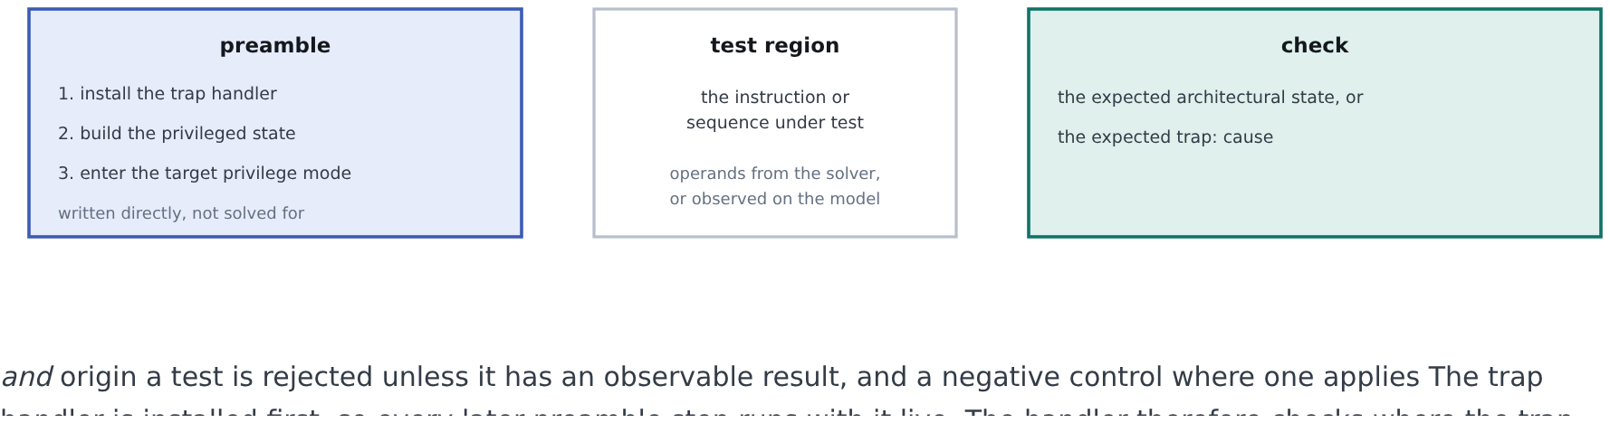
State is built before the test region begins. The symbolic backend cannot place an opcode at an address reached through a data-computed transfer, so this boundary is what makes privileged targets reachable.
Group | How the state is constructed
Privilege modes | Configure the privilege state, then enter it with the appropriate return instruction
CSRs | Access legal registers at the appropriate privilege level
Traps | Construct the faulting condition, then verify the trap cause and its origin
Interrupts | Configure pending, enable and delegation state
Virtual memory | Construct page tables and configure satp
PMP | Configure entries, then make permitted and denied accesses
PMA | Select a platform configuration whose region attributes produce the case, then make the access
PMP and PMA differ only in where the configuration comes from. PMP is written by the test into CSRs; PMA is a per-region attribute in the model’s configuration file — so a PMA test needs only a configuration and an access.

Deriving cases from the model
Privileged features are not instructions, and their case list is not something to write by hand. It is derived in two stages.
 | Stage | What it does
1 | Case extraction | The Oracle leg reads the deciding functions in the Sail sources — the enumerations, bitfields and match arms — and writes out a case file. It reads the model and runs nothing
2 | Case execution | The case is passed to the emitter as flags. The emitter writes the setup code for that case, ISLA solves the operands of the instruction, and the two go into one program
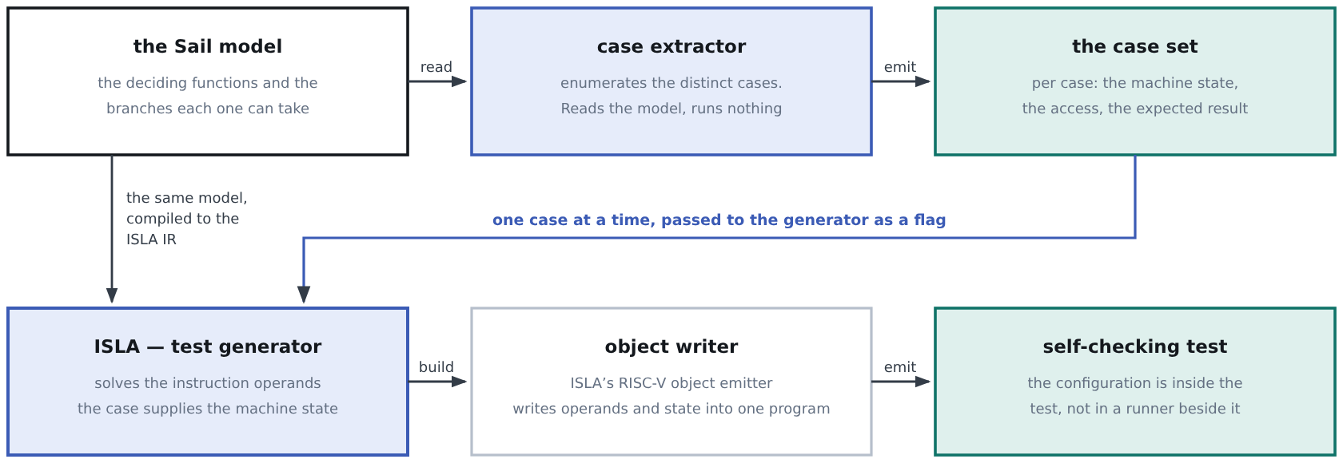
ISLA solves the operands; the case supplies the machine state. The flag selects which case, and the object writer turns it into preamble instructions — so adding a case adds an entry, not a code path.
The object writer is ISLA’s RISC-V emitter, and the single place that turns a case into a program. It emits every part of the test; the case flags decide only the state-building step.
What it emits | Contents
The preamble | The trap vector first, then the machine state the case calls for — PMP entries, page tables, delegation and interrupt state, mstatus bits — then the transition into the privilege the case runs in
The page table | Written into the data section when the case needs translation, with the entries the case specifies
The instruction under test | Raw encoding bytes, with the operands ISLA solved for. Emitting the encoding rather than a mnemonic keeps the test on the exact encoding the model decoded
The expected state | Register and memory tables compiled in as data, which the test compares itself against
The trap handler | The cause check, the origin check, and the report-from-handler path a violation test needs
The reporting code | The HTIF write that ends the run and carries the verdict
The linker script | Every section pinned at a fixed, non-overlapping address
Only the state-building step varies. The handler, the comparison, the reporting and the linker script are identical in every test, so a new case changes what the preamble programs and nothing else.
ISLA is not bypassed here. It still solves the operands of the instruction under test. The case supplies the state around it, which the solver cannot derive — nothing in the model asks for a PMP entry to be placed anywhere.

The five privileged paths
All five derive their cases the same way. They part company at the point of application: four program their state from inside the test, while a memory attribute is a property of the platform and can only be chosen by picking the configuration.
Feature | What the extractor reads | How the state is applied | What the test checks
PMP | The address-match modes, the configuration bitfield, the range comparisons, the permission arms, and the rule that legalises a configuration write | Preamble writes to the pmpaddr and pmpcfg registers | The access is permitted, or faults with the expected cause
Translation | The satp mode decoding, the PTE flag bitfield, the invalid-PTE disjuncts, and the three permission gates | A page table into the data section, then satp, sfence.vma, and the drop to Supervisor | The address translates, or raises the expected page or access fault
Exceptions | The exception cause mapping, the rule that decides when a trap value is written, and the delegation legaliser | The preamble sets delegation and privilege; the test region holds the faulting instruction | The cause register, and which mode took the trap
Interrupts | The interrupt cause mapping, the priority order the model checks in, which bits are undelegatable, and which are writable | Preamble writes to the pending, enable and delegation registers, and the global enable | Which interrupt is taken, and at which privilege
PMA | The region attributes the platform configuration declares | Not applied by the test. The configuration is selected before the run | The access is permitted, or faults, according to the region's attributes
PMA is the one path not yet built. The other four are implemented. It needs no new generator capability — every attribute is already a field in the model’s configuration — so it is a configuration exercise, not a generator one.

Executing and validating a generated test
Each test is a RISC-V ELF that decides its own verdict, so no harness is required. It reports through an HTIF (host-target interface) write to tohost, the mechanism riscv-arch-test and Spike already expect. One output format and one runner, so the same ELF runs unmodified on Sail, an independent simulator, and RTL.
 | Step
1 | Generate assembly
2 | Assemble and link with the RISC-V toolchain
3 | Produce the ELF
4 | Run the ELF on Sail
5 | Run the same ELF on Spike or another independent simulator
6 | Collect both results
7 | Compare the architectural state, or the trap result
8 | Record coverage and classify any failure
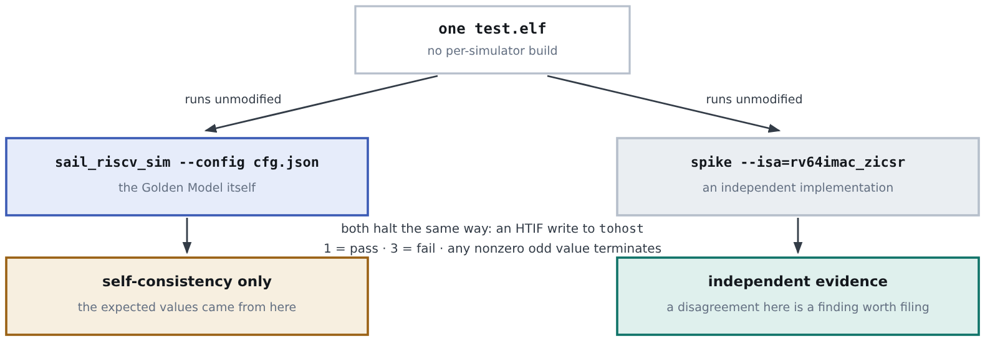
Every report preserves the split at the bottom: re-running a test on the model it came from confirms the derivation, not the architecture.
Concern | How it is handled
Matching configurations | A mismatched ISA string is the most common cause of an apparent disagreement between simulators, which is why they all derive from one parsed configuration
Classifying a failure | Every failure is classified as a model issue, a framework issue, or a correctly reported result. A bare pass/fail count is not an acceptable output
The two runs have different jobs. Sail is the Golden Model and provides the instrumented coverage. Spike, QEMU and RTL are independent environments, not derived from Sail, used for cross-platform validation.
Coverage does not depend on the two agreeing. A disagreement is classified and reported, and the Sail run still contributes its coverage — coverage is a property of what the model executed.

Coverage, and what 100% means
The RFP asks for coverage in terms of the Sail code, so it is measured from the instrumented model. For each configuration the framework first determines which targets are reachable; those are the denominator. A target is covered when at least one test reaches it.
100% coverage means that every reachable, in-scope Sail coverage target for a selected configuration is exercised by at least one generated test.
Reachable denominator = instrumented targets minus configuration-infeasible, structurally unreachable, and explicitly excluded targets.
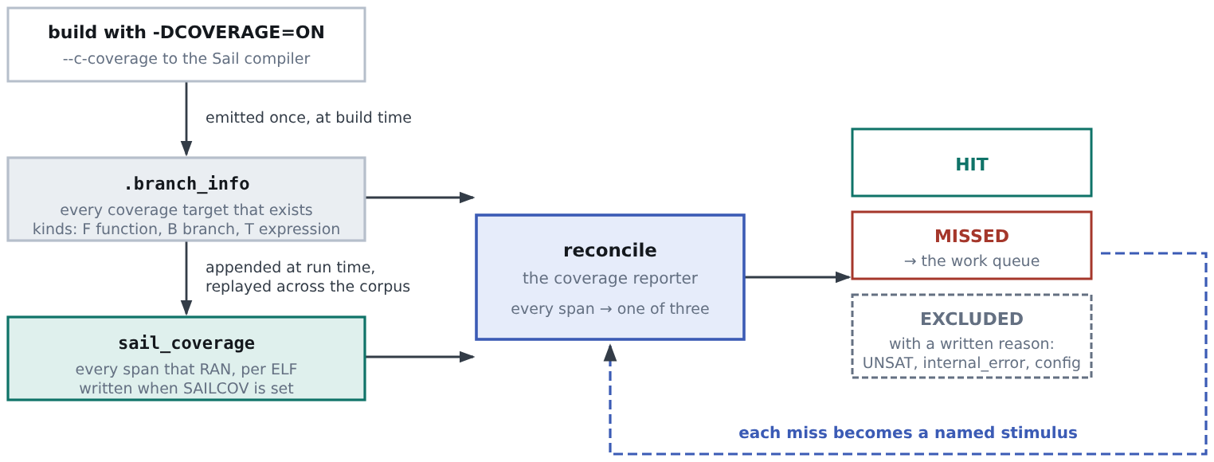
Two files do the work: a manifest of every instrumented target in the build, and a trace of the targets a run executed.
Excluded from the denominator | Example | Evidence
Structurally unreachable | internal_error arms; the reverse direction of a bidirectional mapping | Reaching it would mean the model is broken, or that a decode path exists which does not
Proved unreachable | A path for which the solver returns UNSAT | A proof from the symbolic backend
Configuration-infeasible | A target needing an extension this configuration does not enable | The configuration file. It is counted in a configuration that does enable it
Sail coverage and ACT4 coverage are different measures. Sail coverage measures model execution targets. ACT4 coverage and certification requirements are handled separately where applicable. Sail coverage is not equivalent to RISC-V architectural certification coverage, and this proposal does not claim it is.
Results are reported per configuration, never averaged. Where FP and Vector sit outside the committed scope, both the in-scope and combined figures are given, so the deferral neither flatters nor hides the result.

ACT4 integration
How does a generated test run through the RISC-V Architectural Certification Test (ACT4) framework? We produce the test in ACT4’s own format; its existing pipeline does the rest unchanged.
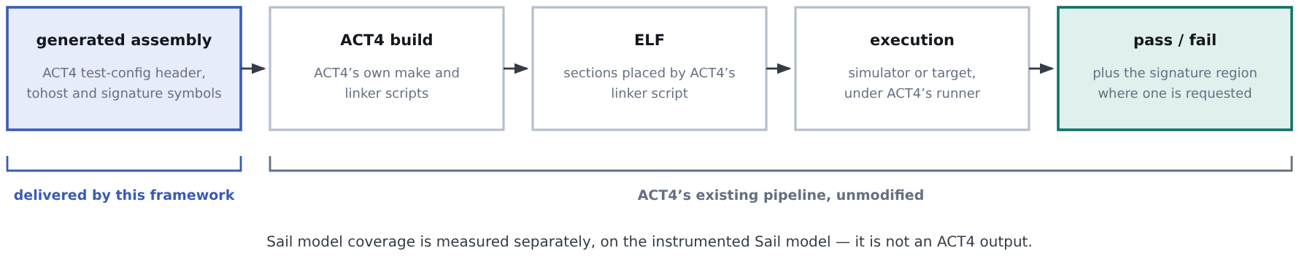
The integration point is the test format. Everything downstream is ACT4’s own build and runner.
What the project delivers for ACT4
ACT4-compatible generated tests
The test metadata and configuration header ACT4’s discovery reads
Build integration: tests build under ACT4’s own make
Simulator execution through ACT4’s runner
Pass/fail reporting, and the signature region where one is requested
CI integration, as committed in Deliverable 4
This is integration, not certification. The project delivers integration with the ACT4 framework. It does not deliver architectural certification, and no claim of compliance is made on the basis of this integration. Coverpoint tagging is a stretch item and is listed as such.

ACT4 integration points
The requirements a generated test must satisfy to build and run under ACT4’s own pipeline. All are implemented.
Integration point | Requirement
Compile configuration | The framework’s Sail compile configuration is cross-checked against ACT4’s own, so both describe the same machine
Host interface symbols | tohost/fromhost must be a real, sized, backed section. A host interface reads the symbol’s ELF size and will not start if it is zero, which a bare label gives
Signature region | begin_signature/end_signature must bracket real data, because ACT4 extracts results between those symbols
Test-config header | ACT4’s test discovery reads it. Zicsr is declared unconditionally, because the preamble always writes the trap vector whatever the tested instruction needs
Section placement | The .text.init section name matches the address ACT4’s linker scripts fix, which is also the generator’s own default, so a test lands correctly under either script
Part 3

Existing prototype evidence, and proposed work
Prototype evidence demonstrates feasibility. The project will extend this prototype into a maintainable, configurable and integrated framework. The two are separated so that nothing already built is presented as a deliverable, and nothing still to be built is presented as done.

Existing prototype evidence
Demonstrated | What it establishes
Both routes produce self-checking ELFs from the unmodified Sail model | The hybrid architecture works end to end
The instruction inventory is parsed from the Sail sources | Model-derived enumeration works at the scale of the real model
RV32 and RV64 both generate and run, on both routes | The design is not tied to one XLEN
Coverage measured against the Sail sources, with exclusions carrying written reasons | The reachable denominator is computable, not only definable
Privileged scenarios: privilege transitions, PMP violations, Sv39 walks, interrupt delivery, each with negative controls | Preamble-based state construction reaches privileged targets
The same ELFs run on Sail, an independent simulator, QEMU and CVA6 RTL | Portable artefacts, which is what independent validation depends on
Generated tests build and run through ACT4’s own pipeline | The ACT4 integration point is proven, not assumed
A Golden Model defect found, fixed and filed as a pull request | Deliverable 5 is a demonstrated capability

Proposed work
Work | Why it is needed
Complete the M-mode required set | The RFP names this set as required, and one item in it still has no coverage today
Extend translation to every committed scheme, through Sv48 | Only one scheme is exercised today; the scope table commits to Svbare, Sv32, Sv39 and Sv48
Widen PMP and virtual-memory permission cases, including the joint case | Only part of the access-kind and permission space is exercised today
Extend from the two configurations run today to the seven committed configurations | Each has its own reachable denominator and coverage result; the three largest VLEN configurations are Oracle-only
Per-test coverage attribution alongside suite-level coverage | Required by the RFP, and what lets coverage steer generation rather than only report it
Harden the control layer into a configurable, documented tool | The prototype is script-driven; the deliverable must be usable and maintainable by others
Developer documentation for community maintenance | Named in Deliverable 1, and the thinner half of the documentation today
CI integration into the Golden Model, and the pull requests carrying it | Deliverable 4, not started, and dependent on maintainer review
Part 4

Plan and cost
Milestone | Duration | Deliverable
M1 · Tooling | 2 weeks | Configuration handling, target enumeration, both generation backends, and the coverage and reporting components, under one control layer
M2 · Unprivileged | 2 weeks | Generation across the unprivileged ISA, except floating point and Vector
M3 · Privileged | 4 weeks | Privileged extensions with and without translation: CSR access, trap entry and return, privilege transitions, PMP, PMA, interrupt delivery and delegation, translation schemes, PTE features and fault cases
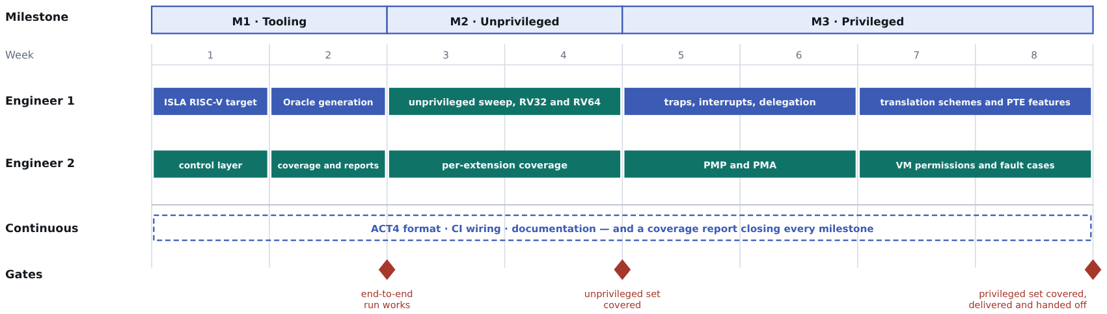
Two engineers in parallel lanes across eight weeks. ACT4 format, CI wiring and documentation run continuously rather than as a final phase, and each milestone closes with a coverage report whose uncovered remainder is the next milestone’s input.

Repositories, and what needs someone else’s review
The work touches four repositories. Only one of them is ours, and the deliverables that depend on the other three complete when a maintainer merges them, not when we finish the code.
Repository | Role | What changes | Gate
The framework repository | The deliverable itself | Generators, control layer, case extraction, coverage and reporting, and the documentation | Ours. Apache-2.0, no external gate
riscv/sail-riscv | The Golden Model | Model fixes the framework depends on (Deliverable 5), and the CI wiring that runs the suite (Deliverable 4) | Upstream review and merge
riscv-non-isa/riscv-arch-test | ACT4 | Generated tests in ACT4’s format, and a fix to ACT4’s own trap handler found while integrating | Upstream review and merge
rems-project/isla-testgen | The symbolic generator | The RISC-V target and the case flags it takes | Upstream review, if contributed back
This is the schedule risk we can least control. Deliverables 4 and 5 are defined as merged pull requests, so they complete on maintainer response times, not on our effort.

Cost
Duration | 8 weeks, three milestones
Total | USD 20,000
Licence | Apache-2.0, compatible with the Golden Model and named as preferred in the RFP
Prepared by 10xEngineers for RISC-V International, against RFP v1.1, Automatic Test Generation using the Sail RISC-V Golden Model. Results quoted in this document are reproducible from the repository; coverage figures are reported per configuration and dated to the corpus run that produced them.

