# DBHelper

package com.example.sqlite;

import android.content.ContentValues; import android.content.Context; import android.database.Cursor;

import android.database.sqlite.SQLiteDatabase; import android.database.sqlite.SQLiteOpenHelper; import androidx.annotation.Nullable;

public class DBHelper extends SQLiteOpenHelper { private static final String *dbName*="studentdb"; private static final String *tbName*="student" ; private static final int *dbVersion* = 1 ;

public DBHelper(@Nullable Context context, @Nullable String name, @Nullable

SQLiteDatabase.CursorFactory factory, int version) { super(context, *dbName*, null, *dbVersion*);

}

@Override

public void onCreate(SQLiteDatabase db) { db.execSQL("CREATE TABLE "+*tbName*+"(uname VARCHAR(10), password

VARCHAR(10))"+";");

}

@Override

public void onUpgrade(SQLiteDatabase db, int oldVersion, int newVersion) { db.execSQL("DROP TABLE IF EXISTS "+*tbName*); onCreate(db);

}

public long adduser(String name,String password){

SQLiteDatabase sqLiteDatabase=this.getWritableDatabase();

ContentValues cv=new ContentValues(); cv.put("uname",name); cv.put("password",password);

long result=sqLiteDatabase.insert(*tbName*,null,cv); sqLiteDatabase.close(); return result;

}

public void update(String name, String password){

SQLiteDatabase sqLiteDatabase=this.getWritableDatabase(); sqLiteDatabase.execSQL("UPDATE "+*tbName*+ "SET passw="+password+"

"+"WHERE uname="+name+";"); sqLiteDatabase.close();

}

public void delete(String name){

SQLiteDatabase sqLiteDatabase=this.getWritableDatabase(); sqLiteDatabase.execSQL("DELETE FROM"+*tbName*+" WHERE uname="+name+";"); sqLiteDatabase.close();

}

public String display(Context ctx){

SQLiteDatabase sqLiteDatabase=this.getReadableDatabase();

Cursor cursor=sqLiteDatabase.rawQuery("SELECT * FROM "+*tbName*,null);

String finalres=" "; while (cursor.moveToNext()){ finalres += cursor.getString(0)+":"+cursor.getString(1);

}

return finalres;

}

}

# delete

package com.example.sqlite; import androidx.appcompat.app.AppCompatActivity;

import android.content.Intent; import android.os.Bundle; import android.view.View; import android.widget.Button; import android.widget.EditText;

public class delete extends AppCompatActivity {

EditText uname;

Button delete; DBHelper dbHelper;

private static final String *dbName*="studentdb"; private static final String *tbName*="student" ; private static final int *dbVersion* = 1 ;

@Override

protected void onCreate(Bundle savedInstanceState) { super.onCreate(savedInstanceState); setContentView(R.layout.*activity_delete*);

uname=findViewById(R.id.*name*); delete=findViewById(R.id.*del*);

delete.setOnClickListener(new View.OnClickListener() {

@Override

public void onClick(View v) { dbHelper=new DBHelper(delete.this,*dbName*,null,*dbVersion*); dbHelper.delete(uname.getText().toString());

Intent it = new Intent(delete.this, MainActivity.class); startActivity(it);

}

});

}

}

# display

package com.example.sqlite; import androidx.appcompat.app.AppCompatActivity;

import android.os.Bundle; import android.widget.TextView;

public class display extends AppCompatActivity {

TextView text; DBHelper dbHelper;

private static final String *tbName*="student" ; private static final String *dbName*="studentdb"; private static final int *dbVersion* = 1 ;

@Override

protected void onCreate(Bundle savedInstanceState) { super.onCreate(savedInstanceState); setContentView(R.layout.*activity_display*);

text=findViewById(R.id.*text*);

dbHelper=new DBHelper(display.this,*dbName*,null,*dbVersion*);

String out=dbHelper.display(display.this); text.setText(out);

} }

# MainActivity

package com.example.sqlite; import androidx.appcompat.app.AppCompatActivity;

import android.content.Intent; import android.os.Bundle; import android.view.View; import android.widget.Button;

public class MainActivity extends AppCompatActivity {

Button registration, display, update, delete;

@Override

protected void onCreate(Bundle savedInstanceState) { super.onCreate(savedInstanceState); setContentView(R.layout.*activity_main*); registration=findViewById(R.id.*register*); display=findViewById(R.id.*display*); update=findViewById(R.id.*update*); delete=findViewById(R.id.*delete*);

registration.setOnClickListener(new View.OnClickListener() {

@Override

public void onClick(View v) {

Intent it=new Intent(MainActivity.this,registration.class); startActivity(it);

} });

display.setOnClickListener(new View.OnClickListener() {

@Override

public void onClick(View v) {

Intent it=new Intent(MainActivity.this,display.class); startActivity(it);

} });

update.setOnClickListener(new View.OnClickListener() {

@Override

public void onClick(View v) {

Intent it=new Intent(MainActivity.this,update.class); startActivity(it);

} });

delete.setOnClickListener(new View.OnClickListener() {

@Override

public void onClick(View v) {

Intent it=new Intent(MainActivity.this,delete.class); startActivity(it);

}

});

} }

# Registration

package com.example.sqlite; import androidx.appcompat.app.AppCompatActivity;

import android.content.Intent;

import android.database.sqlite.SQLiteDatabase; import android.os.Bundle; import android.view.View; import android.widget.Button; import android.widget.EditText; import android.widget.Toast;

public class registration extends AppCompatActivity {

EditText uname;

EditText upass ;

DBHelper dbHelper; Button register;

private static final String *dbName*="studentdb"; private static final String *tbName*="student" ; private static final int *dbVersion* = 1 ;

@Override

protected void onCreate(Bundle savedInstanceState) { super.onCreate(savedInstanceState); setContentView(R.layout.*activity_registration*);

uname=findViewById(R.id.*uname*); upass=findViewById(R.id.*password*); register=findViewById(R.id.*submit*);

register.setOnClickListener(new View.OnClickListener() {

@Override

public void onClick(View v) { dbHelper = new

DBHelper(registration.this,*dbName*,null,*dbVersion*); long

val=dbHelper.adduser(uname.getText().toString(),upass.getText().toString());

if(val -1)

{

Toast.*makeText*(registration.this, "Error in adding user",

Toast.*LENGTH_SHORT*).show();

} else {

Toast.*makeText*(registration.this, "USER REGISTERED", Toast.*LENGTH_SHORT*).show(); 13(f)

Intent it = new Intent(registration.this,

MainActivity.class); startActivity(it); }

}

});

}

}

# update

package com.example.sqlite; import androidx.appcompat.app.AppCompatActivity;

import android.content.Intent; import android.os.Bundle; import android.view.View; import android.widget.Button; import android.widget.EditText;

public class update extends AppCompatActivity {

EditText uname;

EditText upass;

Button update; DBHelper dbHelper;

private static final String *dbName*="studentdb"; private static final String *tbName*="student" ; private static final int *dbVersion* = 1 ;

@Override

protected void onCreate(Bundle savedInstanceState) { super.onCreate(savedInstanceState); setContentView(R.layout.*activity_update*);

uname=findViewById(R.id.*uname*); upass=findViewById(R.id.*password*); update=findViewById(R.id.*update*);

update.setOnClickListener(new View.OnClickListener() {

@Override

public void onClick(View v) {

dbHelper=new DBHelper(update.this,*dbName*,null,*dbVersion*);

dbHelper.update(uname.getText().toString(),upass.getText().toString()); Intent it=new Intent(update.this,MainActivity.class); startActivity(it);

} });

}

}

# delete.xml

<?xml version="1.0" encoding="utf-8"?>

<LinearLayout xmlns:android="http: schemas.android.com/apk/res/android" xmlns:app="http: schemas.android.com/apk/res-auto" xmlns:tools="http: schemas.android.com/tools" android:layout_width="match_parent" android:layout_height="match_parent"

tools:context=".delete" android:orientation="vertical" android:layout_margin="20dp" android:background="#cb968b">

<TextView android:layout_width="match_parent" android:layout_height="wrap_content" android:text="Delete page" android:layout_margin="30dp" android:textSize="30dp"

<EditText android:layout_width="match_parent" android:layout_height="wrap_content" android:hint="Enter a username" android:layout_marginTop="30dp" android:id="@+id/name" android:layout_marginRight="30dp" android:layout_marginLeft="30dp" android:textSize="20dp"

<Button android:layout_width="match_parent" android:layout_height="wrap_content"

android:text="Delete" android:textSize="20dp" android:layout_marginTop="50dp" android:id="@+id/del" android:layout_marginRight="30dp" android:layout_marginLeft="30dp"

LinearLayout>

# display.xml

<?xml version="1.0" encoding="utf-8"?>

<LinearLayout xmlns:android="http: schemas.android.com/apk/res/android" xmlns:app="http: schemas.android.com/apk/res-auto" xmlns:tools="http: schemas.android.com/tools" android:layout_width="match_parent" android:layout_height="match_parent"

tools:context=".display" android:orientation="vertical" android:layout_margin="20dp" android:background="#cb968b"

>

<TextView android:layout_width="match_parent" android:layout_height="wrap_content" android:text="Display page" android:layout_margin="30dp" android:textSize="30dp" android:id="@+id/text"

LinearLayout>

# activitymain.xml

<?xml version="1.0" encoding="utf-8"?>

<LinearLayout xmlns:android="http: schemas.android.com/apk/res/android" xmlns:app="http: schemas.android.com/apk/res-auto" xmlns:tools="http: schemas.android.com/tools" android:layout_width="match_parent" android:layout_height="match_parent" tools:context=".MainActivity" android:orientation="vertical" android:layout_margin="20dp" android:background="#cb968b" >

<Button android:layout_width="match_parent" android:layout_height="wrap_content" android:layout_marginTop="100dp" android:layout_marginLeft="20dp" android:layout_marginRight="20dp" android:text="Register" android:textSize="20dp" android:fontFamily="sans-serif-black" android:id="@+id/register"

<Button android:layout_width="match_parent" android:layout_height="wrap_content" android:layout_marginTop="20dp" android:layout_marginLeft="20dp" android:layout_marginRight="20dp"

android:text="Display" android:textSize="20dp" android:fontFamily="sans-serif-black" android:id="@+id/display"

<Button android:layout_width="match_parent" android:layout_height="wrap_content" android:layout_marginTop="20dp" android:layout_marginLeft="20dp" android:layout_marginRight="20dp"

android:text="Update" android:textSize="20dp" android:fontFamily="sans-serif-black" android:id="@+id/update"

<Button android:layout_width="match_parent" android:layout_height="wrap_content" android:layout_marginTop="20dp" android:layout_marginLeft="20dp" android:layout_marginRight="20dp"

android:text="Delete" android:textSize="20dp" android:fontFamily="sans-serif-black" android:id="@+id/delete"

LinearLayout>

# registration.xml

<?xml version="1.0" encoding="utf-8"?>

<LinearLayout xmlns:android="http: schemas.android.com/apk/res/android" xmlns:app="http: schemas.android.com/apk/res-auto" xmlns:tools="http: schemas.android.com/tools" android:layout_width="match_parent" android:layout_height="match_parent" tools:context=".registration" android:orientation="vertical" android:layout_margin="20dp" android:background="#cb968b">

<TextView android:layout_width="match_parent" android:layout_height="wrap_content" android:text="Registration page" android:layout_margin="30dp" android:textSize="30dp"

<EditText android:layout_width="match_parent" android:layout_height="wrap_content" android:hint="Enter a username" android:layout_marginTop="30dp" android:id="@+id/uname" android:layout_marginRight="30dp" android:layout_marginLeft="30dp" android:textSize="20dp"

<EditText android:layout_width="match_parent" android:layout_height="wrap_content" android:hint="Enter a password" android:layout_marginTop="30dp" android:id="@+id/password" android:layout_marginRight="30dp" android:layout_marginLeft="30dp" android:textSize="20dp"

<Button android:layout_width="match_parent" android:layout_height="wrap_content"

android:text="SUBMIT" android:textSize="20dp" android:layout_marginTop="50dp" android:id="@+id/submit" android:layout_marginRight="30dp" android:layout_marginLeft="30dp"

LinearLayout>

# update.xml

<?xml version="1.0" encoding="utf-8"?>

<LinearLayout xmlns:android="http: schemas.android.com/apk/res/android" xmlns:app="http: schemas.android.com/apk/res-auto" xmlns:tools="http: schemas.android.com/tools" android:layout_width="match_parent" android:layout_height="match_parent"

tools:context=".update" android:orientation="vertical" android:layout_margin="20dp" android:background="#cb968b"

>

<TextView android:layout_width="match_parent" android:layout_height="wrap_content" android:text="Update page" android:layout_margin="30dp" android:textSize="30dp"

<EditText android:layout_width="match_parent" android:layout_height="wrap_content" android:hint="Enter a username" android:layout_marginTop="30dp" android:id="@+id/uname" android:layout_marginRight="30dp" android:layout_marginLeft="30dp" android:textSize="20dp"

<EditText android:layout_width="match_parent" android:layout_height="wrap_content" android:hint="Enter a password" android:layout_marginTop="30dp" android:id="@+id/password" android:layout_marginRight="30dp" android:layout_marginLeft="30dp" android:textSize="20dp"

<Button android:layout_width="match_parent" android:layout_height="wrap_content" android:text="UPDATE" android:textSize="20dp" android:layout_marginTop="50dp" android:id="@+id/update" android:layout_marginRight="30dp" android:layout_marginLeft="30dp"

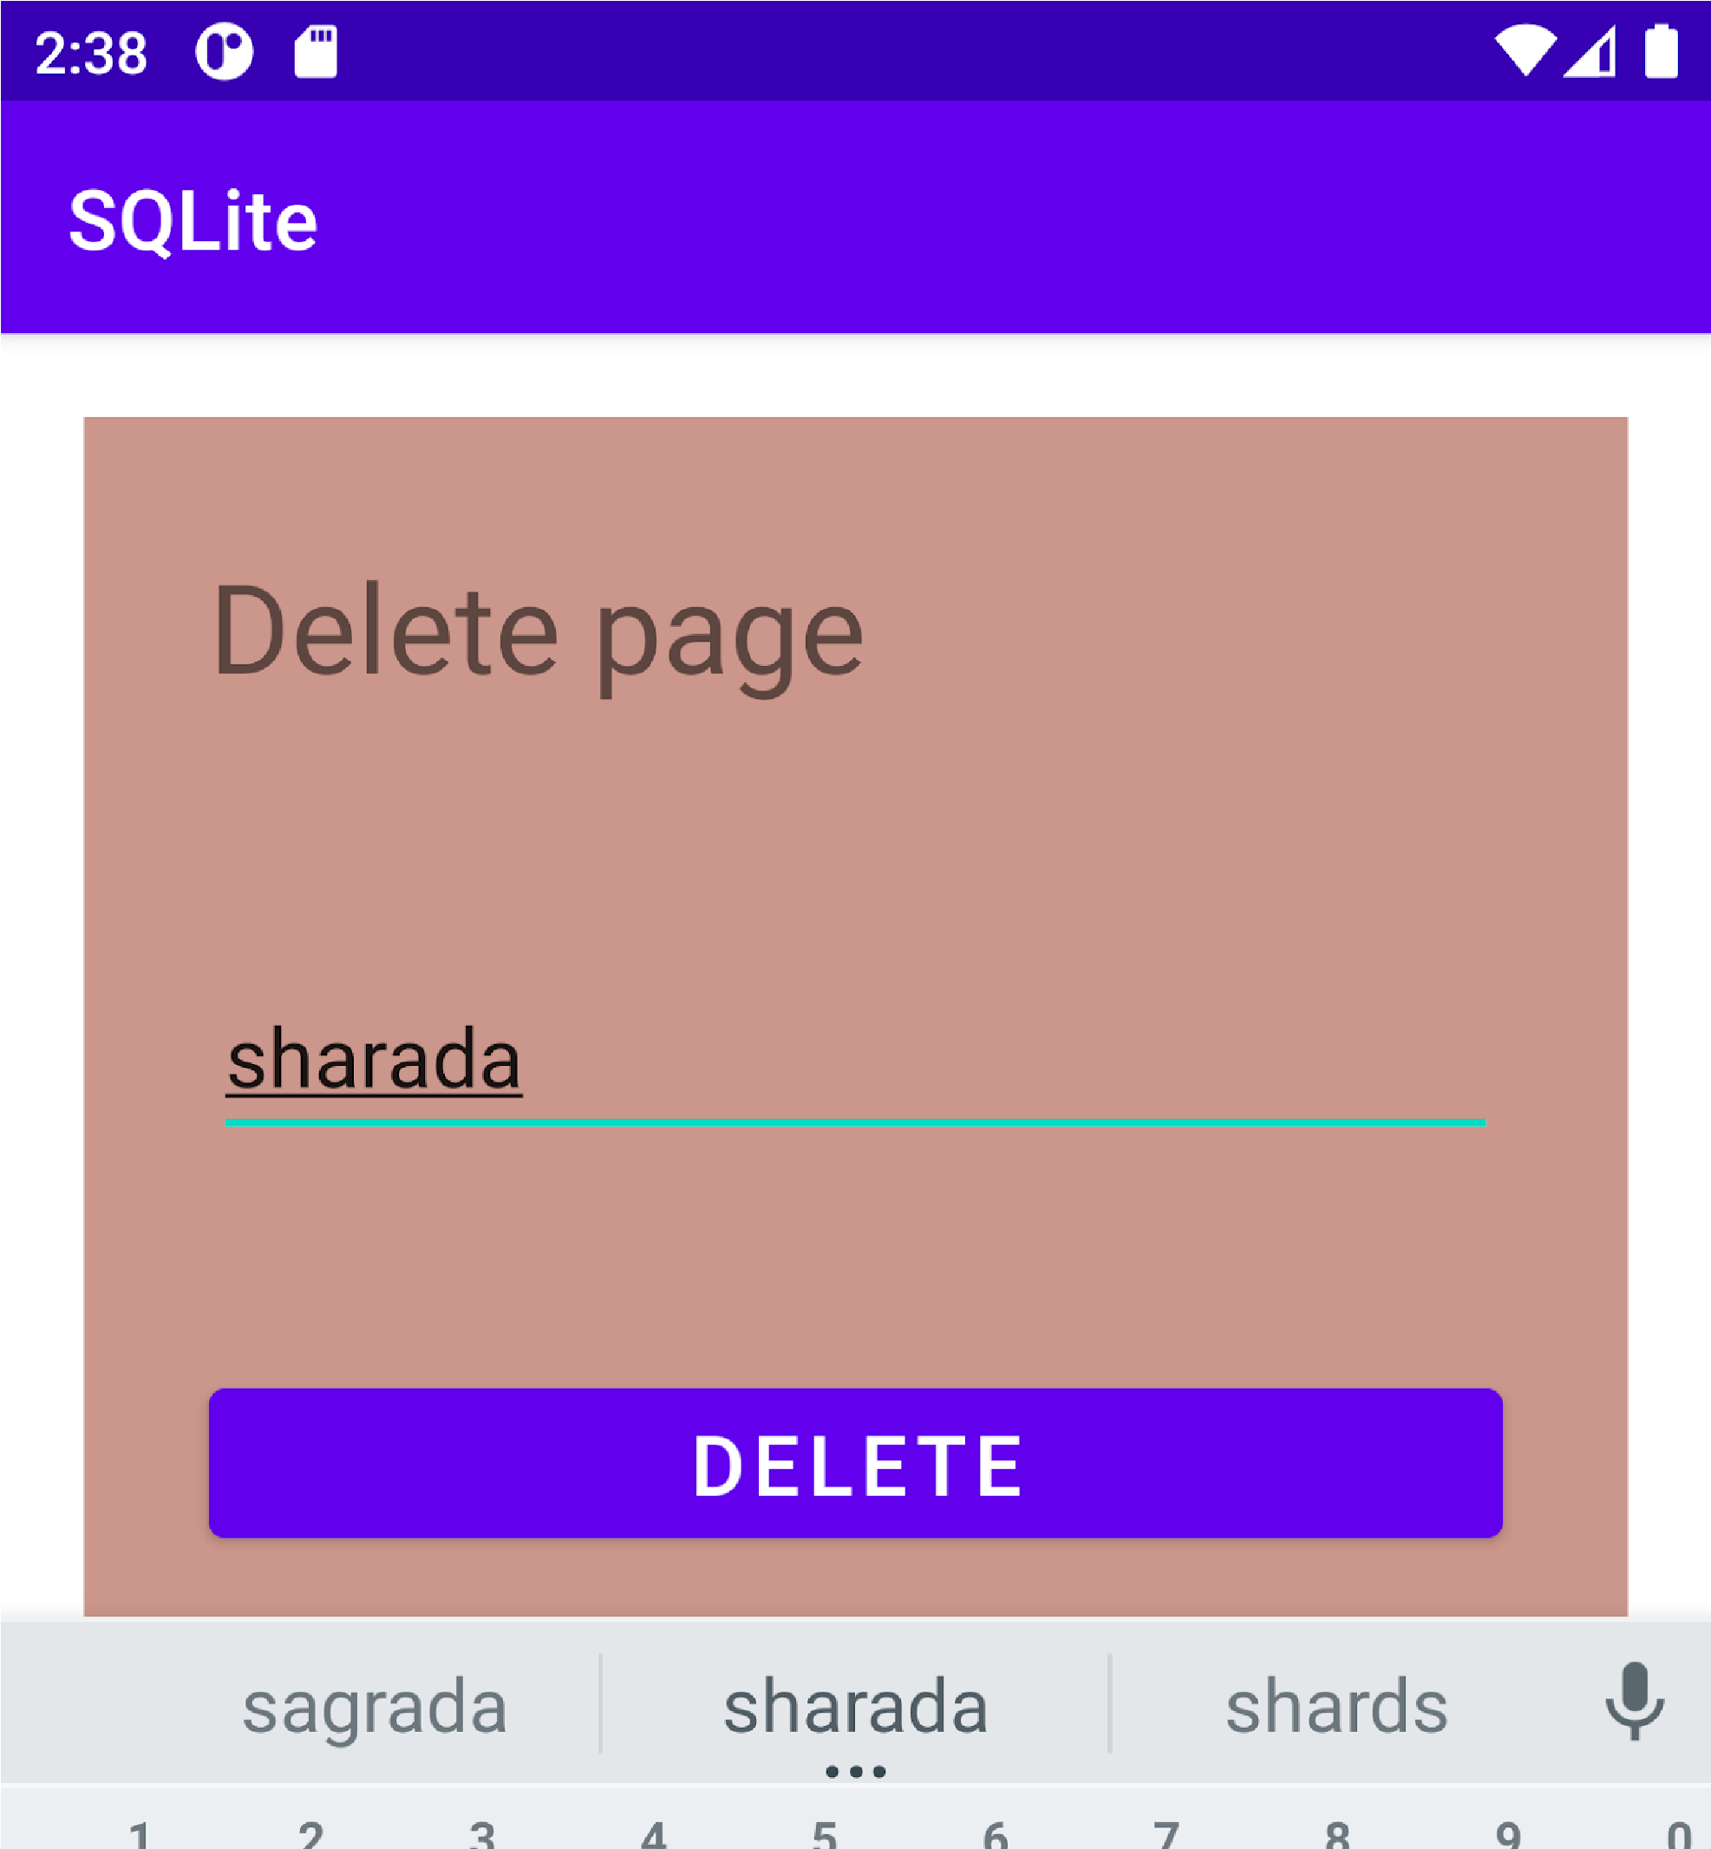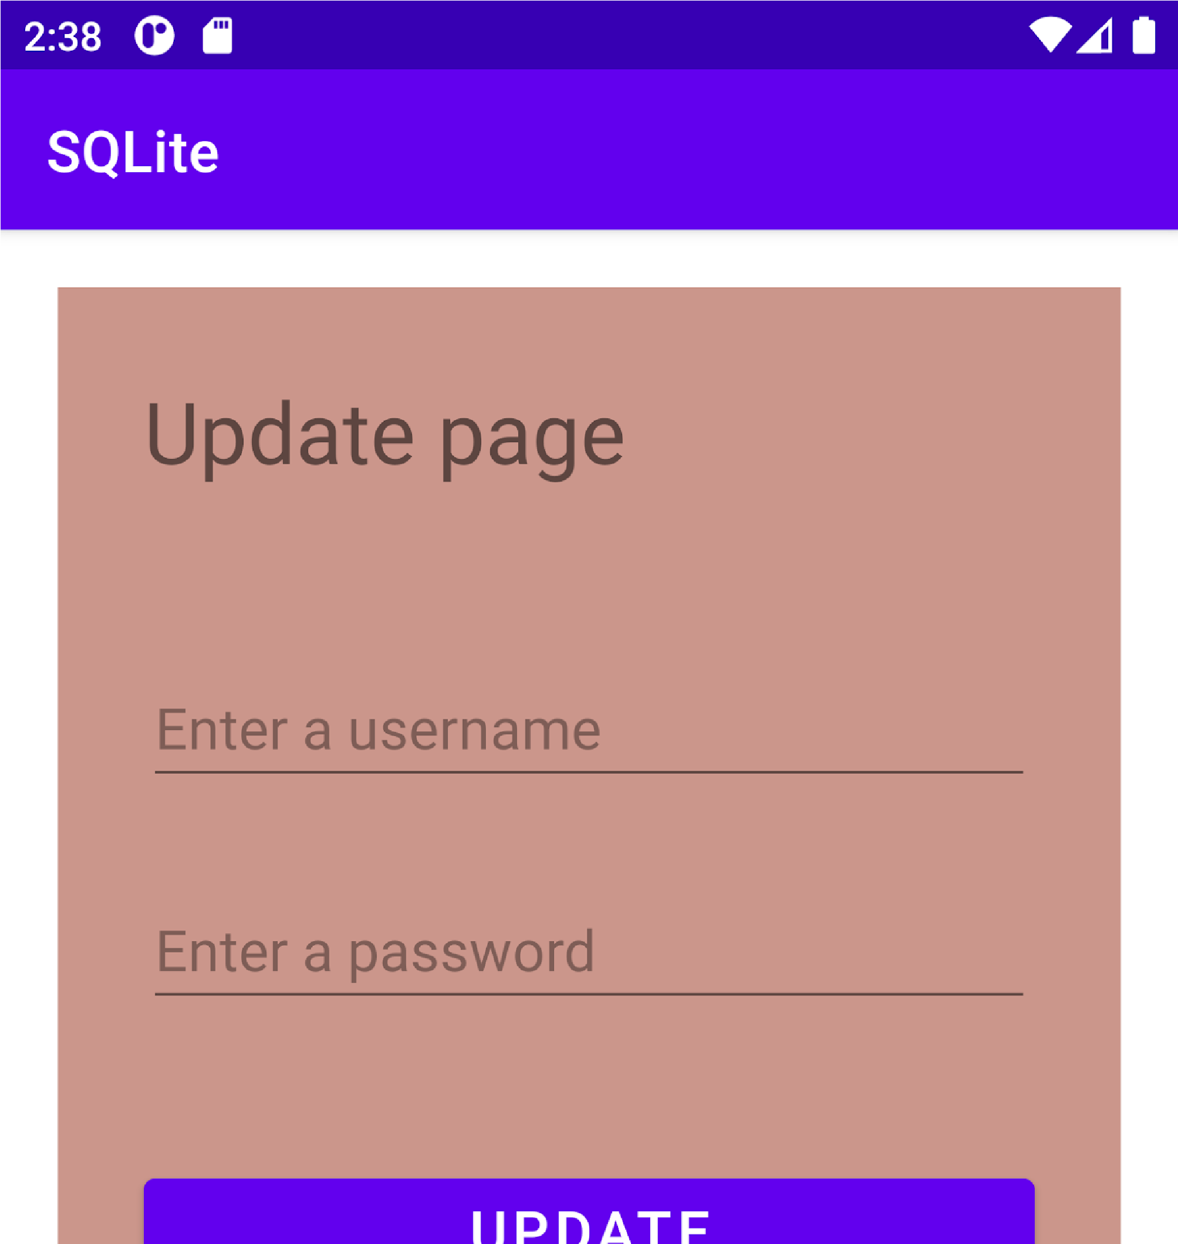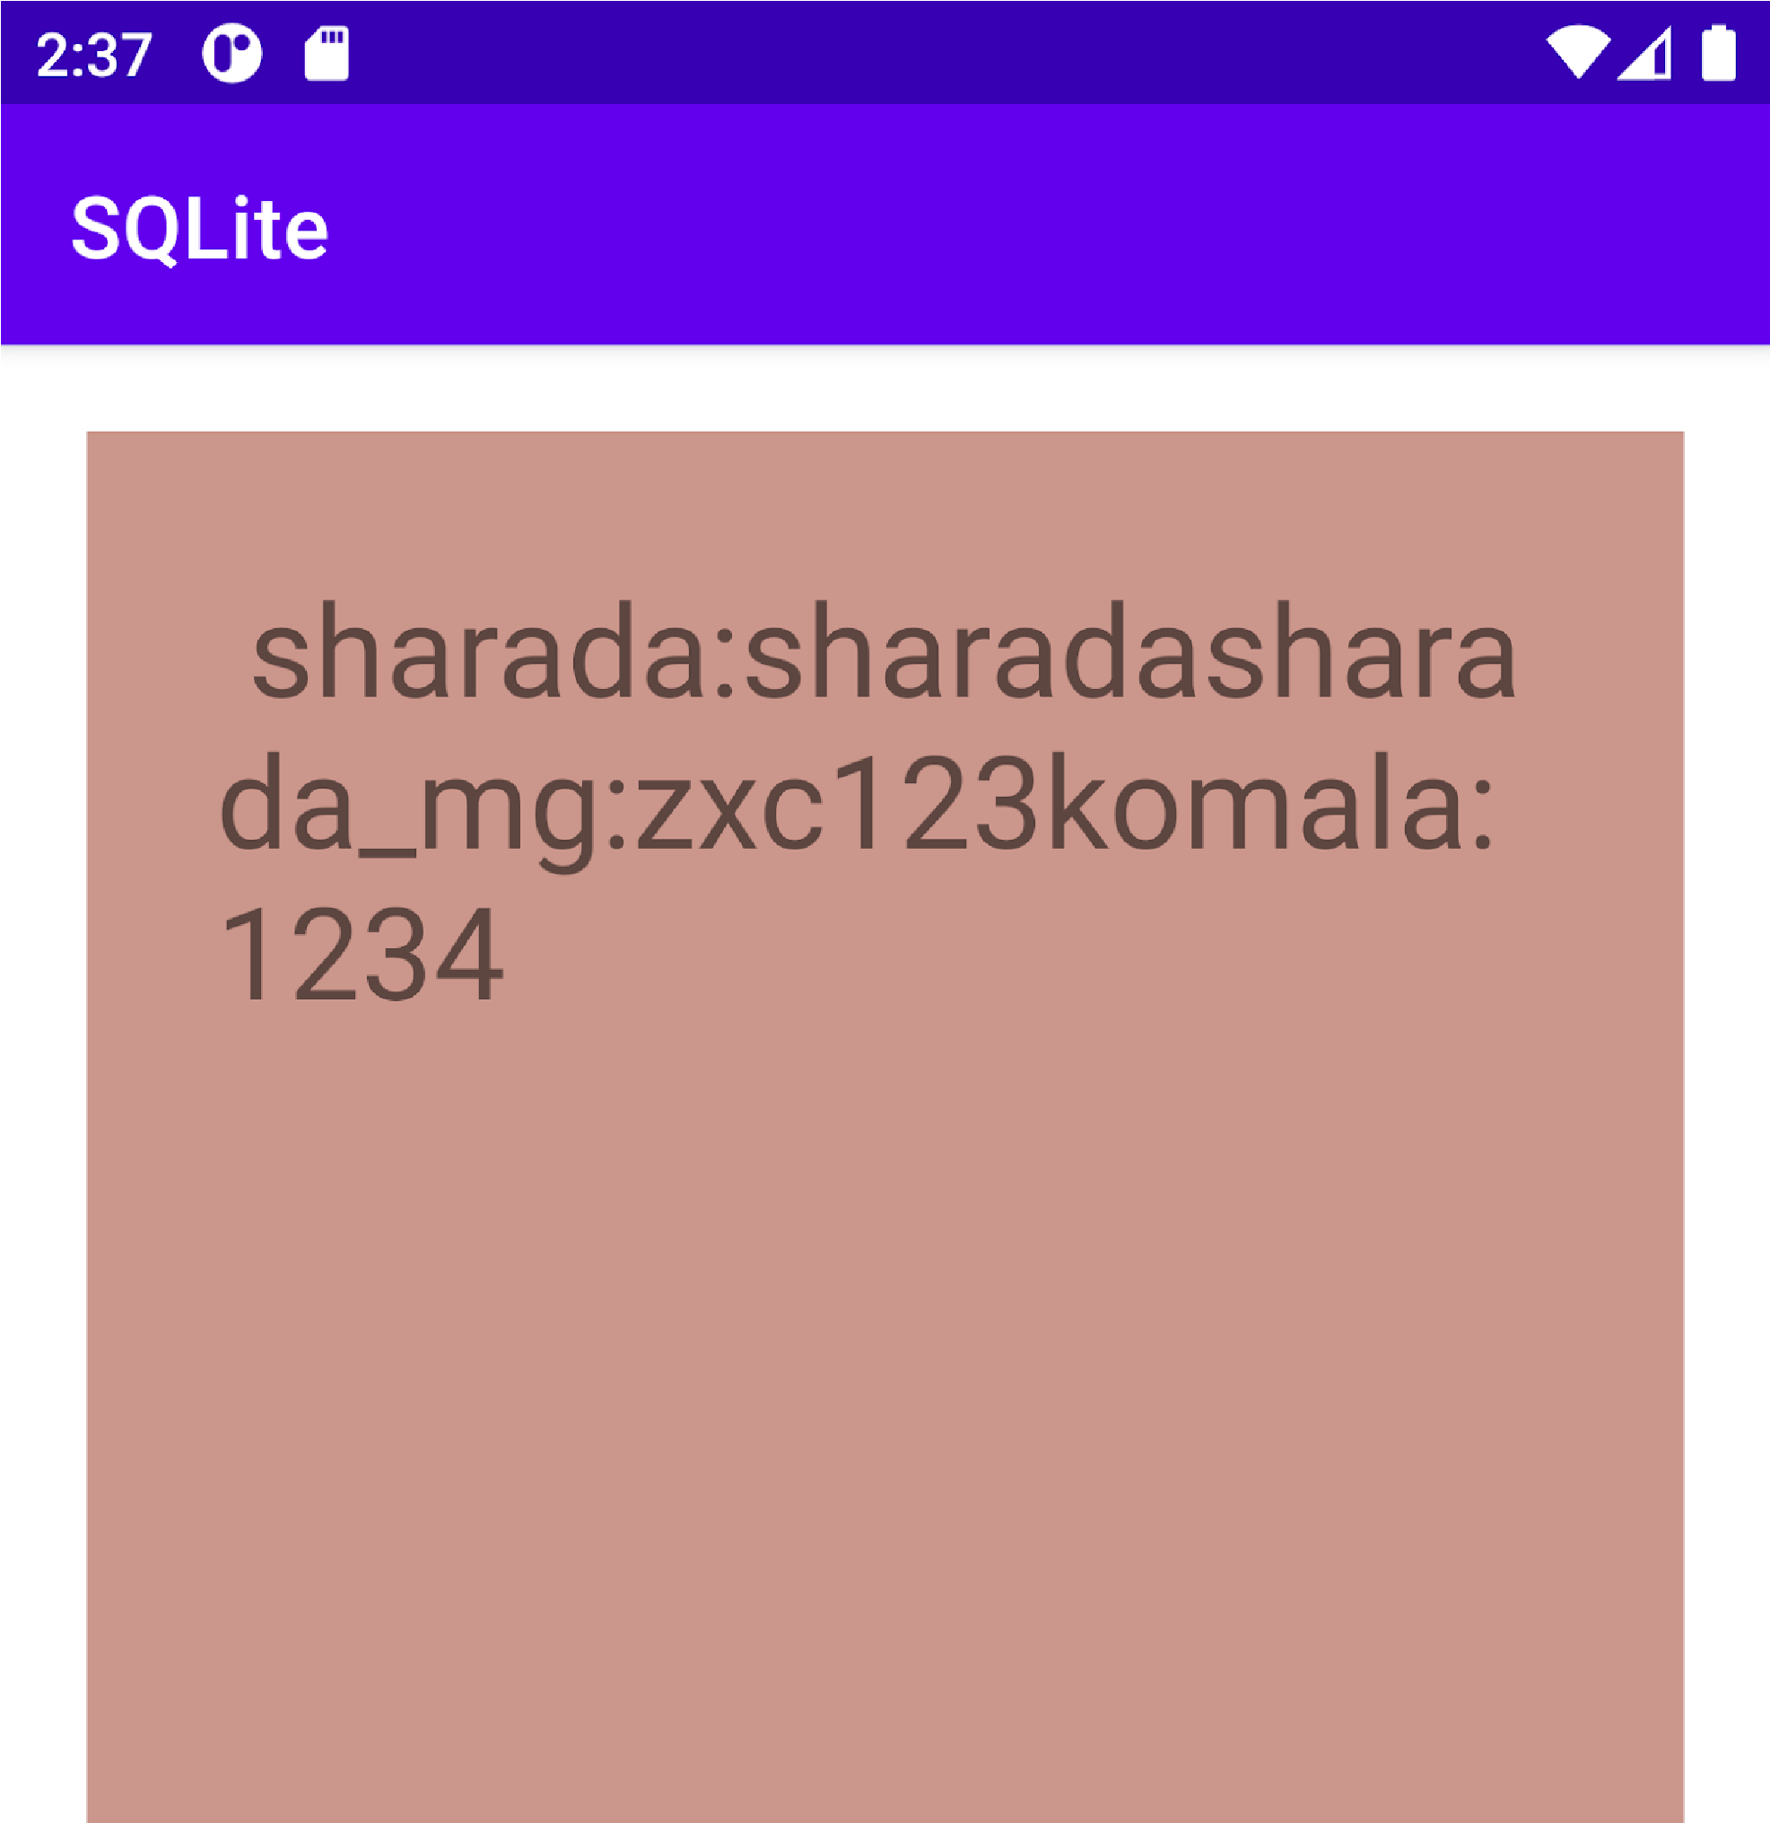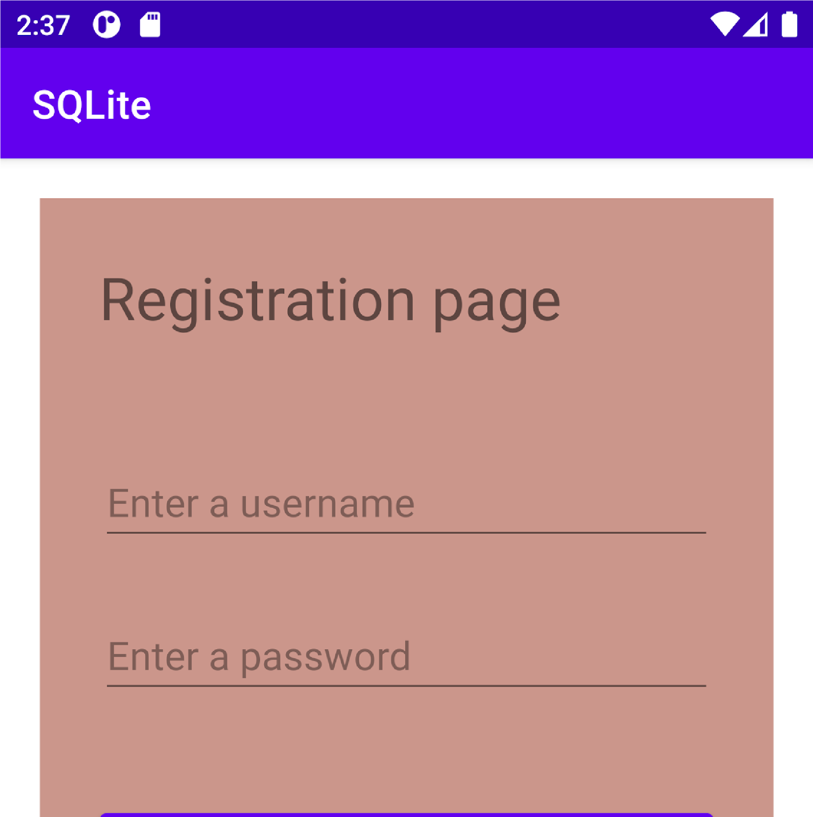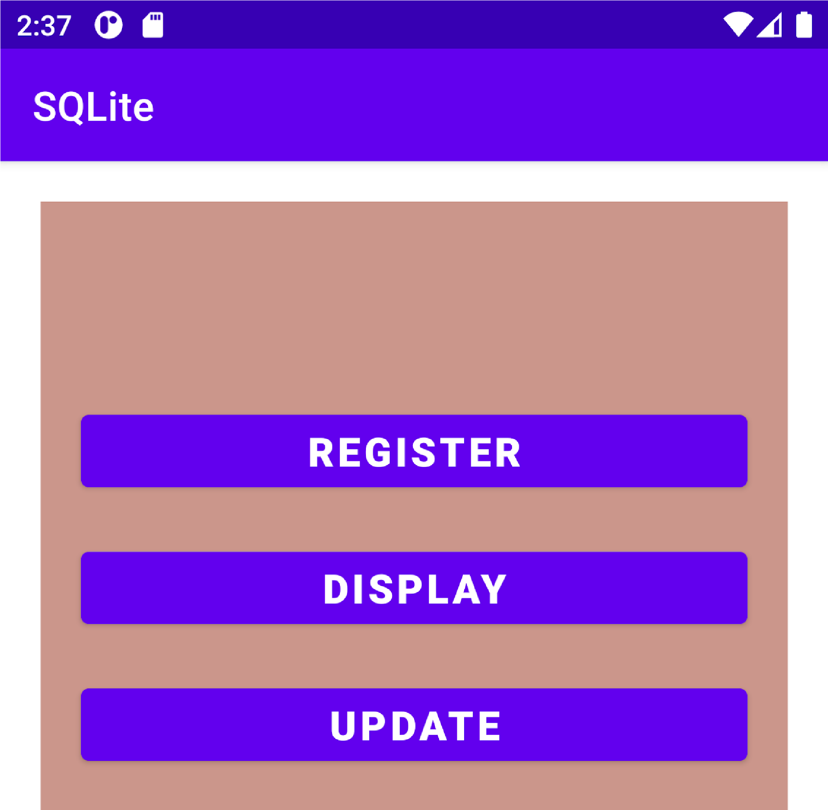

LinearLayout>