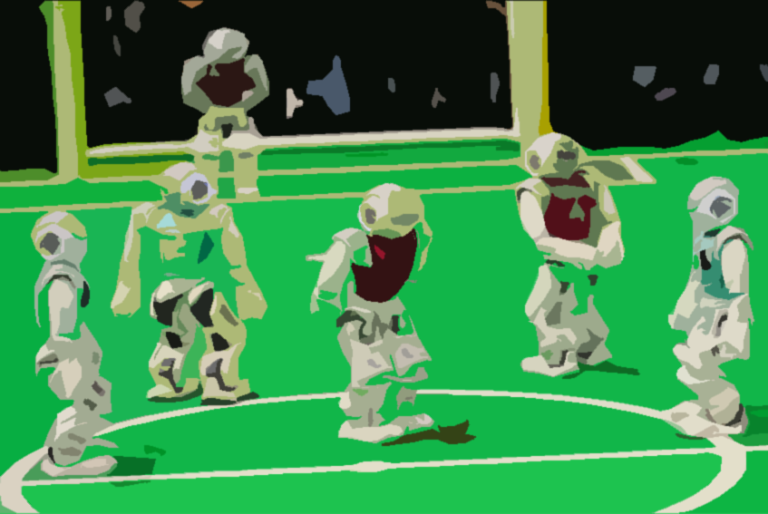ROBOCUP

GOAL-KEEPING AGENT

Group: 110100100b2

Karthigasen Govenden-Pillay: 216068363 (Group Rep)

Shimal Harichurn: 216004768

Lisa Dayaram: 216062690

We have developed a python turtle simulation of a goal-keeping agent. This agent (goalie) is programmed to observe the playing field for incoming shots. When a potential shot is perceived, the goalie changes its location and moves to a location (impact position) that can block the shot. Depending on the speed of ball, the goalie can either save or miss the shot. The speed of the goalie remains constant.

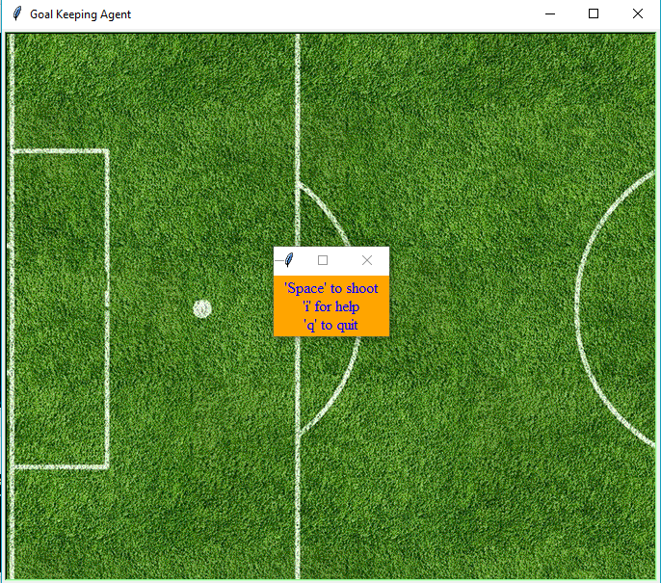

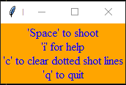

Space key – shoot

‘i’ – help key

‘c’ – clears the dotted lines(grey) that show the path of the ball

‘q’ – quit/close program

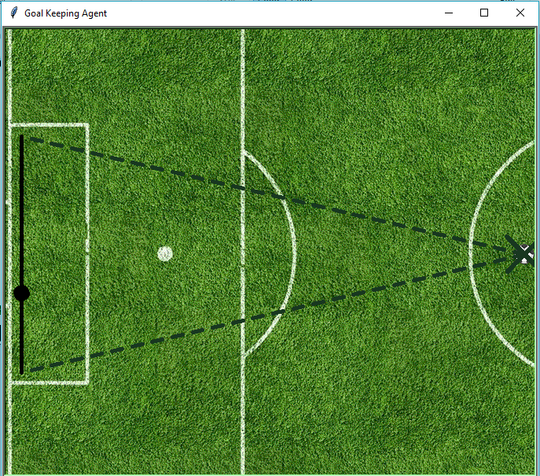

The dashed lines show the range of the goalie’s playing field. The ball can only be shot within the lines.

The goalie is randomly assigned a position on the solid goal line at the start of the program.

When the space key is pressed, the ball moves from X position towards the goal post at a random speed.

Speed, in this simulation, is defined as pixels moved per iteration of a loop(pixels/iteration).

A goal is scored when the centre of the ball touches any point on the line. If the ball and the goalie meet at the same point the goal is saved. A label is displayed (a new window) with a message (“GOAL!!!”/ “SAVE!!!”) and a score update. The label self-destructs after 5 seconds.

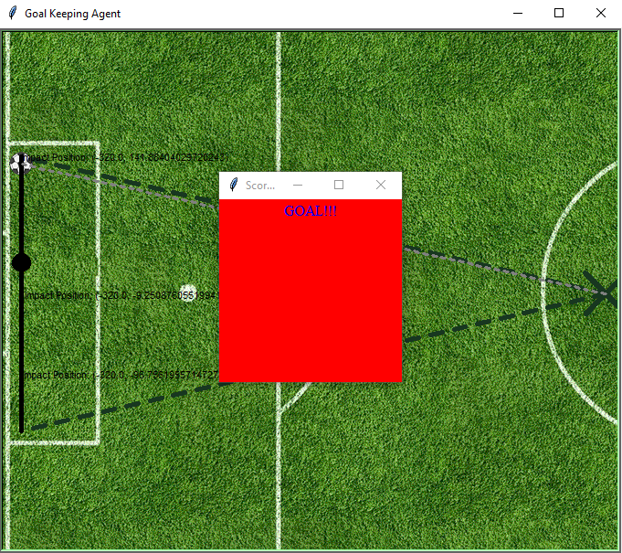

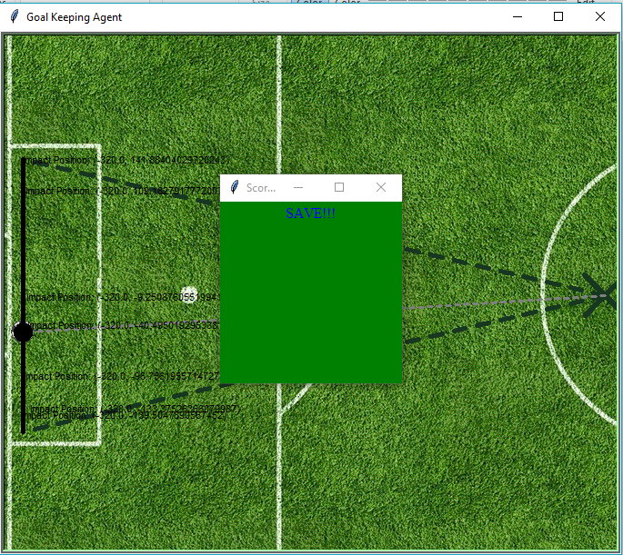 In the event that the user presses the space key again, the ball then returns to its original position at X and prepares for another shot.

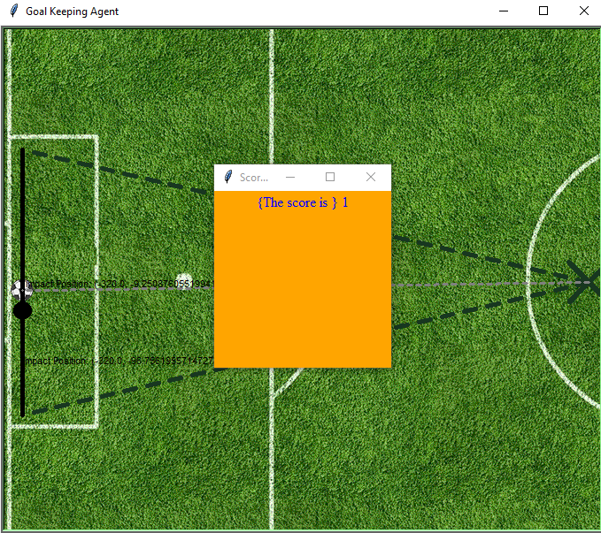

The ball’s impact position is calculated using basic trigonometry and a randomly generated angle (which falls within the playing field limits)

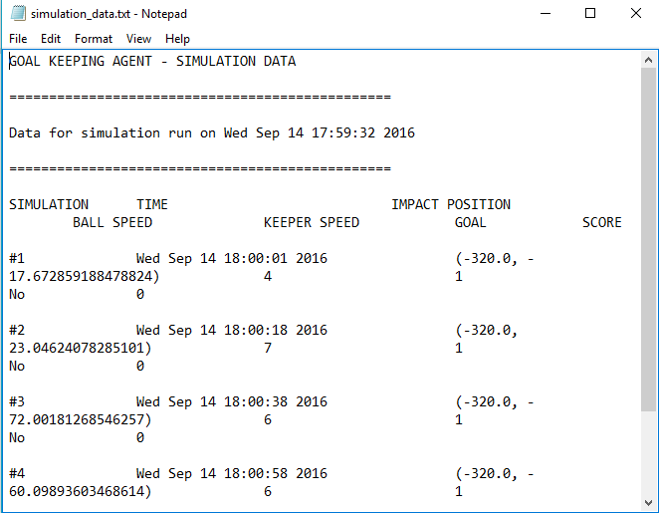

A text file called, “simulation_data.txt” , contains the number of times the simulation is run and the date & time. The imapct position, keeper’s(goalie) speed, the speed of the ball and the score is also written to the file.