3GPP TS 29.281 V8.0.0 (2008-12)
Technical Specification
3rd Generation Partnership Project;
Technical Specification Group Core Network and Terminals;
General Packet Radio System (GPRS) Tunnelling Protocol User Plane (GTPv1-U)
(Release 8)


The present document has been developed within the 3rd Generation Partnership Project (3GPP TM) and may be further elaborated for the purposes of 3GPP.
The present document has not been subject to any approval process by the 3GPP Organizational Partners and shall not be implemented.
This Specification is provided for future development work within 3GPP only. The Organizational Partners accept no liability for any use of this Specification.
Specifications and reports for implementation of the 3GPP TM system should be obtained via the 3GPP Organizational Partners' Publications Offices.

Keywords
EPS, GSM, UMTS, packet mode, GPRS
3GPP
Postal address

3GPP support office address
650 Route des Lucioles - Sophia Antipolis
Valbonne - FRANCE
Tel.: +33 4 92 94 42 00 Fax: +33 4 93 65 47 16
Internet
http://www.3gpp.org
Copyright Notification
No part may be reproduced except as authorized by written permission.
The copyright and the foregoing restriction extend to reproduction in all media.

© 2008, 3GPP Organizational Partners (ARIB, ATIS, CCSA, ETSI, TTA, TTC).
All rights reserved.
UMTS™ is a Trade Mark of ETSI registered for the benefit of its members
3GPP™ is a Trade Mark of ETSI registered for the benefit of its Members and of the 3GPP Organizational Partners
LTE™ is a Trade Mark of ETSI currently being registered for the benefit of its Members and of the 3GPP Organizational Partners
GSM® and the GSM logo are registered and owned by the GSM Association
Contents
Foreword 5
1 Scope 6
2 References 6
3 Definitions and abbreviations 7
3.1 Definitions 7
3.2 Abbreviations 7
4 General 7
4.1 GTP Path 7
4.2 GTP-U Tunnels 8
4.2.1 GTP-U Tunnel description 8
4.2.2 IP transport 8
4.2.3 GTP-U Tunnel IP transport 8
4.2.4 Ingress GTP tunnel (GTPv1-U sending endpoint) 9
4.2.5 Egress GTP tunnel (GTPv1-U receiving endpoint) 9
4.3 GTP-U Protocol Entity 9
4.3.1 Handling of Sequence Numbers 9
4.4 Protocol stack 10
4.4.1 UDP/IP 10
4.4.2 UDP header and port numbers 10
4.4.2.1 Echo Request Message 10
4.4.2.2 Echo Response Message 10
4.4.2.3 Encapsulated T-PDUs 10
4.4.2.4 Error Indication 10
4.4.2.5 Supported Extension Headers Notification 10
4.4.3 IP header and IP addresses 11
4.4.3.1 Echo Request Message 11
4.4.3.2 Echo Response Message 11
4.4.3.3 Encapsulated T-PDUs 11
4.4.3.4 Error Indication 11
4.4.3.5 Supported Extension Headers Notification 11
4.5 Transmission Order and Bit Definitions 11
4.6 New Functionality 11
5 GTP-U header 12
5.1 General format 12
5.2 GTP-U Extension Header 13
5.2.1 General format of the GTP-U Extension Header 13
5.2.2 Extension Header types 14
5.2.2.1 UDP Port 14
5.2.2.2 PDCP PDU Number 14
6 GTP-U Message Formats 15
6.1 General 15
6.2 Presence requirements of Information Elements 15
7 GTP-U Messages 16
7.1 General 16
7.2 Path Management Messages 16
7.2.1 Echo Request 16
7.2.2 Echo Response 16
7.2.3 Supported Extension Headers Notification 16
7.3 Tunnel Management Messages 17
7.3.1 Error Indication 17
7.3.2 End Marker 17
8 Information Elements 18
8.1 Information Element Types 18
8.2 Recovery 19
8.3 Tunnel Endpoint Identifier Data I 19
8.4 GTP-U Peer Address 19
8.5 Extension Header Type List 20
8.6 Private Extension 20
9 Error Handling 20
10 Security 20
11 Reliable Delivery of Signalling Messages 20
12 GTP Parameters 21
12.1 General 21
12.2 Timers 21
12.3 Others 21
13 Tunnelling Scenarios 21
13.1 General 21
13.2 Tunnelling between Serving GWs 21
13.3 Transfer of the user plane data between PDN GWs 21
13.4 Tunnelling between SGSNs 22
13.5 Tunnelling between Source RNC and Target RNC 22
13.6 Transfer of the user plane data between GGSNs 22
Annex A (informative): Change history 23

Foreword
This Technical Specification has been produced by the 3rd Generation Partnership Project (3GPP).
The contents of the present document are subject to continuing work within the TSG and may change following formal TSG approval. Should the TSG modify the contents of the present document, it will be re-released by the TSG with an identifying change of release date and an increase in version number as follows:
Version x.y.z
where:
x the first digit:
1 presented to TSG for information;
2 presented to TSG for approval;
3 or greater indicates TSG approved document under change control.
y the second digit is incremented for all changes of substance, i.e. technical enhancements, corrections, updates, etc.
z the third digit is incremented when editorial only changes have been incorporated in the document.

1 Scope
The present document defines the user plane of GTP used on:
- the Gn and Gp interfaces of the General Packet Radio Service (GPRS);
- the Iu, Gn and Gp interfaces of the UMTS system;
- the S1-U, X2, S4, S5, S8 and S12 interfaces of the Evolved Packet System (EPS);
This definition ensures full backwards compatibility with RNC, SGSN and GGSN implementations according to release 7 of 3GPP TS 29.060 [6].
NOTE: Releases previous to Release-8 have used 3GPP TS 29.060 [6] as normative definition of the user plane of GTP. This shall be considered when essential corrections are included in the present document or in pre-release-8 version of 3GPP TS 29.060 [6].
Fallback from GTPv1-U to GTPv0-U shall not be supported. Therefore, 3GPP Rel-8 and onwards GTPv1-U entity should not listen to the well-known GTPv0 port 3386. If GTPv1 entity listens to the GTPv0 port, the entity shall silently discard any received GTPv0-U message.

2 References
The following documents contain provisions which, through reference in this text, constitute provisions of the present document.
- References are either specific (identified by date of publication, edition number, version number, etc.) or non-specific.
- For a specific reference, subsequent revisions do not apply.
- For a non-specific reference, the latest version applies. In the case of a reference to a 3GPP document (including a GSM document), a non-specific reference implicitly refers to the latest version of that document in the same Release as the present document.
[1] 3GPP TR 21.905: "Vocabulary for 3GPP Specifications".
[2] 3GPP TS 23.003: "Numbering, addressing and identification".
[3] 3GPP TS 23.007: "Restoration procedures".
[4] 3GPP TS 23.060: "General Packet Radio Service (GPRS); Service description; Stage 2".
[5] 3GPP TS 23.401: "General Packet Radio Service (GPRS) enhancements for Evolved Universal Terrestrial Radio Access Network (E-UTRAN) access".
[6] 3GPP TS 29.060: "General Packet Radio Service (GPRS); GPRS Tunnelling Protocol (GTP) across the Gn and Gp interface".
[7] 3GPP TS 29.274: "3GPP Evolved Packet System; Evolved GPRS Tunnelling Protocol for EPS (GTPv2)".
[8] 3GPP TS 32.295: "Telecommunication management; Charging management; Charging Data Record (CDR) transfer".
[9] IETF RFC 768 (STD 0006): "User Datagram Protocol", J. Postel.
[10] IETF RFC 791 (STD 0005): "Internet Protocol", J. Postel.
[11] IETF RFC 2373: "IP Version 6 Addressing Architecture".
[12] 3GPP TS 33.210: "3G security; Network Domain Security (NDS); IP network layer security".
[13] 3GPP TS 23.121: "Architectural requirements for Release 1999".
[14] 3GPP TS 43.129: "Packet-switched handover for GERAN A/Gb mode; Stage 2".
[15] IETF RFC 2460: "Internet Protocol, Version 6 (IPv6) Specification", Standards Track
[16] 3GPP TS 25.413: "UTRAN Iu interface RANAP signalling".
[17] 3GPP TS 36.300: "Evolved Universal Terrestrial Radio Access (E-UTRA) and Evolved Universal Terrestrial Radio Access Network (E-UTRAN); Overall description; Stage 2".

3 Definitions and abbreviations

3.1 Definitions
For the purposes of the present document, the terms and definitions given in TR 21.905 [1] and the following apply. A term defined in the present document takes precedence over the definition of the same term, if any, in TR 21.905 [1].
GTP-U peer: node implementing at least one side of any of the GTP user plane based protocols. RNC, SGSN, GGSN, eNodeB, SGW or PGW.

3.2 Abbreviations
For the purposes of the present document, the abbreviations given in TR 21.905 [1] and the following apply. An abbreviation defined in the present document takes precedence over the definition of the same abbreviation, if any, in TR 21.905 [1].

GTP GPRS Tunnelling Protocol
GTP-C GTP Control
GTP-U GTP User
IE Information Element
IGMP Internet Group Management Protocol
IP Internet Protocol
IPv4 Internet Protocol version 4
IPv6 Internet Protocol version 6
QoS Quality of Service
RANAP Radio Access Network Application Part
RNC Radio Network Controller
TEID Tunnel Endpoint IDentifier
UDP User Datagram Protocol
UTRAN UMTS Terrestrial Radio Access Network

4 General

4.1 GTP Path
For the definition of GTP Path, see 3GPP TS 29.060 [6].
Editor's Note: The definition of GTP Path defined in TS 29.060 needs to be moved to this clause.

4.2 GTP-U Tunnels

4.2.1 GTP-U Tunnel description
GTP-U Tunnels are used to carry encapsulated T-PDUs and signalling messages between a given pair of GTP-U Tunnel Endpoints. The Tunnel Endpoint ID (TEID) which is present in the GTP header shall indicate which tunnel a particular T-PDU belongs to. In this manner, packets are multiplexed and de-multiplexed by GTP-U between a given pair of Tunnel Endpoints. The TEID value to be used in the TEID field shall be negotiated using a control plane protocol like GTPv1-C, GTPv2-C, RANAP or S1-AP.
In what follows we refer to the outer GTPv1-U IP packet as the IP packet that carries a GTPv1-U packet. The inner IP packet in a GTPv1-U packet (T-PDU) is either
- An IP packet sent to the UE/MS in the downlink direction over one or more tunnels from the external network identified by the APN.
- An IP packet sent from a UE/MS in the uplink direction over one or more tunnels to the external network identified by the APN.
NOTE 1: Not all tunnels in 3GPP networks will necessarily be GTPv1-U,
NOTE 2: The inner MTU size of the GTPv1-U tunnel is typically not the same as the outer MTU size of the IP path carrying the outer IP packets.
The maximum size of a T-PDU that may be transmitted without fragmentation by GGSN or the MS is defined in 3GPP TS 23.060 [4].

4.2.2 IP transport
According to IETF RFC 791 [10], any IPv4 router in the backbone may fragment the outer IPv4 GTPv1-U packet with a flag of DF=0.
Unnecessary fragmentation should be avoided when possible due to the following;
- Fragmentation is bandwidth inefficient, since the complete IP header is duplicated in each fragment.
- Fragmentation is CPU intensive since more fragments require more processing at both GTPv1-U endpoints and IP routers. It also requires additional memory at the receiver.
- If one fragment is lost, the complete packet has to be discarded. The reason is there is no selective retransmission of IP fragments provided in IPv4 or IPv6.
To avoid unnecessary fragmenting the outer IP packets backbone links between GTP peers should, when possible, have outer MTU values that exceed the sum of the maximum value of the inner MTU size plus the size of the tunnel headers (outer IP header, outer UDP header, and GTP header, including any possible GTP extension headers) in order to avoid unnecessary IP fragmentation in the backbone.
To avoid unnecessary fragmenting the inner IP packets the UE/MS, or a server in an external network, may find out the inner MTU by path MTU discovery and hence fragment correctly at the source.

4.2.3 GTP-U Tunnel IP transport
Functionality for IP transport and IP fragmentation at a RAN node on the Iu interface or S12 is defined in 3GPP TS 25.414 [16].
Functionality for IP transport and IP fragmentation at an eNodeB on the S1-U and X2 interface is defined in 3GPP TS 36.300 [17].
Editor's Note: It assumed above that S12 will use the Iu specification on the RAN side otherwise a different 3GPP RAN reference should be used.
The following text as well as sub-clauses 4.2.4 and 4.2.5 apply only to core network GTPv1-U endpoints.
The IPv4 (IETF RFC 791 [10]) protocol shall be supported at the outer GTPv1-U packet layer, IPv6 (IETF RFC 2460 [15]) support is optional at the outer GTPv1-U packet layer.
GTPv1-U tunnel endpoints do not need to change the hopcount/TTL or to perform any IP routing functions in respect to inner IP packet other than the functions explicitly stated here. However, other co-located functions may do so. For example, the GGSN/PGW may change the hopcount/TTL as the IP datagram enters/leaves the Gi/SGi interface from/to the GTPv1-U tunnel interface and IP packets may be discarded or rejected at any point by a co-located function due to local policy and/or QoS (the policy enforcement point).

4.2.4 Ingress GTP tunnel (GTPv1-U sending endpoint)
An inner IP packet shall be encapsulated at the GTPv1-U sender with a GTP header, UDP and IP header. If the resulting outer IP packet is larger than the MTU of the first link towards the destination GTPv1-U endpoint, fragmentation of the IP packet shall be performed by the sender as per IETF RFC 791 [10] for an outer layer of IPv4 and IETF RFC 2460 [15] for an outer layer of IPv6. The GTPv1-U sender should preferably fragment the IP packet to the smallest MTU of any link between GTPv1-U sender and GTPv1-U receiver.
Fragmentation policy of the inner datagram is implementation dependent but shall interwork with IETF RFC 791 [10] for inner IPv4 datagrams and IETF RFC 2460 [15] for inner IPv6 packets.

4.2.5 Egress GTP tunnel (GTPv1-U receiving endpoint)
The GTPv1-U receiving endpoint packets shall reassemble any IP fragments in datagrams received from the GTPv1-U sending endpoint as per IETF RFC 791 [10] for outer IPv4 datagrams and as per IETF RFC 2460 [15] for outer IPv6 datagrams. The IP reassembly buffer in the receiving endpoint shall be at least the inner MTU size plus the size of the tunnel headers (outer IP header, outer UDP header, and GTP header, including any GTP extension headers).
The completely reassembled IP packet shall then be passed to the IP/UDP/GTPv1-U layers to extract the inner IP packet which is then processed further according to the receiving node's functionality.

4.3 GTP-U Protocol Entity
The GTP-U protocol entity provides packet transmission and reception services to user plane entities in the RNC, SGSN, GGSN, eNodeB, SGW and PDN-GW. The GTP-U protocol entity receives traffic from a number of GTP-U tunnel endpoints and transmits traffic to a number of GTP-U tunnel endpoints. There is a GTP-U protocol entity per IP address.
The TEID in the GTP-U header is used to de-multiplex traffic incoming from remote tunnel endpoints so that it is delivered to the User plane entities in a way that allows multiplexing of different users, different packet protocols and different QoS levels. Therefore no two remote GTP-U endpoints shall send traffic to a GTP-U protocol entity using the same TEID value except for data forwarding as part of mobility procedures.

4.3.1 Handling of Sequence Numbers
This functionality is provided only when the S bit is set to 1 in the GTP-U header.
For PGW, SGW and eNodeB the usage of sequence numbers in G-PDUs is optional, but if GTP-U protocol entities in these nodes are relaying G-PDUs to other nodes, they shall relay the sequence numbers as well.
An RNC, SGSN or GGSN shall reorder out of sequence T-PDUs when in sequence delivery is required. This is optional at the SGSN for UTRAN access. The GTP-U protocol entity shall deliver to the user plane entity only in sequence T-PDUs and notify the sequence number associated to each of them. The notification of the sequence number is not necessary at the GGSN, but it is mandatory at the SGSN and RNC. The user plane entity shall provide a sequence number to the GTP-U layer together with T-PDUs to be transmitted in sequence. GTP-U protocol entities at the GGSN may optionally generate autonomously the sequence number, but should be able to use sequence numbers provided by the user plane entity. The sequence number is handled on a per GTP-U Tunnel (that is TEID) basis.
When the sequence number is included in the GTP-U header, a user plane entity acting as a relay of T-PDUs between GTP-U protocol entities, or between PDCP (or SNDCP) protocol entities and GTP-U protocol entities, shall relay the sequence numbers between those entities as well. In this way it is possible to keep consistent values of sequence numbers from the GGSN to the UE (MS in GPRS) by relaying the sequence number across the CN GTP-U bearer, the Iu GTP-U bearer and the Radio bearer (via PDCP or SNDCP N-PDU numbers). This functionality is beneficial during SRNS relocation.
For GTP-U signalling messages having a response message defined for a request message, Sequence Number shall be a message number valid for a path. Within a given set of continuous Sequence Numbers from 0 to 65535, a given Sequence Number shall, if used, unambiguously define a GTP-U signalling request message sent on the path (see section Reliable delivery of signalling messages). The Sequence Number in a signalling response message shall be copied from the signalling request message that the GSN or RNC is replying to. For GTP-U messages not having a defined response message for a request message, i.e. for messages Supported Extension Headers Notification and Error Indication, the Sequence Number shall be ignored by the receiver.

4.4 Protocol stack

4.4.1 UDP/IP
UDP/IP is the only path protocol defined to transfer GTP messages in the version 1 of GTP.
A User Datagram Protocol (UDP) compliant with IETF RFC 768 [9] shall be used.
An Internet Protocol (IP) compliant with IETF RFC 791 [10] shall be used.

4.4.2 UDP header and port numbers

4.4.2.1 Echo Request Message
The UDP Destination Port number for GTP-U request messages is 2152. It is the registered port number for GTP-U.
The UDP Source Port is a locally allocated port number at the sending GTP-U entity.

4.4.2.2 Echo Response Message
The UDP Destination Port value shall be the value of the UDP Source Port of the corresponding request message.
The UDP Source Port shall be the value from the UDP Destination Port of the corresponding request message.

4.4.2.3 Encapsulated T-PDUs
The UDP Destination Port number shall be 2152. It is the registered port number for GTP-U.
The UDP Source Port is a locally allocated port number at the sending GTP-U entity.

4.4.2.4 Error Indication
The UDP destination port for the Error Indication shall be the user plane UDP port (2152).
The UDP source port shall be locally assigned at the sending node.
NOTE: In network deployments including non-GTP-aware stateful firewalls, those firewalls must be configured to allow response messages coming from a different UDP port and IP address than the triggering message.

4.4.2.5 Supported Extension Headers Notification
The UDP destination port for the Supported Extension Headers Notification shall be the user plane UDP port (2152).
The UDP source port shall be locally assigned at the sending node.

4.4.3 IP header and IP addresses

4.4.3.1 Echo Request Message
The IP Source Address shall be an IP address of the source GTP-U entity from which the message is originating.
The IP Destination Address in a GTP request message shall be an IP address of the destination GTP-U entity.

4.4.3.2 Echo Response Message
The IP Source Address shall be copied from the IP destination address of the GTP request message to which this GTP-U entity is replying.
The IP Destination Address shall be copied from the IP Source Address of the GTP request message to which this GTP-U entity is replying.

4.4.3.3 Encapsulated T-PDUs
The IP Source Address shall be an IP address of the source GTP-U entity from which the message is originating.
The IP Destination Address shall be an IP address of the destination GTP-U entity.

4.4.3.4 Error Indication
The IP source address shall be an address of the source GTP-U entity from which the message is originated
NOTE: In network deployments including non-GTP-aware stateful firewalls, those firewalls must be configured to allow response messages coming from a different UDP port and IP address than the triggering message.
The IP destination address for Error Indication shall be the source address of the GTP-PDU that is the cause for this GTP-U entity to send this message.

4.4.3.5 Supported Extension Headers Notification
The IP Source Address for the Supported Extension Headers Notification shall be copied from the IP destination address of the GTP message that triggered the GTP-U entity to send this message.
The IP Destination Address for the Supported Extension Headers Notification shall be copied from the IP source address of the GTP message that triggered the GTP-U entity to send this message.

4.5 Transmission Order and Bit Definitions
As specified in 3GPP TS 29.060 [6], clause 5.

4.6 New Functionality
With regard to the previous releases, the present specification may define some new functions. Such new functions shall ensure full backwards compatibility with Pre-Rel-8 nodes conforming to 3GPP TS 29.060 [6]. If the new functions are specified with the Extension Headers, bits 8 and 7 of the Extension Header Type shall be set to 0, 0 respectively or 0, 1 respectively. If the new functions are specified with Information Elements, such Information Elements shall be TLV-encoded and optional.

5 GTP-U header

5.1 General format
The GTP-U header is a variable length header whose minimum length is 8 bytes. There are three flags that are used to signal the presence of additional optional fields: the PN flag, the S flag and the E flag. The PN flag is used to signal the presence of N-PDU Numbers. The S flag is used to signal the presence of the GTP Sequence Number field. The E flag is used to signal the presence of the Extension Header field, used to enable future extensions of the GTP header defined in this document, without the need to use another version number. If and only if one or more of these three flags are set, the fields Sequence Number, N-PDU and Extension Header shall be present. The sender shall set all the bits of the unused fields to zero. The receiver shall not evaluate the unused fields.
Always present fields:
- Version field: This field is used to determine the version of the GTP-U protocol. The version number shall be set to '1'.
- Protocol Type (PT): This bit is used as a protocol discriminator between GTP (when PT is '1') and GTP' (when PT is '0'). GTP is described in this document and the GTP' protocol in 3GPP TS 32.295 [8]. Note that the interpretation of the header fields may be different in GTP' than in GTP.
- Extension Header flag (E): This flag indicates the presence of a meaningful value of the Next Extension Header field. When it is set to '0', the Next Extension Header field either is not present or, if present, shall not be interpreted. When it is set to '1', the Next Extension Header field is present, and shall be interpreted, as described below in this section.
- Sequence number flag (S): This flag indicates the presence of a meaningful value of the Sequence Number field. When it is set to '0', the Sequence Number field either is not present or, if present, shall not be interpreted. When it is set to '1', the Sequence Number field is present, and shall be interpreted, as described below in this section.
For the GTP-U messages Echo Request, Echo Response, Error Indication and Supported Extension Headers Notification, the S flag shall be set to '1'.
- N-PDU Number flag (PN): This flag indicates the presence of a meaningful value of the N-PDU Number field. When it is set to '0', the N-PDU Number field either is not present, or, if present, shall not be interpreted. When it is set to '1', the N-PDU Number field is present, and shall be interpreted, as described below in this section.
- Message Type: This field indicates the type of GTP-U message.
- Length: This field indicates the length in octets of the payload, i.e. the rest of the packet following the mandatory part of the GTP header (that is the first 8 octets). The Sequence Number, the N-PDU Number or any Extension headers shall be considered to be part of the payload, i.e. included in the length count.
- Tunnel Endpoint Identifier (TEID): This field unambiguously identifies a tunnel endpoint in the receiving GTP-U protocol entity. The receiving end side of a GTP tunnel locally assigns the TEID value the transmitting side has to use. The TEID shall be used by the receiving entity to find the PDP context, except for the following cases:
- The Echo Request/Response and Supported Extension Headers notification messages, where the Tunnel Endpoint Identifier shall be set to all zeroes.
- The Error Indication message where the Tunnel Endpoint Identifier shall be set to all zeros.
Optional fields:
- Sequence Number: This field is an optional field in G-PDUs. An increasing sequence number for T-PDUs is transmitted via GTP-U tunnels, when transmission order must be preserved. For GTP-U message, Supported Extension Headers Notification and Error Indication the Sequence Number shall be ignored by the receiver
- N-PDU Number: This field is used at the Inter SGSN Routeing Area Update procedure and some inter-system handover procedures (e.g. between 2G and 3G radio access networks). This field is used to co-ordinate the data transmission for acknowledged mode of communication between the MS and the SGSN. The exact meaning of this field depends upon the scenario. (For example, for GSM/GPRS to GSM/GPRS, the SNDCP N-PDU number is present in this field).
- Next Extension Header Type: This field defines the type of Extension Header that follows this field in the GTP-PDU.
 |  | Bits
Octets |  | 8 | 7 | 6 | 5 | 4 | 3 | 2 |  | 1
1 |  | Version |  |  | PT | (*) | E |  | S |  | PN
2 |  | Message Type
3 |  | Length (1st Octet)
4 |  | Length (2nd Octet)
5 |  | Tunnel Endpoint Identifier (1st Octet)
6 |  | Tunnel Endpoint Identifier (2nd Octet)
7 |  | Tunnel Endpoint Identifier (3rd Octet)
8 |  | Tunnel Endpoint Identifier (4th Octet)
9 |  | Sequence Number (1st Octet)¹⁾ ⁴⁾
10 |  | Sequence Number (2nd Octet)¹⁾ ⁴⁾
11 |  | N-PDU Number²⁾ ⁴⁾
12 |  | Next Extension Header Type³⁾ ⁴⁾

NOTE 0: (*) This bit is a spare bit. It shall be sent as '0'. The receiver shall not evaluate this bit.
NOTE 1: 1) This field shall only be evaluated when indicated by the S flag set to 1.
NOTE 2: 2) This field shall only be evaluated when indicated by the PN flag set to 1.
NOTE 3: 3) This field shall only be evaluated when indicated by the E flag set to 1.
NOTE 4: 4) This field shall be present if and only if any one or more of the S, PN and E flags are set.

Figure 5.1-1: Outline of the GTP-U Header

5.2 GTP-U Extension Header

5.2.1 General format of the GTP-U Extension Header
The format of GTP-U Extension Headers is depicted in figure 5.2.1-1. The Extension Header Length field specifies the length of the particular Extension header in 4 octets units. The Next Extension Header Type field specifies the type of any Extension Header that may follow a particular Extension Header. If no such Header follows, then the value of the Next Extension Header Type shall be 0.
Octets 1 |  | Extension Header Length
2 - m |  | Extension Header Content
m+1 |  | Next Extension Header Type

Figure 5.2.1-1: Outline of the Extension Header Format
The length of the Extension header shall be defined in a variable length of 4 octets, i.e. m+1 = n*4 octets, where n is a positive integer.
Bits 7 and 8 of the Next Extension Header Type define how the recipient shall handle unknown Extension Types. The recipient of an extension header of unknown type but marked as 'comprehension not required' for that recipient shall read the 'Next Extension Header Type' field (using the Extension Header Length field to identify its location in the GTP-PDU).
The recipient of an extension header of unknown type but marked as 'comprehension required' for that recipient shall:
- If the message with the unknown extension header was a request, send a response message back with CAUSE set to "unknown mandatory extension header".
- Send a Supported Extension Headers Notification to the originator of the GTP PDU.
- Log an error.
Bits 7 and 8 of the Next Extension Header Type have the following meaning:
Bits  8 7 | Meaning
0 0 | Comprehension of this extension header is not required. An Intermediate Node shall forward it to any Receiver Endpoint
0 1 | Comprehension of this extension header is not required. An Intermediate Node shall discard the Extension Header Content and not forward it to any Receiver Endpoint. Other extension headers shall be treated independently of this extension header.
1 0 | Comprehension of this extension header is required by the Endpoint Receiver but not by an Intermediate Node. An Intermediate Node shall forward the whole field to the Endpoint Receiver.
1 1 | Comprehension of this header type is required by recipient (either Endpoint Receiver or Intermediate Node)

Figure 5.2.1-2: Definition of bits 7 and 8 of the Extension Header Type
An Endpoint Receiver is the ultimate receiver of the GTP-PDU (e.g. an RNC or the GGSN for the GTP-U plane). An Intermediate Node is a node that handles GTP but is not the ultimate endpoint (e.g. an SGSN for the GTP-U plane traffic between GGSN and RNC).
Next Extension Header Field Value | Type of Extension Header
0000 0000 | No more extension headers
0000 0001 | Reserved - Control Plane only.
0000 0010 | Reserved - Control Plane only.
0100 0000 | UDP Port. Provides the UDP Source Port of the triggering message.
1100 0000 | PDCP PDU Number [4]-[5].
1100 0001 | Reserved - Control Plane only.
1100 0010 | Reserved - Control Plane only.

Figure 5.2.1-3: Definition of Extension Header Type

5.2.2 Extension Header types
Extension header types marked as "Reserved – Control Plane only" in figure 5.2.1-3 are not used in the GTP user plane. These extension header types are defined in 3GPP TS 29.060 [6].
The following subclauses define the format of the extension header types applicable to the GTP user plane.

5.2.2.1 UDP Port
This extension header may be transmitted in Error Indication messages to provide the UDP Source Port of the G-PDU that triggered the Error Indication. It is 4 octets long, and therefore the Length field has value 1.
When used between two eNBs at the X2 interface in E-UTRAN, bits 5-8 of octet 2 are spare.

 |  | Bits
Octets |  | 8 | 7 | 6 | 5 | 4 | 3 | 2 | 1
1 |  | 0x40
2-3 |  | UDP Port number
4 |  | Next Extension Header Type (note)

NOTE: The value of this field is 0 if no other Extension header follows.

Figure 5.2.2.1-1: UDP Port Extension Header

5.2.2.2 PDCP PDU Number
This extension header is transmitted, for example in UTRAN, at SRNS relocation time, to provide the PDCP sequence number of not yet acknowledged N-PDUs. It is 4 octets long, and therefore the Length field has value 1.
When used between two eNBs at the X2 interface in E-UTRAN, bits 5-8 of octet 2 are spare. The meaning of the spare bits shall be set to zero.

 |  | Bits
Octets |  | 8 | 7 | 6 | 5 | 4 | 3 | 2 | 1
1 |  | 0x01
2 |  | PDCP PDU number
3 |  | PDCP PDU number.
4 |  | Next Extension Header Type (note)

NOTE: The value of this field is 0 if no other Extension header follows.

Figure 5.2.2.2-1: PDCP PDU Number Extension Header

6 GTP-U Message Formats

6.1 General
GTP-U defines a set of messages between the two ends of the user plane of the interfaces Iu-U, Gn, Gp, S1-U, S4, S5, S8, S12 and X2-U.
GTP-U messages are sent across a GTP user plane tunnel. A GTP-U message may be either a signalling message across the user plane tunnel, or a G-PDU message.
- GTP-U signalling messages are used for user plane path management, or for user plane tunnel management.
- G-PDU is a vanilla user plane message, which carries the original packet (T-PDU). In G-PDU message, GTP-U header is followed by a T-PDU.
A T-PDU is an original packet, for example an IP datagram, from an UE, or from a network node in an external packet data network.
The complete range of message types defined for GTPv1 is defined in 3GPP TS 29.060 [6]. The table below includes those applicable to GTP user plane. The three columns to the right define which of the three protocols sharing the common header of GTPv1 (GTP-C, GTP-U or GTP') might implement the specific message type.
Table 6.1-1: Messages in GTP-U
Message Type value (Decimal) | Message | Reference | GTP-C | GTP-U | GTP'
1 | Echo Request |  | X | X | x
2 | Echo Response |  | X | X | x
3-25 | Reserved in 3GPP TS 32.295 [8] and 3GPP TS 29.060 [6]
26 | Error Indication |  |  | X
27-30 | Reserved in 3GPP TS 29.060 [6]
31 | Supported Extension Headers Notification |  | X | X
32-253 | Reserved in 3GPP TS 29.060 [6]
254 | End Marker |  |  | X
255 | G-PDU |  |  | X

6.2 Presence requirements of Information Elements
As specified in 3GPP TS 29.060 [6], subclause 7.1.1.

7 GTP-U Messages

7.1 General
GTP-U Tunnels are used to carry encapsulated T-PDUs and signalling messages between a given pair of GTP-U Tunnel Endpoints. The Tunnel Endpoint ID (TEID) which is present in the GTP header shall indicate which tunnel a particular T-PDU belongs to. In this manner, packets are multiplexed and de-multiplexed by GTP-U between a given pair of Tunnel Endpoints. The TEID value to be used in the TEID field shall be negotiated for instance during the GTP-C Create PDP Context and the RAB assignment procedures that take place on the control plane.
User payload is transmitted in G-PDU packets. A G-PDU is a packet including a GTP-U header and a T-PDU. A G-PDU may include extension headers. A G-PDU shall not include any information element.
GTP-U signalling messages are classified into path management messages, defined in subclause 7.2 of the present document, and tunnel management messages, defined in subclause 7.3 of the present document.

7.2 Path Management Messages

7.2.1 Echo Request
A GTP-U peer may send an Echo Request on a path to the other GTP-U peer to find out if it is alive (see section Path Failure). Echo Request messages may be sent for each path in use. A path is considered to be in use if at least one PDP context, EPS Bearer, MBMS UE context, or MBMS bearer context uses the path to the other GTP-U peer. When and how often an Echo Request message may be sent is implementation specific but an Echo Request shall not be sent more often than every 60 s on each path. This doesn’t prevent resending an Echo Request with the same sequence number according to the T3-RESPONSE timer.
A GTP-U peer shall be prepared to receive an Echo Request at any time and it shall reply with an Echo Response. The optional Private Extension contains vendor or operator specific information.
Table 7.2.1-1: Information Elements in an Echo Request
Information element | Presence requirement | Reference
Private Extension | Optional | 8.6

7.2.2 Echo Response
The message shall be sent as a response to a received Echo Request.
The Restart Counter value in the Recovery information element shall not be used, i.e. it shall be set to zero by the sender and shall be ignored by the receiver. The Recovery information element is mandatory due to backwards compatibility reasons.
The optional Private Extension contains vendor or operator specific information.
Table 7.2.2-1: Information Elements in an Echo Response
Information element | Presence requirement | Reference
Recovery | Mandatory | 8.2
Private Extension | Optional | 8.6

7.2.3 Supported Extension Headers Notification
This message indicates a list of supported Extension Headers that the GTP entity on the identified IP address can support. This message is sent only in case a GTP entity was required to interpret a mandatory Extension Header but the GTP entity was not yet upgraded to support that extension header. The GTP endpoint sending this message is marked as not enabled to support some extension headers (as derived from the supported extension header list). The peer GTP entity may retry to use all the extension headers with that node, in an attempt to verify it has been upgraded. Implementers should avoid repeated attempts to use unknown extension headers with an endpoint that has signalled its inability to interpret them.
Table 7.2.3-1: Information Elements in Supported Extension Headers Notification
Information element | Presence requirement | Reference
Extension Header Type List | Mandatory | 8.5

7.3 Tunnel Management Messages

7.3.1 Error Indication
A GTP-U peer shall send an Error Indication to the other GTP-U peer if no active PDP context, EPS context, MBMS Bearer Context, or RAB exists for a received G-PDU.
GTP entities may include the "UDP Port" extension header (Type 0x40), in order to simplify the implementation of mechanisms that can mitigate the risk of Denial-of-Service attacks in some scenarios.
For GPRS, when an Error Indication is received from a GSN, the receiving GSN shall delete its PDP context and the GSN may notify the Operation and Maintenance network element.
For EPS, when an Error Indication is received from an SGW or PGW, it shall delete its EPS bearer context and it might notify the Operation and Maintenance network element.
For MBMS, when an Error Indication is received from an SGSN, the receiving GGSN shall delete all information associated with the relevant SGSN in its MBMS Bearer Context and the GGSN may notify the Operation and Maintenance network element. In addition, for broadcast mode the GGSN may request the re-establishment of the MBMS Bearer Context by sending an MBMS Session Start Request message (see subclause 7.5A.2.5). Furthermore, if the GGSN serves only one downstream SGSN for MBMS data transfer and the GGSN does not support the re-establishment procedure, the GGSN shall delete its MBMS Bearer Context together with the affected MBMS UE Context(s).

The SGSN shall indicate to the MS when a PDP context has been deleted due to the reception of an Error Indication message from the GGSN. The MS may then request the re-establishment of the PDP context.
The behaviour of the GSN when it receives an Error Indication from an RNC is specified in 3GPP TS 23.060 [4].
The behaviour of the RNC when it receives an Error Indication from a GSN is specified in 3GPP TS 23.060 [4].
The information element Tunnel Endpoint Identifier Data I shall be the TEID fetched from the G-PDU that triggered this procedure.
The information element GTP-U Peer Address shall be the destination address (e.g. destination IP address, MBMS Bearer Context) fetched from the original user data message that triggered this procedure. A GTP-U Peer Address can be a GGSN, SGSN, RNC, PGW, SGW or eNodeB address. The TEID and GTP-U peer Address together uniquely identify the related PDP context, RAB or EPS bearer in the receiving node.
The optional Private Extension contains vendor or operator specific information.
Table 7.3.1-1: Information Elements in an Error Indication
Information element | Presence requirement | Reference
Tunnel Endpoint Identifier Data I | Mandatory | 8.3
GTP-U Peer Address | Mandatory | 8.4
Private Extension | Optional | 8.6

7.3.2 End Marker
End Marker message shall be sent across S1-U and X2 interfaces as specified in 3GPP TS 23.401 [5]. The End Marker message shall be sent for each GTP-U tunnel (multiple messages). The End Marker message indicates the end of the payload stream on a given tunnel, i.e. a G-PDU that arrives after an End Marker message on this tunnel shall be silently discarded. Table 7.3.2-1 specifies the information element included in the End Marker message.
The optional Private Extension contains vendor or operator specific information.
Table 7.3.2-1: Information Elements in End Marker message
Information element | Presence requirement | Reference
Private Extension | Optional | 8.6

8 Information Elements

8.1 Information Element Types
A GTP-U Signalling message may contain several information elements. The TLV (Type, Length, Value) or TV (Type, Value) encoding format shall be used for the GTP information elements. The information elements shall be sorted, with the Type fields in ascending order, in the signalling messages. The Length field contains the length of the information element excluding the Type and Length field.
For all the length fields, bit 8 of the lowest numbered octet is the most significant bit and bit 1 of the highest numbered octet is the least significant bit.
Within information elements, certain fields may be described as spare. These bits shall be transmitted with the value defined for them. To allow for future features, the receiver shall not evaluate these bits.
The most significant bit in the Type field is set to 0 when the TV format is used and set to 1 for the TLV format.
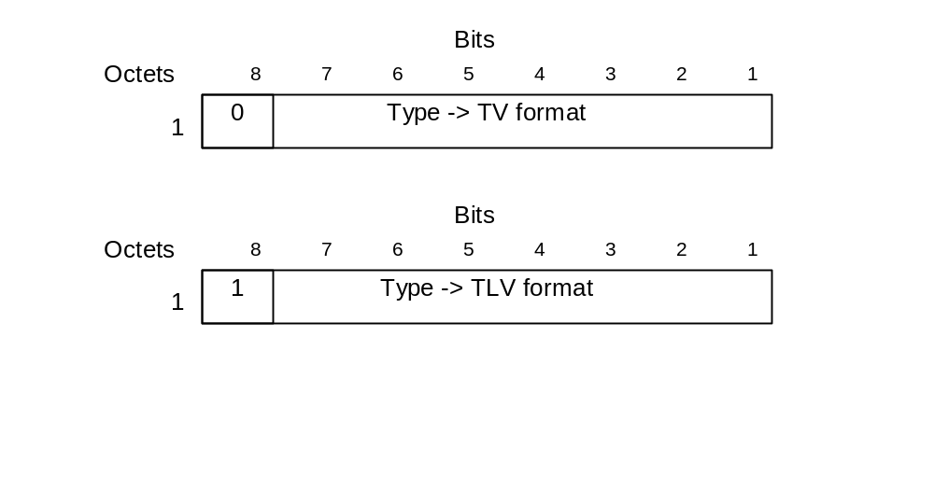
Figure 8.1-1: Type field for TV and TLV format
The complete range of information element types defined for GTPv1 is defined in 3GPP TS 29.060 [6]. The table below includes those applicable to GTP user plane.
Table 8.1-1: Information Elements
IE Type Value | Format | Information Element | Reference
0-13 | TV | Reserved in 3GPP TS 29.060 [6]
14 | TV | Recovery | 8.2
15 | TV | Reserved in 3GPP TS 29.060 [6]
16 | TV | Tunnel Endpoint Identifier Data I | 8.3
17-132 | TV/TLV | Reserved in 3GPP TS 29.060 [6]
133 | TLV | GSN Address | 8.4
134-140 | TLV | Reserved in 3GPP TS 29.060 [6]
141 | TLV | Extension Header Type List | 8.5
142-254 | TLV | Reserved in 3GPP TS 29.060 [6]
255 | TLV | Private Extension | 8.6

8.2 Recovery
The value of the restart counter shall be set to 0 by the sending entity and ignored by the receiving entity. This information element is used in GTP user plane due to backwards compatibility reasons.

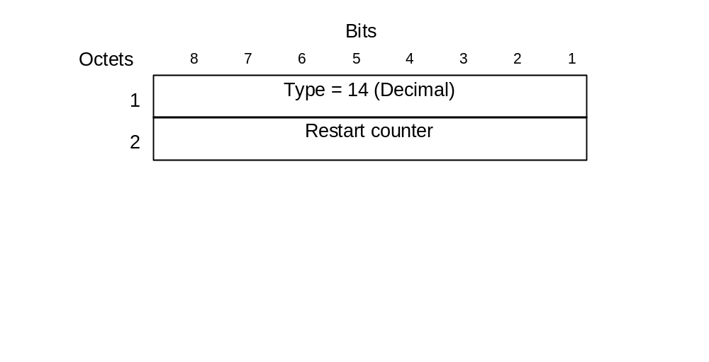
Figure 8.2-1: Restart Counter Information Element

8.3 Tunnel Endpoint Identifier Data I
The Tunnel Endpoint Identifier Data I information element contains the Tunnel Endpoint Identifier used by a GTP entity for the user plane.
 |  | Bits
 | Octets | 8 | 7 | 6 | 5 | 4 | 3 | 2 | 1
 | 1 | Type = 16 (Decimal)
 | 2 - 5 | Tunnel Endpoint Identifier Data I

Figure 8.3-1: Tunnel Endpoint Identifier Data I Information Element

8.4 GTP-U Peer Address
The GTP-U peer Address information element contains the address of a GTP. The Length field may have only two values (4 or 16) that determine if the Value field contains IPv4 or IPv6 address.
The IPv4 address structure is defined in RFC 791 [10].
The IPv6 address structure is defined in RFC 2373 [11].
The encoded address might belong not only to a GSN, but also to an RNC, eNodeB, SGW or PGW.
Figure 8.4-1: GTP-U Peer Address Information Element

8.5 Extension Header Type List
This information element contains a list of 'n' Extension Header Types. The length field is set to the number of extension header types included.
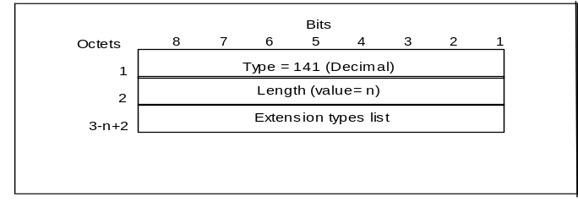
Figure 8.5-1: Extension Header Type List Information Element

8.6 Private Extension
The Private Extension information element contains vendor specific information. The Extension Identifier is a value defined in the Private Enterprise number list in the most recent "Assigned Numbers" RFC (RFC 1700 or later).
This is an optional information element that may be included in any GTP Signalling message. A signalling message may include more than one information element of the Private Extension type.
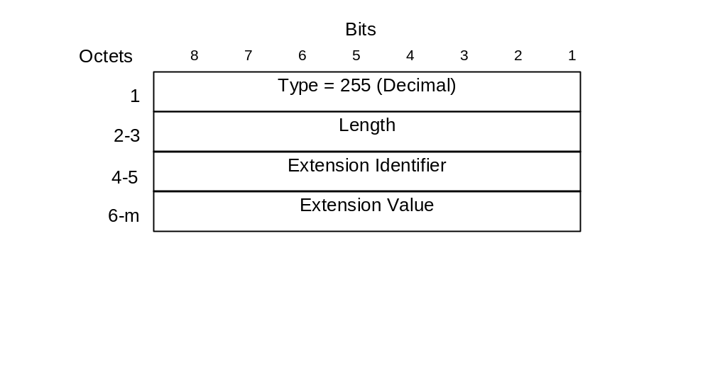
Figure 8.6-1: Private Extension Information Element

9 Error Handling
As specified in 3GPP TS 29.060 [6], subclauses 11.1 and 11.2.

10 Security
Network domain security is not intended to cover protection of user plane data and hence GTP-U is not protected by the NDS/IP mechanisms defined in 3GPP TS 33.210 [12]

11 Reliable Delivery of Signalling Messages
Each path maintains a queue with signalling messages to be sent to the peer. The message at the front of the queue, if it is a request for which a response has been defined, shall be sent with a Sequence Number, and shall be held in a path list until a response is received. Each path has its own list. The Sequence Number shall be unique for each outstanding request message sourced from the same IP/UDP endpoint.
The T3-RESPONSE timer shall be started when a signalling request message (for which a response has been defined) is sent. A signalling message request or response has probably been lost if a response has not been received before the T3-RESPONSE timer expires. At the expiry of the timer the request is retransmitted if the total number of request attempts is less than N3-REQUESTS times.
All received request messages shall be responded to and all response messages associated with a certain request shall always include the same information. Duplicated response messages shall be discarded. A response message without a matching outstanding request should be considered as a duplicate.
If a GTP protocol entity is not successful with the transfer of a signalling message, it shall inform the upper layer of the unsuccessful transfer so that the controlling upper entity may take the necessary measures.

12 GTP Parameters

12.1 General
The GTP system parameters defined here and their recommended values shall not be fixed, but shall be possible to configure as described in section 'Reliable delivery of messages'.

12.2 Timers
The timer T3-RESPONSE holds the maximum wait time for a response of a request message.

12.3 Others
The counter N3-REQUESTS holds the maximum number of attempts made by GTP to send a request message. The recommended value is 5.

13 Tunnelling Scenarios

13.1 General
There are user packets sent between network nodes without a GTP-U interface defined. The scenarios and applicability of GTP-U tunnelling are described in this section.
Editor's note: additional EPS scenarios are FFS.

13.2 Tunnelling between Serving GWs
GTP T-PDU tunnelling is applicable from the old Serving GW to the new Serving GW only when indirect forwarding is applicable during a S1-based Handover procedure or inter-RAT handover procedure with SGW Relocation, as described in the 3GPP TS 23.401 [5].For the GTP-U tunnel setup between Serving GWs, path maintenance messages do not need to be sent.

13.3 Transfer of the user plane data between PDN GWs
GTP shall not specify tunnelling between PDN GWs. Transfer of UE-to-UE traffic between PDN GWs shall use the SGi interface.

13.4 Tunnelling between SGSNs
T-PDUs, stored in the old SGSN and not yet sent to the MS, shall be tunnelled to the new SGSN as a part of the Inter SGSN Routeing Update procedure described in 3GPP TS 23.060 [4]. Some T-PDUs may still be on their way from the GGSN to the old SGSN because they have been sent before the tunnel change. These T-PDUs shall also be tunnelled to the new SGSN.
For intersystem SRNS Relocation, the establishment of the GTP tunnel(s) for the forwarding of G-PDUs is as described in the 3GPP TS 23.121 [13] and in the 3GPP TS 23.060 [4] specifications.
For PS Handover, the establishment of the GTP tunnel(s) for the forwarding of G-PDUs is as described in the 3GPP TS 43.129 [14].

13.5 Tunnelling between Source RNC and Target RNC
For the 3G-3G SRNS Relocation, the establishment of the GTP tunnel for the forwarding of G-PDUs between source and target RNC, is as described in the 3GPP TS 23.121 [13] and in the 3GPP TS 23.060 [4] specifications.

13.6 Transfer of the user plane data between GGSNs
GTP shall not specify tunnelling between GGSNs. Transfer of MS-to-MS traffic between GGSNs shall use the Gi interface.

Annex A (informative):
Change history
Change history
Date | TSG # | TSG Doc. | CR | Rev | Subject/Comment | Old | New
2008-12 | CT#42 | CP-080716 |  |  | V2.0.0 approved in CT#42 | 2.0.0 | 8.0.0

