GeoViva
Pitch and impact reference
Enactus SFU — Forward Vision Capstone Pitch, October 25, 2026
Live prototype: https://geoviva-tau.vercel.app

Everything in this document that describes savings, impact, hardware or finances is modelled, proposed or illustrative unless it says otherwise. GeoViva has not yet run a field pilot, and no hardware has been built or tested. Say this plainly to judges — it strengthens the pitch.

1. What GeoViva is
GeoViva is an advisory irrigation tool for small and medium vegetable and berry growers in British Columbia. It combines soil moisture readings, crop needs and the weather forecast to tell a grower, in plain language, which zones need water today, how much, and when — and why.
Mission: make precision irrigation affordable and accessible to smaller BC producers, so they use less water without hurting their crops.
Advisory, not automatic: GeoViva recommends; the grower decides and turns on the water. Valve automation is a later, optional feature.

Inspiration: Terra-Optima
Terra-Optima won the 2025 Reboot the Earth Morocco hackathon. According to the FAO, it combines AI, IoT sensors and open agricultural data for more sustainable farming, including smart irrigation decision support and crop recommendations, with a freemium model.
Not publicly verified: its exact sensors, algorithms, architecture, water savings or adoption. We do not claim anything about Terra-Optima beyond the FAO announcements.
How GeoViva differs: adapted to BC growers, focused on affordable, explainable irrigation advice, and designed to work with readings a grower already has (manual entry, CSV, existing sensors) as well as an optional low-cost sensor.

2. Problem and customer
- BC growers face hotter, drier summers, watering restrictions and rising water and pumping costs.
- Many small farms water on a fixed timer or by feel, which over-waters in cool or rainy spells and under-waters in heatwaves.
- Precision-irrigation systems exist but are often priced and designed for large operations.
- A free tool already exists: the BC Agricultural Irrigation Scheduling Calculator. GeoViva must add value through multi-zone monitoring, forecast-aware daily advice, live readings and simplicity.
Initial customer hypothesis: small/medium vegetable and berry growers (Fraser Valley and Okanagan) with several growing areas, timer or manual irrigation, and no precision-ag system. This must be validated through grower interviews — none have been completed yet.

3. How the recommendation works
GeoViva uses the FAO-56 root-zone water balance (Allen et al., 1998), the standard method used by irrigation agronomists. Every recommendation is a transparent calculation — no black-box AI.
- Total available water (TAW) = (field capacity − wilting point) × root depth.
- Readily available water (RAW) = p × TAW, where p is the crop’s allowed depletion before stress.
- Current deficit = (field capacity − current moisture) × root depth.
- Crop water use over the next 48 h = Kc × reference evapotranspiration (ET₀) from the forecast; useful rain = 80% of forecast rain above 3 mm.
- If the projected deficit reaches RAW: water today (or soon). If forecast rain covers it: skip. Otherwise: no watering needed.
- Water to apply = deficit ÷ irrigation efficiency (drip 90%, sprinkler 75%); litres = mm × area in m². Large amounts are split into sessions of at most 20 mm.

Worked example (Zone A, tomatoes on loam, drip, 1,998 m²)
TAW = (0.30 − 0.13) × 700 mm = 119 mm; RAW = 0.40 × 119 = 47.6 mm. At 19% moisture the deficit is 77 mm, rising to 89 mm in 48 h. Water to apply = 77 ÷ 0.90 = 85.6 mm ≈ 171,000 L, split into 5 sessions of about 17 mm. The app reproduces these numbers exactly.

Crop and soil constants
Crop | Kc (mid) | Root depth | p | Source
Tomato | 1.15 | 700 mm | 0.40 | FAO-56 Tables 12 & 22; BC Factsheet 619.000-1
Lettuce | 1.00 | 300 mm | 0.30 | FAO-56 Tables 12 & 22
Blueberry | 1.05 | 600 mm | 0.50 | BC Factsheet 619.000-1; FAO-56 berries (bushes)
Strawberry | 0.85 | 200 mm | 0.20 | FAO-56 Tables 12 & 22

Soil | Field capacity | Wilting point | Available water | Source
Sandy loam | 0.23 | 0.11 | 120 mm/m | FAO-56 Table 19; BC factsheet 125 mm/m
Loam | 0.30 | 0.13 | 170 mm/m | FAO-56 Table 19; BC factsheet 175 mm/m
Silt loam | 0.34 | 0.13 | 210 mm/m | FAO-56 Table 19; BC factsheet 208 mm/m
Not yet sourced: the drip/sprinkler efficiencies, the effective-rain rule and the 4.5 mm/day fallback ET₀. All constants should be reviewed by an agronomist before field use.

4. Modelled water savings
Method: a 14-day daily water balance for each sample zone using a sample July fortnight (Fraser Valley, simulated). Two strategies start from the same well-watered soil: a fixed timer schedule (15 mm, 3 times per week) and following GeoViva’s recommendations.
Zone | Area (m²) | Fixed schedule (L) | GeoViva (L) | Avoided (L) | Reduction
Zone A · Field tomatoes (loam, drip) | 1,998 | 179,820 | 109,510 | 70,310 | 39.1%
Zone B · Salad lettuce (sandy loam, sprinkler) | 1,398 | 125,820 | 102,850 | 22,970 | 18.3%
Zone C · Blueberries (silt loam, drip) | 3,196 | 287,640 | 236,610 | 51,030 | 17.7%
Zone D · Strawberries (loam, drip) | 1,998 | 179,820 | 120,450 | 59,370 | 33%
Total | 8,590 | 773,100 | 569,420 | 203,680 | 26.3%
These are modelled results against a fixed schedule, not field results. Real savings depend on the grower’s current practice, weather, soil and crop. A grower who already waters carefully will save less; one who under-waters may need more water.
Formula: Water savings % = (Baseline − GeoViva) ÷ Baseline × 100.

5. UN Sustainable Development Goals
SDG | Link to GeoViva | Indicator we will measure
SDG 6 — Clean Water and Sanitation (lead) | Less unnecessary irrigation water drawn from wells, rivers and municipal supply. | Litres of irrigation avoided per zone per season (metered).
SDG 13 — Climate Action (lead) | Helps growers adapt to heat, drought and erratic rain with forecast-aware decisions. | Water used per kg of marketable crop (climate resilience).
SDG 2 — Zero Hunger | Free tier for community and food-security farms protects yields at low cost. | Number of farms served, including free-tier community farms.

6. Validation and pilot plan
- Customer discovery: interview 10–15 BC growers about irrigation practice, costs, current tools and willingness to pay.
- Pilot with 1–2 growers: baseline season or split field (usual practice vs GeoViva) on the same crop.
- Measure: metered water applied, soil moisture, rainfall, yield and quality, irrigation labour time.
- Success = less unnecessary irrigation without reducing yield or quality.
- Commercial test: offer paid plans after the pilot; track conversion and acquisition cost.

7. Hardware concept
Proposed concept — not built or tested. The images below are AI-generated concept renders, not photos of hardware.
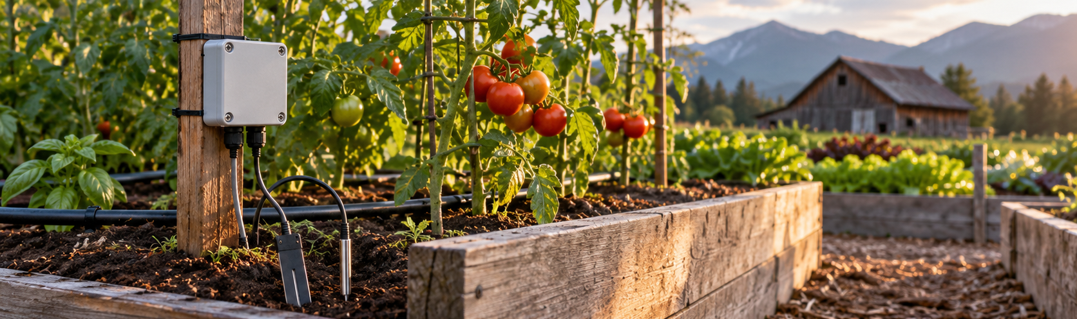
Concept: sensor enclosure installed beside a raised tomato bed.
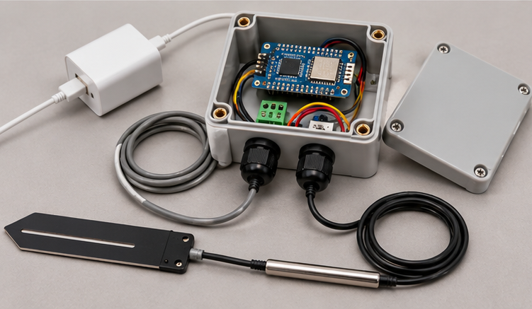
Concept: enclosure with ESP32 board, cable glands, capacitive moisture probe and DS18B20 temperature probe.
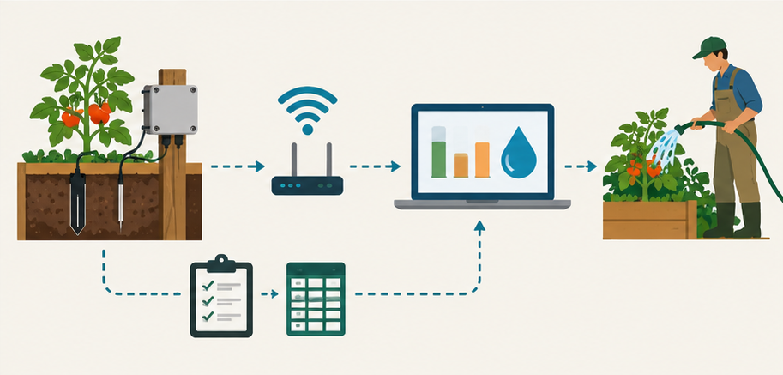
Concept: probe → controller → Wi-Fi → GeoViva → grower; or manual entry / CSV.

How data flows
- A capacitive probe measures soil moisture; a DS18B20 probe measures soil temperature.
- An ESP32 converts the raw signal to moisture using per-soil calibration constants.
- It posts a timestamped reading over Wi-Fi to GeoViva’s secure ingestion endpoint (LoRaWAN via The Things Stack is supported for farms with existing networks).
- GeoViva assigns the reading to its zone and updates the recommendation.

Estimated prototype bill of materials (CAD)
Part | Est. cost
ESP32 development board | $16
Capacitive soil moisture sensor | $12
Waterproof DS18B20 temperature probe | $12
Jumper wires and connectors | $15
USB power supply | $15
Enclosure and cable glands | $25
Shipping, taxes and contingency | $30
Estimated total | ≈ $125

Known limitations
- Low-cost capacitive sensors need calibration for each soil; readings vary with texture and salinity.
- Outdoor electronics need weatherproofing; the prototype is not field-hardened.
- Farm Wi-Fi can be patchy; LoRaWAN or cellular are options.
- Battery or solar power needs extra engineering.
- Large zones may need several probes.

8. Business model
Plan | Price | Includes
Free | $0 | 1 zone, manual readings, basic recommendations
Grower | $99 / year | Up to 5 zones, weather integration, history, CSV import
Farm Pro | $249 / year | More zones, sensor integrations, reports, alerts
Sensor kit (optional) | At cost, ≈ $125 | ESP32 moisture + temperature node
Setup and training | $99–$199 | On-farm onboarding
Social model: paying farms plus grants and water-programme sponsors fund a free tier for community and food-security farms (SDG 2).

Illustrative year-one model (volunteer-run)
 | Q1 | Q2 | Q3 | Q4 | Year 1
Paying farms (end of quarter) | 0 | 5 | 15 | 25 | 25
Subscription revenue | $0 | $161 | $484 | $806 | $1,451
Variable cost ($20/farm/yr) |  |  |  |  | $250
Fixed cost (hosting, tools, pilot travel, insurance, demo kits) | $1,000 | $1,000 | $1,000 | $1,000 | $4,000
Operating result |  |  |  |  | −$2,800
Grant / sponsor target |  |  |  |  | $3,000

Break-even: ≈ 37 paying farms ($4,000 ÷ ($129 average revenue − $20 variable cost)), targeted around month 15–18. This relies on volunteer development in year one; paying founders would raise it.
Value test: at $99/year the tool pays for itself if it saves a farm about 10% of $1,000 in water and pumping costs — but labour savings and avoided crop stress may matter more, and both must be tested in interviews.
All prices and projections are hypotheses, not validated forecasts.

9. Honest risks (prepare these for Q&A)
- Free competitor: the BC Irrigation Scheduling Calculator. Our answer: multi-zone, daily, forecast-aware, sensor-fed, tells you what to do.
- Will farmers pay? Unproven. That is the first thing the pilot tests.
- Sensor accuracy: cheap probes drift; GeoViva stores calibration constants and works with manual readings.
- Savings are modelled: against a fixed schedule; real savings depend on current practice.
- Lettuce in a heatwave: shallow roots on sandy soil can need near-daily watering — the tool shows this honestly.
- Imagery licensing: the prototype uses Esri World Imagery; a commercial launch needs a licensed imagery provider.

10. Pitch structure (5 minutes + 2.5 min Q&A)
Time | Section | Scoring weight it serves
0:00–0:40 | Problem and evidence (BC drought, fixed-schedule watering, discovery stage) | Problem & research 10%
0:40–2:10 | Live demo: farm map → zone needing water → recommendation and reason → draw a new zone | Innovation 20%, Feasibility 15%
2:10–4:20 | Business model, free community tier, SDGs and indicators, pilot plan, what has to be true | Business model 40%
4:20–5:00 | Ask and close | Presentation 15%

11. Sources
- FAO — Reboot the Earth Morocco Hackathon 2025 closing ceremony: https://www.fao.org/maroc/news/detail/reboot-the-earth-morocco-hackathon-2025--an-inspiring-closing-ceremony-in-rabat/en
- FAO e-Agriculture — Terra-Optima wins Morocco’s edition of Reboot the Earth: https://www.fao.org/e-agriculture/news/terra-optima-wins-moroccos-edition-reboot-earth-hackathon
- Allen, R.G. et al. (1998). FAO Irrigation and Drainage Paper 56: Crop evapotranspiration.
- BC Ministry of Agriculture (2002). Factsheet 619.000-1: Soil Water Storage Capacity and Available Soil Moisture.
- Open-Meteo forecast API (weather and ET₀): https://open-meteo.com
- Full constant-by-constant notes: docs/sources.md in the GeoViva repository.

