Music Mixer

Research work

SUBMISSION REQUIREMENTS & DUE DATE

Project must be submitted within Week 12 class time: ONLY THE MAIN BRANCH WILL BE GRADED NOT ZIPPED FILES!

- Github repo: readme.Md file, master branch, design branch, and development branch

- correct structure for a web project (css, js, images, audio, etc, and index.html) - DO NOT INCLUDE AI OR PSD FILES

The SVGs / .png / .jpg in the image folder will do.

- Name the dev branches appropriately per feature IE des. tvr. artwork, dev. tvr. script

GRADING RUBRIC/20

Folder Setup & Naming/1

GitHub Best Practices/3

Valid HTML and CSS/2

Design and Layout /4

Functionality and Interactivity/10

**IMPORTANT NOTES**

**Step one: 1 Design Process**

For this assignment, we are trying to go for the literal Music mixer design concept. The idea will be shown below:

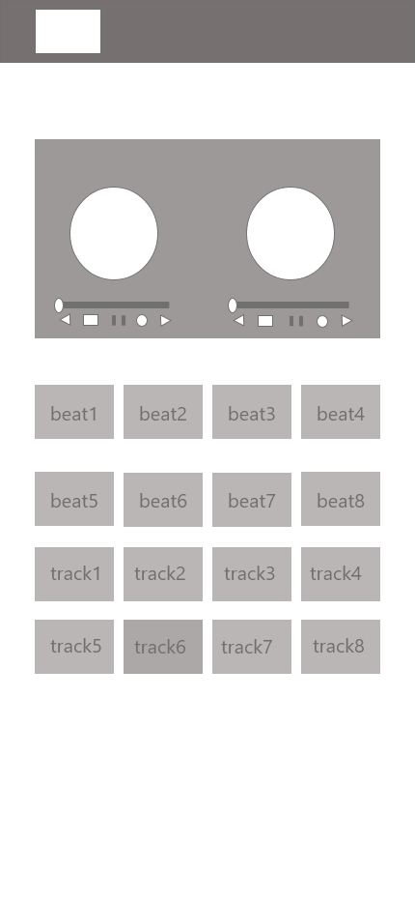

This is our own design that we made using XD.

Step 2: color pallet”

The color that we are choosing for this project will be a mix of bright red and blue to make that contest and a blackish grey for the back. These are known as the primary color making them easy to work with and find that these colors will make a good combination.

Color:

#03A9F5

#D7141A

#1D1D1D

Border:

#707070

These are the specific color values used for our project build.

Step 3: font

The font that will be used for this are:

Chakra Petch

# Bruno Ace SC

# Cardo

# Carter One

These will be the font that we will use.

Final product look :

