Step1: Connect to AWS Account (using the credentials) as Root user

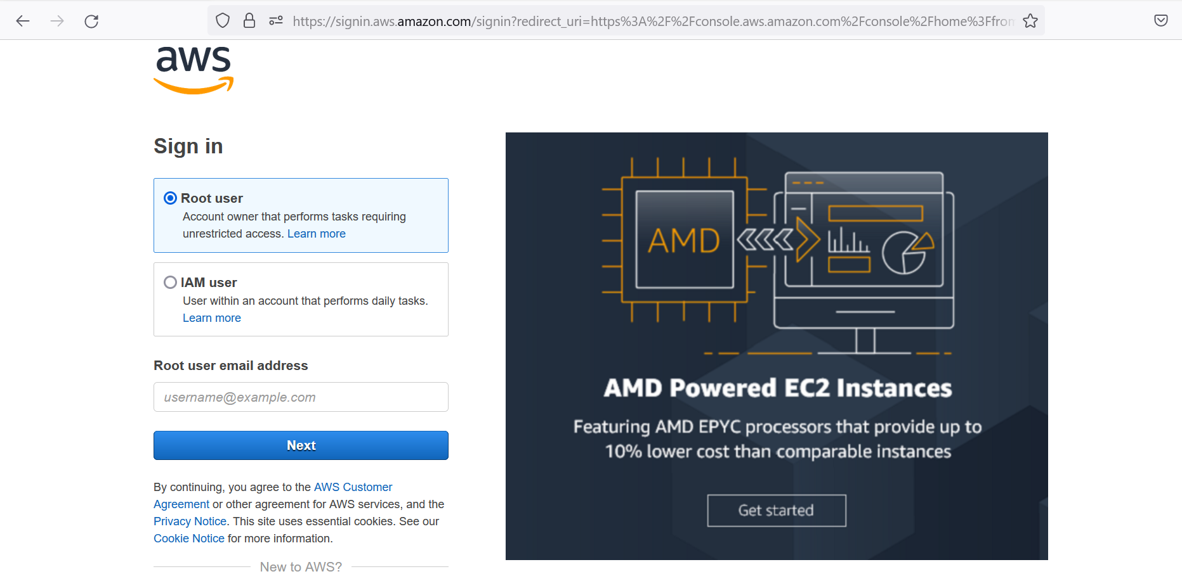

Step2: Open the **Services** tab and select **EC2** service (highlighted in yellow)

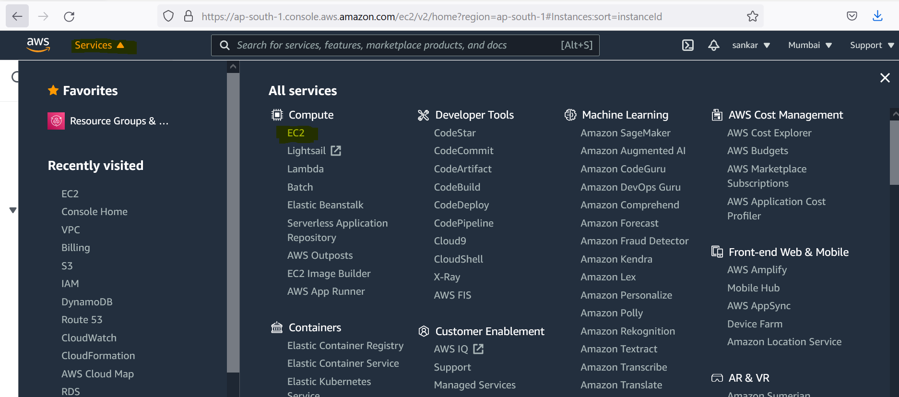

Step3: click on **Instances**

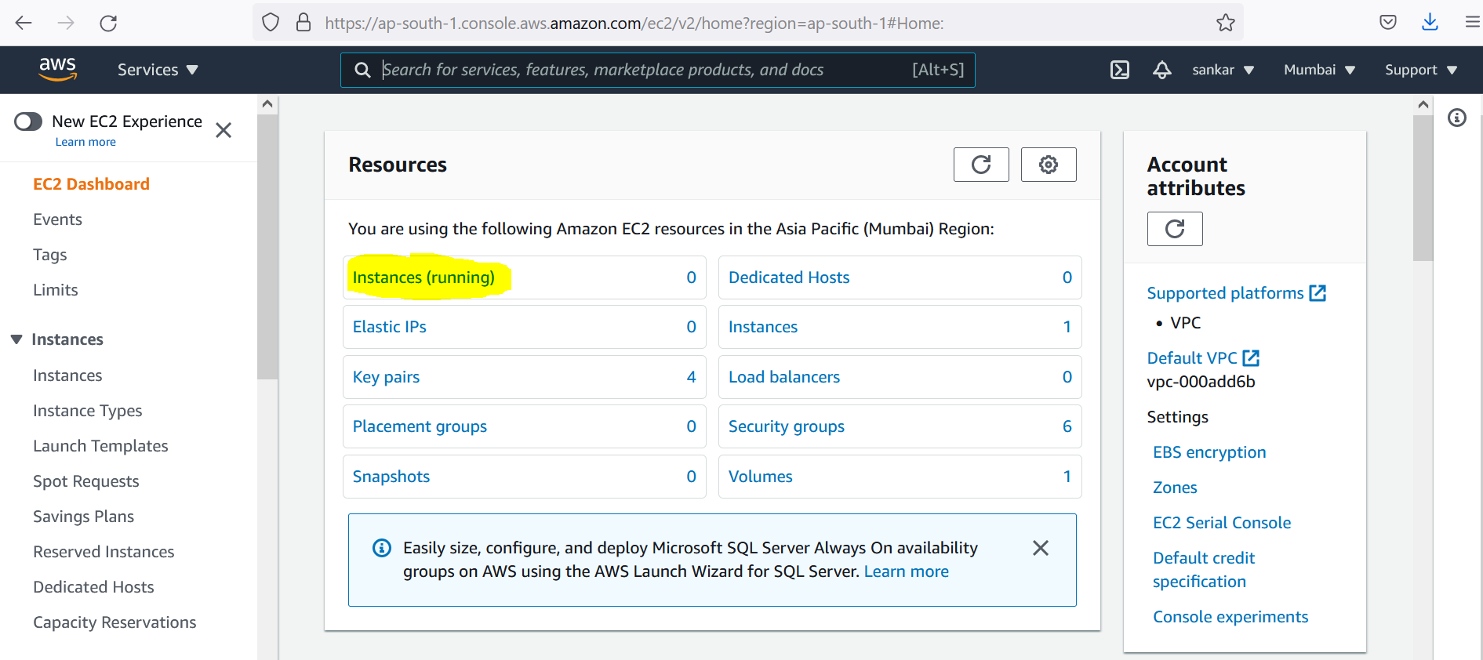

Step4: Click on **Launch Instance**

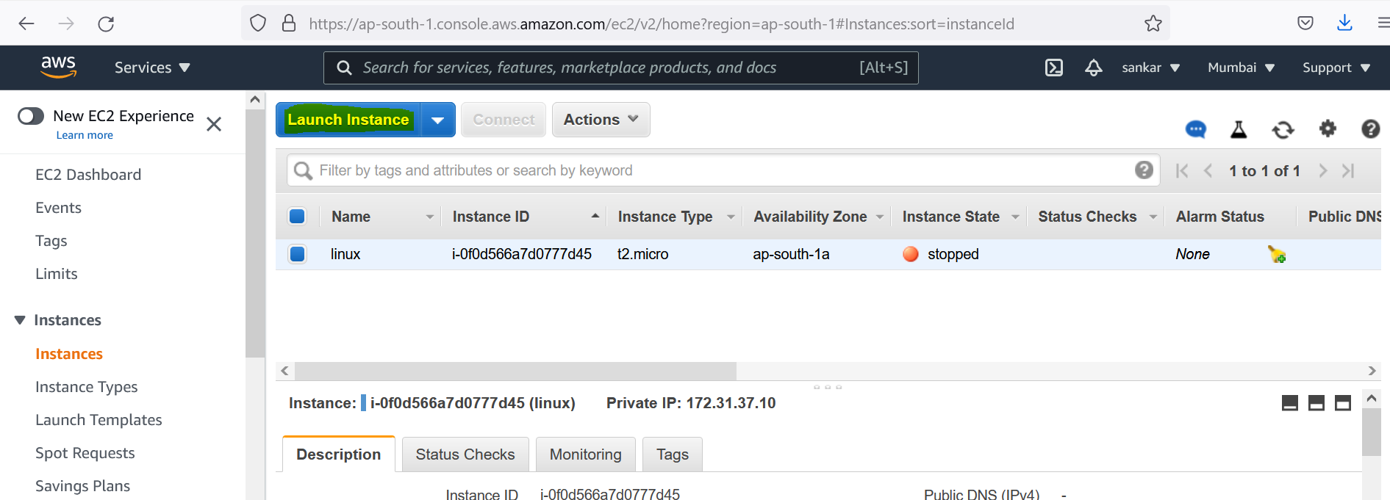

Step5: Select the AMI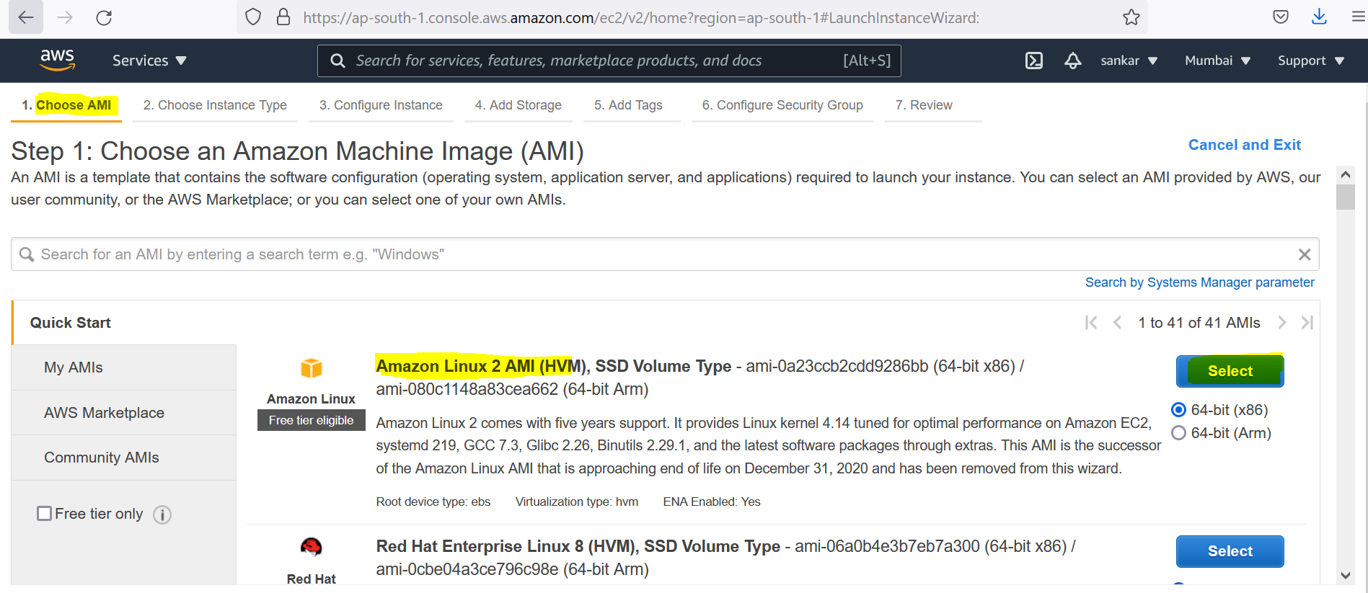

Step6: by default instance type with t2.micro(leave it as it is), click on **Review and Launch** button

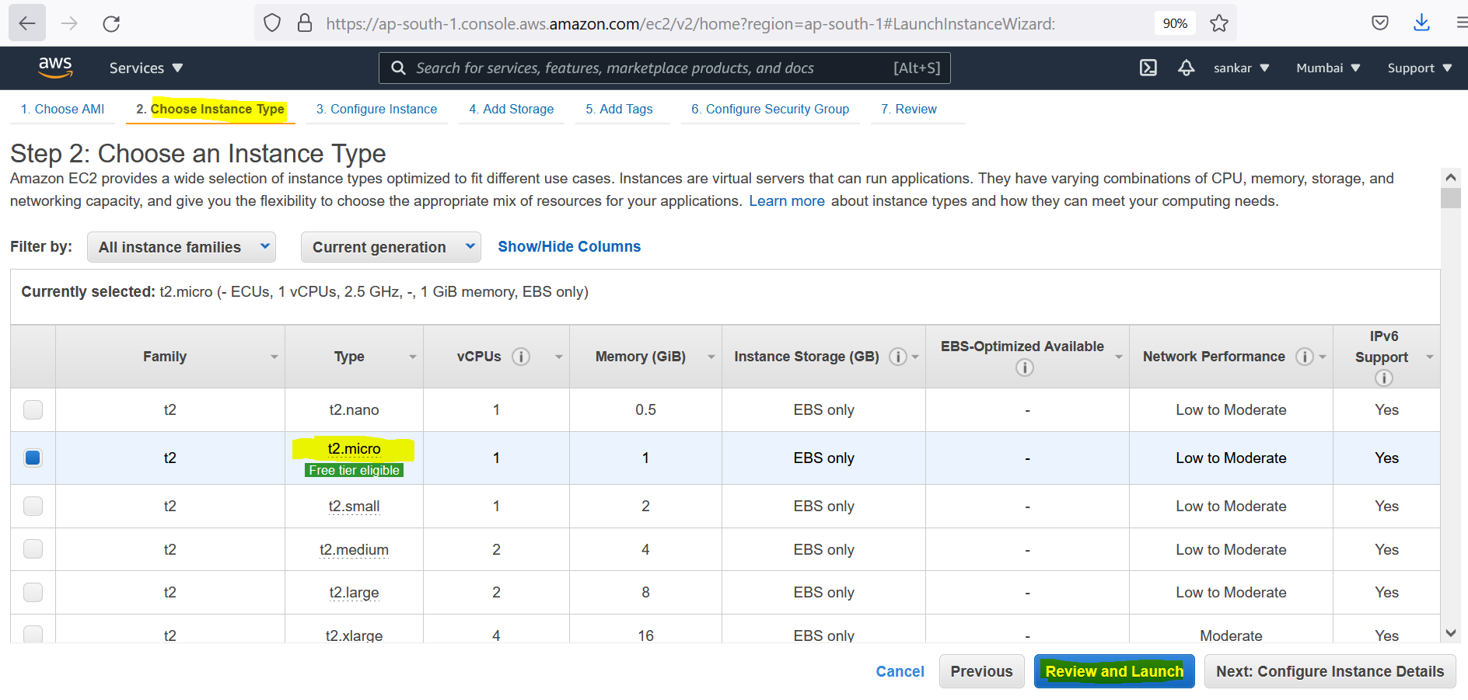

Step7: Click on **Launch** button (no changes are required)

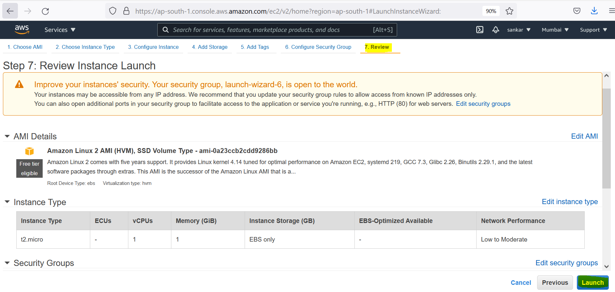

Step8: Provide the private key details to connect the instance

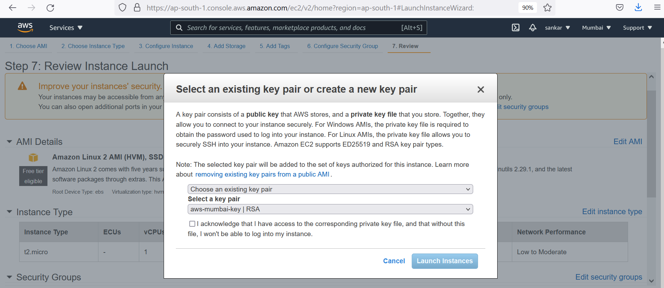

Step9: If you are creating first time the instance, go with option **Create a new key pair** from drop down and provide the key name in the text box, click on **Download key pair**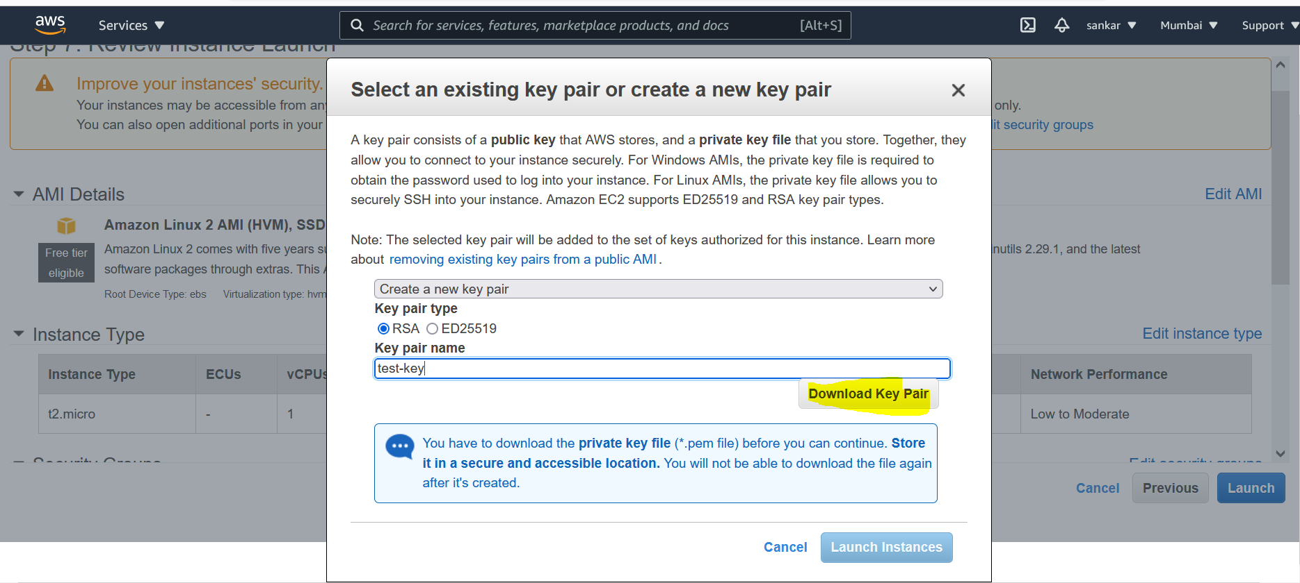

Step10: Click on **Launch Instance** button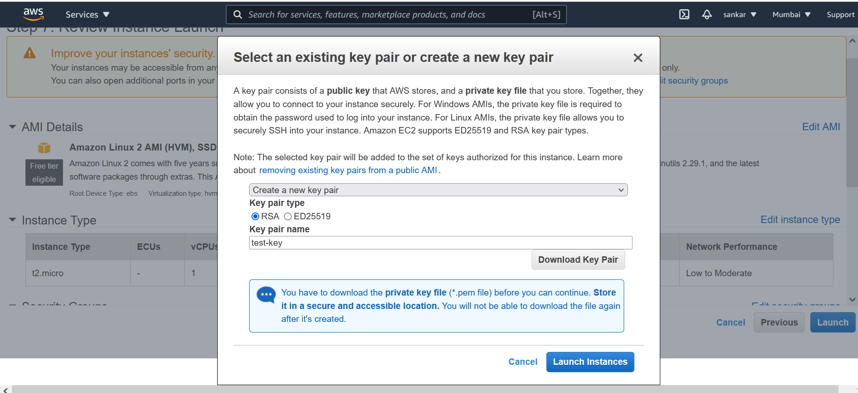

Note: Private key will be downloaded into Downloads folder of Laptop/Desktop

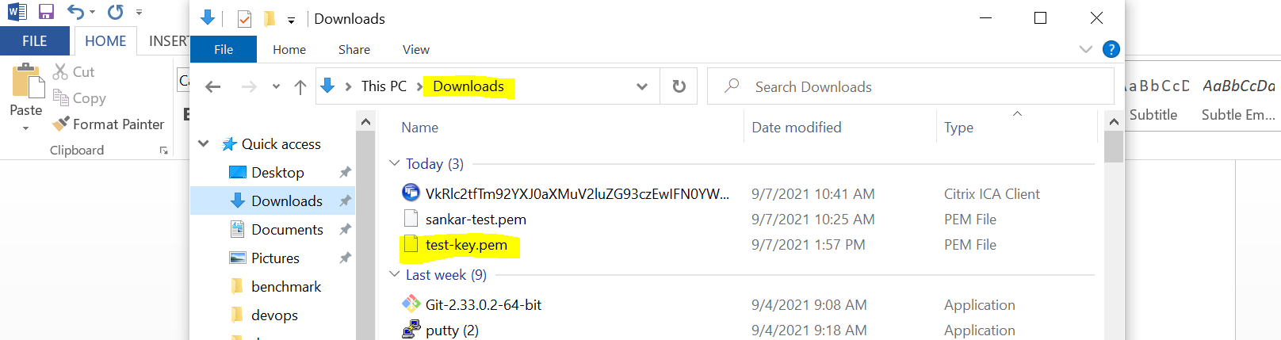

Step11: We can observe in AWS dashboard new instance is created and wait for the instance state to show as **Running**

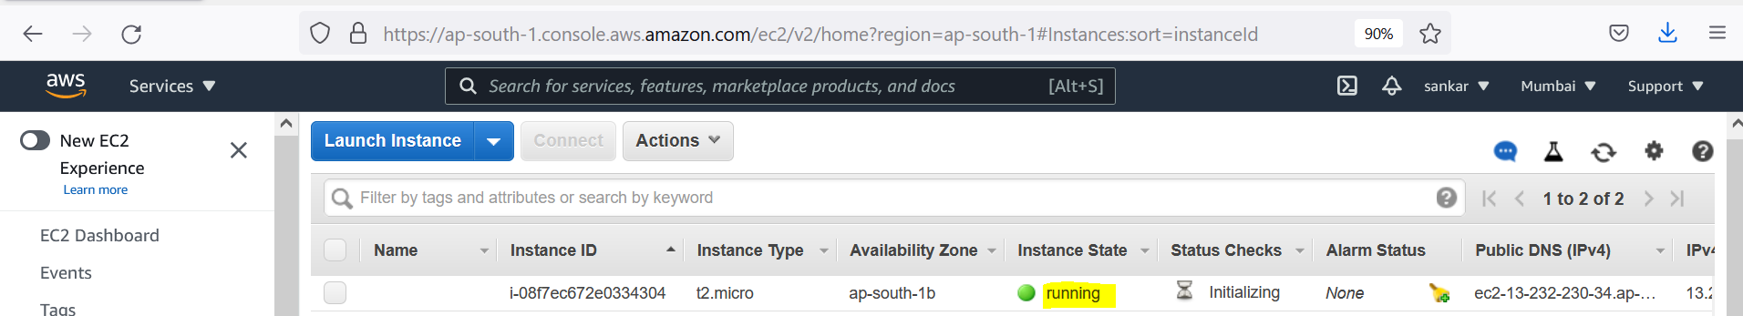

**Connecting to AWS Instance from Laptop/Desktop**

**Method-1:** Using Git Bash

Step1 : Go to the link and download Git Bash binary

Link : <https://git-scm.com/downloads>

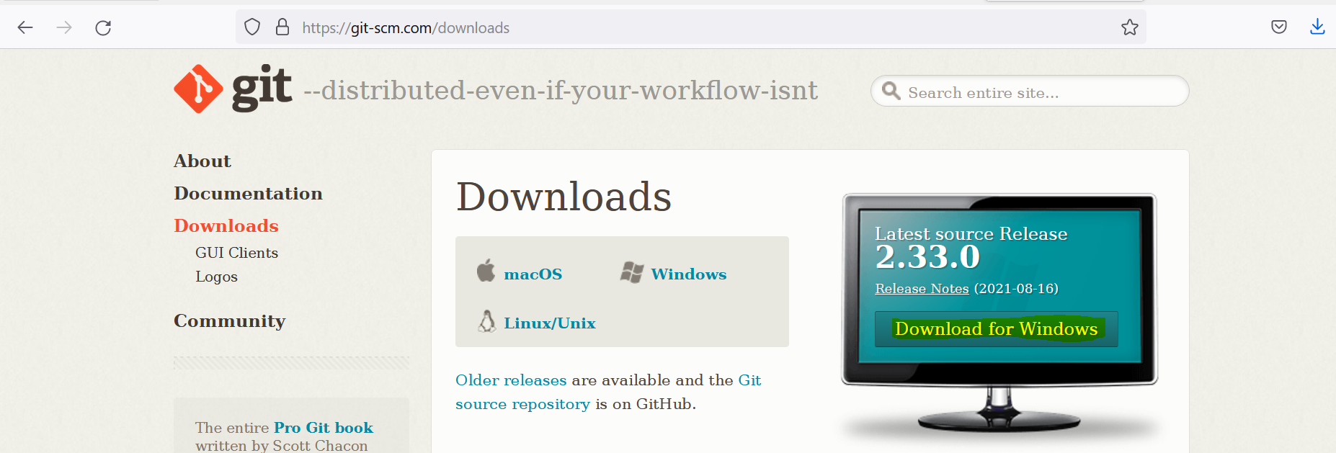

Click on Download for Windows

Step2: Double click on the .exe file and go for the installation

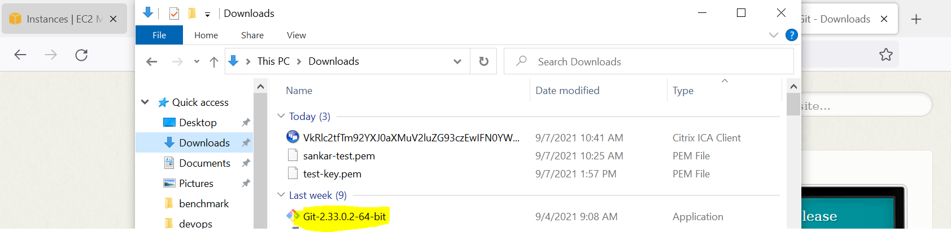

Step3: Open the menu and click on Git Bash

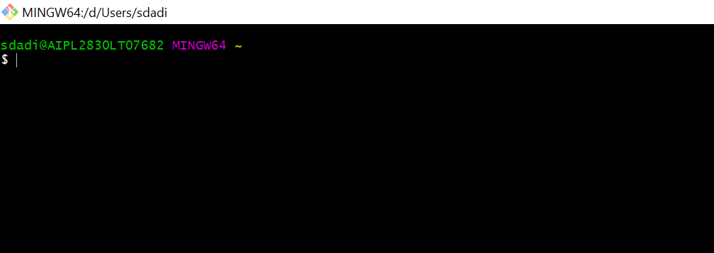

Step4: Switch to the location where .pem file downloaded (default is Downloads folder)

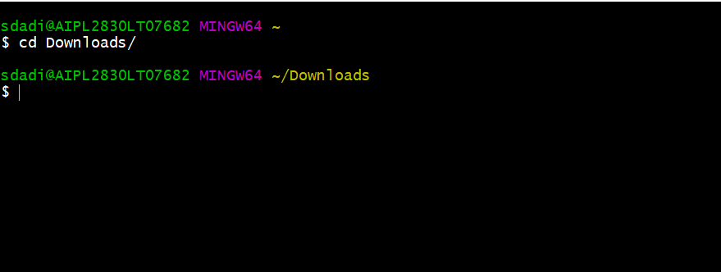

Step5: Go to the AWS dashboard and select the instance and click on **Connect** button

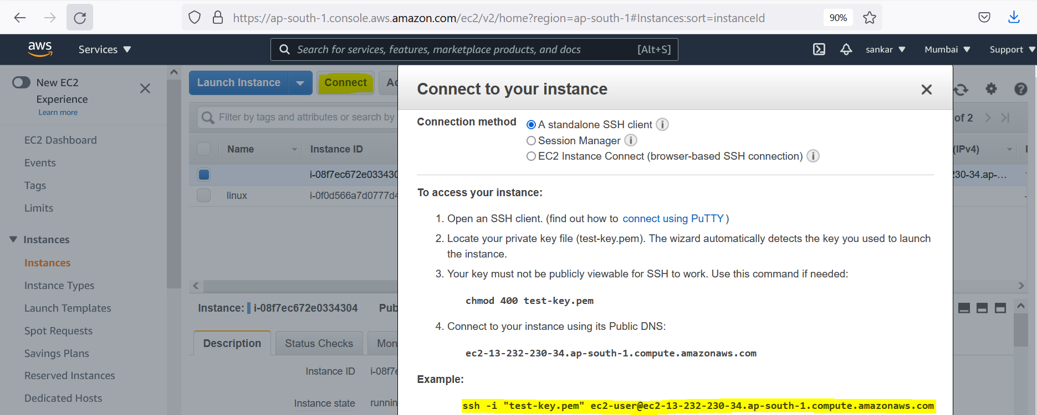

Step6: Copy the path under Example section, then go to Git Bash console and paste it

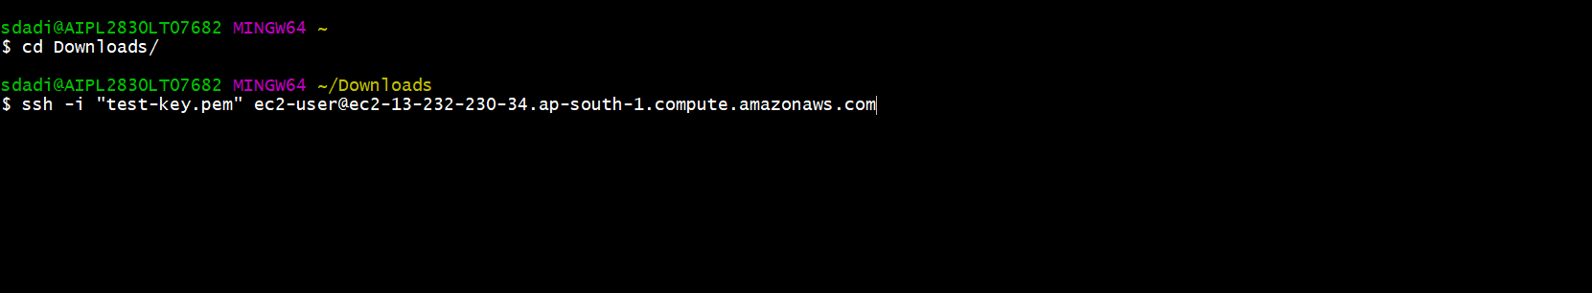

Step7: provide the input “**Yes**” then hit enter

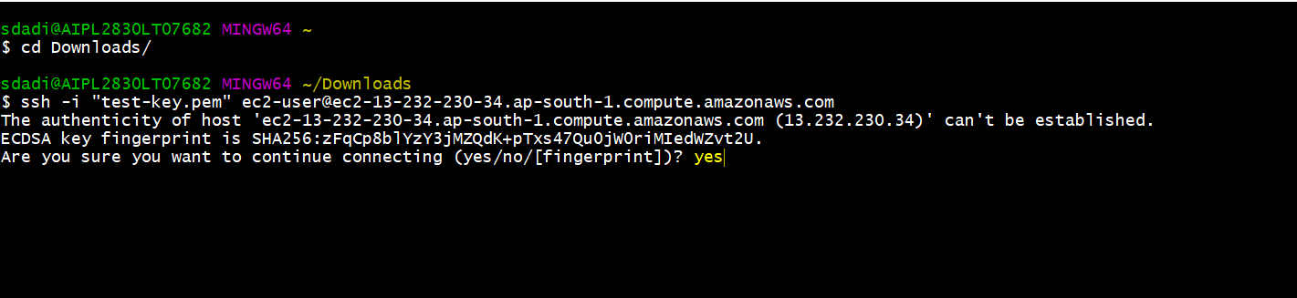

Step8: Connected to the Instance

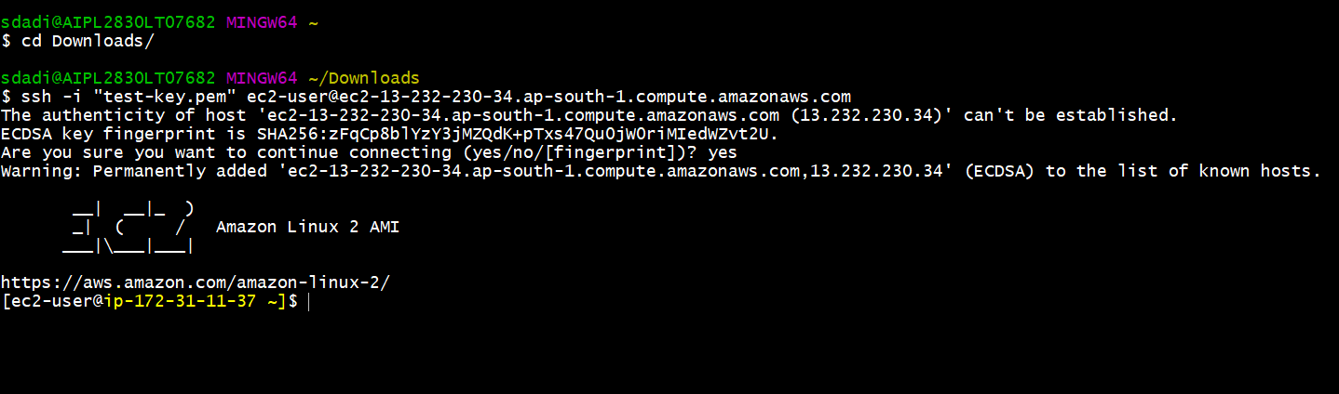

**Method-2** : Using Putty

Follow the steps which are provided in below link to connect instance with Putty

https://asf.alaska.edu/how-to/data-recipes/connect-to-your-ec2-instance-using-putty-v1-1/