[DECEMBER 3, 2017](https://tonyredhead.com/amazon-s3/create-aws-account)

[**Create an AWS Account**](https://tonyredhead.com/amazon-s3/create-aws-account)

An increasing number of 360˚ Panorama photographers are hosting their final output files on the Amazon S3 platform. This short tutorial provides step-by-step instructions on how to open an Amazon Web Services (AWS) account to enable access to the services provided.

***Note:*** *A valid credit card is required to complete the signup and a mobile phone to receive the security number.*

Once you have finished this tutorial and created your account "Publishing to S3" tutorial takes you through the process of creating a bucket and uploading and publishing Pano2VR or Krpano project folders.

**Getting Started**

1. Navigate to Amazon S3 Homepage at [https://aws.amazon.com](https://aws.amazon.com/) and either click on the **'Create an AWS Account'** or **‘Create a Free Account’** button (figure #1)

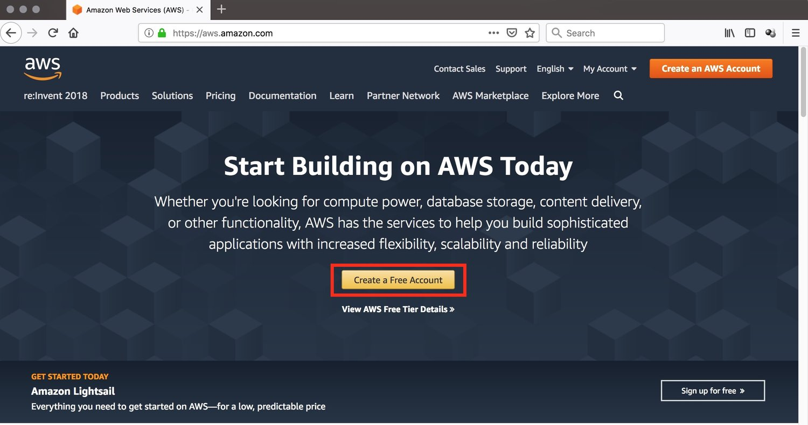

2. **Fill in all of the required fields** and then click the **'Continue'** button (figure #2)

***Note:*** *The AWS account name can be changed in your account settings after you sign up.*

***Note:*** *When you create a new AWS account you have 12 months of Free Tier Access. You can read more about this offer at* [***https:aws.amazon.com/free***](https://tonyredhead.com/amazon-s3/aws.amazon.com/free)*As an example in this account you would have 5Gb of Standard Storage, 20,000 Get Requests and 2,000 Put Requests for 12 months before any payments kick in.*

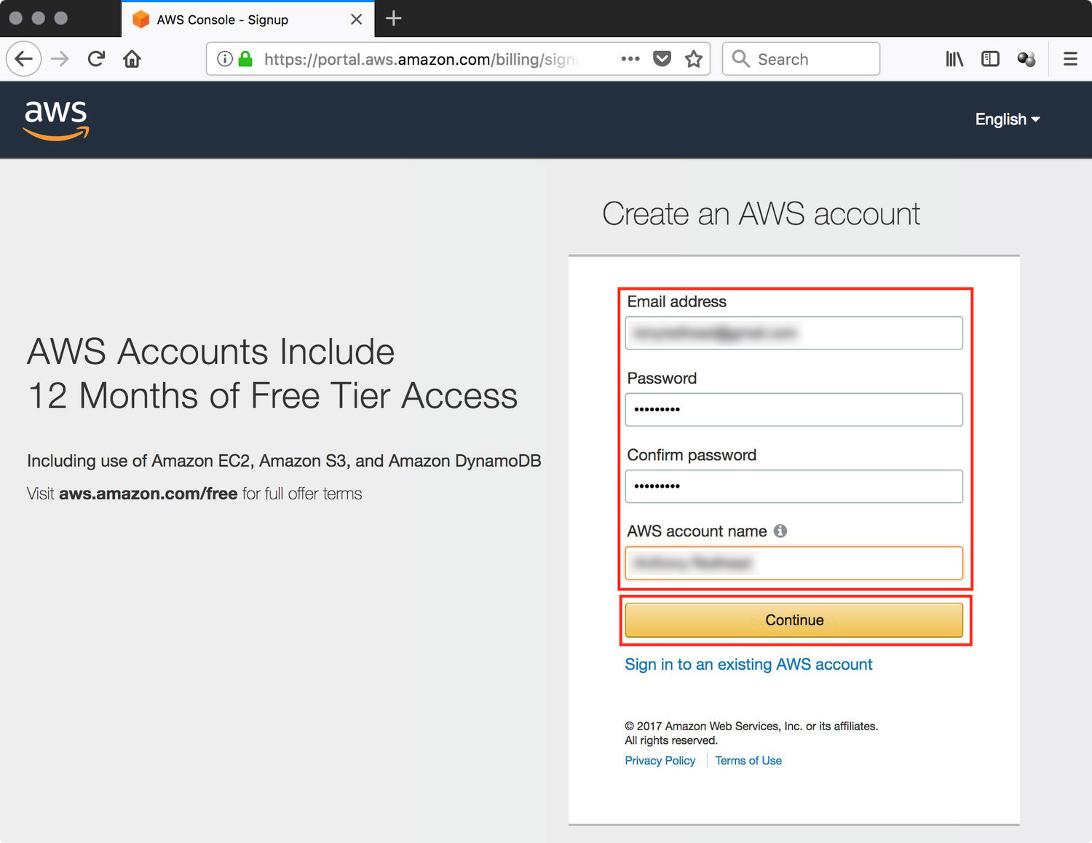

figure #2: Account Information

3. Select the **Type of Account** you want create, either **Professional** or **Personal**. In this example I'm creating a Personal account.

***Note:*** *Select Professional if you intend to use this AWS account within your company, educational institution or organization. Otherwise, select Personal.*

**Fill in the required Contact Information fields** and then click on **'Create Account and Continue'** (figure #3)

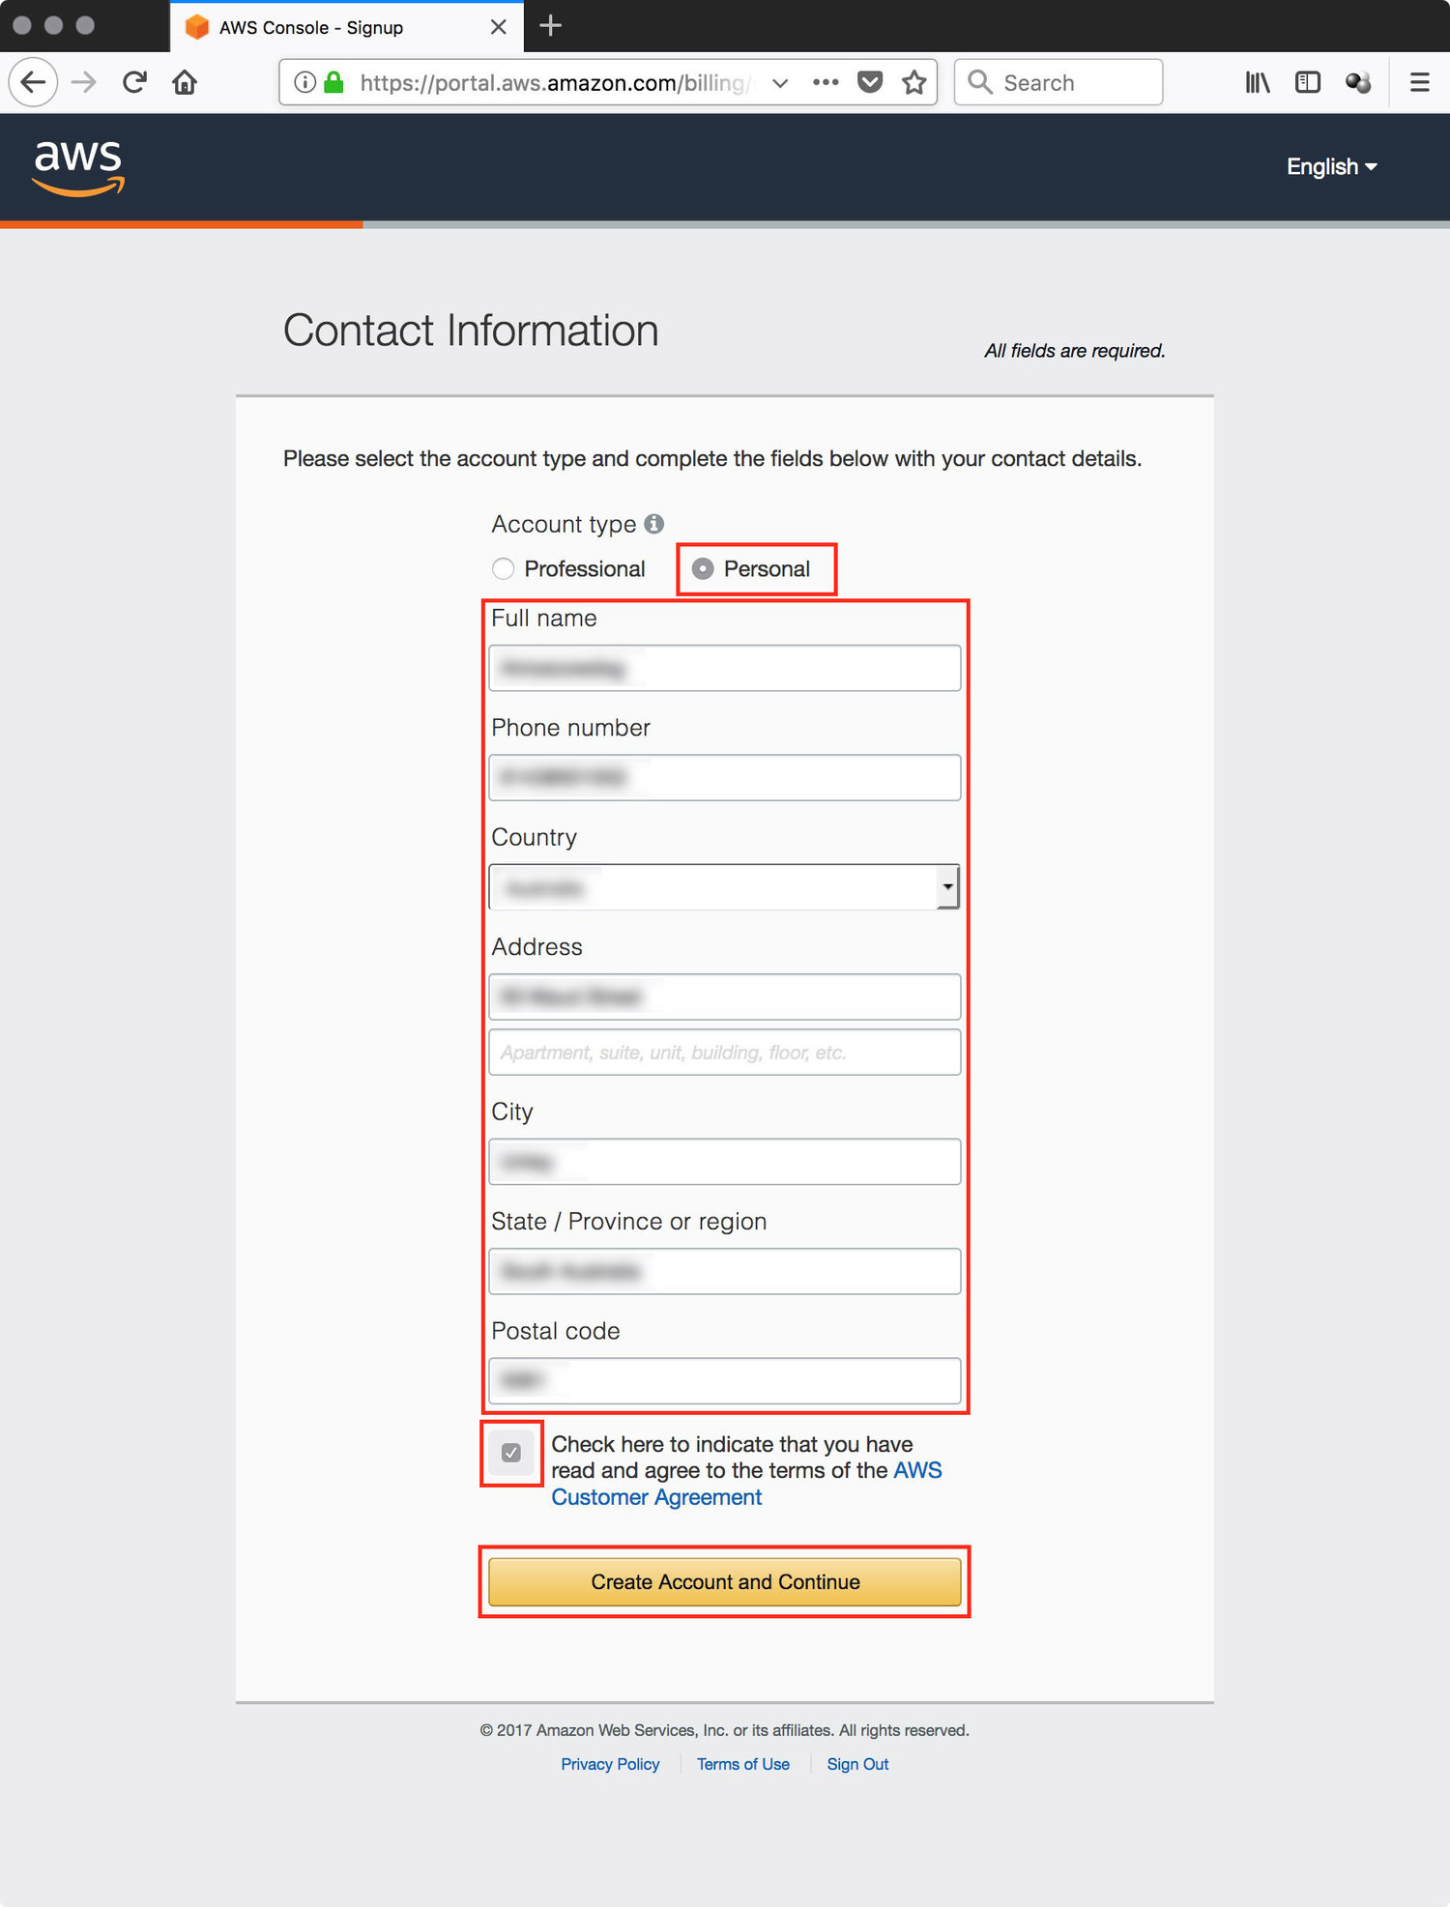

figure #3: Contact Information

4. Using a valid credit card **Fill in the required Payment Information** fields and then click on **'Secure Submit'** (figure #4)

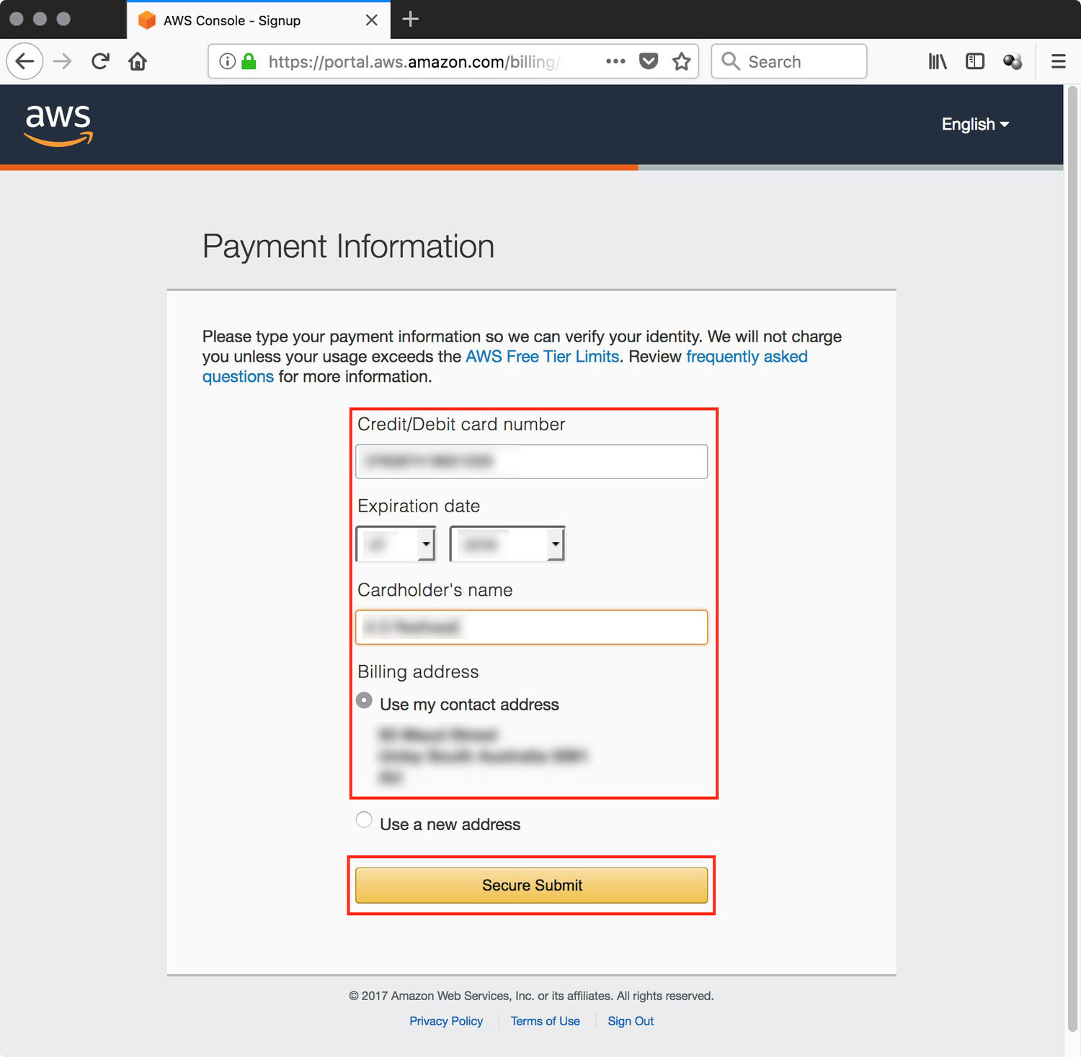

figure #4: Payment Information

5. The Phone Verification page automatically loads the **Country Code** and **Phone Number** from the entries in the Contact Information page.

*Note: If you wish to use a different location and number you can change the entries.*

**Complete the Security Check** field and click on the **'Call Me Now'** button (figure #5)

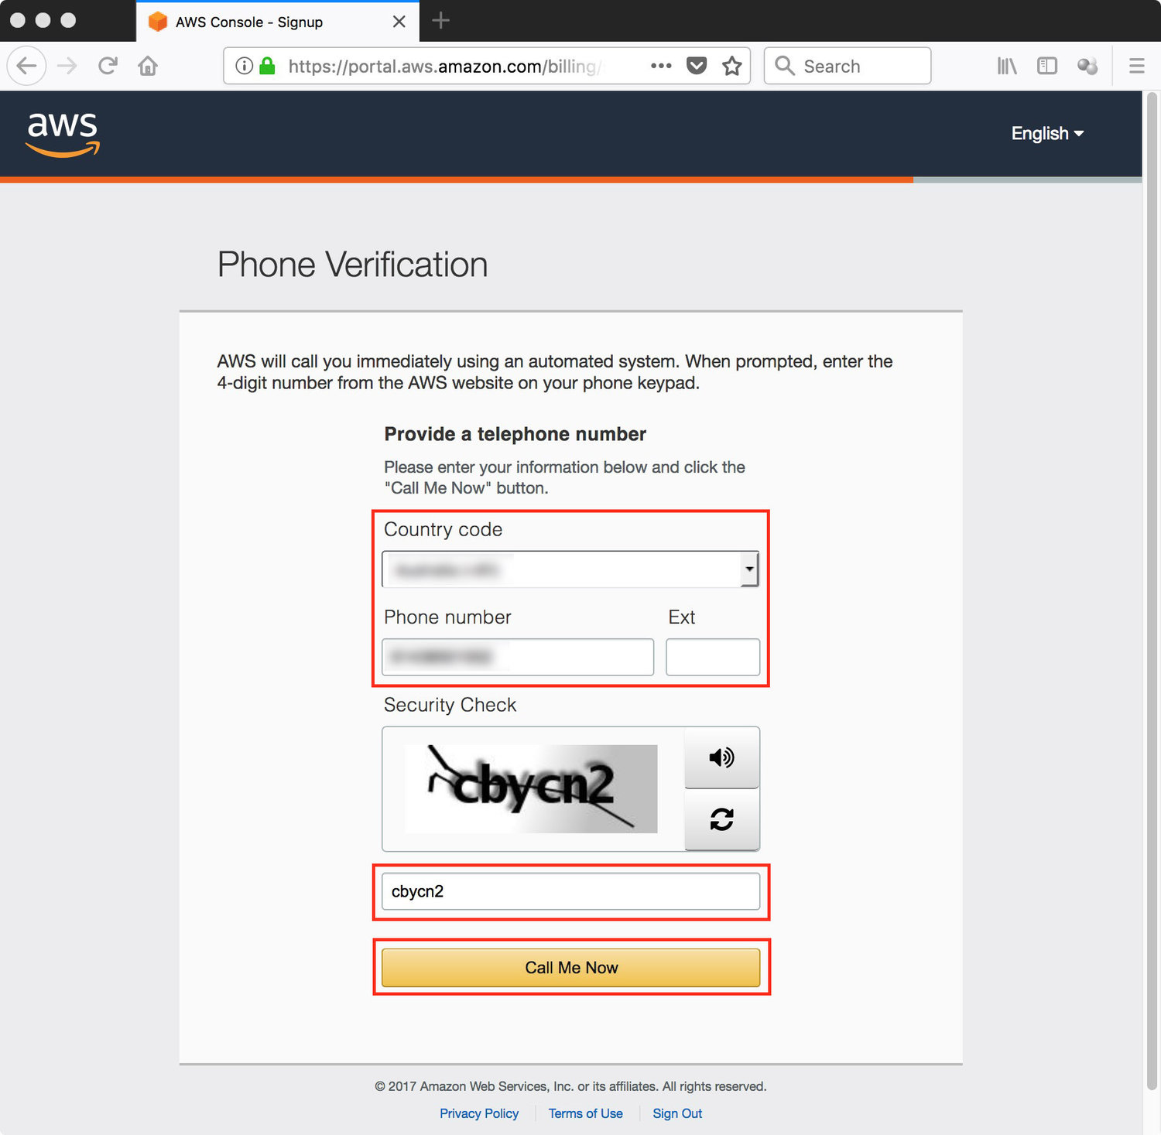

figure #5: Phone Verification

6. After selecting 'Call Me Now' the browser will refresh and display a **4 digit code** and your **phone will ring** with an automated message asking you to enter the code currently displayed in your browser. Enter the numbers displayed in the browser. (figure #6)

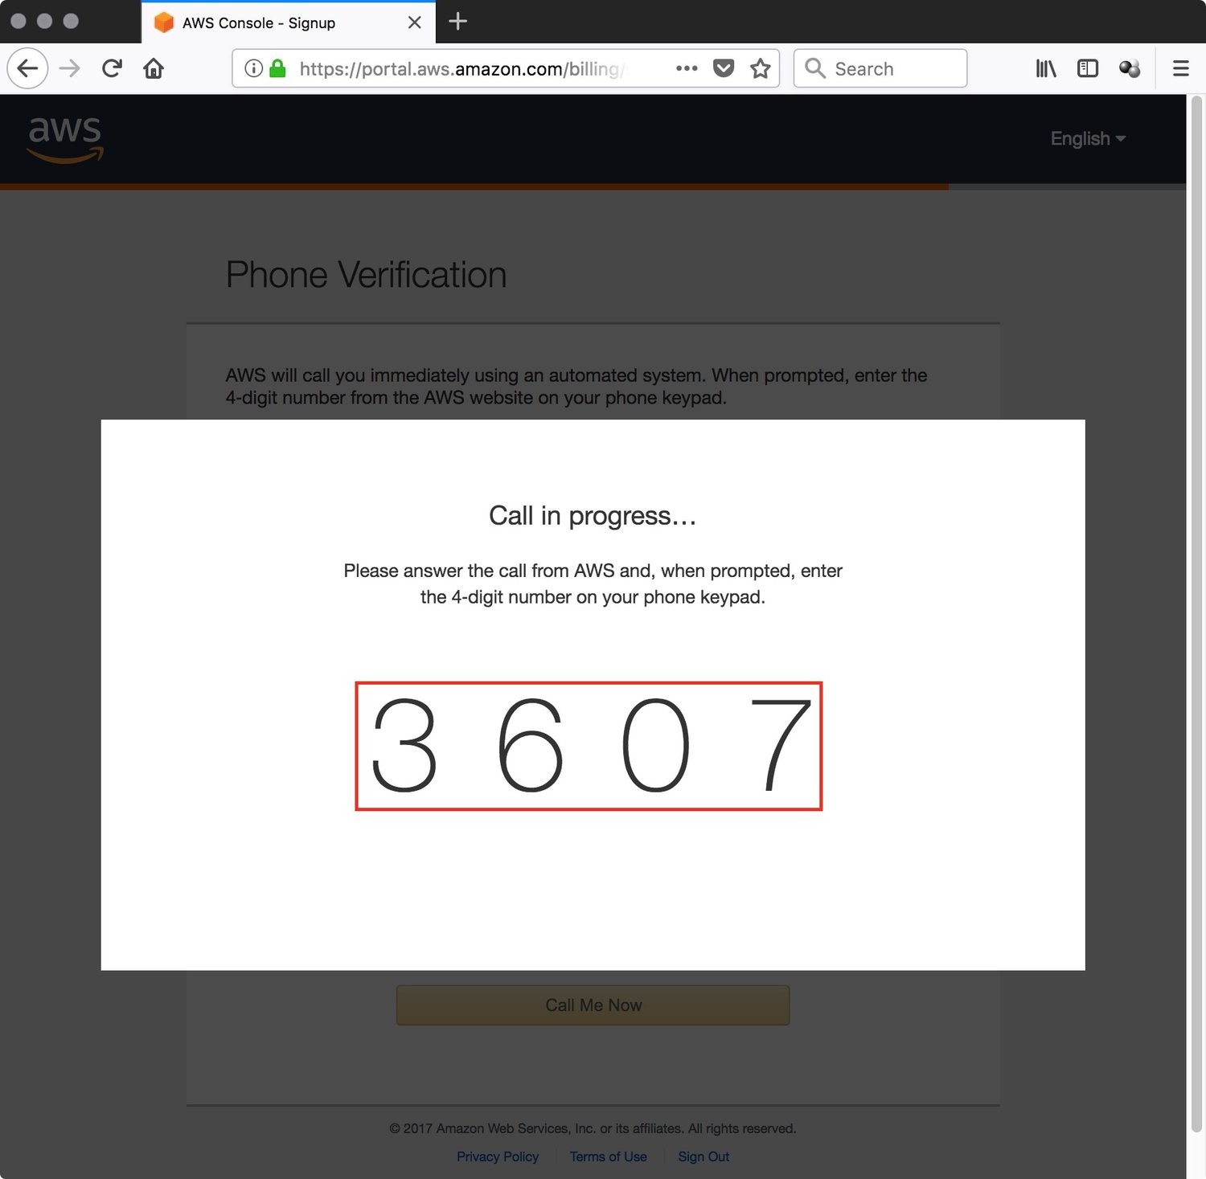

figure #6: Verification Code

7. After you have entered the code the browser will refresh again and a message displayed that your identity has been verified successfully. Click on **'Continue'** (figure #7)

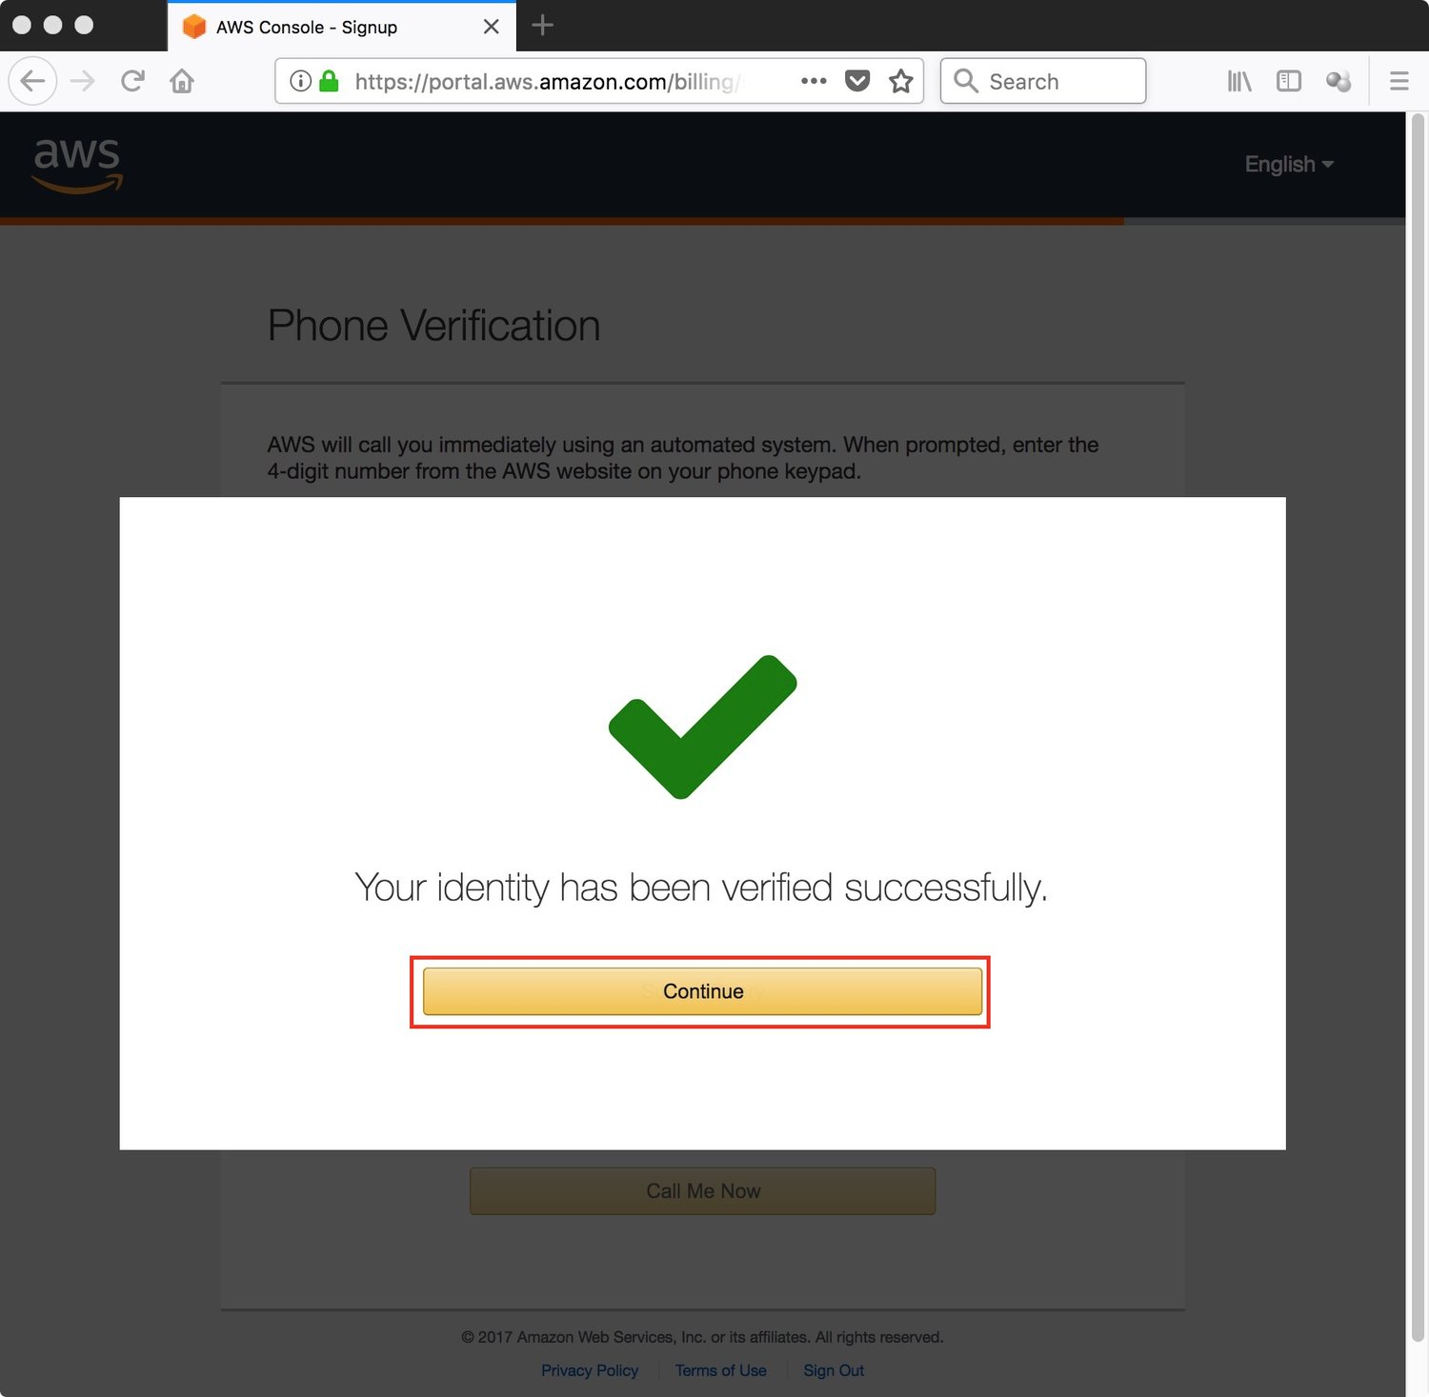

figure #7: Verified

8. Click on the **'Free'** option under Support Plans (figure #8)

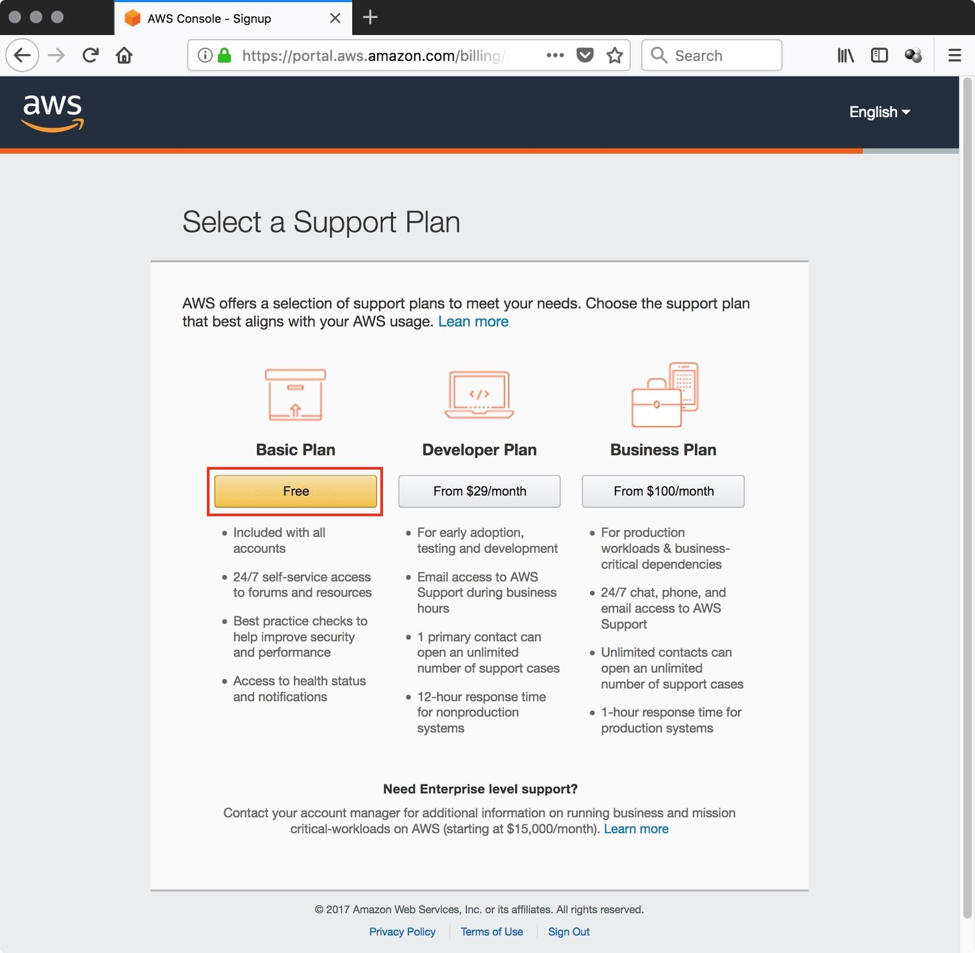

figure #8: Support Plans

9. You have successfully finished creating your AWS account and you can now proceed by clicking on the **'Sign in to the Console'** button. (figure #9)

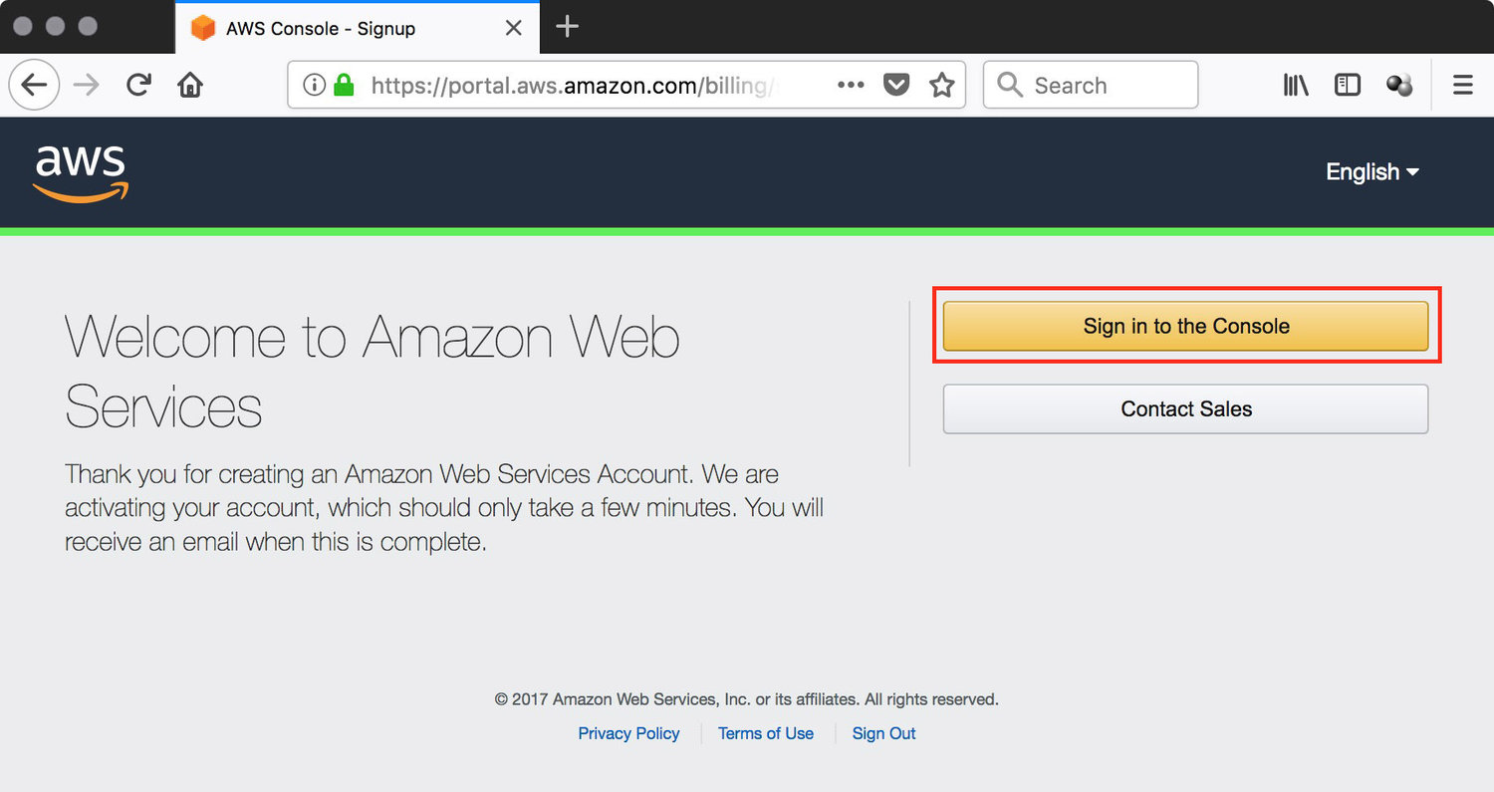

figure #9: Welcome to AWS