ME 203:Exam 2

Group Members:

Brandon Ramirez Lopez: Worked on problems 1 and 4 Gabriel Ritch: Worked on problems 3 and 5

Emerson Fleming: Worked on problems 2 and 6

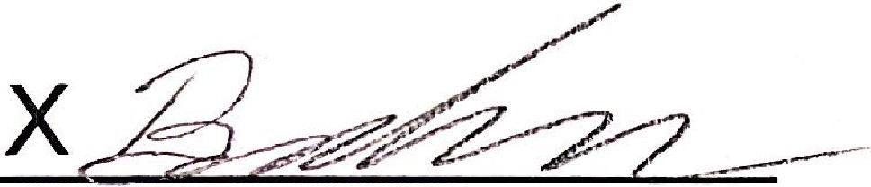

Brandon Ra mirez Lopez

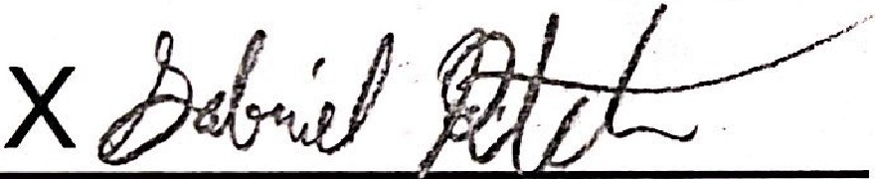

Gabriel Ri t ch

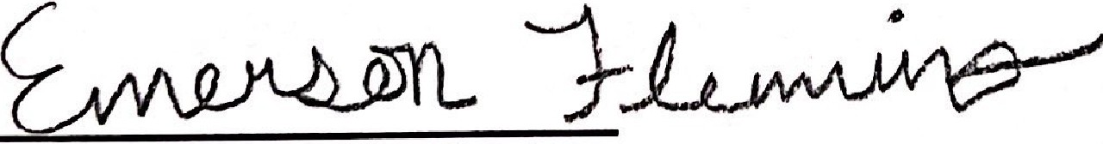 X

Emerson Fleminq

Scanned with CamScanner