**REPORT FOR TASK 1 (QUESTION 1)**

From the equation: dS(t) = 0.1 dt + 0.26 dB(t) with the initial price, S(0) = 39. We can know that the µ(mu) is equal to 0.1 and the σ(sigma) is equal to 0.26. In order to obtain an accurate expected value and variance, I have simulated 1000 runs of geometric Brownian motion (GBM) and there is 1000 number of partitions in the interval. Furthermore, we only determine from first year to third year.

Besides that, the formula of stock price, S(t) = S(0)*exp[(µ-(σ*σ/2)*t)] + σBt. So the code is S[:,1] = S(0)*p.exp((µ-σ*σ/2)*t[1:]+σ*B[:,1:].

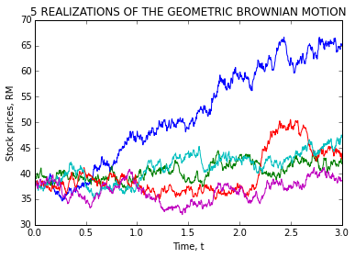 Example 1.1

As per requested by the question, we only plot 5 realizations among the 1000 runs of GBM. Hence, from the example 1.1 we can see that there is only 5 types of lines appeared on the graph. But due to the number that I used to generate the GBM is random number, so the graph will be slightly different when I run the code every time. We plotted time, t as the x-label and stock prices, RM as the y-label.

In addition, to calculate the expected value and variance for 3 years, we picked the last price at year 3 for all paths that we called these as last_price_x. Hence, the E[S(3)] is the mean of last_price_x. While for the variance, Var[S(3)] is the variance of (last_price_x).

Besides that, to calculate the probability that the stock prices for 3 years which is larger than 39, we have to find out all the possible values that are larger than 39 (initial price) first. Lastly, the P[S(3)>39] is equal to the total sum of all the possible values that are larger than 39 then diving by the 1000 runs.

In order to obtain the expected value of stock prices for 3 years given that the stock prices for 3 years which is larger than 39, we have to find out the total sum of last price at year 3 for all paths (last_price_x) multiply with all the possible values that are larger than 39. We called this as z. Hence, the E[S(3)|S(3)>39] is equal to the z by dividing by the total sum of all the possible values.

**REPORT FOR TASK 1 (QUESTION 2)**

From the equation: dR(t) = [0.064 - R(t)] dt + 0.27 R(t) dB(t) with initial value, R(0) = 3. We can know that the α(alpha) is 1, θ(theta) is 0.064 and σ(sigma) is 0.27. We have stimulated 1000 runs of mean reversal process and there is 1000 number of partitions in the interval. For this question, we only determine for 1 year.

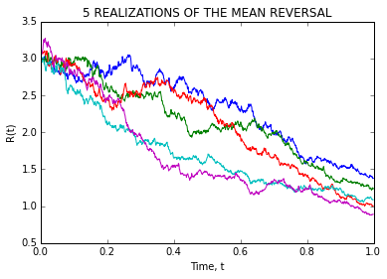 Example 1.2

As per requested by the question, we only plot 5 realizations of the mean reversal process with Time, t as x-label and R(t) as y-label. From the two graph at above, we can know that there is some different between the example 1.1 and example 1.2.

From the equation: R[:,col+1]=R[:,col]+(theta*R[:,col])*dt+sigma*R[:,col]*dB[:,col+1]

We can know that each column is calculated towards the previous column. Besides, we add the range limit of n(1000).

In order to calculate an accurate expected value of R(1) based on the simulation, we picked the R value at year 1 for all paths that we called this as x. Hence, the E[R(1)] is the mean of x.

Besides that, we have to find out all the possible R values that are larger than 2 in order to calculate the probability that the R(1) is larger than 2. Then, added together all the possible R values that are larger than 2. Therefore, the P[R(1)>2] is equal to total sum of all possible R values that are larger than 2 dividing by the 1000 runs.

**REPORT FOR TASK 2 (QUESTION 1)**

There are total 30 component stocks in FTSE Bursa Malaysia KLCI. The details were taken at 23/07/2015.

|  |  |  |  |  |  |  |
| --- | --- | --- | --- | --- | --- | --- |
| **BIL** | **STOCK SECTOR** | **STOCK NAME** | **STOCK  CODE** | **WEIGHTED IN  FTSEKLCI %** | **P/E RATIO** | **NET MARKET CAPITAL**  **(in Billion)** |
| 1 | Banks | CIMB Group Holdings | 1023 | 5.76 | 17.42 | 47.29 |
| 2 | AMMB Holdings | 1015 | 2.38 | 8.88 | 17.42 |
| 3 | Hong Leong Bank | 5819 | 1.67 | 11.74 | 14.74 |
| 4 | Hong Leong Financial | 1082 | 0.64 | 9.97 | 16.63 |
| 5 | Public Bank Bhd | 1295 | 11.60 | 15.34 | 73.99 |
| 6 | RHB Capital | 1066 | 1.06 | 9.37 | 19.52 |
| 7 | Malayan Banking | 1155 | 9.32 | 12.41 | 87.85 |
| 8 | Telecommunications | Axiata Group Bhd | 6888 | 5.62 | 24.31 | 55.52 |
| 9 | Digi.com | 6947 | 4.16 | 20.75 | 42.14 |
| 10 | Maxis Bhd | 6012 | 3.45 | 30.09 | 49.41 |
| 11 | Telekom Malaysia | 4863 | 2.96 | 32.63 | 25.14 |
| 12 | Alternative Electricity | Tenaga Nasional | 5347 | 9.28 | 9.16 | 69.53 |
| 13 | Diversified Industrials | Sime Darby Bhd | 4197 | 5.51 | 21.66 | 53.91 |
| 14 | Hotels | Genting | 3182 | 3.68 | 19.49 | 31.52 |
| 15 | Genting Malaysia Bhd | 4715 | 2.50 | 20.45 | 25.71 |
| 16 | Commodity Chemicals | PETRONAS Chemicals  Group Bhd | 5183 | 3.55 | 22.21 | 52.8 |
| 17 | Exploration & Production | Petronas Gas | 6033 | 3.40 | 22.83 | 42.5 |
| 18 | Health Care Providers | IHH Healthcare | 5225 | 3.28 | 63.42 | 48.59 |
| 19 | Farming & Fishing | IOI | 1961 | 2.99 | 74.43 | 27.84 |
| 20 | Kuala Lumpur Kepong | 2445 | 2.28 | 29.18 | 24.55 |
| 21 | Oil Equipment & Services | SapuraKencana Petroleum | 5218 | 1.98 | 12.03 | 14.44 |
| 22 | Integrated Oil & Gas | Petronas Dagangan Bhd | 5681 | 1.21 | 37.02 | 20.52 |
| 23 | Food Products | PPB Group | 4065 | 1.80 | 17.73 | 18.14 |
| 24 | Tobacco | British American Tobacco  (Malaysia) | 4162 | 1.70 | 20.11 | 18.76 |
| 25 | Multiutilities | YTL Corp | 4677 | 1.63 | 15.05 | 17.38 |
| 26 | Automobiles | UMW Holdings | 4588 | 1.37 | 20.37 | 11.94 |
| 27 | Broadcasting & Entertainment | Astro Malaysia Holdings | 6399 | 1.22 | 28.69 | 15.76 |
| 28 | Transportation | MISC | 3816 | 2.45 | 16.07 | 36.07 |
| 29 | Westports Holdings | 5246 | 0.93 | 26.86 | 14.39 |
| 30 | Real Estate Holding &  Development | KLCC Prop&Reits-Stapled Sec | 5235SS | 0.63 | 28.16 | 12.66 |
|  |  |  |  | 100.01 |  |  |

**REPORT FOR TASK 2 (QUESTION 2)**

For question 2, I had chosen Malayan Banking with code 1155 to download its daily data from Yahoo! Finance starting from 1 Jan 2011 until 31 Dec 2014.

Firstly, I have assigned the data of Malayan Banking into an array that I named it as data. After get the data for 3 years, I added up all the cumulative closing price and form an empty matrix with 2 rows. The first row is for the cumulative sum of data start from the fifth day until the last day that I named it as matrix[0,:]. The second row is for the total which is starting from the first day until the last five days that I named it as matrix[1,1:]. Hence, the formulae for calculating the 5-days moving average is matrix[0,:] minus matrix[1,1:] the dividing by 5-days.

So, the data of Malayan Banking is plotted as shown as below:

The title of the graph is 5-days moving average of Malayan Banking from 1 Jan 2011 to 31 Dec 2014. Besides, I have labeled the x-axis as days and y-axis as 5 days average.

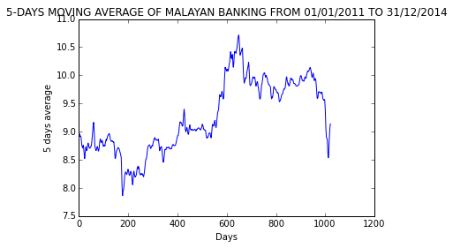 Example 2.1

In addition, I had computed the correlation of Malayan Banking with FTSEKLCI. The result that I get as shown as below:

|  |
| --- |
| THE CORRELATION OF MALAYAN BANKING IS  1155.KL ^KLSE  1155.KL 1.000000 0.898374  ^KLSE 0.898374 1.000000 |