**Familiar Strangers in ATAC-seq**

**Topic 1: The Structure of Tn5 Transposon**

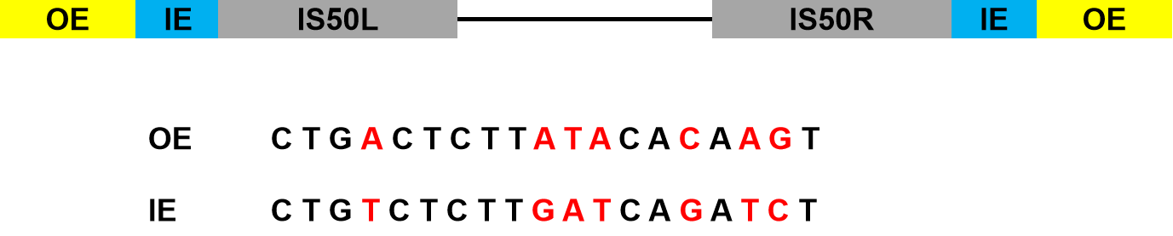

**Figure 1. The structure of Tn5 transposon.** Tn5 is composed of two insertion sequences IS50L and IS50R. IS50R codes for Tn5 transposase. Each insertion sequence is flanked by 19-bp end sequences termed outside end (OE) and inside end (IE). The grey box represents the OE and the yellow box represents the IE. The OE and IE differ by 7 bases (shown in red)[1](#_ENREF_1" \o "Bhasin, 1999 #1).

**Topic2: Cleavage step: formation of the synaptic complex**

Transposase binds to the transposon DNA at the end recognition sequences (OE). Then the end sequences are brought together via transposase oligomerization to form a complex nucleo-protein structure termed a synaptic complex[2](#_ENREF_2" \o "Mizuuchi, 1992 #2), [3](#_ENREF_3" \o "Sakai, 1995 #3). Once a stable synaptic complex has been formed, it can cut the transposon to form a 3’ hydrolytic nick. The free 3’OH then attacks the phosphodiester bond on the opposite strand, forming a hairpin at the transposon end[1](#_ENREF_1" \o "Bhasin, 1999 #1) (that’s why some paper called it a blunt end). Then the hairpin will be solved by a transposase-catalysed hydrolytic cleavage. For more detailed information is shown in Figure2[4](#_ENREF_4" \o "Gradman, 2008 #4).

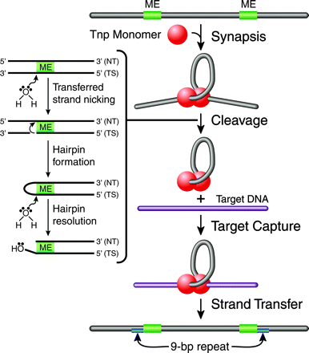

**Figure 2. Tn5 transposition mechanism[4](#_ENREF_4" \o "Gradman, 2008 #4).** Transposition is initiated by

Tnp binding to the transposon-specifific ESs and the formation of a

highly ordered nucleoprotein complex (synaptic complex) through a

process called synapsis. The synaptic complex contains two protomers

of Tnp, which exist as a dimer, and two ESs. Catalytic cleavage occurs

when an activated water molecule coordinated by Mg2+ nicks the

transferred DNA strand (TS) on both sides of the transposon, through

a nucleophilic attack, forming a 3’-hydroxyl group. The free 3’-hydroyxl

group acts as a nucleophile and cleaves the nontransferred DNA strand (NT), forming a hairpin. A second activated water molecule resolves the hairpin, resulting in a double-stranded DNA cleavage product. The postcleavage synaptic complex is now free to bind to target DNA through target capture. The 3’-hydroxyl group of the transposon end attacks the phosphodiester backbone of target DNA during strand transfer. A 9-bp duplication in the target results, due to the staggered strand transfer reactions followed by DNA repair by host

enzymes.

**Topic 3: Strand transfer**

The two 3’OH groups are 41 Å apart, slightly further than desired for attacking the two target phosphodiester bonds the required 9 bp apart. After target capture, the two 3’OH ends attack the target DNA phosphates 9 bp apart resulting in integration of the transposon into the target. That is why some papers said that 3’OHs attack phosphodiester bonds in the target DNA in a staggered fashion and this will form the two 9-bp duplications flanking the inserted sequences (Figure 3[5](#_ENREF_5" \o "Reznikoff, 2003 #5)).

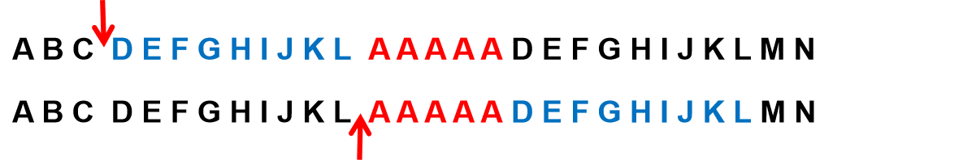**Figure 3. Schematic of the formation of 9 duplicated sequences.** The segment AAAAA represents the inserted sequence (colored in red) and the segment DEFGHIJKL represents the 9-bp repeat.

**Reference**

1 Bhasin A, Goryshin IY, Reznikoff WS. Hairpin formation in Tn5 transposition. *Journal of Biological Chemistry* 1999; **274**:37021-37029.

2 Mizuuchi M, Baker TA, Mizuuchi K. Assembly of the active form of the transposase-Mu DNA complex: a critical control point in Mu transposition. *Cell* 1992; **70**:303-311.

3 Sakai J, Chalmers RM, Kleckner N. Identification and characterization of a pre‐cleavage synaptic complex that is an early intermediate in Tn10 transposition. *The EMBO journal* 1995; **14**:4374-4383.

4 Gradman RJ, Reznikoff WS. Tn5 synaptic complex formation: role of transposase residue W450. *Journal of bacteriology* 2008; **190**:1484-1487.

5 Reznikoff WS. Tn5 as a model for understanding DNA transposition. *Molecular microbiology* 2003; **47**:1199-1206.