**Background for Tn5 transposase**

Familiar Strangers in ATAC-seq

ATAC: Assay for Transposase Accessible Chromatin

**The characteristics of Tn5 transposon: The Structure of Tn5 Transposon**

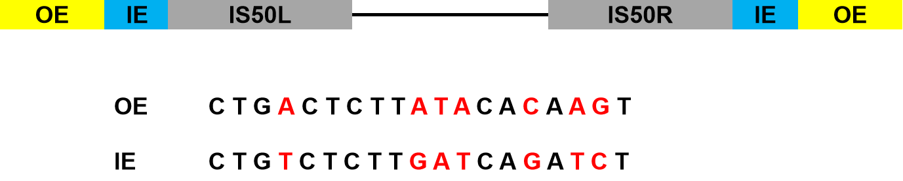

**Figure 1. The structure of Tn5 transposon.** Tn5 is composed of two insertion sequences IS50L and IS50R. IS50R codes for Tn5 transposase. Each insertion sequence is flanked by 19-bp end sequences termed outside end (OE) and inside end (IE). The grey box represents the OE and the yellow box represents the IE. The OE and IE differ by 7 bases (shown in red)[1](#_ENREF_1" \o "Bhasin, 1999 #1).

**The characteristics of the wild type and hyperactive Tn5 transposases.**

The Tn5 transposase is 476-amino-acid long and it is inactive in vivo. It contains a DNA binding domain (N-terminus) and a dimerization domain (C-terminus). These two domains may inhibit each other’s activity most likely because they are located close to each other[2](#_ENREF_2" \o "York, 1996 #7), [3](#_ENREF_3" \o "Braam, 1999 #8). so it is necessary to get some sort of conformation change to separate these two domains[4](#_ENREF_4" \o "Reznikoff, 2002 #6). Researchers had got a hyperactive Tn5 transposase contained mutations. EK54 enhances OE binding activity of Tnp[5](#_ENREF_5" \o "Zhou, 1997 #9). MA56 blocks the synthesis of Inh[6](#_ENREF_6" \o "Wiegand, 1992 #10), thus removing its possible inhibitory activity from the reaction. LP372 enhances Tnp activity possibly by altering the dimerization potential for Tnp[7](#_ENREF_7" \o "Weinreich, 1994 #11).

**The mechanism of transposation by Tn5 transposase**

**①** cleavage step: formation of the synaptic complex

Transposase binds to the transposon DNA at the end recognition sequences (OE). Then the end sequences are brought together via transposase oligomerization to form a complex nucleo-protein structure termed a synaptic complex[8](#_ENREF_8" \o "Mizuuchi, 1992 #2), [9](#_ENREF_9" \o "Sakai, 1995 #3). Once a stable synaptic complex has been formed, it can cut the transposon to form a 3’ hydrolytic nick. The free 3’OH then attacks the phosphodiester bond on the opposite strand, forming a hairpin at the transposon end[1](#_ENREF_1" \o "Bhasin, 1999 #1) (that’s why some paper called it a blunt end). Then the hairpin will be solved by a transposase-catalysed hydrolytic cleavage. For more detailed information is shown in Figure2[10](#_ENREF_10" \o "Gradman, 2008 #4).

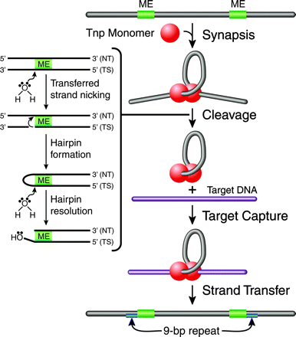

**Figure 2. Tn5 transposition mechanism[10](#_ENREF_10" \o "Gradman, 2008 #4).** Transposition is initiated by

Tnp binding to the transposon-specifific ESs and the formation of a

highly ordered nucleoprotein complex (synaptic complex) through a

process called synapsis. The synaptic complex contains two protomers

of Tnp, which exist as a dimer, and two ESs. Catalytic cleavage occurs

when an activated water molecule coordinated by Mg2+ nicks the

transferred DNA strand (TS) on both sides of the transposon, through

a nucleophilic attack, forming a 3’-hydroxyl group. The free 3’-hydroyxl

group acts as a nucleophile and cleaves the nontransferred DNA strand (NT), forming a hairpin. A second activated water molecule resolves the hairpin, resulting in a double-stranded DNA cleavage product. The postcleavage synaptic complex is now free to bind to target DNA through target capture. The 3’-hydroxyl group of the transposon end attacks the phosphodiester backbone of target DNA during strand transfer. A 9-bp duplication in the target results, due to the staggered strand transfer reactions followed by DNA repair by host

enzymes.

**②** Strand transfer

The two 3’OH groups are 41 Å apart, slightly further than desired for attacking the two target phosphodiester bonds the required 9 bp apart. After target capture, the two 3’OH ends attack the target DNA phosphates 9 bp apart resulting in integration of the transposon into the target. That is why some papers said that 3’OHs attack phosphodiester bonds in the target DNA in a staggered fashion and this will form the two 9-bp duplications flanking the inserted sequences (Figure 3[11](#_ENREF_11" \o "Reznikoff, 2003 #5)).

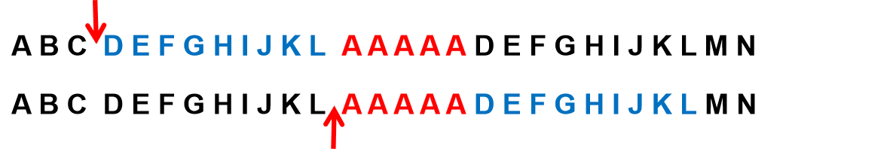**Figure 3. Schematic of the formation of 9 duplicated sequences.** The segment AAAAA represents the inserted sequence (colored in red) and the segment DEFGHIJKL represents the 9-bp repeat.

**The Tn5 transposase integrates DNA fragments at a specific site in the nucleosomal DNA.**

The nucleosomes are connected with the linker DNA segments in chromatin. In the nucleus, the linker DNA lengths are not uniform. Researchers had found that Tn5 transposase preferentially targets near the entry-exit DNA regions within the nucleosome[12](#_ENREF_12" \o "Sato, 2019 #12). The linker DNA between the two nucleosomes is important for the Tn5 transposase activity.

**Reference**

1 Bhasin A, Goryshin IY, Reznikoff WS. Hairpin formation in Tn5 transposition. *Journal of Biological Chemistry* 1999; **274**:37021-37029.

2 York D, Reznikoff WS. Purification and biochemical analyses of a monomeric form of Tn 5 transposase. *Nucleic acids research* 1996; **24**:3790-3796.

3 Braam LAM, Goryshin IY, Reznikoff WS. A Mechanism for Tn5 Inhibition carboxyl-terminal dimerization. *Journal of Biological Chemistry* 1999; **274**:86-92.

4 Reznikoff WS. Tn5 transposition. Mobile DNA II: American Society of Microbiology 2002:403-422.

5 Zhou M, Reznikoff WS. Tn 5 transposase mutants that alter DNA binding specificity. *Journal of molecular biology* 1997; **271**:362-373.

6 Wiegand TW, Reznikoff WS. Characterization of two hypertransposing Tn5 mutants. *Journal of bacteriology* 1992; **174**:1229-1239.

7 Weinreich MD, Gasch A, Reznikoff WS. Evidence that the cis preference of the Tn5 transposase is caused by nonproductive multimerization. *Genes & development* 1994; **8**:2363-2374.

8 Mizuuchi M, Baker TA, Mizuuchi K. Assembly of the active form of the transposase-Mu DNA complex: a critical control point in Mu transposition. *Cell* 1992; **70**:303-311.

9 Sakai J, Chalmers RM, Kleckner N. Identification and characterization of a pre‐cleavage synaptic complex that is an early intermediate in Tn10 transposition. *The EMBO journal* 1995; **14**:4374-4383.

10 Gradman RJ, Reznikoff WS. Tn5 synaptic complex formation: role of transposase residue W450. *Journal of bacteriology* 2008; **190**:1484-1487.

11 Reznikoff WS. Tn5 as a model for understanding DNA transposition. *Molecular microbiology* 2003; **47**:1199-1206.

12 Sato S, Arimura Y, Kujirai T *et al.* Biochemical analysis of nucleosome targeting by Tn5 transposase. *Open biology* 2019; **9**:190116.