**NGS Glossaries**

**Sequencing depth:** The average number of sequenced bases that align to, or “cover,” known reference bases. For example, a whole genome sequenced at 30× coverage means that, on average, each

base in the genome was sequenced 30 times. The sequencing coverage level often determines whether variant discovery can be made with a certain degree of confidence at particular base positions.

**Molecular barcoding:** Unique molecular identifiers (UMIs) provide the highest levels of error correction and accuracy. UMIs are short sequences, often with degenerate bases, that incorporate a unique barcode onto each molecule within a given sample library. UMIs have been shown to reduce the rate of false-positive variant calls and increase sensitivity of variant detection. By incorporating individual barcodes on each original DNA fragment, variant alleles present in the original sample (true variants) can be distinguished from errors introduced during library preparation, target enrichment, or sequencing. Any identified errors can be removed by bioinformatics methods before final data analysis.

**DNA/RNA sequences recorded direction: from 5’ to 3’:**

An example of two complementary strands of DNA would be:

(5' -> 3') ATGGAATTCTCGCTC      (Coding, sense strand)  
(3' <- 5') TACCTTAAGAGCGAG      (Template, antisense strand)

(5' -> 3') AUGGAAUUCUCGCUC (mRNA made from Template strand)

**Frequently asked questions in NGS**

### **Adapter trimming:** Why are adapter sequences trimmed from only the 3' ends of reads?

The adapters contain the sequencing primer binding sites, the index sequences, and the sites that allow library fragments to attach to the flow cell lawn. Libraries prepared with Illumina library prep kits require adapter trimming only on the 3’ ends of reads, because adapter sequences are not found on the 5’ ends (Figure1).

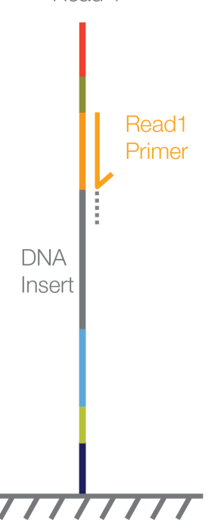

Figure1 Illustration the reason of why adapter sequences only occur in the 3’ end.

**3’**

**5’**

The following picture (Figure2) shows the structures of adapter variants.

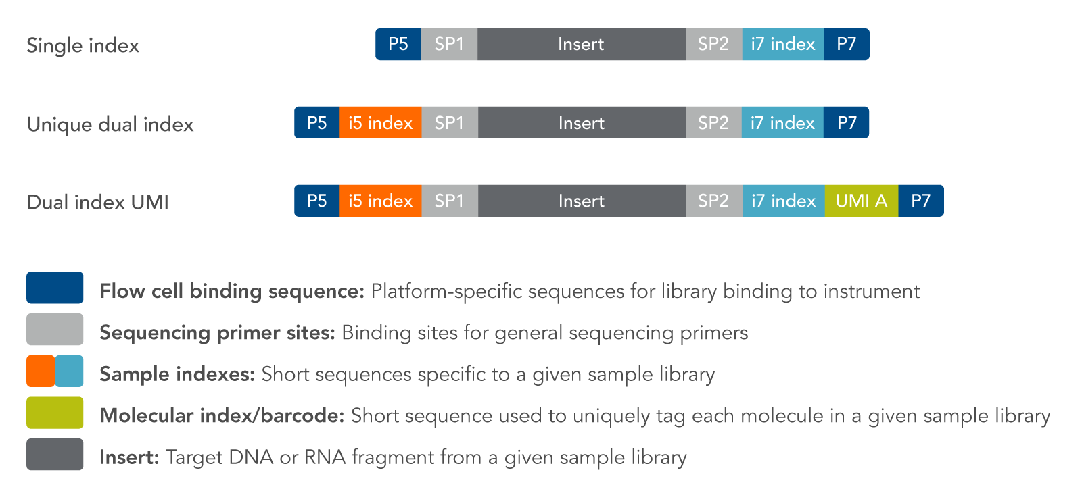

Figure2 Adapter variants for NGS. The primers are adjacent to the inserted segments.