高等應用數學 HW3 黃展皇110621013

1.

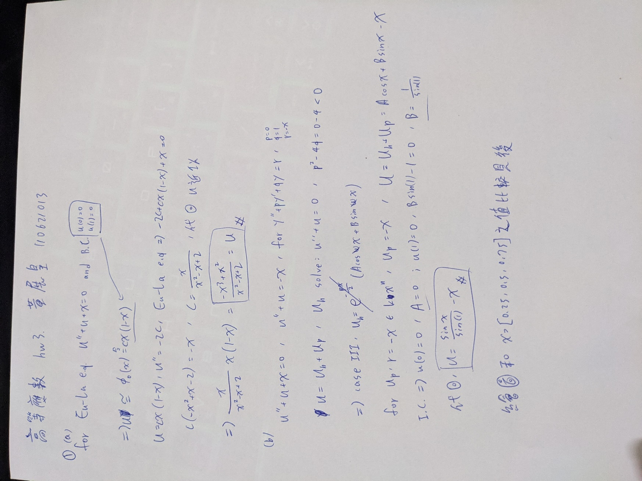

在-10~10區間的解析解vs.近似解，以及解析解-近似解的差值：

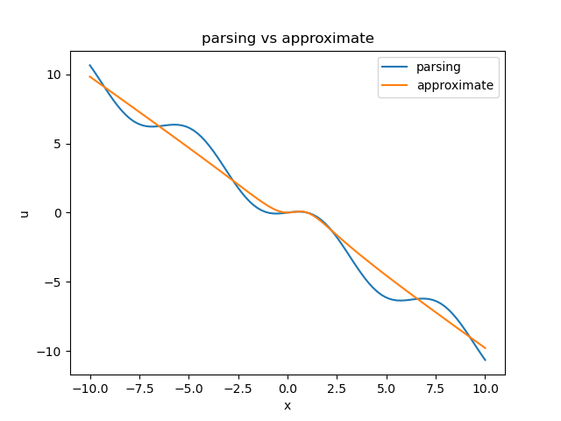

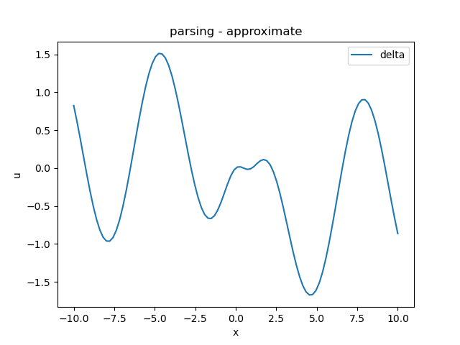

在-2~2區間的解析解vs.近似解，以及解析解-近似解的差值：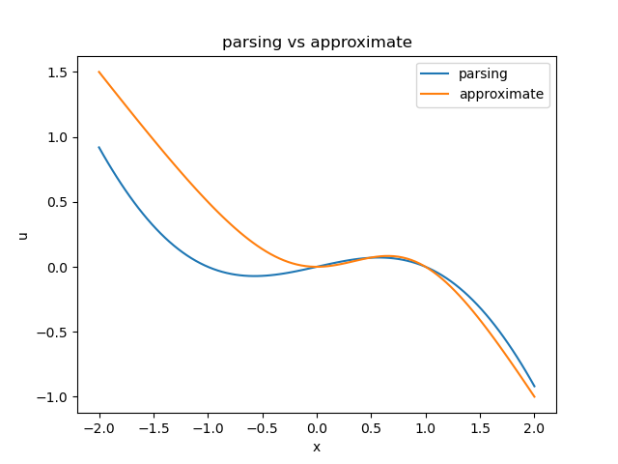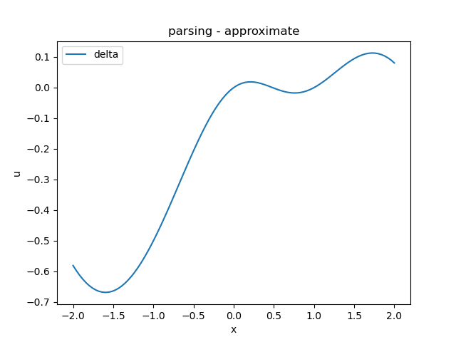

最後可知在x=[0.25, 0.5, 0.75]時

解析解：[0.0440, 0.0697, 0.0601]

近似解：[0.0259, 0.0714, 0.0776]

2.如下兩圖，分別為cubic spline計算各區段係數與繪圖結果，自然邊界條件

|  |  |  |  |  |
| --- | --- | --- | --- | --- |
|  | a | b | c | d |
| i =0 | 0.8036 | 0 | 1.1964 | -7 |
| i =1 | 0.9821 | 2.4107 | 3.6071 | -5 |
| i =2 | -0.7321 | 5.3571 | 11.375 | 2 |
| i =3 | -1.0536 | 3.1607 | 19.8929 | 18 |

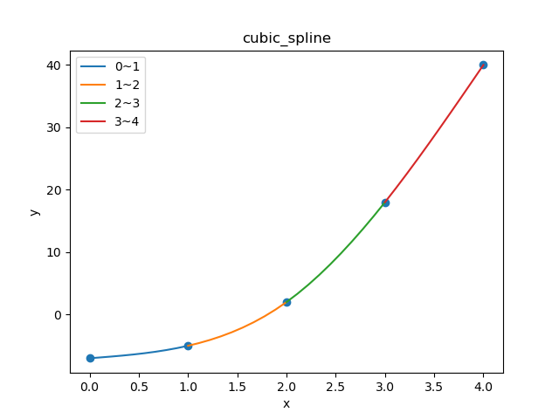

3. 如下兩圖，分別為cubic spline計算各區段係數與繪圖結果，自然邊界條件

|  |  |  |  |  |
| --- | --- | --- | --- | --- |
|  | a | b | c | d |
| i =0 | 7.0906 | 0 | -35.0906 | 20 |
| i =1 | -4.9313 | 21.2719 | -13.8187 | -8 |
| i =2 | 1.1319 | -8.3157 | 12.0936 | 10 |
| i =3 | -0.1559 | 1.8712 | -7.2400 | 2 |

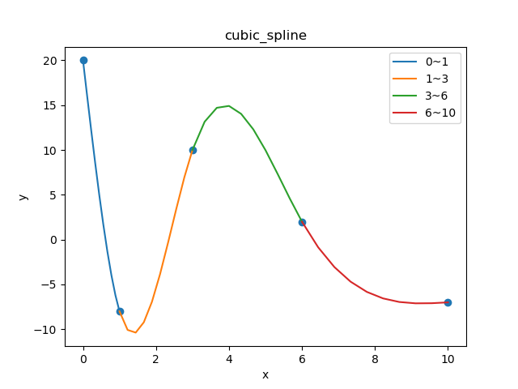

提供題2題3原始碼：(環境python3.8.10，numpy、matplotlib套件)

import numpy as np

# give arr -> LU, check ok

def LU_decomposition(arr):

assert len(arr.shape)==2

assert arr.shape[0]==arr.shape[1]

n = arr.shape[0]

L = np.full_like(arr, 0.0, dtype=np.double)

for i in range(n):

L[i][i] = 1.0

for col in range(n-1):

for row in range(col+1, n):

L[row][col] = arr[row][col] / arr[col][col]

arr[row] = arr[row] - L[row][col]*arr[col]

return L, arr

# use LU_decomposition to solve linear eq, check ok

def LU_solve_eq(A, B):

n = B.shape[0]

L, U = LU_decomposition(A)

D, m = np.zeros_like(B), np.zeros_like(B)

# LD = B

for i in range(n):

D[i] = B[i]

for j in range(i+1, n):

B[j] -= L[j][i] * D[i]

# Um = D

for i in range(n-1, -1, -1):

m[i] = D[i] / U[i][i]

for j in range(i-1, -1, -1):

D[j] -= U[j][i] * m[i]

return m

def get_cubic_spline_coefficient(x, y):

n = len(x)-1 # intervel nums

h = [x[i+1]-x[i] for i in range(n)]

A = np.zeros((n+1, n+1))

B = np.zeros((n+1))

# natural condition

A[0][0] = 1

A[n][n] = 1

for i in range(1, n):

A[i][i] = 2*(h[i-1]+h[i])

A[i][i-1] = h[i-1]

A[i][i+1] = h[i]

B[i] = 6*((y[i+1]-y[i])/h[i] - (y[i]-y[i-1])/h[i-1])

m = LU_solve_eq(A, B)

coefficient = []

for i in range(n):

coef = []

coef.append((m[i+1]-m[i])/6/h[i])

coef.append(m[i]/2)

coef.append((y[i+1]-y[i])/h[i] - h[i]*m[i]/2 - h[i]*(m[i+1]-m[i])/6)

coef.append(y[i])

coefficient.append(coef)

return coefficient

def cubic_spline_plot(x, y, coefficient):

import matplotlib.pyplot as plt

n = len(x)-1 # intervel nums

plt.scatter(x, y)

for i in range(n):

plot_x = np.linspace(x[i], x[i+1], 10)

plot_x_to_y = np.linspace(0.0, x[i+1]-x[i], 10)

plot_y = coefficient[i][0]*plot_x_to_y**3 + coefficient[i][1]*plot_x_to_y**2 + coefficient[i][2]*plot_x_to_y**1 + coefficient[i][3]*plot_x_to_y**0

plt.plot(plot_x, plot_y, label='{}~{}'.format(str(x[i]), str(x[i+1])))

plt.legend()

plt.title('cubic_spline')

plt.xlabel('x')

plt.ylabel('y')

plt.show()

plt.close()

if __name__ == '__main__':

print('gogo')

x = [0, 1, 2, 3, 4]

y = [-7, -5, 2, 18, 40]

coefficient = get_cubic_spline_coefficient(x, y)

print('coefficient:', coefficient)

cubic_spline_plot(x, y, coefficient)

x = [0, 1, 3, 6, 10]

y = [20, -8, 10, 2, -7]

coefficient = get_cubic_spline_coefficient(x, y)

print('coefficient:', coefficient)

cubic_spline_plot(x, y, coefficient)