Date of publication xxxx 00, 0000, date of current version xxxx 00, 0000.
Digital Object Identifier 10.1109/ACCESS.2017.Doi Number
Defect Inspection Application for Ski Goggle Lenses
Dinh-Thuan Dang¹, Jing-Wein Wang², (Member, IEEE),
¹Department of Electronics Engineering, National Kaohsiung University of Science and Technology, Kaohsiung 80778, Taiwan
²Institute of Photonics Engineering, National Kaohsiung University of Science and Technology, Kaohsiung 80778, Taiwan
³E

Corresponding author: Jing-Wein Wang (e-mail: jwwang@ nkust.edu.tw).
This work was supported in part by the Ministry of Science and Technology, Taiwan, under Grant
ABSTRACT Ski goggles are helpful to protect the eyes and enhance eyesight. The quality of ski goggles has leaped with technological advances, but so have the defects on its lenses. This work presents the AI-based defect detection system for ski goggle lenses based on the supervised learning approach. In the first step, we set up the optical inspection system that includes cameras and light sources. This step aims to capture clear and high-resolution images from the lenses and annotate the defects' type. Next, we detect defects by fine-tuning the specific object detector suitable for mobile devices because most automatic optical inspection devices are low-power electronics. The mentioned mobile-friendly object detection model that is the MobileNetV3 backbone was used in a Feature Pyramid Network along with the Faster-RCNN detector. Our experiments demonstrate the effectiveness of defect detection; also, the inference speed is fast. The defect detection accuracy achieves a mAP of 55%. Our work' highlights are the automatic integration of all steps, from capturing images to defect detection. Besides, we also publicize an available goggle defect dataset under the COCO standard for future research.
INDEX TERMS Ski goggle lens, surface defect, automatic optical inspection, two-stage object detector, faster-RCNN, MobileNetV3

I. INTRODUCTION
Winter sporting activities are much enjoyable, like skiing, snowboarding, and snowshoeing. Ski goggles are the crucial equipment to perform better in these activities. There are many advantages that can help protect your eyes from harmful ultraviolet rays, provide safety protection for both your eyes and face, and offer color and contrast enhancement. Fig. 1 shows some samples of ski goggles.
The most critical component of ski goggles is its lens that makes an unrivaled visual experience. In the ski goggles manufacturing process, there are defects [1], [2] on the surface of the lens that are unavoidable. So, the lens manufacturers should deploy the visual defect inspection system [3], [4] to improve the product quality.
There are some challenging issues in the defect inspection for the ski goggles’ lenses. Firstly, the lens surfaces are curved and different in size, so it is challenging to design the image acquisition system to capture its entire surface. Fig. 2 shows some lens samples which are a typical size. Secondly, the color of the lenses is coated with various tints, so it is a challenge to customize the light source because of the multiple reflections. Thirdly, some surface defects are tiny, which are inconspicuous and subtle. That is to say, detection of such minor defects is particularly difficult, that requires higher precision.
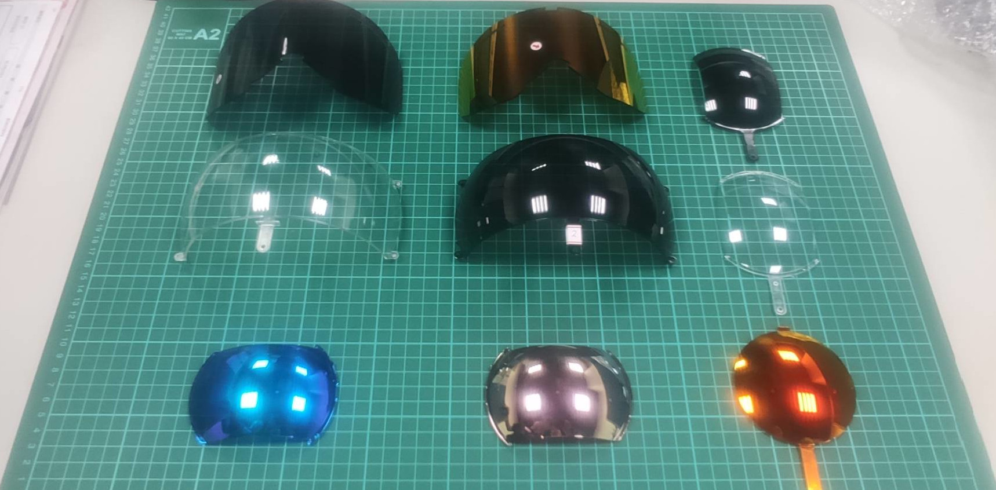
FIGURE 1. Some lens samples of ski goggles. They have different sizes and curvatures. In addition, its colors are varied.
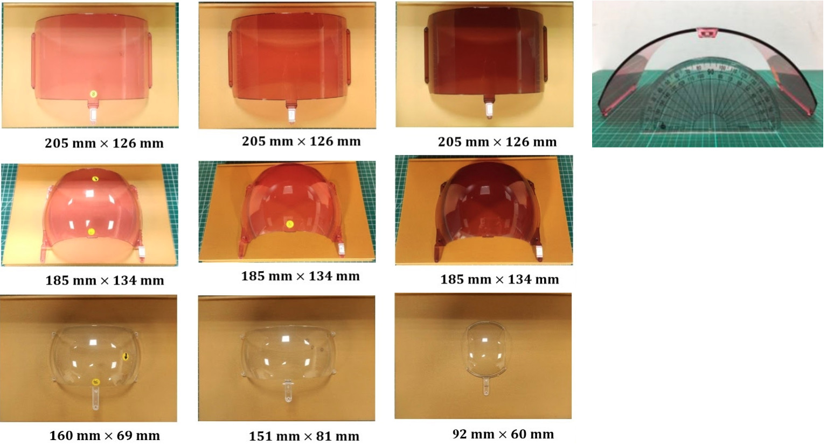
FIGURE 2. Some standard sizes of the ski goggle lenses. The width ranges from 92 to 205 mm, and the height ranges from 60 to 126 mm.
Artificial intelligence (AI) technologies can help organizations gain an edge over the competition [5]. AI has proven especially beneficial for improving product quality, lowering costs. For manufacturers, AI promises benefits at every level of the value chain. The AI-based system can detect defects faster and more accurately than the human eye.
From the above challenges and trends, the work of this paper is to include: (1) develop an image acquisition model to capture the surface of ski goggle lenses, (2) build a defect dataset of lenses by labeling data, (3) fine-tune the most suitable deep learning model for recognizing defects.
The paper is organized as follows. Section II introduces some related works before presenting the image acquisition technique, labeling data for defects, and the defect detection model in deep learning in Section III. Section IV presents some experiments for defect detection with other models and fine-tuned procedures. Section V contains the conclusion and future work.
II. RELATED WORKS
A. OPTICAL ILLUMINATION
To ensure the stability of the image and obtain a high contrast image, an optical illumination platform needs to overcome the interference of environmental lighting. The main goal of optical illumination is to make the important features of the objects can be prominent and reduce undesired features. The development of optical illumination has a long history [6]. In the 1980s, with the transition of vision defect inspection systems from laboratory to industry, the important role of optical illumination in the visual inspection system has been understood at a preliminary level. In [7], Mersch analyzed the application of color filters and polarization. He pointed out the advantages of optical fiber lighting for the illumination of a small area. Furthermore, he discussed the flash lighting technology and fluorescent marking lighting method. In [8], Sieczka et al. discussed some important factors related to light sources such as light source size, packaging, light divergence, and spectral content. In [9], Kopparapu proposed the design method combining multiple lighting sources to achieve uniform illumination. Until now, optical illumination still plays a significant role in visual inspection systems. a specially designed optical illumination can also meet the real-time requirements of the production line visual inspection. Optical illumination design should be considered carefully.
Light source: The light emits an energy source for image formation. Common light source devices include LED lamps of various shapes, optical fiber halogen lamps, high-frequency fluorescent. LED lamps are a common device used in machine vision applications. The common structures of LED lamps are the circular ring array and the linear array. In some particular scenarios, an LED light source can be customized in several array configurations to achieve the desired irradiance [10], [11]. Based on wavelength, light is classified as visible light and invisible light. The visible light is emitted from the white, blue, red, green light source. Invisible light could be ultraviolet light, infrared light, or X-rays. To enhance the visibility of desired features, it is necessary to consider the rule of the propagation of light on the surface of different materials, and the relationship between the wavelength of light and the color of objects. These matters depend on types of designs of illumination structure.
The illumination structure is classified by some factors. Based on the position of the light source, object, and camera, the illumination can be divided into forward and back illuminations. Based on the performance of the light source, it can be divided into stroboscopic light and structured light. Fig. 3 shows some modes of the forward light and back light.
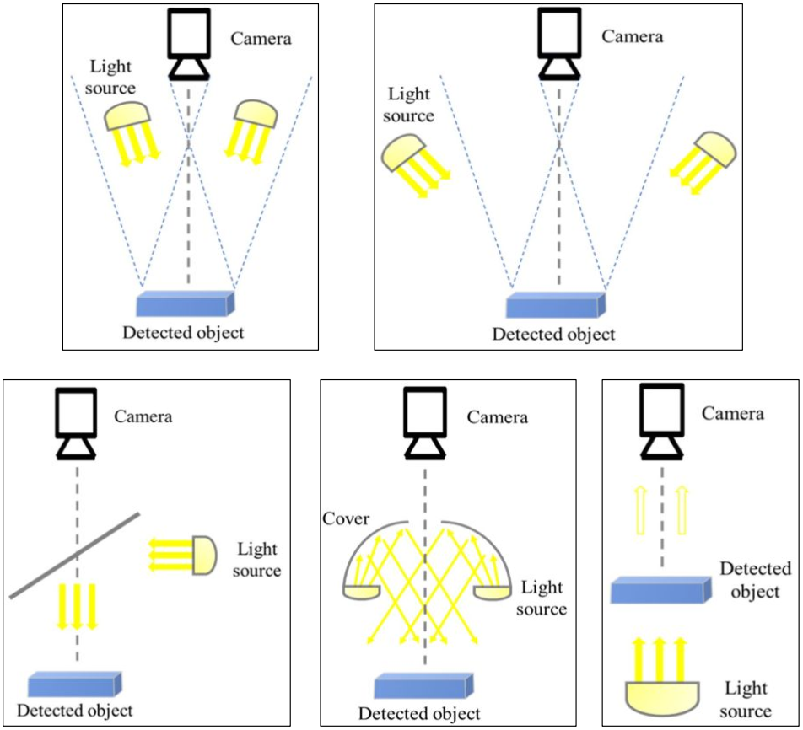
FIGURE 3. Some light source schemas in image acquisition system.
B. IMAGE ACQUISITION
There are three steps to acquiring an image. The appropriate optical illumination shines the object of interest, leading to the object's surface reflecting the amount of energy. The optical lens focuses on the region of interest. The camera sensor measures the energy on the surface. The optical signal is transformed into a digital signal that the computer can process into an image. Image acquisition technology focuses on the attributes of sensor devices and the field of view design. The sensor devices transform the optical signals into electrical signals. There are two types of photosensitive camera devices: the charged coupled device (CCD) [12] and the complementary metal-oxide-semiconductor (CMOS) [13]. The CCD sensors are widely used in machine vision systems. They have a series of advantages, such as low noise, minor distortion, lightweight, self-scanning, small power consumption, and high reliability. The CMOS sensors can get an image quality equal to CCD's and have made excellent power consumption and integration breakthroughs. The field of view design consists of multiple views, omnidirectional vision, micro-domain vision, multispectral, high-dynamic-range imaging, and multi-vision imaging systems. Depending on each defect detection task, it is necessary to consider the features of defects and the specific requirements to select the suitable image acquisition method. Fig. 4 shows the typical inspection system architecture and main components in the industry.
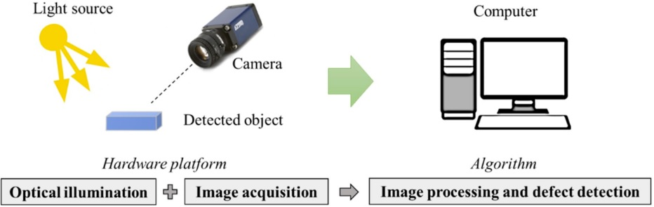
FIGURE 4. Some main components in optical inspection system.
C. OBJECT DETECTION ALGORITHM
Object detection algorithms have been widely applied to detect defects on the surface of industrial productions such as steel, plastic, wood, and silk [14], [15], [16]. The task of object detection in computer vision includes two main functions: detect localization [17] and classification [18]. In traditional computer vision, classifiers [19] such as SVM, KNN, and K-Mean clustering had played a primary role in classifying categories. Meanwhile, object localization mainly used the fast template matching-based algorithm [20].
In recent years, neural networks, machine learning, and deep learning made significant progress. Classifiers such as ResNet [21], VGG [22], EfficientNet [23], and VisionTransformer [24] achieved state of the art for classification tasks. Meantime, object localization had applied to the Anchor-based and Anchor-free methods [25]. The anchor-based approach is also called the two-stage object detector, such as the Faster R-CNN [26] family. The anchor-free approach is known as the one-stage object detectors such as YOLO [27] and FCOS [28].
The remarkable success is transparently the seamless integration of the tasks of locating and classifying many objects in deep learning. For insight, we also need to understand the automatic pipeline of the Faster R-CNN architecture deeply. The Faster R-CNN model is a systematic combination of the customizable neural sub-network blocks such as the Backbone block, Region Proposal Network (RPN) [29], and ROI-Head block.
The role of the Backbone network is to extract feature maps from the input image. The backbone network connects to the feature pyramid networks block to enhance the multi-scale feature maps. ResNet50 and ResNet100 models are usually integrated into the Backbone block.
RPN block is responsible for creating the anchor-box proposals and detecting object regions from the multi-scale feature maps. RPN plays the primary role in increasing the accuracy of object position recognition.
The ROI-Head block gets the multi-scale features from Backbone and the box proposals from RPN as the input data. The input data is fine-tuned before performing the bounding-box regression and object classification.
The following section will describe the detailed technologies for the image acquisition system of the ski goggle lenses and the defect detection algorithm. The algorithm is custom from the Faster R-CNN architecture.
III. METHODOLOGY
Fig. 5 is the fundamental paradigm for our proposed approach. The system has two modules: the image acquisition and the defect detection module. The first one is responsible for capturing the ski goggle lenses' image, extracting the region of interest, and data labeling. The second one will train the model with the input data and detect defects in the inference phase. We designed the customized object detection model based on the Faster R-CNN architecture to integrate into this module.
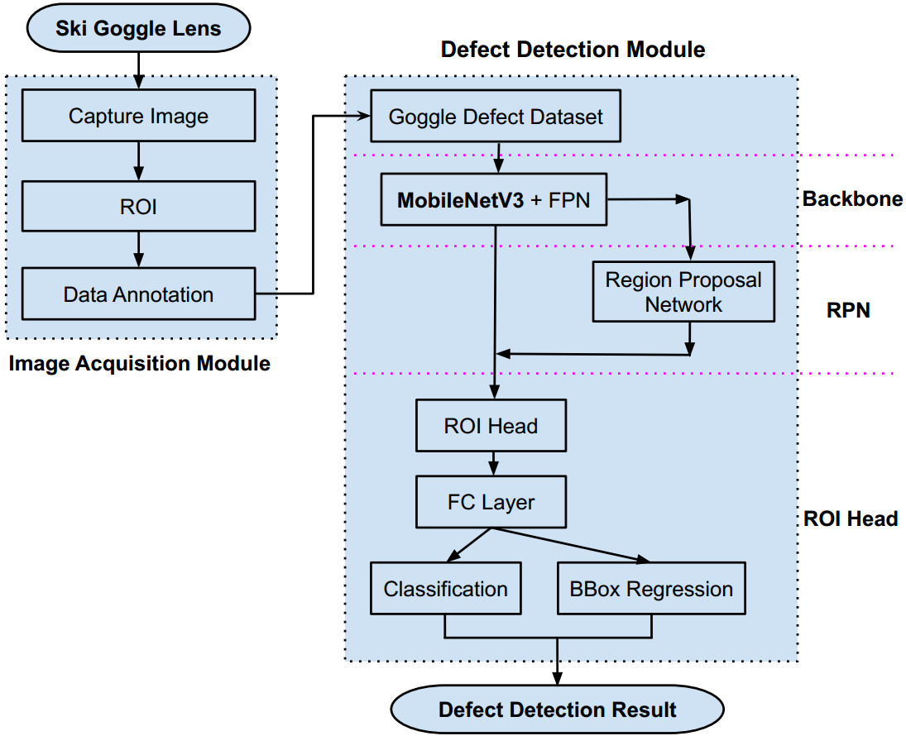
FIGURE 5. The flowchart of the proposed method. There are two modules for processing images. The first one is the image acquisition to capture the raw image, extract regions of interest, and data labeling. The second module is defect detection, which involves training data and inferencing defects. This module combines Faster R-CNN, MobileNetV3, and FPN to create the customized end-to-end model. It is compatible with data of the ski goggle lenses.
A. IMAGE ACQUISITON MODULE
This module aims to collect accurate and high-quality images from the surface of the ski goggle lenses. It also prepares the well-formatted data for the next module.
1) CAPTURE IMAGE
The first one of the module is the image capture part, which consists of the cameras, the light sources, and the ski goggle lens samples. To design the image capture system for the ski goggle lens needs to overcome some challenges mentioned in Section I. Surface of the lens is broad, and one camera can’t cover the whole of the lens surface. So we designed the image acquisition system using five cameras. Each camera will focus on each region marked on the lens, as in Fig. 6
Besides, the surface is also curved, so we designed the custom light source as in Fig. 7. The curvature of the light source is similar to the curvature of the lens, which helps to reflect uniform rays over the lens surface. The custom light source has five pieces of flat LED lights connected by an angle of 125 degrees. Fig. 8 describes the detailed design diagram of the image acquisition system. The ray of each flat LED piece transit through the lens to the opposite cameras, respectively. Fig. 9 depicts the actual pieces of equipment when deployed.
The parameters of a camera, such as resolution, sensor, pixel size, and frame rate, are significantly influential in designing the distance from the camera lens to the inspected object. Table 1 lists the parameters of the image acquisition system.
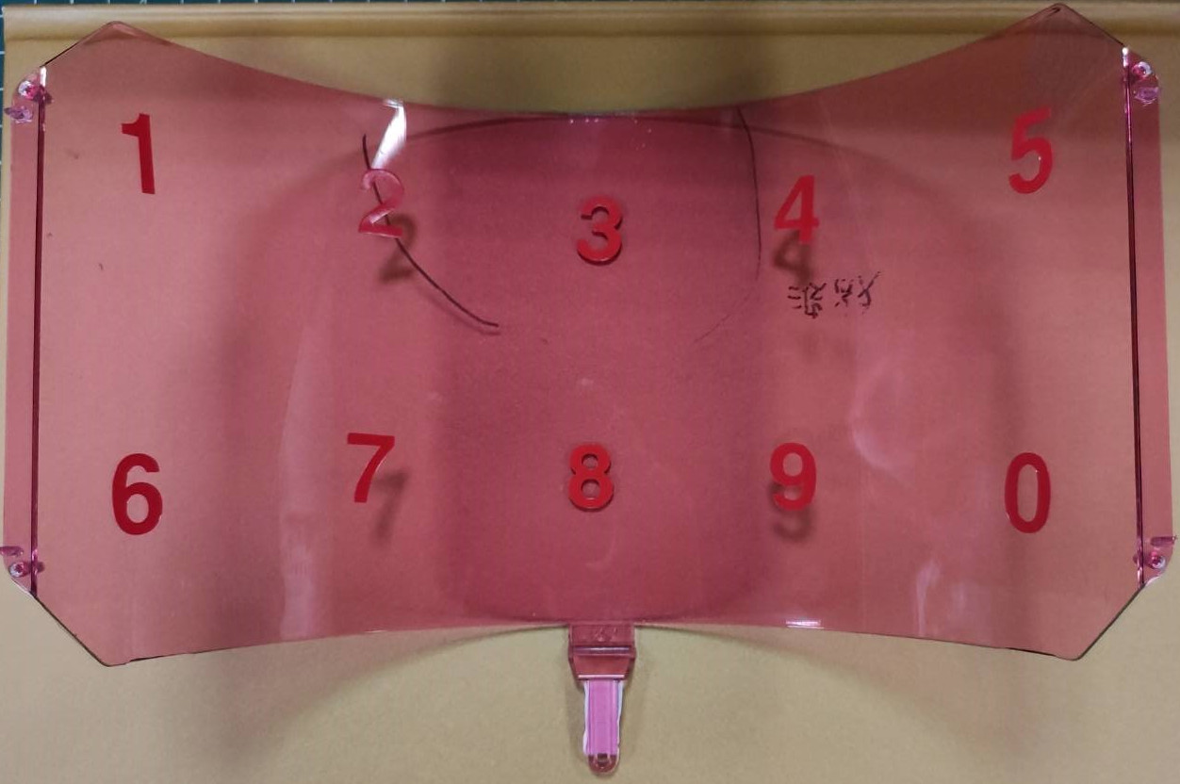
FIGURE 6. This is the ski goggle’s lens sample. It’s wide and curved; thus, we mark its surface to be easily controlled by cameras.

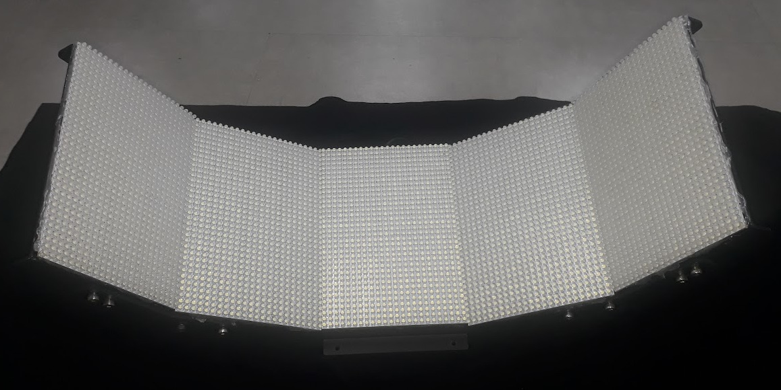
FIGURE 7. The custom light source meets the curvature of the most ski goggle lens. Five dot matrix LED modules are connected by an angle of 125°.
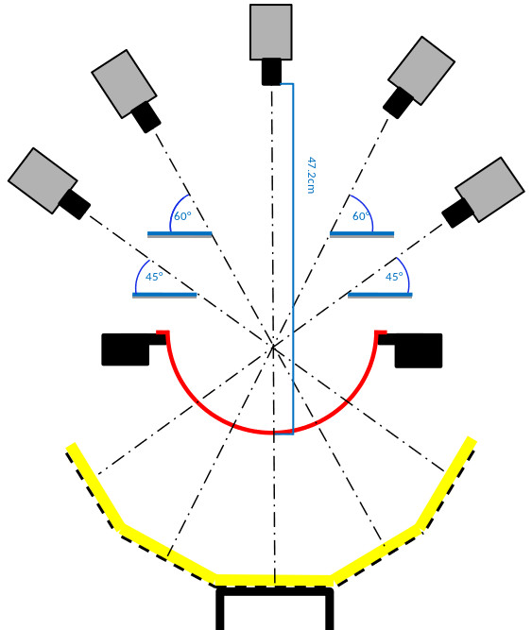
FIGURE 8. Design diagram of the image acquisition system. It has five cameras placed at the top. The custom light source (yellow) is placed at the bottom. The ski goggle's lens sample (red) is positioned in the middle and held on two sides.
Table I
the equipment description of the image acquisition system
Equipment | Producer | Specification
Camera | Basler | Model acA4112-30uc, sensor Sony IMX352, resolution 12mp, pixel size 3.45 × 3.45 µm, frame rate 30 fps.
Acquisition Card | Basler | USB 3.0 Interface Card PCIe, Fresco FL1100, 4HC, x4, 4Ports. Data transfer with rates of up to 380 MB/s per Port.
Vision Lens | Tokina | Model TC3520-12MP, image format 4/3 inch, mount C, focal length 35mm, aperture range F2.0-22
Light Source | Custom | The custom-designed light source comprises five dot matrix LED modules that are connected by an angle of 125°.
Computer | Asus | Windows 10 Pro; Hardware based on: Mainboard Asus Z590-A, CPU Intel I7-11700K, RAM 16G, VGA Gigabyte RTX 3080Ti 12GB.

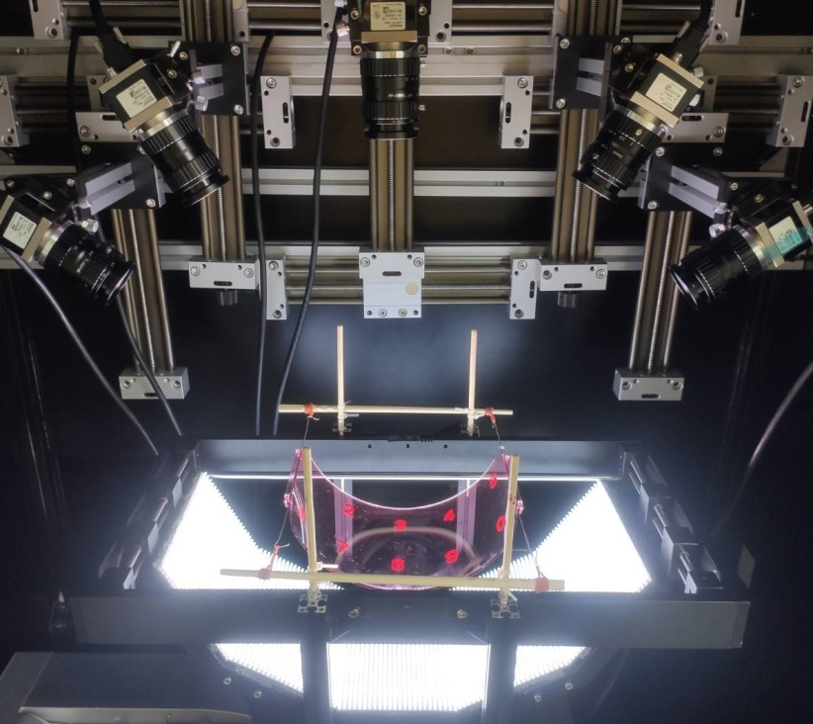
FIGURE 9. The actual model of image acquisition. The bottom is a custom light source that shines through the ski goggle lens surface to the cameras. The computer controls the five cameras through the acquisition card. The developed program will access the card's interface to capture images simultaneously.
For ease of visualization, Fig. 10 shows the input and output of the system. Inputs are lens samples. The system captures its surface, thus, outputs images of the lens surface. We also write a python program to control simultaneously five cameras. The program integrated into the system can capture five images simultaneously and crop the areas of interest (ROI) automatically.
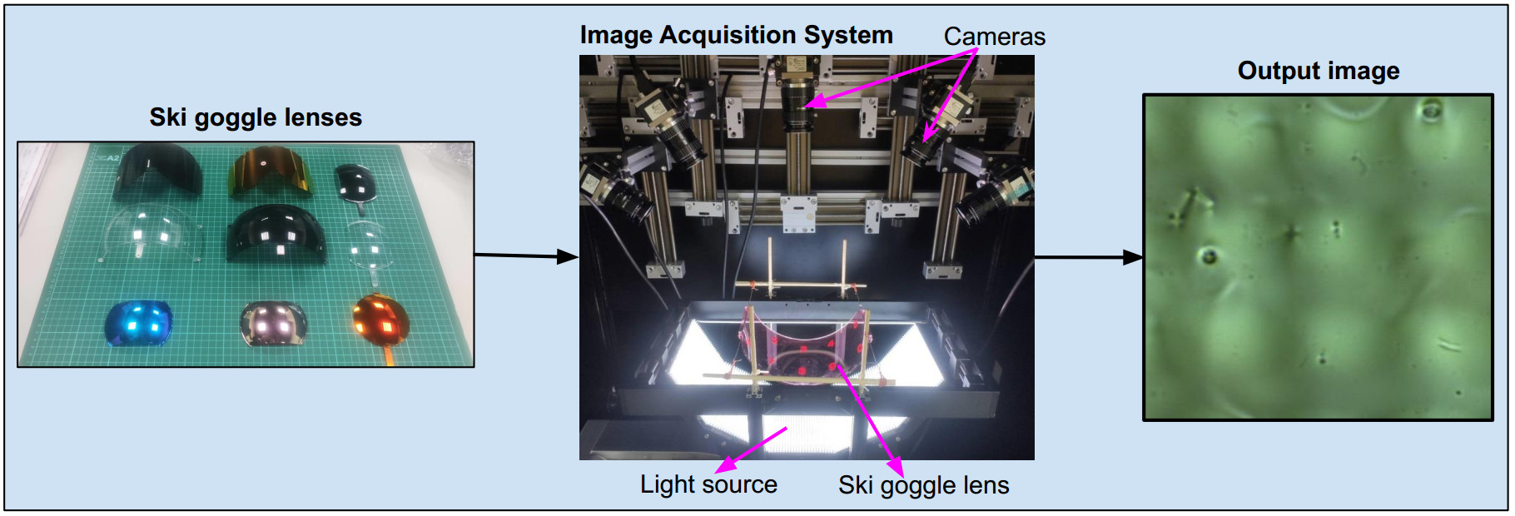
FIGURE 10. Input and Output of image acquisition. Input is some lens samples of ski goggles, and Output is raw images from five cameras.
2) REGION OF INTEREST
The system uses five cameras to capture the whole of the lens surface, and each camera only focuses on a portion of the lens. There are limitations in the experiment, such as the cameras can capture the overlapping or out boundary parts. So we need to generate the ROIs from each raw image so that when stitched together, they become the image of the whole lens. The first line of Fig. 11 shows five natural photos taken from the cameras, each containing redundant portions such as overlaps or outside of the lens. The five below images are the results of creating ROIs, respectively. We develop a program to capture images and generate ROIs seamlessly. The program was inherited from the Pypylon package of Basler and PyTorch framework.
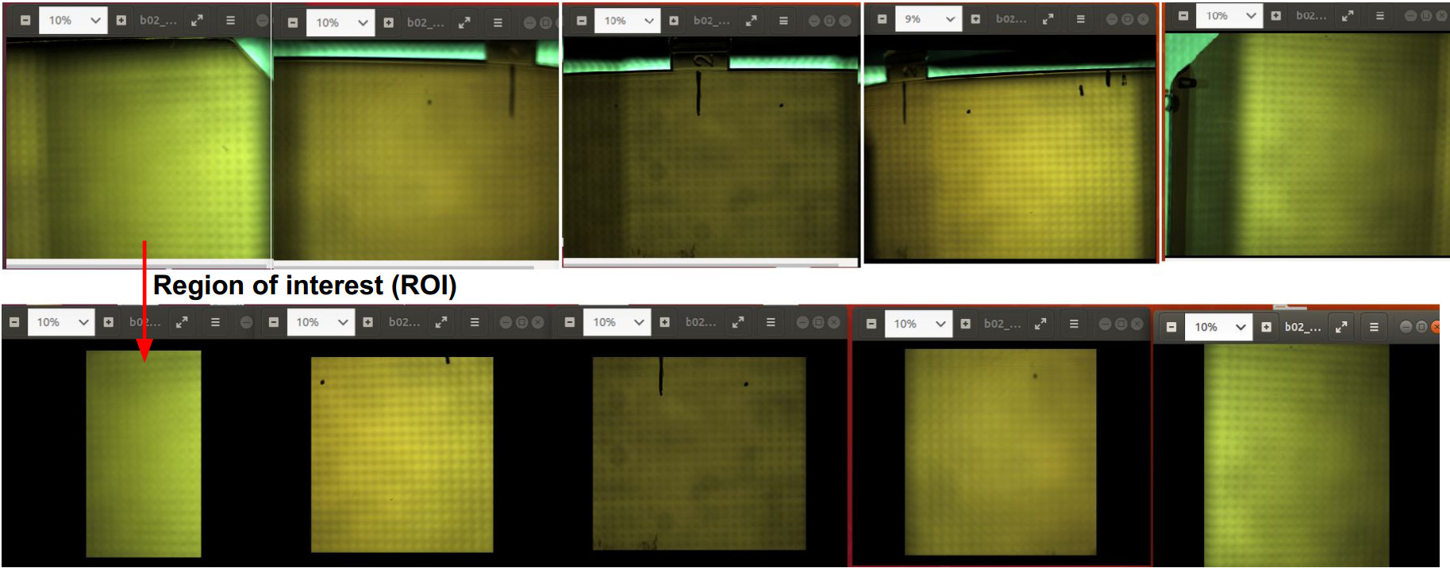
FIGURE 11. Crop regions of interest from raw images. Five cameras capture five images in the first row. To facilitate data labeling, extracting parts of good images is necessary. The bottom row is five regions of interest.

3) DATA LABELING
Based on our practical experience with the imaging system and discussing with the ski goggle manufacturer, we agree on the surface of the ski goggle lenses that there are common types of defects: scratch, watermark, spotlight, border, stain, dust-line, and dust-spot. Illustrate the detailed defect types as shown in Fig. 12.
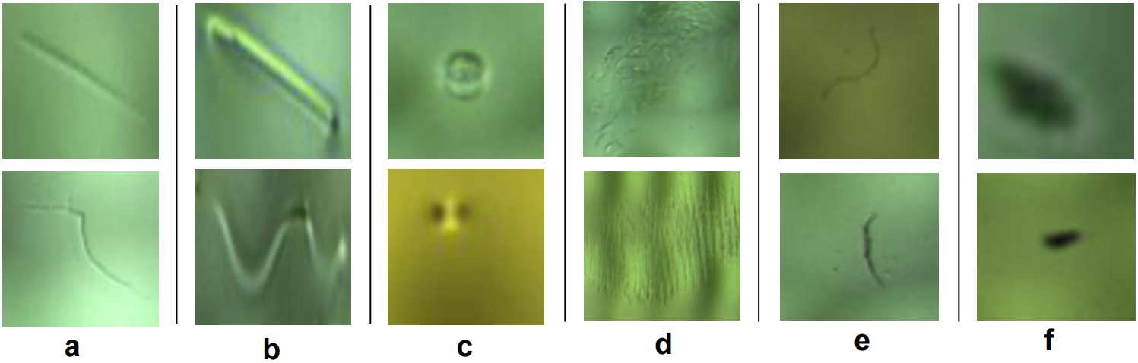
FIGURE 12. Some defect samples on surface of ski goggle lenses. Column a: scratch defects, b: watermark, c: spotlight, d: stain, e: dust-line, f: dust-spot.
Because detect detection is based on supervised deep learning methods, the image data needs to be labeled for the training phase. We use the LabelMe tool [30] to mark the defect regions with bounding boxes. Fig. 13 illustrates the defect labeling interface using the label tool.
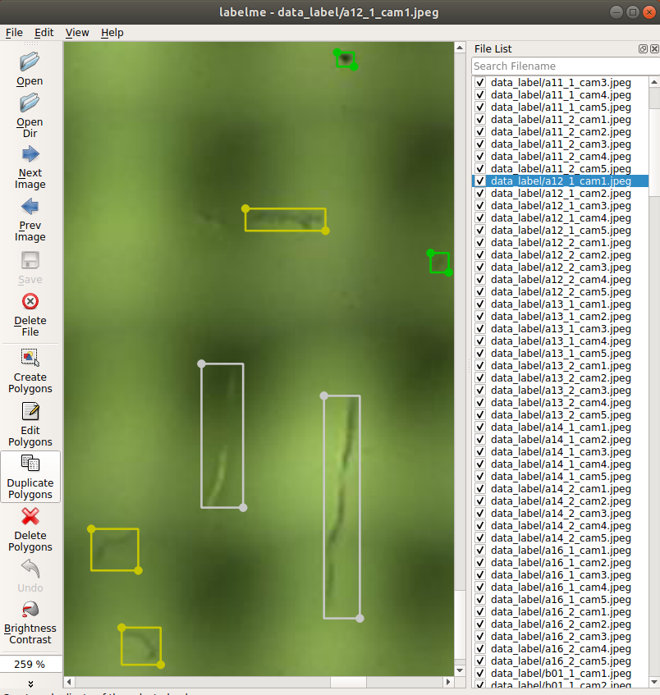
FIGURE 13. This is GUI of Labelme. It is the image annotation tool that is used to label defects on surface of ski goggle lenses.
B. DEFECT DETECTION MODULE
Finding a suitable object detection model for each data type is always tricky. Faster R-CNN architecture is the two-state object detector, which has proved the high accuracy and end-to-end trainable. Our work is to fine-tune this architecture by integrating the MobileNetV3 [31] backbone and feature pyramid network for extracting multi-scale features. MobileNetv3 model is a lightweight neural network suitable for devices with a limited computational resource budget. Besides, we also reduce the number of channels to reduce latency in inference.
The following sections will cover the overview method of supervised machine learning theory, the overview of the integrated faster-RCNN architecture is shown in Fig. 5. The backbone, RPN, and ROI-Head are the three main sub-networks in the defect detection module. First, the backbone block combines MobilenetV3 and FPN to extract multi-scale feature maps. Second, the RPN will create and propose the candidate defect regions. Finally, the ROI-Head block will locale the position of defects and classify them. The related theories, such as the bounding box regression, binary classification, multiclass classification, and assigning the boxes to the level of feature maps also discussed in detail.
1) Object Detection Problem Setting based on supervised learning approach
There are various machine-learning paradigms, such as supervised, unsupervised, and reinforcement learning. Because of the tasks related to detecting and classifying defects, we apply the supervised learning approach. This direction is related to the input data, labels, generative networks, loss functions, and measure metrics. This section describes the basic theory of supervised learning.
Description: Given an image, determine whether or not there are instances of objects from predefined classes and, if present, return the box bounding of each instance.
Input: A collection of N annotated images 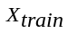 and a label set 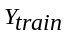.
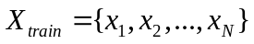 1
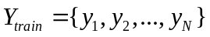 2
Where is annotation in image, and each has 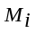 objects belong to classes.
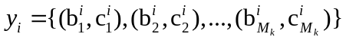 3
With 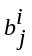 and 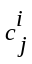 denote bounding-box of 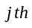 object in, and the class, respectively.
Algorithm: Optimize the loss function of classification 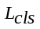 and bounding-box regression 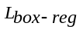:
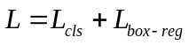 4
Formally, 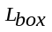 based on the Sum of Squared Errors (SSE) loss function, and based on the Cross Entropy loss function. The loss function is optimized by training the neural network after a specific amount of epochs.
Prediction: For 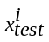, the prediction result is 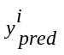 , 5
With 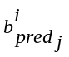, 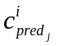 , 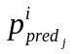 are results of the bounding-box, object class, and reliability. For filtering the object detection results, we can use a predefined threshold that compares the reliability.
Evaluation metric: For evaluating the detection algorithms’ performance, the primary metric used is the mean Average Precision (mAP). This metric considers the prediction of correct category labels and accuracy location. An Intersection-Over-Union (IoU) measure refers to the accuracy of object location.
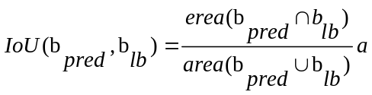 6
2) Backbone: Feature extractor based on mobilenetv3 and Feature pyramid networks (fpn)
MobileNetV3: We emphasize the integration of the MobileNetV3 model into the Faster R-CNN architecture by its suitability for optic inspection systems. Most hardware of the inspection systems are low resource use cases, so apply mobile-friendly models to reduce latency. MobileNetV3 backbone plays the role of a feature extractor in object detectors. MobileNetV1 [32] proposed depth-wise separable convolution to reduce the number of parameters to improve computation efficiency, and MobileNetV2 [33] introduced the inverted residual block to expand to a higher-dimensional feature space internally to make more efficient layer structures. MobileNetV3 inherited advances of V1 and V2; it deployed the Squeeze-and-Excitation [34] in the inverted residual bottleneck and flexibly used the h-swish nonlinearity to improve the accuracy of neural networks significantly.
The inverted residual is the main building block of the MobileNet-V3 network. The block follows a narrow-wide-narrow approach by input-output channels. As an example in fig. 14, the input channel is 24, the space expansion channel is 72, and the output channel is 40. The inverted residual block uses a combination of the expand convolution, the depth-wise convolution, the squeeze-excitation block , and the projection convolution, as in Fig. 14.
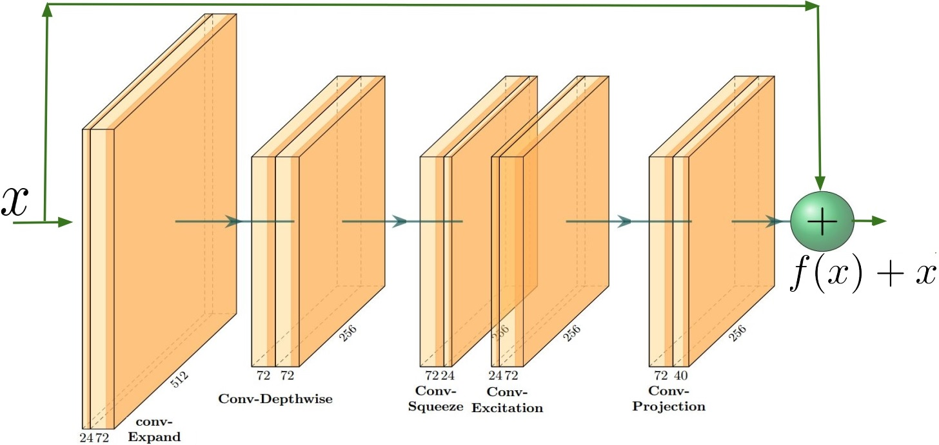
FIGURE 14. This is an instant of the inverted-residual block in MobileNetV3 architecture. First is a convolutional expand layer that widens channels from 24 to 72. Second is the convolutional depth-wise layer for better efficiency than traditional convolution. Its input and output channels are equal to 72, and the striking attribute of convolution halves the resolution. Next is the squeeze and excitation module to improve the power of features in the network. The final convolutional projection layer presents features in the lower dimension space, from 72 to 40.
FPN [35]: The object detection field has many more innovative algorithms, but current image data has become much more challenging, for instance, small object detection issues with only a few pixels. It is hard to extract the information about small objects in feature maps. FPN proposes a method to improve small object detection performance. It is an essential component that exploits the features of small objects on different levels of feature maps. FPN is an extended idea of pyramidal feature hierarchy that its architecture is a combination between top-down pathway, bottom-up pathway, and lateral connections.
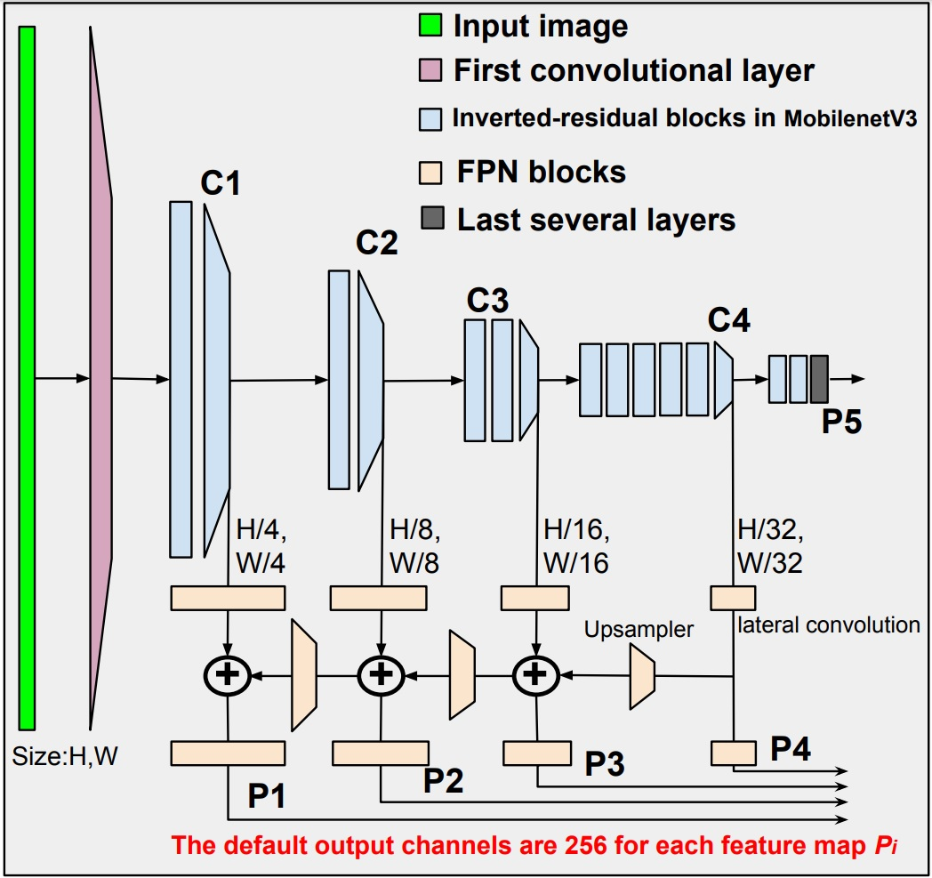
FIGURE 15. Backbone: the feature pyramid network (FPN) and MobileNet-V3 backbone together. The input is the image of size 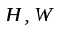. Firstly, The MobileNet-V3 extracts the image to many multi-scale feature maps 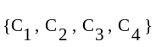. Secondly, the multi-scale output of MobileNet-V3 is the input for FPN. The final result is the feature maps at multiple levels 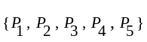.
As in Fig. 15, the backbone architecture combines the Mobilenet-V3 and FPN. It is to extract multi-scale feature maps from the input image. The input is fed to MobilenetV3, which has 15 inverted residual blocks. The output is the multi-scale feature maps 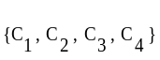, which are the input for FPN. FPN convolute and upsample 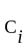 to output the better quality multi-scale feature maps .
The output channels of FPN present the multi-scale feature maps . This hyper-parameter is vital to guarantee the quality of feature maps. Its default value is 256 for the large benchmark dataset. With the customized dataset, we will fine-tune the number of the output channels to get better performance. The result shows in Table. 2.
The output feature maps from FPN are , which are also the input to the feature pyramid network and the ROI-Head. In next section will describe these two blocks in detail.
3) RPN: Region proposal network
Detecting the position of objects is one of the two main tasks in object detection. The theoretical basis for initializing the temporary object position remains more challenging. In classical computer vision, Selective Search [36], Multiscale Combinatorial Grouping [37], and CPMC [38] apply a strategy based on grouping super-pixels. EdgeBoxes [39], Objectness in Windows [40] use the window scoring technique. In deep learning-based computer vision, Shaoqing et al. [26] propose Region Proposal Networks to create the box Anchors to filter the potential positions. Anchor boxes are defined by two parameters: the wide range of scales and aspect ratios.
RPN initialized a set of anchor boxes on each image or feature map by two hyper-parameters that are scales and aspect ratio. They have a large impact on the final accuracy. So, we try to exploit them for optimal results. As in Fig. 16 illustrates the creation of anchors on an image. The left one is an original image consist of the red defect labels. The right one initializes a set of anchor boxes with aspect ratios [16, 32, 64] and a range of scale [0.5, 1, 2]. Anchors are white, black, yellow, green, and blue rectangular boxes in the right image.
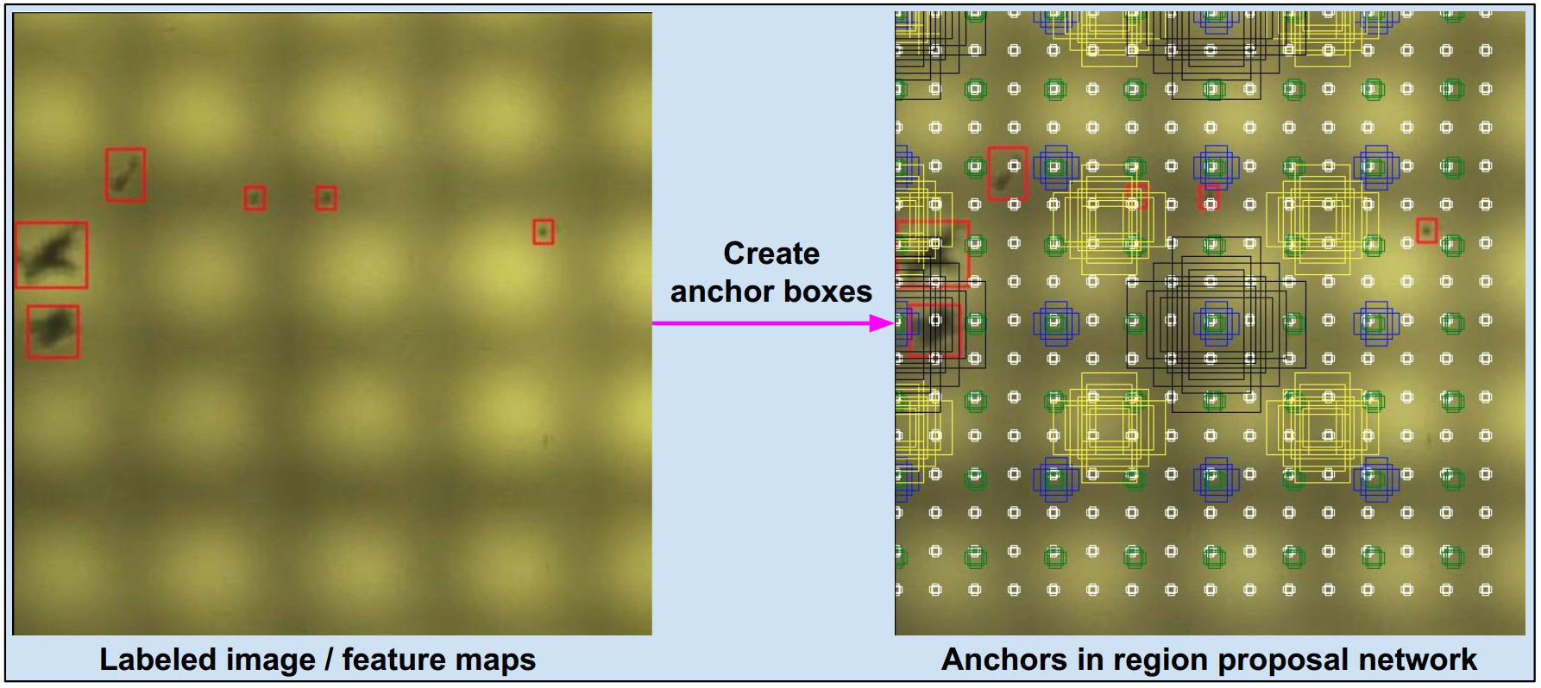
FIGURE 16. Illustrate how to create the box anchors in the region proposal network. Left is the image containing some red ground-truth boxes. RPN generates the reference boxes called "anchors" to map to ground-truth boxes. The multi-scale anchors are generated on the right image at various positions. They are the rectangle boxes marked with colors as white, black, yellow, green, and blue.
The number of anchors generated is enormous. RPN now tries to find anchors similar to the ground boxes (labels). The metric that tells whether an anchor is similar to the ground boxes is the IoU calculation. The pre-defined IoU thresholds are set to label the anchors as foreground, background, or ignored. If IoU is larger than the first threshold (typically 0.7), the anchor is assigned to one of the ground-truth boxes and labeled as foreground (‘1’). If IoU is smaller than the second threshold (typically 0.3), the anchor is labeled as a background (‘0’), otherwise ignored (‘-1’).
In the really, the majority of anchors are background (the label is “0”), so it’s hard to learn the foreground ones due to the label imbalance. To solve the imbalance issue, the target number of foreground boxes N and the target number of background M are pre-defined.
At this time, we have the labeled anchor set and a target set, as shown in Fig. 17. The RPN should learn to find rules to recognize the exact locations and shapes of ground-truth boxes. This issue is known as bounding box regression which will present in the next section.
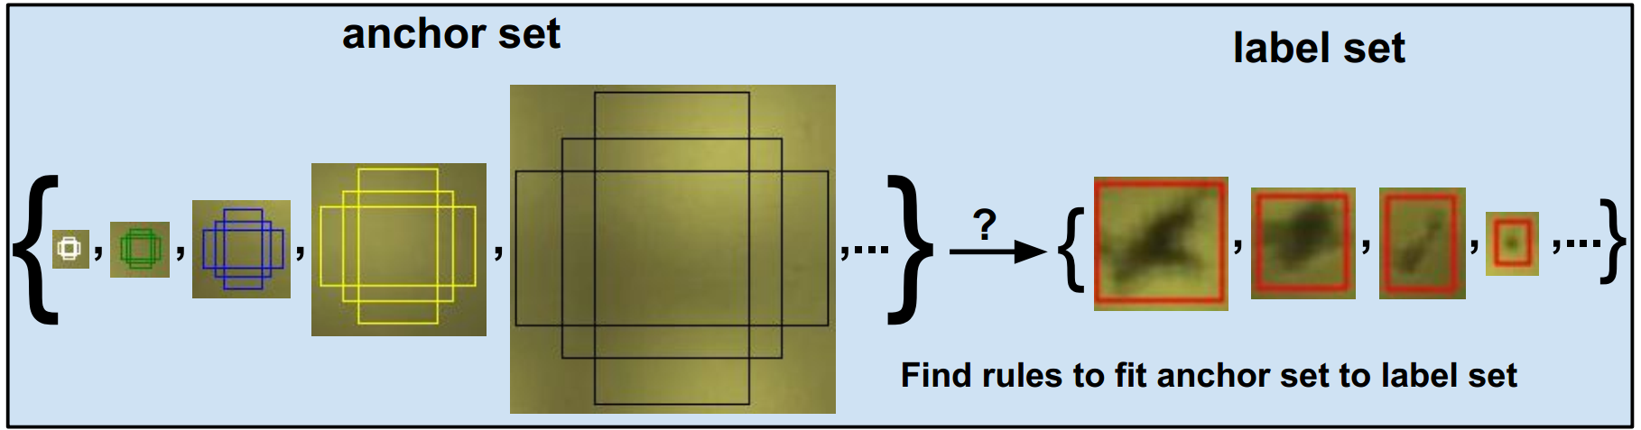
FIGURE 17. Box regression transforms the proposal anchor set to ground-truth label set.
The role of RPN is to propose the potential regions that contain the defects. To achieve this task, training the RPN is to regress the anchor boxes to the defect regions and classify anchors as the labels “1” or “0”. Because of the large number of anchors, we only choose some of the quality anchors called proposals for the next sub-network. The loss function of RPN includes the 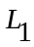 [20] loss function for bounding box regression and binary cross-entropy loss function for classifying the anchor as ground-truth or background.
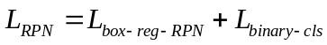 7
The following section details the bounding box regression and its loss function.
4) bounding Box regression
Bounding box regression will find some rules to scale-invariant transform a bounding box (anchor) to another bounding box (ground-truth/defect). The best idea is to consider the relationship between the center coordinates, and their width-high dimensions are significant. This section describes the formula between the ground truth box and anchor.
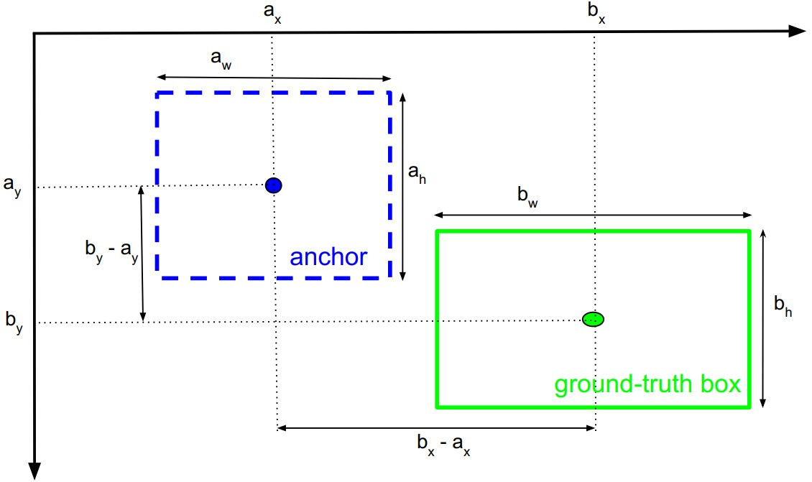
FIGURE 18. Illustration of transformation from the anchor to the ground-truth box . The formula is in Eq. (7).

“” and “” denote anchor box and ground truth box, respectively. Each one is represented by a 4-tuple in the form of 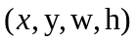, where 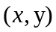 is the center coordinate and 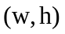is the width and height dimension. The regressor aims to predict the transformation from the anchor to the target ground-truth box represented as follows:
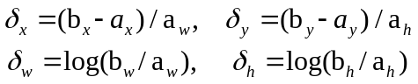 8
The image feature is the input of regressor then the output is a prediction 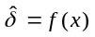. The training process will minimize the bounding box loss function:
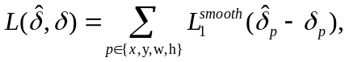 9
Where the function 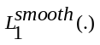is the robust 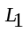loss defined as Eq. (10).
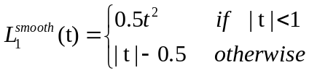
To calculate the final prediction box coordinates, the regressed anchor is inferred based on the inverse transformation of Eq. (8) as follows:
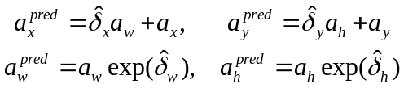 10
The final summary is as follows: the bounding box regressor is a neural network with the input , which are the image or feature maps, and the label is . A prediction is 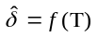. The training process will optimize the loss function 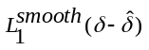. With the formulas 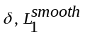 and in Eq. (7), (9), (10), respectively.
5) ROI-Head
ROI-head converts the selected proposals on each feature map into a small fixed window (usually 7x7), and next is fed to the linear neural network to regress the bounding boxes and classify defects.
The inputs of ROI-Head are: The feature maps {P2, P3, P4, P5} from the backbone block; The proposal boxes from the RPN block; The label of defects. The ratio of foreground and background boxes will be customized to accelerate the training. The proposals with higher IoUs than the threshold are counted as foreground and the others as background. This step will choose k the best proposals based on the IoU metric.
Before getting into the ROI process, assign the top-k proposals to each level P_{i} of the appropriate feature maps based on the formula in Eq. (12).
11
The ROIAlignV2 [37] process crops the rectangle regions on the feature maps specified by the proposal boxes. The linear neural network feds the results of ROI to regress the proposals to ground boxes and classify the defect type.
In during training the ROI-Head network, the loss function sums up the cost of classification 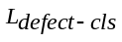 and bounding box regression 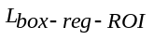 as in Eq. (9).
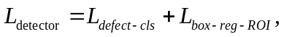 12
With is the defect classification loss function computes the cross entropy loss; is the smooth loss as in Eq. (9).
6) end-to-end Learning
The RPN block needs the cost to classify anchors as background or foreground (binary cross-entropy) and find proposals for the candidate locations of defects (bounding box regression). The ROI-Head network costs to classify the defect type (cross-entropy) and locate the defects' accuracy position (bounding box regression). So, the network can be trained in an end-to-end manner using the multi-task loss function as follows:
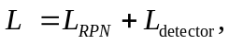 13
With 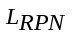and 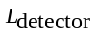formula as in Eq. (7) and Eq. (13), respectively.
IV. EXPERIMENT AND DISSCUSION
- EXPERIMENTAL SETTING
Defects are labeled and converted to COCO format to be compatible with object detection models. All images are resized to 1333px for long edge and 800px for short edge. We split the dataset into the training and test sets with a ratio of 80:20. In the First step, we train and test on some of the standard defect detection architectures such as two-stage object detectors (Faster- RCNN) and one-stage object detectors (Retina, FCOS). All models are implemented with the default configuration in PyTorch Vision [41].
Table II shows that the Faster R-CNN architecture with backbone Mobile-Large gets good computational efficiency while accuracy can be accepted. In the second step, for increment accuracy, we fine-tune hyper-parameters in RPN, while also computational efficiency, we reduce the output channel of FPN in the backbone. The final result is presented in Table III.
The models are trained with 2 GPUs with a batch size of 8 for 26 epochs using SGD optimizer. The learning rate is initialized to 0.02 and learning ratio step at 16 and 22. Computer configuration is a CPU AMD Ryzen5 3600X, 64G RAM, 2 GPUs Gigabyte 2060 6G.
The method evaluates detection results based on the standard COCO style Average Precision (AP) was measured at IoU thresholds from 0.5 to 0.75.
- DEFECT DETECTION RESULTS
To have a result baseline of the defect detection for the defect dataset on the surface of ski goggle lenses, we train and test over different architectures and backbones. Parameters of Faster-RCNN-ResNet50, Faster-RCNN-Mobile-large, Faster-RCNN-Mobile-small, FCOS-Resnet50, Retina-Resnet50 models are 41.1M, 18.9M, 15.8M, 31.85M, 32.05M, respectively. Table 2 shows the linear result that the bigger architecture (more than parameter) is better accuracy (AP), but computational efficiency (speed s/it) is slower. The balance between accuracy and computational efficiency is an issue in automatic optical inspection because hardware characteristics are compact. We recognize the Faster-RCNN-Mobile-large model archived a possible result for balancing accuracy and computational efficiency. From this idea, we decide to fine-tune the Faster R-CNN with backbone Mobile-large to achieve a better result.
Table II
Comparison of defect detection between each other architectures trained on the ski goggle defect dataset without any hyper-parameters adaptation.
Architecture | Backbone | IoU metric |  |  | Speed(s/it)
Architecture | Backbone | AP | AP₅₀ | AP₇₅ | Train | Test
Faster RCNN | ResNet50 | 56.3 | 78.5 | 63.3 | 0.528 | 0.126
Faster RCNN | Mobile- large | 41.3 | 72.8 | 38.1 | 0.127 | 0.059
Faster RCNN | Mobile-small | 10.0 | 25.1 | 08.4 | 0.086 | 0.045
FCOS | ResNet50 | 59.6 | 78.6 | 64.0 | 0.352 | 0.126
RetinaNet | ResNet50 | 10.2 | 25.2 | 05.9 | 0.331 | 0.140

Faster R-CNN has proved to be a state-of-the-art object detector archived with high accuracy, and especially the modular ability is flexible. So, it can be integrated into some sub-network to improve performance better. We implement the Faster R-CNN-based detector that uses an FPN-style backbone that extracts features from different convolutions of the MobileNetV3 model. The advance of MobileNetV3 block helps improve speed; Alternatively, FPN presents the invariant of feature maps, leading to improving the small defect detection. However, Faster R-CNN has a back draw because of the complicated computation in creating the anchor boxes. Its hyper-parameters in RPN are often sensitive to the final detection performance. The above disputation leads to fine-tuning Faster R-CNN to archive high performance.
First, we fine-tune the output channel of FPN to improve the network's speed. All feature maps extracted from the network have their output projected down to the channel number [256, 128, 96, 64] of the FPN block.
Second, we fine-tune the anchor scale factor in RPN to improve the slight defect characteristic. The anchor scales affect to handle the bounding boxes with different sizes. Its invalid value setting causes the imbalance between negative and positive samples in training. The default value of anchor scales in the Faster R-CNN model is 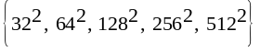. We augment two values 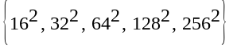 and 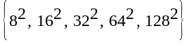.
Table III shows the aggregate results of fine-tuning the output channel number in FPN and the anchor scales in RPN. If the output channel of FPN decreases, then the training and testing speed is better, while accuracy decreases a little. Observing the efficiency of anchor scales, configuration archived better results than two configurations and , with the same channel of FPN. From this result, for balance in computational efficiency and accuracy, we choose the optimistic parameter set with the output channel equal to 128 and the anchor scales equal to .
Table III
Defect detection results from fine-tuning the output channel of FPN and the anchor scale in RPN.
FPN | RPN | IoU metric |  | Speed (s/it)
Out channel | Anchor scales | AP | AP_{S} | Train | Test
256 | {8²,16²,32²,64²,128²} | 55.3 | 53.4 | 0.4864 | 0.1161
256 | {16²,32²,64²,128²,256²} | 49.2 | 42.8 | 0.4867 | 0.1179
128 | {8²,16²,32²,64²,128²} | 53.6 | 45.4 | 0.3040 | 0.1133
128 | {16²,32²,64²,128²,256²} | 55.0 | 47.0 | 0.3080 | 0.1074
96 | {8²,16²,32²,64²,128²} | 46.7 | 39.6 | 0.2857 | 0.1094
96 | {16²,32²,64²,128²,256²} | 51.8 | 42.7 | 0.2860 | 0.1046
64 | {8²,16²,32²,64²,128²} | 47.6 | 38.3 | 0.2517 | 0.0993
64 | {16²,32²,64²,128²,256²} | 51.4 | 46.0 | 0.2520 | 0.0968

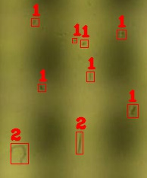 | 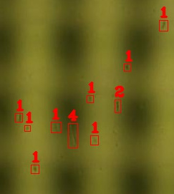
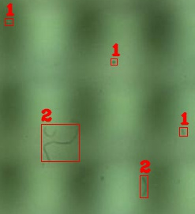  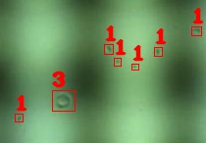 | 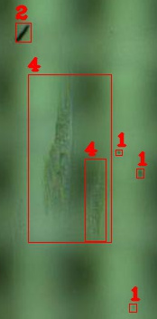  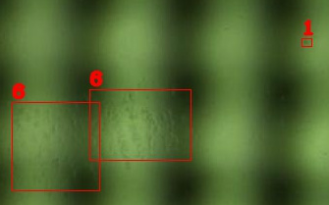
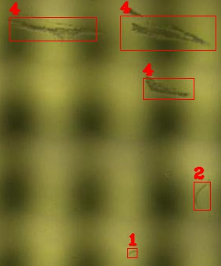 | 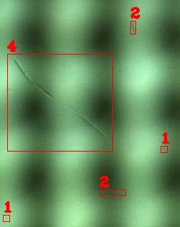
FIGURE 19. More examples of defect detection result. Defects are marked by the red rectangle boxes and its above label is the defect type.
V. CONCLUSION
This paper solved the defect detection problem on the surface of ski goggle lenses based on the deep learning approach. The work includes: designing the image capture system that has five cameras cover the entire curved surface of the lenses and can acquire images automatically from all cameras at the same time; The work needed more effort to build the surface defect detection dataset of the ski goggle lenses that diversify the surface data source in the defect detection field based on deep learning; The automatic optical inspection system usually has the limited hardware resource, so the work also proposed the defect detection architecture that achieved the best trade-off between accuracy and the computational performance. The large default number of the output channel in FPN generally guarantees to present feature maps for some massive benchmark datasets. With the defect dataset of ski goggle lenses, we reduce the number of output channels to help better computational performance. Besides, the work refined the hyper-parameter in RPN because the defect characteristic is tiny in size, leading to better accuracy. The experiment result also found the hyper-parameter set and values to optimize this dataset's defect detection performance.
REFERENCES
[1] D.-T. Dang, J.-W. Wang, J.-S. Lee, and C.-C. Wang, “Defect Classification System for Ski Goggle Lens,” in 2021 International Symposium on Intelligent Signal Processing and Communication Systems (ISPACS), 2021, pp. 1–3. doi: 10.1109/ISPACS51563.2021.9651116.
[2] N. T. Le, J.-W. Wang, C.-C. Wang, and T. N. Nguyen, “Novel Framework Based on HOSVD for Ski Goggles Defect Detection and Classification,” Sensors, vol. 19, no. 24, 2019, doi: 10.3390/s19245538.
[3] Q. Luo et al., “Automated Visual Defect Classification for Flat Steel Surface: A Survey,” IEEE Trans. Instrum. Meas., vol. 69, no. 12, pp. 9329–9349, 2020, doi: 10.1109/TIM.2020.3030167.
[4] Q. Luo, X. Fang, L. Liu, C. Yang, and Y. Sun, “Automated Visual Defect Detection for Flat Steel Surface: A Survey,” IEEE Trans. Instrum. Meas., vol. 69, no. 3, pp. 626–644, 2020, doi: 10.1109/TIM.2019.2963555.
[5] R. S. Peres, X. Jia, J. Lee, K. Sun, A. W. Colombo, and J. Barata, “Industrial Artificial Intelligence in Industry 4.0 - Systematic Review, Challenges and Outlook,” IEEE Access, vol. 8, pp. 220121–220139, 2020, doi: 10.1109/ACCESS.2020.3042874.
[6] Z. Ren, F. Fang, N. Yan, and Y. Wu, “State of the Art in Defect Detection Based on Machine Vision,” Int. J. Precis. Eng. Manuf.-Green Technol., vol. 9, no. 2, pp. 661–691, Mar. 2022, doi: 10.1007/s40684-021-00343-6.
[7] S. Mersch, “Overview of Machine Vision Lighting Techniques,” in Optics, Illumination, and Image Sensing for Machine Vision, 1987, vol. 0728, pp. 36–38. doi: 10.1117/12.937821.
[8] E. J. Sieczka and K. G. Harding, “Light source design for machine vision,” in Optics, Illumination, and Image Sensing for Machine Vision VI, 1992, vol. 1614, pp. 2–10. doi: 10.1117/12.57965.
[9] S. K. Kopparapu, “Lighting design for machine vision application,” Image Vis. Comput., vol. 24, no. 7, pp. 720–726, 2006, doi: https://doi.org/10.1016/j.imavis.2005.12.016.
[10] I. Moreno, “Image-like illumination with LED arrays: design,” Opt Lett, vol. 37, no. 5, pp. 839–841, Mar. 2012, doi: 10.1364/OL.37.000839.
[11] A. N. Chertov, E. V. Gorbunova, V. V. Korotaev, and V. S. Peretyagin, “Solution of multi-element LED light sources development automation problem,” in Thirteenth International Conference on Solid State Lighting, 2014, vol. 9190, p. 919015. doi: 10.1117/12.2061781.
[12] I. Hirschberg and R. Bashe, “Charge Coupled Device (CCD) Imaging Applications–A Modular Approach,” in Applications of Electronic Imaging Systems, 1978, vol. 0143, pp. 11–18. doi: 10.1117/12.956543.
[13] R. Martins et al., “Complementary Metal Oxide Semiconductor Technology With and On Paper,” Adv. Mater., vol. 23, no. 39, pp. 4491–4496, 2011, doi: https://doi.org/10.1002/adma.201102232.
[14] Z. He and Q. Liu, “Deep Regression Neural Network for Industrial Surface Defect Detection,” IEEE Access, vol. 8, pp. 35583–35591, 2020, doi: 10.1109/ACCESS.2020.2975030.
[15] G. Li, R. Shao, H. Wan, M. Zhou, and M. Li, “A Model for Surface Defect Detection of Industrial Products Based on Attention Augmentation,” Comput. Intell. Neurosci., vol. 2022, p. 9577096, May 2022, doi: 10.1155/2022/9577096.
[16] D. Zhang, X. Hao, L. Liang, W. Liu, and C. Qin, “A novel deep convolutional neural network algorithm for surface defect detection,” J. Comput. Des. Eng., vol. 9, no. 5, pp. 1616–1632, Jul. 2022, doi: 10.1093/jcde/qwac071.
[17] Y. He, C. Zhu, J. Wang, M. Savvides, and X. Zhang, “Bounding Box Regression With Uncertainty for Accurate Object Detection,” in 2019 IEEE/CVF Conference on Computer Vision and Pattern Recognition (CVPR), 2019, pp. 2883–2892. doi: 10.1109/CVPR.2019.00300.
[18] H. Touvron, A. Vedaldi, M. Douze, and H. Jegou, “Fixing the train-test resolution discrepancy,” in Advances in Neural Information Processing Systems, 2019, vol. 32. [Online]. Available: https://proceedings.neurips.cc/paper/2019/file/d03a857a23b5285736c4d55e0bb067c8-Paper.pdf
[19] O. Okwuashi and C. E. Ndehedehe, “Deep support vector machine for hyperspectral image classification,” Pattern Recognit., vol. 103, p. 107298, 2020, doi: https://doi.org/10.1016/j.patcog.2020.107298.
[20] J. Jiao, X. Wang, Z. Deng, J. Cao, and W. Tang, “A fast template matching algorithm based on principal orientation difference,” Int. J. Adv. Robot. Syst., vol. 15, no. 3, p. 1729881418778223, 2018, doi: 10.1177/1729881418778223.
[21] K. He, X. Zhang, S. Ren, and J. Sun, “Deep Residual Learning for Image Recognition,” in 2016 IEEE Conference on Computer Vision and Pattern Recognition (CVPR), 2016, pp. 770–778. doi: 10.1109/CVPR.2016.90.
[22] K. Simonyan and A. Zisserman, “Very Deep Convolutional Networks for Large-Scale Image Recognition,” in 3rd International Conference on Learning Representations, ICLR 2015, San Diego, CA, USA, May 7-9, 2015, Conference Track Proceedings, 2015. [Online]. Available: http://arxiv.org/abs/1409.1556
[23] M. Tan and Q. Le, “EfficientNet: Rethinking Model Scaling for Convolutional Neural Networks,” in Proceedings of the 36th International Conference on Machine Learning, Jun. 2019, vol. 97, pp. 6105–6114. [Online]. Available: https://proceedings.mlr.press/v97/tan19a.html
[24] A. Dosovitskiy et al., “An Image is Worth 16x16 Words: Transformers for Image Recognition at Scale,” ICLR, 2021.
[25] S. Zhang, C. Chi, Y. Yao, Z. Lei, and S. Z. Li, “Bridging the Gap Between Anchor-Based and Anchor-Free Detection via Adaptive Training Sample Selection,” in 2020 IEEE/CVF Conference on Computer Vision and Pattern Recognition (CVPR), 2020, pp. 9756–9765. doi: 10.1109/CVPR42600.2020.00978.
[26] S. Ren, K. He, R. Girshick, and J. Sun, “Faster R-CNN: Towards Real-Time Object Detection with Region Proposal Networks,” IEEE Trans. Pattern Anal. Mach. Intell., vol. 39, no. 6, pp. 1137–1149, 2017, doi: 10.1109/TPAMI.2016.2577031.
[27] J. Redmon, S. Divvala, R. Girshick, and A. Farhadi, “You Only Look Once: Unified, Real-Time Object Detection,” in 2016 IEEE Conference on Computer Vision and Pattern Recognition (CVPR), 2016, pp. 779–788. doi: 10.1109/CVPR.2016.91.
[28] Z. Tian, C. Shen, H. Chen, and T. He, “FCOS: A Simple and Strong Anchor-Free Object Detector,” IEEE Trans. Pattern Anal. Mach. Intell., vol. 44, no. 4, pp. 1922–1933, 2022, doi: 10.1109/TPAMI.2020.3032166.
[29] D. W. Ma, X. J. Wu, and H. Yang, “Efficient Small Object Detection with an Improved Region Proposal Networks,” IOP Conf. Ser. Mater. Sci. Eng., vol. 533, no. 1, p. 012062, May 2019, doi: 10.1088/1757-899x/533/1/012062.
[30] K. Wada, “labelme: Image Polygonal Annotation with Python,” GitHub repository. GitHub, 2018. [Online]. Available: https://github.com/wkentaro/labelme
[31] A. Howard et al., “Searching for MobileNetV3,” in 2019 IEEE/CVF International Conference on Computer Vision (ICCV), 2019, pp. 1314–1324. doi: 10.1109/ICCV.2019.00140.
[32] A. G. Howard et al., “MobileNets: Efficient Convolutional Neural Networks for Mobile Vision Applications,” CoRR, vol. abs/1704.04861, 2017, [Online]. Available: http://arxiv.org/abs/1704.04861
[33] M. Sandler, A. Howard, M. Zhu, A. Zhmoginov, and L.-C. Chen, “MobileNetV2: Inverted Residuals and Linear Bottlenecks,” in 2018 IEEE/CVF Conference on Computer Vision and Pattern Recognition, 2018, pp. 4510–4520. doi: 10.1109/CVPR.2018.00474.
[34] J. Hu, L. Shen, and G. Sun, “Squeeze-and-Excitation Networks,” in 2018 IEEE/CVF Conference on Computer Vision and Pattern Recognition, 2018, pp. 7132–7141. doi: 10.1109/CVPR.2018.00745.
[35] T.-Y. Lin, P. Dollár, R. Girshick, K. He, B. Hariharan, and S. Belongie, “Feature Pyramid Networks for Object Detection,” in 2017 IEEE Conference on Computer Vision and Pattern Recognition (CVPR), 2017, pp. 936–944. doi: 10.1109/CVPR.2017.106.
[36] J. R. R. Uijlings, K. E. A. van de Sande, T. Gevers, and A. W. M. Smeulders, “Selective Search for Object Recognition,” Int. J. Comput. Vis., vol. 104, no. 2, pp. 154–171, Sep. 2013, doi: 10.1007/s11263-013-0620-5.
[37] P. Arbeláez, J. Pont-Tuset, J. Barron, F. Marques, and J. Malik, “Multiscale Combinatorial Grouping,” 2014.
[38] J. Carreira and C. Sminchisescu, “CPMC: Automatic Object Segmentation Using Constrained Parametric Min-Cuts,” IEEE Trans. Pattern Anal. Mach. Intell., vol. 34, no. 7, pp. 1312–1328, 2012, doi: 10.1109/TPAMI.2011.231.
[39] C. L. Zitnick and P. Dollár, “Edge Boxes: Locating Object Proposals from Edges,” in Computer Vision – ECCV 2014, Cham, 2014, pp. 391–405.
[40] C. H. Lampert, M. B. Blaschko, and T. Hofmann, “Beyond sliding windows: Object localization by efficient subwindow search,” in 2008 IEEE Conference on Computer Vision and Pattern Recognition, 2008, pp. 1–8. doi: 10.1109/CVPR.2008.4587586.
[41] A. Paszke et al., “PyTorch: An Imperative Style, High-Performance Deep Learning Library,” in Advances in Neural Information Processing Systems, 2019, vol. 32. [Online]. Available: https://proceedings.neurips.cc/paper/2019/file/bdbca288fee7f92f2bfa9f7012727740-Paper.pdf

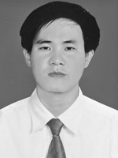
DINH-THUAN DANG received the B.Sc. degree in computer science from the Danang University of Science and Technology in 2006, and the M.Sc. degree in computer science from the VNUHCM - University of Information Technology in 2014. He is currently a Lecturer with the Department of Information Technology, Pham Van Dong University, Vietnam. His research interests include computer vision, deep learning.
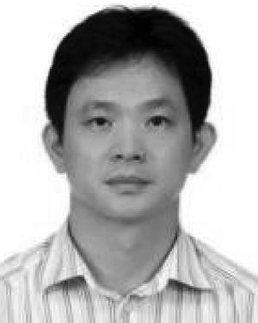
JING-WEIN WANG (Member, IEEE) received the B.S. and M. S. degrees in electrical engineering from the National Taiwan University of Science and Technology, in 1986 and 1988, respectively, and the Ph.D. degree in electrical engineering from the National Cheng Kung University, Taiwan, in 1998. He was the Chief Project Leader at the Equipment Design Center of PHILIPS, Taiwan, from 1992 to 2000. In 2000, he joined the Faculty of the National Kaohsiung University of Science and Technology and served as the Dean for the College of Electrical Engineering and Information Science, from August 2017 to July 2019. He is currently a Distinguished Professor at the Institute of Photonics Engineering. His current research interests include combinatorial optimization, pattern recognition, and wavelets and their applications.

