YANJUN CHEN

216327327

assignment 1a

SIT772

### Task 1.1

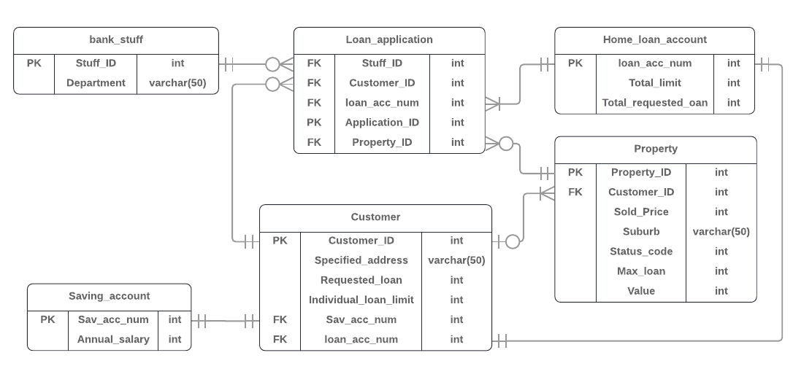

### Task 1.2

The digraph meets following requirements:

* Every customer should own a saving account and a property address. They may not own a home loan account yet, or already own their only loan account.
* A stuff may never support an application, but an application must be support by one stuff.
* Each customer has her/his own home loan max limit.
* One customer can apply loan for more than one property.
* One customer can own more than one property.
* A property must have maximum home loan and value.
* A property may not have a buyer yet, or maybe have been involved into loan application more than once since its owner changed.
* One home loan account should link with a customer, or maybe link with many customers.

The digraph meets following transactions:

* A customer can start a loan application with help from a stuff, for one property and on a loan account at once.
* A customer can start many applications on one loan account to allow this account to cover new properties.
* A loan account can be applicated for many times to allowed new customer to join or some new loan to be applied.

The diagram has following limitations:

* It can’t show the relationship between property value and the average of the sold price of the properties located in the same suburb.
* It can’t show that a customer’s requested loan limitation is depends on their total salary in ten years.
* It can’t show how the max loan limitation of a property has been calculated.
* It can’t help customer to request home loan that lower than their loan limitation.
* It can’t show that the home loan limit of a joint account depends on all the joint customers in the home loan
* It can’t show the rule that a customer should own a saving account before own a loan account.

### Task 1.3

### Task 2.1

Let’s assume we are making ERD for a delivery company which is similar but much smaller than Australia Post, and following are requirements:

* Each customer will have a customer ID.
* After a customer pay for a delivery, he or she will have a receipt with an order number and a tracking number.
* A tracking number will help with tracking their parcel. A tracking statement should display its tracking number and all the completed transportation activities that made the parcel moves.
* A transportation activity has its ID, starting place and arriving place, starting time and arriving time. When it finishes, a stuff should confirm it and signed, and fill the ID of the vehicle which finished this transportation.
* Only one vehicle be used during one transportation. When there’s another vehicle carries the parcel, there should be a different transportation with different transportation ID.
* Each vehicle has their owner, and each owner may have more than one vehicle.
* Each stuff of this company works in a store and has an ID. This company has many stores and each of them has an ID.

### Task 2.2



