YANJUN CHEN

216327327

SIT772 2022 T1

Assignment 1b

1.1

1.2

1.4

1.5

1.6

2.1

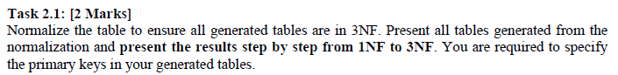

**\*All the primary key of following table has been highlighted with yellow.**

1NF

2NF

3NF

2.2

2.3

