<https://chatgpt.com/share/6708e9eb-9a48-8010-a3a2-cb2ee8b3b20f>

this is the main conversation, due to long talk, I just capture the most important part,and show the address above

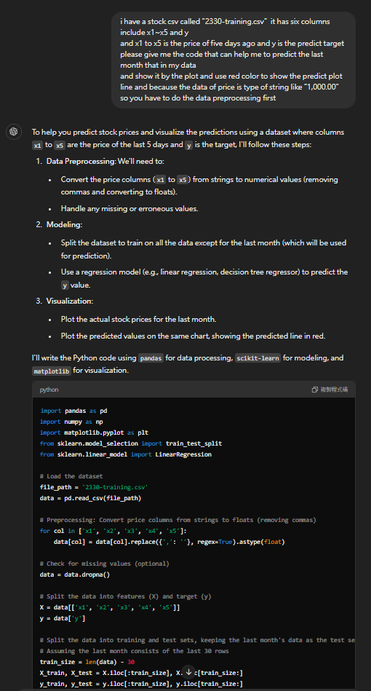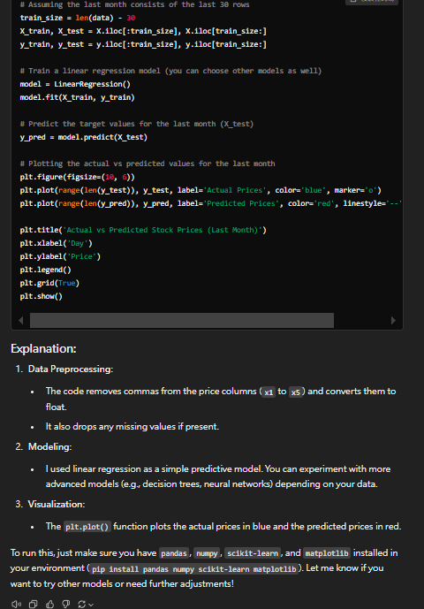

Result：

