Power BI Capstone Project Report
This report presents a comprehensive overview of the Power BI dashboard developed to answer the key business questions outlined in the capstone project. Each section corresponds to one specific question/task, showcasing the visualizations created, explaining the insights derived, and how the dashboard effectively addresses the business needs.
Data Cleaning & Preparation Steps
Tools Used: Power Query Editor in Power BI
Key Steps:
  - Removed unnecessary duplicates with identical zip code prefixes, states, city names, latitudes and longitudes and changed city names in English replacing accent letters to avoid duplicates in geolocation table.
  - Promoted headers for better readability.
  - Cleaned and trimmed texts for avoiding unwanted formatting issues and ensuring data consistency.
- Merged & Related Tables:
  - Used proper primary-foreign key relationships like order_id, product_id etc.
  - Ensured no circular or ambiguous relationships existed.
Outcome:
These steps ensured the data was clean, usable, and relationships were well-defined for accurate reporting.

Data Model Overview
Purpose:
This section shows the relationships between different tables used in the Power BI dashboard. Establishing proper one-to-many and many-to-one relationships ensures accurate data aggregation and filtering across visuals.
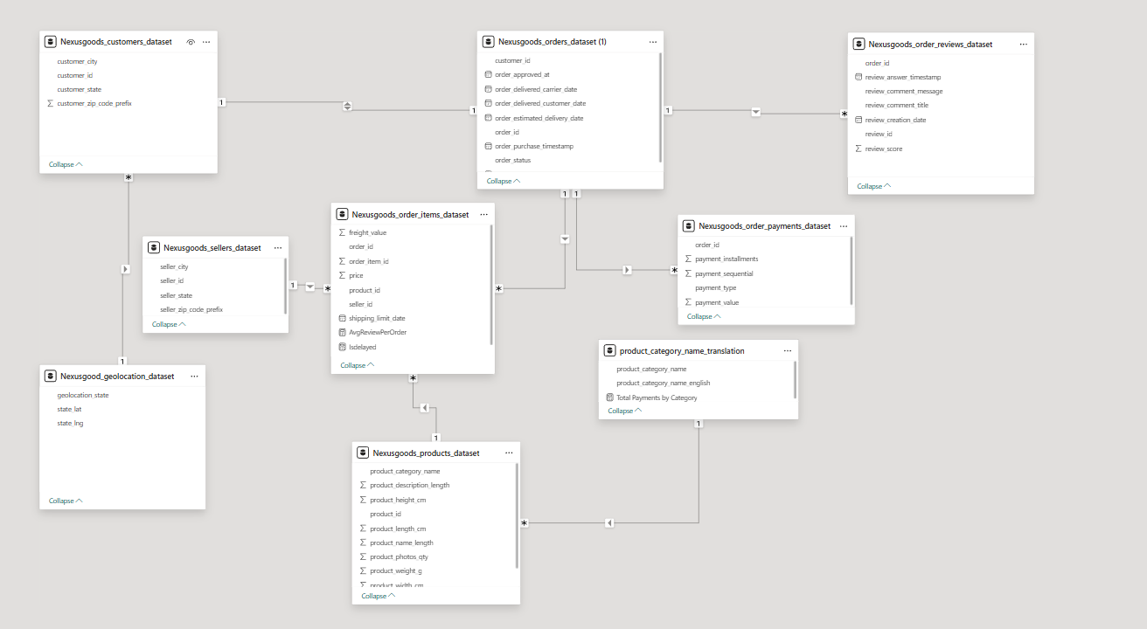

Sales Performance Overview
This page provides a comprehensive snapshot of overall sales activity and key business metrics across different dimensions. It includes visualizations that highlight top-performing product categories, regional sales distribution, revenue breakdown by payment methods, and seasonal sales trends over years. The insights from this page help identify what is driving revenue, how customer preferences vary by location, and which product segments are contributing most to business performance. It includes a slicer for dynamic filtering based on Year, Quarter, and Month using the date hierarchy, enabling time-based exploration across all visuals.

- Top 10 Product Categories by Total Sales
Task: Identify top-performing product categories
Visualization: Clustered Bar Chart
Explanation:
This visual highlights the top 10 product categories contributing the highest total sales. The clustered bar chart provides a clear and immediate visual comparison of sales performance across categories. It helps stakeholders quickly identify which product lines are the most profitable and should be prioritized for marketing, inventory planning, or strategic promotions.
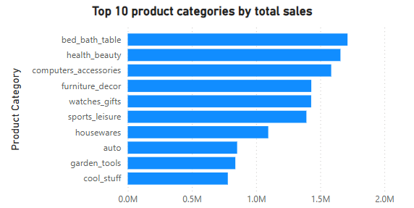

- Distribution of Revenue by Payment Methods
Task: Understand how customers prefer to pay
Visualization: Pie Chart
Explanation: The pie chart shows the percentage share of each payment method used. This helps tailor customer experience and evaluate which payment options might need better integration or promotion.
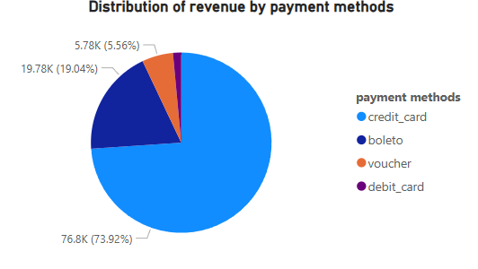
- Regional Sales Performance
Task: Analyse sales performance across geographic regions
Visualization: Map (Bubble Map)
Explanation: The map visual displays the total revenue generated from various states in Brazil. Larger bubbles represent higher sales volumes, while the colour scheme enhances interpretation—green for high sales, yellow for medium, and red for low sales. This helps regional managers quickly assess market penetration and performance across different regions.
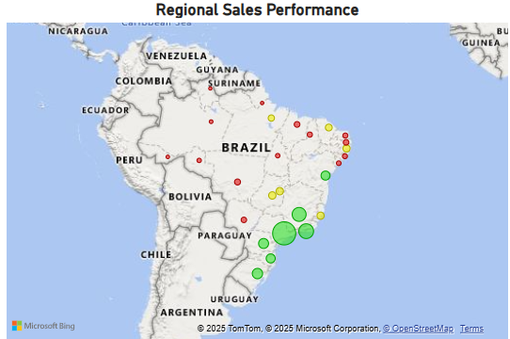

- Total Revenue Over Time
Task: Analyse the yearly total revenue trend
Visualization: Line and Clustered Column Chart
Explanation: The visual shows a consistent upward trend in total revenue across the years. The combination of line and bar elements makes it easier to identify year-over-year revenue growth patterns. Additionally, the built-in drill-down feature—enabled through the date hierarchy—allows users to explore revenue trends at quarterly and monthly levels. This layered insight supports more granular sales forecasting and performance analysis.
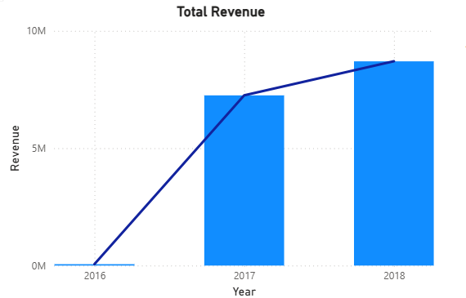
Customer Insights
This page provides a comprehensive view of customer experience and satisfaction based on delivery performance and product ratings. It helps identify service quality issues by comparing delayed and on-time deliveries across months and evaluating customer sentiment through review scores. It also shows seasonal trends in sales data. These insights can guide operational improvements and enhance customer retention strategies.
- Highest and Lowest Rated Product Categories
Task: Determine product categories with highest and lowest average customer ratings
Visualization: Two Clustered Bar Charts (Top 10 & Bottom 10)
Explanation: These bar charts reveal customer satisfaction across different product categories. Higher-rated categories indicate good product quality and service, while lower-rated ones may require quality improvement or better customer support.
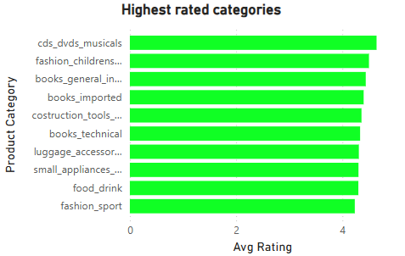
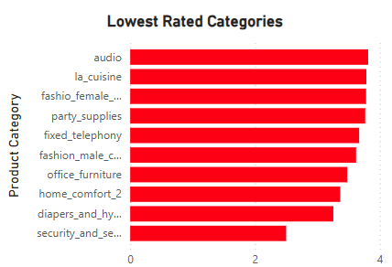

- Product Category-Wise Delayed Orders
Task: Track the number of delayed orders across product categories
Visualization: Clustered Bar Chart
Explanation: The visual provides clarity on which product categories suffer from delayed deliveries, indicating potential supply chain or logistics issues that need to be addressed.
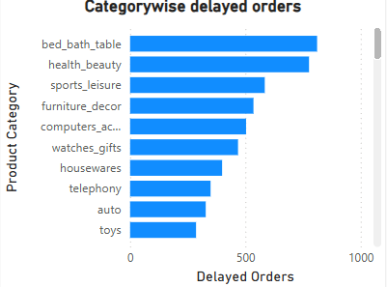
- Seasonal Trends in Sales Data
Task: Analyse seasonal sales trends on a quarterly basis
Visualization: Line Chart
Explanation: The quarterly revenue line chart displays clear seasonal patterns, with sales peaking in 2018. Recognizing this helps the business prepare for seasonal demand by adjusting inventory and marketing strategies.
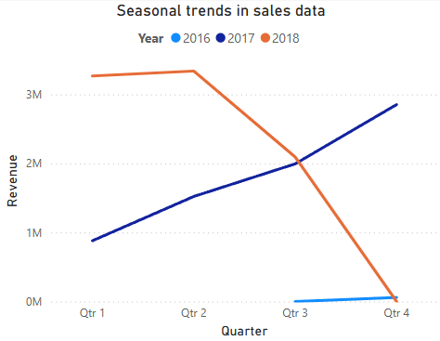

- Delayed vs. On-Time Deliveries Over Time
Task: Compare the number of delayed vs. on-time orders for each month
Visualization: Line Chart with Secondary Y-Axis
Explanation:
This dual-axis line chart visualizes monthly trends for both delayed and on-time deliveries. While on-time deliveries dominate, tracking delays—though fewer—is critical for maintaining customer satisfaction and operational efficiency. The chart also helps detect seasonal spikes in delays, aiding in proactive supply chain planning.
Interactive Feature:
Users can hover over any month's data point and use the drillthrough feature by right clicking on the required month to navigate directly to the Delivery Insights page for deeper analysis.
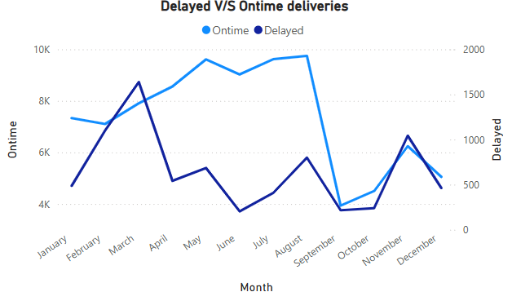

Drillthrough Page: Delivery Insights
Task: Provide deeper insights into delayed and on-time deliveries
Visualization: Clustered Bar Charts, Donut, KPI
Explanation:
The Delivery Insights page is an interactive drillthrough destination from the main line chart. It provides a detailed breakdown of delivery performance across dimensions such as:
- Customer State (to identify regional delay trends)
- Seller Performance (to assess which sellers contribute to delays)
- Average Delivery Time (to measure efficiency)
These insights help pinpoint delivery inefficiencies and support data-driven decision-making for service improvement.

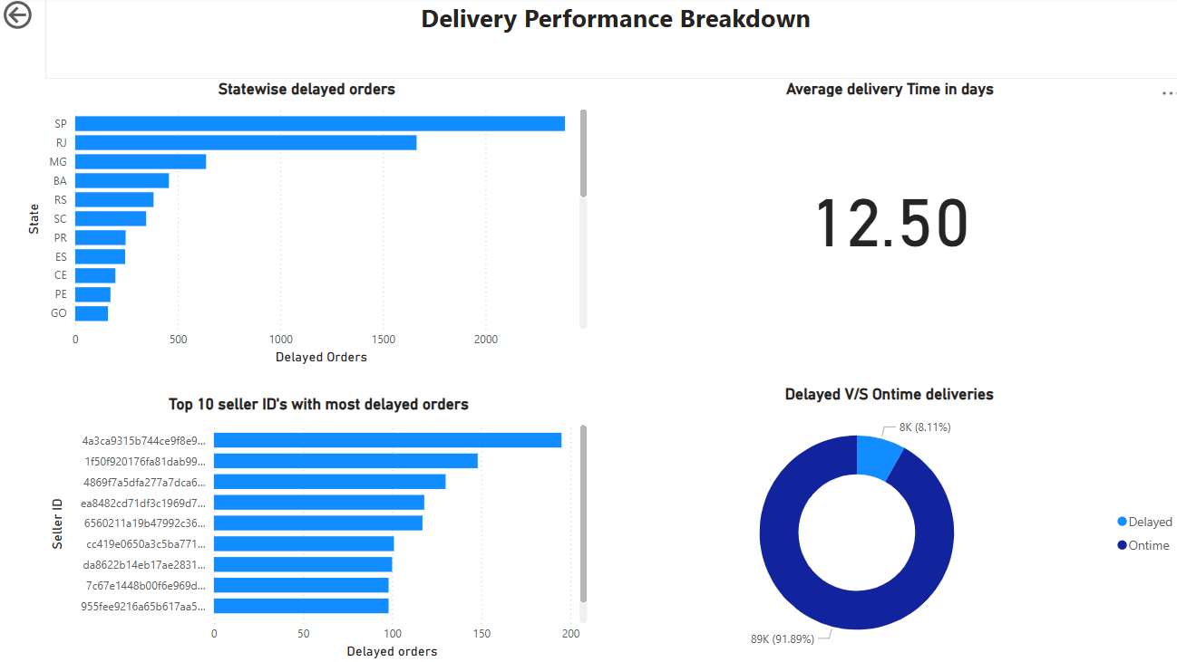

Notes:
- A time hierarchy slicer and state wise slicer has been added and synced across relevant pages.
- Visuals have been spaced out and arranged logically across three pages.
- Filters and titles have been applied to clarify the context of each visual.

This concludes the comprehensive explanation of the Power BI dashboard.

