**OUTPUTS**

**SERVER IDLE:**

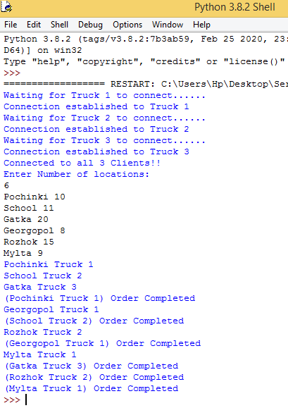

**CLIENT – 1 IDLE**

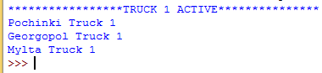

Truck 1 Entries

**CLIENT – 2 IDLE**

Truck 2 Entries

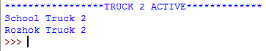

**CLIENT – 3 IDLE**

Truck 2 Entries



**OUTPUT.txt FILE**

