JMH 454 GROUP ASSIGNMENT · PART 1 · VIRTUAL TOUR
Footprints of War: Boarding Pass
A teaser website that Grade 9 learners visit before the Google Earth virtual tour, to spark curiosity and prepare them for it.
OPEN THE WEBSITE  https://1111kaykay1111.github.io/footprints-of-war/teaser/  Backup link: https://claude.ai/artifact/KX7FndJF9CxMwdCN45nNLr  Companion website (all 16 stops, Street View and tasks): https://1111kaykay1111.github.io/footprints-of-war/  Best in Chrome on a computer, with the sound on. It also works on phones. |   Scan to open on a phone

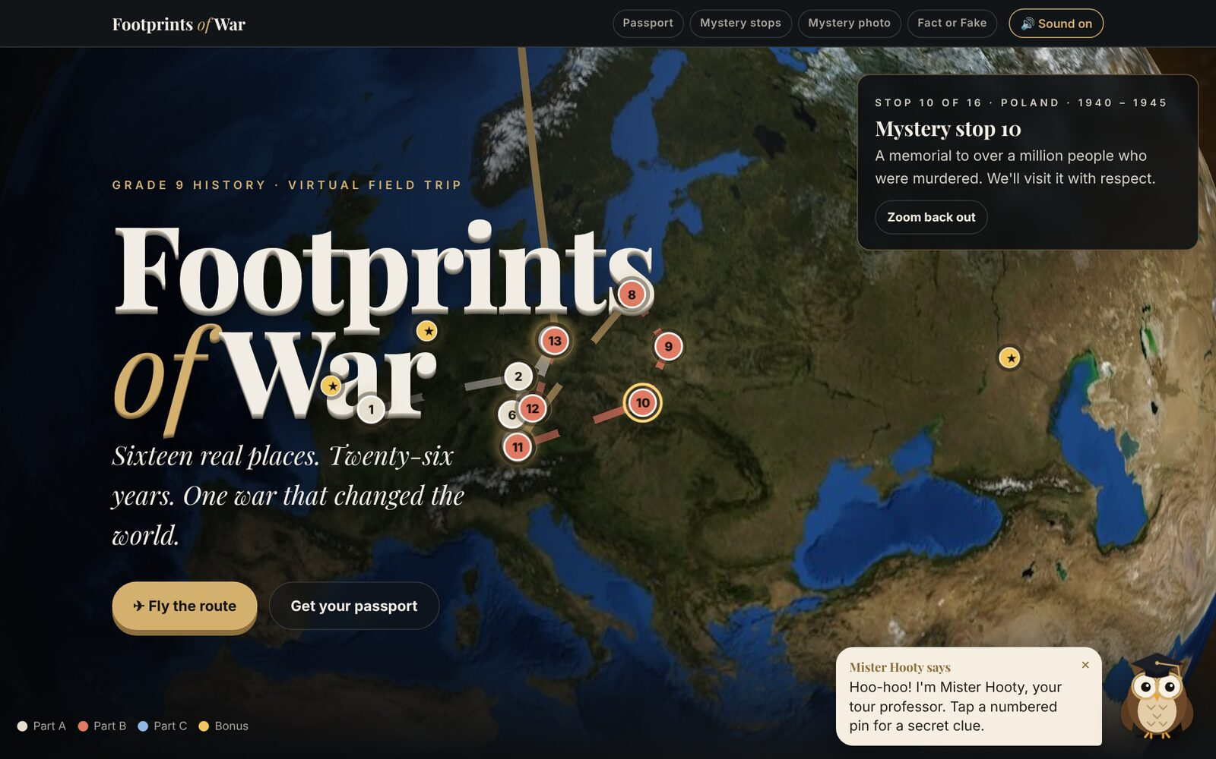
The opening screen: a 3D globe with the 16 tour stops, 10 bonus stops and the routes between them. Mister Hooty, an owl professor, gives tips in the corner.
What learners do on the website
- Spin a 3D globe and tap pins for secret clues about the 16 stops, or press "Fly the route" to fly through them in date order.
- Complete four boarding checks: get a personal passport, solve mystery-stop riddles, analyse a zoomed-in mystery photo, and play Fact or Fake.
- Learn six key words they will meet on the tour, such as Blitzkrieg, propaganda and dictatorship.
- Meet the tour's three big questions, one for each part of the tour.
- Follow Mister Hooty, who gives tips, reacts to answers and models respectful behaviour at the Holocaust-related content.
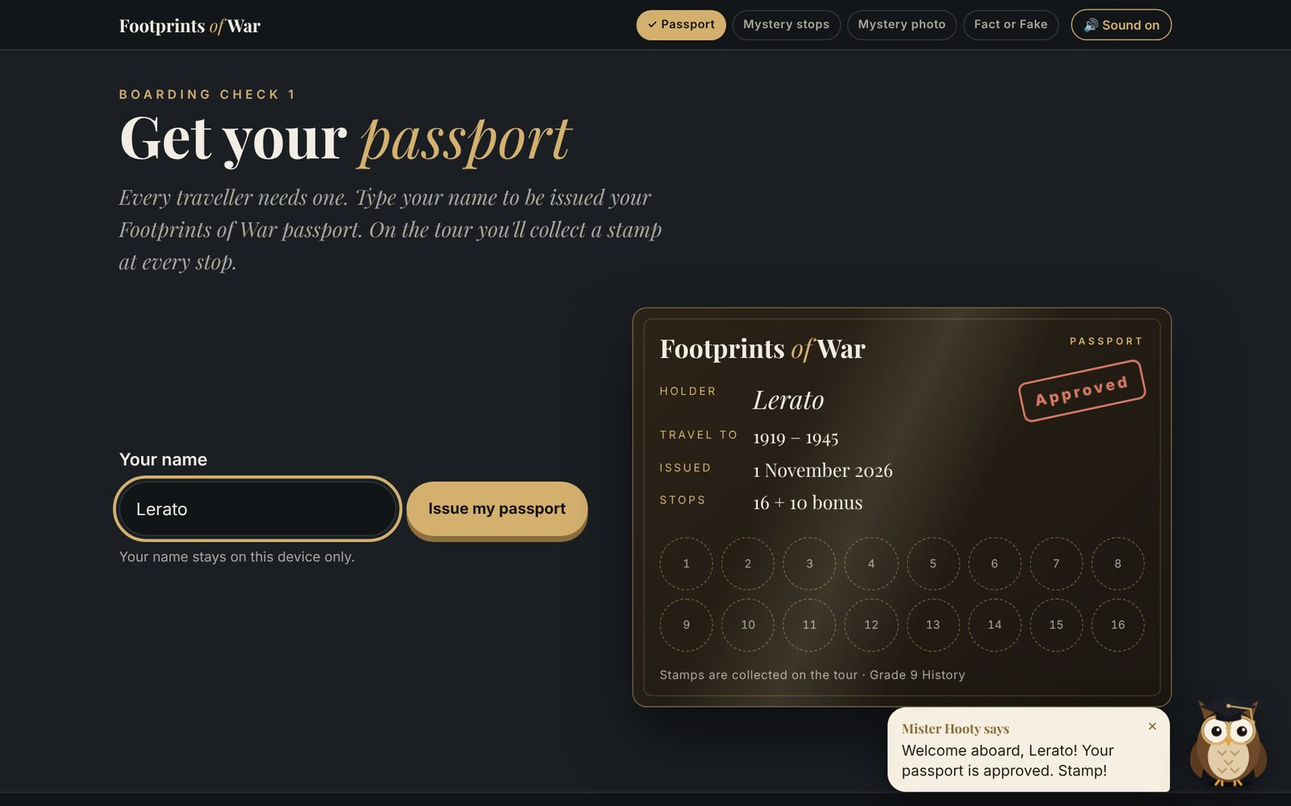  Boarding check 1: learners get their own passport, stamped "Approved". | 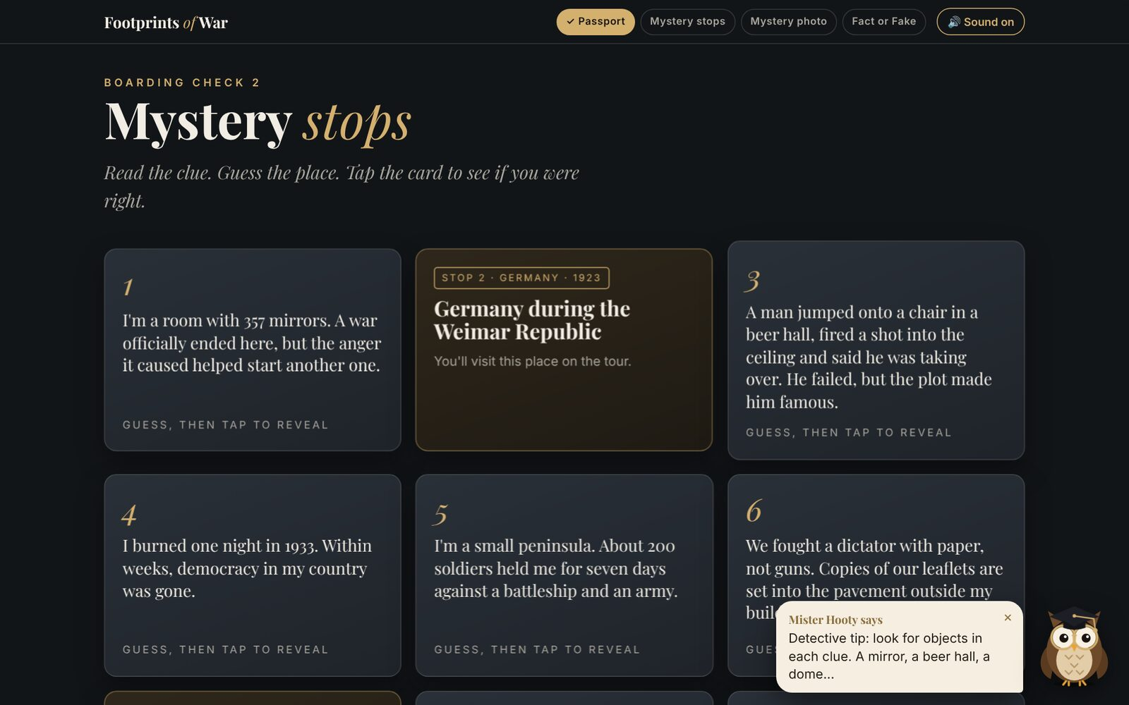  Boarding check 2: mystery-stop riddle cards that flip to reveal the place.
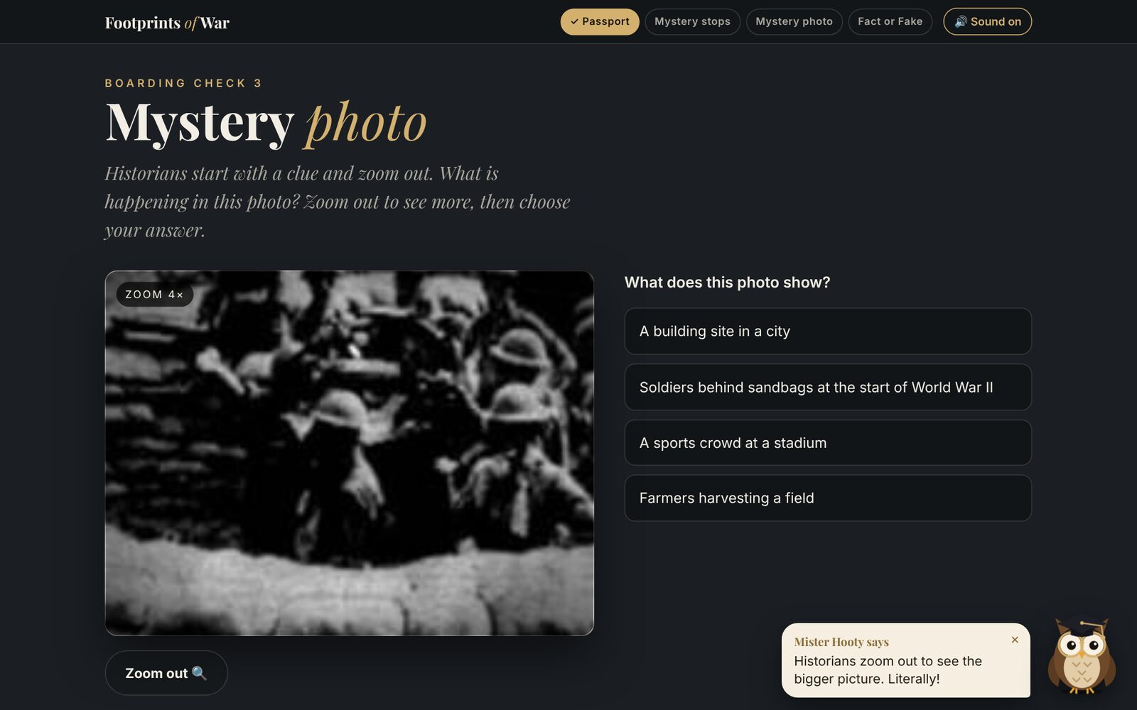  Boarding check 3: a mystery photo that zooms out like a historian's source analysis. | 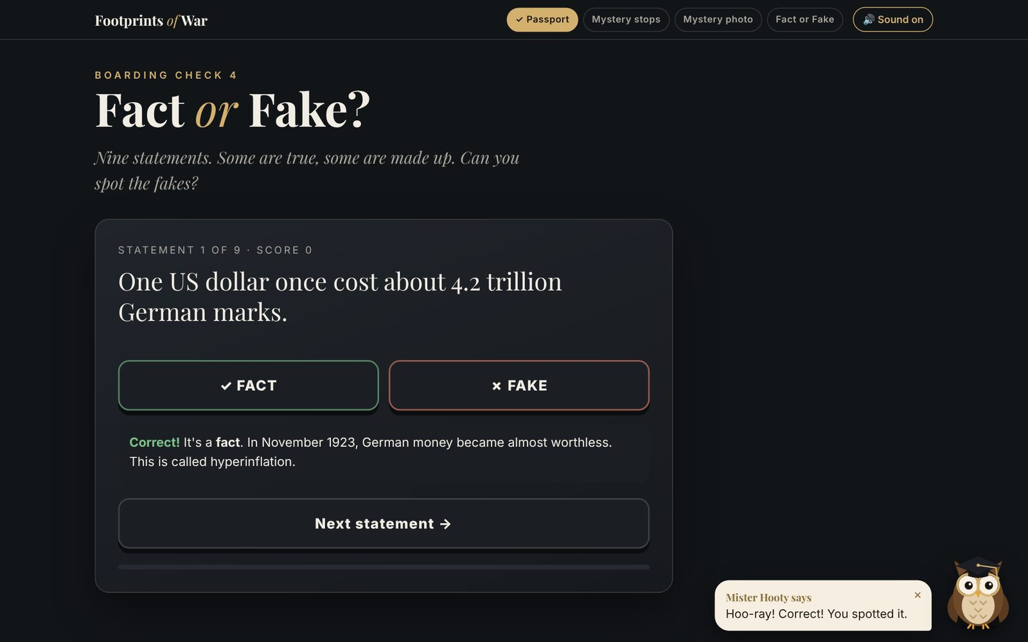  Boarding check 4: Fact or Fake, with feedback that teaches.
How it supports the virtual tour
- Hook: builds curiosity before the lesson, so learners arrive wanting to find out more.
- Vocabulary: pre-teaches key terms used at the tour stops.
- Historical thinking: the mystery photo practises reading a source as evidence; the riddles and Fact or Fake practise chronology and checking claims.
- Inquiry: the three big questions give learners a purpose for the Google Earth tour.
- Respect: Holocaust-related places are never turned into games, and learners are told how to approach them.

