**This documentation illustrates how to use cloudlet features at OpenStack**

1. Open browser (Chrome or Firefox is preferred.)
2. Connect to <http://hail.elijah.cs.cmu.edu/>
3. Login in (id: elijah-cloudlet1)

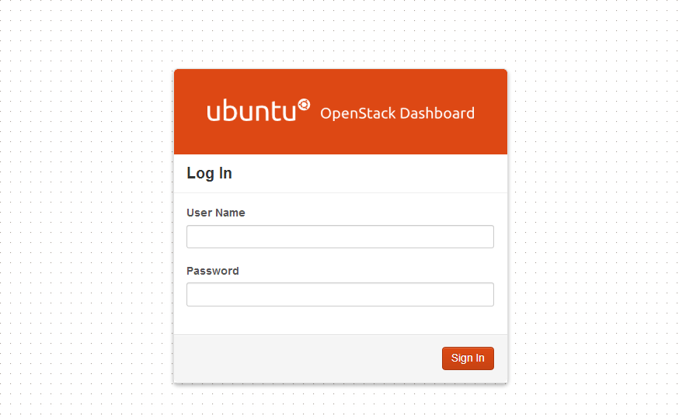

1. Go to project 🡪 Cloudlet menu

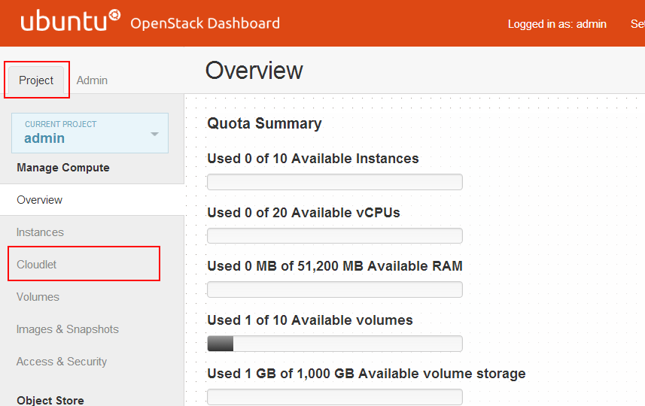

1. There are 3 tables; 1) List of *base VMs* 2) List of *VM overlays* 3) List of running VMs

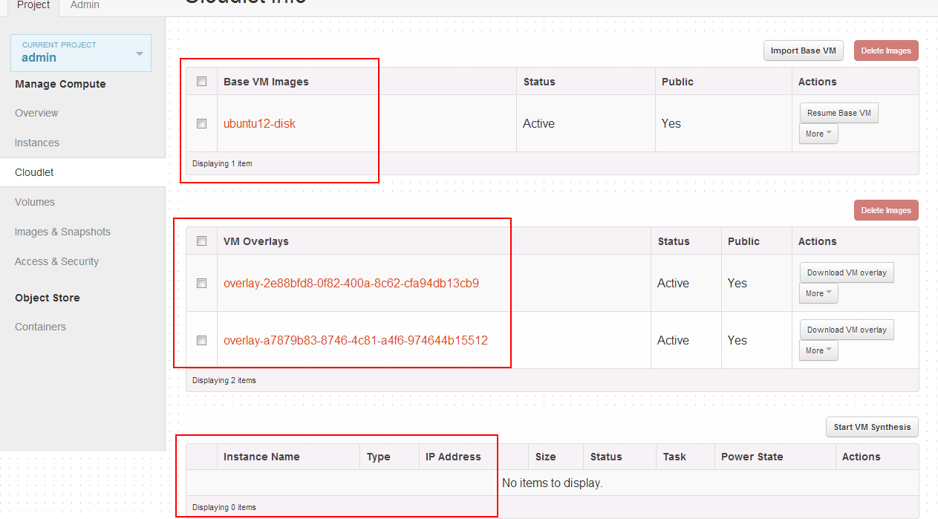

1. To create your own VM overlay, click “Resume Base VM”. It will create new VM instance which is a resumed base VM.

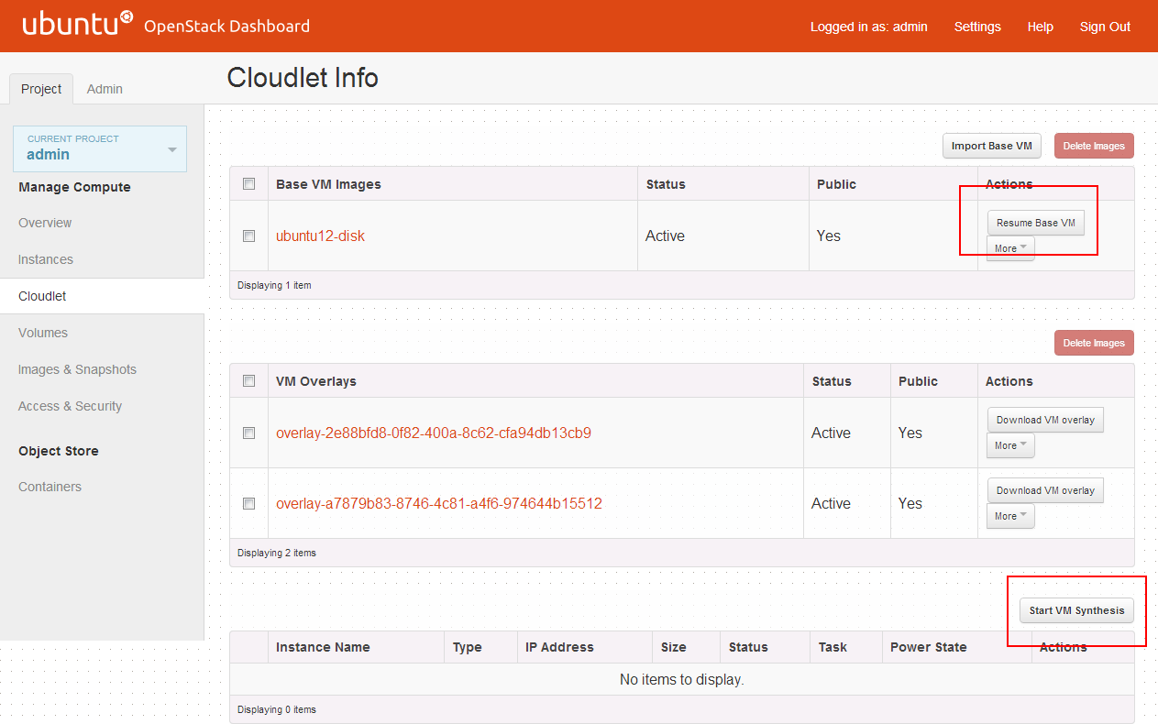

1. You can start customizing the VM by connecting the VM over VNC by clicking instance name 🡪 Console. After finishing customization, click “Create VM overlay” to start creating VM overlay.

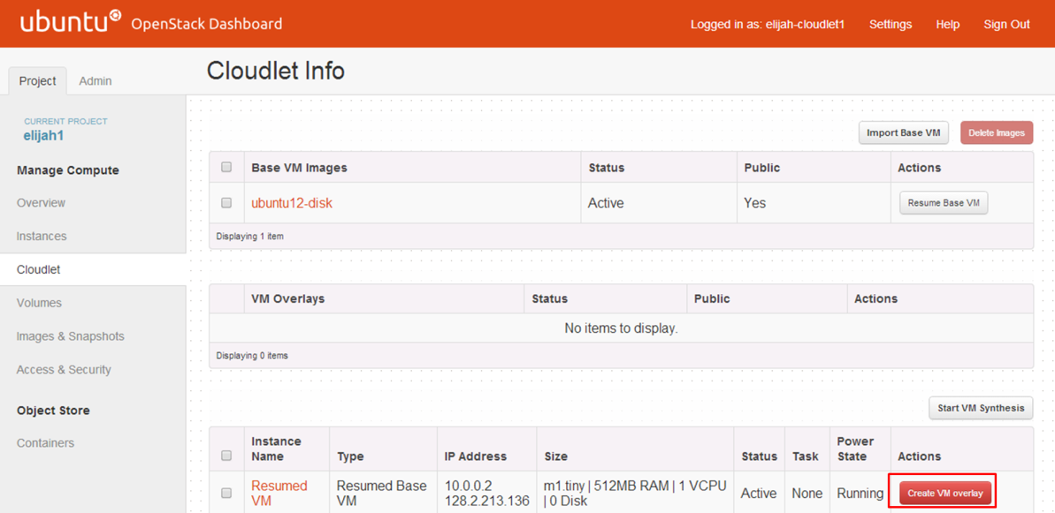

1. To perform VM synthesis, click “VM synthesis” button. It will ask you to input URL for the VM overlay.

