|  |  |
| --- | --- |
| Real-Time Concurrent Systems | Abstract  The system will consist of an elevator controller (the Scheduler), a simulator for the elevator cars (which includes, the lights, buttons, doors, and motors) and a simulator for the floors (which includes, buttons, lights and last, but not least, people who are too lazy to take the stairs).  **Group 7**  Ismail, Zakaria  Liu, Patrick  Nguyen, Trong  Elmokdad, Hussein  Ngo Huu Gia, Bao  SYSC3303A  WINTER 2021 |

Table of Contents

1. Team Members 2

2. Breakdown of Responsibilities 2

3. Diagrams 5

3.1. UML Class diagram: Scheduler 5

3.2. UML Class diagram: Elevator 6

3.3. UML Class diagram: Floor 7

3.4. UML Class diagram: Entire System 8

3.5. State Machine Diagram: Scheduler 9

3.6. Sequence Diagram: Error Scenarios 10

3.7. Timing Diagram: Scheduler 11

4. Set-up and test instructions 14

4.1. Setting up the Application 14

4.2. Executing the Application 16

4.3. Configuration of the Application 16

4.4. Testing Instructions 17

5. Results from measurements 18

5.1. Experimental procedure 18

5.2. Data reduction methods and results 18

5.3. Interpretation of data (synthesis) and discussion 19

5.4. VisualVM Sampling of Concurrent Thread Run-Time Analysis 22

6. Schedulability Analysis 24

6.1. System Throughput 24

6.2. Service Time 25

6.3. System Utilization 25

6.4. Waiting Queue Time and System Response Time 26

6.5. Transit Time 27

7. Reflections on Design 28

4. Appendices 29

4.1. Appendix A: Work Distribution 29

## Team Members

Group 7

* Ismail, Zakaria
* Liu, Patrick
* Nguyen, Trong
* Elmokdad, Hussein
* Ngo Huu Gia, Bao (Bobby)

## Breakdown of Responsibilities

The distribution of work was coordinated using *Atlassian Jira Software* which can be viewed using this link: [ECSS](https://sysc3303-project-group-7.atlassian.net/jira/software/c/projects/ECSS/issues) and for quick reference see Appendix A. Everyone took part in major code reviews and approved pull requests. Here below is a general summary:

|  |  |
| --- | --- |
| Iteration 5 @version 5.0, 04/10/23 | |
| Trong | * Implemented GUI for a whole system/console logging * Fixing timing bug of the Parser * Design script to auto-generate Elevator Events and fault * Timing diagram, Javadocs * Documentation (report writing, measurements, reflection) |
| Bobby | * Improved algorithm for Scheduler * UML class diagram, documentation (work distribution, README) * Resolved multiple elevator concurrency direction bug * Console UI integration with static model of domain |
| Hussein | * Improved Floor Subsystem * Fixing bugs of the floor subsystem * Addressed multiple floor/GUI component bugs in the system * Implemented data-transfer object for floor GUI |
| Patrick | * Updated the Parser functionality by adding new column representing the error * Updated Sequence diagram |
| Zak | * Improved, added unit tests, and fixed bug for Elevator subsystem * Handle packet lost simulation * Implement data-transfer objects for GUI * Added additional homing state * Added mode for disabled elevator state transition to timeout |

|  |  |
| --- | --- |
| Iteration 4 @version 4.0, 03/25/23 | |
| Trong | * Implemented encode & decode interfaces for data transfer objects * Implemented floor request dispatching at a relative offset time * Documentation and Javadocs * Implement/improved distributed processes |
| Bobby | * Refactored Scheduler subsystem, implemented event-driven state machine * Developed optimal elevator job assignment algorithm * Unit testing of the elevator, scheduler, & floor subsystems * Documentation |
| Hussein | * Implement multiple floors and elevators each running on separate threads * Updated messaging interface to use UDP instead of RPC * Refactoring overall system communication |
| Patrick | * Refactored Scheduler subsystem, implemented event-driven state machine * Developed network communication interfaces for the Scheduler subsystem * Validated elevator car shaft traversal algorithm * Class Diagrams for subsystems * Added timestamp parser feature |
| Zak | * Refactored Elevator subsystem, designed * Implemented event-driven state machine * Developed elevator car shaft traversal algorithm * Added fault states, and associated elevator behaviours |

|  |  |
| --- | --- |
| Iteration 3 @version 3.0, 03/11/23 | |
| Trong | * Implement Remote Procedure Calls using UDP * Implement distributed system processes * Documentation: Update class UML, sequence UML, Work Distribution Document, README * Javadocs/refactoring code smells |
| Bobby | * Improve elevator traversal to each floor sequentially * Create UI integration with Static Model of Domain (buttons, sensors…) * Preliminary elevator scanning algorithm |
| Hussein | * Implement multiple floors and elevators each running on separate threads * Integration of UI console output for better system view |
| Patrick | * Improved parser by sorting elevator request prior to sending to Floor |
| Zak | * Elevator subsystem refactoring & design * Initiate diagrams and generated system ideas |

|  |  |
| --- | --- |
| Iteration 2 @version 2.0, 02/27/23 | |
| Trong | * Implement SchedulerState class, FloorState class, SchedulerStateTest, FloorStateTest class, and javadocs |
| Bobby | * Implement FloorState class, README, refactoring, documentation |
| Hussein | * UI improvements, refactoring |
| Patrick | * Update Elevator Location feature, UML, and State diagrams |
| Zak | * Proposing ideas and revisions |

|  |  |
| --- | --- |
| Iteration 1 @version 1.0, 02/04/23 | |
| Trong | * Developed and implemented Elevator class * Documentation README, UML class & sequence, refactoring |
| Bobby | * Developed and implemented Scheduler class * Documentation README, UI logger |
| Hussein | * Developed and implemented Floor class, FloorTest, ElevatorTest |
| Patrick | * Developed and implemented Parser class, ElevatorRequest class, ParserTest, Exception class |
| Zak | * Integration of system and system testing * Overall revisions |

## Diagrams

### UML Class diagram: Scheduler

**Figure 3.1.** UML class diagram focusing on the Scheduler system.

### UML Class diagram: Elevator

**Figure 3.2.** UML class diagram focusing on the Elevator system.

### UML Class diagram: Floor

**Figure 3.3.** UML class diagram focusing on the Floor system.

### UML Class diagram: Entire System

**Figure 3.4.** UML class diagram of the Elevator Control and Simulator system.

### State Machine Diagram: Scheduler

**Figure 3.5.** State machine diagram of the Scheduler.

### Sequence Diagram: Error Scenarios

**Figure 3.6.** Sequence diagram of the system.

### Timing Diagram: Scheduler

#### Timing Diagram: No faults (happy-path)

**Figure 3.6.1.** Timing diagram for no fault occurrence in the system.

#### Timing Diagram: Soft-fault (door-obstruction)

**Figure 3.6.2.** Timing diagram for soft fault occurrence in the system.

#### Timing Diagram: Hard-fault (elevator-stuck)

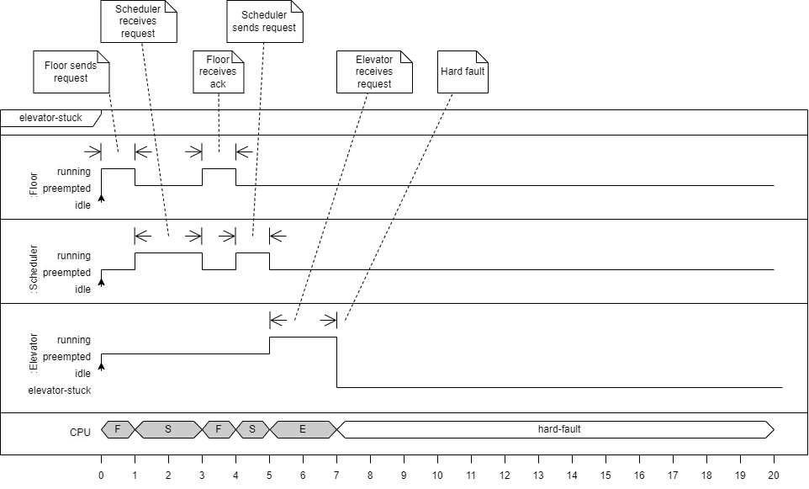

**Figure 3.6.3.** Timing diagram for hard fault occurrence in the system.

## Set-up and test instructions

### Setting up the Application

1. Download the .zip file containing the project
2. Unzip the compressed folder in a known directory
3. Open Eclipse IDE
4. Create a Java project

- File > New > Java Project

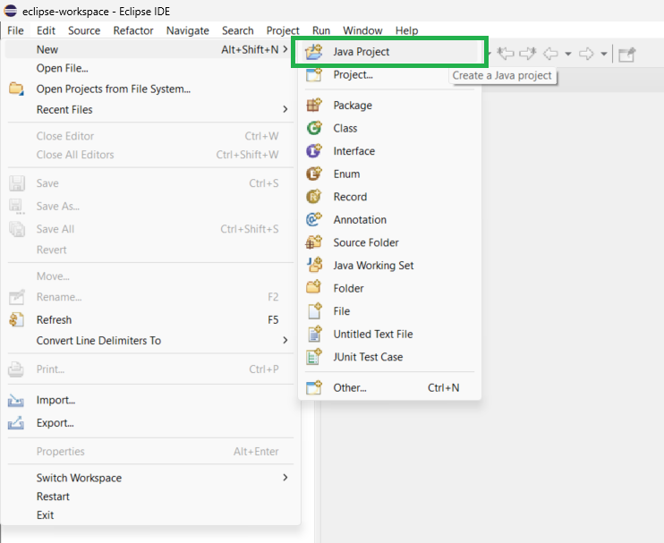

1. Click on “Java Project” menu option to navigate to “New Java Project”

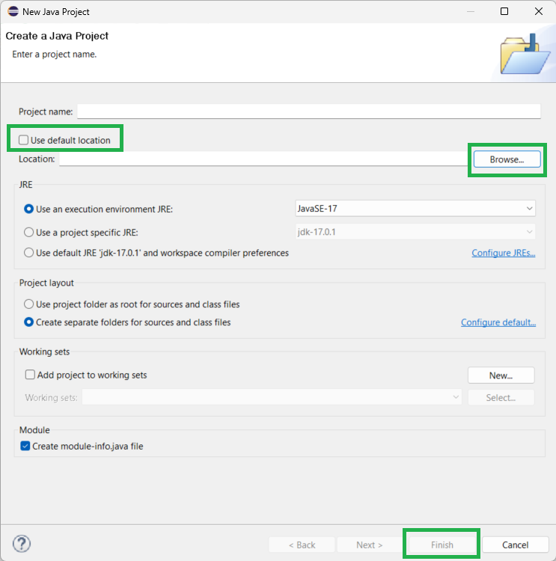

1. Untick “Use default location”
2. Click “Browse…”
3. Navigate to the extracted compressed fold containing the project
4. “Project name” field should auto-populate to *elevatorControlSystemAndSimulator*
5. Click “Finish”
6. Update the module name, if required and build file path as required
7. Expand directory and navigate to Main class

- elevatorControlSystemAndSimulator > src > main > java > Main

### Executing the Application

1. Right-click on Main

- Run as > Java Application

1. Select “input.txt” for default running parameters
2. Otherwise, select “faults.txt” to execute hard and soft faults in the application

### Configuration of the Application

This application offers the ability to customize to enable dynamic numbers of elevators and floors. There are also configurable features that allow the application to run the various components on separate computers. The configurations can be inspected under:

- elevatorControlSystemAndSimulator > src > main > java > resources > config.properties

### 4.4. Testing Instructions

Assuming that JUnit4 library has been imported correctly.

1. Right-click on the main directory name: elevatorControlSystemAndSimulator
2. To run all the unit testing

- Run as > JUnit Test

1. All unit test cases should pass

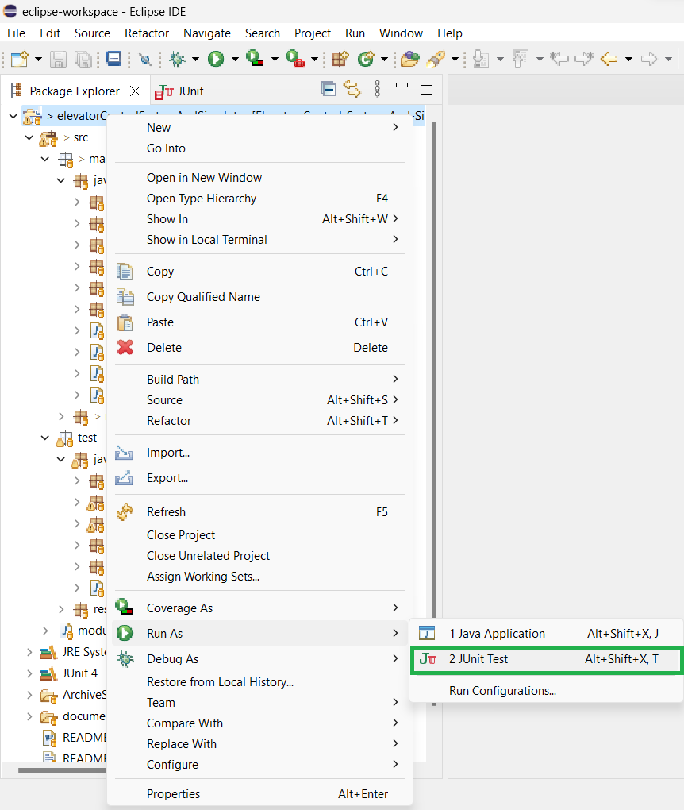

## Results from measurements

### Experimental procedure

Objective

The objective was to gather and record timing data for the time it takes an elevator to move between floors and to load/unload car. We decided to use the elevators located in the Canal Building during minimal usage hours for optimal consistency and maximize efficiency.

Questions

We are looking to determine the maximum speed of the elevator, the rate of acceleration for the elevator, and the average loading/unloading time.

Assumption

A difference in height of 4 meters between each floor.

Observation

The approach we took was to get a variety of times by going onto multiple floors and noting the time to travel between various floor differences, as seen in **Table 5.1**. For most measurements, we took 6 measurements of the same type to add some statistical backing in our findings. We also collected the boarding/exit time for when passengers would ideally load and unload the elevator car, as seen in **Table 5.2.**

### Data reduction methods and results

Analyze Data

Interpreting the data. We decided to perform a geometric mean of the trials as it is the most appropriate for series that exhibit serial correlation meaning that one time frame will affect another timeframe. This is the case when we measured floor-by-floor as opposed to traveling multiple floors without stopping. Performed a standard deviation based on sample sized. However, the arithmetic and geometric means did not really differ dramatically in our dataset. Then we perform a confidence interval with an α = 0.05 for our sample size to satisfy the common 95% benchmark for confidence.

Sample Calculations

We measured for a difference of one (1) floor the distance between floors is 4 meters and the time travel is (10.479±00.242) s. And our largest timeframe was measured for six (6) floors difference giving us as travel time of (22.187±00.387) s. Therefore, we can assume that the maximum velocity can be represented as the following equation,

However, since this was our maximum range, we can assume that 1.708 m/s is maximum velocity.

We assumed to measure the time it takes to move between two adjacent floors and time it takes to move multiple floors. And, assuming that initial velocity is 0. We can model the relationship between velocity and distance in the following equation.

Thus, using the equation for acceleration,

### Interpretation of data (synthesis) and discussion

Conclusion

Therefore, we can state that the maximum speed of the elevator is (1.708±0.895) m/s. The rate of acceleration for the elevator to be (0.365±0.112) m/s2. And the average loading/unloading time to be (4.766±0.085) s, as seen in **Table 5.3.** Reference **Table 5.4.** for a tabulated summary of requested parameters outline as per objective requirement.

There was quite a handful of assumptions that went into interpreting and applying real world dynamics towards theorical predictions and relationships. Note that real elevators accelerate and decelerate as that start up and stop, so the time it takes to move between two floors depends on whether the car needs to stop or start. From the raw data, we made some mathematical and statistical trade-offs to best highlight the main objective to be able to measure tangible metrics of real-time mechanics and attempt to translate them into real-time process that can be executable via a code source. There are many edge cases that were not captured due to time and resource constraints. However, this just highlights the minute details that contribute to creating real-time systems.

**Table 5.1.** Collected sample timing between different floors with details on starting floor, direction, and car button pressed on the elevator.

|  |  |  |  |  |
| --- | --- | --- | --- | --- |
| **Trial No.** | **Time** | **Floor Button** | **Starting Floor** | **Car Button** |
|  | hh:mm:ss.mmm | Up/Down | n | n |
| Floor diff = 1 | | | | |
| 1 | 00:00:10.150 | Up | 1 | 2 |
| 2 | 00:00:10.200 | Up | 2 | 3 |
| 3 | 00:00:10.660 | Up | 3 | 4 |
| 4 | 00:00:10.580 | Up | 4 | 5 |
| 5 | 00:00:10.600 | Up | 5 | 6 |
| 6 | 00:00:10.700 | Up | 7 | 7 |
| GEOMEAN | 00:00:10.479 |  |  |  |
| STDEV | 00:00:00.242 |  |  |  |
| CONFIDENCE | 00:00:00.254 |  |  |  |
| Floor diff = 2 | | | | |
| 1 | 00:00:12.530 | Up | 1 | 3 |
| 2 | 00:00:12.210 | Up | 4 | 6 |
| 3 | 00:00:13.090 | Up | 5 | 7 |
| 4 | 00:00:12.420 | Down | 4 | 2 |
| 5 | 00:00:12.190 | Down | 5 | 3 |
| 6 | 00:00:13.140 | Down | 6 | 4 |
| GEOMEAN | 00:00:12.591 |  |  |  |
| STDEV | 00:00:00.422 |  |  |  |
| CONFIDENCE | 00:00:00.443 |  |  |  |
| Floor diff = 4 | | | | |
| 1 | 00:00:17.440 | Up | 3 | 7 |
| 2 | 00:00:17.340 | Up | 2 | 6 |
| 3 | 00:00:17.570 | Up | 2 | 6 |
| 4 | 00:00:16.530 | Down | 7 | 3 |
| 5 | 00:00:17.090 | Down | 7 | 2 |
| 6 | 00:00:17.180 | Down | 6 | 2 |
| GEOMEAN | 00:00:17.188 |  |  |  |
| STDEV | 00:00:00.367 |  |  |  |
| CONFIDENCE | 00:00:00.386 |  |  |  |
| Floor diff = 6 | | | | |
| 1 | 00:00:22.420 | Up | 1 | 7 |
| 2 | 00:00:22.310 | Down | 7 | 1 |
| 3 | 00:00:22.520 | Up | 1 | 7 |
| 4 | 00:00:21.450 | Down | 7 | 1 |
| 5 | 00:00:22.330 | Up | 1 | 7 |
| 6 | 00:00:22.110 | Down | 7 | 1 |
| GEOMEAN | 00:00:22.187 |  |  |  |
| STDEV | 00:00:00.387 |  |  |  |
| CONFIDENCE | 00:00:00.406 |  |  |  |

**Table 5.2.** Collected data for the boarding and exit times of the elevator.

|  |  |  |  |
| --- | --- | --- | --- |
| **Trial No.** | **Boarding/exit Time** | **Door Open + Idle Time** | **Load/Unload Time** |
| 1 | 00:00:08.070 | 00:00:03.330 | 00:00:04.740 |
| 2 | 00:00:08.090 | 00:00:03.350 | 00:00:04.740 |
| 3 | 00:00:08.010 | 00:00:03.360 | 00:00:04.650 |
| 4 | 00:00:08.020 | 00:00:03.110 | 00:00:04.910 |
| 5 | 00:00:08.120 | 00:00:03.360 | 00:00:04.760 |
| 6 | 00:00:08.130 | 00:00:03.340 | 00:00:04.790 |
| GEOMEAN | 00:00:08.073 | 00:00:03.307 | 00:00:04.766 |
| STDEV | 00:00:00.050 | 00:00:00.098 | 00:00:00.085 |
| CONFIDENCE | 00:00:00.053 | 00:00:00.103 | 00:00:00.089 |

**Table 5.3.** Summary table of all the statistical analysis performed on the data of the timing between elevator floors collected with sample size = 6 and α = 0.05.

|  |  |  |  |
| --- | --- | --- | --- |
| **Floor difference** | **GEOMEAN**  hh:mm:ss.mmm | **STDEV**  hh:mm:ss.mmm | **CONFIDENCE**  hh:mm:ss.mmm |
| **1** | 00:00:10.479 | 00:00:00.242 | 00:00:00.254 |
| **2** | 00:00:12.591 | 00:00:00.422 | 00:00:00.443 |
| **4** | 00:00:17.188 | 00:00:00.367 | 00:00:00.386 |
| **6** | 00:00:22.187 | 00:00:00.387 | 00:00:00.406 |
| **Boarding/exit** | 00:00:08.073 | 00:00:00.050 | 00:00:03.651 |
| **Door Open** | 00:00:03.307 | 00:00:00.098 | 00:00:00.103 |
| **Load/Unload** | 00:00:04.766 | 00:00:00.085 | 00:00:00.089 |

**Table 5.4.** Summary table of results and interpretation calculated from raw metric date of the elevator times. NB. Error values were calculated using propagation of uncertainty.

|  |  |  |
| --- | --- | --- |
|  | **VALUE** | **ERROR** |
| **AVG SPEED [m/s]** | 1.708 | ± 0.895 |
| **d TIME [s]** | 4.676 | ± 0.111 |
| **ACCELERATION [m/s2]** | 0.365 | ± 0.902 |
| **LOAD/UNLOAD [s]** | 4.766 | ± 0.085 |

### VisualVM Sampling of Concurrent Thread Run-Time Analysis

Java VisualVM is a tool that provides a visual interface for troubleshooting and profiling Java applications while they are running on a Java Virtual Machine (JVM). It can be used to view detailed information about the application's performance and to improve it. CPU profiling is a command that returns detailed data on method-level CPU performance and shows the total execution time and number of invocations for each method. Java VisualVM instruments all the methods of the profiled application, and threads emit the "method entry" and "method exit" events when entering and exiting a method, respectively, which are processed in real-time.

This allows us to visualize the most CPU taxing threads in our application. It is no surprize that most of these processes involve message passing, decode/encode data, and handle events within the system.

## Schedulability Analysis

### System Throughput

The program has detailed logging with timestamps to measure temporal performance metrics. There is a system in place that can accelerate time for testing purposes, but the measurements provided were conducted without time acceleration. During time measurements, the time formatting was temporarily changed to show milliseconds for precision but reverted to avoid cluttering the logging.

**Table 6.1.** System throughput of the elevator simulator.

|  |  |
| --- | --- |
| **Trial No.** | **Time** [HH:mm:ss.mmm] |
| 1 | 00:03:42.966 |
| 2 | 00:04:03.005 |
| 3 | 00:03:53.000 |
| 4 | 00:03:37.000 |
| 5 | 00:03:47.547 |
| 6 | 00:03:46.706 |
| AVERAGE | 00:03:48.371 |
| STDEV | 00:00:08.917 |
| CONFIDENCE | 00:00:09.358 |
| AVERAGE [ms] | 228371 |
| STDEV [ms] | 8917 |
| CONFIDENCE [ms] | 9358 |
| Num. Request Completed (C) | 30 |
| AVERAGE THRU TIME (X=C/T) | 0.000131365 |
| STDEV | 0.00336436 |
| CONFIDENCE | 0.003205813 |

### Service Time

It's important to note that the estimate of the average service time based on the demo input file may not accurately represent the true average service time in a real-world scenario with a different set of variables. However, it can provide a baseline for further optimization and improvement.

Regarding the implementation of a more sophisticated system for tracking the average service time, machine learning systems can be trained on large datasets to improve predictions and estimate more complex patterns in the data. However, it's important to consider the cost of implementing such a system and whether it's worth the additional resources required to maintain and improve it. It may also be necessary to collect additional data and modify the system as the environment changes to maintain accurate predictions.

**Table 6.2.** Service time of the elevator simulator.

|  |  |
| --- | --- |
| **Trial No.** | **Time** [HH:mm:ss.mmm] |
| 1 | 00:03:42.966 |
| 2 | 00:04:03.005 |
| 3 | 00:03:53.000 |
| 4 | 00:03:37.000 |
| 5 | 00:03:47.547 |
| 6 | 00:03:46.706 |
| AVERAGE (B) | 00:03:48.371 |
| STDEV | 00:00:08.917 |
| CONFIDENCE | 00:00:09.358 |
| Num. Request Completed (C) | 30 |
| AVERAGE SERVICE TIME (S=B/C) | 00:00:07.612 |
| STDEV | 00:00:00.297 |
| CONFIDENCE | 00:00:00.312 |
| AVERAGE SERVICE TIME (S) [ms] | 7612 |
| STDEV [ms] | 267 |
| CONFIDENCE [ms] | 312 |

### System Utilization

Utilization refers to the percentage of time that an elevator is being used to perform work or provide service. In the context of queuing theory, utilization is the ratio of the average service time to the average time between arrivals of an elevator.

Utilization is an important metric in analyzing the performance of queuing systems because it affects both the throughput (rate of processing requests) and the service time (time taken to process a request). When the utilization of a server is high, it can lead to longer service times and reduced throughput, as the CPU is working at its capacity and may not be able to keep up with the incoming requests. On the other hand, when the utilization is low, the server may be underutilized and not performing to its maximum potential.

**Table 6.3.** System utilization of the elevator simulator.

|  |  |
| --- | --- |
| Utilization (U = X * S) | 0.999951833 |

### Waiting Queue Time and System Response Time

It's important to note that the true value of the average queuing time will be affected by many factors, such as the number of active elevators, the capacity of each elevator, the scheduling algorithm, and the distribution of floor requests over time. Therefore, the estimated value based on the console log analysis should be considered with caution and may not accurately reflect the true value of the average queuing time in all scenarios.

**Table 6.4.** Waiting Queue Time and System Response Time of the elevator simulator.

|  |  |  |
| --- | --- | --- |
| **Trial No.** | **Time** [HH:mm:ss.mmm] | **Average number of requests in Queue** (N) |
| 1 | 00:00:25.230 | 3 |
| 2 | 00:00:36.317 | 2 |
| 3 | 00:00:44.502 | 3 |
| 4 | 00:00:24.662 | 4 |
| 5 | 00:00:20.663 | 5 |
| 6 | 00:00:14.395 | 1 |
| AVERAGE (W) | 00:00:27.628 | 3 |
| STDEV | 00:00:10.940 | 1.41421356 |
| CONFIDENCE | 00:00:11.481 | 1.48412611 |
| Num. Request Completed (C) | 30 |  |
| AVERAGE RESPONSE Time  (R = W/C) | 00:00:09.209 |  |
| STDEV | 00:00:00.365 |  |
| CONFIDENCE | 00:00:00.383 |  |

Over any time, interval, the area between the arrival and completion functions represents the accumulated time W in system during that interval, measured in request-seconds (or request-minutes, etc.). System response time is the time taken by a system to respond to a user request or input. It includes the time taken for the system to receive the request, process it, and provide a response. In general, a shorter response time is considered better as it implies that the system can process requests quickly and efficiently.

Little's law is a fundamental theorem in queuing theory, which relates the average number of elevator requests in a queuing system to the arrival rate of elevators and the average time they spend in the system. It states that the long-term average number of elevators in a stable system (that is, one in which the arrival rate equals the departure rate) is equal to the product of the average arrival rate and the average time that a elevator spends in the system. In mathematical notation, Little's law can be expressed as: L = λW

where L is the long-term average number of elevator requests in the system, λ is the average arrival rate of elevator request entry and W is the average time that an elevator spends in the system. Little's law is widely used in operations research, industrial engineering, and computer science, to estimate the performance of queuing systems, to design efficient production lines, and to optimize computer networks, among other applications.

### Transit Time

The program will determine the average transit time by analyzing the console log to identify when passengers are picked up and when they are delivered to their destination. The measurement will not consider overlapping paths with other requests for simplicity, and the results will only be used as estimates for the timing diagrams.

**Table 6.5.** Transit Time of the elevator simulator.

|  |  |
| --- | --- |
| **Trial No.** | **Time** [HH:mm:ss.mmm] |
| 1 | 00:00:16.612 |
| 2 | 00:00:13.736 |
| 3 | 00:00:24.226 |
| 4 | 00:00:20.795 |
| 5 | 00:00:19.610 |
| 6 | 00:00:14.486 |
| AVERAGE (T) | 00:00:18.244 |
| STDEV | 00:00:04.032 |
| CONFIDENCE | 00:00:04.231 |
| AVERAGE (T) [ms] | 182244 |
| STDEV [ms] | 4032 |
| CONFIDENCE [ms] | 4231 |
| Num. Request Completed (C) | 30 |
| AVERAGE TRANSIT TIME/request | 6074.8 |
| STDEV | 134.4 |
| CONFIDENCE | 141.0333333 |

The note explains that the reason why the individually measured transit times and queueing times do not add up to the average service time is because the latter is based on multiple elevators with temporal acceleration, whereas the former two are measured for a single elevator. Additionally, the average service time is calculated based on an average of 7.5 requests per elevator.

## Reflections on Design

The group is satisfied with the project's design choices, which were based on the single responsibility principle, making enhancements easy to implement as the project progressed. The design is configurable and flexible, requiring minimal modifications to accommodate varying configurations. However, the group acknowledges the need for automated testing, as the testing framework initially developed was not updated in accordance with the project.

The first improvement suggested is to use generics to implement serializable encode/decode once, and then have all data transfer objects inherit a parent class with this implementation to avoid rewriting the method.

However, there is a scalability issue with the current approach of opening a new network port each time new data needs to be sent. This approach is not scalable because there is a limited number of ports on a computer. The reason for opening new ports is to avoid having to parse and figure out what kind of object it is, but a potential improvement would be to wrap data transfer object packets with a header to indicate the type of object that it is, and then route the object to the correct method accordingly.

This could be achieved by wrapping the object in a superclass with an identifier that tells you how to "route" the object when you send it to a host. For example, ElevatorRequest objects could be wrapped with an attribute String value "pendingRequest", which is like a URI resource in REST API interfaces. When the scheduler detects an object with attribute "pendingRequest", it takes the packet and treats it like a pending request. Similarly, a packet sent to the scheduler wrapped with "arrivalNotification" will be treated as an ElevatorStatus arrival notification.

Another improvement suggested is to change the scheduler to not use a state machine, as it does not fit nicely and feels hammered into the current approach. Instead, a different approach could be used, where each request is a thread competing for a critical section. The request should wait if there is no ideal elevator yet and notify all waiting threads on every arrival notification elevator status update. However, there is no defined new approach for this yet.

## Appendices

### 4.1. Appendix A: Work Distribution

Iteration 5

Iteration 4

Iteration 3

Iteration 2

Iteration 1

