添加Event
EventBrowser::OnCaptureLoaded
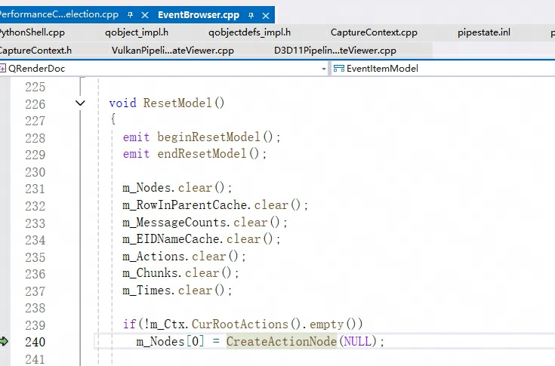
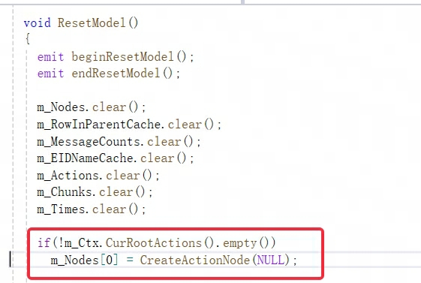
显示到UI
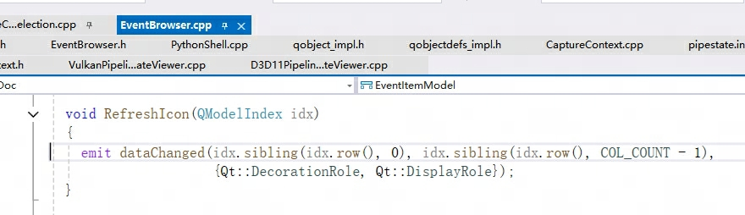
emit触发struct EventItemModel : public QAbstractItemModel
Head绘制
