无法识别C++命令
第一种方法：安装minGW安装g++
第二种方法：改指令用vs编译
renderdoc\CMakeLists.txt
#COMMAND ${HOST_NATIVE_CPP_COMPILER} 3rdparty/include-bin/main.cpp -o ${CMAKE_RUNTIME_OUTPUT_DIRECTORY}/include-bin
COMMAND "C:\\Program Files (x86)\\Microsoft Visual Studio\\2017\\Enterprise\\Common7\\Tools\\VsDevCmd.bat" && cl.exe /Zi /EHsc /Fe:${CMAKE_RUNTIME_OUTPUT_DIRECTORY}/include-bin.exe "D:/RenderDocInlineHook/renderdoc/3rdparty/include-bin/main.cpp"

找不到java
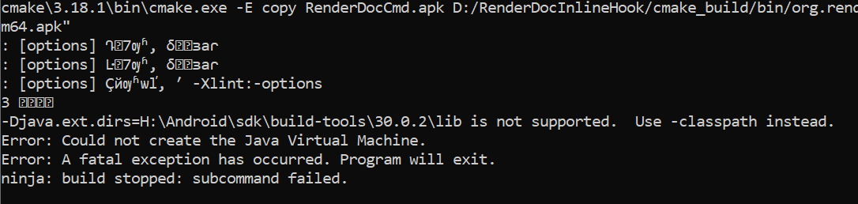
把sdk\build-tools\26.0.1的bat里的-Djava.ext.dirs="%frameworkdir%"全替换成-classpath "%frameworkdir%"

