例如：
glEGLImageTargetTexture2DOES
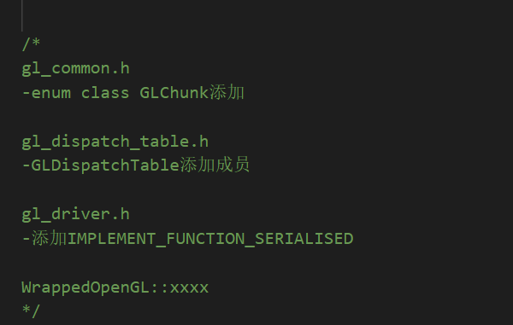
1、gl_dispatch_table_defs.h
ForEachUnsupported中移动到ForEachSupported
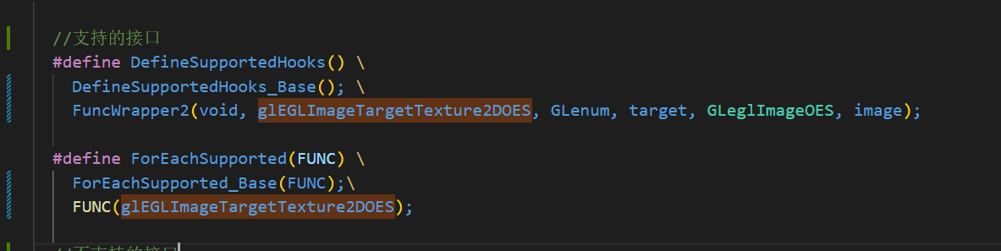

2、gl_common.h枚举GLChunk添加
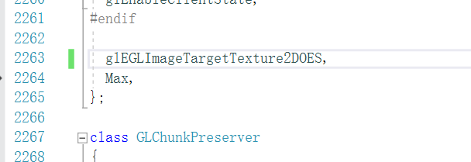

2、gl_dispatch_table.h
添加成员
PFN_glEGLImageTargetTexture2DOES_PROC

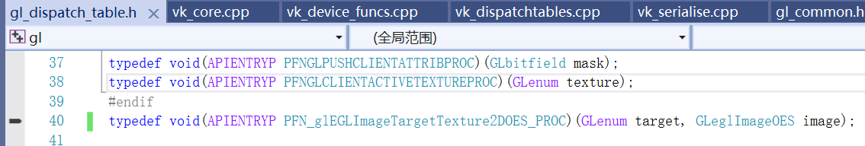
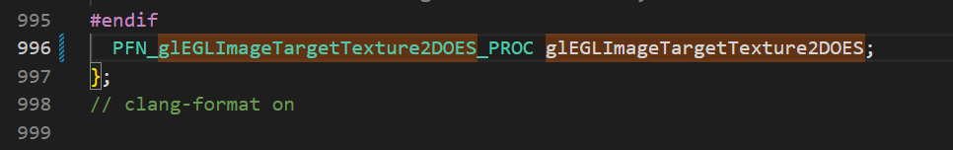

- gl_driver.h
WrappedOpenGL::ProcessChunk添加
Serialise_glEGLImageTargetTexture2DOES
-添加IMPLEMENT_FUNCTION_SERIALISED

- gl_texture_funcs.cpp添加Wrapped
