**//公開測資**

**測資 1(30%)**

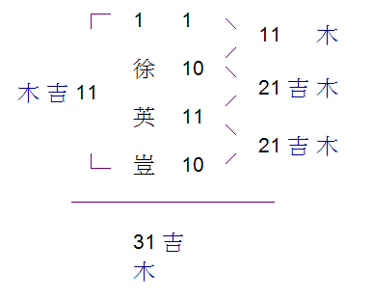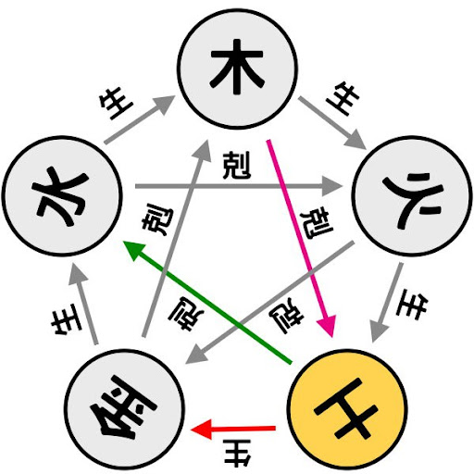

s111111

Please enter the strokes of the last name=10

Please enter the strokes of the first character of the first name =11

Please enter the strokes of the second character of the first name =10

Sky= 11 Wood

People= 21 Wood

Land= 21 Wood

Outside=11 Wood

Total=31 Wood

Sky equal People

Sky equal Land

Sky equal Outside

Sky equal Total

People equal Land

People equal Outside

People equal Total

Land equal Outside

Land equal Total

Outside equal Total

**//公開測資**

**測資2(30%)**

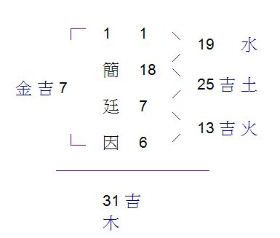

s111111

Please enter the strokes of the last name=18

Please enter the strokes of the first character of the first name =7

Please enter the strokes of the second character of the first name =6

Sky= 19 Water

People= 25 Earth

Land= 13 Fire

Outside=7 Mental

Total=31 Wood

Sky generate Total

Sky restraint Land

People restraint Sky

People generate Outside

Land generate People

Land restraint Outside

Outside generate Sky

Outside restraint Total

Total generate Land

Total restraint People