高通启动流程
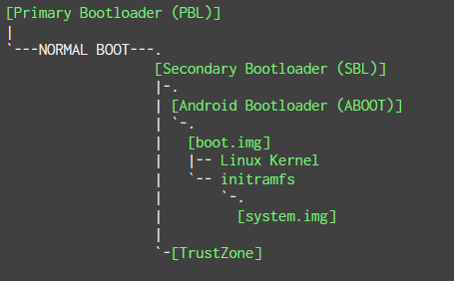

PBL:加载有数字签名的SBL到internal memory (imem)，验证签名。
SBL:初识化DDR，加载有数字签名的镜像如ABOOT（实现fastboot），truszone,验证签名。The signed certificates have a root certificate anchored in hardware.
ABOOT:
ABOOT then verifies the authenticity of the boot or recovery images, loads the Linux kernel and initramfs from the boot or recovery images. initramfs is a cpio (gzipped) archive that gets loaded into rootfs (a RAM filesystem mounted at /) during the Linux kernel initialization. It contains the init binary, the first userspace process. ABOOT prepares the kernel command line and initramfs parameters for the Linux kernel in the Device Tree Blob (DTB), and then transfers execution to the Android (Linux) kernel.

Emergency Download Mode (EDL)
高通芯片特有。这个模式下芯片在连接在usb上显示为。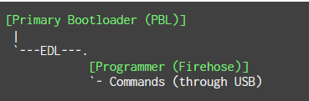
EDL由PLB实现，不会受上层程序的破坏。EDL模式是使用高通的Sahara protocol协议进行通讯。EDL会通过USB接收一个有签名的程序（OEM-digitally-signed programmer）并运行。(an ELF binary in recent devices, MBN in older ones)当做SBL，这个程序通常是Firehose(Firehose protocol)。

进入EDL模式
启动过程中连接主板上的触点
PBL校验SBL失败，进入EDL
SBL初始化或者校验失败，进入EDL
短接USB D+/GND 进入EDL
Adb reboot edl
fastboot

https://alephsecurity.com/2018/01/22/qualcomm-edl-1/

