电机2
TIM8_CH1 Pwm2 PC6
C7
C8

电机1
TIM1_CH1 Pwm1 PA8
B1
B2

方向舵机
TIM4_CH1 Pwm3 PB6

Uart1 PA9 PA10
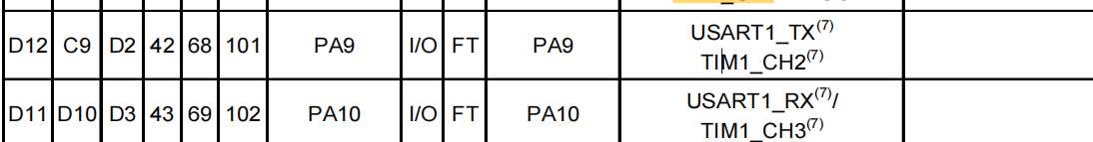
Uart2 PA2 PA3
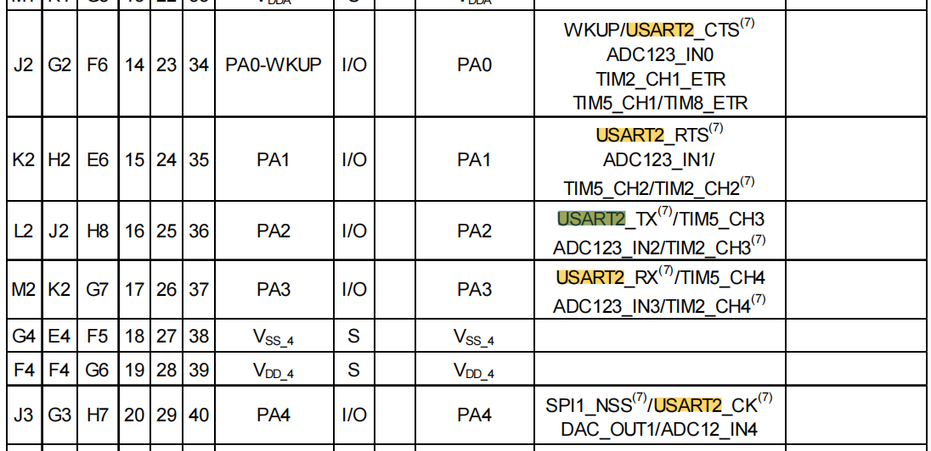

NRF24L01 Spi1 PA6 PA7
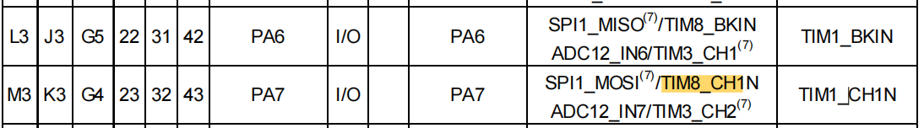

REMOTER端
Spi1
PA5 SCK
PA6 MISO
PA7 MOSI
CE PA3
IRQ PA2
CS PA4

ADC1
PA0
PA1

PC13

