Pwm2 tim8 m2

Pwm1 tim1
PA8 m1

Pwm3 tim4
PB6

Uart1
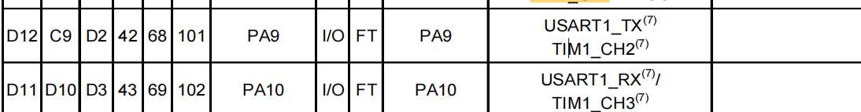
Uart2
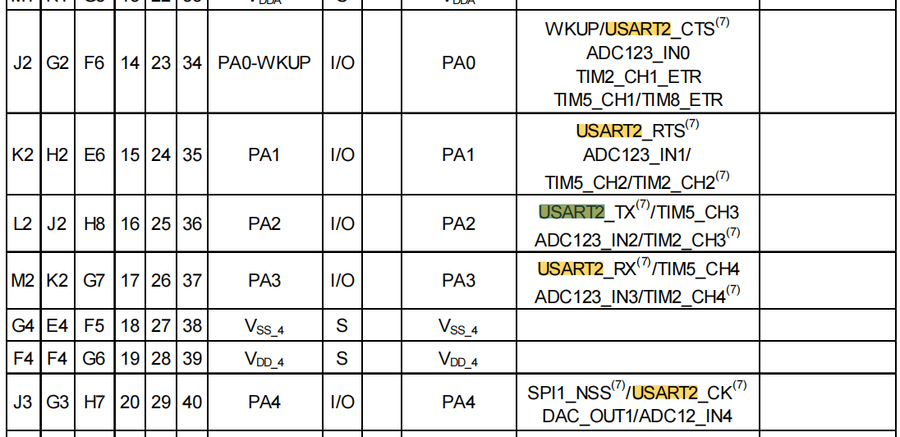
Spi1
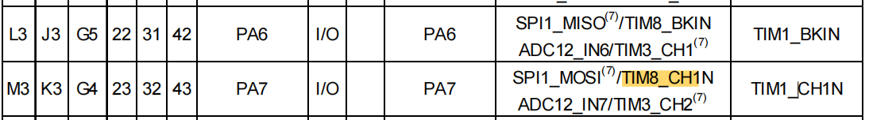
Spi2
PB13 SCK
PB14 MISO
PB15 MOSI
CE PG6
CS PG7
IRQ PG8

电机1
B1
B2
电机2
C7
C8

