**About the College**

R.M.D. Engineering College was started in the year 2001-2002 at Kavaraipettai, Gummidipoondi Taluk, and Tiruvallur District under the auspices of Sri Swaminatha Naidu Educational

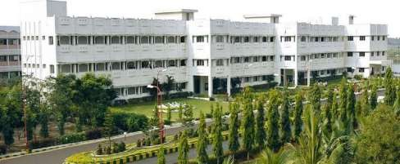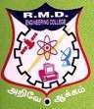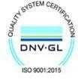

**R.M.D. EngineeringCollege**

**R.S.M. Nagar, Kavaraipettai, Gummidipoondi Taluk,**

**Tiruvallur District,**

**Tamil Nadu, Pin code: 601 206.**

Trust. The trust renders philanthropic and services to Telugu linguistic people living in bordering Tamil Nadu and Andhra Pradesh.

educational

rural areas



To create an environment in which the students

flourish through technological innovations with professional commitment and socially responsible to become a globally competent IT Professional.

**CHIEFPATRONS**

Shri R. S. Munirathinam, Founder Chairman

**PATRONS**

Smt. Manjula Munirathinam, Chairperson Shri. R. Jothi Naidu, Director

Shri. R. M. Kishore, Vice Chairman

Shri. Yalamanchi Pradeep, Secretary

Dr. Durgadevi Pradeep, Vice Chairperson

Smt. Sowmya Kishore, Trustee Dr. N. Anbuchezhian, Principal Dr. K. Sivaram,Dean(Research)

Dr. K. K.Thyagharajan,Dean(Academics)

**ADVISORS**

Dr. M.S. Palanichamy

Shri. P. Pitchandi I.A.S (Rtd.) Shr. V.Manoharan **CONFERENCECHAIR**

Dr. K. Balasubadra, Prof &Head

**CONFERENCE CO-CHAIR**

Dr. P. M. Joe Prathap, Professor

**ADVISORY & TECHNICALCOMMITTEE**

Dr. A. P.Shanthi, Prof, CSE,

CEG Campus, Anna University.

Dr.E.Iniya Nehru, Senior Technical Director,

National Information Centre, Chennai.

Mr. E. Raja, Project Manager, TCS, Chennai.

**ORGANIZING COMMITTEE**

Dr. R. Jothilakshmi, Associate Professor

Dr. V.Prasanna Srinivasan, Associate Professor

**Department Vision**

**About the Department**

The Department of Information Technology (IT) was established in the year 2001 with the aim of providing inclusive technology education to students, and thereby creating responsible citizens who would be a globally competent individuals contributing to the betterment of their families, society and nation. IT department started with UG Program with a sanctioned intake of 60 students. Some of the laboratories have also been set up in collaboration with industries as part of Centre of Excellence (CoE) such as Inautix, CTS and Virtusa-Polaris. The department is ISO 9001:2008 certified and also accredited by the National Board of Accreditation (NBA) in the year 2017.

**Department of Information Technology**

Organizes Tenth National

Conference on

***Latest Issues in Information Technology***

***2020***

**LIIT-2020**

**Department Mission**

* Attaining academic excellence in Information Technology

through effective teaching learning process.

* Providing suitable environment for the students to develop professionalism to meet challenges with ethical and social responsibility.
* Enhancing the knowledge of the faculty in technological advancements by participating in training programs.
* Facilitating industry institute interaction in teaching and

learning practices to satisfy global standards.

**Latest Issues in Information Technology 2020**

**LIIT-2020**

**4ͭͪApril 2020**

**Department of Information Technology,**

### About the Conference

The objective of the National Conference on Latest Issues in Information Technology (LIIT-2020) is a premiere event focused on the recent issues in Information Technologies, Computer Science and related disciplines. The main scope of LIIT-2020 is to bring together the researchers, engineers and research students in all areas of Computer Engineering, Information Technology and Telecommunication in and

### Submission of Paper

Selected Papers should be presented at the conference by one of the authors. Full Paper: 4 Pages length should be submitted in doc/docx format through e-mail.

*Certificates with authors photo will be issued to all

authors and registration fees includes conference kit,

**R.M.D. Engineering College,**

**R.S.M. Nagar,**

around India to exchange original research results,

theory and practical views and ideas.

new

breakfast, tea and lunch.

**Kavaraipettai-601206 Call for Papers**

## Key Dates

Submission of full paper

:20-03-2020

## Registration form

Name : ……………………….

Address : ……………………….

………………………

Researchers, academicians and post graduate students are invited to present their research papers only original submissions will be accepted and must not be under review or published in another conference. The topics include but are not limited to Artificial Intelligence and Knowledge based software engineering Communication

Notification of Acceptance

Submission of camera ready copy with copyright form **Registration Fee**

Students and Research Scholars

:25-03-2020

:27-03-2020

: Rs250

Phone

E-Mail Presenting paper

If Yes, Title

DD details

Signature of

: ………………………

: ………………………

: Yes/No

:………………………

: ………………………

Systems and Networks-Components- Based Software Engineering-Computer & Software Engineering – Data mining and knowledge Recovery – Digital Image Processing - Distributed Intelligent Systems - Engineering

of Embedded and Real-time Software – human - computer interaction - Information system engineering middleware design techniques-mobile, ubiquitous and pervasive computing-parallel and Distributed computing- Reengineering Reverse Engineering – Reliability Modeling and Analysis – Services Oriented Architecture -

Registration fee should be paid as demand draft in

favor of **“The Principal, R.M.D. Engineering College, Kavaraipettai”**

# For Details Contact

**LIIT-2020**

#### Department of Information Technology,

**R.M.D. Engineering College,**

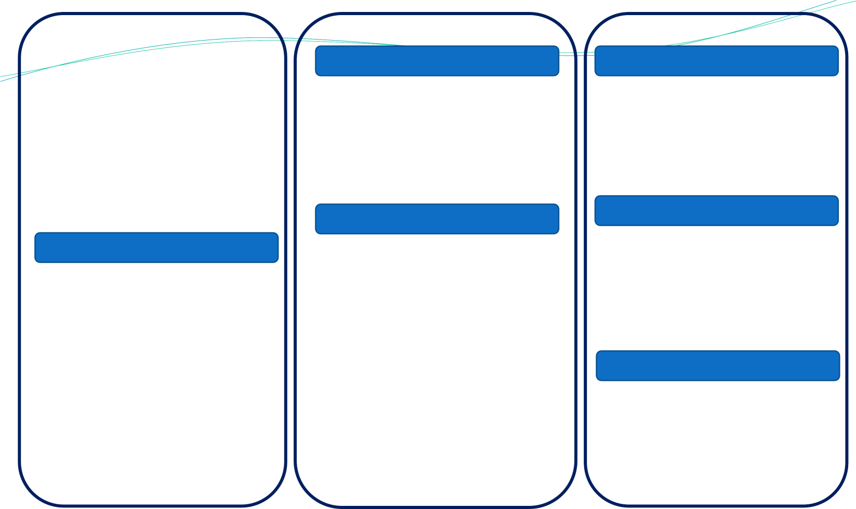the Candidate: ………………………



Signature of the HOD:

Telecommunication – Virtual Reality and Computer

Graphics – Visual and Multimedia Computing –Web Engineering – Web – Based Applications - Wireless Computing - Wireless Sensor Networks - Mobile Ad-hoc Network (MANET) - vehicular Ad-hoc Networks(VANET) - Big Data

#### R.S.M. Nagar, Kavaraipettai-601206 Phone no-044-67919191

[**http://www.rmd.ac.in/LIIT2020/**](http://www.rmd.ac.in/LIIT2020/)

Email: [rmdliit20@gmail.com](mailto:rmdliit20@gmail.com)