# 结构体

STRUCT_MAP_ROAD（道路标识信息）

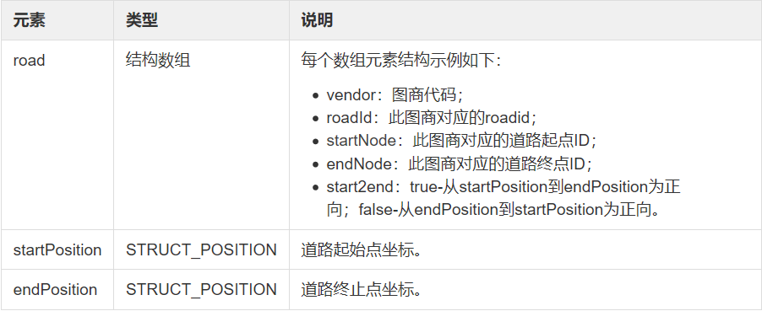

STRUCT_POSITION（WGS84坐标）

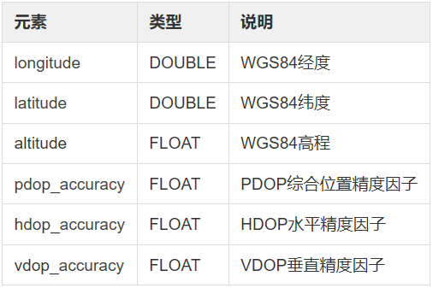

STRUCT_CUBE（立方体）

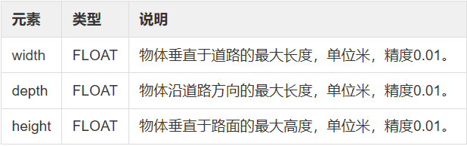

STRUCT_DIRECTION

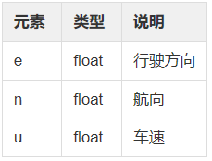

STRUCT_MAP_LANES（车道列表）

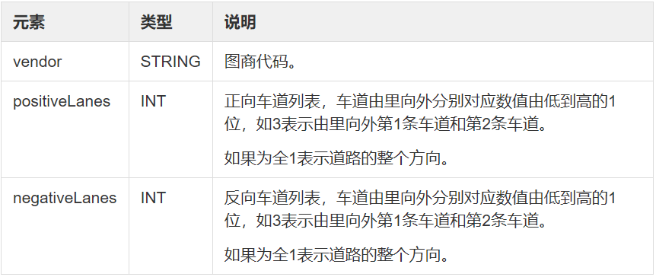

STRUCT_CELL（广播单元）

polycon和circle二选一。

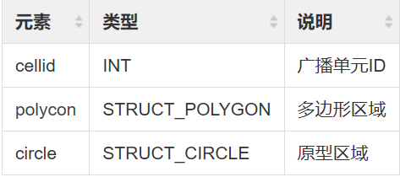

STRUCT_POLYGON（多边形区域）

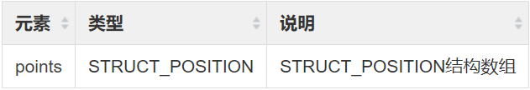

STRUCT_CIRCLE（圆形区域）

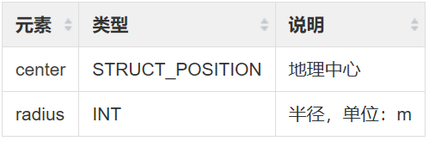

STRUCT_ROAD_RESTRICTION（道路限制信息）

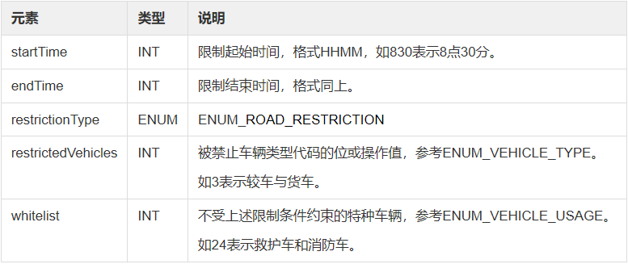

STRUCT_ROAD_VEHICLE（道路上的车辆）

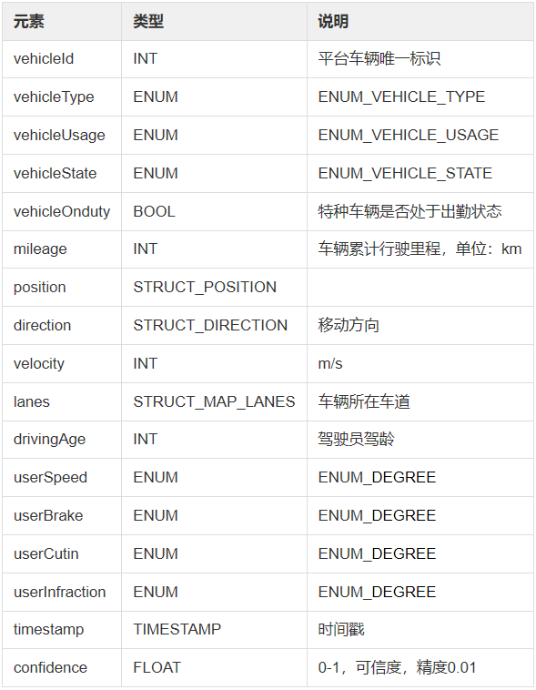

STRUCT_ROAD_GEO（事件点地理信息）

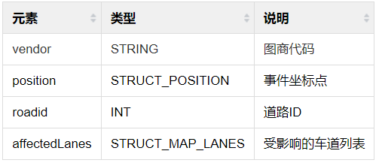

STRUCT_MAP_NODE（连接点）

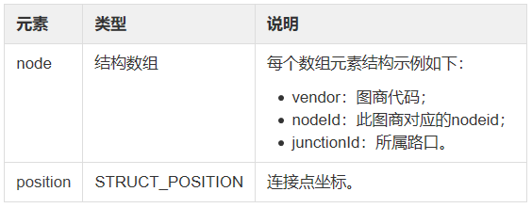

STRUCT_MAP_CONNECTING（路口内连接线）

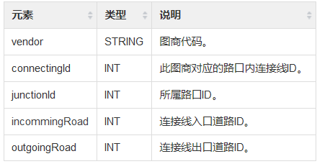

# 枚举

ENUM_ROAD_OBSTACLE（道路障碍类型）

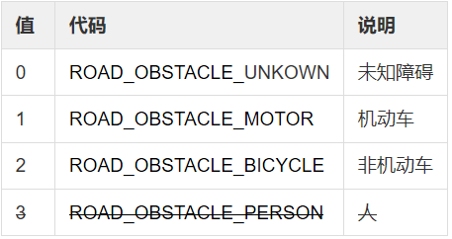

ENUM_COLOR（颜色）

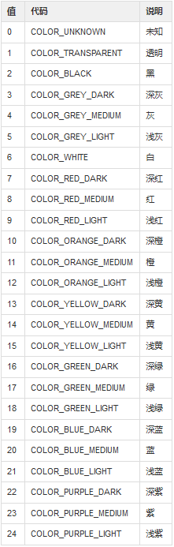

ENUM_DEGREE（等级）

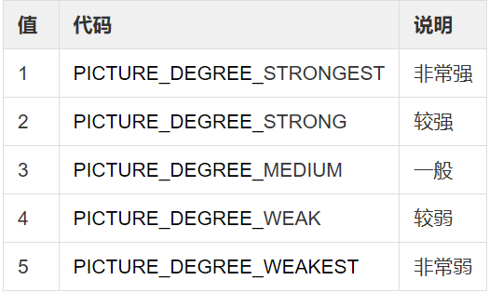

ENUM_ROAD_EVENT（道路异常事件）

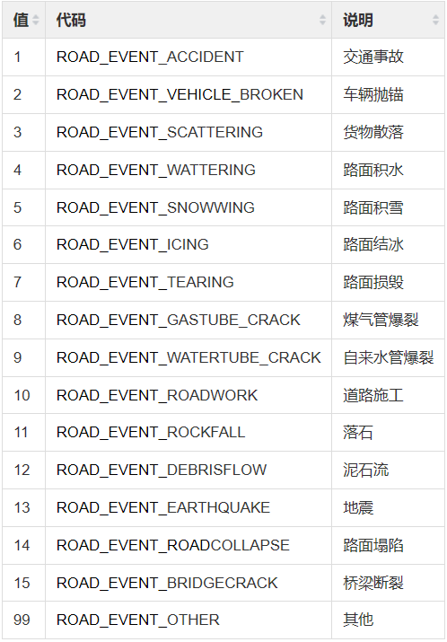

ENUM_ROAD_RESTRICTION（道路限制信息）

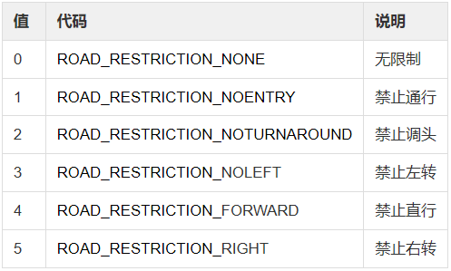

ENUM_TSC_FLASHMODE（信号机闪光状态）

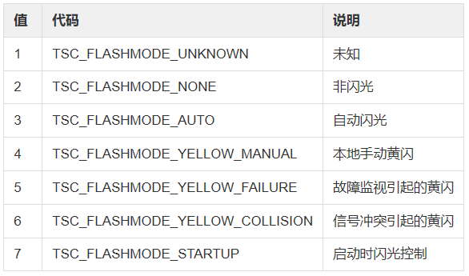

ENUM_TSC_LIGHT（信号灯状态）

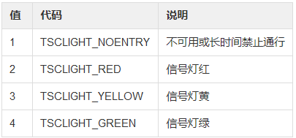

ENUM_TSC_EXIT（信号灯出口方向）

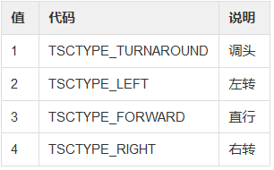

# 基础数据

查询车辆vehicleId （文中也称为vehicle_num），拼接数据或topic时需要

## 下发查询本车VID

Topic:tbox/request/yktype

发布信息体：

[{

"yktype": "vid"

}]

## 回复本车VID

Topic:tbox/reply/yktype

发布信息体：

[{

"yktype": "vid"，

"value": "xxxxxxx"

}]

# 下发数据：

## 道路施工/道路结冰（DM0202_路面异常事件信息）

Topic:cpub/<vehicle_num>/road/anomaly

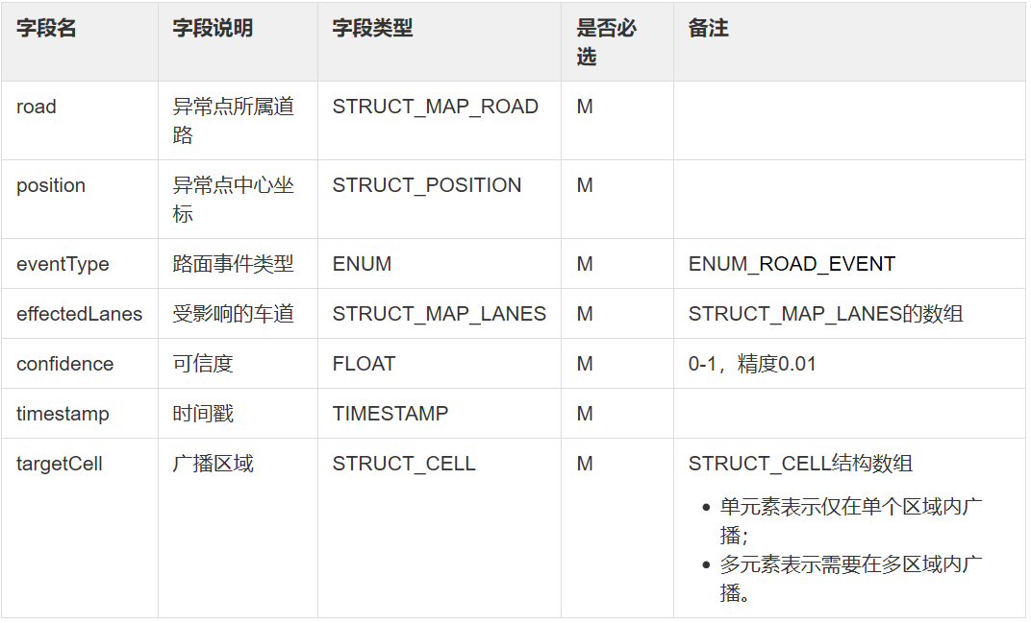

示例

{

[{

"road": {

"road": [{

"vendor": "dfjkdshfkj",

"roadId": 34,

"startNode": "",

"endNode": "",

"start2end": false

}],

"startPosition": {

"longitude": 116.395093,

"latitude": 40.008196,

"altitude": 0.0,

"pdop_accuracy": 0.1,

"hdop_accuracy": 0.1,

"vdop_accuracy": 0.1

},

"endPosition": {

"longitude": 116.397599,

"latitude": 40.008314,

"altitude": 0.0,

"pdop_accuracy": 0.1,

"hdop_accuracy": 0.1,

"vdop_accuracy": 0.1

}

},

"position": {

"longitude": 116.376691,

"latitude": 39.973882,

"altitude": 20.973882,

"pdop_accuracy": null,

"hdop_accuracy": null,

"vdop_accuracy": null

},

"eventType": 12,

"effectedLanes": [{

"vendor": null,

"positiveLanes": 343,

"negativeLanes": 213

}],

"timestamp": 1528105852000,

"confidence": 0.88,

"targetCell": [{

"cellid": 1004,

"polygon": {

"points": [{

"longitude": 116.393188,

"latitude": 40.012966,

"altitude": 0.0,

"pdop_accuracy": 0.1,

"hdop_accuracy": 0.1,

"vdop_accuracy": 0.1

},

{

"longitude": 116.394949,

"latitude": 40.008625,

"altitude": 0.0,

"pdop_accuracy": 0.1,

"hdop_accuracy": 0.1,

"vdop_accuracy": 0.1

},

{

"longitude": 116.394976,

"latitude": 40.008179,

"altitude": 0.0,

"pdop_accuracy": 0.1,

"hdop_accuracy": 0.1,

"vdop_accuracy": 0.1

},

{

"longitude": 116.393417,

"latitude": 40.008113,

"altitude": 0.0,

"pdop_accuracy": 0.1,

"hdop_accuracy": 0.1,

"vdop_accuracy": 0.1

},

{

"longitude": 116.393188,

"latitude": 40.012966,

"altitude": 0.0,

"pdop_accuracy": 0.1,

"hdop_accuracy": 0.1,

"vdop_accuracy": 0.1

}]

},

"circle": null

}]

}]

}

## 有障碍物（DM0203_路面障碍异常信息）

Topic:cpub/<vehicle_num>/road/obstacle

示例

{

[{

"road": {

"road": [{

"vendor": "dfjkdshfkj",

"roadId": 78,

"startNode": "",

"endNode": "",

"start2end": false

}],

"startPosition": {

"longitude": 116.395093,

"latitude": 40.008196,

"altitude": 0.0,

"pdop_accuracy": 1.0E-6,

"hdop_accuracy": 1.0E-6,

"vdop_accuracy": 1.0E-6

},

"endPosition": {

"longitude": 116.397599,

"latitude": 40.008314,

"altitude": 0.0,

"pdop_accuracy": 1.0E-6,

"hdop_accuracy": 1.0E-6,

"vdop_accuracy": 1.0E-6

}

},

"position": {

"longitude": 116.376691,

"latitude": 39.973882,

"altitude": 20.973882,

"pdop_accuracy": null,

"hdop_accuracy": null,

"vdop_accuracy": null

},

"obstacleType": 99,

"size": {

"width": 45.2,

"depth": 23.1,

"height": 33.2

},

"color": 3,

"movable": false,

"direction": {

"e": 67.23,

"n": 45.55,

"u": 23.56

},

"velocity": 0.33,

"dangerLevel": 1,

"effectedLanes": [{

"vendor": null,

"positiveLanes": 343,

"negativeLanes": 213

}],

"timestamp": 1528105852000,

"confidence": 0.88,

"targetCell": [{

"cellid": 1004,

"polygon": {

"points": [{

"longitude": 116.397729,

"latitude": 40.008714,

"altitude": 0.0,

"pdop_accuracy": 0.1,

"hdop_accuracy": 0.1,

"vdop_accuracy": 0.1

},

{

"longitude": 116.39936,

"latitude": 40.008759,

"altitude": 0.0,

"pdop_accuracy": 0.1,

"hdop_accuracy": 0.1,

"vdop_accuracy": 0.1

},

{

"longitude": 116.399364,

"latitude": 40.0084,

"altitude": 0.0,

"pdop_accuracy": 0.1,

"hdop_accuracy": 0.1,

"vdop_accuracy": 0.1

},

{

"longitude": 116.397729,

"latitude": 40.008314,

"altitude": 0.0,

"pdop_accuracy": 0.1,

"hdop_accuracy": 0.1,

"vdop_accuracy": 0.1

},

{

"longitude": 116.397729,

"latitude": 40.008714,

"altitude": 0.0,

"pdop_accuracy": 0.1,

"hdop_accuracy": 0.1,

"vdop_accuracy": 0.1

}]

},

"circle": null

}]

}]

}

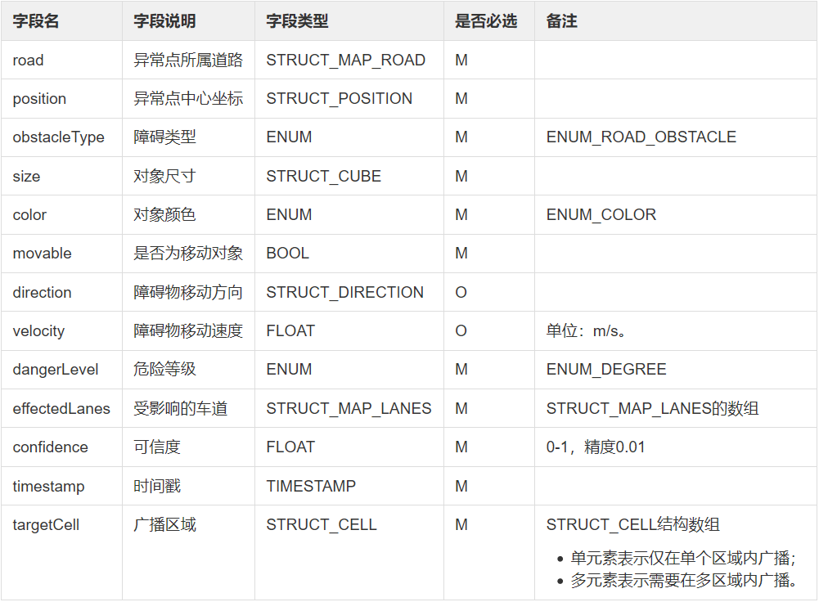

## 公交专用道（DM0208_动态车道规划）

Topic: cpub/<vehicle_num>/traffic/tidal

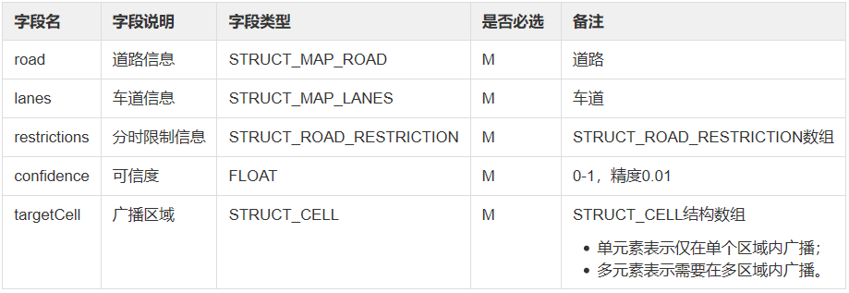

示例

{

[{

"confidence": 0.9,

"road": {

"road": [{

"vendor": "BEC",

"roadId": 32423,

"startNode": "001",

"endNode": "002",

"start2end": true

},

{

"vendor": "baidu",

"roadId": 23432,

"startNode": "001",

"endNode": "002",

"start2end": true

}],

"startPosition": null,

"endPosition": null

},

"lanes": [{

"positiveLanes": 302,

"negativeLanes": 101

}],

"restrictions": [{

"startTime": 830,

"endTime": 835,

"restrictionType": 4,

"restrictedVehicles": 2,

"whitelist": 6

},

{

"startTime": 900,

"endTime": 930,

"restrictionType": 4,

"restrictedVehicles": 4,

"whitelist": 1

}],

"targetCell": [{

"cellid": 28,

"polygon": {

"points": [{

"longitude": 116.3825,

"latitude": 39.971324,

"altitude": 20.971882,

"pdop_accuracy": null,

"hdop_accuracy": null,

"vdop_accuracy": null

},

{

"longitude": 116.3835,

"latitude": 39.970324,

"altitude": 20.970882,

"pdop_accuracy": null,

"hdop_accuracy": null,

"vdop_accuracy": null

},

{

"longitude": 116.3845,

"latitude": 39.972324,

"altitude": 20.979882,

"pdop_accuracy": null,

"hdop_accuracy": null,

"vdop_accuracy": null

},

{

"longitude": 116.3825,

"latitude": 39.971324,

"altitude": 20.977882,

"pdop_accuracy": null,

"hdop_accuracy": null,

"vdop_accuracy": null

}]

}

}]

}]

}

## 危险车辆（DM0205_旁车信息）

Topic:cpub/<vehicle_num>/info

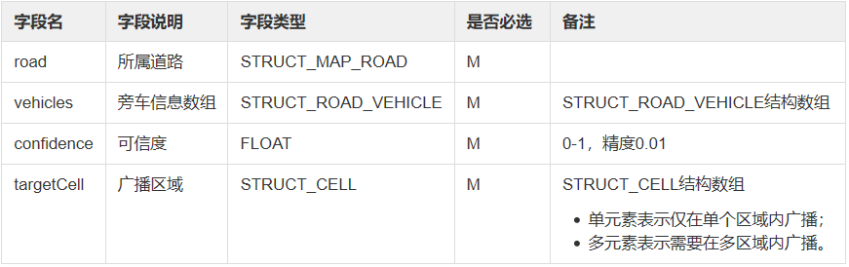

示例

{

    "road": {

        "road": [{

            "vendor": "sdhgdsf",

            "startNode": "sdfdsfd",

            "roadId": 12321,

            "endNode": "dsfdsfds",

            "start2end": false

        }],

        "endPosition": {

            "altitude": 20.973882,

            "latitude": 39.974324,

            "longitude": 116.3865

        },

        "startPosition": {

            "altitude": 20.973882,

            "latitude": 39.973882,

            "longitude": 116.376691

        }

    },

    "confidence": 0.88,

    "vehicles": [{

        "vehicleUsage": 2,

        "userBrake": 2,

        "velocity": 44,

        "userSpeed": 3,

        "userCutin": 4,

        "drivingAge": 30,

        "lanes": [{

            "positiveLanes": 324,

            "negativeLanes": 232

        }],

        "vehicleId": 23,

        "vehicleOnduty": true,

        "position": {

            "altitude": 20.973882,

            "latitude": 39.973882,

            "longitude": 116.376691

        },

        "vehicleType": 4,

        "vehicleState": 3,

        "mileage": 23,

        "direction": {

            "e": 67.23,

            "u": 23.56,

            "n": 45.55

        },

        "userInfraction": 1,

        "timestamp": 1526435852123

    }],

    "targetCell": [{

        "polygon": {

            "points": [{

                "altitude": 20.971882,

                "latitude": 39.971324,

                "longitude": 116.3825

            }, {

                "altitude": 20.970882,

                "latitude": 39.970324,

                "longitude": 116.3835

            }, {

                "altitude": 20.979882,

                "latitude": 39.972324,

                "longitude": 116.3845

            }, {

                "altitude": 20.977882,

                "latitude": 39.971324,

                "longitude": 116.3825

            }]

        },

        "cellid": 23,

        "circle": {

            "center": {

                "altitude": 20.970882,

                "latitude": 39.972882,

                "longitude": 116.377791

            },

            "radius": 20

        }

    }]

}

## 信号灯（DM0211_信号灯实时状态）

Topic: cpub/<vehicle_num>/traffic/signal

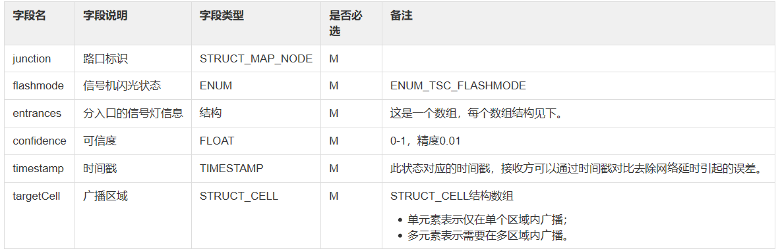

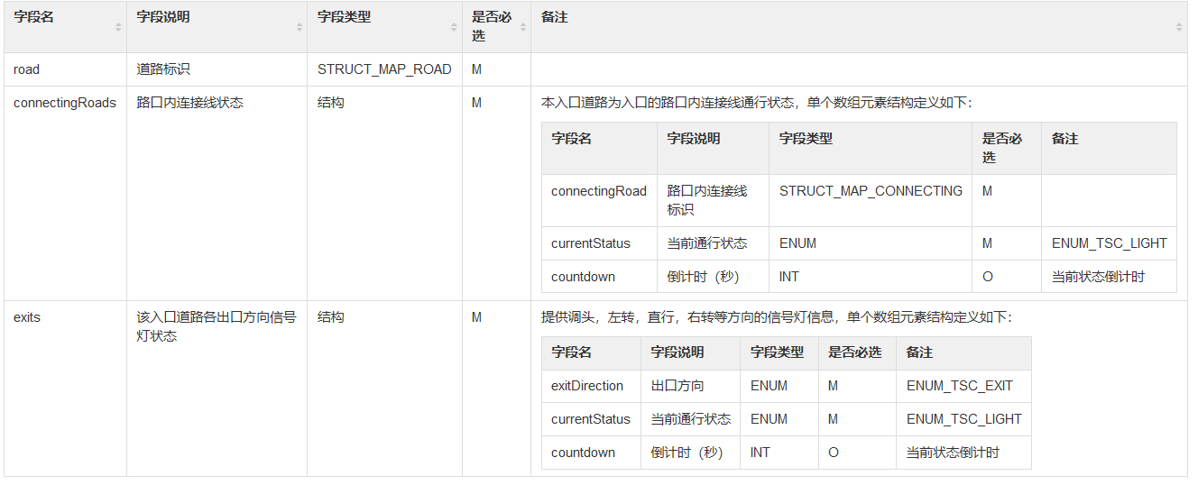

*注 次结构略有变更，详情与研发人员沟通

示例

{

[{

"junction": {

"node": [{

"vendor": "EMG",

"junctionId": 464364,

"nodeId": 21321

}],

"position": {

"altitude": 32.44456,

"latitude": 45.66543,

"hdop_accuracy": null,

"vdop_accuracy": null,

"pdop_accuracy": null,

"longitude": null

}

},

"confidence": 0.8,

"flashmode": 3,

"targetCell": [{

"cellid": 28,

"polygon": {

"points": [{

"longitude": 116.3825,

"latitude": 39.971324,

"altitude": 20.971882,

"pdop_accuracy": null,

"vdop_accuracy": null,

"hdop_accuracy": null

},

{

"longitude": 116.3835,

"latitude": 39.970324,

"altitude": 20.970882,

"pdop_accuracy": null,

"vdop_accuracy": null,

"hdop_accuracy": null

},

{

"longitude": 116.3845,

"latitude": 39.972324,

"altitude": 20.979882,

"pdop_accuracy": null,

"vdop_accuracy": null,

"hdop_accuracy": null

},

{

"longitude": 116.3825,

"latitude": 39.971324,

"altitude": 20.977882,

"pdop_accuracy": null,

"vdop_accuracy": null,

"hdop_accuracy": null

}]

}

}],

"entrances": [{

"exits": [{

"currentStatus": null,

"countdown": 9,

"exitDirection": 4

}],

"road": {

"road": [{

"vendor": "EMG",

"startNode": "1222",

"roadId": "1224312",

"endNode": "1224",

"start2end": true

}],

"endPosition": {

"altitude": 33.4784,

"latitude": 46.6456,

"hdop_accuracy": null,

"vdop_accuracy": null,

"pdop_accuracy": null,

"longitude": null

},

"startPosition": {

"altitude": 32.44456,

"latitude": 45.66543,

"hdop_accuracy": null,

"vdop_accuracy": null,

"pdop_accuracy": null,

"longitude": null

}

},

"connectingRoads": [{

"connectingRoad": {

"incommingRoad": 343242,

"vendor": "EMG",

"junctionId": 2342324,

"outgoingRoad": 3423423,

"connectingId": 123123

},

"currentStatus": null,

"countdown": 12

}]

}],

"timestamp": 1528253838907

}]

}

## GPS数据

每100ms通知一次，

Topic:tbox/send/position

发布信息体：

{

*"longitude": 116.376691,*

*"latitude": 39.973882,*

*"altitude": 20.973882,*

*"direction": 90.55*

}

# 上报数据

## 道路施工/道路结冰（DM0109_路面条件异常）

Topic: vpub/perception/pavementAnomaly

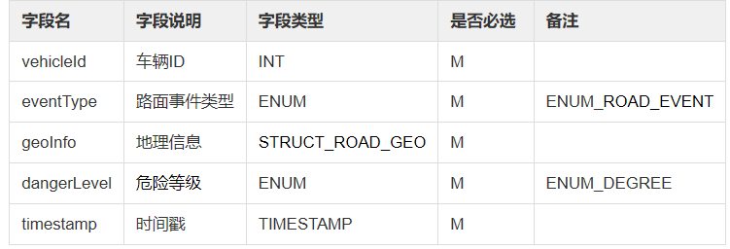

示例

{

[{

"vehicleId": 67,

"eventType": 12,

"geoInfo": {

"vendor": "dfjkdshfkj",

"position": {

"longitude": 116.376691,

"latitude": 39.973882,

"altitude": 20.973882,

"pdop_accuracy": 0.9,

"hdop_accuracy": 0.9,

"vdop_accuracy": 0.9

},

"roadid": 34,

"affectedLanes": [{

"positiveLanes": 343,

"negativeLanes": 213

}]

},

"dangerLevel": 1,

"timestamp": 1528105852000

}]

}

## 障碍物提醒（DM0110_障碍物感知）

Topic: vpub/perception/obstacle

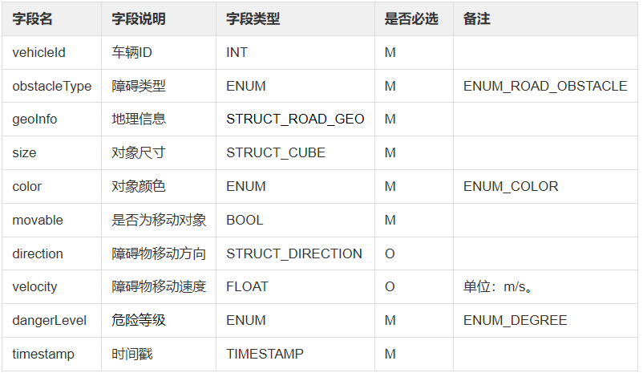

示例

{

[{

"vehicleId": 23,

"obstacleType": 1,

"geoInfo": {

"vendor": "dfjkdshfkj",

"position": {

"longitude": 116.376691,

"latitude": 39.973882,

"altitude": 20.973882,

"pdop_accuracy": 0.9,

"hdop_accuracy": 0.9,

"vdop_accuracy": 0.9

},

"roadid": 78,

"affectedLanes": [{

"positiveLanes": 343,

"negativeLanes": 213

}]

},

"size": {

"width": 45.2,

"depth": 23.1,

"height": 33.2

},

"color": 2,

"movable": false,

"direction": {

"e": 67.23,

"n": 45.55,

"u": 23.56

},

"velocity": 0.33,

"dangerLevel": 1,

"timestamp": 1528105852000

}]

}