APT2090-A GROUP WORK

Course Name: Computer Graphics
Course Code: APT 2090-A

Instructor: Prof. Aloo, Linus; PhD
Semester: Fall 2024
GROUP FOUR
Names
Francis Mwangi -667286
Joy Kosgei-668324
Eugene juma-668855
Esther Zolabird-666620
Mohamed Salat-667207
Boston Palanga 666234

TITLE: PRACTICING COMPUTER GRAPHICS USING OpenGL AND C++
Objectives
i. To draw Basic 2D Shapes using OpenGL AND C++.
ii. To apply the OpenGL program to draw and rotate a 3D cube about the x-axis and y-axis.
iii. To implement Bresenham's Line Drawing Algorithm for drawing a line between two points using an OpenGL program and C++.
iv. To write and implement a C++ OpenGL program to draw a circle using the Midpoint Circle Algorithm.
v. To write and implement a C++ OpenGL program to draw a 3D pyramid with a square base.
vi. To write and implement a C++ OpenGL program to animate a 2D square moving horizontally across the screen.
vii. To implement selected clipping alogrithms (for point, line and polygon clipping) using OpenGL AND C++.
viii.

Methodology
Activity 1: Drawing Basic 2D Shapes
Problem:
Write, simulate, and explain an OpenGL program in C++ to draw a 2D house consisting of a triangle roof and a rectangle base.
HINT:
- Use gluOrtho2D to set up a 2D orthographic projection.
- Use glBegin(GL_POLYGON) and glBegin(GL_TRIANGLES) to draw the house base and roof.
C++ CODE
#include <GL/glut.h>

void display() {
glClear(GL_COLOR_BUFFER_BIT);

glColor3f(0.5f, 0.25f, 0.0f);
glBegin(GL_POLYGON);
glVertex2f(-0.6f, -0.5f);
glVertex2f( 0.6f, -0.5f);
glVertex2f( 0.6f, 0.5f);
glVertex2f(-0.6f, 0.5f);
glEnd();

glColor3f(1.0f, 0.0f, 0.0f);
glBegin(GL_TRIANGLES);
glVertex2f(-0.7f, 0.5f);
glVertex2f( 0.7f, 0.5f);
glVertex2f( 0.0f, 1.0f);
glEnd();

glFlush();
}

int main(int argc, char** argv) {
glutInit(&argc, argv);
glutInitDisplayMode(GLUT_SINGLE | GLUT_RGB);
glutInitWindowSize(500, 500);
glutCreateWindow("2D House with OpenGL");

glClearColor(1.0f, 1.0f, 1.0f, 1.0f);
glOrtho(-1.0f, 1.0f, -1.0f, 1.0f, -1.0f, 1.0f);

glutDisplayFunc(display);

glutMainLoop();

return 0;
}
CODE EXPLANATION
- Include Libraries:
  - #include <GL/glut.h> is used to include the OpenGL Utility Toolkit (GLUT), which helps in creating the window and handling the OpenGL context.
- display() Function:
  - This function is responsible for drawing the scene. The OpenGL calls within display() render the house.
  - Clear the screen: glClear(GL_COLOR_BUFFER_BIT); ensures that each frame starts with a blank canvas.
  - Draw the house base (rectangle):
    - We use glColor3f(0.5f, 0.25f, 0.0f); to set a brown color for the rectangle base of the house.
    - The rectangle is drawn using glBegin(GL_POLYGON) and specifying the four corners of the rectangle with glVertex2f().
  - Draw the roof (triangle):
    - The color for the roof is set using glColor3f(1.0f, 0.0f, 0.0f); (red).
    - The triangle is drawn using glBegin(GL_TRIANGLES), with three vertices specifying the corners of the triangle.
- main() Function:
  - This function initializes GLUT, creates the window, sets up OpenGL settings, and enters the rendering loop.
  - glutInit() initializes GLUT.
  - glutInitDisplayMode() sets the display mode (single buffering and RGB color).
  - glutInitWindowSize() specifies the window size (500x500 pixels).
  - glCreateWindow() creates the OpenGL window with a title.
  - glClearColor() sets the background color of the window to white.
  - glOrtho() sets the orthographic projection, which defines the coordinate system where (-1.0, -1.0) is the lower-left corner and (1.0, 1.0) is the upper-right corner in normalized device coordinates.
  - glutDisplayFunc() registers the display() function to be called whenever the window needs to be redrawn.
  - glutMainLoop() starts the GLUT main loop, which continuously calls the display() function to update the window.
SCREENSHOTS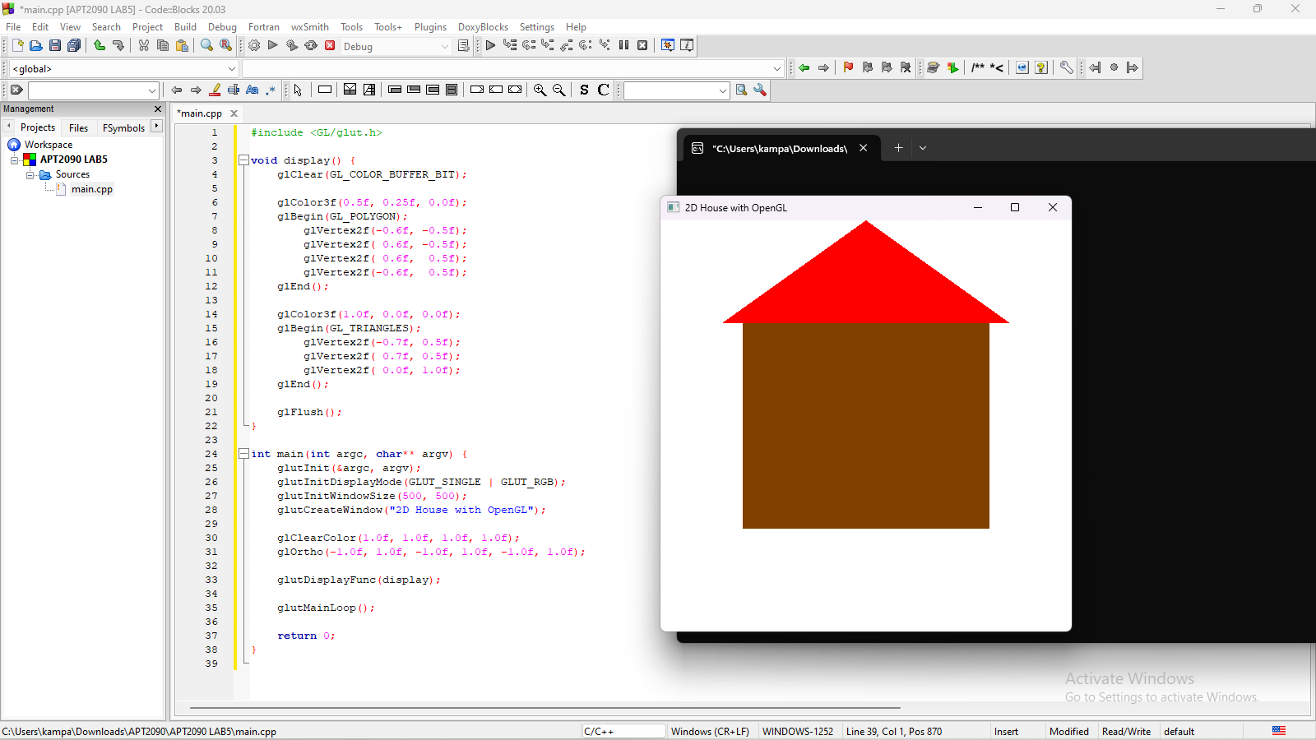
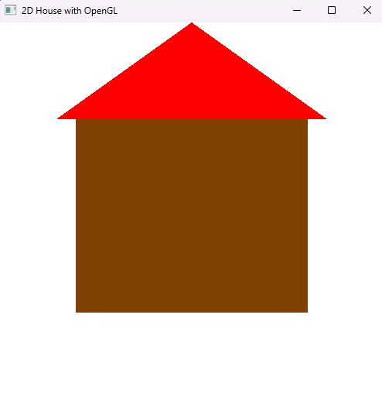

Activity 2: Drawing a Rotating 3D Cube
Problem:
Write, simulate, and explain an OpenGL program to draw and rotate a 3D cube about the x-axis and y-axis.
Code:
#include <GL/glut.h>

// Unique names for rotation angles
float rotationAngleX = 0.0f;
float rotationAngleY = 0.0f;
int refreshRateMs = 16; // Timer refresh rate in milliseconds (~60 FPS)

// Initialize OpenGL settings
void initializeOpenGL() {
glEnable(GL_DEPTH_TEST); // Enable depth testing for 3D objects
}

// Draw the cube
void drawRotatingCube() {
glBegin(GL_QUADS);

// Front face (z = 1.0f)
glColor3f(1.0f, 0.0f, 0.0f); // Red
glVertex3f(-1.0f, -1.0f, 1.0f);
glVertex3f(1.0f, -1.0f, 1.0f);
glVertex3f(1.0f, 1.0f, 1.0f);
glVertex3f(-1.0f, 1.0f, 1.0f);

// Back face (z = -1.0f)
glColor3f(0.0f, 1.0f, 0.0f); // Green
glVertex3f(-1.0f, -1.0f, -1.0f);
glVertex3f(-1.0f, 1.0f, -1.0f);
glVertex3f(1.0f, 1.0f, -1.0f);
glVertex3f(1.0f, -1.0f, -1.0f);

// Top face (y = 1.0f)
glColor3f(0.0f, 0.0f, 1.0f); // Blue
glVertex3f(-1.0f, 1.0f, -1.0f);
glVertex3f(-1.0f, 1.0f, 1.0f);
glVertex3f(1.0f, 1.0f, 1.0f);
glVertex3f(1.0f, 1.0f, -1.0f);

// Bottom face (y = -1.0f)
glColor3f(1.0f, 1.0f, 0.0f); // Yellow
glVertex3f(-1.0f, -1.0f, -1.0f);
glVertex3f(-1.0f, -1.0f, 1.0f);
glVertex3f(1.0f, -1.0f, 1.0f);
glVertex3f(1.0f, -1.0f, -1.0f);

// Right face (x = 1.0f)
glColor3f(1.0f, 0.0f, 1.0f); // Magenta
glVertex3f(1.0f, -1.0f, -1.0f);
glVertex3f(1.0f, 1.0f, -1.0f);
glVertex3f(1.0f, 1.0f, 1.0f);
glVertex3f(1.0f, -1.0f, 1.0f);

// Left face (x = -1.0f)
glColor3f(0.0f, 1.0f, 1.0f); // Cyan
glVertex3f(-1.0f, -1.0f, -1.0f);
glVertex3f(-1.0f, -1.0f, 1.0f);
glVertex3f(-1.0f, 1.0f, 1.0f);
glVertex3f(-1.0f, 1.0f, -1.0f);

glEnd();
}

// Display callback function
void renderScene() {
glClear(GL_COLOR_BUFFER_BIT | GL_DEPTH_BUFFER_BIT); // Clear color and depth buffers

glLoadIdentity(); // Reset the view
glTranslatef(0.0f, 0.0f, -6.0f); // Move cube into the scene

// Apply rotations
glRotatef(rotationAngleX, 1.0f, 0.0f, 0.0f);
glRotatef(rotationAngleY, 0.0f, 1.0f, 0.0f);

drawRotatingCube(); // Draw the cube

glutSwapBuffers(); // Swap the front and back buffers
}

// Timer callback function
void updateRotationAngles(int value) {
rotationAngleX += 2.0f; // Increment the rotation angle for x-axis
rotationAngleY += 3.0f; // Increment the rotation angle for y-axis

if (rotationAngleX > 360.0f) rotationAngleX -= 360.0f;
if (rotationAngleY > 360.0f) rotationAngleY -= 360.0f;

glutPostRedisplay(); // Redraw the scene
glutTimerFunc(refreshRateMs, updateRotationAngles, 0); // Schedule the next update
}

// Window reshape callback function
void handleWindowResize(int w, int h) {
glViewport(0, 0, w, h);

glMatrixMode(GL_PROJECTION);
glLoadIdentity();
float aspect = (float)w / (float)h;
glFrustum(-aspect, aspect, -1.0, 1.0, 1.0, 100.0); // Replace gluPerspective

glMatrixMode(GL_MODELVIEW);
}

// Main function
int main(int argc, char** argv) {
glutInit(&argc, argv);
glutInitDisplayMode(GLUT_DOUBLE | GLUT_RGB | GLUT_DEPTH);
glutInitWindowSize(800, 600);
glutCreateWindow("3D Rotating Cube");

initializeOpenGL();

glutDisplayFunc(renderScene);
glutReshapeFunc(handleWindowResize);
glutTimerFunc(0, updateRotationAngles, 0);

glutMainLoop();
return 0;
}

Output:
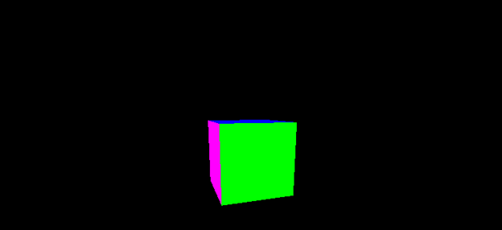
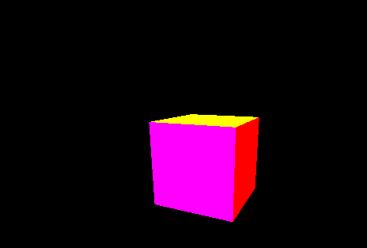
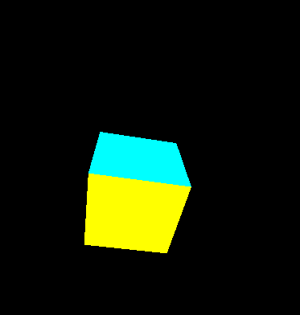

Activity 3: Implementing a Bresenham's Line Drawing Algorithm
Problem:
Write, simulate, and explain an OpenGL program to implement Bresenham's Line Drawing Algorithm for drawing a line between two points.
HINT:
- You can declare a bresenhamLine function that calculates the points between two coordinates using Bresenham's Line Algorithm.
- You can create another function called the setPixel function that places pixels on the screen.

Code
#include <GL/glut.h>
#include <iostream>

// Set a pixel on the screen
void setPixel(int x, int y) {
glBegin(GL_POINTS);
glVertex2i(x, y);
glEnd();
}

// Bresenham's Line Drawing Algorithm
void bresenhamLine(int x1, int y1, int x2, int y2) {
int dx = abs(x2 - x1); // Change in x
int dy = abs(y2 - y1); // Change in y
int sx = (x2 >= x1) ? 1 : -1; // Step in x-direction
int sy = (y2 >= y1) ? 1 : -1; // Step in y-direction

int err = dx - dy; // Decision parameter
while (true) {
setPixel(x1, y1); // Set the current pixel

// Break when the endpoint is reached
if (x1 == x2 && y1 == y2) break;

int e2 = 2 * err; // Double the decision parameter
if (e2 > -dy) {
err -= dy; // Move horizontally
x1 += sx;
}
if (e2 < dx) {
err += dx; // Move vertically
y1 += sy;
}
}
}

// Display function for OpenGL
void display() {
glClear(GL_COLOR_BUFFER_BIT); // Clear the screen
glColor3f(1.0, 1.0, 1.0); // Set drawing color to white

// Define line endpoints
int x1 = 50, y1 = 50;
int x2 = 300, y2 = 200;

// Draw the line using Bresenham's algorithm
bresenhamLine(x1, y1, x2, y2);

glFlush(); // Render the line
}

// Initialize OpenGL
void init() {
glClearColor(0.0, 0.0, 0.0, 1.0); // Set background color to black
glColor3f(1.0, 1.0, 1.0); // Set drawing color to white
glPointSize(2.0); // Set point size
glMatrixMode(GL_PROJECTION);
glLoadIdentity();
glOrtho(0.0, 400.0, 0.0, 400.0, -1.0, 1.0);// Set coordinate system
}

int main(int argc, char** argv) {
glutInit(&argc, argv); // Initialize GLUT
glutInitDisplayMode(GLUT_SINGLE | GLUT_RGB);
glutInitWindowSize(400, 400); // Set window size
glutInitWindowPosition(100, 100); // Set window position
glutCreateWindow("Bresenham's Line"); // Create window
init(); // Initialize OpenGL
glutDisplayFunc(display); // Set display callback
glutMainLoop(); // Start the main loop
return 0;
}
SCREENSHOTS
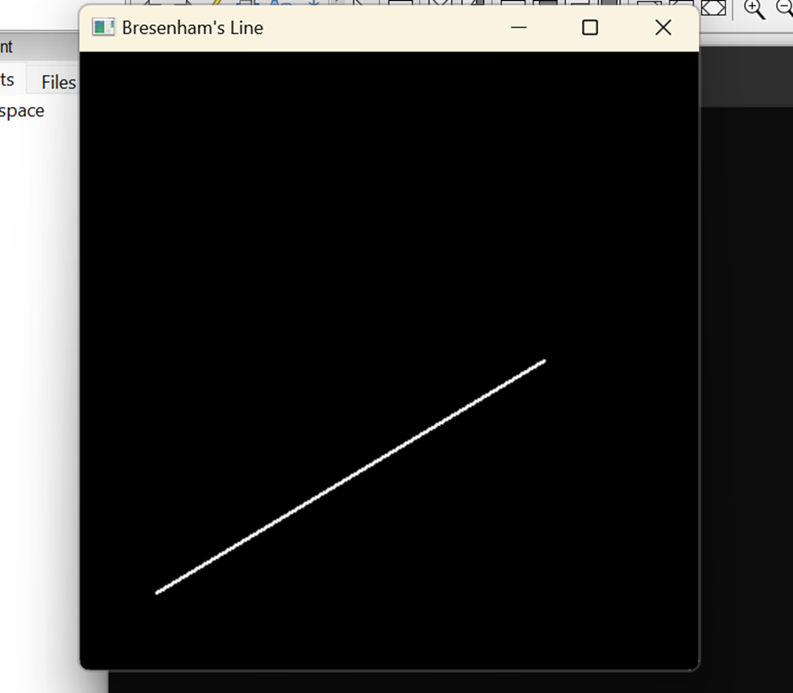

Activity 4: Drawing a Circle using the Midpoint Circle Algorithm
Problem:
Write, simulate, and explain a C++ OpenGL program to draw a circle using the Midpoint Circle Algorithm.
HINT:
- You can declare and use the midpointCircle function to implement the midpoint circle algorithm to draw a circle using symmetry.
- You may use the setPixel and drawCirclePoints as helper functions to set and reflect points for the circle.

CODE
#include <GL/glut.h>
#include <cmath>
#include <iostream>

// Set pixel on the screen
void setPixel(int x, int y) {
glBegin(GL_POINTS);
glVertex2i(x, y);
glEnd();
}

// Reflect points using symmetry
void drawCirclePoints(int xc, int yc, int x, int y) {
setPixel(xc + x, yc + y); // Octant 1
setPixel(xc - x, yc + y); // Octant 2
setPixel(xc + x, yc - y); // Octant 3
setPixel(xc - x, yc - y); // Octant 4
setPixel(xc + y, yc + x); // Octant 5
setPixel(xc - y, yc + x); // Octant 6
setPixel(xc + y, yc - x); // Octant 7
setPixel(xc - y, yc - x); // Octant 8
}

// Midpoint Circle Algorithm
void midpointCircle(int xc, int yc, int r) {
int x = 0, y = r;
int d = 1 - r; // Initial decision parameter
drawCirclePoints(xc, yc, x, y);

while (x < y) {
if (d < 0) {
d += 2 * x + 3; // Decision parameter for E
} else {
d += 2 * (x - y) + 5; // Decision parameter for SE
y--;
}
x++;
drawCirclePoints(xc, yc, x, y);
}
}

// Display function for OpenGL
void display() {
glClear(GL_COLOR_BUFFER_BIT); // Clear screen
glColor3f(1.0, 1.0, 1.0); // Set color to white

int xc = 200, yc = 200, r = 100; // Circle center and radius
midpointCircle(xc, yc, r); // Draw circle

glFlush(); // Render
}

// Initialize OpenGL
void init() {
glClearColor(0.0, 0.0, 0.0, 1.0); // Set background color to black
glColor3f(1.0, 1.0, 1.0); // Set drawing color to white
glPointSize(2.0); // Set point size
glMatrixMode(GL_PROJECTION);
glLoadIdentity();
glOrtho(0.0, 400.0, 0.0, 400.0, -1.0, 1.0); // Set coordinate system
}

int main(int argc, char** argv) {
glutInit(&argc, argv); // Initialize GLUT
glutInitDisplayMode(GLUT_SINGLE | GLUT_RGB);
glutInitWindowSize(400, 400); // Set window size
glutInitWindowPosition(100, 100); // Set window position
glutCreateWindow("Midpoint Circle"); // Create window
init(); // Initialize OpenGL
glutDisplayFunc(display); // Set display function
glutMainLoop(); // Start main loop
return 0;
}
SCREENSHOTS

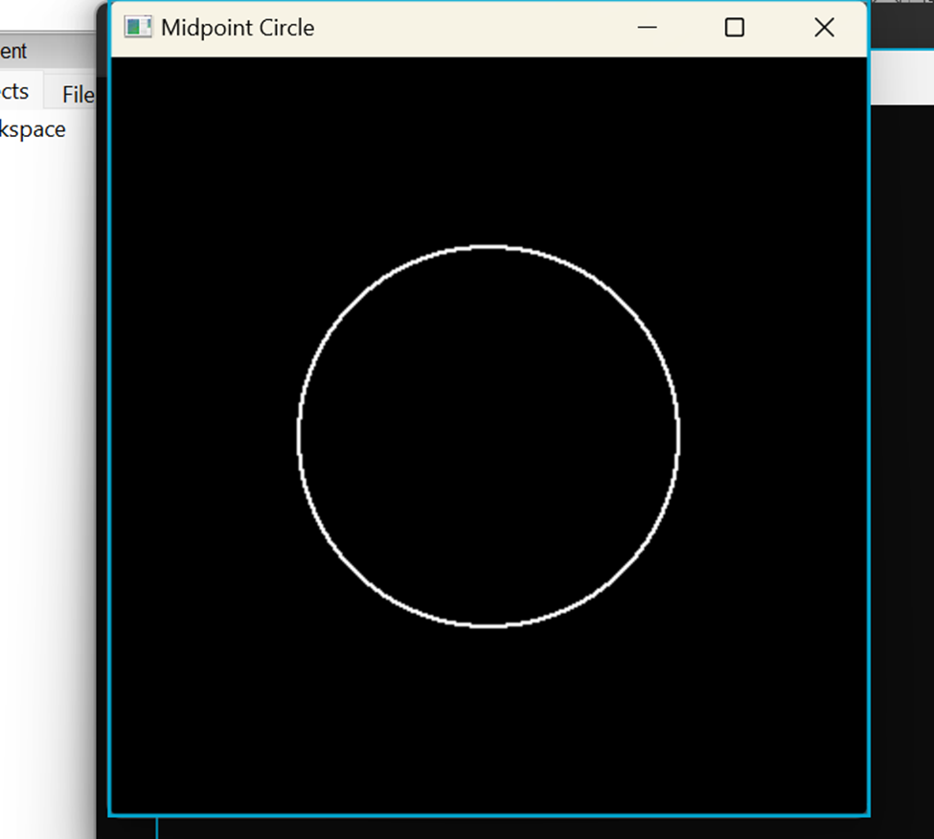

Activity 5: Drawing a 3D Pyramid
Problem:
Write, simulate, and explain a C++ OpenGL program to draw a 3D pyramid with a square base.
#include <GL/glut.h>

// Initialize OpenGL settings
void initializeOpenGL() {
glEnable(GL_DEPTH_TEST); // Enable depth testing for 3D objects
}

// Draw the pyramid with a square base
void drawPyramid() {
// Draw the square base
glBegin(GL_QUADS);
glColor3f(0.3f, 0.3f, 0.3f); // Dark Grey
glVertex3f(-1.0f, -1.0f, -1.0f);
glVertex3f(1.0f, -1.0f, -1.0f);
glVertex3f(1.0f, -1.0f, 1.0f);
glVertex3f(-1.0f, -1.0f, 1.0f);
glEnd();

// Draw the four triangular faces
glBegin(GL_TRIANGLES);

// Front face
glColor3f(0.5f, 0.5f, 0.5f); // Medium Grey
glVertex3f(0.0f, 1.0f, 0.0f); // Apex
glVertex3f(-1.0f, -1.0f, 1.0f); // Bottom-left
glVertex3f(1.0f, -1.0f, 1.0f); // Bottom-right

// Right face
glColor3f(0.6f, 0.6f, 0.6f); // Light Grey
glVertex3f(0.0f, 1.0f, 0.0f); // Apex
glVertex3f(1.0f, -1.0f, 1.0f); // Bottom-left
glVertex3f(1.0f, -1.0f, -1.0f); // Bottom-right

// Back face
glColor3f(0.4f, 0.4f, 0.4f); // Darker Grey
glVertex3f(0.0f, 1.0f, 0.0f); // Apex
glVertex3f(1.0f, -1.0f, -1.0f); // Bottom-left
glVertex3f(-1.0f, -1.0f, -1.0f); // Bottom-right

// Left face
glColor3f(0.7f, 0.7f, 0.7f); // Lightest Grey
glVertex3f(0.0f, 1.0f, 0.0f); // Apex
glVertex3f(-1.0f, -1.0f, -1.0f); // Bottom-left
glVertex3f(-1.0f, -1.0f, 1.0f); // Bottom-right

glEnd();
}

// Display callback function
void renderScene() {
glClear(GL_COLOR_BUFFER_BIT | GL_DEPTH_BUFFER_BIT); // Clear color and depth buffers

glLoadIdentity(); // Reset the view
glTranslatef(0.0f, 0.0f, -6.0f); // Move pyramid into the scene

drawPyramid(); // Draw the pyramid

glutSwapBuffers(); // Swap the front and back buffers
}

// Window reshape callback function
void handleWindowResize(int w, int h) {
glViewport(0, 0, w, h);

glMatrixMode(GL_PROJECTION);
glLoadIdentity();
float aspect = (float)w / (float)h;
glFrustum(-aspect, aspect, -1.0, 1.0, 1.0, 100.0); // Replace gluPerspective

glMatrixMode(GL_MODELVIEW);
}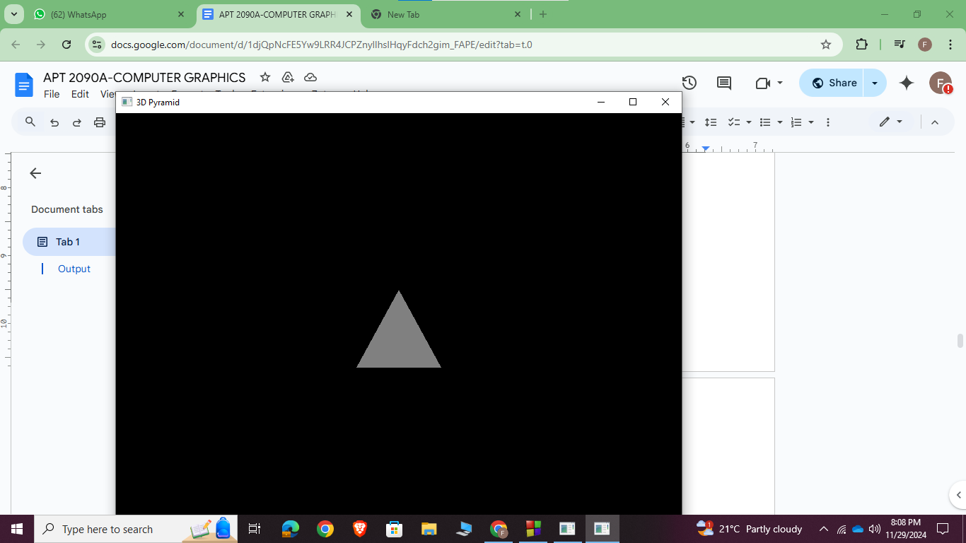

// Main function
int main(int argc, char** argv) {
glutInit(&argc, argv);
glutInitDisplayMode(GLUT_DOUBLE | GLUT_RGB | GLUT_DEPTH);
glutInitWindowSize(800, 600);
glutCreateWindow("3D Pyramid");

initializeOpenGL();

glutDisplayFunc(renderScene);
glutReshapeFunc(handleWindowResize);

glutMainLoop();
return 0;
}

Activity 6: Simple 2D Animation (Moving a Square)
Problem:
Write a C++ OpenGL program to animate a 2D square moving horizontally across the screen.
C++ CODE
#include <GL/glut.h>

// Initial position of the square
float squareX = -0.8f; // Starting position
float squareSpeed = 0.01f; // Speed of movement

// Function to render the scene
void display() {
glClear(GL_COLOR_BUFFER_BIT); // Clear the screen
glLoadIdentity(); // Reset transformations

// Draw the square
glColor3f(0.0f, 1.0f, 0.0f); // Green color
glBegin(GL_QUADS);
glVertex2f(squareX, -0.2f);
glVertex2f(squareX + 0.4f, -0.2f);
glVertex2f(squareX + 0.4f, 0.2f);
glVertex2f(squareX, 0.2f);
glEnd();

glutSwapBuffers(); // Swap buffers to display the current frame
}

// Function to update the position of the square
void update(int value) {
squareX += squareSpeed; // Move the square to the right
if (squareX > 1.0f) { // Reset position when it goes off-screen
squareX = -1.0f;
}

glutPostRedisplay(); // Redraw the scene
glutTimerFunc(16, update, 0); // Call update again after 16ms (~60 FPS)
}

// Function to initialize OpenGL settings
void init() {
glClearColor(0.0f, 0.0f, 0.0f, 1.0f); // Set background color to black
}

// Main function
int main(int argc, char** argv) {
glutInit(&argc, argv);
glutInitDisplayMode(GLUT_DOUBLE | GLUT_RGB); // Double buffering and RGB color
glutInitWindowSize(800, 600); // Window size
glutCreateWindow("2D Square Animation"); // Window title

init(); // Initialize OpenGL settings

glutDisplayFunc(display); // Set the display callback
glutTimerFunc(16, update, 0); // Start the timer for animation

glutMainLoop(); // Enter the GLUT main loop
return 0;
}

OUTPUT
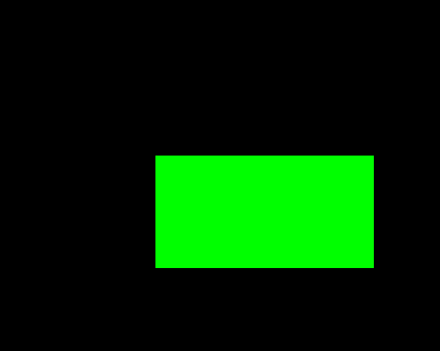
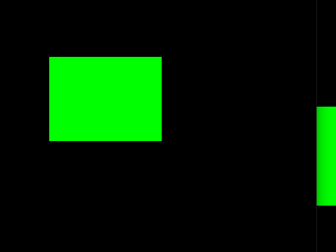
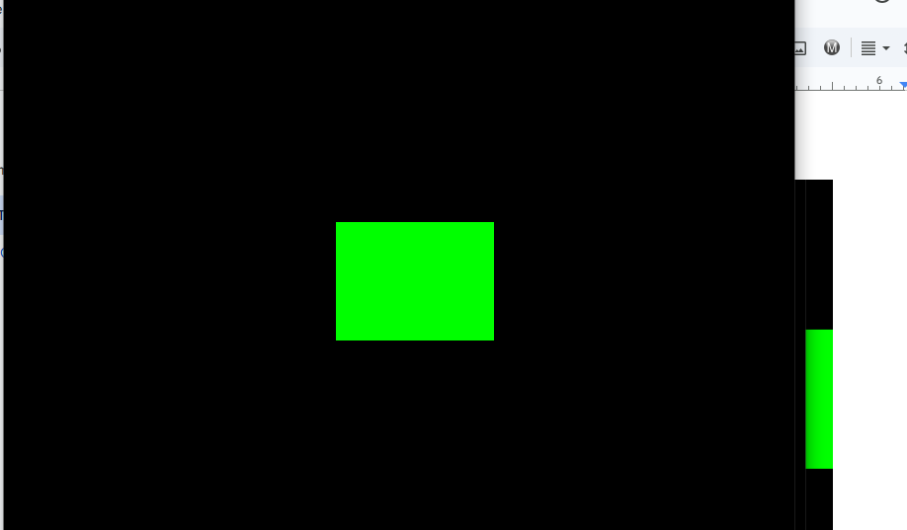

Activity 7: Implementation of Clipping algorithms using OpenGL AND C++.

Write, simulate and implement selected clipping algorithms for point, line and polygon clipping using OpenGL and C++.
HINT:
- Provide a suitable point clipping algorithm in OpenGL using C++.
#include <GL/glut.h>
#include <iostream>

// Define the clipping window boundaries
float xmin = -0.5, ymin = -0.5, xmax = 0.5, ymax = 0.5;

// Array of points to be clipped
float points[][2] = {
{-0.7, 0.0}, // Outside (left)
{0.3, 0.4}, // Inside
{0.6, 0.6}, // Outside (top-right)
{0.0, -0.3}, // Inside
{-0.4, 0.8} // Outside (top)
};
int numPoints = sizeof(points) / sizeof(points[0]);

// Function to check if a point is inside the clipping window
bool isInside(float x, float y) {
return (x >= xmin && x <= xmax && y >= ymin && y <= ymax);
}

// Display function
void display() {
glClear(GL_COLOR_BUFFER_BIT);

// Draw the clipping window
glColor3f(0.0, 1.0, 0.0); // Green
glBegin(GL_LINE_LOOP);
glVertex2f(xmin, ymin);

glVertex2f(xmax, ymin);
glVertex2f(xmax, ymax);
glVertex2f(xmin, ymax);
glEnd();

// Draw original points
glColor3f(0.0, 0.0, 1.0); // Blue for original points
glPointSize(5.0);
glBegin(GL_POINTS);
for (int i = 0; i < numPoints; i++) {
glVertex2f(points[i][0], points[i][1]);
}
glEnd();

// Draw clipped points
glColor3f(1.0, 0.0, 0.0); // Red for clipped points
glPointSize(8.0);
glBegin(GL_POINTS);
for (int i = 0; i < numPoints; i++) {
if (isInside(points[i][0], points[i][1])) {
glVertex2f(points[i][0], points[i][1]);
}
}
glEnd();

glFlush();
}

// Main function
int main(int argc, char** argv) {
glutInit(&argc, argv);
glutInitDisplayMode(GLUT_SINGLE | GLUT_RGB);
glutInitWindowSize(500, 500);
glutCreateWindow("Point Clipping");
glClearColor(1.0, 1.0, 1.0, 1.0); // White background
glOrtho(-1.0, 1.0, -1.0, 1.0, -1.0, 1.0); // Set coordinate system
glutDisplayFunc(display);
glutMainLoop();
return 0;
}

Output
- A green rectangle represents the clipping window.
- All points (blue) are shown on the screen.
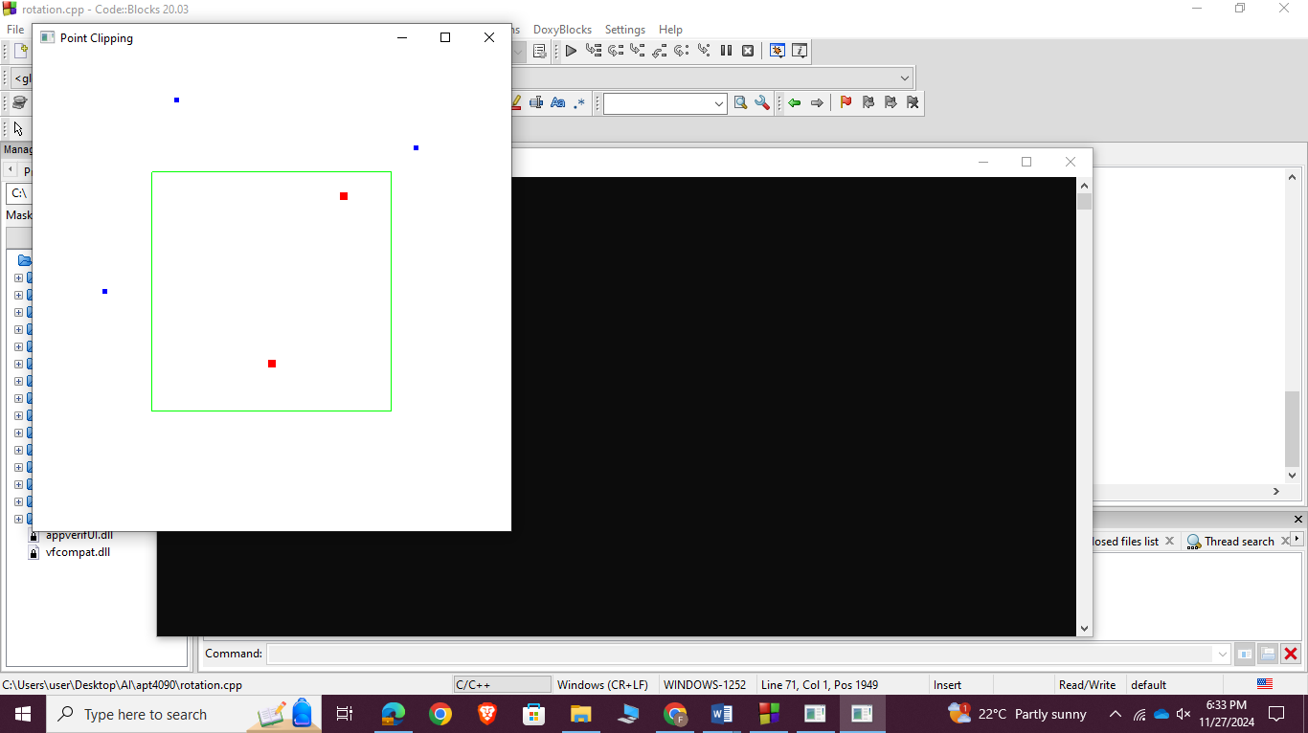
Points inside the clipping window are highlighted in red.

- Use the Cohen-Sutherland Algorithm for the line segment clipping.
#include <GL/glut.h>
#include <iostream>

// Define the clipping window boundaries
float xmin = -0.5, ymin = -0.5, xmax = 0.5, ymax = 0.5;

// Define region codes
enum OutCode { INSIDE = 0, LEFT = 1, RIGHT = 2, BOTTOM = 4, TOP = 8 };

// Function to compute the region code for a point
OutCode computeOutCode(float x, float y) {
OutCode code = INSIDE; // Initialize as inside
if (x < xmin) code = (OutCode)(code | LEFT);
else if (x > xmax) code = (OutCode)(code | RIGHT);

if (y < ymin) code = (OutCode)(code | BOTTOM);
else if (y > ymax) code = (OutCode)(code | TOP);
return code;
}

// Cohen-Sutherland Line Clipping Algorithm
void cohenSutherlandLineClip(float x0, float y0, float x1, float y1) {
OutCode outCode0 = computeOutCode(x0, y0);
OutCode outCode1 = computeOutCode(x1, y1);
bool accept = false;

while (true) {
if (!(outCode0 | outCode1)) { // Trivial accept
accept = true;
break;
} else if (outCode0 & outCode1) { // Trivial reject
break;
} else {
float x, y;
OutCode outCodeOut = outCode0 ? outCode0 : outCode1;

// Find intersection point
if (outCodeOut & TOP) { // Top
x = x0 + (x1 - x0) * (ymax - y0) / (y1 - y0);
y = ymax;
} else if (outCodeOut & BOTTOM) { // Bottom
x = x0 + (x1 - x0) * (ymin - y0) / (y1 - y0);
y = ymin;
} else if (outCodeOut & RIGHT) { // Right
y = y0 + (y1 - y0) * (xmax - x0) / (x1 - x0);
x = xmax;
} else { // Left
y = y0 + (y1 - y0) * (xmin - x0) / (x1 - x0);
x = xmin;
}

// Update endpoint outside the clipping window
if (outCodeOut == outCode0) {
x0 = x;
y0 = y;

outCode0 = computeOutCode(x0, y0);
} else {
x1 = x;
y1 = y;
outCode1 = computeOutCode(x1, y1);
}
}
}

if (accept) {
// Draw the clipped line
glColor3f(1.0, 0.0, 0.0); // Red for the line
glBegin(GL_LINES);
glVertex2f(x0, y0);
glVertex2f(x1, y1);
glEnd();
}
}

// Display function
void display() {
glClear(GL_COLOR_BUFFER_BIT);

// Draw the clipping window
glColor3f(0.0, 1.0, 0.0); // Green for the window
glBegin(GL_LINE_LOOP);
glVertex2f(xmin, ymin);
glVertex2f(xmax, ymin);
glVertex2f(xmax, ymax);
glVertex2f(xmin, ymax);
glEnd();

// Define and clip lines
glColor3f(0.0, 0.0, 1.0); // Blue for original lines
glBegin(GL_LINES);
glVertex2f(-0.7, 0.2);
glVertex2f(0.7, 0.6);
glVertex2f(-0.3, -0.3);
glVertex2f(0.3, 0.3);
glVertex2f(-0.6, -0.6);

glVertex2f(-0.2, -0.2);
glEnd();

// Apply Cohen-Sutherland algorithm to clip lines
cohenSutherlandLineClip(-0.7, 0.2, 0.7, 0.6);
cohenSutherlandLineClip(-0.3, -0.3, 0.3, 0.3);
cohenSutherlandLineClip(-0.6, -0.6, -0.2, -0.2);

glFlush();
}

// Main function
int main(int argc, char** argv) {
glutInit(&argc, argv);
glutInitDisplayMode(GLUT_SINGLE | GLUT_RGB);
glutInitWindowSize(500, 500);
glutCreateWindow("Cohen-Sutherland Line Clipping");
glClearColor(1.0, 1.0, 1.0, 1.0); // White background
glOrtho(-1.0, 1.0, -1.0, 1.0, -1.0, 1.0); // Set coordinate system
glutDisplayFunc(display);
glutMainLoop();
return 0;
}

Output
- A green rectangle represents the clipping window.
- The original line (blue) is shown.
- The clipped line (red) displays the portion of the polygon inside the clipping window.
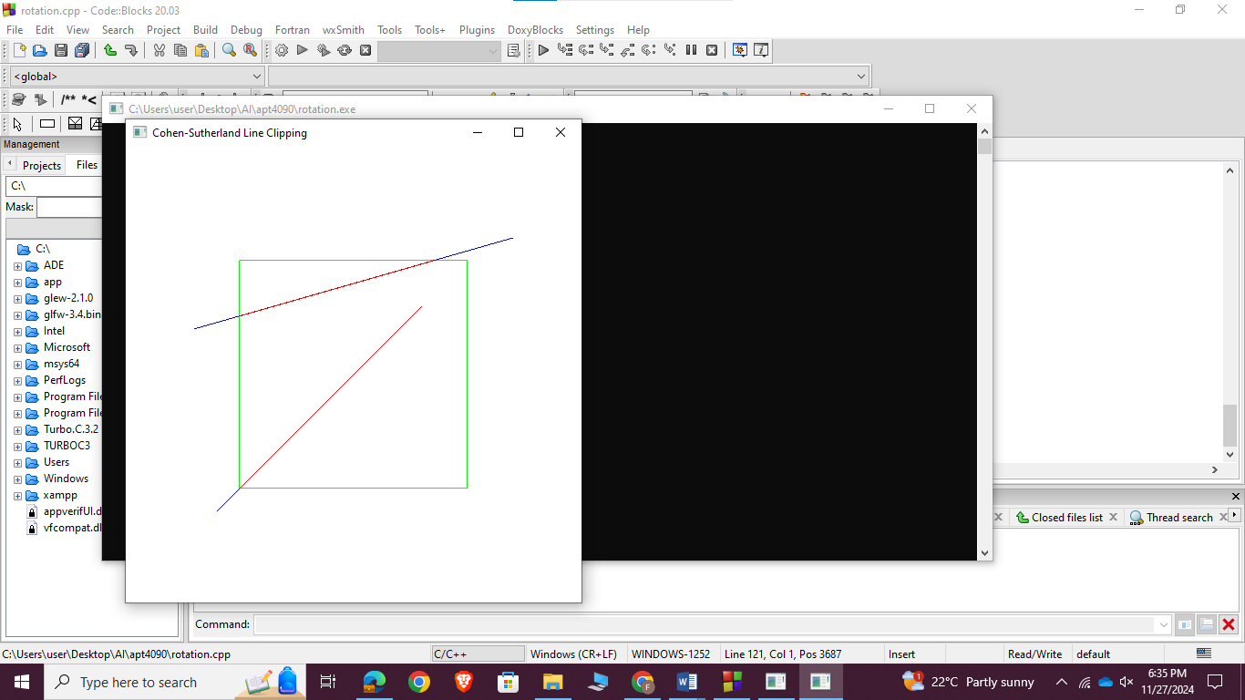

1. Perform Polygon Clipping (convex and/or non-convex) using the Sutherland–Hodgman Algorithm.
#include <iostream>
#include <vector>
#include <GL/glut.h> // GLUT functions
#include <GL/glu.h> // GLU functions like gluOrtho2D
#include <GL/gl.h> // Core OpenGL functions

using namespace std;

// Define a point structure
struct Point {
float x, y;
};

// Clipping window boundaries
const float xmin = -0.5f, ymin = -0.5f, xmax = 0.5f, ymax = 0.5f;

// Function to compute the intersection point
Point getIntersection(Point p1, Point p2, Point edge1, Point edge2) {
float x1 = p1.x, y1 = p1.y, x2 = p2.x, y2 = p2.y;
float x3 = edge1.x, y3 = edge1.y, x4 = edge2.x, y4 = edge2.y;

float den = (x1 - x2) * (y3 - y4) - (y1 - y2) * (x3 - x4);
float t = ((x1 - x3) * (y3 - y4) - (y1 - y3) * (x3 - x4)) / den;

return {x1 + t * (x2 - x1), y1 + t * (y2 - y1)};
}

// Function to check if a point is inside the clipping window
bool isInside(Point p, Point edge1, Point edge2) {
float x1 = edge1.x, y1 = edge1.y, x2 = edge2.x, y2 = edge2.y;
return (x2 - x1) * (p.y - y1) > (y2 - y1) * (p.x - x1);
}

// Sutherland-Hodgman clipping algorithm
std::vector<Point> clipPolygon(const std::vector<Point>& inputPolygon, const std::vector<Point>& clipWindow) {
std::vector<Point> outputPolygon = inputPolygon;

for (size_t i = 0; i < clipWindow.size(); i++) {
std::vector<Point> newPolygon;
Point edge1 = clipWindow[i];
Point edge2 = clipWindow[(i + 1) % clipWindow.size()];

for (size_t j = 0; j < outputPolygon.size(); j++) {
Point current = outputPolygon[j];
Point prev = outputPolygon[(j + outputPolygon.size() - 1) % outputPolygon.size()];

if (isInside(current, edge1, edge2)) {
if (!isInside(prev, edge1, edge2)) {
newPolygon.push_back(getIntersection(prev, current, edge1, edge2));
}
newPolygon.push_back(current);
} else if (isInside(prev, edge1, edge2)) {
newPolygon.push_back(getIntersection(prev, current, edge1, edge2));
}
}

outputPolygon = newPolygon;
}

return outputPolygon;
}

// Function to render a polygon
void drawPolygon(const std::vector<Point>& polygon) {
glBegin(GL_LINE_LOOP);
for (const auto& point : polygon) {
glVertex2f(point.x, point.y);
}
glEnd();
}

// Display function
void display() {
glClear(GL_COLOR_BUFFER_BIT);

// Original polygon (non-convex example)
std::vector<Point> inputPolygon = {
{-0.7f, -0.7f}, {0.0f, -0.3f}, {0.7f, -0.7f},
{0.3f, 0.0f}, {0.7f, 0.7f}, {0.0f, 0.3f}, {-0.7f, 0.7f}, {-0.3f, 0.0f}
};

// Clipping window
std::vector<Point> clipWindow = {{xmin, ymin}, {xmax, ymin}, {xmax, ymax}, {xmin, ymax}};

// Perform clipping
std::vector<Point> clippedPolygon = clipPolygon(inputPolygon, clipWindow);

// Draw the clipping window
glColor3f(1.0f, 0.0f, 0.0f); // Red
drawPolygon(clipWindow);

// Draw the original polygon
glColor3f(0.0f, 1.0f, 0.0f); // Green
drawPolygon(inputPolygon);

// Draw the clipped polygon
glColor3f(0.0f, 0.0f, 1.0f); // Blue
drawPolygon(clippedPolygon);

glFlush();
}

// OpenGL initialization
void init() {
glClearColor(0.0f, 0.0f, 0.0f, 1.0f);
glMatrixMode(GL_PROJECTION);
glLoadIdentity();
gluOrtho2D(-1.0, 1.0, -1.0, 1.0);
}

// Main function
int main(int argc, char** argv) {
glutInit(&argc, argv);
glutInitDisplayMode(GLUT_SINGLE | GLUT_RGB);
glutInitWindowSize(800, 800);
glutCreateWindow("Polygon Clipping - Sutherland-Hodgman Algorithm");

init();
glutDisplayFunc(display);
glutMainLoop();

return 0;
}

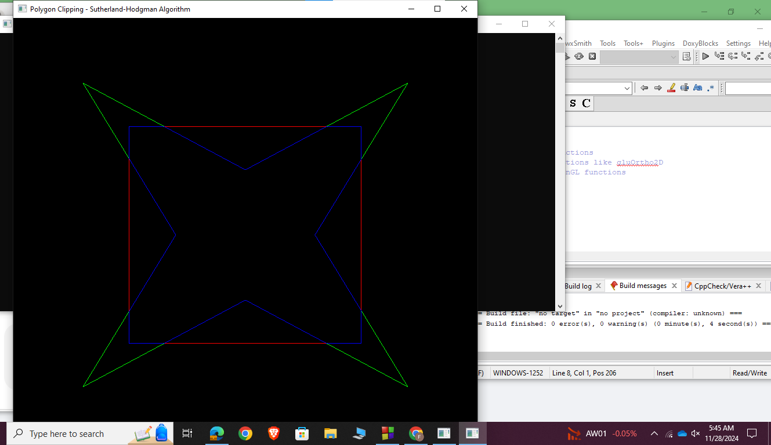

Output
· A green rectangle represents the clipping window.
· The original convex rectangle before clipping is shown in blue.
· The clipped rectangle (red) displays the portion of the polygon inside the clipping window.

END

