

**WorkKar: A Decentralized Gig Enabler Platform for Blue-Collar Workers**

**🔹 1. Problem Statement**

India's informal workforce—comprising plumbers, electricians, carpenters, painters, and other blue-collar workers—faces major hurdles in accessing job opportunities fairly. Most workers rely on word-of-mouth referrals or middlemen who take a large cut of their earnings. Existing online platforms charge high commissions, limit worker autonomy, or are inaccessible in regional languages and smaller towns. At the same time, users often struggle to find reliable, verified local service providers.

There is a pressing need for a **commission-free, trust-based, tech-enabled platform** that directly connects workers with customers—especially in **Tier 2 and Tier 3 cities**—to improve employment, income, and service access.

**🔹 2. Innovation & Uniqueness**

WorkKar is a **decentralized, zero-commission gig platform** built specifically for India’s blue-collar workforce. It removes platform interference and middlemen, allowing workers to:

* Create and manage verified profiles
* Set their own service pricing
* Choose working hours and service areas
* Receive bookings directly from customers via location-based discovery

Unlike existing platforms (e.g., Urban Company), WorkKar does **not control worker pricing or cut commissions**, offering full autonomy and ownership to the worker.

The platform is multilingual, responsive (web + mobile via PWA), and built to work in areas with **limited connectivity** and **basic smartphones**. It includes real-time location-based service discovery, user and worker review systems, and supports both role-based dashboards and offline-first functionality.

**🔹 3. Concept & Working**

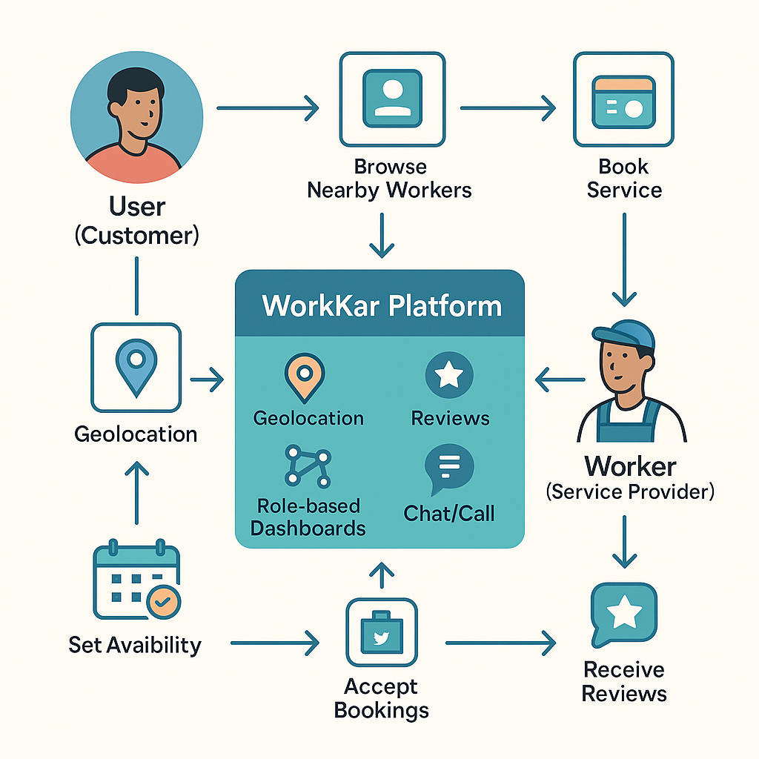

WorkKar operates as a **progressive web application (PWA)** and mobile-compatible platform. It has two primary user roles:

1. **User (Customer):**
   * View nearby verified workers by category (e.g., electrician, plumber)
   * View service ratings, availability, and rates
   * Book a service and optionally chat or call the worker
2. **Worker (Service Provider):**
   * Register and build a service profile (with optional document verification)
   * Set service availability, pricing, and location preferences
   * Accept bookings, manage schedule, and receive reviews

An **admin panel** supports platform governance and analytics without interfering in bookings or pricing.

**🔹 4. Technology Stack**

WorkKar is built with:

* **Frontend:** React + TypeScript for component-based scalability
* **Styling:** Tailwind CSS for responsive design
* **Backend & Auth:** Supabase (PostgreSQL + Realtime)
* **Mobile Compatibility:** Capacitor (enables PWA/mobile from same codebase)
* **Maps & Geo:** Leaflet/Mapbox for location discovery
* **Other Tools:** Lucide Icons, ShadCN UI, Recharts (for dashboards)

The entire stack supports **offline-first**, low-data environments, with minimal dependencies and fast deployments.

**🔹 5. Application & Use Cases**

WorkKar is suitable for:

* **Urban & semi-urban households** in need of reliable blue-collar services
* **Housing societies & gated communities** for internal service discovery
* **Local governments/municipalities** as part of e-governance and Smart City programs
* **NGOs/SHGs** working in rural employment and upskilling
* **Skill Development Missions** for job enablement
* **Construction firms and MSMEs** needing short-term on-site labor

Its modular, lightweight design makes it **deployable across regions** with minimal setup or training required.

**🔹 6. Market Potential**

India has an estimated **450+ million informal workers**, most of whom remain unlisted or exploited by intermediaries. The gig economy is expected to grow to **$455 billion by 2025**, but most platforms cater only to urban, English-speaking service providers.

WorkKar directly targets this underserved majority, making it highly scalable and adaptable. Its business model is designed for:

* **Local-to-national expansion** with multi-language support
* **White-labeled deployments** for NGOs, municipalities, or housing boards
* **Monetization through optional premium services** (worker verifications, analytics, SaaS dashboards)

With potential integration into government schemes like **Digital India**, **Startup India**, and **National Urban Livelihoods Mission (NULM)**, WorkKar can become a **nationwide public utility** for decentralized employment.

**🔹 7. Impact & Sustainability**

WorkKar promotes:

* **Self-employment** and **worker dignity** by restoring control to gig workers
* **Employment generation** in rural and peri-urban areas
* **Digital literacy** through simple onboarding and regional language UI
* **Sustainable economic growth** by reducing dependence on exploitative agents

The platform aligns with **SDG Goals 8 (Decent Work)** and **9 (Industry, Innovation and Infrastructure)**.

**🔹 8. Conclusion**

WorkKar is more than an app — it’s a grassroots-level employment solution designed with **digital inclusivity**, **decentralization**, and **worker empowerment** at its core. With minimal infrastructure requirements, strong local demand, and wide societal relevance, it holds strong potential as both a **social innovation** and a **scalable digital startup**.