###### 

PUCIT

Punjab University College of Information Technology

**First Deliverable**

**Version 1.0**

Table of Contents

First Deliverable Guide 3

1 Introduction 3

1.1 Project/Product Feasibility Report 3

1.1.1 Technical Feasibility 4

1.1.2 Operational Feasibility 4

1.1.3 Economic Feasibility 4

1.1.4 Schedule Feasibility 4

1.1.5 Specification Feasibility 5

1.1.6 Information Feasibility 5

1.1.7 Motivational Feasibility 5

1.1.8 Legal & Ethical Feasibility 5

1.2 Project/Product Scope 5

1.3 Project/Product Costing 5

1.3.1 Project Cost Estimation By Function Point Analysis 6

1.3.2 Project Cost Estimation by using COCOMO’81 (Constructive Cost Model) 8

1.4 CPM - Critical Path Method 9

1.5 Gantt chart 12

1.6 Introduction to Team member and their skill set 13

1.7 Tools and Technology with reasoning 13

1.8 Vision Document 13

1.9 Risk List 14

1 Introduction 15

1.1 Systems Specifications 16

1.2 Identifying External Entities 17

1.3 Context Level Data Flow Diagram 17

1.4 Capture "shall" Statements 17

1.5 Allocate Requirements 18

1.6 Prioritize Requirements 18

1.7 Requirements Trace-ability Matrix 18

1.8 Example 18

1.8.1 Introduction 18

1.8.2 Existing System Business Organization 18

1.8.4Scope of the System 19

1.8.5 Summary of Requirements:(Initial Requirements) 20

1.8.6 Identifying External Entities 22

1.8.9 Capture "shall" Statements and External Entities 23

1.8.10 Allocate Requirements 23

1.8.11 Priorities Requirements 25

1.8.12 Requirements Traceability Matrix 28

1.9 High Level Usecase Diagram 30

# First Deliverable Guide

## 1 Introduction

First part of this deliverable is all about planning and scheduling of project. This deliverable contains following artifacts:

1. Project Feasibility
2. Project Scope
3. Project Costing
4. Critical Path Method Analysis (CPM Analysis)
5. Gantt Chart
6. Introduction to team members
7. Tools and Technologies
8. Vision Document
9. Risk List

## 1.1 Project/Product Feasibility Report

### 1.1.1 Technical Feasibility

Womanista is a completely Android based application. The tools used to meet application capacity are:

• Flutter (software development kit)

• Firebase

• Visual Studio (IDE)

Each technology is feasible and all the team members have the required technical and project managing skills. Project can be completed within the given time constraints. Womanista will be available for all Android devices.

### 1.1.2 Operational Feasibility

The team members have all the required technical skills (App development by Flutter, Database management, Quality Assurance) and can manage the project easily within the given resources.

The problem statement is to facilitate women with respect to their safety and provide them a single platform that can help them with their necessities and quick availability of different services. So, the problem is worth solving and needs a solution.

The solution for this problem is that it provides all services related to women. An app which is really easy to use and reliable in case of any emergency. The main motive is to make all women feel safe, confident and fearless.

The managers and end users consider this problem to be addressed and find a feasible solution which could benefit the women.

### 1.1.3 Economic Feasibility

The tools that’ll be used in this project are open source and free to use. The developers will not charge anything for this project so there will be no any cost.

The app will be widely used because of its vast scope which makes is beneficially feasible

### 1.1.4 Schedule Feasibility

The project will be completed in a time span of 6 months. The team working on this project will have 5 members. The project will have sprints of 3 weeks each and the work assigned for each sprint will be met by deadline strictly.

### 1.1.5 Specification Feasibility

The requirements for the project have been acquired by keeping the fact in view the user priorities and their demands and problem they face.

The constraints for the project can be easily understood.

### 1.1.6 Information Feasibility

The requirements of this project are clear and meaningful. The gathered information is sufficient, complete, reliable and feasible.

### 1.1.7 Motivational Feasibility

The project team is self-motivated to work and doing the right things at the right time. Resource allocation has been done through proper analysis of skills, abilities, knowledge and interests of the team members so that at any point no team member de-motivates oneself or another.

### 1.1.8 Legal & Ethical Feasibility

There are no infringements or liabilities in this project. All the rules and regulations regulated by the government will be followed. There is no violation of copyright issues. The idea is unique in itself and we are not accessing any uninformed personal info which can be misused. So, this project is ethically feasible.

## 1.2 Project/Product Scope

Our application facilitates the user (women) of Android smart phones by providing them a platform which will help them to ease the normal life difficulties they face regarding safety from going one place to another or getting the urgent delivery of their necessary products or booking of a gynecologist for an appointment.

The user can book an appointment from the given registered doctors (females) for regular check-ups or emergency purpose. User can set the particular time and date on which she needs a doctor.

Also, there will be video tutorials regarding Self Defense guidance available in the app.

Our app also has a module of e-commerce. There will be Self Defense tools available in the option (defense tools). The user can order these tools such as pepper spray, knife etc. The user will enter her address details and the products will be delivered within 3-4 days. User can order sanitary products in case of emergency as well; the products will be delivered within 40-50mins.

There will be an article available which will show all laws on WOMEN PROTECTION.

The last feature is that user can book a cab. She can enter the destination point and pickup point and the App will show her the available drivers near her location. She can select the driver of her choice and can add an emergency number over there; there will be an emergency button that will redirect the user to call dial log where that number will be written automatically if the user thinks that driver is taking wrong route. She can share her ride details with her friends or family.

## 1.3 Project/Product Costing

### 1.3.1 Project Cost Estimation by Function Point Analysis

#### Number of User Inputs:

|  |  |  |
| --- | --- | --- |
| **Sr. No.** | **Input** | **Complexity** |
| 1. | Sign up | Average |
| 2. | Sign in | High |
| 3. | Address | Average |
| 4. | Contact Number | Low |
| 5. | User email | Low |
| 6. | User Password | High |
| 7. | Product Pictures | Average |
| 8. | Product Details | Low |
| 9. | Cab Car Details | Average |
| 10. | Permission for Location | High |

**Number of User Outputs:**

|  |  |  |
| --- | --- | --- |
| **Sr. No.** | **Outputs** | **Complexity** |
| 1. | Successful Sign up | Average |
| 2. | Successful Sign in | High |
| 3. | Category Selection | Average |
| 4. | Show available drivers | High |
| 5. | Contact Number Error | Low |
| 6. | User email Error | Low |
| 7. | User Password Error | Average |
| 8. | Successful Order Placed | High |
| 9. | Successful Cab booking | High |

#### Number of User Inquiries:

|  |  |  |
| --- | --- | --- |
| **Sr.**  **No.** | **User Inquires** | **Complexity** |
| 1. | View profile | Average |
| 2. | Edit profile | Average |
| 3. | Select Category | High |
| 4. | Edit Address | High |
| 5. | Edit Phone Number | Low |
| 6. | Edit User email | Low |
| 7. | Add Image | Average |
| 8. | View Image | Low |
| 9. | View Ride Details | High |
| 10. | View Cart | Average |
| 11. | Edit Cart | High |

**Number of Logical Files:**

|  |  |  |
| --- | --- | --- |
| **Sr.**  **No.** | **Number of Logical Files** | **Complexity** |
| 1. | Database for saving files | High |

**Number of external interfaces:**

|  |  |  |
| --- | --- | --- |
| **Sr.**  **No.** | **Number of external interfaces** | **Complexity** |
| 1. | Storage Media | Average |
| 2. | Google Drive | High |
| 3. | Google Maps | High |

|  |  |  |  |  |  |
| --- | --- | --- | --- | --- | --- |
| **Type of component Complexity of Components** | | | | | |
|  | **Low** | **Average** | **High** | **Total** | |
| External Inputs | 3*3=9 | 4*4=16 | 3*6=18 | 43 | |
| External Outputs | 2*4=8 | 3*5=15 | 4*7=28 | 51 | |
| External Inquiries | 3*3=9 | 4*4=16 | 4*6=24 | 49 | |
| External Logical files | 0*7=0 | 0*10=0 | 1*15=15 | 15 | |
| External Interface file | 0*5=0 | 1*7=7 | 2*10=20 | 27 | |
|  | | | Total number of Unadjusted Function points | | 185 |
| Multiplied Value of adjustment Factor | | 50 |
| Total Adjusted Function Points | | 212.75 |

To compute function points (FP), the following relationship is used:

FP est. = Count Total * [ 0.65 + 0.01 * (Fi)]

FP est. = 185 * [0.65 + 0.01 * 50] = 212.75

Where count total is the sum of all FP entries obtained from above table and (Fi) is value adjustment factor (VAF) is based on 14 general system characteristics (GSC's) that rate the general functionality of the application being counted. Each characteristic has associated descriptions that help determine the degrees of influence of the characteristics. The degrees of influence range on a scale of zero to five, from no influence to strong influence.

**Value adjustment factor (VAF):**

|  |  |  |
| --- | --- | --- |
| 1. | Data communications | 5 |
| 2. | Distributed data processing | 4 |
| 3. | Performance | 4 |
| 4. | Heavily used configuration | 4 |
| 5. | Transaction rate | 0 |
| 6. | On-Line data entry | 4 |
| 7. | End-user efficiency | 5 |
| 8. | On-Line update | 3 |
| 9. | Complex processing | 4 |
| 10. | Reusability | 4 |
| 11. | Installation ease | 4 |
| 12. | Operational ease | 4 |
| 13. | Multiple sites | 2 |
| 14. | Facilitate change | 3 |

### 1.3.2 Project Cost Estimation by using COCOMO’81 (Constructive Cost Model)

Basic COCOMO

|  |  |  |
| --- | --- | --- |
| Type | Effort | Schedule |
| Organic | PM= 2.4(5)1.05 = 12.6 | TD= 2.5(12.6)0.38 = 11.97 |
| Semi-Detached | PM= 3.0(5)1.12 = 18.2 | TD= 2.5(18.2)0.35 = 15.925 |
| Embedded | PM= 2.4(4)1.20 = 11.52 | TD= 2.5(16.6)0.32 = 13.28 |

PM= person-month (effort)

KLOC= lines of code, in thousands

TD= number of months estimated for software development (duration)

People Required (Organic) = Effort / Duration = 12.6/11.97 = 1.052

## 1.4 CPM - Critical Path Method

|  |  |  |  |
| --- | --- | --- | --- |
| **Activity** | **Activity Name** | **Immediate Predecessor** | **Duration (Weeks)** |
| A | Project Planning | Null | 3 |
| B | Login and Authentication | A | 3 |
| C | UI Implementation / Prototype | B | 3 |
| D | Ecommerce Module Integration | C | 3 |
| E | Cab Booking Module | C | 3 |
| F | Gynaecologist Home Appointment Module | C | 3 |
| G | Self Defense training Module | C | 3 |
| H | Woman Protection Law Awareness Module | C | 3 |
| I | Final Testing | D, E, F, G, H | 3 |
| J | Deployment | I | 3 |

**Network Diagram:**

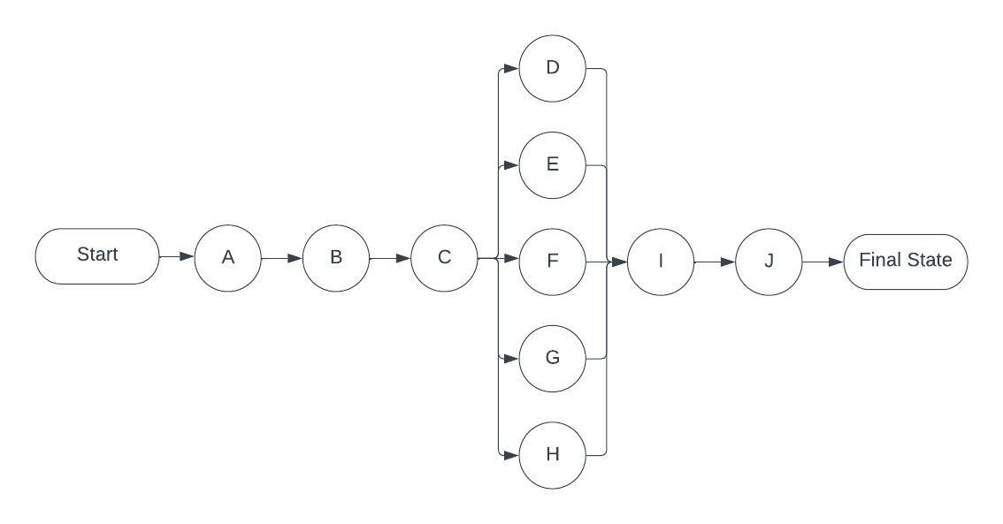

Network Diagram for the above-mentioned activities

#### Critical Path method:

|  |  |  |  |  |  |  |  |
| --- | --- | --- | --- | --- | --- | --- | --- |
| **Activity** | **Duration** | **ES** | **EF** | **LS** | **LF** | **TS** | **FS** |
| A | 3 | 0 | 3 | 0 | 3 | 0 | 0 |
| B | 3 | 3 | 6 | 3 | 6 | 0 | 0 |
| C | 3 | 6 | 9 | 6 | 9 | 0 | 0 |
| D | 3 | 9 | 12 | 9 | 12 | 0 | 0 |
| E | 3 | 9 | 12 | 9 | 12 | 0 | 0 |
| F | 3 | 9 | 12 | 9 | 12 | 0 | 0 |
| G | 3 | 9 | 12 | 9 | 12 | 0 | 0 |
| H | 3 | 9 | 12 | 9 | 12 | 0 | 0 |
| I | 3 | 12 | 15 | 12 | 15 | 0 | 0 |
| J | 3 | 15 | 18 | 15 | 18 | 0 | 0 |

The parameters and slacks are calculated as follows:

**The critical path is:**

## A-> B->C->D->I->J

## 1.5 Gantt chart

## 

## 1.6 Introduction to Team member and their skill set

**BSEF19A007 Alishba Siddique:**

* Good in documentation
* Flexibility with environment
* Proficient in project management
* Designing Front-end skills

**BSEF19A008 Fatima Shahid:**

* Programing skills
* logic building skills
* Prototyping
* Quality Assurance skills

**BSEF19A013 Hamza Jamil:**

* Analytical skills
* Problem Solving capability
* Programming Skills
* Project management skills

**BSEF19A020 Muhammad Talha Riaz:**

* Good in supervising and planning project
* Leadership Qualities
* Programming Skills
* Database management skills

**BSEF19A043 Khadija Zubair:**

* Project Management
* Software engineering skills
* Quality Assurance
* Communication skills

## 1.7 Tools and Technology with reasoning

### Development process: Agile process because it is an iterative process and can handle changes during the process.

### Host platforms: Android studio for android app development and vs code on windows for smooth workflow.

### Target platforms: Android Smartphone because it is a mobile application and will only be functional in smartphones.

### Programming language:

### Dart: because it does faster UI rendering, ahead of time compilations and allows an application to natively execute binary files.

### Backend: Firebase because it provides working in No SQL, Real time database and uses cloud storage.

### Frontend: Flutter because it is cross platform, has faster time to market and it is an emerging technology.

### Existing Tool: Google APIs because We’ll need Maps for cab service module

### Testing: Postman because we’ll have to test APIs and For Quality Assurance, we’ll be using **Kobiton** which will test the performance and working of the app.

## 1.8 Vision Document

This app is all about women. It provides all women-related services **in one place**. Womanista is affordable, time efficient, safe, easy to use, and reliable in case of any emergency. It's an app that every woman wishes for.

**Problem Statement:**

Being a woman is not easy. Every woman faces many problems in her everyday life problems, has to go through the difficult times and have these reality checks as menstruation. Mobile technology is very fast growing an incredible yet there is Not a single app that satisfy all her day-to-day life needs at one place in no time. A Mobile application which is safe, convenient and easy to use would a solution for this.

**Successful Statement:**

The problem statement for our proposal is to provide a SAFE platform for woman to solve their daily problem at one place in no time by booking a cab with a shared ride for travelling securely, delivery of Sanitary products and Self Defense tools, booking a Gynecologist Appointment at home service, learn the art of self-defense to protect herself and be aware of the Women Rights by reading from the app, Application has interfaces for them.

**List of Stakeholders:**

* End Users
* Project Advisor (Ma'am Natalia Chaudhry)
* Admin
* Employees (Group Members)
* Delivery Boys
* Cab Drivers
* Gynecologist Doctors

**List of Actors:**

* End Users
* Delivery Boys
* Cab Drivers
* Gynecologist Doctors

**Key Features:**

Our application will have different interfaces.:

* Gynecologist Home Appointment.
* Self-defense Training.
* Self-defense Tools Delivery.
* Sanitary Products Emergency Delivery
* Women Protection Law Awareness
* Cab Booking

Each interface will have different categories like, in Cab Booking we have

User can enter the destination point and pickup point by selecting and then the map will show the driver ride location after reaching A screen appears, that will locate your real-time location on Google Maps. To start a ride, enter your pickup location User need to mention the complete address or else you can enable the location access in your mobile. After that, enter User drop location. ‘*Your pickup location'* and ‘*Select Destination*’ from the map or by searching the location then the App will show her the available drivers near her location. She can select the driver of her choice by ‘Select Driver' and confirm ride by ‘Confirm Ride’. User will instantly get confirmation of the driver and its details on your mobile phone. In a few seconds user will see the en-route option on the map. Through it, user can track your driver.

* Application shows user an interface where she can book an appointment from the given registered doctors (females) for regular check-ups or emergency purpose. User can set the particular time and date on which she needs a doctor.
* Application shows user an interface where she can learn Self Defense guidance online
* Application shows user an interface where there will be Self Defense tools available in the option (defense tools). The user can order these tools such as pepper spray, knife etc. The user will enter her address details and will select the mode of payment such as cash on delivery or online payment. The products will be delivered within 3-4 days.
* Application shows user an interface where user can order sanitary products in case of emergency, she can enter her address details and the products will be delivered within 40-50mins.
* Application shows user an interface where there will be an article available which will show all laws on WOMEN PROTECTION.

## 1.9 Risk List

In order to work on this project, we will might face many kind risks some are described below:

* **Performance Risk:**

Inadequate skills and experience for application development.

* **Strategic risk:**

The technology that we will be using may cause problem at the time of implementation and may require changes.

* **Operational Risk:**

Poor distribution of tasks among team members based on their skills could create some problem in future for us.

* **Schedule Risk:**

There might be risk in scheduling our tasks like we may not have completed task on given time and that can cause problem.

* **Scope Risk:**

Requirements can be changed over time and new functionalities might be added if required.

* **Technical Risks:**

Adding customization option in our application may cause problems. Also, we may face database security issues. The devices we will be using may have technical problems.

* **Business Risks:**

There might be risk in business due to the unavailability of a purchase order, doctors, drivers and delivery boys, delay in the getting of goods from market, etc.

* **Technology Risks:**

There might be risk in technology for us as Flutter is a new technology a change in it, can concern the sudden or complete change in the app.

*********************REQUIREMENTS ENGINEERING*********************

## 1 Introduction

Being a woman is not easy. Every woman faces many problems in her everyday life problems, has to go through the difficult times and have these reality checks as menstruation. Mobile technology is very fast growing an incredible yet there is Not a single app that satisfy all her day-to-day life needs at one place in no time. This app is all about women. It provides all women-related services **in one place**. Womanista is affordable, time efficient, safe, easy to use, and reliable in case of any emergency. It's an app that every woman wishes for.

Here, requirements specification is to be discussed. Requirements specification would lead to the following four steps:

* Identify external interfaces
* Development of context diagram
* Capture “shall statements
* Allocate requirements
* Prioritize requirements
* Development of requirements traceability matrix

### **1.1 Summary of Requirements:(Initial Requirements)**

The purposed system must fulfill following requirements as follow:

* Large Database
* Internet is required
* **User Registration:**

Unregistered Users will have access only to the home screen where they will be able to select different services. User Registration will be required in order to access other stuff, and on registering, a confirmation email will be sent to the user’s email address. Completely registered users will have access to the full application specifications.

* **Admin Dashboard:**

Admin dashboard will be a very important component of the application. Features and Customers will be added, updated, deleted, viewed by the admin. Data from files, APIs, and products list will be added to the database by the admin through this dashboard. Other important statistics will also be shown to the admin using this dashboard.

* **Performance Management**

As our app deals with different kinds of features, so performance management would be a major concern. Attention should be given to all the performance breach aspects in order to keep the application as active as possible for the users and perform all features

* **Security Management**

As this app is all about women safety will have their personal details accounts, so security management would be a major concern. Attention should be given to all the security breach aspects in order to keep the application as secure as possible for the users.

### 1.2 Existing System Business Organization:

### Currently, there is no existing system. However, there are Different apps for each Functionality Which we are providing in a single app

**1.3 Business Organization Chart**

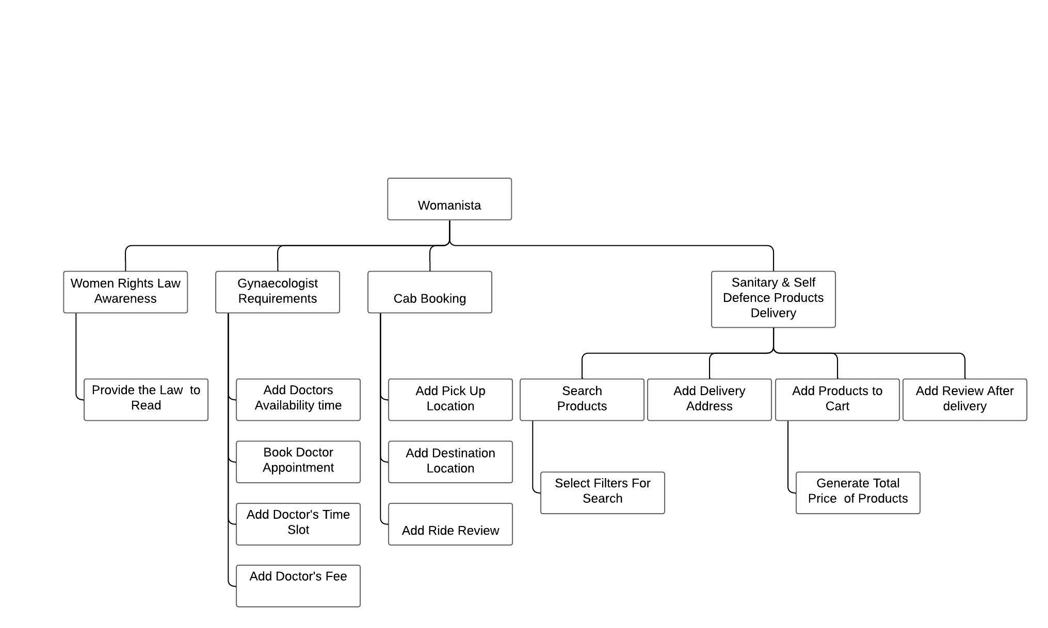

### 

### 1.4 Scope of the System:

Womanista is divided in to three phases.

#### Phase 1

Phase 1 includes:

* Admin roles
* Admin dashboard
* User Register
* User login
* User Dashboard

#### **Phase 2**

Phase 2 includes following business areas:

* Cab Service
  1. Ride Booking
  2. Trip Management
  3. Emergency Call
  4. Share ride information
* Product Delivery
  1. Product Order
  2. Instant Delivery
* Doctor Appointment
  1. Availability of Doctor
  2. Booking of Appointment

#### Phase 3

Phase 3 includes:

Phase 3 covers all the remaining features. It includes remaining business areas which are not developed in the previous phases such as:

* Self-Defense Video tutorials
* Articles on Law of Woman Protection

### 1.5 Identifying External Entities or Actors

### The external entities or Actors are:

**Primary Actor:**

* Customer
* Admin

**Secondary Actors:**

* Drivers
* Female **GD**
* Delivery Boys

**Offstage Actors:**

* Investors
* Customer Support Staff

The Identification of External Entities or Actors is done in two phases.  
  
**1.6 Over Specify Entities from Abstract**   
  
On the basis of the Abstract, one might identify the following entities from case study.

* Customer Account
* Credit Card
* Cheque
* Request
* Book Ride
* Book GD
* Order
* Order Product
* Shipment
* Invoice
* Product
* Payment

**1.7 Perform Refinement**

* Customer
* Inventory
* Shipment
* Account

The Identification of External Entities or Actors is done in two phases.

### **1.8 Context Level Data Flow Diagram**

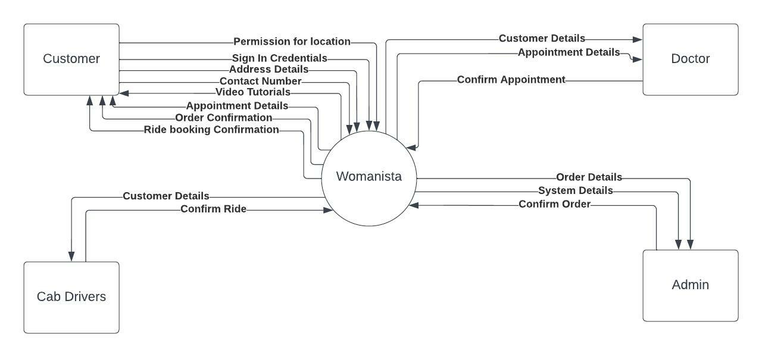

### 1.8.9 Capture "shall" Statements and the external entities (Actors)

|  |  |  |
| --- | --- | --- |
| **Para #** | **External Entity** | **Initial Requirements** |
| 1.0 | customer | A customer “shall” book a ride |
|  |  | A customer “shall” book an appointment to doctor |
|  |  | A customer “shall” take online training sessions |
| 1.0 | customer | A customer “shall” place order for goods |
| 1.0 | customer | A customer “shall” register himself to the system |
| 1.0 | Admin | Admin “shall” accept, reject and temporarily waive the requests on the basis of credentials provided. |
| 1.0 | customer | A customer “shall” login to the system and can change his password |
| 1.0 | System | System “shall” process different types of updating e.g., updating of his personal/shipping details, or upgrading of his status from registered to privileged customer, or updating of his payment methodology |
| 1.0 | customer | A customer “shall” view his details for verification purposes |
| 1.0 |  | System “shall” search any customer details |
| 2.0 | customer | Customer “shall” make payment; |
| 2.0 |  | System “shall” generate invoice, confirmation receipt and finally will place order |
| 2.0 |  | User “shall” view the status of their orders by providing the Order Number |
| 2.0 | customer | Customer “shall” place the request for the cancellation of the order. But all these updating and cancellation requests are to be viewed by the Admin in order to accept, reject, or waive them. |
| 3.0 | System | The system “shall” generate an action by sending notifications whenever the items are restocked. |
| 4.0 | doctor | A doctor “shall” register himself to the system and add details about herself |
| 4.0 | doctor | A doctor “shall” select its available time slot and fee |
| 5.0 | delivery boy | A delivery boy “shall” register himself to the system and add details about himself |
| 5.0 | delivery boy | A deliver boy “shall” select its available time slot |
| 6.0 | driver | A driver “shall” register himself to the system add details about himself |
| 6.0 | driver | A driver “shall” select its available time slot |

### 1.8.10 Allocate Requirements

|  |  |  |
| --- | --- | --- |
| **Para #** | **Initial Requirements** | **Use Case Name** |
| 1.0 | A customer “will” place order for goods | UC_Place_Order |
| 1.0 | A customer “will” book an appointment to doctor | UC_Book_Appointment |
| 1.0 | A customer “will” take online training | UC_Take_Training |
| 1.0 | A customer “will” book a ride | UC_Book_Ride |
| 1.0 | A customer “shall” register himself to the system | UC_Registration_Request |
| 1.0 | A customer “shall” login to the system and can change his password | UC_Login |
| 1.0 | System “shall” update the customer's Request | UC_Update_Request |
| 1.0 | System “shall” process different types of updating e.g., updating of his personal/shipping details, or upgrading of his status from registered to privileged customer, or updating of his payment methodology | UC_Change_Status |
| 1.0 | A customer “shall” track his/her order | UC_View_Order_Details |
| 1.0 | System “shall” search any customer details | UC_Search_Customer |
|  |  |  |
| 2.0 | Customer “will” make payment; | UC_Pay_For_Order |
| 2.0 | System “will” send the confirmation message to customer | UC_Confirmation_Message |
| 2.0 | User “shall” view the status of their orders by providing the Order Number | UC_Search_Orders |
| 2.0 | Customer “shall” place the request for the cancellation of the order. But all these updating and cancellation requests are to be viewed by the Admin | UC_Change_Payment_Details,  UC_Change_Status,  UC_Change_Personal_Details |
| 3.0 | A doctor “will” register himself to the system by adding her medical certificate number | UC_Register_Doctor  UC_Add_Personal_Details |
| 3.0 | A doctor “shall” select its available time slot and fee | UC_Add_Time_Slot |
| 4.0 | A delivery boy “will” register himself to the system by adding details about himself and his vehicle | UC_Register_Delivery_Boy  UC_Add_Personal_Details |
| 4.0 | A deliver boy “shall” select its available time slot | UC_Add_Time_Slot |
| 5.0 | A driver “will” register himself to the system by adding details about himself and his vehicle | UC_Register_Driver  UC_Add_Personal_Details |
| 5.0 | A driver “shall” select its available time slot | UC_Add_Time_Slot |

### 1.8.11 Priorities Requirements

|  |  |  |  |  |  |  |  |
| --- | --- | --- | --- | --- | --- | --- | --- |
| *Para #* | | **Rank** | **Initial Requirements** |  | **Use Case ID** | | **Use Case Name** |
| 1.0 | | Highest | A customer “will” place order for goods | UC_1 | | UC_PlaceOrder | |
| 1. 0 | A customer “will” book an appointment to doctor. | | |  | UC_Book_Appointment | | |
| 1.0 | A customer “will” take online training | | |  | UC_Take_Training | | |
| 1.0 | A customer “will” book a ride | | |  | UC_Book_Ride | | |
| 1.0 | | Highest | A customer “shall” register himself to the system |  | UC_5 | | UC_Registration_Request |
| 2.0 | | Highest | Customer “will” make payment |  | UC_6 | | UC_Pay_For_Order |
| 2.0 | | Highest | System “will” generate invoice, confirmation receipt and finally will place order |  | UC_7 | | UC_Invoice_Generation, |
| 3.0 | | Medium | The system “shall” generate an action by sending notifications whenever the items are restocked. |  | UC_8 | | UC_Create_Action |
| 1.0 | | Medium | Admin “shall”accept, reject and temporarily waive the requests on the basis of credentials provided. |  | UC_9  UC_10  UC_11 | | UC_Accept_Customer_Request  UC_Reject_Customer_Request  UC_View_Customer_Request |
| 1.0 | | Medium | System “shall” update the customer's Request |  | UC_11 | | UC_Update_Request |
| 1.0 | | Medium | System “shall” process different types of updating e.g., updating of his personal/shipping details. |  | UC_12  UC_13  UC_14 | | UC_Change_Status,  UC_Change_Personal_Details |
| 2.0 | | Medium | User “shall” view the status of their orders by providing the Order Number |  | UC_17 | | UC_Serach_Orders |
| 3.0 | | Medium | A doctor “will” register himself to the system by adding her medical certificate number |  | UC_18  UC_19 | | UC_Register_Doctor  UC_Add_Personal_Details |
| 3.0 | | Medium | A doctor “shall” select its available time slot and fee |  | UC_20 | | UC_Add_Time_Slot |
| 4.0 | | Medium | A delivery boy “will” register himself to the system by adding details about himself and his vehicle |  | UC_25  UC_26 | | UC_Register_Delivery_Boy  UC_Add_Personal_Details |
| 4.0 | | Medium | A deliver boy “shall” select its available time slot |  | UC_20 | | UC_Add_Time_Slot |
| 5.0 | | Medium | A driver “will” register himself to the system by adding details about himself and his vehicle |  | UC_27  UC_28 | | UC_Register_Driver  UC_Add_Personal_Details |
| 5.0 | | Medium | A driver “shall” select its available time slot |  | UC_20 | | UC_Add_Time_Slot |
| 1.0 | | Lowest | A customer “shall” login to the system and can change his password |  | UC_22  UC_23 | | UC_Login, |
| 3.0 | | Lowest | Corresponding admin “shall” view his Action List containing different actions, and correspondingly process these pending actions |  | UC_24 | | UC_View_Action, |

### 1.8.12 Requirements Traceability Matrix

|  |  |  |  |  |  |
| --- | --- | --- | --- | --- | --- |
| **Sr#** | **Para #** | **System Specification Text** | **Build** | **Use Case Name** | **Category** |
| 1 | 1.0 | A customer “will” place order for goods | B1 | UC_Place_Order | Business |
| 2 | 1.0 | A customer “will” book an appointment to doctor. | B1 | UC_Book_Appointment | Business |
| 3 | 1.0 | A customer “will” take online training | B1 | UC_Take_Training | Business |
| 4 | 1.0 | A customer “will” book a ride | B1 | UC_Book_Ride | Business |
| 5 | 1.0 | A customer “shall” register himself to the system | B1 | UC_Registration_Request | Business |
| 6 | 1.0 | Customer “will” make payment | B1 | UC_Pay_For_Order | Business |
| 7 | 1.0 | System “will” generate invoice, confirmation receipt and finally will place order | B1 | UC_Invoice_Generation, | Business |
| 8 | 1.0 | The system “shall” generate an action by sending notifications whenever the items are restocked. | B1 | UC_Create_Action | Business |
| 9 | 1.0 | Admin “shall” accept, reject and temporarily waive the requests on the basis of credentials provided. | B1 | UC_Accept_Customer_Request  UC_Reject_Customer_Request  UC_View_Customer_Request | Business |
| 10 | 1.0 | System “shall” update the customer's Request | B1 | UC_Update_Request | Business |
| 11 | 1.0 | System “shall” process different types of updating e.g., updating of his personal/shipping details. | B1 | UC_Change_Status,  UC_Change_Personal_Details | Business |
| 12 | 1.0 | User “shall” view the status of their orders by providing the Order Number | B1 | UC_Serach_Orders | Business |
| 13 | 1.0 | A customer “shall” login to the system and can change his password |  | UC_Login, | Business |
| 14 | 1.0 | Corresponding admin “shall” view his Action List containing different actions, and correspondingly process these pending actions |  | UC_View_Action, | Business |
| 15 | 1.0 | A doctor “will” register himself to the system by adding her medical certificate number |  | UC_Register_DoctorUC_Add_Personal_Details | Business |
| 16 | 1.0 | A doctor “shall” select its available time slot and fee |  | UC_Add_Time_Slot | Business |
| 17 | 1.0 | A delivery boy “will” register himself to the system by adding details about himself and his vehicle |  | UC_Register_Delivery_Boy  UC_Add_Personal_Details | Business |
| 18 | 1.0 | A delivery boy “shall” select its available time slot |  | UC_Add_Time_Slot | Business |
| 19 | 1.0 | A driver “will” register himself to the system by adding details about himself and his vehicle |  | UC_Register_Driver  UC_Add_Personal_Details | Business |
| 20 | 1.0 | A driver “shall” select its available time slot |  | UC_Add_Time_Slot | Business |

### 1.9 High Level Use Case Diagram

