1. How many trips have been recorded total during the chosen period?

394,829 rides in 2018

1. By what percentage has total ridership grown?

It fluctuates between months. It’s more popular in the summer

1. How has the proportion of short-term customers and annual subscribers changed?

The proportion does not change over time. There is more subscribers.

1. What are the peak hours in which bikes are used during summer months?

The summer peak hours is between 8:00 am and 6:00 pm.

1. What are the peak hours in which bikes are used during winter months?

The winter peak house is also between 8:00 am and 6:00 pm.

1. Today, what are the top 10 stations in the city for starting a journey? (Based on data, why do you hypothesize these are the top locations?)

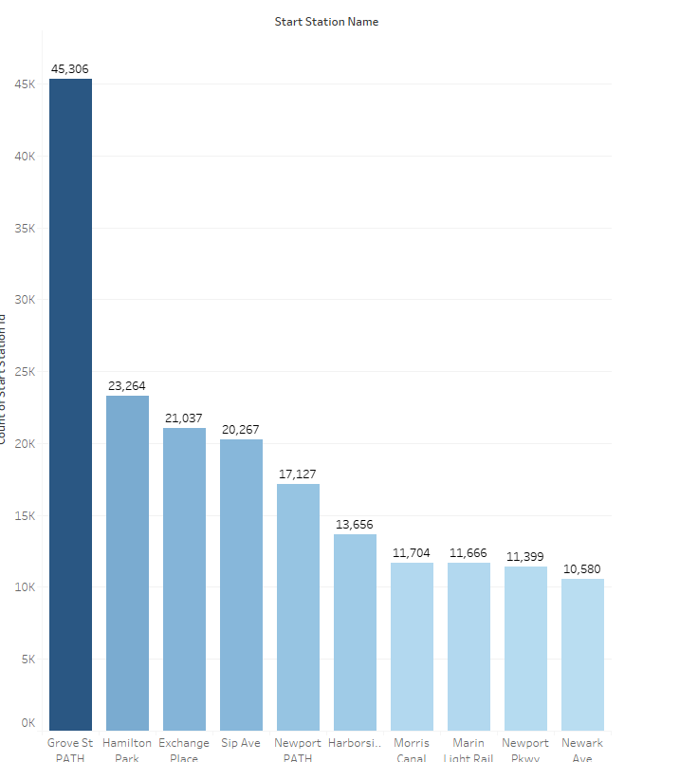

1. Today, what are the top 10 stations in the city for ending a journey? (Based on data, why?)

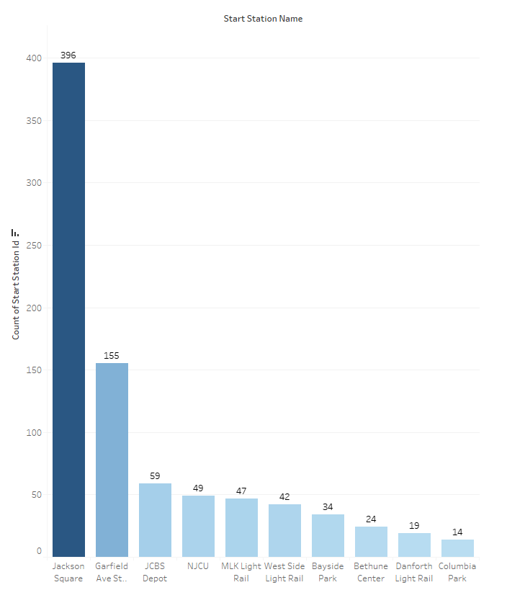

1. Today, what are the bottom 10 stations in the city for starting a journey? (Based on data, why?)

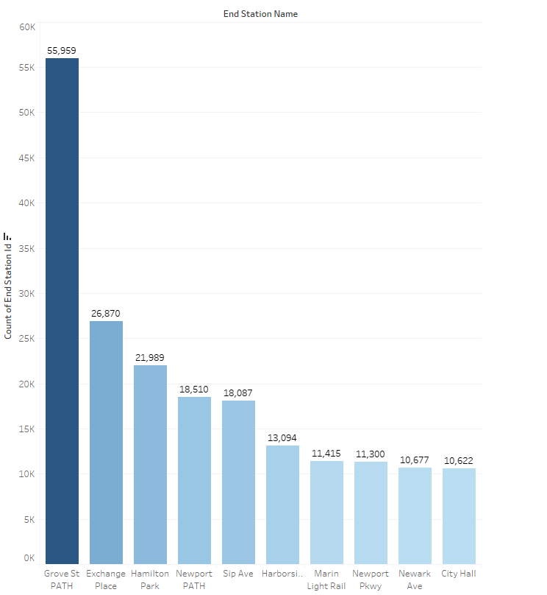

1. Today, what are the bottom 10 stations in the city for ending a journey (Based on data, why?)

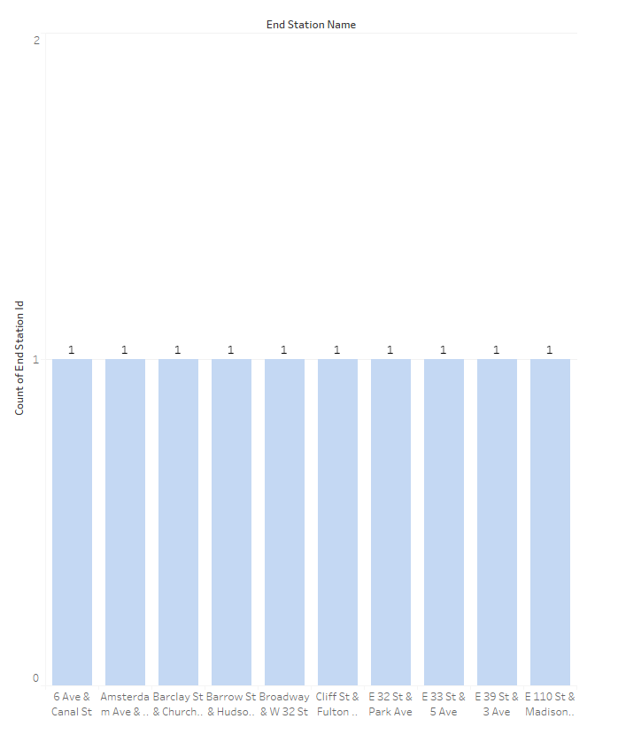

1. Today, what is the gender breakdown of active participants (Male v. Female)?

72.4% male, 21.4% female and 6.21% unknow.

1. How effective has gender outreach been in increasing female ridership over the timespan?

Female ridership has been steadily increasing.

1. How does the average trip duration change by age?

Majority of the bike rental are under 25 years old.

1. What is the average distance in miles that a bike is ridden?

0.6 miles

1. Which bikes (by ID) are most likely due for repair or inspection in the timespan?

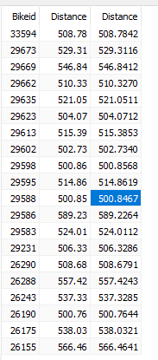

1. How variable is the utilization by bike ID?

It seems like bike ID between 28000 and 30000 are the most popular bikes

1. Find at least two unexpected phenomena in the data and provide a visualization and analysis to document their presence.

This bike stations are located in the white collar area of the town and high income area.

