**IDM 250: Content Management Systems**

**Week 01**

* **Overview**
  + No book required, readings provided
  + Must have hosting
  + In this class we will be learning how to work with Content Management Systems and how to design custom templates for them. The final project for this site will be designing your own custom template for WordPress to display your online portfolio. In order to do this we will be looking into learning HTML5/CSS3, PHP/MySQL, and the WordPress Codex. But before we jump into the code let’s take a look at our class rules…
  + Review syllabus on BBLearn
  + You will be creating a WordPress portfolio. Important for co-op.
* **CMS Description**
  + [WordPress](http://www.wordpress.org)
  + [Joomla](http://www.joomla.org)
  + [Drupal](http://www.drupal.org)
  + [Django](http://www.djangoproject.com)
  + ExpressionEngine
  + Ghost
  + Craft
* **Install Wordpress**
  + Log into Host Dashboard
    - <https://www.bluehost.com/>
    - Go to CPanel
    - MySQL Databases
    - Create a Database with a meaningful name
    - Create a user with password (that you saved somewhere)
    - Add user to database
    - Add all privileges
    - Go to wordpress.org and download zip
    - Unzip
    - Log in to website with FTP
    - Create a folder called idm250
    - Uploaded wordpress folder contents and wait to upload
    - Go to your website <http://website.com/wbdv243>
    - Go through install
    - Login
* **Wordpress Tours**
  + Dashboard
  + Posts
    - Title (and link to edit)
    - WYSIWYG
    - Preview
    - Publish
    - Format
    - Categories
    - Tags
    - Featured Image
  + Pages
    - Child Pages
  + Comments
  + Appearance
    - Themes
    - Customize
    - Widgets
    - Menus
    - Header
    - Background
    - Editor
  + Plugins
  + Users
  + Tools
  + Settings
    - PERMALINKS

**Books:**

No book purchases are required. But there will be assigned readings of pdf files, eBooks in the Haggerty Electronic Resources, and various Internet posts.

**Introductions**

Hi my name is....

In this class we will be learning how to work with Content Management Systems and how to design custom templates for them. The final project for this site will be designing your own custom template for WorPress to display your online portfolio. In order to do this we will be looking into learning HTML5/CSS3, PHP/MySQL, and the WordPress Codex. But before we jump into the code lets take a look at our class rules…

**click on syllabus link and review policies

---

Everyone here should have already taken WBDV-240. This means that you have a good working knowledge of HTML5 & CSS3 as well as an online portfolio. How many of you are happy with your current site? As I mentioned earlier you will be designing a custom template for WordPress. Since many of you are going to be going on co-op next year I can not stress how instrumental the work you create in this class will be in helping you land a quality co-op. So, if you are happy with your current design, you will probably only need to make a few tweaks in order to get it working with WordPress (notice I said design, not code), but if you want to start over with the design process, this is your opportunity to do so.

Make sure you have hosting. BlueHost offers a discount for Drexel.

**Content Management Systems and Dynamic Websites**

Web based content management systems, commonly referred to as CMS, are designed to simplify the publication of web content to web sites and mobile devices — in particular, allowing content creators to submit content without requiring technical knowledge of HTML or the uploading of files.[1]

Several web-based content management systems exist both in the Open Source and commercial domains.

* [WordPress](http://www.wordpress.org)
* [Joomla](http://www.joomla.org)
* [Drupal](http://www.drupal.org)
* [Django](http://www.djangoproject.com)
* [TikiWiki](http://info.tiki.org/Tiki+Wiki+CMS+Groupware)
* [MediaWiki](http://www.mediawiki.org/wiki/MediaWiki)

They are typically built using a combination of HTML, CSS, JavaScript, MySQL and PHP. Although some use alternate server-side languages like Perl, Ruby, .NET, Java.

Most modern web based CMS are developed so that you really do not need to know much beyond the basics of PHP in order to work with the system as a designer as they are built using custom functions. But if you are planning on really diving into customization with Plugin and Widget development you will need to fully understand the server language. (Understanding [Regular Expressions](http://www.google.com/url?q=http%3A%2F%2Fen.wikipedia.org%2Fwiki%2FRegular_expression&sa=D&sntz=1&usg=AFQjCNFn8AzydG1ItFnaedkGUGb3UZoFgQ) will help too.)

---

**Setting Up WordPress**

This tutorial will show you how to install WordPress onto your domain. First we access the hosting control panel and set up a database (that contains tables, records, fields) that will be used to hold all the information WordPress will use to generate your dynamic web pages. NOTE: All hosting providers do not all use the same control panel; therefore, my control panel screens may or may not match your control panel screens. It depends on which hosting provider you are using.

[ NOTE to instructor: Walk students through how to setup a basic Wordpress site on the overhead projector. Students that have a domain can follow along. Students that do not have a domain can take notes.]

**Log in to the control panel of your web server (cPanel)**

**Find the MySQL Database Page**

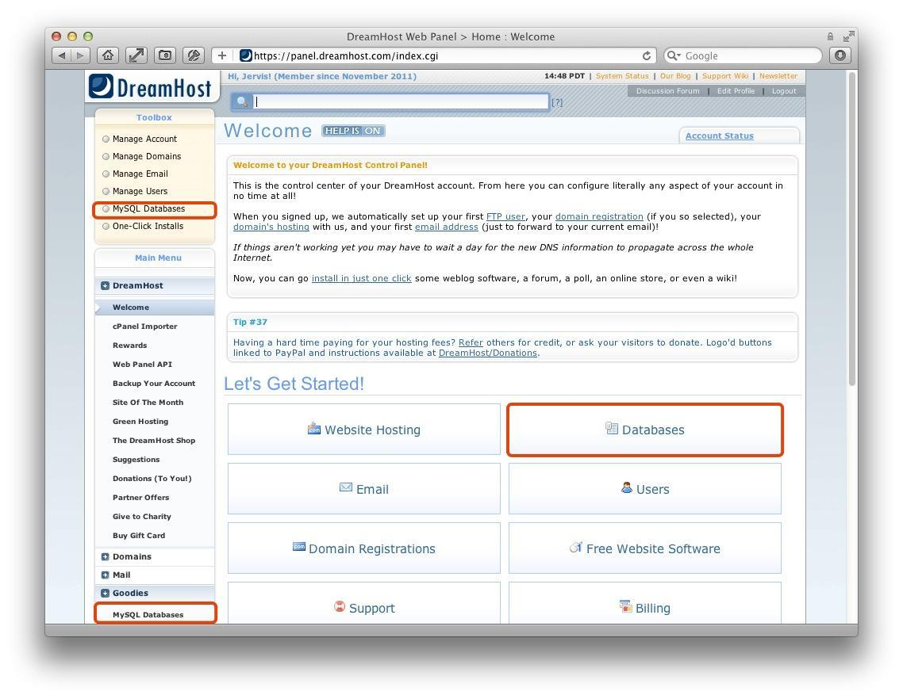

**Create a meaningful database**

**Create A Username To Associate With Your Database**

**Create A New MySQL Database**

**Associate Your Username With Your WordPress Database**

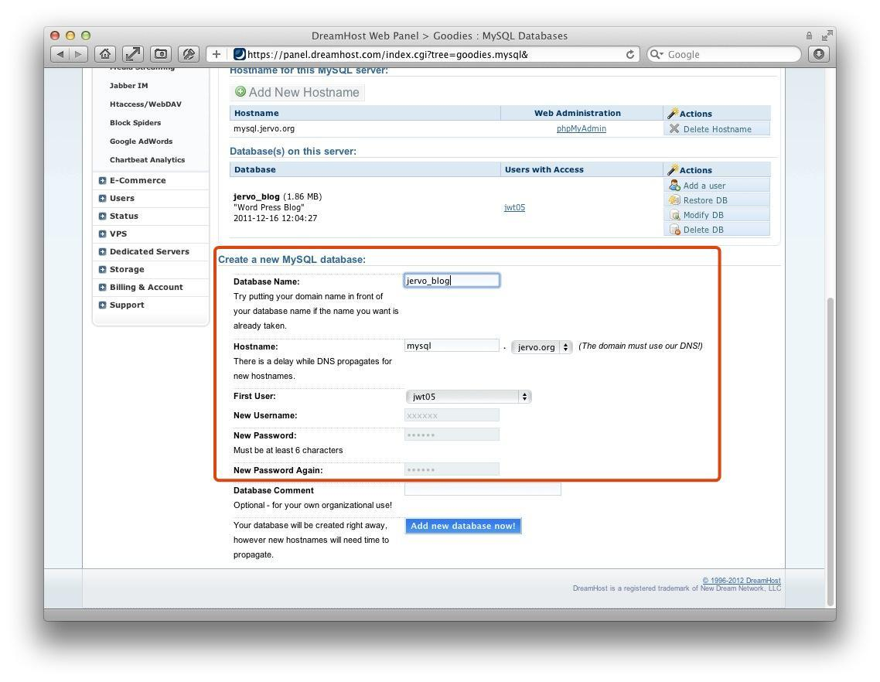

**Assign ALL table privileges to your Username**

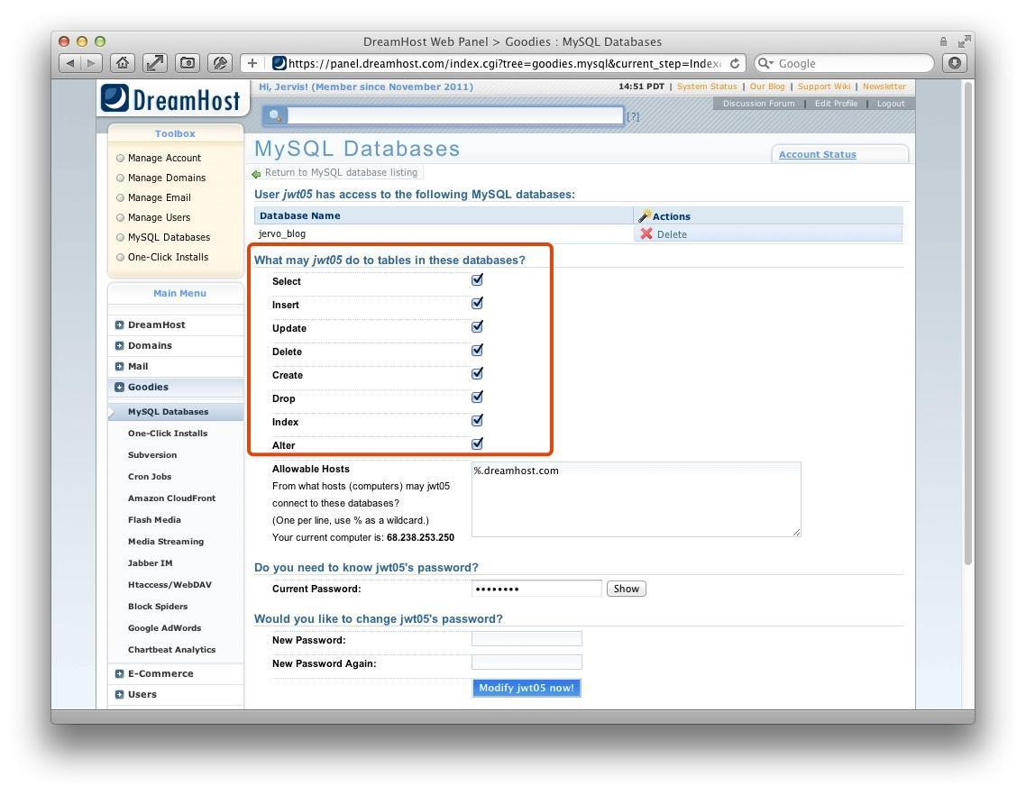

**Setting Up FTP client (i.e. Dreamweaver)**

Open up your FTP software.

At the top go to Sites > New Site...

Click on the “Site” category.

Enter a desired name for your site, a path where you want your local files to be.

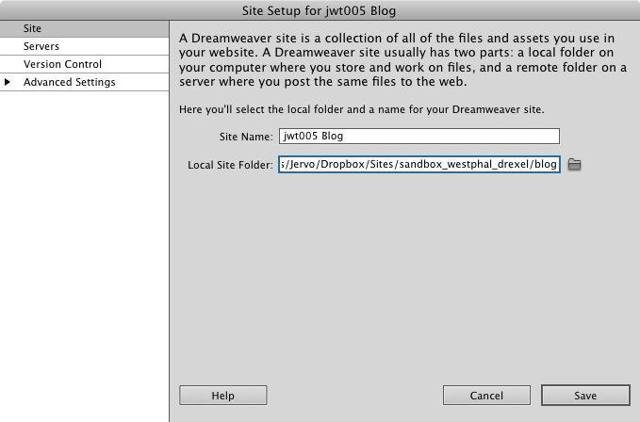

Now click on the “Servers” category located to the left.

Turn on "Remote" and "Testing" check boxes.

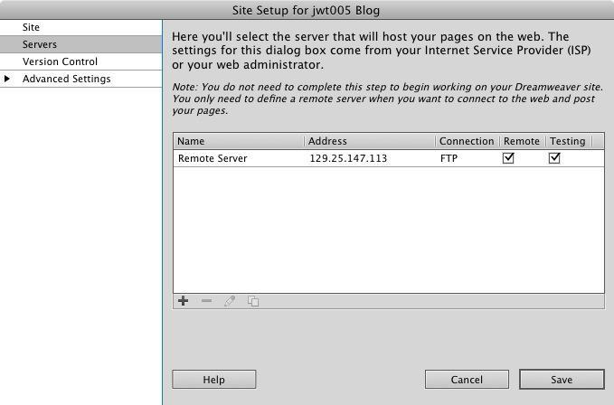

Click on the pencil icon to edit your Remote Server settings.

Select "FTP" next to "Connect using"

Under “FTP Address” fill in the ftp address to your site.

In Host Directory write /public_html/**blog/**

Then Fill in your login/password information.

Hit “Test” to make sure your ftp connection works.If it worked hit OK, and then OK again to close the site manager.

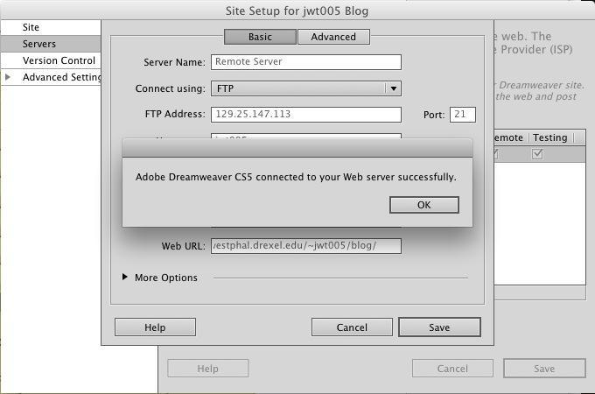

**Download The WordPress Files**

Open a new browser window and go to <http://wordpress.org/download/>

Click the blue “Download WordPress 3.#” button located on the right.

Save the .zip file to your local hard drive.

Unzip the file to the local directory you defined in Dreamweaver.

**Setting Up Your Configuration File**

Before uploading your files to the server, you must edit the wp-config-sample.php file located inside your “WordPress” folder.

Go back into Dreamweaver and find the “Files” Tab at the bottom right

of your screen and select your site.

You should see your WordPress folder inside the root of your local directory.

Inside the folder find “wp-config-sample.php” and rename it “wp-config.php”

Open the newly named file and click to see “Code” view in Dreamweaver

In this file look for a block of code like this:

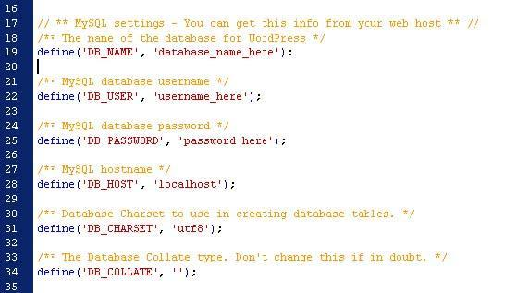

Here is where you must input the database information you created earlier. This includes your database name, and the username/password you connected to the database.

Replace ‘database_name_here’, ‘username_here’, and ‘password_here’ with your information, retaining the single-quotation marks. Remember that your database and user names are automatically prefixed with your drexel username. For example, abc123_dbname and abc123_username

Leave the rest of the information alone.

Save.

Go down further in the document and find this snippet of code:

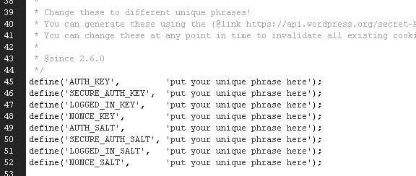

Here you must enter your “Secret Keys” which help make WordPress more secure.

You can obstain keys from the url listed in the comments in orange.

[https://api.wordpress.org/secret-key/1.1/salt/](http://www.google.com/url?q=https%3A%2F%2Fapi.wordpress.org%2Fsecret-key%2F1.1%2Fsalt%2F&sa=D&sntz=1&usg=AFQjCNHX_S7DQq4KWxGAGLj0XRqnOJx5ug)

This URL will automatically generate the code with random keys provided.

Copy and Paste the code provided over the old code.

Save the file.

**Upload The WordPress Files**

Right click your local WordPress folder and select “Put” to upload your files

to the remote server.

Select yes if asked if you wish to put dependant files.

**FINALLY, Installing WordPress Onto Your Server!**

Open a new browser window/tab.

Navigate to your install file in the wp-admin folder of your WordPress root

This would be something like:

*http://www.domain.com/wordpressfoldername/wp-admin/install.php*

You should see this screen:

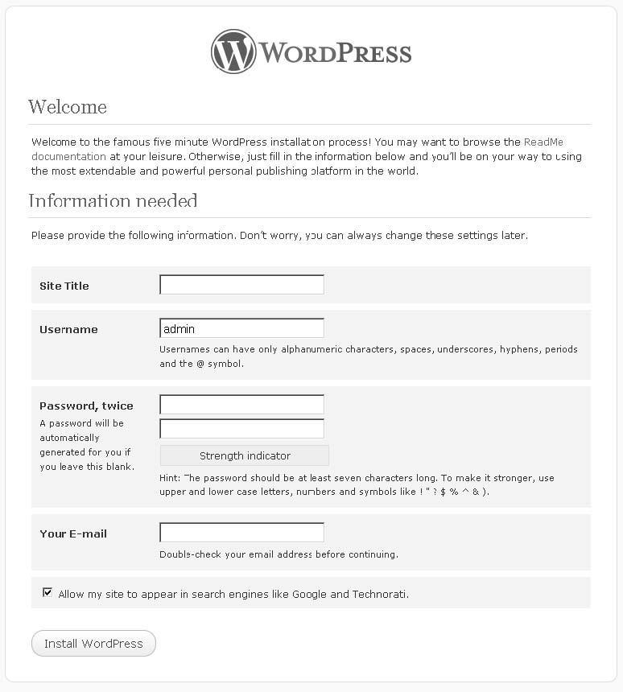

Fill in all the information in the fields provided.

Its recommended not to leave your username as “admin” for security reasons and to either pick a strong password or let WordPress pick one for you.

TURN OFF search engines like Google and Technorati check box.

When you are finished, hit “Install WordPress”.

You’ll then be shown a screen with your chosen username and password.

If you let WordPress pick your password, make sure to record the password here.

Then hit “Log In”

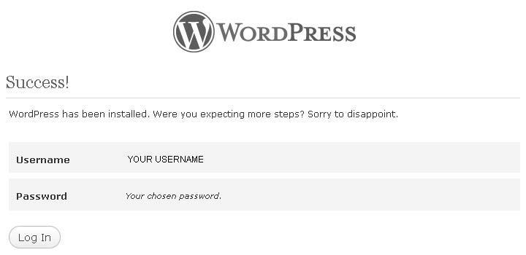

**LOG IN!**

Your WordPress installation is complete!

Enter the username/password you just created to access the admin dashboard.

---

see also: <http://codex.wordpress.org/Installing_WordPress>

If you are self hosting your process may be easier than this. Most hosts use cPanel and have either the WordPress or **SimpleScripts** plug in that does this whole process for you in the matter of a few clicks. #justSaying

[ NOTE to instructor: I (jervo) do NOT recommend this option it limites student control. i.e. Students can not control database name, nor can they install more than one Wordpress site]

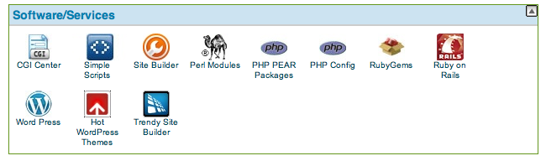

---

**Intro To Using WordPress**

Two of my favorite resources are [http://codex.WordPress.org](http://www.google.com/url?q=http%3A%2F%2Fcodex.wordpress.org&sa=D&sntz=1&usg=AFQjCNEXM3472hhijW3sM3N6gON5EWicOg) and Thord Daniel Hedengren's[*Smashing WordPress*](http://www.google.com/url?q=http%3A%2F%2Fwww.amazon.com%2FSmashing-WordPress-Beyond-Blog-Magazine%2Fdp%2F0470684151%2Fref%3Dsr_1_1%3Fs%3Dbooks%26ie%3DUTF8%26qid%3D1299903037%26sr%3D1-1&sa=D&sntz=1&usg=AFQjCNHZDSXQOus1lbySVYl9TpgHaVaqUA)

In order to ensure that you do not accidentally ruin the code that makes the WP system work, WordPress keeps all its core file separate from the other files. The only core file you should ever touch is the wp-config.php file when installing the system. Otherwise you may not only end up breaking the system or theme and plugin functionality, you may also open up your server to malicious attacks. The only files you should ever edit are those inside the wp-content folder. This is where you will store your theme, plugins, and all media you upload.

We will talk more about designing next week. Lets get some basic features set first.

First make sure you are logged in to your new WP install. If not go to *http://www.domain.com/wordpressfoldername/wp-admin/* and log in.

**Dashboard**

Each box on the dashboard is a widget. you can specify the number of columns, drag to rearrange, collapse or turn off widgets. Some plugins add widgets to the dashboard as well. Some widgets are configurable.

**QuickPress**

This is a quick nut limited way to write a basic blog post. You can use tags but not categories, media uploads but not the rich text editor, and you can't change the post's publication date or status

**Incoming Links**

The Incoming Links widget is set up to show you Google Blog Search results for your site's URL. The widget is configurable (Figure 3-4), so if you'd rather see results from some other service (like Technorati) or if you want to change the number of search results displayed, click Configure in the widget's title bar and edit the settings.

From the menu on the left click on Settings.

**Settings**

Most of the settings in WordPress are good straight our of the box for most blogs. But as you get into developing custom themes and add custom functionality to your site you may what to change some of these.

**General**

These are the basic settings that you set as you setup your wp install.

**Writing**

Sets your preferences of your default views when adding pages/posts. Also has the ability to set up posting via email. But if you have a smart phone you can download the free WordPress app that has many more option (iphone/Android/Blackberry).

**Reading**

Here you determine what your visitors will see when they visit your site. The default is to show the home page as a list of the 10 most recent posts. But you can choose a Page as your home page to make your site look more like a traditional site rather than a blog.

**Discussion**

This is where you control how your site handles comments and trackbacks: : whether comments and/or trackbacks are allowed, how they're moderated, who's allowed to comment, how you get notified of new comments, and whether commenters' avatars are displayed.

One common misconception is that turning off comments will remove the comments boxes from your posts. Turning off comments here will only add "comments are disabled" in the comments field of your posts. To truly remove comments from your site you need to both turn off the commenting here and remove the comment code from your template.

"A trackback is one of three types of linkback methods for Web authors to request notification when somebody links to one of their documents. This enables authors to keep track of who is linking, and so referring, to their articles." - wikipedia http://en.wikipedia.org/wiki/Trackbacks

*"Hey! Remember when we thought comments were a good idea? We'll turn the Internet into a conversation. The wisdom of crowds. Haha! hooboy."*

- Mike Lee, @bmf

"*If "The Fifth Element" were made today: Lilu enjoys watching videos on the Internet, then reads the comments and decides not to save mankind.*"

- Mike Lee, @bmf

**Media**

This screen allows you to set your preferred maximum dimensions for your images. When you upload an image, WordPress automatically checks the resolution then generates multiple copies of the image at different sizes where applicable: thumbnail, medium and large.

**Privacy**

Here we only have two options. Searchable or non-searchable by search engines. This does not stop people from going to your site, only search engines and crawlers the obey the robots.txt commands. if you want to make your entire site private you will need to either password protect your main public_html directory or use a plug in such as Members Only.

**Permalinks**

The WordPress default:ugly is to is to use IDs: example.com.?p=1

Here you can choose your URL structure. Most people use the Month and Name option. More info can be found at: [http://codex.WordPress.org/Using_Permalinks](http://codex.wordpress.org/Using_Permalinks)

**Short URLs**

If you have included your post name in your permalink structure, or if you have deeply nested pages with long titles, your permalinks can get very long. Sometimes you'll want shorter URLs to paste into an email or Twitter message. A number of URL shortening plugins are available; Short URL is one of the most popular.

However, you don't need a plugin to get a shorter URL. No matter what permalink structure you have chosen, the default ("ugly") structure will always work. To use it, just find the ID of your post or page—it's in the URL in the Edit Post/Page screen, among other places.

**Category Base**

Category and tag archive pages contain a permalink "base," which by default will be "category" for categories and "tag" for tags (http://example.com/tag/humor/). It's possible to remove the category base—for search engine optimization purposes, to keep your URLs short, or just because you don't like the way it looks—using a plugin such as No Category Base or No Tag Base

**Pages & Posts**

Like Mr. Miyagi says "Different, but same."



People often have trouble distinguishing between posts and pages. When displayed in a browser they typically have the same visual characteristics. So when entering data how do you know which to choose? Posts should be used for date-based content such as; blogs, podcasts, articles, news releases, etc… Pages should be used for long term content that will need to be accessed most commonly (typically requiring minimal updating) such as: resumes, contact info, bio, etc…

One of the big differences is that Posts can have tags and categories, while Pages can not. Pages can have hierarchical (parent/child) relationships while Posts can not (although Post categories can be hierarchical). Also Pages are not included in RSS feeds.

One thing to note about WordPress and it's documentation. When we discuss websites we say that they contain pages of html. In this case the page has a lower case "p". When we talk about the WordPress taxonomy of Posts and Pages, the word Page has a capital "P". So while WordPress sites can have a lot of pages, typically most of the pages are Posts, and few of the pages are Pages. Get it?

You can also create your own taxonomies and create additional content types beyond Pages and Posts. We will look into this later in the term.

**Posts**

Posts are the entries that display in reverse chronological order on your home page. In contrast to pages, posts usually have comments fields beneath them and are included in your site's RSS feed. This is the most commonly created content which will populate your site.

To create a new post, you log into the admin interface of your WordPress install and click the "Post" tab on the left navigation. At the top of the page next to the title "Post" you hit the button called "Add New".

You can use various functions built into WordPress to customize how posts are displayed, how many are displays and which categorys/tags of posts are loaded.

New posts contain a title, main content (usually text), any tags or categories used for various things (discussed later), Images, Excerpts and the possibility for custom fields.

Excerpts are short summaries of your post that you can display when having a list of posts rather then the actual content of the post

Custom fields allow you to add your own set of content within the metadata of your post. You can later access this data in the loop of your blog to add things such as media content or any type of special content you which to call out and/or style different than the rest of the post.

Also you have the option of allow comments and trackbacks/pingbacks on your post. Trackbacks and pingbacks are just a way to notify other blogs that you have linked to their content.

**Pages**

Pages are typically used for static content that doesn't change as much over time compared to a post. They are typically used for things like about pages or contact information. However, by adding code like WordPress' loop, you can do just about anything with them.

Creating a new page provides you many of the same options that a post does. However, pages are listed at the top of your blog in the main navigation. By default, a WordPress install already has created a secondary page for you called "About". You don't have to create any content for a page within the admin interface, in fact you can add all the content for a page with PHP.

What is nice about pages is that each can have its own custom template that you can style to look anyway you want, providing any information you want and with much more flexibility than a post.

**Categories & Tags**

**Categories**

Categories are the general topic the post can be classified in. Generally, bloggers have 7-10 categories for their content. Readers can browse specific categories to see all posts in the category.

To add a new category, click the +Add New Category link in this section. You can manage your categories by going to Posts > Categories.

Categories can be used as filters to display on certain categories or excluding categories when WordPress loops through your posts. Each Category can have its own template for you to distinguish them from other categories. Categories can be further organized into sub-categories.

**Tags**

Tags refer to micro-categories for your blog. Posts with similar tags are linked together when a user clicks one of the tags. Tags have to be enabled with the right code in your theme for them to appear in your post. Tags allow you to specify topics you may cover within a post which allow visitors of your site to click a tag to see all articles relating to that tag in the same way it works for categories. Tags can NOT be further organized into sub-tags.

Add new tags to the post by typing the tag into the box and clicking "Add".

**Editing Your Content**

Content on your site can be edited at any time, including posts and pages. There are multiple ways to do this but both require to be logged in as an administrator. You can either edit content by surfing your site directly and hitting the edit link that is provided only to those who are administrators of the site or you can go into the admin interface.

To edit inside the admin interface, you can click the link on the left side of the corresponding type of content you wish to edit, such as posts. Here you will find a list of all the posts you created. By Hovering over a post, you will get the option to edit, quick edit, trash, or view the post.

Quick edit will open up an editor right on the current screen where you can make quick changes. The edit option brings you back to a page similar to the one you used to create the post originally.

**Adding Media**

You can add various types of media to your WordPress content using the built in uploading tools accessible in the admin interface.

The easiest way to connect media to a post is by clicking the buttons located above the main content input area. Here, you will see "Upload/Insert" and a set of icons, each corresponding to a type of media, images, video, audio and a general media button which allows you to add any type of media.

Once you upload media, it allows you to add some metadata to the image and various other options you can set for how the media will display with your post.

Another option you have is to click the "Media" tab on the left navigation. Here you will see a list of the all the media you have uploaded and what they are attached to. From here, you can edit, delete and add media.

**Importing Content**

WordPress allows you to import content from other blogging systems like: Blogger, LiveJournal, MoveableType/TypePad, Textpattern, and WordPress.com, as well as a host of other platforms.

Tumblr has no export feature, but you can import its RSS feed, or try one of the migration tools like Tumblr2WordPress.com which generates an XML file with all the content, comments, tags and files that can be imported to your WordPress.

WordPress does not import HTML files but default, but there are a few plugins that can assist with this process.

Nothing's Perfect.

Do not expect importing content to be a single click and everything is perfect. Things often go wrong. The most common issues are image/media files not being imported and links being broken.

To help assist with this clean up, under settings you will find a Search & Replace option so that you can mass update broken links and other content issues.

http://codex.WordPress.org/Importing_Content

**Plugins**

Plugins are composed of php scripts that add additional functionality to your blog. They offer new additions to your blog that either enhance features that were already available or add otherwise unavailable new features to your site.

Plugins are often used to handle comment spam, alter what type of information is displayed on a page, and add features like lightbox easily into their WordPress install. For example, the lightbox 2 plugin is an advantage to using the traditional manual javascript implementation because it automatically sets up images to be used with lightbox when the images are linked to a post.

You can find WordPress Plugins in Administration Panels > Plugins > Add New panel or WordPress [Plugins Repository](http://www.google.com/url?q=http%3A%2F%2Fcodex.wordpress.org%2FPlugins%23Plugin_Repositories&sa=D&sntz=1&usg=AFQjCNHrmlufAypZf6bfY6h7x15pf2GSDg) site.

From the Administration Panels, click on the Plugin tab. Once you have uploaded a plugin to your WordPress plugin directory, activate it from the Plugins Management page.

We will dive more into these later.

**Themes**

Themes are essentially the custom frameworks built on top of the core WordPress structure. Each theme can not only be styled as its creator wishes, but also can change the organization and display of information within the site. Themes use various templates to determine the structure, layout, style, and content of the site. You can create custom templates for most aspects of the WordPress system.

To change themes, login into the admin panel and click Appearence> Themes. From here you can switch between themes you have already download and also search for new ones to download then activate as you current theme.

**Feeds**

WordPress automatically generates RSS2.0 and Atom1.0 feeds for your posts. There are also a slew of hidden feeds for; comments, categories, tags, taxonomies, authors, content types, oplm, and more…

http://codex.WordPress.org/WordPress_Feeds

---

**Assignment 01:**

**Read**

**Beginning WordPress 3: Make Great Websites the Easy Way**

http://www.library.drexel.edu/cgi-bin/r.cgi?url=http://library.books24x7.com/library.asp?^B&bookid=35680

Chapters 1 - 5

**Build**

Get familiar with WordPress (if you are not already):

* Turn on plugin "**Akismet**" and apply your API key. (Hint: You can get your API key for free).
* Make min 3 pages
* Make min 3 meaningful posts
* Using the default "Twenty Eleven" theme customize wp to your prefs (Customize, Widgets, Menus, Options, Header, Background)

**Submit**

URL to new WordPress installation that you will be using for this class.

*http://www.domain.com/wordpressfoldername/*

***Note:*** *If you switch hosts you will need to resubmit the new url via bbVista Mail*