**DIGM-243: Web Authoring II**

**Week 02**

**Planning your theme design**

In DIGM-240 you designed and coded static html pages. Everything that existed on the page, that you viewed in your browser window, was coded into the html file. With Content Management Systems like WordPress, the main sections of each page is broken into distinct parts (header, content, sidebar, footer), and the actual content is stored in a database. When you request a page in your browser the WordPress system dynamically assembles each page on the fly, grabbing the pieces and content that it needs, and generates the static html that is served to your browser. All of this information regarding style and layout is stored in your Theme folder. Since every page is dynamically driven it is important to have a comprehensive plan before you start coding or even designing.

**Defining your goals**

First you need to define your audience. Who will be using your site? ("Everyone" is never the answer here.) To do this you need to decide what it is that you wish your site will accomplish. Most of you will be designing a website to assist you in landing a good co-op, or possible a full time job after graduation. If this is your goal, then your number one target audience is going to be someone like the creative director, project manager, producer, etc… Now that you have these two areas defined, you need to think about how the user will access the info on the site. What is it they want to see most, and how can you assist them in finding this info?

**Defining your structure & functionality**

Now that you have this big picture in mind it will be easier to define what pages you need and how they should be linked to each other. You now know about Pages and Posts. How will you use these? What specific content will they hold. Will your home page be a custom page or a list of the latest posts? Do you want to write blog posts? In a few weeks I will show you how to create a custom taxonomy. This means that in the left sidebar of the dashboard where you have posts and pages you will be able to add a custom post type, ie: Portfolio. This way you can have your Pages (home, resume, contact, bio, etc…) and use Posts for blog entries, but put all of your Portfolio samples into a custom section. You do not have to do this. Some of you will not want to blog, and will use the Posts for Portfolio, others will what Portfolio and Blog entries inter mingled. It is up to you. But you should decide now.

The best plan is the focus on the structure of the site before you code and even before you think about opening PhotoShop to start designing it. Creating sketches of site maps and diagrams of site interaction, what pages lead to where, is usually the best plan. Then sketching out the layout of your pages and determine what pages are similar to one another in addition to what content you want to put where. If you realize that the archive, search, and category/tag listings aren't all that different, you could potentially just leave WordPress to fallback to the archive.php page or even index.php for all those types of pages. With the use of conditional tags, you can make minor changes to how information is displayed with very little work.

It is impossible to plan for every single page a WordPress site will contain since in theory it is an ever expanding system. What you need to do instead, is to plan out the core content strategy. Make a plan for the generic structure of your site (site map) and then define where the individual blocks of content will show up on your pages (wireframes).

When wireframing for WordPress you can get as detailed as you like. Some sites have a vast number of different layouts, others as few as four. The four you want to start with are: home page, default page view, single post view, list of posts. Sketching out wireframes of your site will also allow you to find flaws in your design early and fix them as well as giving you an overview of what can be broken down into separate templates. From wire frames you can determine if you need any alternate headers, footers, or sidebars and so on. This allows you to have a much clearer focus on what needs to be designed when you get to that stage. Even more so, having a clear picture of where you are putting content will simplify the task of adding code to your templates when you go to integrate WordPress functionality.

**NOTE:** Before you start diving into wireframes you should do some research. Look at other themes that are out there and how they display content. Search for plugins and widgets to see what extra functionality you can easily add to your site. Once you get an idea of how you want it to display and what you want it to display it is time to start working on your wireframes. In order to build your wireframes you need to understand two aspects of the system and your site: the components and the pages.

---

**Defining the Components**

**Header**:

This typically contains the logo, the name, and the tagline of the site. It sometimes also includes any or all of the following: search, navigation, advertising, social media links, bread crumbs, login and registration. A successful header will tell the user where they are and what to expect from the site.

**Navigation**:

Horizontal or vertical? Single level or drop-down/fly-out? WordPress 3 offers a menu system to help you build and define multiple menus where you can define which pages should be displayed in each. You do not have to use it, but the default is to use the function wp_listpages (more on this later) which will list all pages in the menu system. Where you may what legal and/or privacy notice pages to appear in the footer only and not in your main nav. Some people put the main menu in the header, some put it under the header, others put it in the sidebar, or even entirely in the footer.You need to decide which pages show in which menu and how the menu will appear in each part of the page.

**Content**

WordPress uses what they call "The Loop" to sift through the database and pull out the main content that should be display on the requested page. By default the loop will include post title, the main content, meta data (tags, categories, post date, author), and comments. The default view is title,date and author, content, tags and categories, then comments. You will be able to customize what displays where or if at all.

There are also pagination controls. You can allow your viewer to click to older or newer entries, or see a number line when there are enough entries.

**Comments**

Some love them, some hate them. If you decide to use them you need to keep a vigilant eye on them. Nothing turns a visitor off like a comment thread full of spam. That said, comments have a fair amount of options as well. Can anyone comment or must they e registered first? Show avatars or not? Show as individual list view or threaded ( allow commenters to comment on other commenters' comments). Often people highlight or slightly change the style of comments that are posted by the author.

**Sidebars & Widgets**

Wordpress can be a single column design, or two or three columns. But wordpress uses the term 'sidebar' to define a specific column that plugins and widgets can add extra content to. This is where most people list categories/tags, their blogroll, and add in extra features via plugins/widgets like social media feeds/links, advertising,

**Footer**

Traditionally site footers are a color bar with a few links and copyrights, but lately people have used it as an area to treat their visitors for their continued interest in the site.

The famous WordPress Theme called Hemingway removed the side bar and put all the side bar info into the footer. <http://warpspire.com/hemingway/>

* <http://www.smashingmagazine.com/2008/04/08/footers-in-modern-web-design-creative-examples-and-ideas/>
* <http://sixrevisions.com/web_design/25-stylish-website-footer-designs/>
* <http://www.youthedesigner.com/2010/03/29/examples-website-footer-designs/>
* <http://vandelaydesign.com/blog/galleries/blog-footers/>

**Search**

WP has search functionality built in. Will you use it? Where will you put it?

**Extra Features**

You might also want to consider Extra features like (but not limited to): Feature Sliders, Custom Page Templates, Advertising and Social Media Links.

---

**Defining the pages**

**Home**

What will your visitor see when they go to the top level of the site. Here is where you want to show off your best features/work. The design of this page should tie in directly to the message you are trying to send. This sets the tone and structure for all subsequent pages.

**Single Page**

Themes vary on whether or not to show the sidebar on Pages, especially since these are the pages that the menu system links to. It is a possibility to design custom Page templates so that not every Page looks exactly alike.

**Single Post**

This could contain portfolio entries, blog posts, or both. These are the pages that are defined by tags and categories. Lists of tags and categories usually go in the sidebar to help the view sift through the content. These not only show the Post Title and Content, but also Comments (if enabled) and an extensive list of metadata.

**Archive, Author, Category, and Tag pages**

You can also allow the user to view lists of Posts that sort out all the Posts that fulfill a specific requirement, such as all Posts with a specific Tag, Category, etc… These usually show a list of Posts including: title, content excerpt, and limited meta.

**Search Results**

This page works the same as the archive, author, category and tag pages, but you can fine tune exactly what you want this page to reveal.

**404**

WordPress provides built in "page not found" 404 error handling. Rather than just sending you user back to where they came from or to the home page, it is nice to let them know that there was some sort of error and try to help them find it by including search functionality, a list of tags/categories, latest posts, and most popular posts. Some people have a lot of fun with this.

* <http://www.smashingmagazine.com/2007/08/17/404-error-pages-reloaded/>
* <http://www.hongkiat.com/blog/60-really-cool-and-creative-error-404-pages/>
* <http://www.tutzone.org/2009/05/31-cool-404-error-page-designs.html>

---

**Defining Wireframes**

Just to reiterate, [wireframes](http://en.wikipedia.org/wiki/Website_wireframe) are blueprints that define a web page’s structure, content and functionality. They represent the arrangement of the page's content, including: interface elements, navigational systems, and content areas. They do not convey design – e.g. colors, graphics, or fonts.

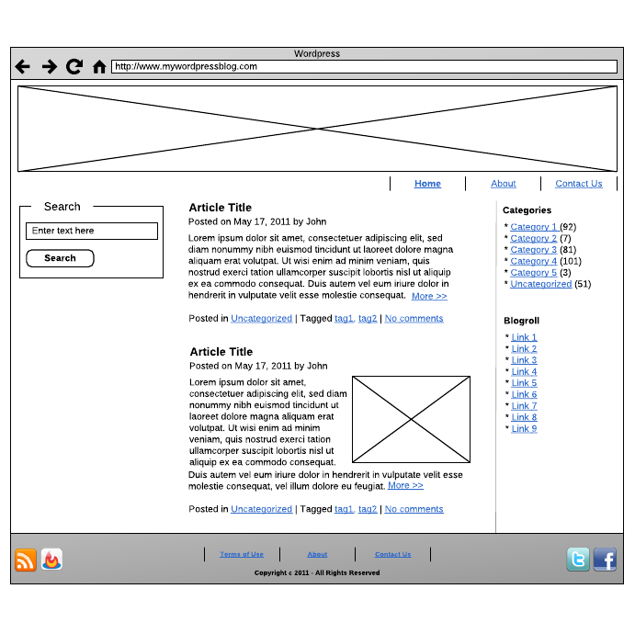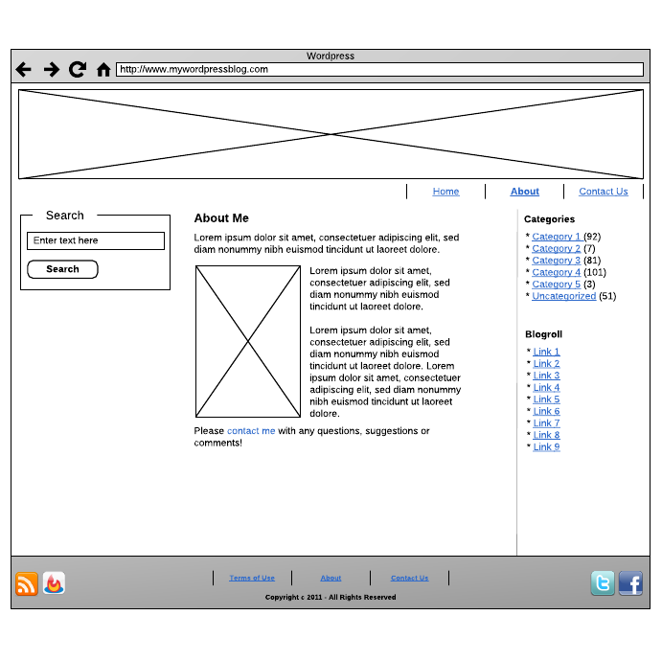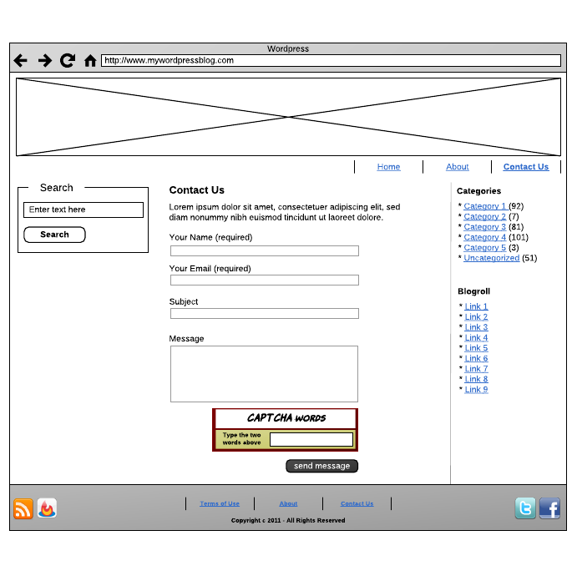

Please review these links*:*

* <http://sixrevisions.com/user-interface/website-wireframing/>
* <http://www.smashingmagazine.com/2009/09/01/35-excellent-wireframing-resources/>
* <http://mashable.com/2010/07/15/wireframing-tools/>

---

**Homework:**

**Read:**

**Build Your Own Wicked WordPress Themes**by Allan Cole  
Collingwood, Vic. : SitePoint Pty. Ltd., 2010  
http://www.library.drexel.edu/cgi-bin/r.cgi?url=http://library.books24x7.com/library.asp?^B&bookid=41318

Ch.2 Planning Your Theme

Ch. 3 Theme Design 101

Six Revision's *Ultimate Guide to Website Wireframing*

* <http://sixrevisions.com/user-interface/website-wireframing/>
* <http://www.smashingmagazine.com/2009/09/01/35-excellent-wireframing-resources/>
* <http://mashable.com/2010/07/15/wireframing-tools/>

**Build:**

Update your WordPress content:

* Update your Wordpress website with TEXT content to ALL of your web site PAGES.
* Update your WP website with at least three meaningful post.
* Build a menu for your PAGES.

Complete Site map of your future wp (Wordpress) web site

At least three wireframe versions of your site based on wireframe reading assignments.

**Submit:**

URL to new WordPress installation that you will be using for this class.

*http://www.domain.com/wordpressfoldername/*

URL to your complete site map

URL to at least 3 wireframes of your wp web site

**Other:**

**Blogs/RSS Feeds You May Want To Consider Following:**

* <http://www.cssdrive.com>
* <http://www.makebetterwebsites.com>
* <http://net.tutsplus.com/>
* <http://sixrevisions.com>
* <http://www.smashingmagazine.com/>