



**Midterm Project Report**

**Advanced Computer Programming**

**Web Scraping with Python**

**Student Name : Otneil Xander Susanto**

**Student ID : 112021198**

**Teacher : DINH-TRUNG VU**

**2024-04**

# Introduction

## Github

1. **Personal Github Account**: https://github.com/nielderto
2. **Group Github Account**: https://github.com/112021179
3. **Group Project Repository**: https://github.com/112021179/1
4. **List of submitted files**:
   * 112021198.ipynb

## Topic

Build a web scraper to extract information about stock historical data from a website page:

https://github.com/nielderto/Weather

## Project Overview

This program have used requests, BeautifulSoup, It has extracted information about the weather of a city in the world, once it is given a city it will extract data from google and give you the following information, Celsius, humidity, precipitation , wind speed.

# Implementation

## Function 1

This Python script retrieves current weather information for a specified city using web scraping techniques. It prompts the user to input a city name, converts it to lowercase for consistency, and constructs a Google search URL for weather information about the specified city. The script sends an HTTP GET request to this URL, pretending to be a web browser using a specific User-Agent string to avoid being blocked or receiving different content. It then uses BeautifulSoup to parse the HTML content of the response. The script extracts and displays the current temperature, precipitation, humidity, and wind speed for the specified city by searching for specific <span> elements with unique IDs (wob_tm for temperature, wob_pp for precipitation, wob_hm for humidity

# Results

## Result 1

. 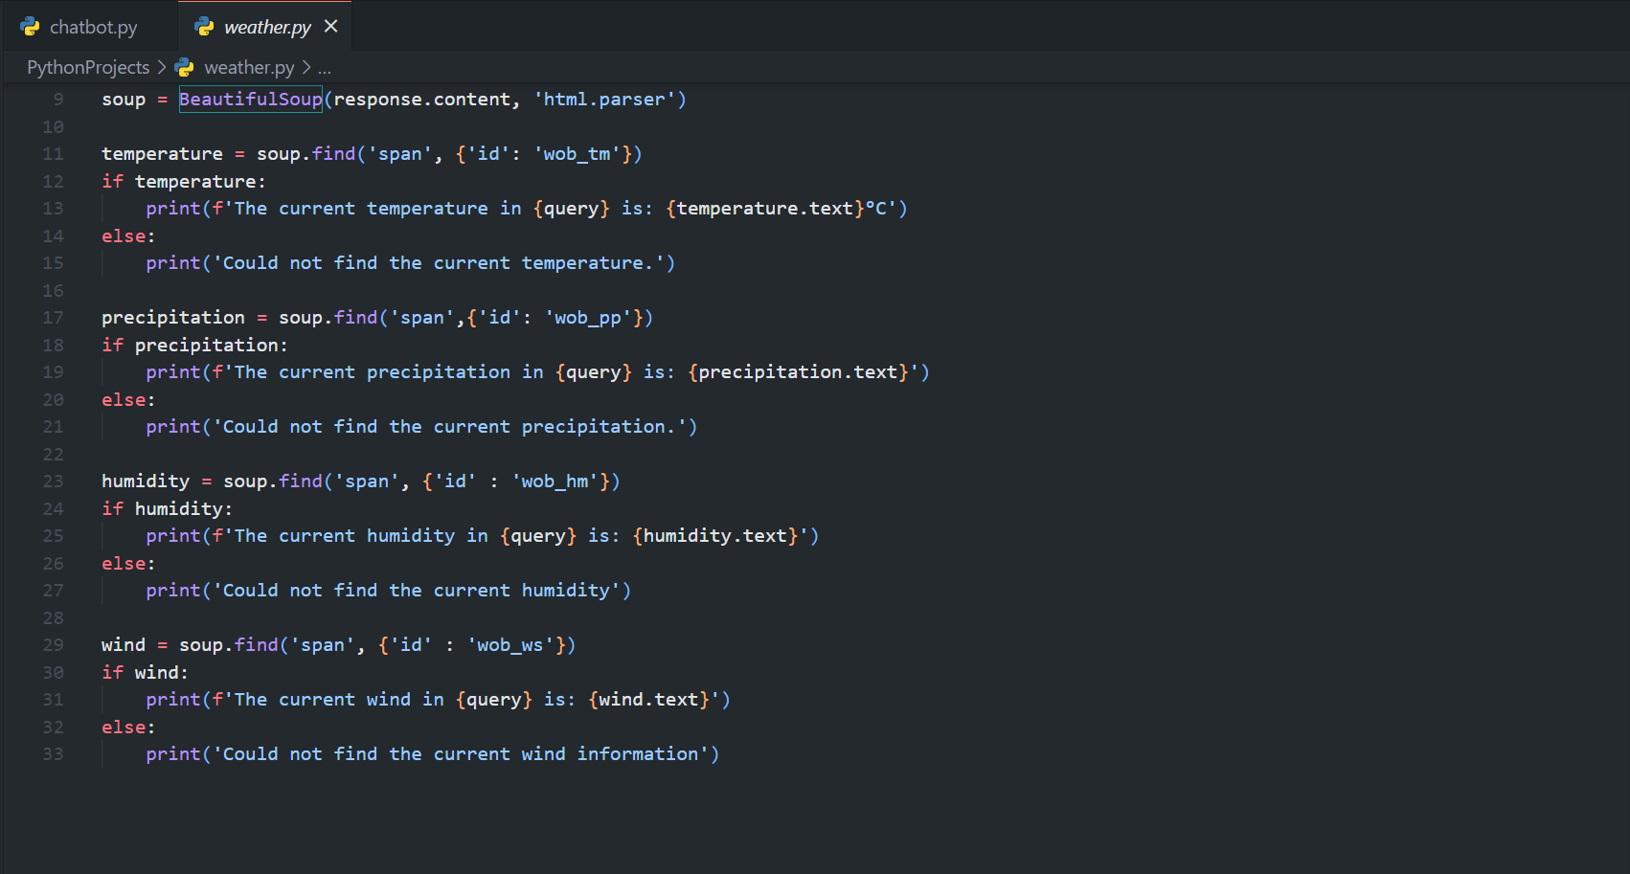

## Result 2

.

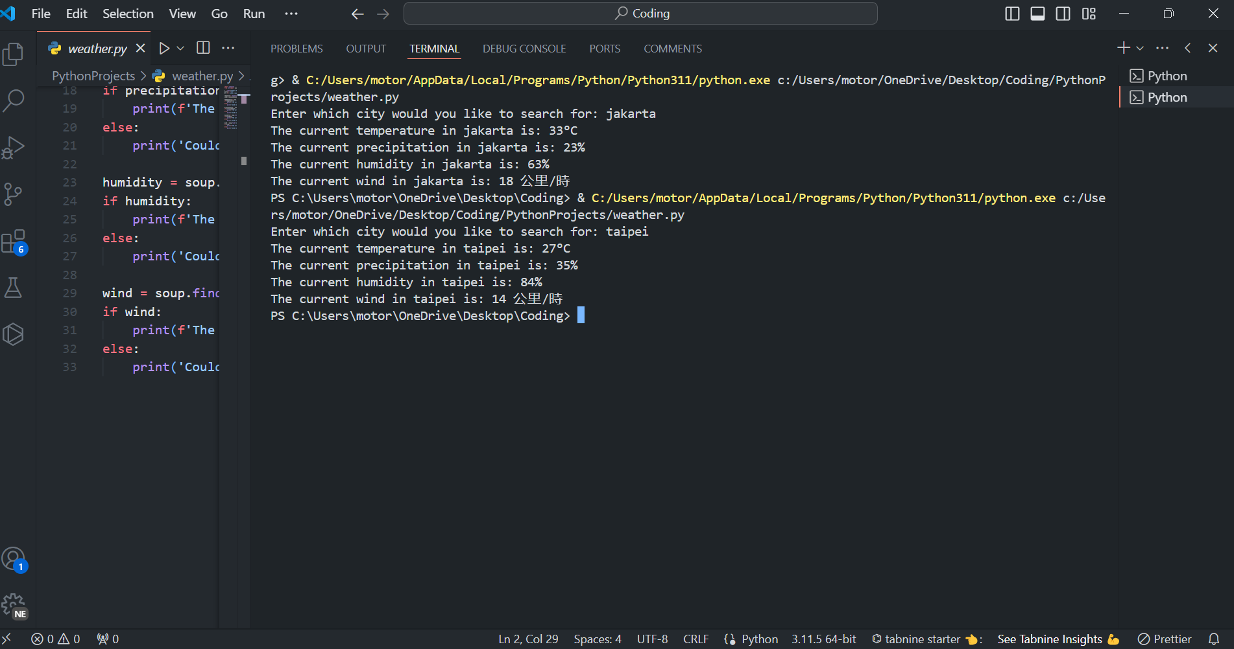

# Conclusions

As in conclusions, I learned a lot on how to code, to create such program that does what we wanted it to do, a lot of error in the process which makes me even more stressed but gives me the opportunity to grow, to learn how improve my skills. I also feel this code wasn’t that advanced yet, cause this is temporarily my skill level in coding, I will try to do my best in my next assignment.