|  |
| --- |
| **Data Science & Artificial Intelligence Implementation** |
|  |
|  |
| Project Proposal for |
|  |
| Samajik Suraksha Yojana |

|  |  |
| --- | --- |
| **Audience:** | Abhinav Chandra, IAS  Secretory, Dept. of Labour  Govt. of West Bengal |
| **Venue:** | Panchayat Bhawan  Sector III, Salt Lake, Kolkata |
| **Date:** | 14/09/2018 |
| **Presented by:** | Anirban Chakrabarty  Director, Artificial Intelligence  Fluxion Bits |

|  |  |  |
| --- | --- | --- |
| **Table of Audit** | | |
| **Edited By** | **Date** | **Note** |
| Anirban Chakrabarty | 14/09/2018 | Document Version 1.0 created |
|  |  |  |

Contents

1. Introduction 4

2. Benefits from the Project 6

3. Technical Description 7

3.1 Technical Architecture 7

3.2 Technology Stack 8

3.3 Modules 8

3.4 Demo Project 8

4. Delivery Model and Methodology 9

4.1 Agile Scrum Methodology 9

4.2 Scaled Agile Framework 10

4.3 Data security 11

4.4 T&M 11

5. Resourcing & Cost 11

6. Assumptions, Queries and Ambiguities 11

7. Conclusions 11

8. Qualifications 12

1. Introduction

With a great deal of passion, we believe in providing right social security to our Indian fellow citizens to be the most important measure in shaping up our beloved nation. At Fluxion Bits, we truly recognise its far-fetched and deep-rooted significance. Hence with profuse enthusiasm, we honour the enormous endeavours of the Labour Department of West Bengal Govt. towards the unprecedented project, **Samajik Suraksha Yojana** – Social Security for the Unorganized Workers.

At Fluxion Bits, (<http://www.fluxionbits.com/>) our ethos is to consistently innovate and utilize the cutting-edge technologies to deliver the best in class solutions to our esteemed customers. We expertise in providing user friendly solutions that create impact.

|  |  |
| --- | --- |
| Fig 1: Analytics and AI in Digital Transformation | As part of our experience in digital transformation of all our valued customers, we observe one growing trend that most organizations today are already custodians of huge databases. This is a goldmine of information. Precise and vital decisions can be timely and very accurately taken with the help of mathematical inferences derived by applying sophisticated analytics and artificial intelligence algorithms on this data.  With the huge share of West Bengal’s population registering in SSY we already have a substantial database at the Labour Department. FluxionBits brings |

in the expertise to support policy makers use data backed inferences to arrive at appropriate decisions that can help the entire state to move to the next level in the field of social security. This will not only benefit the government with highest levels of visibility, efficiency and precise predictions but also benefit the citizens with the sense of security, reliability and confidence on the government like never before. This will leave an extremely deep rooted positive impact on the overall prosperity of West Bengal.

On the other hand, maintaining a significant database and not utilizing it statistically for the optimum benefits of end users and stakeholders at the correct time today, will be a huge blunder that will be irreparable in the future. Lot of funds can be wasted to inefficiency and lack of proper visibility. This can lead to dissatisfaction among the citizens and lead to severe consequences.

At Flexion Bits, we look at Analytics and Machine learning as the missing link between a system implementation and moving to the next level as an organisation, using the data. If proper analytics is not performed upon the data

|  |  |
| --- | --- |
| and metrics derived from the implemented system, decisions for system improvements cannot be taken correctly or accurately.  Therefore, we propose data science & artificial intelligence as a very important part of the project implementati-for Samakik Suraksha Yojana. | Fig 2: Analytics and AI in Digital Transformation |

Priyanko – please add one concluding line here that links the text to the next section.

1. Benefits from the Project

How the Government of West Bengal will be benefited from this project. Tangible benefits. Financial cost savings, gains. – Priyanko’s Points.

Satisfaction among citizens. Intangible benefits.

Use pictures, grids and graphs showing the benefits. Benefits should be presented well.

1. Technical Description

The complete technical aspects of the proposed project are described from end to end in this section. It is followed by a link to the demo application that has been built for this project with database that has been programmatically synthesised to mock the actual data distribution. It will help the honoured audience visualize the key concepts better.

### Technical Architecture

Following diagram describes a very high-level technical architecture for the proposed Data Science & Artificial Intelligence Implementation project.

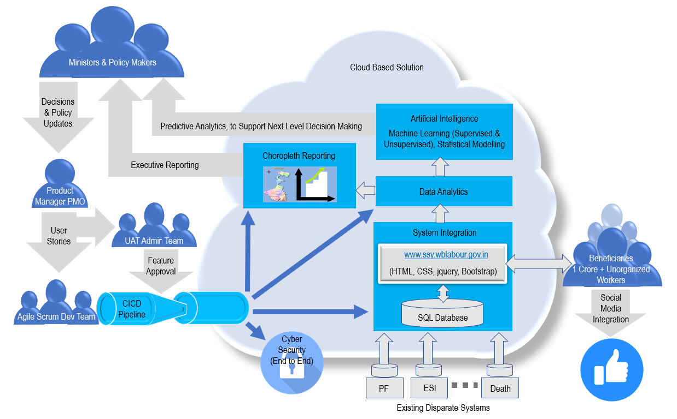

Fig 5: Architecture Diagram

Development team from Fluxion Bits will develop the system feature by feature, incrementally, according to the requirements laid down by the product owner from the Labour Department and the decisions of the policy makers on top. This will be involving a highly matured and responsive Scaled Agile methodology. The incremental and shippable features will be placed in an automated Continuous Integration and Deployment (CICD) pipeline for designated end users from the department to do the user acceptance testing. Once approved at UAT, this will be automatically deployed in production from the CICD pipeline.

### Technology Stack

Anirban to flesh out most sections here.

* + 1. Machine Learning & Artificial Intelligence

Rakesh to flesh out here.

* + 1. Data Analytics

Anirban to flesh out here.

* + 1. Cloud Computing and Hosting

Anirban to flesh out here.

* + 1. Python

Anirban to flesh out here.

* + 1. Choropleth & BI Reporting

Anirban to flesh out here.

* + 1. Web Development in python flash

Anirban to flesh out here.

* + 1. Responsive GUI

Anirban to flesh out here.

* + 1. Automation Testing

Anirban to flesh out here.

* + 1. CICD

Anirban to flesh out here.

* + 1. Cyber Security

Saswata to flesh out here.

* + 1. System and Integration Testing

Anirban to flesh out here.

* + 1. UAT Support

Anirban to flesh out here.

### Demo Project

### Anirban to flesh out here.

1. Delivery Model and Methodology

We at Fluxion Bits believe in delivering the best quality analytics and software to our clients consistently. We rely on agility and responsiveness for our delivery maturity and business effectiveness.

### Agile Scrum Methodology

Agile Scrum is the most popular iterative and incremental software development methodology. It fundamentally incorporates iteration and the continuous feedback that it provides to successively refine and deliver a software system. It involves continuous planning, continuous testing, continuous integration, and other forms of continuous evolution of both the project and the software. It is lightweight, especially compared to traditional waterfall-style processes, and inherently adaptable. What is more important about agile methods is that they all focus on empowering people to collaborate and make decisions together quickly and effectively.

Scrum is a framework within which people can address complex adaptive problems, while productively and creatively delivering products of the highest possible value. Scrum itself is a simple framework for effective team collaboration on complex products.

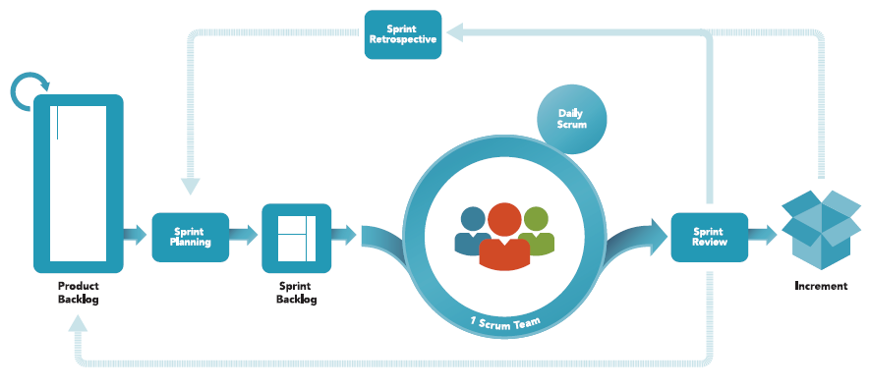

Fig 6: Agile Scrum Framework (picture courtesy: <https://www.scrum.org>)

Agile’s vision and significant principles are as follows:

* Highest priority is to satisfy the customer through continuous delivery of valuable software
* Working software is the primary measure of progress
* Customer collaboration over contract negotiation. Respond to change with responsiveness.
* Build projects around motivated individuals. Give them the environment and support they need, and trust them to get the job done
* Simplicity--the art of maximizing the amount of work not done--is essential

### Scaled Agile Framework

The Scaled Agile Framework (abbreviated as SAFe) is the most common approach to scaling agile practices, across multiple small multifunctional teams by promoting alignment, collaboration, and delivery in a project. It is proposed to be the best suited set of organization and workflow patterns in this engagement. While being used by up to 45% of large corporations it is a great balance between top-down and bottom-up delivery approaches.

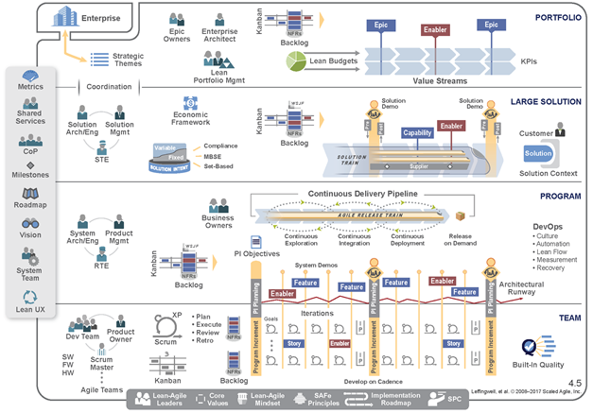

Fig 7: SAFe Framework (picture courtesy: https://www.agilest.org/)

### Data Security

Saswata Basu to flesh out this. Mention network security and also Non Disclosure agreements by internal stakeholders (developers) and scrambling of testing / AI training data. Use diagrams as and when required.

### T&M Type Contract Proposed

Considering the following points, we at Fluxion Bits propose Time and Material type contract for this engagement over Fixed bid or any other type.

* The project scope is not defined at this stage and requirements are expected to be dynamic
* It is presumed to be an ongoing project with deadlines not fixed as of now
* It is not presumed to be a fixed and small budget project with specific MVPs and flexibility is required to vary the workload

We propose to submit billing for actual work scope based on hourly rates of labour defined in the Statement of Work later or proposed the Resourcing & Cost section below. Charges will be calculated for number of hours spent on a specific project, plus costs of materials and cloud services required. The main advantage of T&M model is flexibility and opportunity to adjust requirements, shift directions, replace features, and involve users to get the very product.

Though as an important note, it is worthy of mentioning that we are flexible and will comply by the final decision of the Labour Department, if fixed bid suits the Department more due to any reason unforeseen here, we have no objection against complying by the same.

1. Resourcing & Cost

Anirban - Most proposals also contain a section detailing the costs of the project, whether internal or external. With external projects, you may need to list your hourly rates, projected hours, costs of equipment and supplies, and so forth, and then calculate the total cost of the complete project. With internal projects, there probably won't be a fee, but you should still list the project costs: for example, hours you will need to complete the project, equipment and supplies you'll be using, assistance from other people in the organization, and so on.

1. Assumptions, Dependencies, Queries and Ambiguities

Anirban to put this at the last.

1. Conclusions

Priyanko – Please flesh out:

The final paragraph or section of the proposal should bring readers back to a focus on the positive aspects of the project (you've just showed them the costs). In the final section, you can end by urging them to get in touch to work out the details of the project, to remind them of the benefits of doing the project, and maybe to put in one last plug for you or your organization as the right choice for the project.

1. Qualifications

Priyanko – Please collate this section with CV’s from Anirban, Rakesh, Vivek and Saswata.

Most proposals contain a summary of the proposing individual's or organization's qualifications to do the proposed work. It's like a mini-resume contained in the proposal. The proposal audience uses it to decide whether you are suited for the project. Therefore, this section lists work experience, similar projects, references, training, and education that shows familiarity with the project.