1. Dimensional model (6 Marks):
You are required to design a star schema and describe and justify it. In the report, include a diagram of your star schema[1], justifications for the design choices that you make, and a short description of data grains, dimensions, and fact measures.

Dimension Model Image

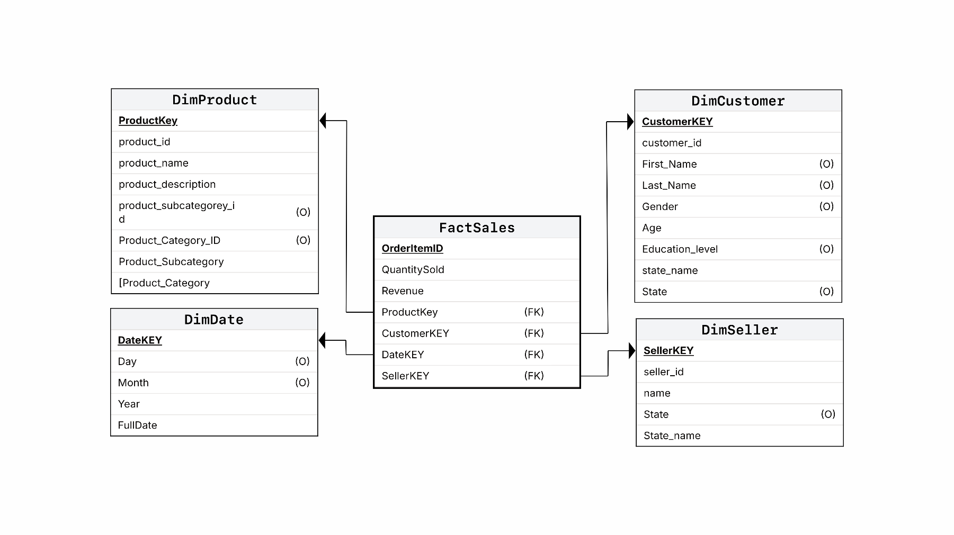

1.2 Description of Dimensional Model (No more than 500 Words):
This dimensional model was designed using Kimball’s four-step process. First, the selected business process is OzMart’s sales transaction because the case requires analysis of customer profiles, product performance, regional differences, and supplier performance. Second, the grain of the fact table is defined as each individual item in an order. In other words, each row in the fact table represents one product sold within one order. This atomic grain provides the lowest level of detail and supports flexible analysis by state, customer age, product type, and seller.
Third, the main dimensions were identified based on the sales event context of who, when, what, and where. DimCustomer captures customer-related descriptive attributes such as age, gender, education, and state, allowing analysis of customer segments. DimDate captures the time aspect of each sale and supports trend analysis by day, month, and year. DimProduct captures product-related attributes such as product name, category, and type, which are necessary for analysing best-selling products. DimSeller captures supplier or seller information and supports the analysis of the largest suppliers by quantity sold. Although “where” is not modeled as a separate geographic dimension, location is sufficiently represented through the state attributes in the customer and seller dimensions for this assignment.
Fourth, the fact table, FactSales, contains the key quantitative measures required for the analysis, including QuantitySold and Revenue. QuantitySold supports identifying the largest suppliers and top-selling products, while Revenue supports identifying the most important customer age profile in each state. The fact table is linked to the four dimensions through foreign keys, forming a clear star schema.
This design is appropriate because it is simple, user-friendly, and aligned with the analytical requirements of the case. It avoids the complexity of a snowflake schema while still providing enough descriptive detail for business analysis. In addition, some attributes are marked as optional because they are suitable descriptive fields for the dimension but are not essential for answering the current analytical questions. Therefore, they do not all need to be included in the SSIS implementation.

2. Implementation of the Dimensional Model:

You are required to implement the dimensional model using the SQL Server Integration Services (SSIS) to integrate and transform data. In the report, add a screenshot of your SSIS transformations and briefly explain your transformations and steps.

2.1 Dimensional Tables implementation (Images from ETL data flow design: One image of data flow process for one dimension table. Please use the tasks from the SSIS toolbox and don’t use SQL queries.)

Date Dimension
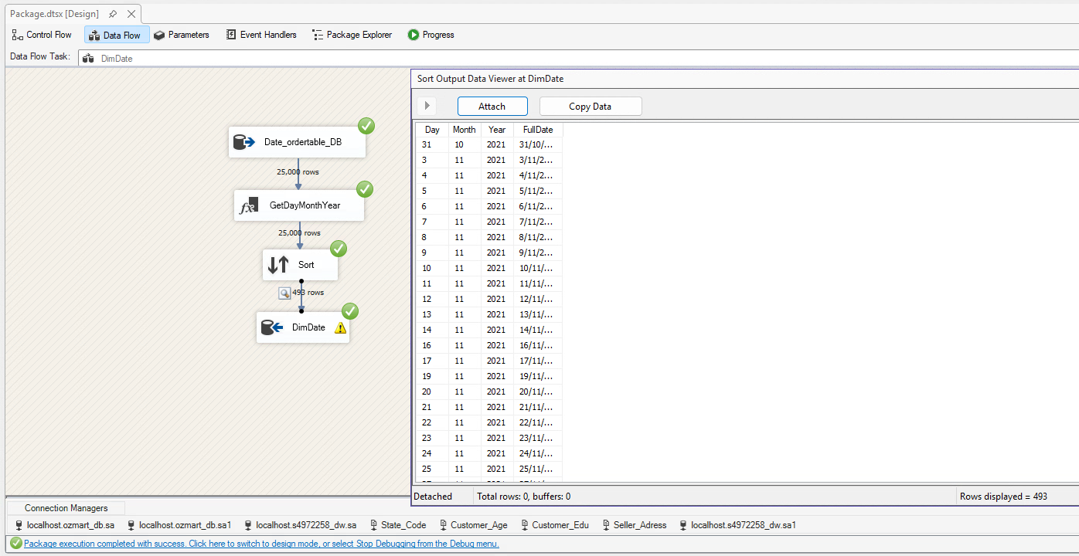

Customer Dimension
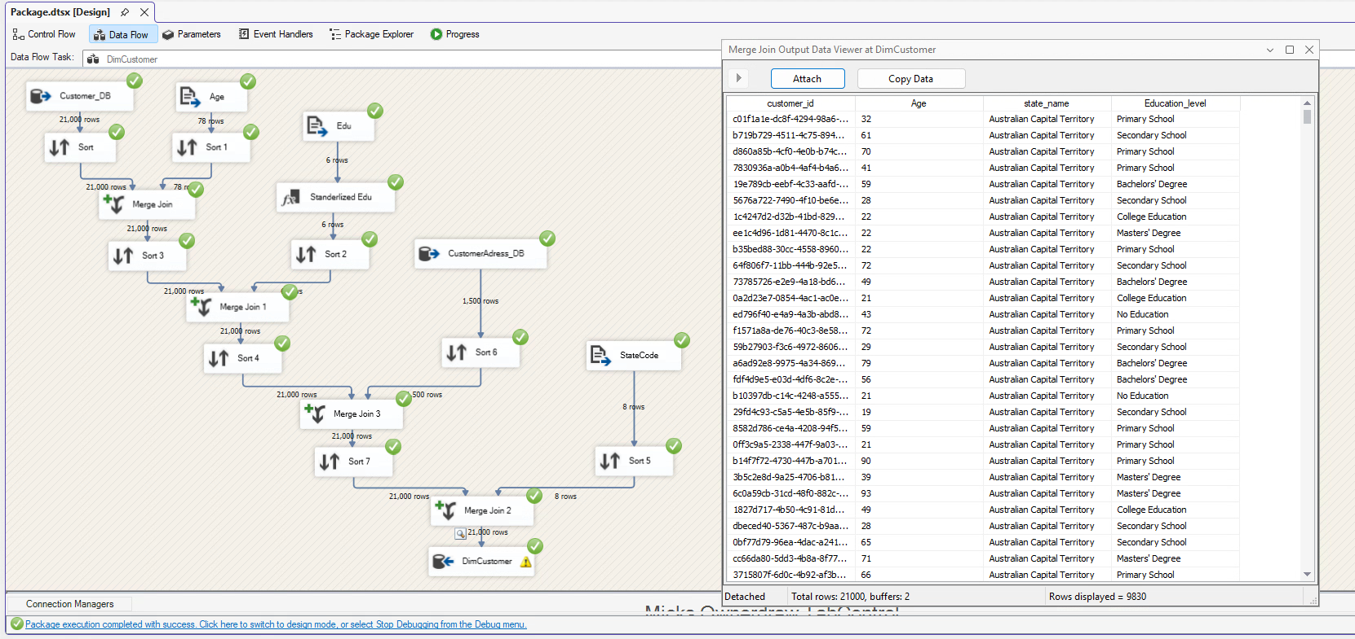

Product Dimension
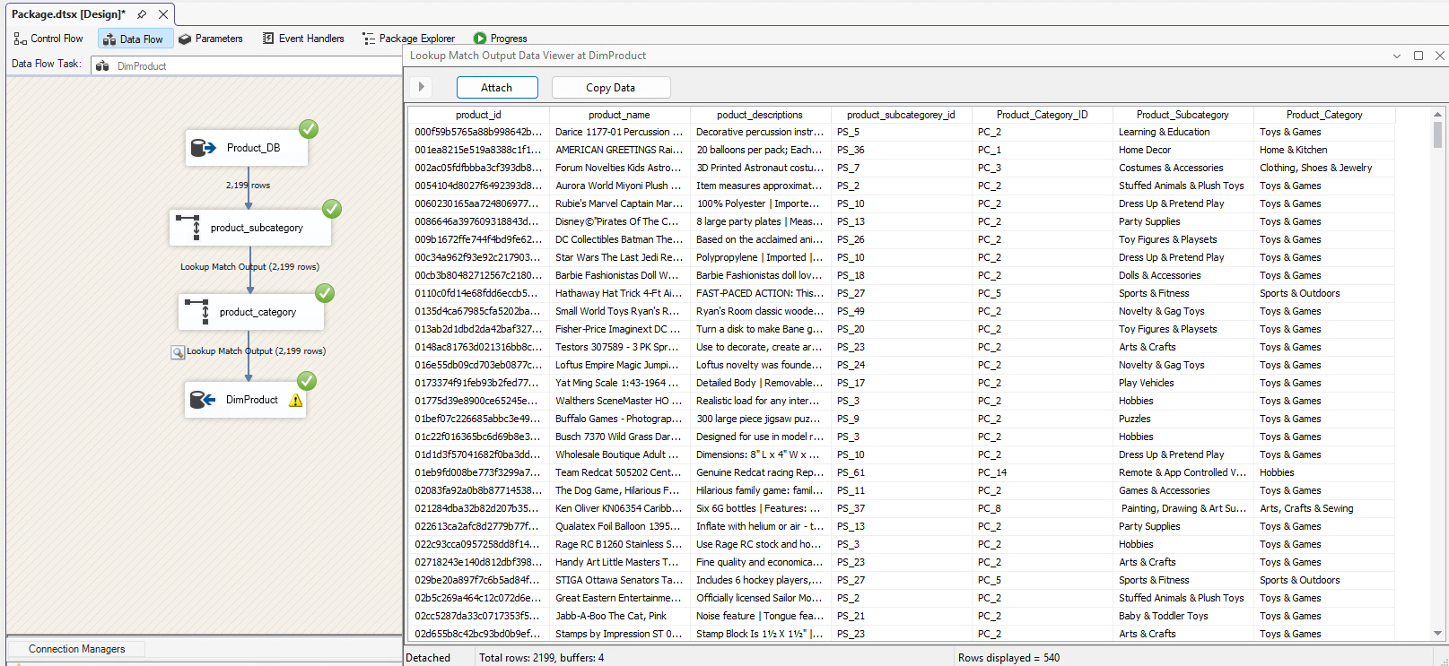

Seller Dimension
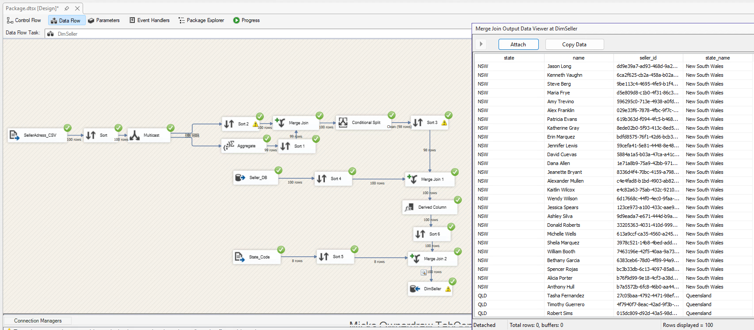

2.2 Fact Table implementation (Image from ETL data flow design: one image from the fact table)

Fact Sales
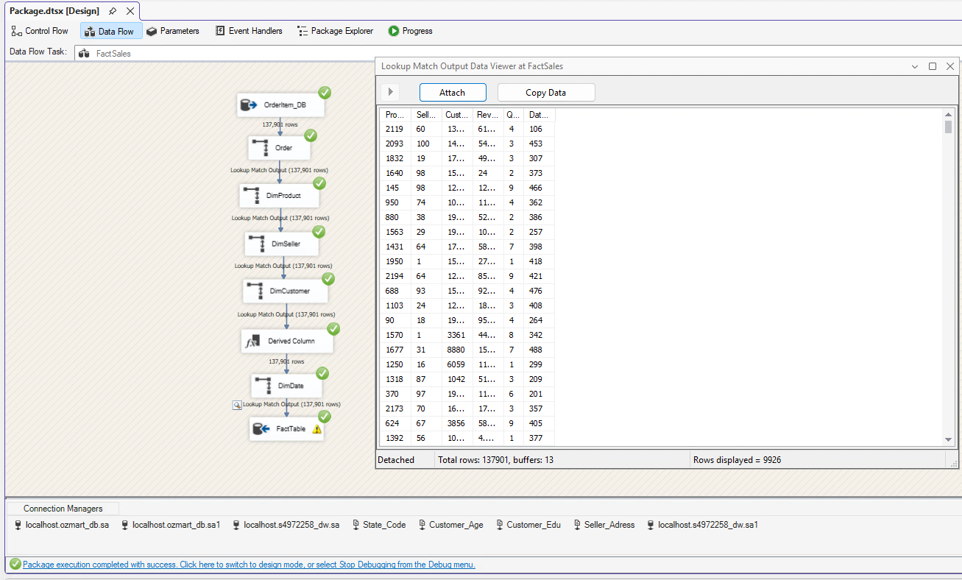

2.3 Description of the Implementation Process (No more than 300 Words)
The dimensional model was implemented in SSIS using separate data flow tasks for each dimension and the fact table, following the assignment requirement to perform ETL through SSIS data flow. Data was extracted from the operational database and supporting reference files, then cleaned, sorted, merged, and transformed before loading into the dimensional tables.
For DimDate, order dates were split into day, month, year, and full date, then sorted and deduplicated before loading. DimProduct was created by integrating product data with category and subcategory reference data through lookup transformations. DimCustomer was built by combining customer, age, education, and address/state information using merge joins and standardisation. DimSeller was created by integrating seller, seller address, and state code data to derive seller location attributes.
A data quality issue was identified in DimSeller. The seller location_id 'ece22fa5b9e06f5b' was shared by different physical locations in the source data. Because the same location ID referred to inconsistent location details, the ETL process could not reliably determine one correct state for all related seller records. To avoid assigning incorrect geographic information, two seller records were assigned the state value “Unknown.”
Finally, FactSales was loaded from order item transactions. Lookup transformations were used to match each transaction with the surrogate keys in DimProduct, DimSeller, DimCustomer, and DimDate, and the measures Revenue and QuantitySold were loaded into the fact table to support the required analytical queries.

3. Analytical Queries (6 Marks)
Once the dimension model is implemented, you can run the SQL queries to generate business insights for Ozmart. You are required to query the dimensional model to answer the analytical queries. Please run SQL queries to answer the analytical questions and report the screenshot of the outputs of your query and the SQL statement.

3.1 Identify the most important (by revenue) customer profile (age) of OzMart in each state

SQL query:
WITH AgeRevenue AS (
SELECT
c.state_name,
c.Age,
SUM(f.Revenue) AS TotalRevenue
FROM FactSales f
INNER JOIN DimCustomer c
ON f.CustomerKEY = c.CustomerKEY
GROUP BY
c.state_name,
c.Age
),
RankedAgeRevenue AS (
SELECT
state_name,
Age,
TotalRevenue,
ROW_NUMBER() OVER (
PARTITION BY state_name
ORDER BY TotalRevenue DESC
) AS rn
FROM AgeRevenue
)
SELECT
state_name,
Age AS MostImportantCustomerAge,
TotalRevenue
FROM RankedAgeRevenue
WHERE rn = 1
ORDER BY state_name;

Result from the above query:
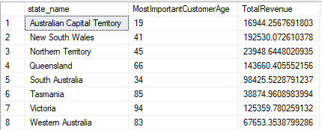

3.2 What are the top 5 best-selling types of products in each state of Australia?

SQL query:
WITH ProductSales AS (
SELECT
c.state_name,
p.Product_Category,
p.Product_Subcategory,
SUM(f.QuantitySold) AS TotalQuantitySold
FROM FactSales f
INNER JOIN DimCustomer c
ON f.CustomerKEY = c.CustomerKEY
INNER JOIN DimProduct p
ON f.ProductKey = p.ProductKey
GROUP BY
c.state_name,
p.Product_Category,
p.Product_Subcategory
),
RankedProductSales AS (
SELECT
state_name,
Product_Category,
Product_Subcategory,
TotalQuantitySold,
ROW_NUMBER() OVER (
PARTITION BY state_name
ORDER BY TotalQuantitySold DESC
) AS rn
FROM ProductSales
)
SELECT
state_name,
Product_Category,
Product_Subcategory,
TotalQuantitySold
FROM RankedProductSales
WHERE rn <= 5
ORDER BY state_name, rn;

Result from the above query:
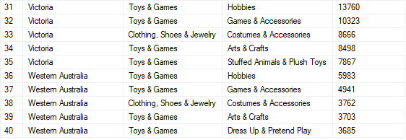
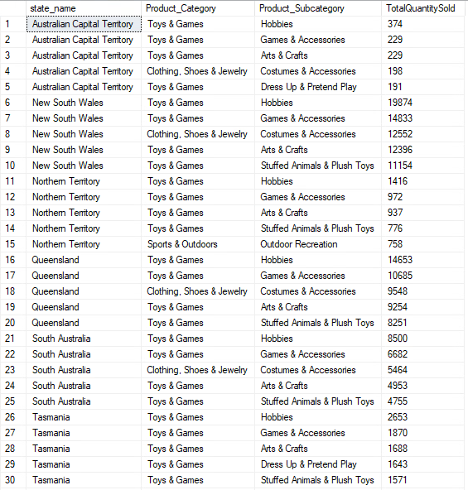

3.3 Who are the 5 largest suppliers (in terms of quantity of items sold) in New South Wales each year?

SQL query:
WITH SellerSales AS (
SELECT
d.[Year],
s.[name] AS SupplierName,
SUM(f.QuantitySold) AS TotalQuantitySold
FROM FactSales f
INNER JOIN DimSeller s
ON f.SellerKEY = s.SellerKEY
INNER JOIN DimDate d
ON f.DateKEY = d.DateKEY
WHERE s.State_name = 'New South Wales'
GROUP BY
d.[Year],
s.[name]
),
RankedSellerSales AS (
SELECT
[Year],
SupplierName,
TotalQuantitySold,
ROW_NUMBER() OVER (
PARTITION BY [Year]
ORDER BY TotalQuantitySold DESC
) AS rn
FROM SellerSales
)
SELECT
[Year],
SupplierName,
TotalQuantitySold
FROM RankedSellerSales
WHERE rn <= 5
ORDER BY [Year], rn;

Result from the above query:
