

SILIWANGI UNIVERSITY LANGUAGE CENTRE
Test of English Language Proficiency (TELP)
TEST REPORT FORM
:
:
:
:
:
:
:
:
Test Date
Valid Until
Certificate Number
Test of English Language Proficiency (TELP) is administered by Siliwangi University Language Centre.
CANDIDATES DETAILS
Name
Date of Birth
Native Country
Native Language
Sex
TEST RESULTS
Listening Comprehension
Structure & Written Expression
Reading Comprehension
Overall Band Score
:
:
:
:
{{ negara }}
{{ bahasa }}
{{ no_sertifikat }}

{{ tanggal_tes }}
{{ berlaku_sampai }}

{{ nama }}

{{ tanggal_lahir }}
{{ jenis_kelamin }}
{{ listening }}
{{ structure }}
{{ reading }}
{{ overall }}
Security Guard  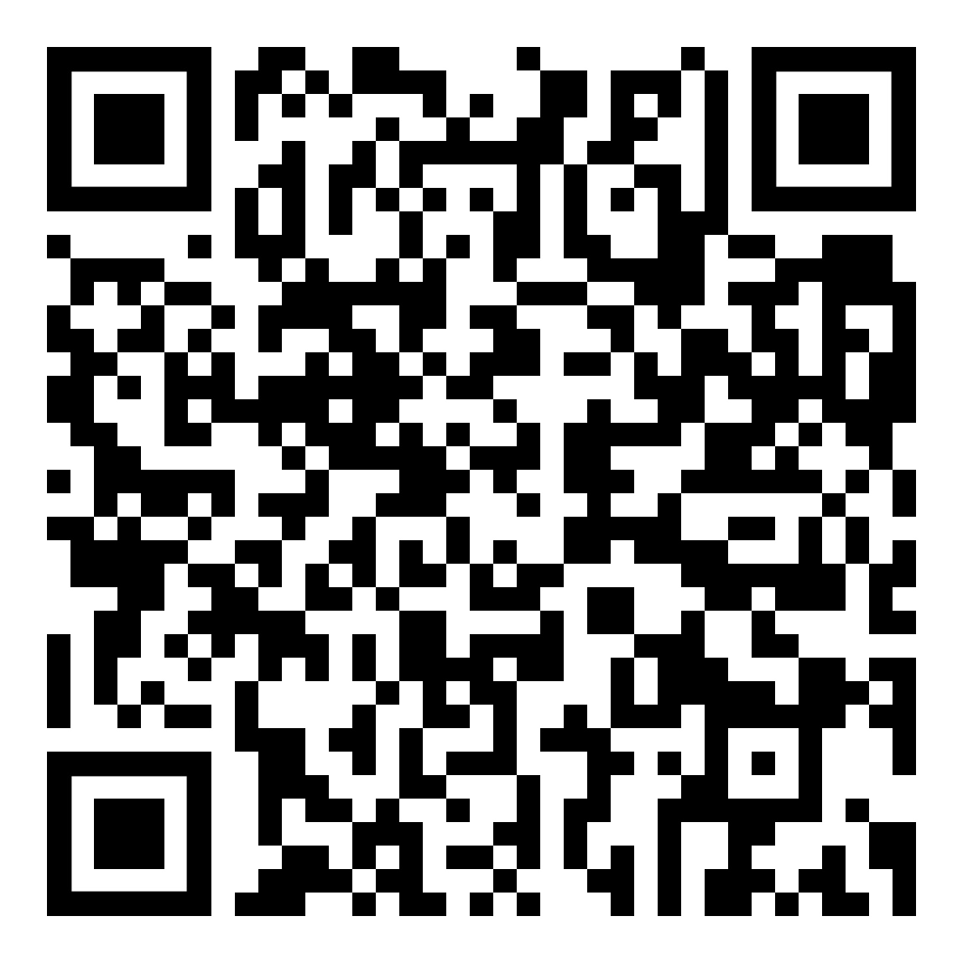 |  | Validation |  | Head of    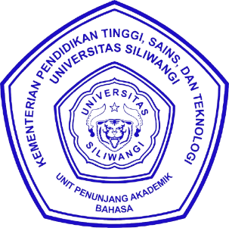    Siliwangi University Language Centre  Dr. Soni Tantan Tandiana, S.Pd.  NIP 197009152021211004

