
FutureXcel Internship Program
Title:
Complete Exploratory Data Analysis (EDA) Using Superstore Dataset
Role:
Data Science Intern
Organization:
FutureXcel
Week: 3
Complete Exploratory Data Analysis (EDA)
Prepared by:
Sharif Ullah
Tools & Technologies:
Python, Pandas, NumPy, Matplotlib, Seaborn, Jupyter Notebook
Submission Date:
17 February 2026

1. Dataset Overview
The dataset contains retail sales transactions of a superstore.
It includes information about orders, customers, regions, products, sales, profit, and discounts.
- Total Rows: 9994
- Total Columns: 21
- Missing Values: 0
- Numeric Columns: Sales, Profit, Discount, Quantity
The dataset is clean and ready for analysis.
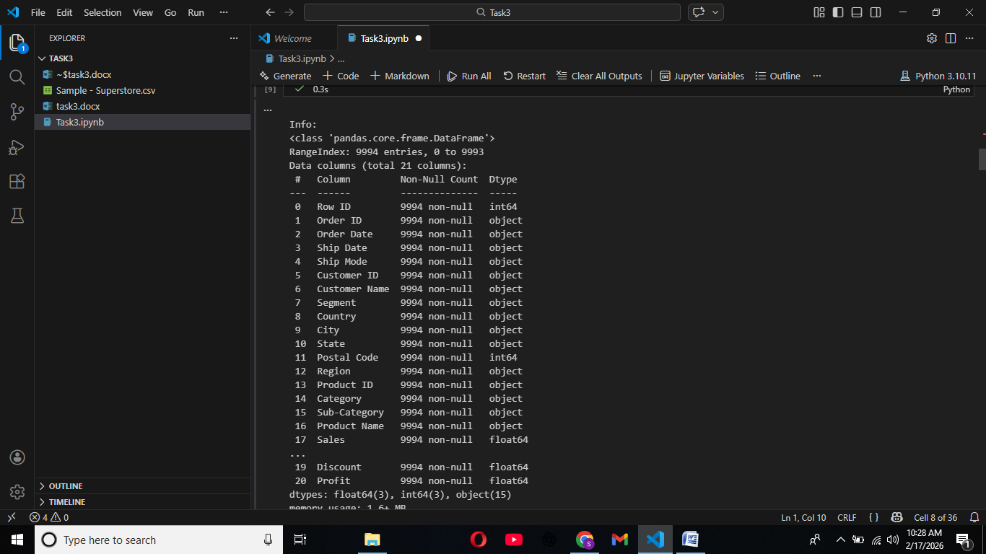
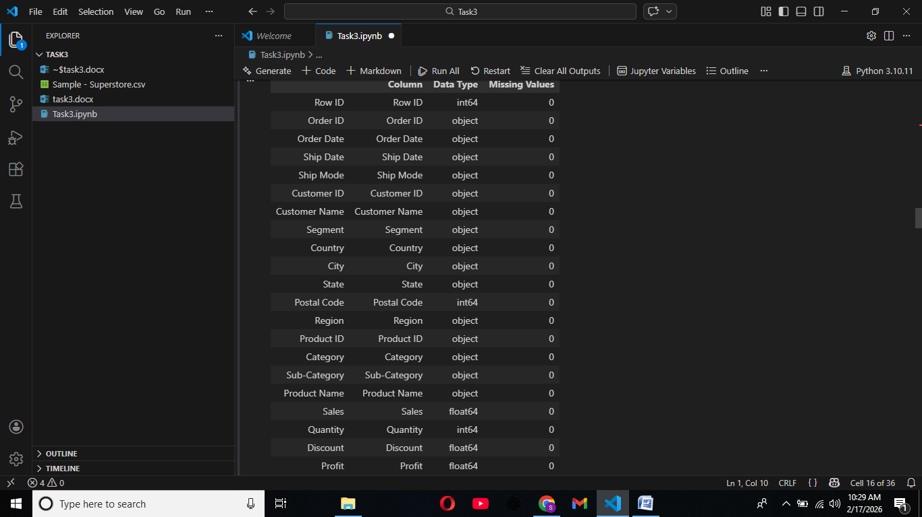

2. Descriptive Statistics
Descriptive statistics help us understand the numerical distribution of the dataset.
- Average Sales: 229
- Average Profit: 28
- Maximum Sales: 22638
- Minimum Profit: -6599
Sales and profit contain extreme values which indicate the presence of outliers.
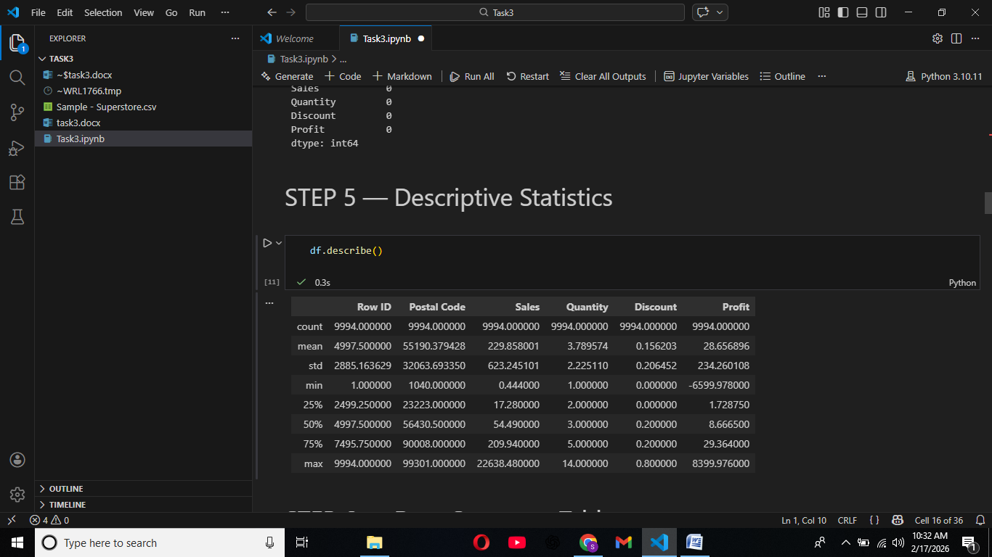

DISTRIBUTION ANALYSIS

3. Distribution Analysis
The distribution of Sales and Profit is highly right-skewed.
- Sales Skewness: 12.97
- Sales Kurtosis: 305
- Profit Skewness: 7.56
- Profit Kurtosis: 397
High skewness indicates that most values are small while a few are extremely large.
High kurtosis indicates the presence of extreme outliers.
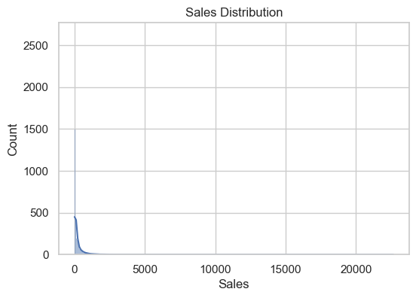
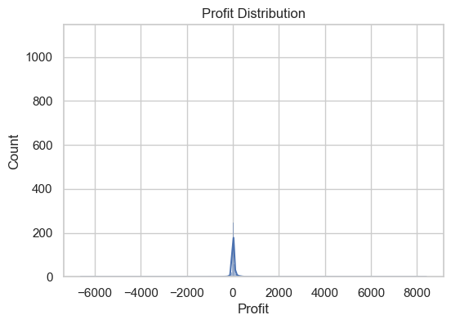
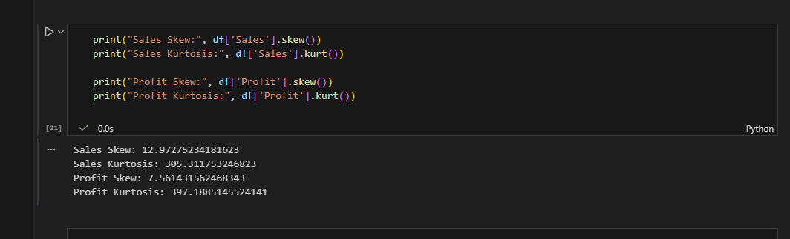

4. Correlation Analysis
The correlation heatmap shows relationships between numerical variables.
Key findings:
- Sales and Profit have a moderate positive correlation.
- Discount and Profit have a negative correlation.
This indicates that higher discounts often reduce profit.
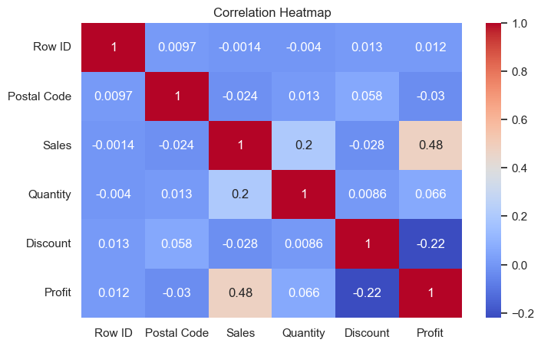

CATEGORY & REGION ANALYSIS

5. Category Analysis
Technology category generates the highest sales.
Office Supplies category generates the lowest sales.
This suggests that technology products are more profitable for the business.
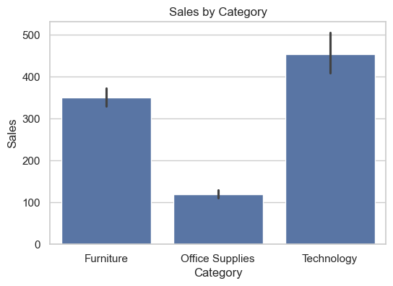

6. Region Analysis
The Central region shows the lowest profit.
The West region shows the highest profit.
This suggests that business strategy in the Central region may need improvement.
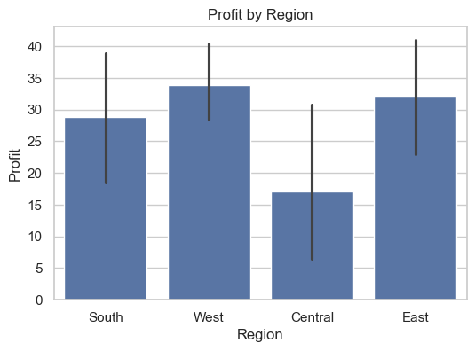

7. Time Series Analysis
Monthly sales trend shows fluctuations across different months.
Some months have significantly higher sales compared to others.
This helps identify seasonal trends and peak sales periods.
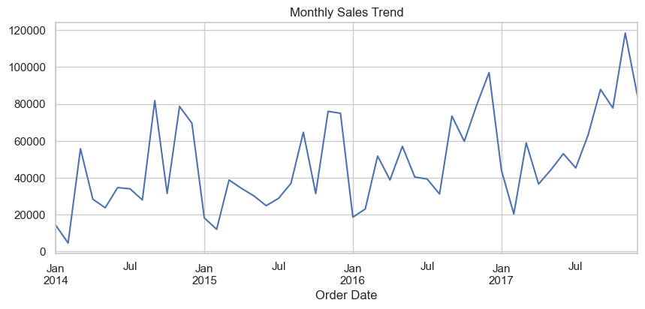

OUTLIERS & INSIGHTS

8. Outlier Analysis
Boxplot analysis shows extreme outliers in sales and profit.
These outliers represent very large transactions or potential anomalies.
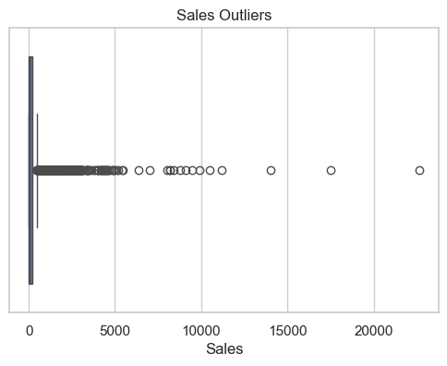

9. Key Insights
- Sales distribution is highly right-skewed with a few very large orders.
- Profit distribution contains negative values indicating loss-making orders.
- Sales and Profit show a moderate positive correlation.
- Discount has a negative correlation with Profit.
- Technology category generates the highest sales.
- Office Supplies category generates the lowest sales.
- Central region has the lowest profit.
- The dataset contains extreme outliers in sales and profit.
- Most orders have small quantity values.
- The dataset is clean with no missing values.

10. Conclusion
The exploratory data analysis reveals key patterns in sales, profit, and discount behavior.
The business should focus on reducing excessive discounts and improving performance in low-profit regions.
Technology products contribute most to revenue and should be prioritized.

