Course: Data Structures (CSE CS203A)
Assignment V: Tree
Student Worksheet Companion

Due date: 2025.12.30 23:59:59
Section 1. Definitions of Tree Variants
Task: Write your own definitions for each tree type. You may use AI for learning, but rewrite in your own words.
- General Tree
Definition:樹狀結構中最基本的形式，由節點組成階層架構，沒有子節點的數量限制，可以是0或無限多
- Binary Tree
Definition:與general tree不同，每個子節點最多只能有兩個子節點，他們有特定的名稱和位置，分別是左子節點和右子節點
- Complete Binary Tree
Definition:是binary tree的分支，著重於填滿空間，絕不會有空缺，所以很省空間，必須滿足除了最後一層，每一層皆是填滿的，以及最後一層需靠左對齊，由上到下、由左至右
- Binary Search Tree (BST)
Definition:是有排序功能的二元樹，能快速搜尋，對於樹中每一個節點，左邊子樹的所有數值一定要小於該節點，而右邊子樹的所有數值一定要大於該節點
- AVL Tree
Definition:解決樹中不平衡導致時間複雜度增加的問題，依賴數學標準保持平衡，平衡因子=左子樹高度-右子樹高度，其平衡因子絕對值不能超過1，當不平衡時執行旋轉來修復
- Red-Black Tree
Definition:在節點上儲存紅色或黑色的資訊，透過規則保證最長路徑不會超過最短路徑的兩倍，每個節點不是黑色就是紅色，根一定為黑色，所有底部的空節點都視為黑色，紅色節點的子節點必為黑色，且從一節點出發走到底下任一節點經過的黑色節點數量需依樣多
- Max Heap
Definition:是一顆Complete Binary Tree，滿足父節點的值>=子節點的值，所以root一定為樹中的最大值，但不保證左邊比右邊大，或右邊比左邊大
- Min Heap
Definition:相反於Max heap，Min tree中所有父節點的值<=子節點的值，root為樹中最小值
Section 2. Tree Family Hierarchy and Transformations
Task: Show how these structures are related (general → specialized). Use a simple diagram and explanations of what constraints are added at each step.
2.1 Tree Family Diagram
You may draw this by hand and paste a photo, or use drawing tools.
Suggested chain example (you may extend or adjust):
General Tree → Binary Tree → Complete Binary Tree
Binary Tree → Binary Search Tree → AVL / Red-Black
Binary Tree → Max Heap / Min Heap
Your Diagram:
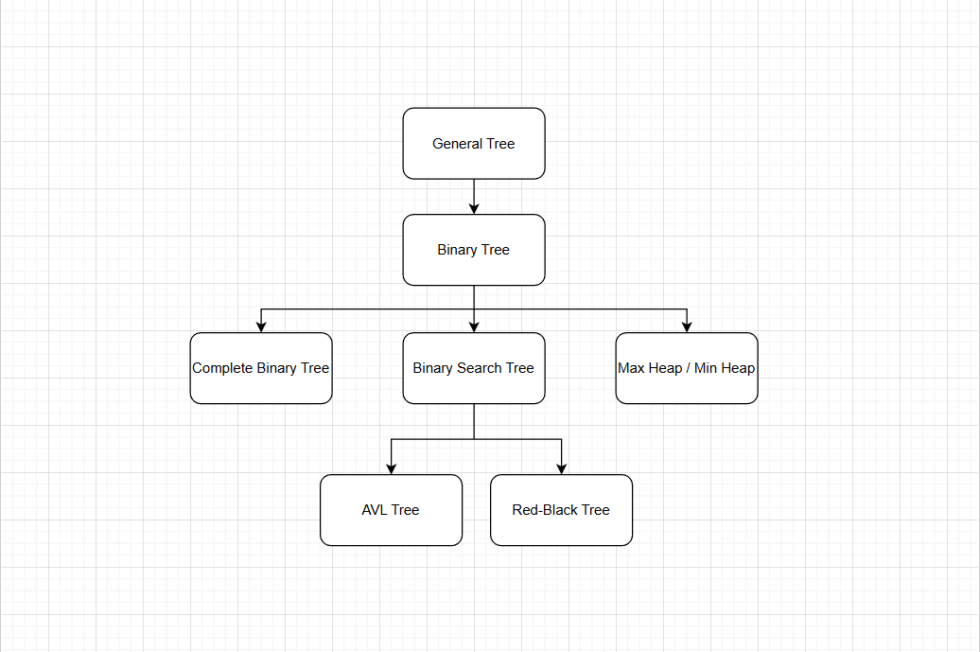
https://app.diagrams.net/?src=about
2.2 Explanation of Transformations
Fill in what new property or constraint is added at each step.
From | To | New property / constraint added
General Tree | Binary Tree | 每一節點最多只能有兩個節點
Binary Tree | Complete Binary Tree | 所有節點須向左排滿
Binary Tree | Binary Search Tree | 依據左小又大進行排序
BST | AVL Tree | 進行層數的平衡，避免傾斜
BST | Red-Black Tree | 增加紅黑顏色存入減少維護成本
Binary Tree | Max Heap | 加入上下層間的大小關係，上需大於下
Binary Tree | Min Heap | 加入上下層間的大小關係，上需小於下

Section 3. Tree Constructions Using Given Integers
Given integers (fixed for all parts):
37, 142, 5, 89, 63, 117, 24, 176, 58, 133, 92, 11, 151, 72, 39, 184, 7, 101, 54, 160
Task: For each tree type below, construct the tree using these integers, take a screenshot of the tree from your chosen tool, record the tool name/URL, and describe the insertion / heap-building procedure.
3.1 Binary Tree
Tool name / URL: https://app.diagrams.net/?src=about
Construction / insertion description:在二元規則下依序排入
Screenshot of Binary Tree (paste below):
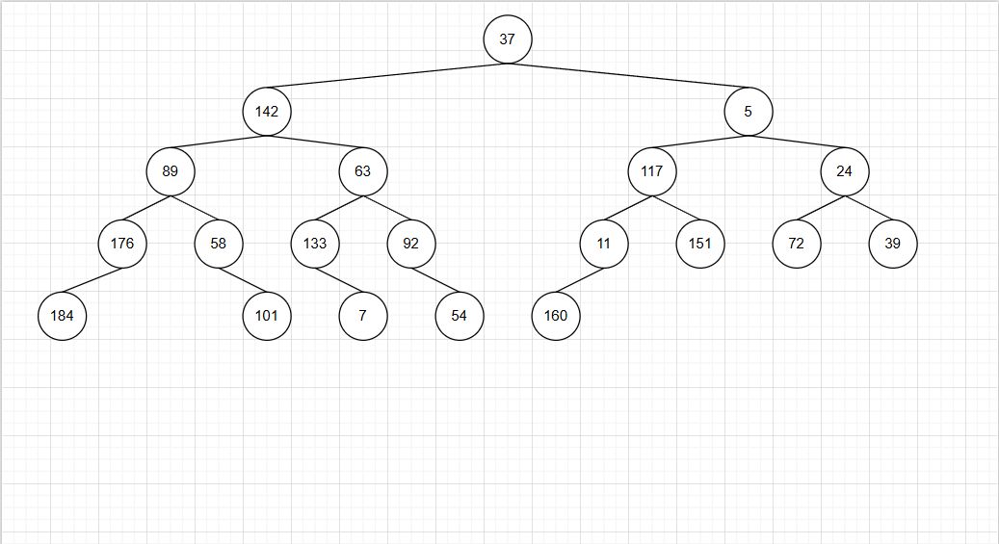
3.2 Complete Binary Tree
Tool name / URL: https://app.diagrams.net/?src=about
Construction / insertion description:由左至右依序排入填滿
Screenshot of Complete Binary Tree (paste below):
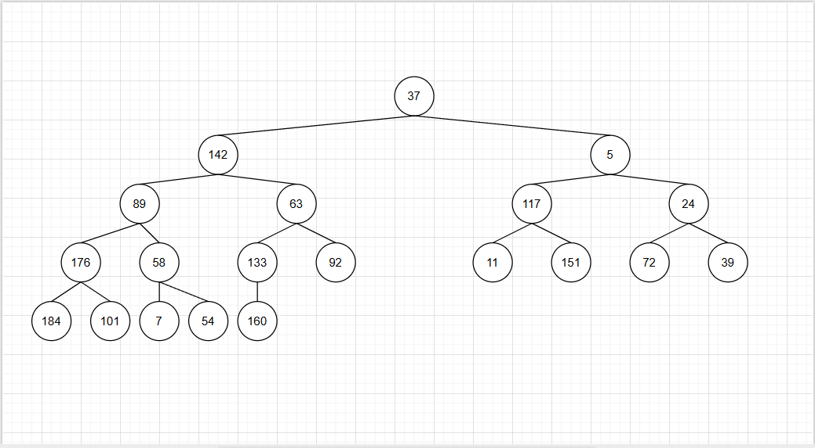
3.3 Binary Search Tree (BST)
Tool name / URL: https://www.cs.usfca.edu/~galles/visualization/BST.html
Insertion rule (e.g., “insert in given order using BST rules”):左小右大的規則排入
Screenshot of BST (paste below):
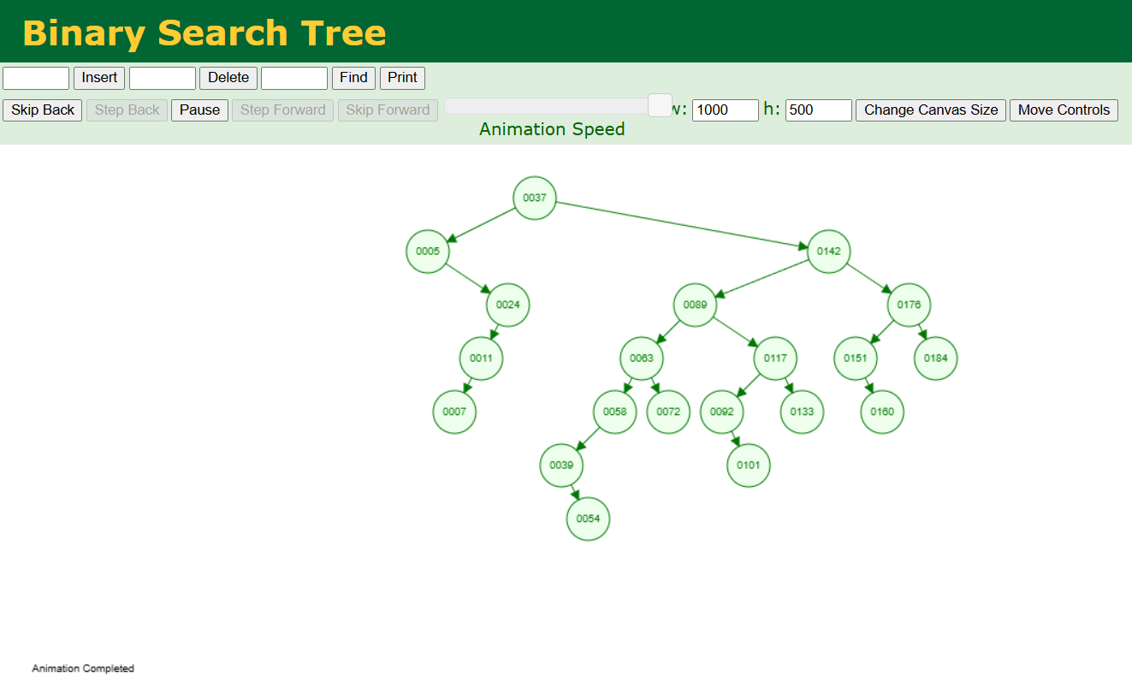
3.4 AVL Tree
Tool name / URL: https://www.cs.usfca.edu/~galles/visualization/AVLtree.html
Insertion & balancing description:根據BST的規則，但平衡每子樹的層數
Screenshot of AVL Tree (paste below):
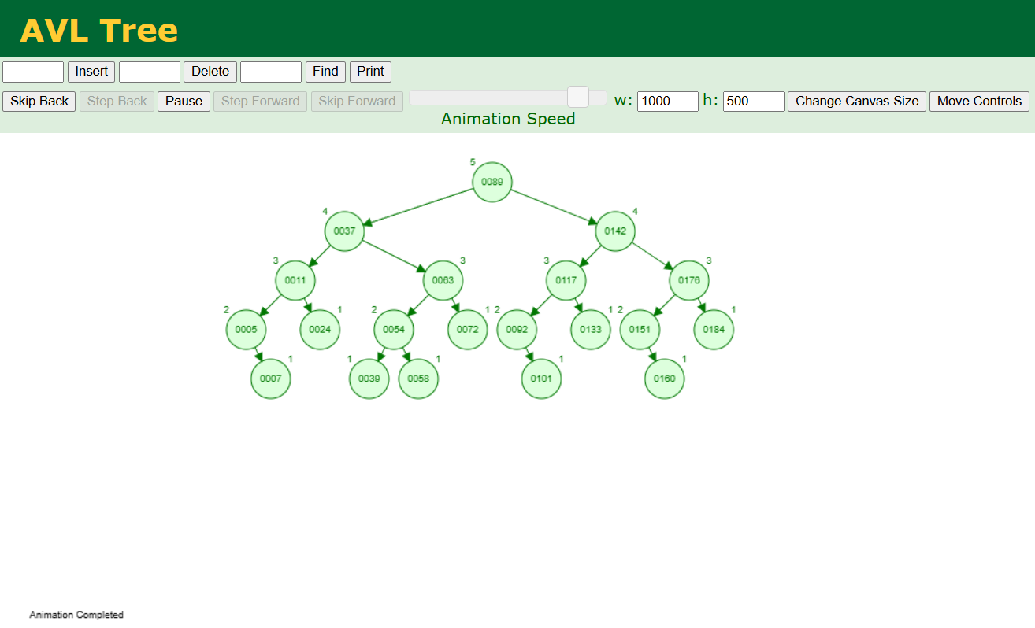
3.5 Red-Black Tree
Tool name / URL: https://www.cs.usfca.edu/~galles/visualization/RedBlack.html
Insertion & balancing description:以BST基礎加上紅色黑色進行排序
Screenshot of Red-Black Tree (paste below):
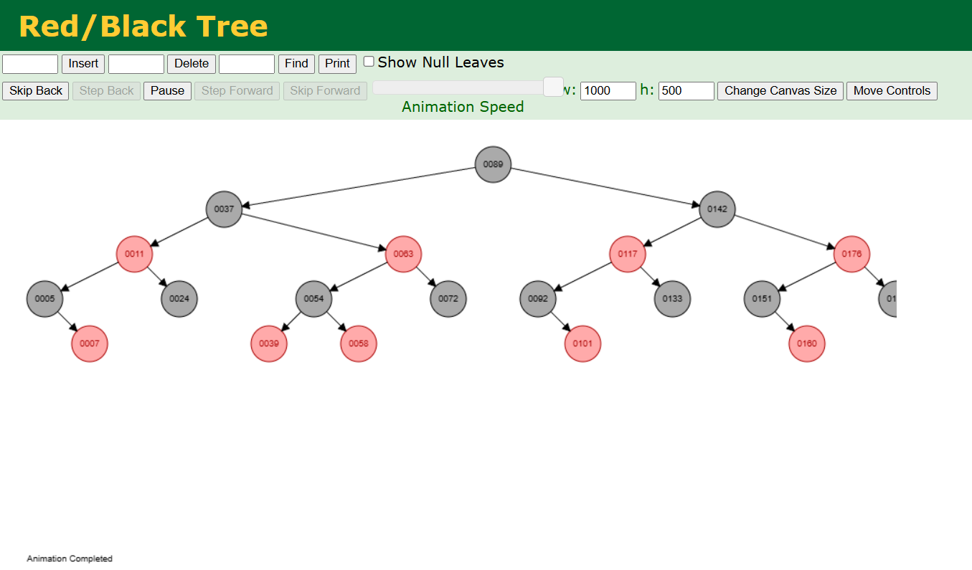

3.6 Max Heap
Tool name / URL: https://visualgo.net/zh/heap
Construction / heap-building description (e.g. heapify, insert-and-sift-up):先依序排入後依據上下層大小更換位置
Screenshot of Max Heap (paste below):
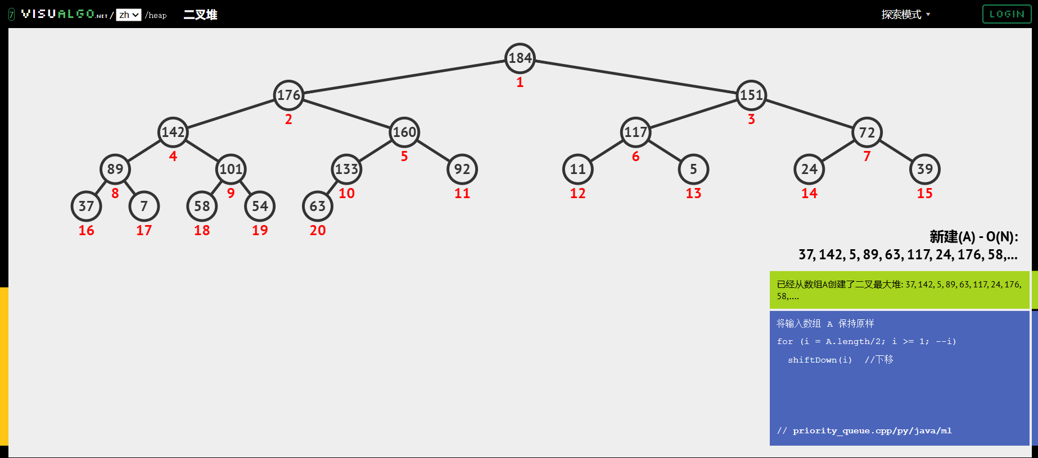
3.7 Min Heap
Tool name / URL: https://www.cs.usfca.edu/~galles/visualization/Heap.html
Construction / heap-building description: 先依序排入後依據上下層大小更換位置
Screenshot of Min Heap (paste below):
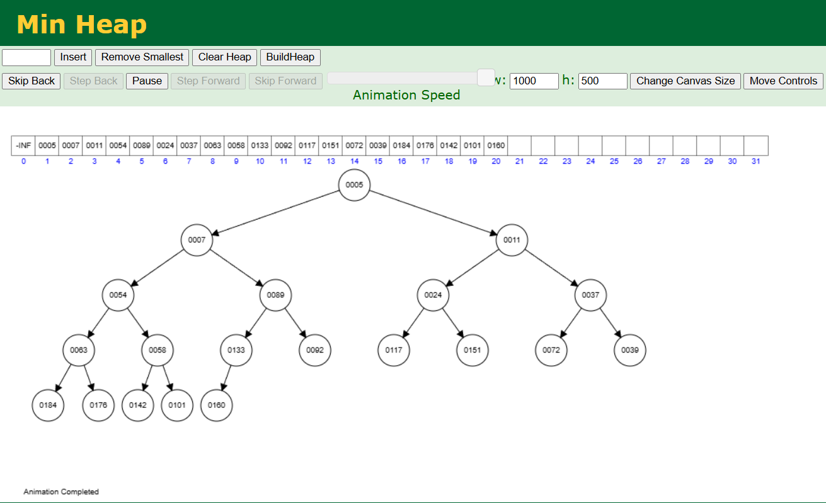
Section 4. Application Examples
Task: For each tree type, choose one application and explain why this tree is suitable.
Tree Type | Application Example (name / context) | Why this tree fits (properties that matter)
Binary Tree | 編譯器 | 程式語言編譯器在讀code 時，會把它變成一棵樹來分析語法
Complete Binary Tree | Max Heap 和 Min Heap | 能保證把樹放進陣列時，中間絕對不會有空洞
Binary Search Tree | 理論基礎與教學 | 容易歪掉變慢，現代軟體很少直接使用
AVL Tree | 字典與拼字檢查 | 單字庫通常建立後很少改動，但需要極為頻繁的查詢，AVL 的嚴格平衡能提供最快的查詢速度
Red-Black Tree | 一般用途的高效儲存 | C++ 時用的 map 背後是紅黑樹
Max Heap | 作業系統排程 | 如果有緊急任務插隊，Max Heap 能瞬間把它排到最前面處理
Min Heap | Google Maps (最短路徑) | 使用 Min Heap 來不斷找出目前距離最近的路口

Section 5. Reflection on Tree Family and Performance (Optional but recommended)
Among BST, AVL, and Red-Black trees, which one would you pick for:
Mostly search (few updates)? Why?
AVL Tree，AVL Tree 是「嚴格平衡」，相比於紅黑樹，AVL Tree 通常壓得更扁、高度更低，搜尋的時間複雜度取決於樹的高度，因為 AVL 樹比較矮，所以在搜尋時需要比較的次數最少，讀取效率極高。
Frequent insertions and deletions? Why?
Red-Black Tree，紅黑樹的平衡條件比較寬鬆，當我們插入或刪除節點時，它不需要像 AVL Tree 那樣頻繁地進行旋轉來維持完美平衡。
If you must store these 20 integers for static search only (no updates), which structure or representation would you prefer (sorted array + binary search, BST, AVL, etc.)? Why?
Complete Binary Tree，形狀相對平衡搜尋快速，不需要大量的維護成本
Section 6. AI Usage Log (Required)
Task: Record every time you ask an AI assistant about this assignment.
Index | Date / Time | AI Service (ChatGPT, Gemini, etc.) | Your Full Prompt / Question
1 | 12/25 01:06 | Gemini | 有什麼推薦的工具嗎
2 | 12/25 01:12 | Gemini | 請問什麼是general tree
3 | 12/25 9:50 | Gemini | 請問什麼是binary tree
4 | 12/25 10:00 | Gemini | 請問什麼是Complete Binary Tree
5 | 12/25 10:06 | Gemini | 請問什麼是Binary Search Tree
6 | 12/25 10:12 | Gemini | 請問什麼是AVL Tree
7 | 12/25 10:19 | Gemini | 請問什麼是Red-Black Tree
8 | 12/25 10:27 | Gemini | 請問什麼是max heap
9 | 12/25 10:33 | Gemini | 請問什麼是min heap
10 | 12/25 11:38 | Gemini | 請問這些tree分別可以做什麼應用呢
You may extend this table as needed.

