LuxEstate
Real Estate Property Management System

TECHNICAL SPECIFICATION DOCUMENT

Version: 1.0
Academic Year: 2025–2026
Platform: Web Application (PHP + MySQL)
Status: Development Complete

1. Project Overview

LuxEstate is a web-based real estate platform connecting property buyers, renters, and owners — eliminating broker dependency through direct owner contact. Built with PHP and MySQL, it provides 24/7 access to property listings with advanced search and filtering.

1.1 Objectives
- Simplify property search by location, type, and budget
- Enable direct communication between buyers/renters and owners
- Showcase properties with high-quality images and detailed specifications
- Implement secure user authentication with bcrypt password hashing
- Deliver a fully responsive interface across desktop, tablet, and mobile
- Organize properties into Buy, Rent, and Villa categories

1.2 Problem Statement
Problem | Description
Time-Consuming Search | Traditional property hunting requires visiting multiple brokers and locations
Lack of Transparency | Limited information about properties leads to confusion and poor decisions
Broker Dependency | Heavy reliance on brokers increases costs by 2–3% of property value
Limited Reach | Newspaper listings have constrained visibility and no image support
Inefficient Communication | Difficulty in reaching property owners directly without intermediaries

2. Entity Relationship Diagram

The LuxEstate database (luxestate_db) consists of 5 tables with 4 foreign key relationships and 8 indexes. The properties table is the central entity, linked to property_images, favorites, and inquiries.

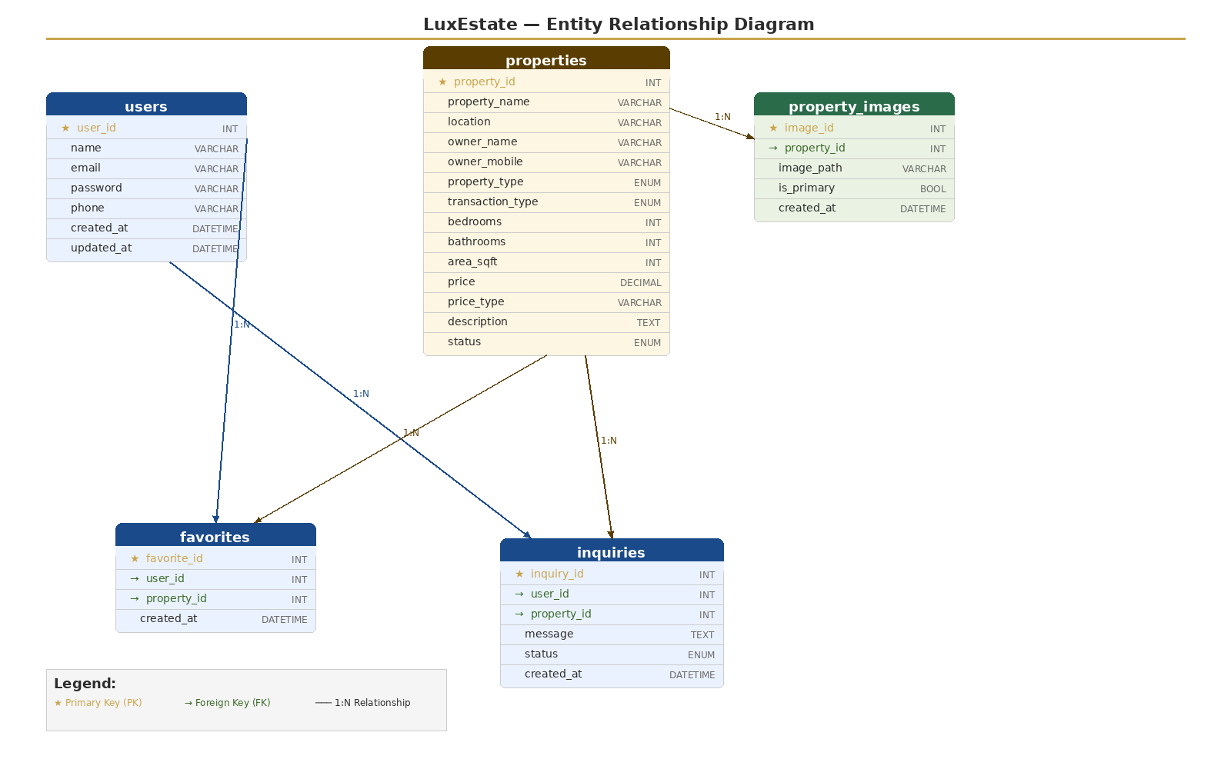

2.1 Relationships Summary
Relationship | Description
users → favorites | One user can save many favorite properties (1:N via user_id FK)
users → inquiries | One user can send many inquiries (1:N via user_id FK)
properties → property_images | One property can have many images (1:N via property_id FK)
properties → favorites | One property can be favorited by many users (1:N via property_id FK)
properties → inquiries | One property can receive many inquiries (1:N via property_id FK)

2.2 Database Schema
Table | Key Fields
users | user_id (PK), name, email (unique), password (bcrypt), phone, created_at, updated_at
properties | property_id (PK), property_name, location, owner_name, owner_mobile, property_type, transaction_type, bedrooms, bathrooms, area_sqft, price, price_type, description, status
property_images | image_id (PK), property_id (FK), image_path, is_primary, created_at
favorites | favorite_id (PK), user_id (FK), property_id (FK), created_at
inquiries | inquiry_id (PK), user_id (FK), property_id (FK), message, status, created_at

3. System Architecture

3.1 Technology Stack
Layer | Details
Frontend | HTML5, CSS3 (Flexbox/Grid), JavaScript (ES6+), Google Fonts (Poppins)
Backend | PHP 7.4+ — server-side scripting, session management, form processing
Database | MySQL 5.7+ / MariaDB 10.3+ — relational data storage with 5 tables
Web Server | Apache 2.4+ (XAMPP/WAMP for dev, Linux for production)
Security | bcrypt password hashing, prepared statements, XSS protection
Dev Tools | VS Code, phpMyAdmin, XAMPP/WAMP, Git, FileZilla

3.2 Three-Tier Architecture
Presentation Layer  HTML/CSS/JS + PHP Views | Business Logic Layer  PHP Controllers & Logic | Data Layer  MySQL — luxestate_db

4. Module Specifications

4.1 User Authentication Module
Attribute | Specification
File | signin.php (login), create.php (registration), logout.php
Registration Fields | Full Name (max 40 chars, alpha only), Email (unique, valid format), Password (min 4 chars, bcrypt), Confirm Password
Login Flow | Email + password input → bcrypt verify → session creation → redirect homepage
Session Data | user_id, email, user_name stored in PHP session
Security | password_hash() bcrypt, prepared statements, htmlspecialchars() XSS protection
Validation | Client-side JS + server-side PHP dual validation

4.2 Property Display Module
Attribute | Specification
File | index.php
Layout | Responsive grid of property cards — image, title, location, bed/bath/area, price, category tag
Filter Categories | All Properties | Buy | Rent | Villas Only (JavaScript client-side filtering)
Search Parameters | Location (text), Property Type (dropdown: Villa/Apartment/House), Budget Range
Data Source | MySQL query on properties table with status = active
Login Gate | View Details requires authenticated session

4.3 Property Details Module
Attribute | Specification
File | details.php
Image Slider | Multiple images with prev/next navigation, smooth CSS transitions
Owner Contact | Direct call (tel: link), WhatsApp integration with owner mobile
Specifications | Bedrooms, bathrooms, area (sqft), price, type, transaction type
Security | Login required, session verification, SQL injection prevention via prepared statements
Image Format | WebP preferred for performance; fallback to JPG

5. System Requirements

5.1 Hardware Requirements
Component | Development | Production Server
Processor | Intel Core i3+ | Dual Core+
RAM | 4 GB (8 GB recommended) | 2 GB minimum
Storage | 500 MB free space | 10 GB SSD
Network | Broadband connection | 10 Mbps minimum

5.2 Software Requirements
Requirement | Specification
Operating System (Dev) | Windows 10/11, Linux, or macOS
Web Server | Apache 2.4+ (XAMPP/WAMP for dev; Nginx acceptable for prod)
PHP Version | 7.4 or higher (8.x recommended for production)
Database | MySQL 5.7+ or MariaDB 10.3+
SSL Certificate | Required for HTTPS in production
Browser Support | Chrome 120+, Firefox 115+, Safari 16+, Edge 120+, Opera 100+
Minimum Screen | 320px width (mobile-first responsive design)

6. UI Design Specifications

6.1 Visual Design System
Token | Value
Primary Color | #C9A44C — Gold (brand color, CTAs, accents)
Background | #F5EFE6 — Cream (page background)
Text Primary | #2C2C2C — Dark Gray (headings, body)
Rent Accent | #6C8F5A — Green (rent category badges)
Font Family | Poppins (Google Fonts) — 300 Light, 400 Regular, 600 SemiBold
Card Radius | 12px border radius on property cards

6.2 Page Inventory
File | Description
index.php | Homepage — navbar, hero with search, property grid, filter tabs
signin.php | Login — centered form with email/password, validation feedback
create.php | Registration — 4-field form with real-time JS validation
details.php | Property detail — image slider, specs grid, owner contact buttons
logout.php | Session destruction and redirect to homepage

6.3 Responsive Breakpoints
Device | Layout Behavior
Desktop | 1920×1080 — full grid, expanded navbar
Laptop | 1366×768 — standard layout
Tablet | 768×1024 — stacked cards, condensed nav
Mobile | 375×667 — single column, touch-friendly buttons
Minimum Width | 320px — hard floor for mobile browsers

7. Test Cases & Results

Test Summary: 10 test cases executed — 10 PASSED, 0 FAILED. Pass rate: 100%

ID | Module | Description | Expected | Status
TC001 | Auth | New user registration with valid data | Account created, success message shown | PASS
TC002 | Auth | Duplicate email registration rejected | Error: Email already registered | PASS
TC003 | Auth | Login with valid credentials | Redirect to homepage, name displayed | PASS
TC004 | Auth | Login with incorrect password | Error: Incorrect password | PASS
TC005 | Display | Property filter by Buy/Rent category | Only matching properties displayed | PASS
TC006 | Details | Property details page and image slider | All info visible, slider functional | PASS
TC007 | Auth | User logout and session clear | Redirected, details require re-login | PASS
TC008 | Validation | Empty form fields on registration | Error: All fields are required | PASS
TC009 | Validation | Invalid email format submitted | Error: Invalid email format | PASS
TC010 | Validation | Password and confirm mismatch | Error: Passwords do not match | PASS

8. Security Specifications

Vector | Mitigation
Password Storage | bcrypt hashing via PHP password_hash() — salted, one-way
SQL Injection | All database queries use PDO/MySQLi prepared statements
XSS Prevention | All output sanitized via htmlspecialchars()
Session Management | PHP sessions with user_id, email, user_name; destroyed on logout
Access Control | Protected pages verify session before serving content
CSRF Protection | Recommended for production (CSRF tokens on all forms)
HTTPS | SSL certificate required in production environment
Input Validation | Dual-layer: client-side JavaScript + server-side PHP

9. Future Enhancements

9.1 Short-Term (Phase 2)
- Admin dashboard — property CRUD, user management, analytics & reports
- User dashboard — saved properties, search history, inquiry tracking
- Property comparison — side-by-side feature and price analysis
- Email & SMS notifications — new listings, price drops, appointment reminders
- Advanced search — price/area range sliders, amenities filter, map-based search

9.2 Medium-Term (Phase 3)
- Payment integration — Razorpay/Stripe for booking fees and rent payments
- In-app messaging — real-time chat between users and property owners
- Mobile application — iOS (Swift) and Android (Kotlin) or cross-platform Flutter
- Social login — Google and Facebook OAuth 2.0
- Virtual tours — 360 degree property views using Three.js / WebXR

9.3 Long-Term (Phase 4)
- AI/ML features — price prediction, recommendation engine, chatbot
- Blockchain — smart contracts for transparent property transactions
- Multi-language support — English, Hindi, regional Indian languages
- Geographic expansion — multiple cities, then international markets

10. Conclusion

LuxEstate successfully delivers a modern, secure, and responsive web-based real estate platform built on PHP and MySQL. The system addresses core pain points of traditional property hunting — broker dependency, lack of transparency, and limited reach — by providing a centralized digital platform with direct owner contact capabilities.

All 10 planned test cases passed with a 100% pass rate. The platform is mobile-first, fully responsive, and implements industry-standard security practices including bcrypt password hashing, prepared statements, and XSS protection.

Objectives Met
- Simplified property search with multi-criteria filtering
- Direct buyer-to-owner communication (call + WhatsApp)
- Secure user authentication with encrypted credentials
- Responsive design from 320px mobile to 1920px desktop
- Property categorization: Buy, Rent, Villas
- Detailed property listings with multi-image gallery slider

The platform is architected for scalability and provides a strong foundation for planned Phase 2-4 enhancements including AI recommendations, mobile apps, payment integration, and multi-city expansion.

